ASSESSMENT SOLUTION FOR DELIVERABLE 1

COURSE MSc COMPUTER SCIENCE WITH PROFESSIONAL PLACEMENT
MODULE: CMP7244 SOFTWARE DEVELOPMENT
MODULE LEADER: KHALED MAHBUB
STUDENT ID: 25105562

BIRMINGHAM CITY UNIVERSITY
Tests cases are developed and recorded sequentially. Test Case 1 is assumed upon initial starting of the program (1st Page). I considered the following 4 issues in designing this test case document: equivalence partitioning, boundary value analysis, statement coverage, decision/condition coverage.
Test Case | Input | Expected Result | Actual Result
1 – Log in (Admin) [Valid] | User selects “Admin Login” button. Provides valid authentication (valid admin username and password) | User is redirected to Log In page and prompted to enter username and password. The user enters both (system validates) and user is redirected to main admin menu.  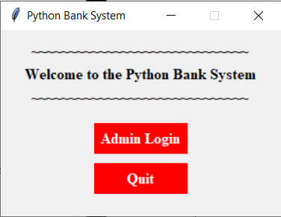  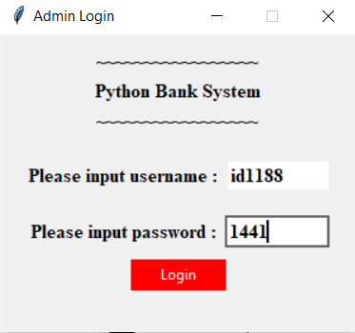  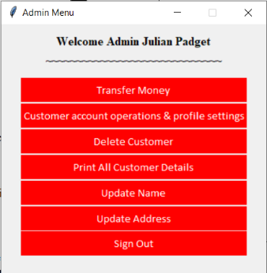 | User is redirected to Log In page and prompted to enter username and password. The user enters both (system validates) and user is redirected to main admin menu.
2 – Quit | User selects “Quit” button | Program terminates. | Program terminates.

Test Case | Input | Expected Result | Actual Result
3 - Log in (Admin) [Invalid] | User selects “Admin Login” button. Provides invalid authentication (invalid admin username and password) | User inputs invalid admin username and password. System denies access.  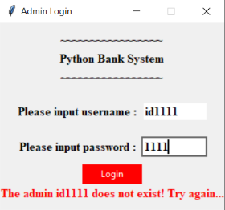 | User is denied access.
4 – Transfer Money (Admin) | User selects “Transfer Money” button. Enters sender and receiver account no. as well as amount to be transferred. | User inputs sender and receiver account no. as well as amount to be transferred. System deducts from sender balance and deposits in receiver balance. | User inputs sender and receiver account no. as well as amount to be transferred. System deducts from sender balance and deposits in receiver balance.  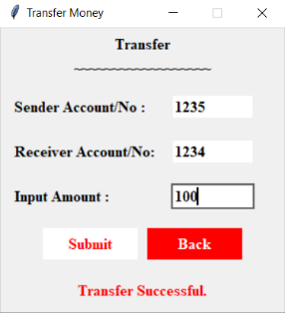
5 - Transfer Money (Admin) [involving non-existing account] | User selects “Transfer Money” button. Enters sender and receiver account no. as well as amount to be transferred. However, receiver account does not exist. | User inputs sender and receiver account no. as well as amount to be transferred. System outputs an error message, stating that transfer cannot be completed. | User inputs sender and receiver account no. as well as amount to be transferred. System outputs an error message and the function does not proceed. (fails validation)  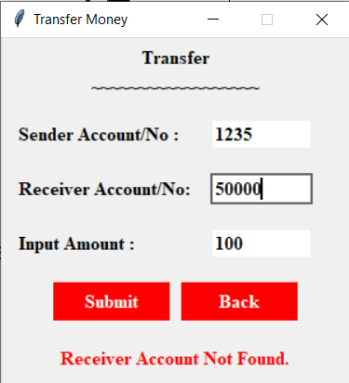
Test Case | Input | Expected Result | Actual Result
6 – Transfer Money (Admin) [insufficient balance] | User selects “Transfer Money” button. Enters sender and receiver account no. as well as amount to be transferred. However, sender account has insufficient balance. | Transfer does not go through. System outputs an error message. | Transfer does not go through. System outputs an error message.  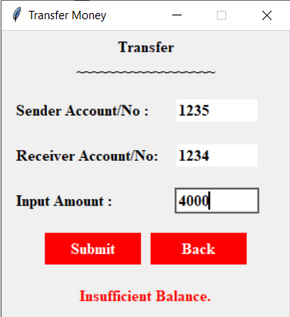
7 – Delete Customer (Admin) | User selects “Delete Customer” button. They then input the customer account.no they wish to delete. | Confirmation is requested, to confirm that user indeed wishes to delete selected account. | Message box prompts confirmation from user before successful deletion of account.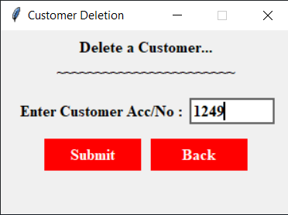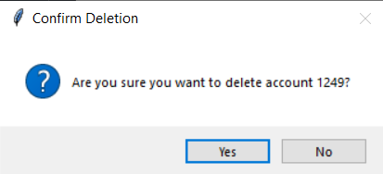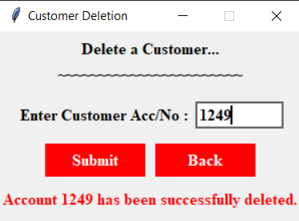

Test Case | Input | Expected Result | Actual Result
8 – Delete Customer (Admin) [Invalid account] | User selects “Delete Customer” button. They then input the customer account.no they wish to delete. | System outputs warning message that process has not been successful. | System outputs warning message for invalid input.  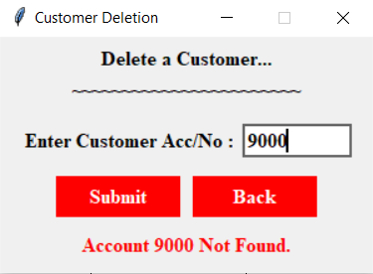
9 – Print all Customer Details (Admin) | User selects “Print all customer details” button. | System outputs a dynamic page detailing total number of accounts, total balance across all accounts, total interest payable (this year) and total overdraft currently taken. | System outputs a dynamic page detailing total number of accounts, total balance across all accounts, total interest payable (this year) and total overdraft currently taken.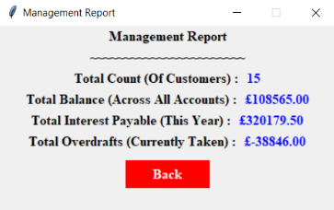
10 – Update Name (Admin) | User selects “Update Name” button. User is then prompted to enter new first and last name. | System changes first and last name for currently active admin account. | System changes first and last name for currently active admin account. Welcome heading is dynamically updated to reflect name change.  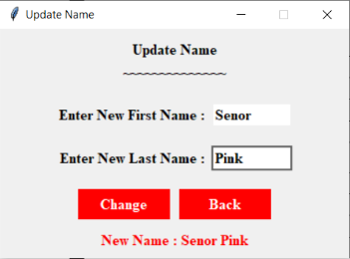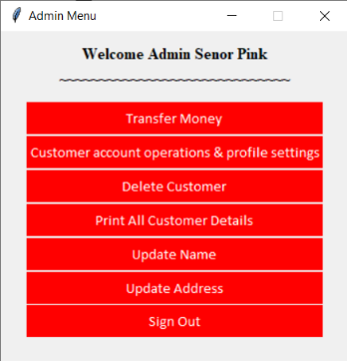

Test Case | Input | Expected Result | Actual Result
11 – Update Name (Admin) [Invalid name change] | User selects “Update Name” button. User is then prompted to enter new first and last name. | System outputs a warning message that name change cannot be accepted. | System outputs a warning message that name change cannot be accepted.  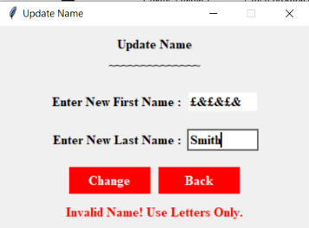
12 – Update Address (Admin) | User selects “Update Address” button. User is then prompted to enter new address. | System changes address for currently active admin account. | System changes address for currently active admin account. Tested for both with and without commas.  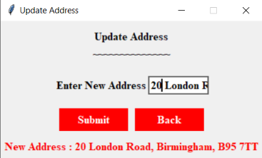  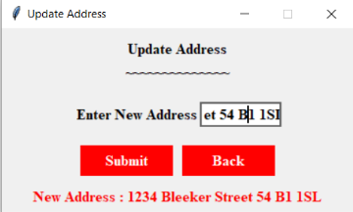
13 – Update Address (Admin) [Invalid name change] | User selects “Update Address” button. User is then prompted to enter new address. | System outputs a warning message that address change cannot be accepted. | System outputs a warning message that address change cannot be accepted.  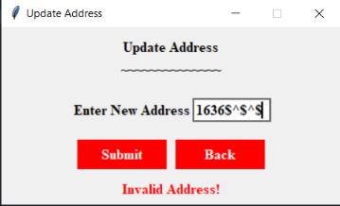

Test Case | Input | Expected Result | Actual Result
14 – Sign out (Admin) | User selects “Sign out” button. | System logs user out of system. Redirects to welcome page. | System logs user out of system. Redirects to welcome page.
15 – Customer Account Operations (Admin) | User selects “Customer account operations and profile settings” button. User enters customer account no. | System redirects user to new window with options to manage customer account (i.e. deposit, withdraw, change customer account details) | System redirects to window prompt to request for customer account no. Upon validation, user is redirected to new window with options to manage said customer account.  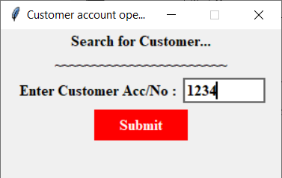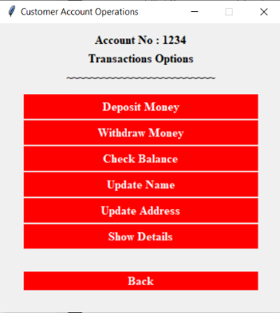
16 – Customer Account Operations (Admin) [Invalid account] | User selects “Customer account operations and profile settings” button. User enters customer account no. | System outputs a warning message that account does not exist. | System outputs a warning message that account does not exist.  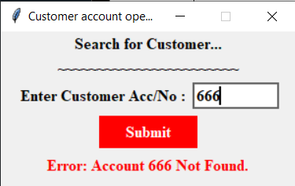

Test Case | Input | Expected Result | Actual Result
17 – Deposit Money (Customer) | User selects “Deposit Money” button. Inputs amount to be deposited. | Inputted amount is deposited into the selected customer’s account balance. | Inputted amount is deposited into the selected customer’s account balance.  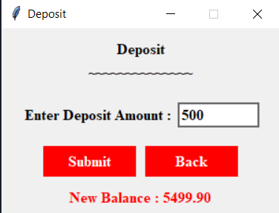
18 – Deposit Money (Customer) [Invalid amount] | User selects “Deposit Money” button. Inputs amount to be deposited. | System outputs a warning message that deposit amount is invalid. | System outputs a warning message that deposit amount is invalid.  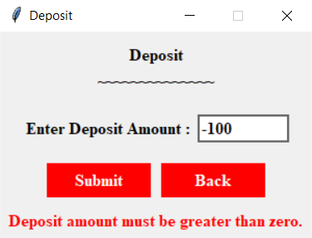
19 – Withdraw Money (Customer) | User selects “Withdraw Money” button. Inputs amount to be withdrawn. | Inputted amount is withdrawn from the selected customer’s account balance. | Inputted amount is withdrawn from the selected customer’s account balance.  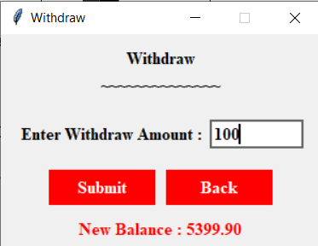
20 – Withdraw Money (Customer) [Invalid Amount] | User selects “Withdraw Money” button. Inputs amount to be withdrawn | System outputs a warning message that withdrawal amount is invalid. | System outputs a warning message that withdrawal amount is invalid.  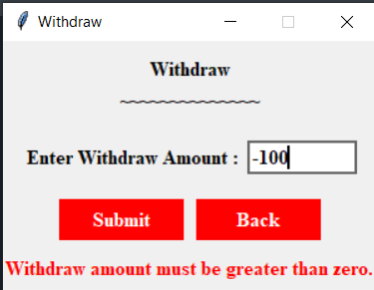

Test Case | Input | Expected Result | Actual Result
21 – Check Balance (Customer) | User selects “Check Balance” button. | Customer account’s balance is shown. | System outputs a window with customer’s balance, dynamically shown to reflect latest balance.  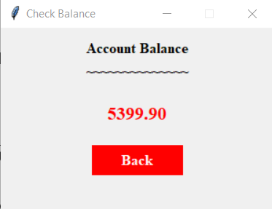
22 – Update Name (Customer) | User selects “Update Name” button. User is prompted to enter new first name and last name. | Customer detail change is confirmed. | Confirmation is given upon successful change.  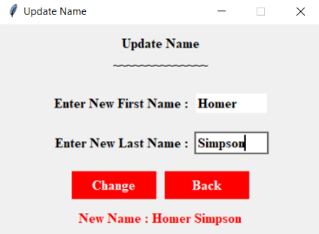
23 – Update Name (Customer) [Invalid name] | User selects “Update Name” button. User is prompted to enter new first name and last name. | System outputs a warning message that name change is invalid. | System outputs a warning message that name change is invalid.  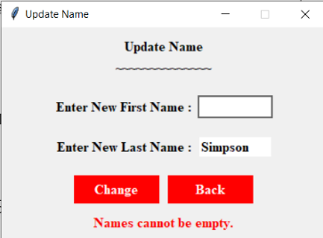
24 – Update Address (Customer) | User selects “Update Name” button. User is prompted to enter new address. | Customer detail change is confirmed. | Confirmation is given upon successful change.  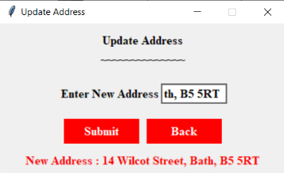

Test Case | Input | Expected Result | Actual Result
25 – Update Address (Customer) [Invalid Address] | User selects “Update Name” button. User is prompted to enter new address. | System outputs a warning message that address change is invalid. | System outputs a warning message that address change is invalid.  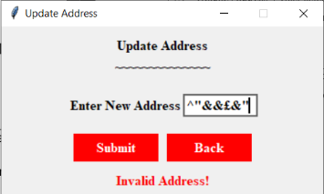
26 – Show Details (Customer) | User selects “Show Details” button. | Customer account details are shown. | System outputs a window with customer’s full details, dynamically shown to reflect latest changes.  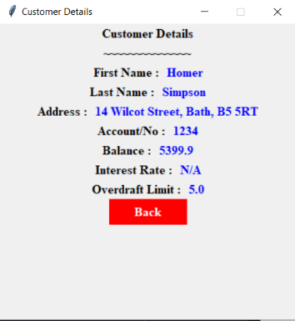
27 – Back (Customer) | User selects “Back” button. | User is directed one step back to the previous window. | User is directed one step back to the previous window.  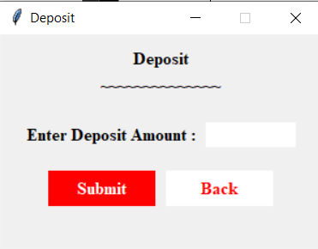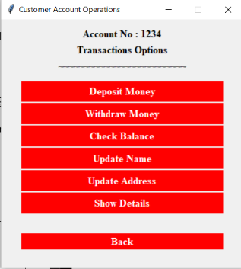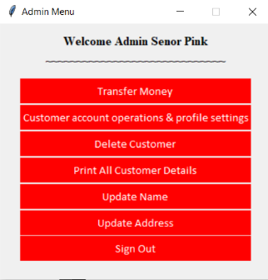
28 – Super-Admin/Non-Super-Admin | User logs in using an admin account flagged for no full admin rights. | User is presented with a more limited version of the system (functionality-wise) | User is presented with a more limited version of the system (functionality-wise)  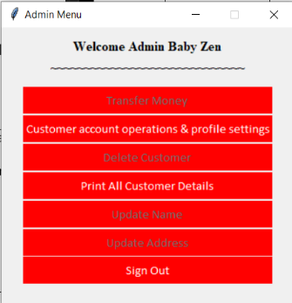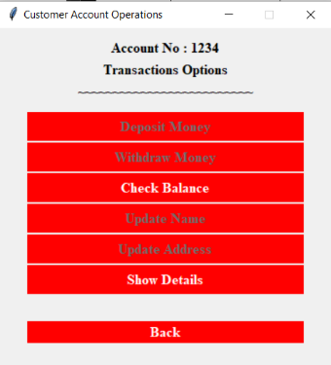

Evaluation of Test Cases for Python Banking System (May 2025)

Introduction
This document provides an evaluation of the test cases conducted during the white box testing of the bank system. The goal of this testing is to test the system’s functionalities and performance across various test scenarios.

Core Functionality
The system has been designed to deliver and does deliver on all required functionalities for a basic bank system. This includes basic log-in authentication functionality for admin accounts, a main admin menu page for basic functions such as handling admin profile details, transferring funds, and accessing customer account operations.

Authentication – TC1
Terminate Program – TC2
Sign Out (Current Session) – TC14
Transfer funds – TC4
Deletion (Customer Account) – TC7
Print Management Report – TC9
Update Name (Current Admin) – TC10
Update Address (Current Admin) – TC12
Customer Account Operations (Access) – TC15
Deposit (Customer) – TC17
Withdraw (Customer) – TC19
Check Balance (Customer) – TC21
Update Name (Customer) – TC22
Update Address (Customer) – TC24
Show Details (Customer) – TC26

The system has also been designed to validate for super-admins (with full admin rights) and disables part of the system’s functionality for when an admin without full admin rights logs in. (Test Case: 28)

Data Validation
Robust attempts were made to validate data inputs at all entry pathways. However, further improvements could be made to account for data repetition (i.e. submitting the same address as current under the pretext of updating). Test cases were provided, showcasing what happens when invalid data is submitted.

Authentication – 3
Transfer funds – TC5, 6
Deletion (Customer Account) – TC8
Update Name (Current Admin) – TC11
Update Address (Current Admin) – TC13
Customer Account Operations (Access) – TC16
Deposit (Customer) – TC18
Withdraw (Customer) – TC20
Update Name (Customer) – TC23
Update Address (Customer) – TC25

Back Functionality
Back buttons have been included at nearly all stages of the system, to allow for the user to backtrack to a previous point or continue with another operation without the need to restart the system. A test case sample has been included to display a successful use.
Especial care has been given into preserving important values when engaging the back function. This includes retaining the admin first and last name on the welcome banner (to keep consistency and confirm that the user remains in the same account) and the customer account no displayed for customer account operations. (Test Case: 27)

Expected Outcomes and Results
All test cases were executed successfully, with all actual outcomes matching expected results in each case. This indicates the system is functioning as intended across all test scenarios.

Areas for Further Improvement
- Performance Testing: Stress testing the system under high load conditions may reveal any potential hidden issues related to usability and performance.
- Security Testing/More Robust Security Features: Login functionality can be improved to better secure bank data. This can limited access attempts before system locks down the terminal access.

Conclusion
Python Bank system functions well and as expected under normal conditions. It passed all presented test cases, indicating functionality. The system has been augmented with advanced GUI features to improve user experience and user-friendliness. Data validation measures have been taken to the best of the programmer’s ability to anticipate any potential shortfalls derived from user input. However, the system in current condition with the level of proven performance has given great confidence in its reliability and readiness for limited test deployment.

