**DAA CIA 2 ASSIGNMENT**

RUSHIKESH MURAHARISETTY

Reg.no. 21011102067

Class: IOTB

GITHUB LINK: https://github.com/zenyuzien/DAA_CIA2

1)

#include <stdio.h>

#include <stdlib.h>

#include <time.h>

#include <math.h>

#define XC 500

#define YC 500

#define NO_CITIES 50

#define POP 1500

#define ITERATIONS 5000

#define MUTATION_P 0.25

#define PRINT_BY 150

typedef struct

{

unsigned x, y;

}city;

typedef struct

{

int solution[NO_CITIES];

double fitness;

}individual;

void swap(int * a, int * b){

int t = *a;

*a = *b;

*b = t;

}

int highest_fitness(individual * population){

int index = 0;

double initial = population[0].fitness;

for (int j = 1; j < POP; j++){

if (population[j].fitness > initial){

initial = population[j].fitness;

index = j;

}

}

return index;

}

void setup_cities(city * cities_map){

for (int i = 0; i < NO_CITIES; i++){

cities_map[i].x = rand() % XC;

cities_map[i].y = rand() % YC;

}

}

void generate_initial_population(individual * population){

int x;

for (int i = 0; i < POP; i++){

for (int j = 0; j < NO_CITIES; j++){

x = rand() % (j+1);

if (x != j){

population[i].solution[j] = population[i].solution[x];

}

population[i].solution[x] = j;

}

}

}

double get_distance(city * cities_map, int id_1, int id_2){

int x1 = cities_map[id_1].x;

int y1 = cities_map[id_1].y;

int x2 = cities_map[id_2].x;

int y2 = cities_map[id_2].y;

double dist = sqrt((x1-x2)*(x1-x2)+(y1-y2)*(y1-y2));

return dist;

}

double * evaluate_fitness(city * cities_map, individual * population){

int id_1, id_2;

double total, fitness_sum = 0;

double * cdf = malloc(sizeof(double) * POP);

for (int i = 0; i < POP; i++){

total = 0;

for (int j = 0; j < NO_CITIES-1; j++){

id_1 = population[i].solution[j];

id_2 = population[i].solution[j+1];

total += get_distance(cities_map, id_1, id_2);

}

population[i].fitness = 1/total;

fitness_sum += population[i].fitness;

}

cdf[0] = population[0].fitness/fitness_sum;

for (int i = 1; i < POP; i++){

cdf[i] = cdf[i-1] + population[i].fitness/fitness_sum;

}

return cdf;

}

int * selection(double * cdf){

double extraction;

int pivot, first, last;

int * candidates = malloc(sizeof(int) * POP);

for (int i = 0; i < POP; i++){

first = 0;

last = POP;

extraction = (double)rand()/RAND_MAX;

while (first != last){

pivot = (first + last)/2;

if (cdf[pivot] == extraction){

break;

}

if (cdf[pivot] > extraction){

last = pivot;

} else {

first = pivot + 1;

}

}

candidates[i] = first;

}

free(cdf);

return candidates;

}

void cycle_crossover(individual * population, int id_1, int id_2, int * child_1, int * child_2){

int parent_1 = id_1, parent_2 = id_2;

int j = 0;

int lookup[NO_CITIES];

int flags[NO_CITIES] = {0};

int visited = 0;

int first = population[id_1].solution[0], last;

for (int i = 0; i < NO_CITIES; i++){

lookup[population[id_1].solution[i]] = i;

}

while (visited < NO_CITIES){

child_1[j] = population[parent_1].solution[j];

child_2[j] = population[parent_2].solution[j];

last = population[id_2].solution[j];

flags[j] = 1;

visited++;

j = lookup[last];

if (first == last){

swap(&parent_1, &parent_2);

while (flags[j]) j++;

first = population[id_1].solution[j];

}

}

}

individual * crossover(individual * population, int * candidates){

individual * new_gen = malloc(sizeof(individual) * POP);

for (int i = 0; i < POP; i+=2){

cycle_crossover(population, candidates[i], candidates[i+1], new_gen[i].solution, new_gen[i+1].solution);

}

free(candidates);

return new_gen;

}

void mutation(individual * population){

int x, y, p = RAND_MAX * MUTATION_P;

for (int i = 0; i < POP; i++){

if (rand() < p){

do {

x = rand() % NO_CITIES;

y = rand() % NO_CITIES;

} while (x == y);

swap(&population[i].solution[x], &population[i].solution[y]);

}

}

}

int main()

{

srand(time(NULL));

city cities_map[NO_CITIES];

individual * population, * new_gen;

population = malloc(sizeof(individual) * POP);

setup_cities(cities_map);

generate_initial_population(population);

int best;

int * candidates;

double length;

double * cdf;

for (int i = 0; i < ITERATIONS; i++)

{

cdf = evaluate_fitness(cities_map, population);

if (i%PRINT_BY == 0)

{

best = highest_fitness(population);

length = 1/population[best].fitness;

printf("the new generation's (gen.no %d) best (fit) length is %f\n", i, length);

}

candidates = selection(cdf);

new_gen = crossover(population, candidates);

free(population);

population = new_gen;

mutation(population);

}

return 0;

}

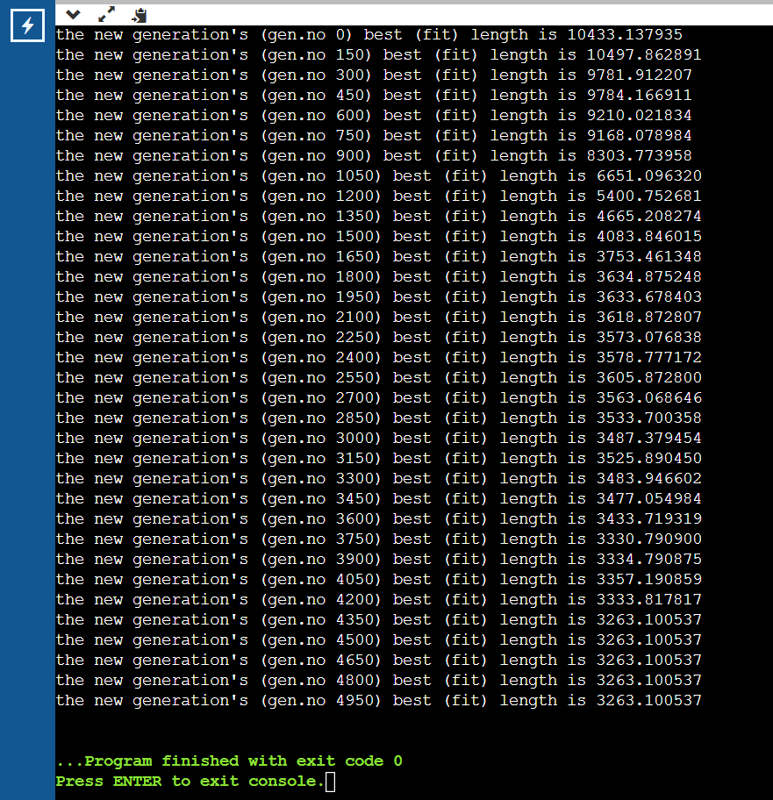

2)

import numpy as np

import matplotlib.pyplot as plt

no_population = 75

num_generations = 125

rate_of_mutation = 0.02

selection_size = 15

population = np.random.uniform(low=0.0, high=2*np.pi, size=(no_population,))

def fitness_f(x):

return np.sum(np.sin(x))

for generation in range(num_generations):

fitness = np.array([fitness_f(x) for x in population])

selected_population = population[np.argsort(fitness)[-selection_size:]]

children = np.empty((no_population,))

for i in range(no_population):

parent1, parent2 = np.random.choice(selected_population, size=2, replace=False)

children[i] = np.random.uniform(low=0.0, high=2*np.pi) if np.random.rand() < rate_of_mutation \

else (parent1 + parent2) / 2

population = children

best_ind = population[np.argmax(np.array([fitness_f(x) for x in population]))]

best_fit = fitness[np.argmax(np.array([fitness_f(x) for x in population]))]

x = np.linspace(0, 2*np.pi, 1000) ; y = np.sin(x)

plt.plot(x, y, label='True function')

y = np.sin(best_ind)

plt.plot(best_ind, y, 'ro', label='Best individual')

plt.legend()

plt.show()

# printing result

print(f'Best individual is {best_ind} and Best fitness is {best_fit}')

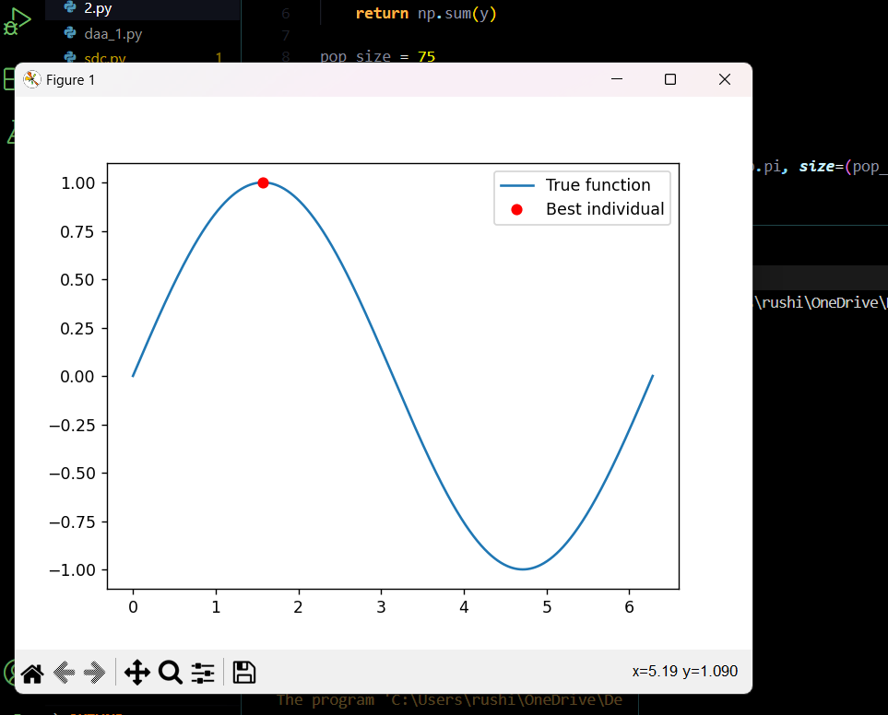 

3)

import numpy as np

import matplotlib.pyplot as plt

def fx(x):

y = np.sin(x)

return np.sum👍

population = 75

iterations = 125

rate_of_mutation = 0.02

selection = 15

cultural_rate = 0.15

pool_size = 7

population = np.random.uniform(low=0.0, high=2*np.pi, size=(population,))

cultural_pool = population[np.argsort(np.array([fx(x) for x in population]))[-pool_size:]]

for generation in range(iterations):

fitness = np.array([fx(x) for x in population])

selected_population = population[np.argsort(fitness)[-selection:]]

for i in range(population):

if np.random.rand() < cultural_rate:

cultural_individual = np.random.choice(cultural_pool)

population[i] = cultural_individual

children = np.empty((population,))

for i in range(population):

parent1, parent2 = np.random.choice(selected_population, size=2, replace=False)

children[i] = np.random.uniform(low=0.0, high=2*np.pi) if np.random.rand() < rate_of_mutation \

else (parent1 + parent2) / 2

population = children

fitness = np.array([fx(x) for x in population])

cultural_pool = population[np.argsort(fitness)[-pool_size:]]

fitness = np.array([fx(x) for x in population])

best_individual = population[np.argmax(fitness)]

best_fitness = fitness[np.argmax(fitness)]

x = np.linspace(0, 2*np.pi, 1000) ; y = np.sin(x)

plt.plot(x, y, label='True function')

y = np.sin(best_individual)

plt.plot(best_individual, y, 'ro', label='Best individual')

plt.legend()

plt.show()

print(f'Best individual is {best_individual} and Best fitness: {best_fitness}')

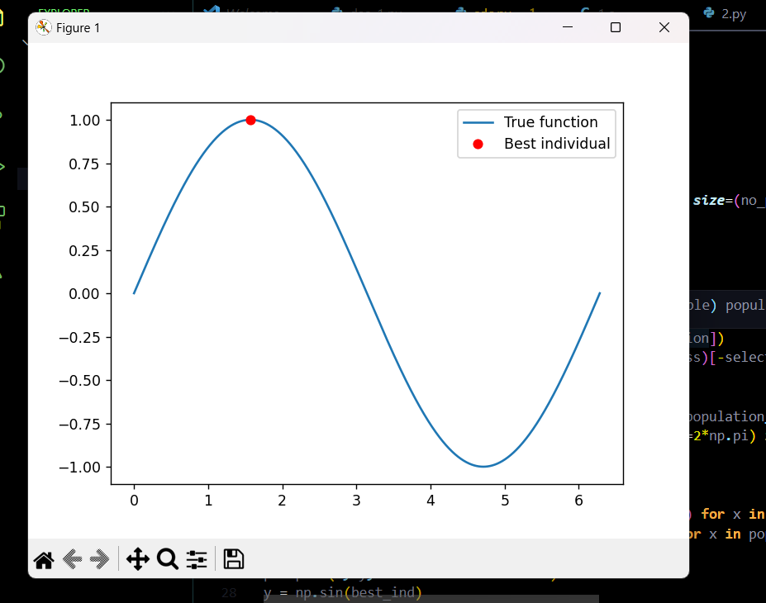 

4)

import random

import math

def sine(y):

return math.sin👍

#PSO algorithm

def psox(func, gen=125, nparts=75, range=(-15, 15), c1=1, c2=1, w=0.5):

particles = []

for i in range(nparts):

particle = {'pos': random.uniform(range[0], range[1]),'velocity': 0,'best_pos': None,'bscore': None}

particle['best_pos'] = particle['pos']

particle['bscore'] = func(particle['pos'])

particles.append(particle)

global_best_pos = particles[0]['best_pos']

gbscore = particles[0]['bscore']

for i in range(gen):

for particle in particles:

particle['velocity'] = w * particle['velocity'] \

+ c1 * random.random() * (particle['best_pos'] - particle['pos']) \

+ c2 * random.random() * (global_best_pos - particle['pos'])

particle['pos'] += particle['velocity']

if particle['pos'] < range[0]:

particle['pos'] = range[0]

elif particle['pos'] > range[1]:

particle['pos'] = range[1]

score = func(particle['pos'])

if score > particle['bscore']:

particle['bscore'] = score

particle['best_pos'] = particle['pos']

if score > gbscore:

gbscore = score

global_best_pos = particle['pos']

return global_best_pos, gbscore

maxima_pos, maxima_val = psox(sine, range=(0, math.pi), nparts=100)

minima_pos, minima_val = psox(lambda x: -sine(x), range=(0, math.pi), nparts=100)

print(f"Maxima pos is {maxima_pos:.4f}, Maxima value: {maxima_val:.4f} and Minima pos: {minima_pos:.4f}, Minima value: {minima_val:.4f}")

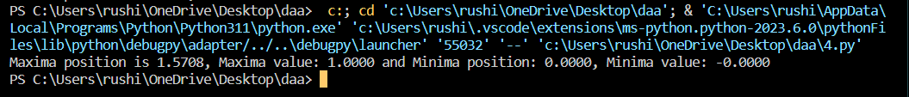

5)

import random

import numpy as np

dist_mat = np.array([[0, 30, 3, 3, 1],

[23, 0, 16, 4, 4],

[14, 6, 0, 18, 2],

[2, 5, 3, 0, 13],

[4, 9, 1, 13, 0]])

ants = 5 ; its = 15

evap_rate = 0.5

alpha = 1 ; beta = 2

Q = 100

mat = np.ones(dist_mat.shape) / len(dist_mat)

def next_city(present_city, mat, dist_mat, alpha, beta):

attractive = mat[present_city]**alpha * (1 / dist_mat[present_city])**beta

attractive[present_city] = 1

probabilities = attractive / attractive.sum()

next_city = np.random.choice(range(len(dist_mat)), p=probabilities)

return next_city

for iteration in range(its):

ant_routes = []

for ant in range(ants):

start_city = random.randint(0, len(dist_mat) - 1)

ant_route = [start_city]

while len(ant_route) < len(dist_mat):

present_city = ant_route[-1]

next_city = next_city(present_city, mat, dist_mat, alpha, beta)

ant_route.append(next_city)

ant_routes.append(ant_route)

delta_mat = np.zeros(dist_mat.shape)

for ant_route in ant_routes:

for i in range(len(ant_route) - 1):

start_city = ant_route[i]

end_city = ant_route[i + 1]

delta_mat[start_city][end_city] += Q / dist_mat[start_city][end_city]

delta_mat[end_city][start_city] += Q / dist_mat[end_city][start_city]

mat = (1 - evap_rate) * mat + delta_mat

best_ant_route = min(ant_routes, key=lambda x: sum([dist_mat[x[i]][x[i+1]] for i in range(len(x) - 1)]))

print(f"Current generation {iteration}, ant route genearted : {best_ant_route}")

