Ex. No.: 1 | NETWORK COMMANDS
26.12.2022 | NETWORK COMMANDS

Aim:
Use network commands like tcpdump, netstat, ifconfig, etc., and create ping and trace route PDUs.
Algorithm:
- Download the required packages, if not already installed.
- Run the corresponding Linux commands on the terminal.
Code:
1) TCPDUMP: sudo tcpdump
2) NETSTAT: netstat -at, netstat -au, netstat -lt, netstat -lu
3) IFCONFIG: ifconfig
4) NSLOOKUP: nslookup www.google.com, nslookup lms.snuchennai.edu.in
5) TRACEROUTE: traceroute www.google.com
6) PING: ping 8.8.8.8
Input/Output:
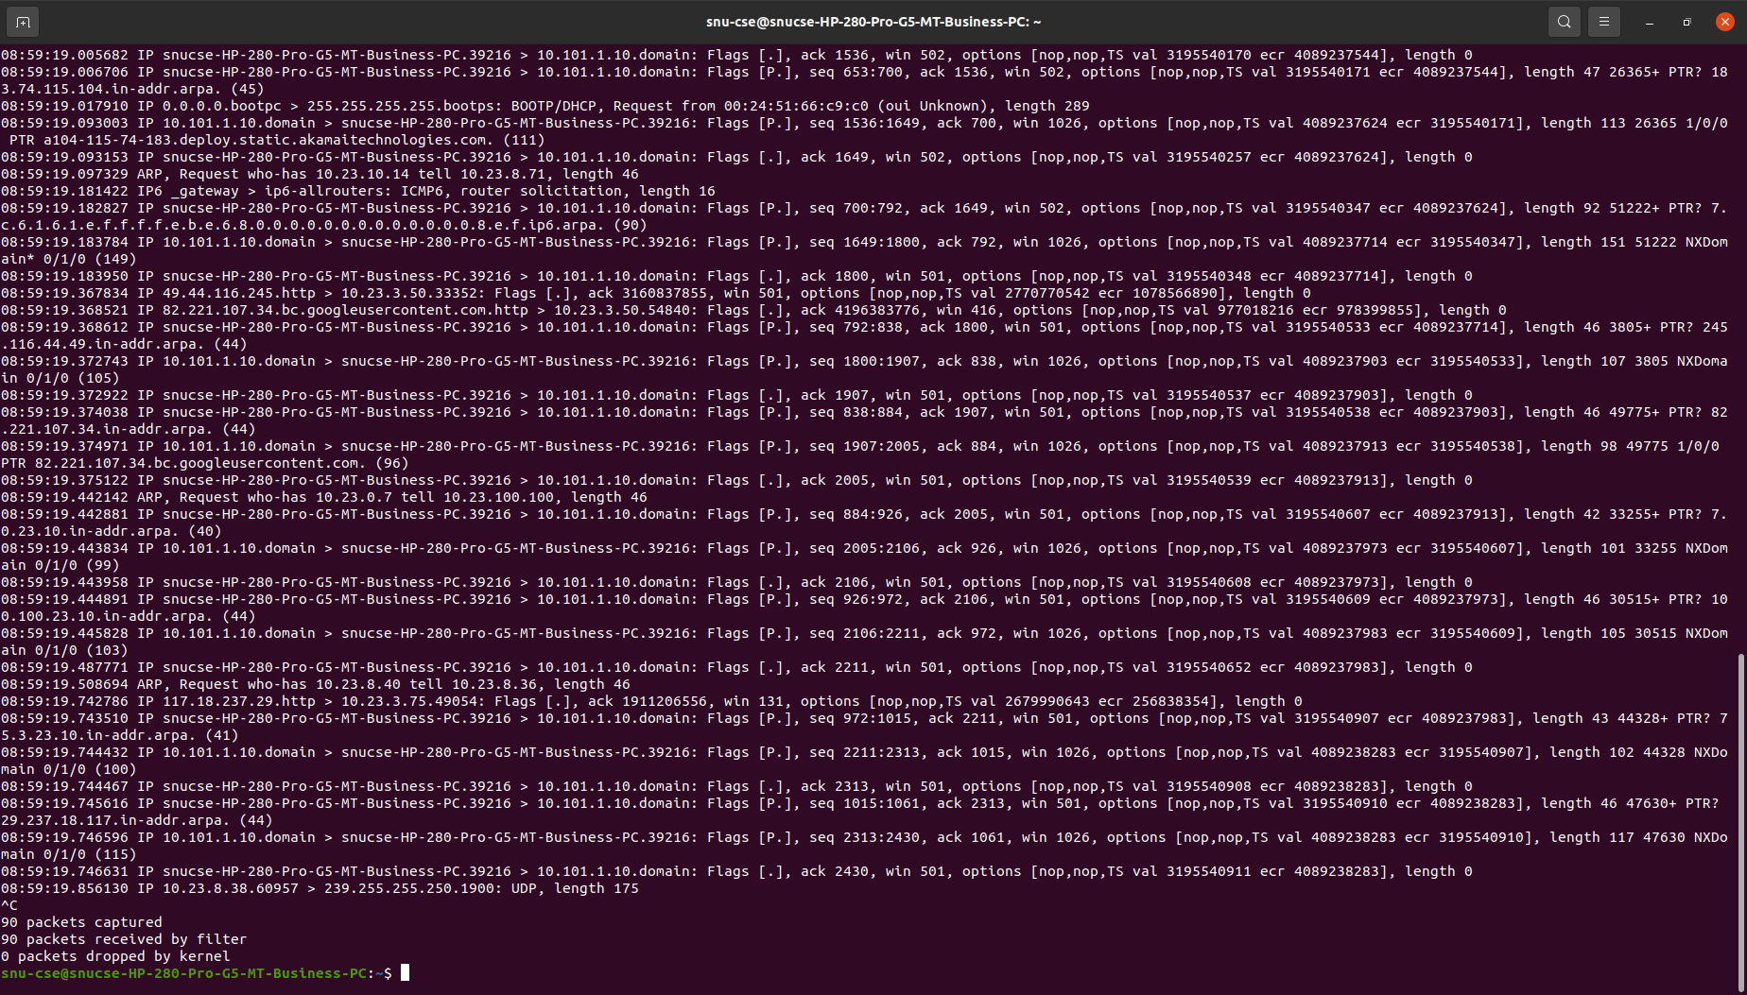
1) TCPDUMP

- NETSTAT
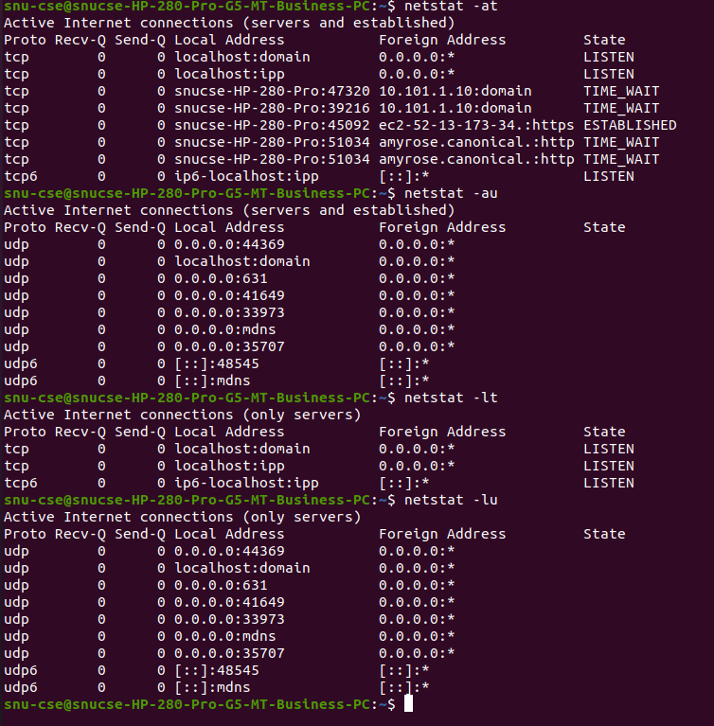
- IFCONFIG
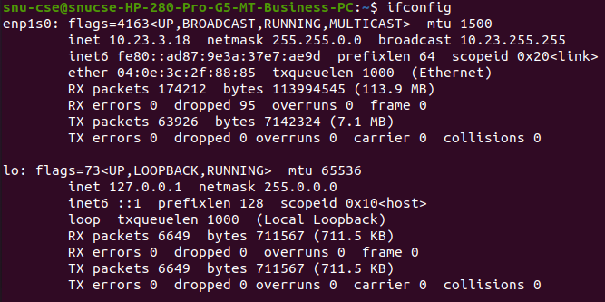

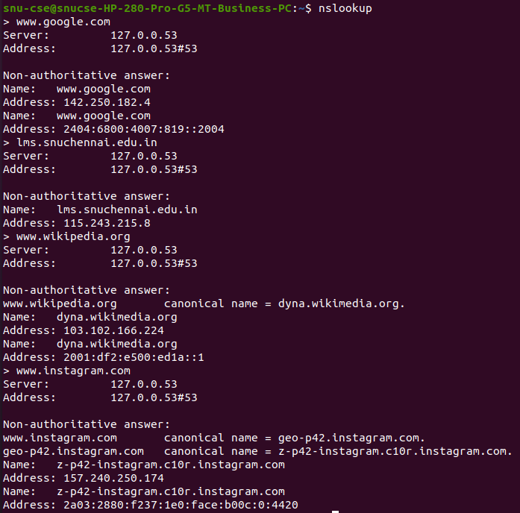
- NSLOOKUP

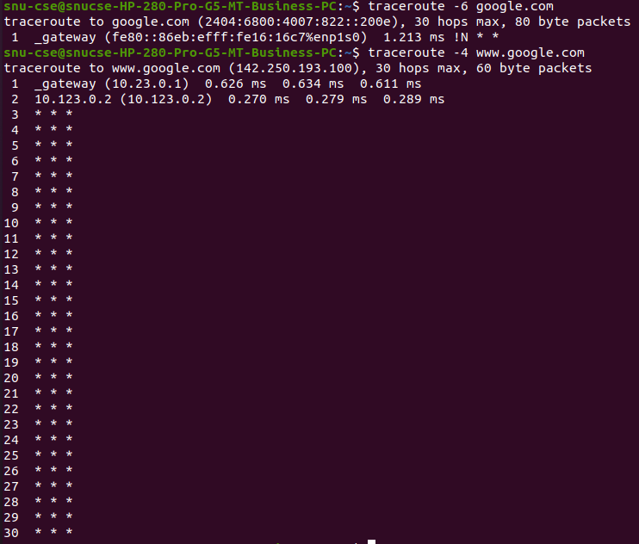
- TRACEOUTE

- PING
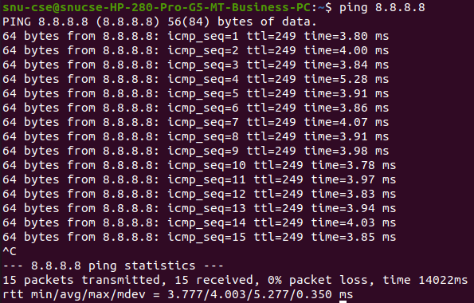

Result:
Network related commands were run on the Linux terminal.

Ex. No.: 2 | SOCKET PROGRAMMING
02.01.2023 | SOCKET PROGRAMMING

Aim:
Write a HTTP web client program to download a web page using TCP sockets.
Algorithm:
- Create a URL object and pass URL as string to download the webpage. URL example = new URL (pass URL of webpage you want to download)
- Create Buffered Reader object and pass openStream(). Method of URL in Input Stream object.
- Create a string object to read each line one by one from stream.
- Write each line in html file where webpage will be downloaded.
- Close all objects.
- Catch exceptions if URL failed to download.
Program:
import java.io.*;
import java.net.*;
public class exercise2
{
public static void main(String[] args) throws Exception
{
URL url = new URL("http://www.google.com");
BufferedReader reader = new BufferedReader(new InputStreamReader(url.openStream()));
BufferedWriter writer = new BufferedWriter(new FileWriter("data.html"));
String line;
while((line=reader.readLine())!=null)
{
System.out.println(line);
writer.write(line);
writer.newLine();
}
reader.close();
writer.close();
}
}

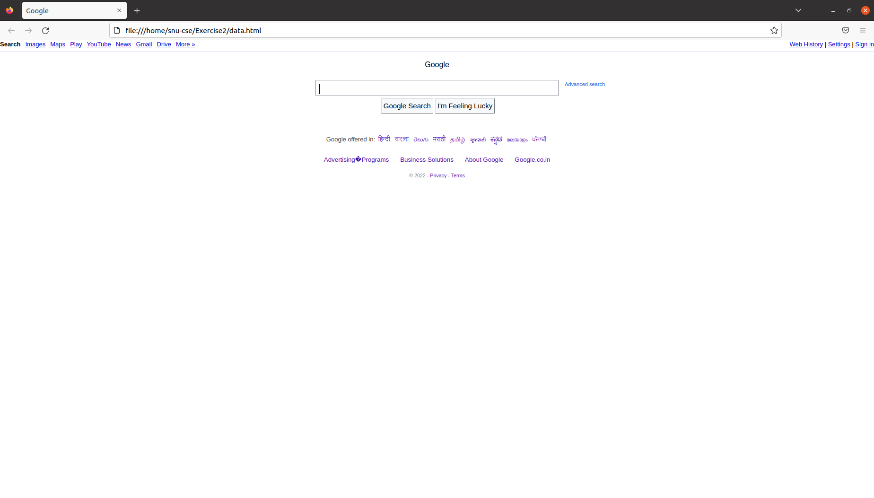
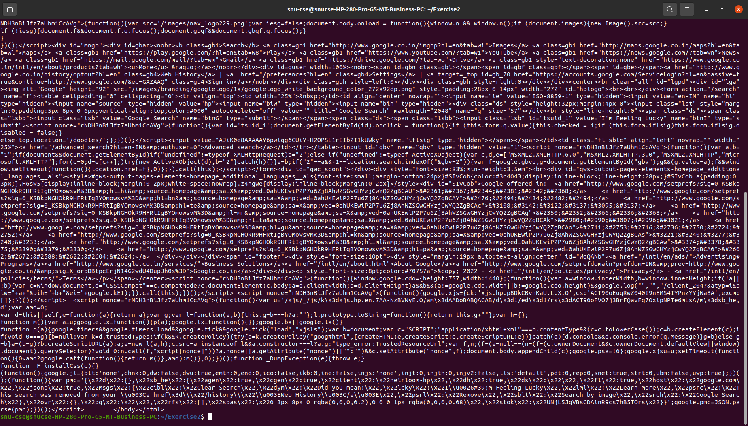
Input/Output:

Result:
A webpage has been downloaded using TCP sockets.
Ex. No.: 3 | SOCKET PROGRAMMING
09.01.2023 | SOCKET PROGRAMMING

Aim:
Socket program to implement ECHO and client-server application for chat using TCP.
Algorithm:
ECHO CLIENT
- Start the program.
- Create a socket which binds the Ip address of server and the port address to acquire service.
- After establishing connection send a data to server.
- Receive and print the same data from server.
- Close the socket. End the program.
ECHO SERVER
- Start the program.
- Create a server socket to activate the port address.
- Create a socket for the server socket which accepts the connection.
- After establishing connection receive the data from client.
- Print and send the same data to client.
- Close the socket.
- End the program.
TCP CLIENT
- Start the program.
- Include necessary package in java.
- To create a socket in client to server.
- The client establishes a connection to the server.
- The client accept the connection and to send the data from client to server.
- The client communicates the server to send the end of the message.
- Stop the program.
TCP SERVER
- Start the program.
- Include necessary package in java.
- To create a socket in server to client
- The server establishes a connection to the client.
- The server accept the connection and to send the data from server to client and
- vice versa.
- The server communicates with the client to send the end of the message.
- Stop the program.

Program:
ECHO CLIENT
import java.io.*;
import java.net.*;
public class eclient
{
public static void main(String args[])
{
Socket c=null;
String line;
DataInputStream is,is1;
PrintStream os;
try
{
c=new Socket("localhost",8080);
}
catch(IOException e)
{
System.out.println(e);
}
try
{
os=new PrintStream(c.getOutputStream());
is=new DataInputStream(System.in);
is1=new DataInputStream(c.getInputStream());
do
{
System.out.println("client");
line=is.readLine();
os.println(line);
if(!line.equals("exit"))
System.out.println("server:"+is1.readLine());
}while(!line.equals("exit"));
}
catch(IOException e)
{
System.out.println("socket closed");
}
}
}

ECHO SERVER
import java.io.*;
import java.net.*;
import java.lang.*;

public class eserver
{
public static void main(String args[])throws IOException
{
ServerSocket s=null;
String line;
DataInputStream is;
PrintStream ps;
Socket c=null;
try
{
s=new ServerSocket(8080);
}
catch(IOException e)
{
System.out.println(e);
}
try
{
c=s.accept();
is=new DataInputStream(c.getInputStream());
ps=new PrintStream(c.getOutputStream());
while(true)
{
line=is.readLine();
System.out.println("msg received and sent back to client");
ps.println(line);
}
}
catch(IOException e)
{
System.out.println(e);
}
}
}

TCP CLIENT
import java.net.*;
import java.io.*;
public class TCPclient1
{
public static void main(String arg[])
{
Socket c=null;
String line;
DataInputStream is,is1;
PrintStream os;
try
{
c=new Socket("127.0.0.1",9999);
}
catch(IOException e)
{
System.out.println(e);
}
try
{
os=new PrintStream(c.getOutputStream());
is=new DataInputStream(System.in);
is1=new DataInputStream(c.getInputStream());
do
{
System.out.println("Client:");
line=is.readLine();
os.println(line);
System.out.println("Server:" + is1.readLine());
}while(line.equalsIgnoreCase("quit")==false);
is1.close();
os.close();
}
catch(IOException e)
{
System.out.println("Socket Closed!Message Passing is over");
}
}
}

TCP SERVER
import java.net.*;
import java.io.*;
public class TCPserver1
{
public static void main(String arg[])
{
ServerSocket s=null;
String line;
DataInputStream is=null,is1=null;
PrintStream os=null;
Socket c=null;
try
{
s=new ServerSocket(9999);
}
catch(IOException e)
{
System.out.println(e);
}
try
{
c=s.accept();
is=new DataInputStream(c.getInputStream());
is1=new DataInputStream(System.in);
os=new PrintStream(c.getOutputStream());
do
{
line=is.readLine();
System.out.println("Client:"+line);
System.out.println("Server:");
line=is1.readLine();
os.println(line);
}while(line.equalsIgnoreCase("quit")==false);
is.close();
os.close();
}
catch(IOException e)
{
System.out.println(e);
}
}
}

INPUT/OUTPUT:
ECHO CLIENT
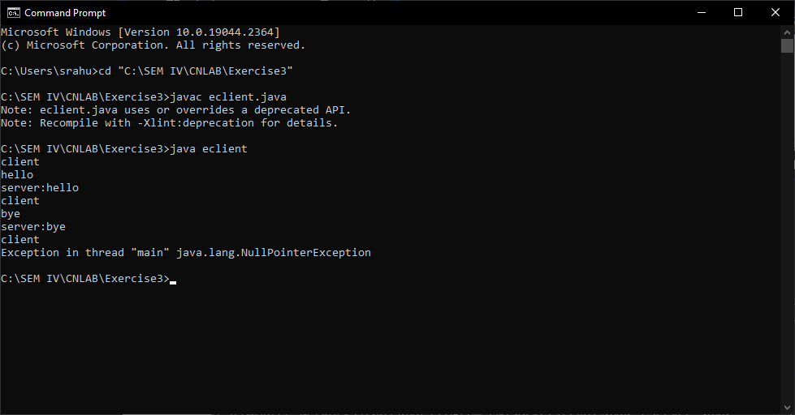
ECHO SERVER
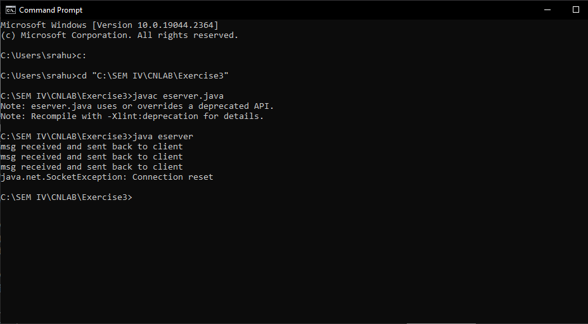
TCP CLIENT
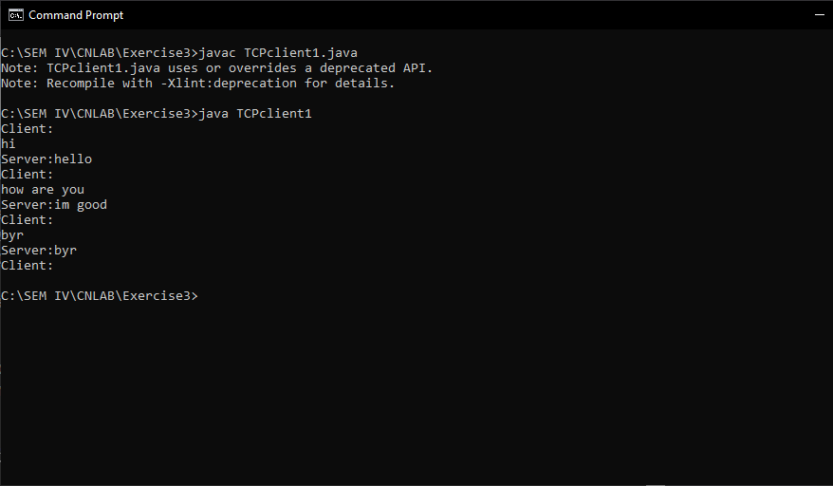TCP SERVER
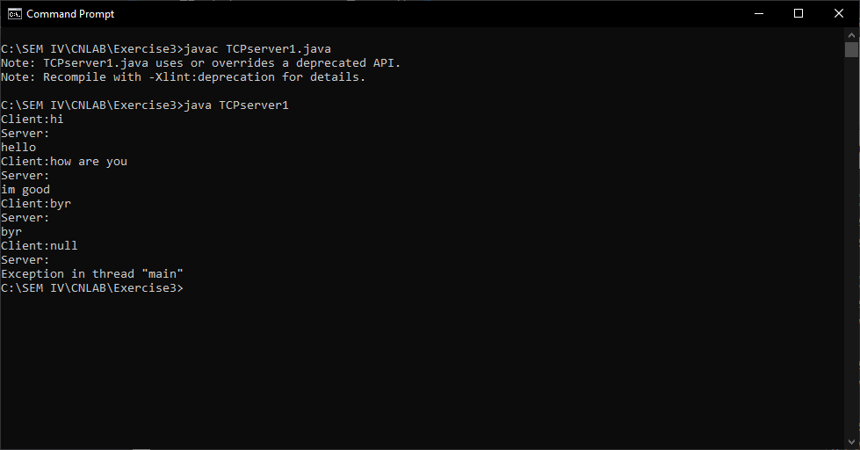

Result:
Sockets were programmed implement ECHO and client-server application for chat using TCP.
Ex. No.: 4 | DOMAIN NAME SYSTEM SIMULATION
17.01.2023 | DOMAIN NAME SYSTEM SIMULATION

Aim:
To simulate Domain Name System using UDP sockets.
Algorithm:
SERVER
- Create an array of hosts and its ip address in another array.
- Create a datagram socket and bind it to a port.
- Create a datagram packet to receive client request.
- Read the domain name from client to be resolved.
- Lookup the host array for the domain name.
- If found, then retrieve corresponding address.
- Create a datagram packet and send ip address to client.
- Repeat steps 3-7 to resolve further requests from clients.
- Close the server socket.
CLIENT
- Create a datagram socket.
- Get domain name from user.
- Create a datagram packet and send domain name to the server.
- Create a datagram packet to receive server message.
- Read server's response.
- If IP address is found, then display it else display "Domain does not exist".
- Close the client socket.
Program:
SERVER
import java.io.*;
import java.net.*;
public class udpserver
{
private static int indexOf(String[] array, String str)
{
str = str.trim();
for (int i=0; i < array.length; i++)
{
if (array[i].equals(str))
return i;
}
return -1;
}

public static void main(String arg[])throws IOException
{
String[] hosts = {"google.com", "wikipedia.org", "youtube.com", "facebook.com"};
String[] ip = {"68.180.206.184", "209.85.148.19", "80.168.92.140", "69.63.189.16"};
System.out.println("Press Ctrl + C to Quit");
while (true)
{
DatagramSocket serversocket=new DatagramSocket(1362);
byte[] senddata = new byte[1021];
byte[] receivedata = new byte[1021];
DatagramPacket recvpack = new
DatagramPacket(receivedata, receivedata.length);
serversocket.receive(recvpack);
String sen = new String(recvpack.getData());
InetAddress ipaddress = recvpack.getAddress();
int port = recvpack.getPort();
String capsent;
System.out.println("Request for host " + sen);
if(indexOf (hosts, sen) != -1)
capsent = ip[indexOf (hosts, sen)];
else
capsent = "Host Not Found";
senddata = capsent.getBytes();
DatagramPacket pack = new DatagramPacket(senddata,
senddata.length,ipaddress,port);
serversocket.send(pack);
serversocket.close();
}
}
CLIENT
import java.io.*;
import java.net.*;
public class udpclient
{
public static void main(String args[])throws IOException
{
BufferedReader br = new BufferedReader(new InputStreamReader(System.in));
DatagramSocket clientsocket = new DatagramSocket();
InetAddress ipaddress;
if (args.length == 0)
ipaddress = InetAddress.getLocalHost();
else
ipaddress = InetAddress.getByName(args[0]);
byte[] senddata = new byte[1024];
byte[] receivedata = new byte[1024];
int portaddr = 1362;
System.out.print("Enter the hostname : ");
String sentence = br.readLine();
senddata = sentence.getBytes();
DatagramPacket pack = new DatagramPacket(senddata, senddata.length, ipaddress, portaddr);
clientsocket.send(pack);
DatagramPacket recvpack =new DatagramPacket(receivedata, receivedata.length);
clientsocket.receive(recvpack);
String modified = new String(recvpack.getData());
System.out.println("IP Address: " + modified);
clientsocket.close();
}
}

Input/Output:
SERVER
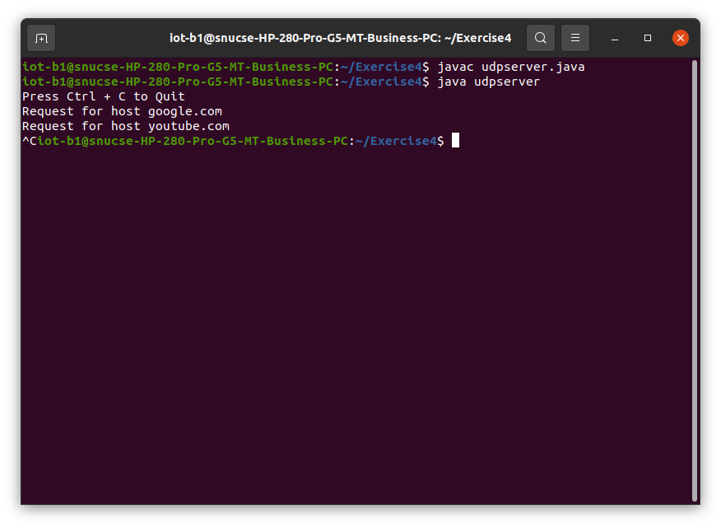
CLIENT
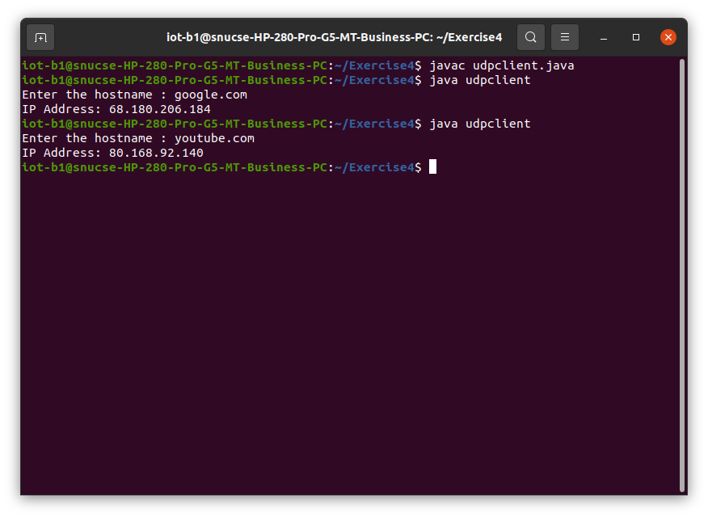
Result:
UDP sockets were used to simulate DNS.
Ex. No.: 5 | ADDRESS RESOLUTION PROTOCOL PROGRAMMING
23.01.2023 | ADDRESS RESOLUTION PROTOCOL PROGRAMMING

Aim:
To simulate the working of address resolution protocol and reverse address resolution protocol using Java.

Algorithm:
ARP SERVER
- Start the program.
- Accept the socket which is created by the client.
- Server maintains the table in which IP and corresponding MAC addresses are stored.
- Read the IP address which is send by the client.
- Map the IP address with its MAC address and return the MAC address to client.
ARP CLIENT
- Start the program.
- Using socket connection is established between client and server.
- Get the IP address to be converted into MAC address.
- Send this IP address to server.
- Server returns the MAC address to client
RARP SERVER
- Start the program.
- Server maintains the table in which IP and corresponding MAC addresses are stored.
- Read the MAC address which is send by the client.
- Map the IP address with its MAC address and return the IP address to client.
RARP CLIENT
- Start the program.
- using datagram sockets UDP function is established.
- Get the MAC address to be converted into IP address.
- Send this MAC address to server.
- Server returns the IP address to client.
Program:
ARP SERVER
import java.io.*;
import java.net.*;
import java.util.*;

class Serverarp
{
public static void main(String args[])throws Exception
{
ServerSocket obj=new ServerSocket(1800);
Socket obj1=obj.accept();
while(true)
{
DataInputStream din=new DataInputStream(obj1.getInputStream());
DataOutputStream dout=new DataOutputStream(obj1.getOutputStream());
String str=din.readLine();
String ip[]={"165.165.80.80","165.165.79.1"};
String mac[]={"6A:08:AA:C2","8A:BC:E3:FA"};
for(int i=0;i<ip.length;i++)
{
if(str.equals(ip[i]))
{
dout.writeBytes(mac[i]+'\n');
break;
}
}
obj.close();
}
}
}

ARP CLIENT
import java.io.*;
import java.net.*;
import java.util.*;

class Clientarp
{
public static void main(String args[])
{
try
{
BufferedReader in=new BufferedReader(new InputStreamReader(System.in));
Socket clsct=new Socket("127.0.0.1",1800);
DataInputStream din=new DataInputStream(clsct.getInputStream());
DataOutputStream dout=new DataOutputStream(clsct.getOutputStream());
System.out.println("Enter the Logical address(IP):");
String str1=in.readLine();
dout.writeBytes(str1+'\n');
String str=din.readLine();
System.out.println("The Physical Address is:"+str);
clsct.close();
}
catch (Exception e)
{
System.out.println(e);
}
}
}

RARP SERVER
import java.io.*;
import java.net.*;
import java.util.*;

class Serverrarp
{
public static void main(String args[])
{
try
{
DatagramSocket server=new DatagramSocket(1309);
while(true)
{
byte[] sendbyte=new byte[1024];
byte[] receivebyte=new byte[1024];
DatagramPacket receiver=new DatagramPacket(receivebyte,receivebyte.length);
server.receive(receiver);
String str=new String(receiver.getData());
String s=str.trim();
InetAddress addr=receiver.getAddress();
int port=receiver.getPort();
String ip[]={"165.165.80.80","165.165.79.1"};
String mac[]={"6A:08:AA:C2","8A:BC:E3:FA"};
for(int i=0;i<ip.length;i++)
{
if(s.equals(mac[i]))
{
sendbyte=ip[i].getBytes();
DatagramPacket sender=new DatagramPacket(sendbyte,sendbyte.length,addr,port);
server.send(sender);
break;
}
}
break;
}
}
catch(Exception e)
{
System.out.println(e);
}
}
}

RARP CLIENT
import java.io.*;
import java.net.*;
import java.util.*;

class Clientrarp
{
public static void main(String args[])
{
try
{
DatagramSocket client=new DatagramSocket();
InetAddress addr=InetAddress.getByName("127.0.0.1");
byte[] sendbyte=new byte[1024];
byte[] receivebyte=new byte[1024];
BufferedReader in=new BufferedReader(new InputStreamReader(System.in));
System.out.println("Enter the Physical address (MAC):");
String str=in.readLine(); sendbyte=str.getBytes();
DatagramPacket sender=new DatagramPacket(sendbyte,sendbyte.length,addr,1309);
client.send(sender);
DatagramPacket receiver=new DatagramPacket(receivebyte,receivebyte.length);
client.receive(receiver);
String s=new String(receiver.getData());
System.out.println("The Logical Address is(IP): "+s.trim());
client.close();
}
catch(Exception e)
{
System.out.println(e);
}
}
}

Input/Output:
ARP SERVER
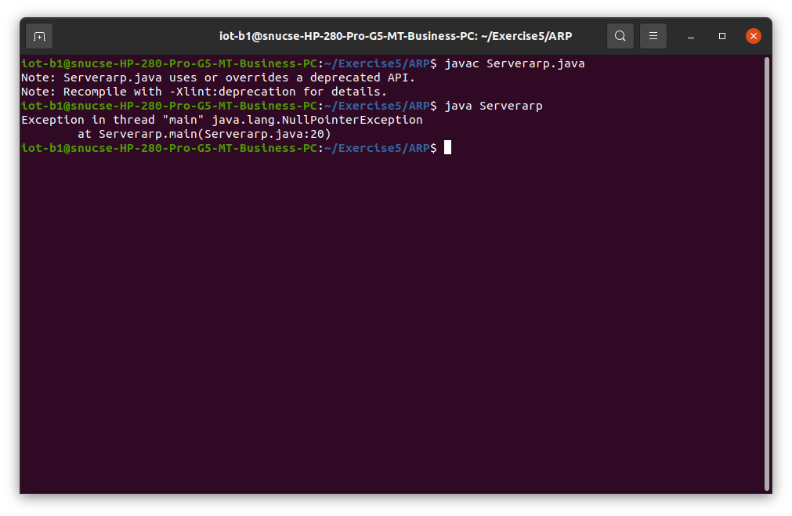
ARP CLIENT
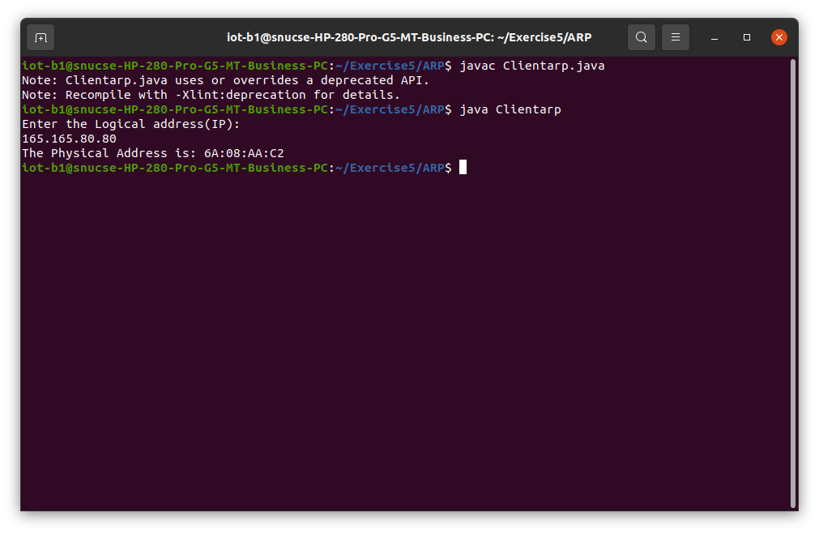
RARP SERVER
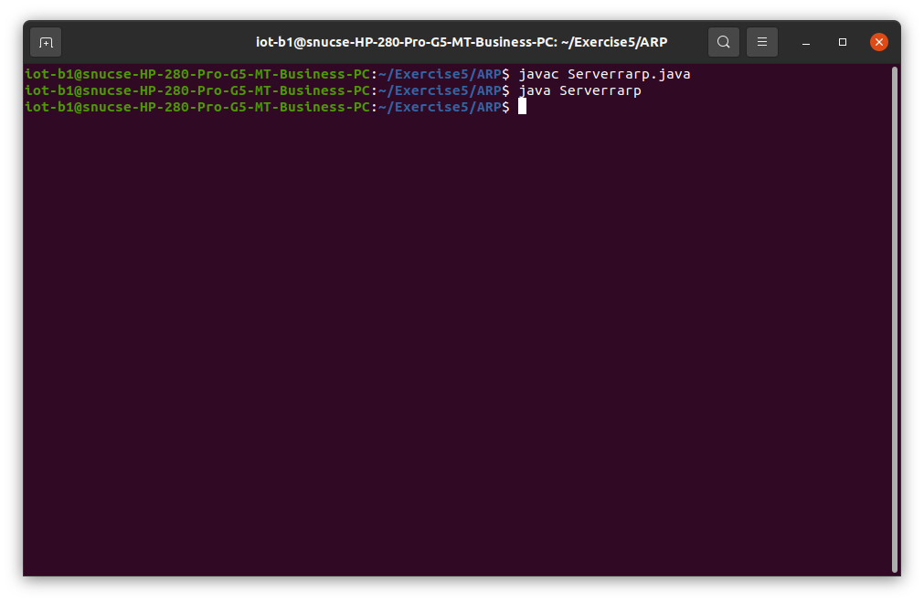
RARP CLIENT
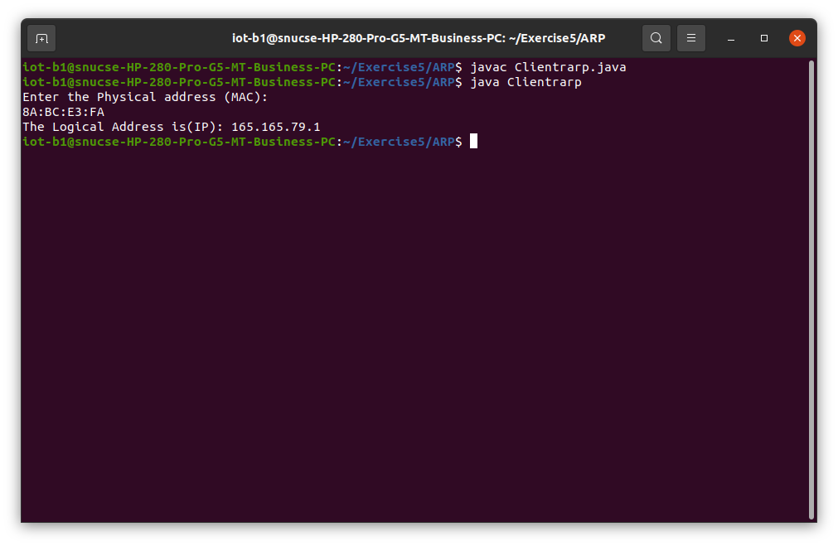

Result:
ARP and RARP were simulated using Java.
Ex. No.: 6 | NS2 PROGRAMMING
07.02.2023 | NS2 PROGRAMMING

Aim:
- To create simple topology using Network Simulator.
- To implement congestion control in TCP using NS-2.
Algorithm:
Exercise a
- Start network simulator OTCL editor.
- Create new simulator using
set ns [new Simulator]
- Create Trace route to Network Animator set nf [open out.nam w] $ns namtrace-all $nf
- Create procedure to trace all path
proc create_testnet {} {
global s1 s2 r1 k1
set s1 [$ns node]
set s2 [$ns node]
set r1 [$ns node]
set k1 [$ns node]
}
- Create full duplex connection using
$ns duplex-link $s1 $r1 8Mb 5ms drop-tail
$ns duplex-link $s2 $r1 8Mb 5ms drop-tail
set L [ns_duplex $r1 $k1 800Kb 100ms drop-tail]
- Connect with TCP and SINK command.
$ns connect
$tcp
$sink
- Run and Execute the program.
$ns run
Exercise b:
- Create a simulator object
- Define different colors for data flows (for NAM)
- Open the NAM trace file.
- Define a 'finish' procedure- Close the NAM trace file and Execute NAM on the trace file.
- Create 4 nodes and duplex links between them.
- Set Queue Size of link (n2-n3) to 10 and give node positions. Monitor the queue for link(n2-n3). (for NAM)
- Setup a TCP connection. Setup a FTP over TCP connection.
- Setup a UDP connection. Setup a CBR over UDP connection.
- Schedule events for the CBR and FTP agents
- Call the finish procedure after 5 seconds of simulation time.
- Print CBR packet size and interval.
- Run the simulation.
Code:
Exercise a:
set nf [open out.nam w]
$ns namtrace-all $nf
set tf [open out.tr w]
$ns trace-all $tf
proc finish {} {
global ns nf
$ns flush-trace
close $nf
exec nam out.nam &
exit 0
}
set n0 [$ns node]
set n1 [$ns node]
set n2 [$ns node]
set n3 [$ns node]
$ns duplex-link $n0 $n2 5Mb 10ms DropTail
$ns duplex-link $n1 $n2 5Mb 10ms DropTail
$ns duplex-link $n2 $n3 1.7Mb 20ms DropTail
$ns queue-limit $n2 $n3 2
$ns duplex-link-op $n0 $n2 orient right-down
$ns duplex-link-op $n1 $n2 orient right-up
$ns duplex-link-op $n2 $n3 orient right
$ns duplex-link-op $n2 $n3 queuePos 0.5
set tcp [new Agent/TCP]
$tcp set class_ 2
$ns attach-agent $n0 $tcp
set sink [new Agent/TCPSink]
$ns attach-agent $n3 $sink
$ns connect $tcp $sink
$tcp set fid_ 1
set ftp [new Application/FTP]
$ftp attach-agent $tcp
$ftp set type_ FTP
set udp [new Agent/UDP]
$ns attach-agent $n1 $udp
set null [new Agent/Null]
$ns attach-agent $n3 $null
$ns connect $udp $null
$udp set fid_ 2
set cbr [new Application/Traffic/CBR]
$cbr attach-agent $udp
$cbr set type_ CBR
$cbr set packet_size_ 1000
$cbr set rate_ 1mb
$cbr set random_ false
$ns at 0.1 "$cbr start"
$ns at 1.0 "$ftp start"
$ns at 4.0 "$ftp stop"
$ns at 4.5 "$cbr stop"
$ns at 4.5 "$ns detach-agent $n0 $tcp ; $ns detach-agent $n3 $sink"
$ns at 5.0 "finish"
puts "CBR packet size = [$cbr set packet_size_]"
puts "CBR interval = [$cbr set interval_]"
$ns run
Exercise b:
set ns [new Simulator]
set n0 [$ns node]
set n1 [$ns node]
set n2 [$ns node]
set n3 [$ns node]
set n4 [$ns node]
set n5 [$ns node]
$ns duplex-link $n0 $n2 2Mb 10ms DropTail
$ns duplex-link $n1 $n2 2Mb 10ms DropTail
$ns duplex-link $n2 $n3 0.3Mb 200ms DropTail
$ns duplex-link $n3 $n4 0.5Mb 40ms DropTail
$ns duplex-link $n3 $n5 0.5Mb 30ms DropTail
set tcp1 [new Agent/TCP/Reno]
$ns attach-agent $n0 $tcp1
set sink1 [new Agent/TCPSink]
$ns attach-agent $n4 $sink1
$ns connect $tcp1 $sink1
set ftp1 [new Application/FTP]
$ftp1 attach-agent $tcp1
$ftp1 set type_ FTP
$ns at 0.1 "$ftp1 start"
$ns at 40.0 "$ftp1 stop"
$ns at 50.0 "finish"
proc plotWindow {tcpSource outfile} {
global ns
set now [$ns now]
set cwnd [$tcpSource set cwnd_]
$ns at [expr $now+0.1] "plotWindow $tcpSource $outfile"
}
set outfile [open "congestion.xg" w]
$ns at 0.0 "plotWindow $tcp1 $outfile"
proc finish {} {
exec xgraph congestion.xg -geometry 300x300 &
exit 0
}
$ns run
Input/Output:
Exercise a:
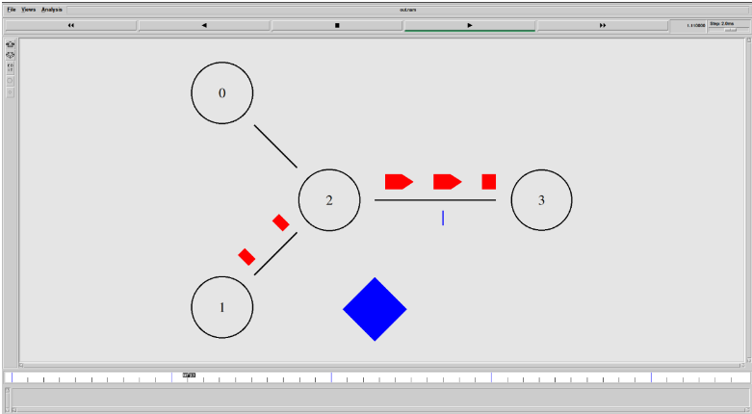
Exercise b:
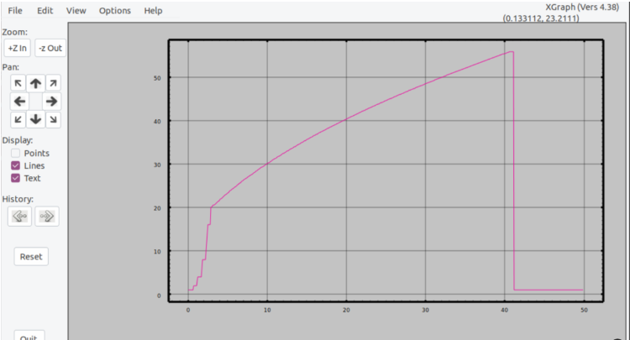

Result:
Successfully created simple topology using Network Simulator and implemented congestion control in TCP using NS-2.
Ex. No.: 7 | ERROR CORRECTION IN COMPUTER NETWORKS
28.02.2023 | ERROR CORRECTION IN COMPUTER NETWORKS

Aim:
To create a program that simulates any error correction method on Java.
Algorithm:
- The original message (dataword) is considered as M(x) consisting of ‘k’ bits and the divisor as C(x) consists of ‘n+1’ bits.
- The original message M(x) is appended by ‘n’ bits of zero’s. Let us call this zero-extended message as T(x).
- Divide T(x) by C(x) and find the remainder.
- The division operation is performed using XOR operation.
- The resultant remainder is appended to the original message M(x) as CRC and sent by the sender(codeword).
Program:
import java.util.*;

class exercise7
{
static int exorOperation(int x, int y)
{
if(x==y)
{
return 0;
}
return 1;
}

static void receiveData(int data[], int divisor[])
{
int rem[]=divideDataWithDivisor(data, divisor);
for(int i=0; i<rem.length; i++)
{
if(rem[i]!=0)
{
System.out.println("Corrupt data received...");
return;
}
}
System.out.println("Data received without error");
}

static int[] divideDataWithDivisor(int oldData[], int divisor[])
{
int rem[]=new int[divisor.length];
int i;
int data[]=new int[oldData.length+divisor.length];

System.arraycopy(oldData, 0, data, 0, oldData.length);
System.arraycopy(data, 0, rem, 0, divisor.length);

for(i=0; i<oldData.length; i++)
{
System.out.println((i+1)+".) First data bit is: "+rem[0]);
System.out.print("Remainder: ");
if(rem[0]==1)
{
for(int j=1; j<divisor.length; j++)
{
rem[j-1]=exorOperation(rem[j], divisor[j]);
System.out.print(rem[j-1]);
}
}
else
{
for(int j=1; j<divisor.length; j++)
{
rem[j-1]=exorOperation(rem[j], 0);
System.out.print(rem[j-1]);
}
}
rem[divisor.length-1]=data[i+divisor.length];
System.out.println(rem[divisor.length-1]);
}
return rem;
}

public static void main(String args[])
{
Scanner scan=new Scanner(System.in);
int size;

System.out.println("Enter size of the data array: ");
size=scan.nextInt();
int data[]=new int[size];
System.out.println("Enter data bits in the array one by one: ");
for(int i=0; i<size; i++)
{
System.out.println("Enter bit "+(size-i)+":");
data[i]=scan.nextInt();
}

System.out.println("Enter the size of the divisor array: ");
size=scan.nextInt();
int divisor[]=new int[size];
System.out.println("Enter divisor bits in the array one by one: ");
for(int i=0; i<size; i++)
{
System.out.println("Enter bit "+(size-i)+":");
divisor[i]=scan.nextInt();
}

int rem[]=divideDataWithDivisor(data, divisor);
for(int i=0; i<rem.length-1;i++)
{
System.out.print(rem[i]);
}

System.out.println("\nGenerated CRC code is:");
for(int i=0; i<data.length; i++)
{
System.out.print(data[i]);
}
for(int i=0; i<rem.length-1; i++)
{
System.out.print(rem[i]);
}
System.out.println();

int sentData[]=new int[data.length+rem.length-1];
System.out.println("Enter bits in the array which you want to send: ");
for(int i=0; i<sentData.length; i++)
{
System.out.println("Enter bit "+(sentData.length-1)+":");
sentData[i]=scan.nextInt();
}

receiveData(sentData, divisor);
}
}

Input/Output:
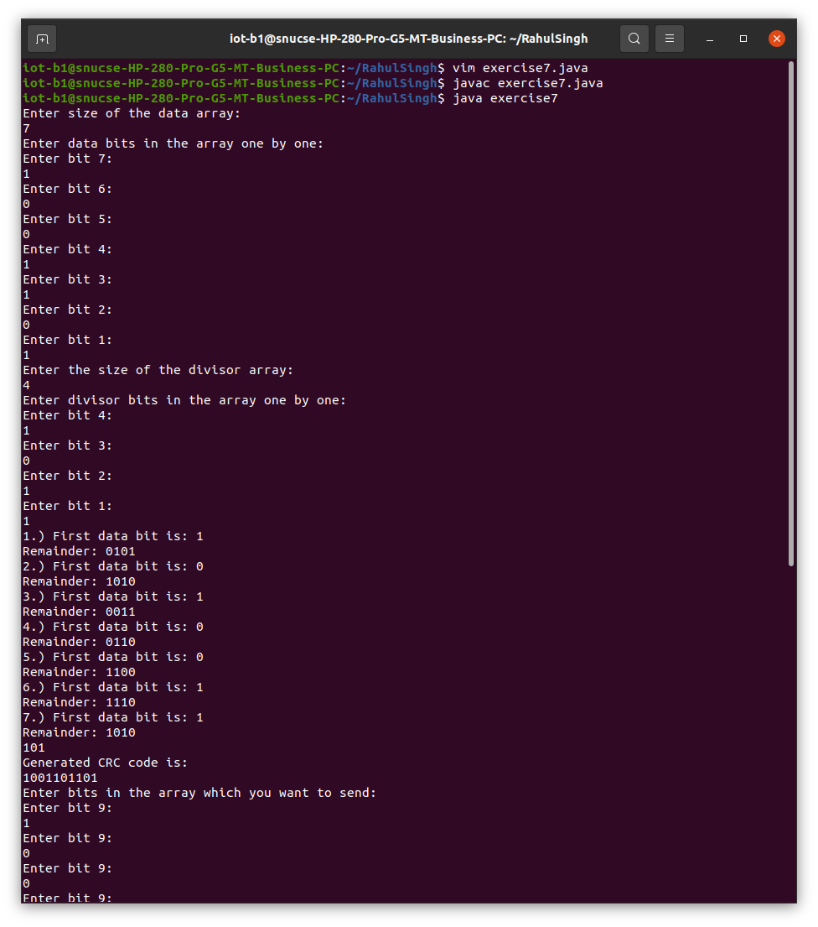
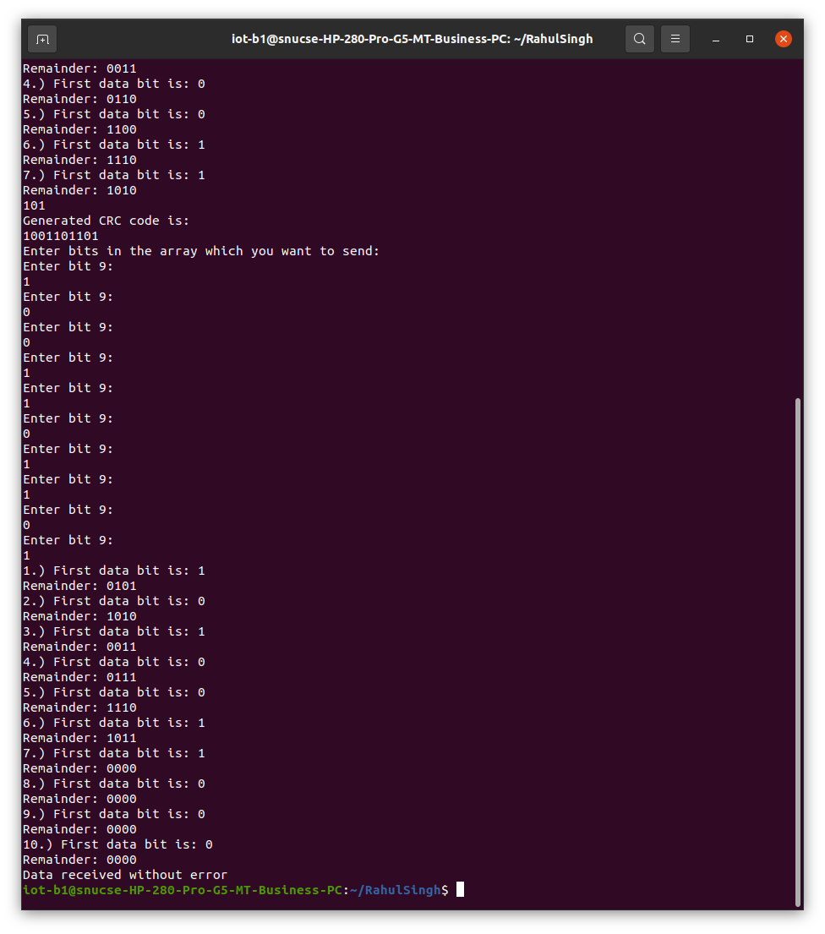

Result:
Cyclic redundancy check was performed on Java.
Ex. No.: 8 | TCP/UDP PERFORMANCE ON NETWORK SIMULATOR
07.03.2023 | TCP/UDP PERFORMANCE ON NETWORK SIMULATOR

Aim:
To implement the study of TCP/UDP performance using Network Simulator.
Algorithm:
- Create a simulation object.
- Set routing protocol to routing.
- Trace packets and all links onto NAM trace and to trace file.
- Create right nodes.
- Describe their layout topology.
- Add a sink agent to node.
- Connect source and sink.
- Observe the traffic route when link is up and down.
- View the simulated events and trace file analyse it.
- Start the scheduler.
Code:
set ns [new Simulator]
set nr [open thro_dt.tr w]
$ns trace-all $nr
set nf [open thro.nam w]
$ns namtrace-all $nf
proc finish { } {
global ns nr nf
$ns flush-trace
close $nf
close $nr
exec nam thro.nam &
exit 0 }
set n0 [$ns node]
set n1 [$ns node]
set n2 [$ns node]
set n3 [$ns node]
set n4 [$ns node]
set n5 [$ns node]
set n6 [$ns node]
set n7 [$ns node]

$ns duplex-link $n0 $n3 1Mb 10ms DropTail
$ns duplex-link $n1 $n3 1Mb 10ms DropTail
$ns duplex-link $n2 $n3 1Mb 10ms DropTail
$ns duplex-link $n3 $n4 1Mb 10ms DropTail
$ns duplex-link $n4 $n5 1Mb 10ms DropTail
$ns duplex-link $n4 $n6 1Mb 10ms DropTail
$ns duplex-link $n4 $n7 1Mb 10ms DropTail
$ns duplex-link-op $n0 $n3 orient right-up
$ns duplex-link-op $n1 $n3 orient right
$ns duplex-link-op $n2 $n3 orient right-down
$ns duplex-link-op $n3 $n4 orient middle
$ns duplex-link-op $n4 $n5 orient right-up
$ns duplex-link-op $n4 $n7 orient right-down
$ns duplex-link-op $n6 $n4 orient left
set udp0 [new Agent/UDP]
$ns attach-agent $n2 $udp0
set cbr0 [new Application/Traffic/CBR]
$cbr0 set packetSize_ 500
$cbr0 set interval_ 0.005
$cbr0 attach-agent $udp0
set null0 [new Agent/Null]
$ns attach-agent $n5 $null0
$ns connect $udp0 $null0
set udp1 [new Agent/UDP]
$ns attach-agent $n1 $udp1
set cbr1 [new Application/Traffic/CBR]
$cbr1 set packetSize_ 500
$cbr1 set interval_ 0.005
$cbr1 attach-agent $udp1
set null0 [new Agent/Null]
$ns attach-agent $n6 $null0
$ns connect $udp1 $null0
set tcp0 [new Agent/TCP]
$ns attach-agent $n0 $tcp0
set cbr2 [new Application/Traffic/CBR]
$cbr2 set packetSize_ 500
$cbr2 set interval_ 0.005

$cbr2 attach-agent $tcp0
set tcpsink0 [new Agent/TCPSink]
$ns attach-agent $n7 $tcpsink0
$ns connect $tcp0 $tcpsink0
$udp0 set fid_ 1
$udp1 set fid_ 2
$tcp0 set fid_ 3
$ns color 1 Red
$ns color 2 Green
$ns color 3 blue
$ns at 0.2 "$cbr0 start"
$ns at 3.5 "$cbr0 stop"
$ns at 0.3 "$cbr1 start"
$ns at 4.5 "$cbr1 stop"
$ns at 0.4 "$cbr2 start"
$ns at 4.5 "$cbr2 stop"
$ns at 5.0 "finish"
$ns run

Input/Output:
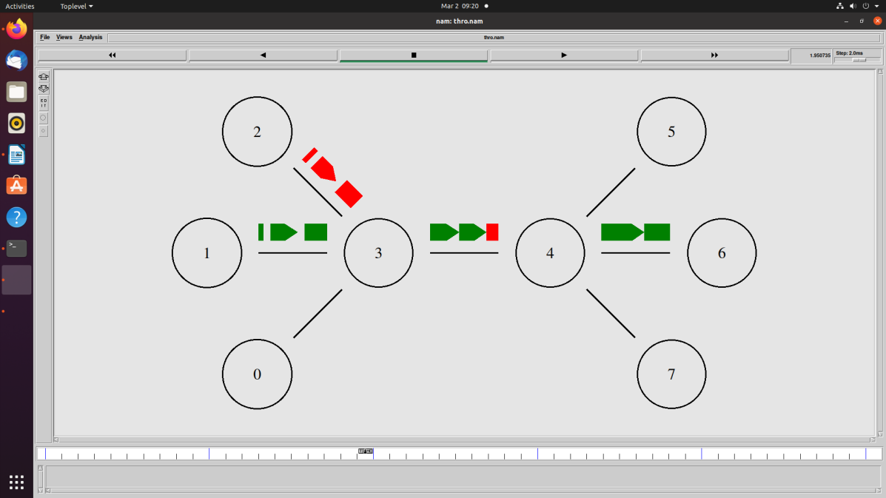
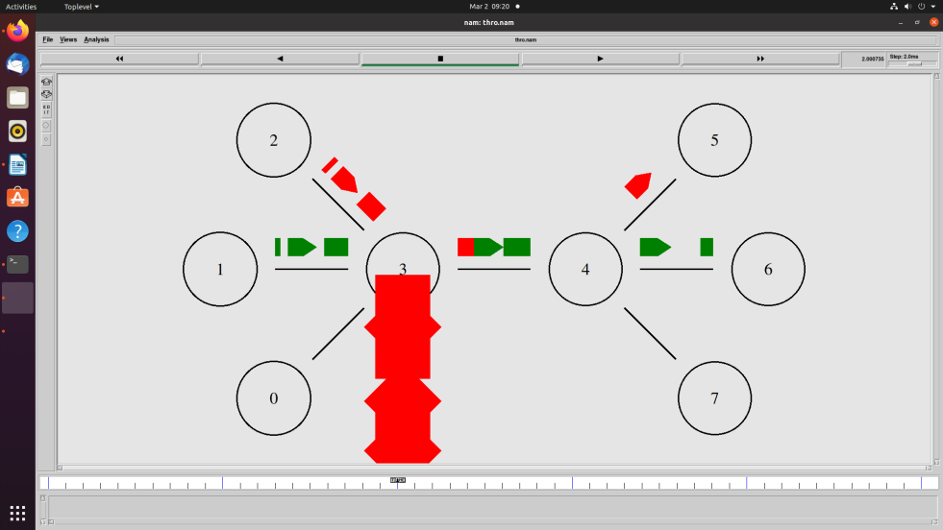
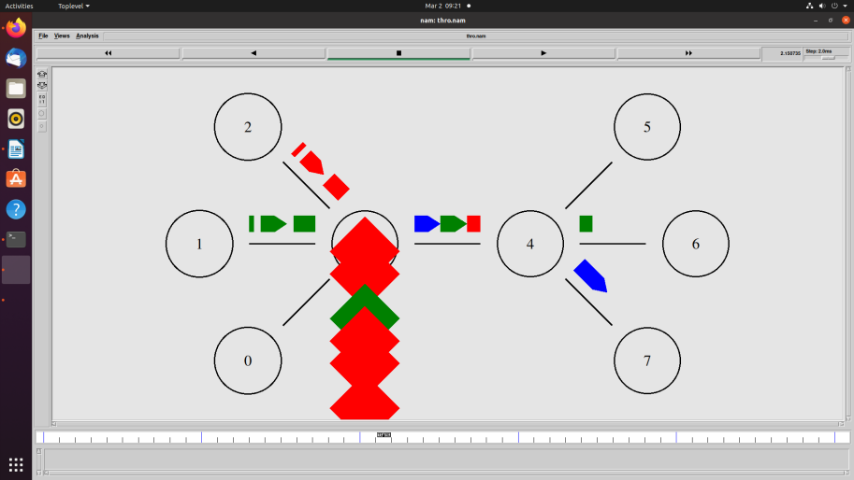

Result:
TCP/UDP performance was studied on NS2.
Ex. No.: 9 | ROUTING ALGORITHMS IN COMPUTER NETWORKS
14.03.2023 | ROUTING ALGORITHMS IN COMPUTER NETWORKS

Aim:
To simulate Distance Vector Routing and Link State Routing Algorithms.
Algorithm:
- A router transmits its distance vector to each of its neighbours in a routing packet.
- Each router receives and saves the most recently received distance vector from each of its neighbours.
- A router recalculates its distance vector when:
  - It receives a distance vector from a neighbour containing different information than before.
  - It discovers that a link to a neighbour has gone down.
Code:
DISTANCE VECTOR ROUTING
import java.io.*;
public class dvr
{
static int graph[][];
static int via[][];
static int rt[][];
static int v;
static int e;

public static void main(String args[]) throws IOException
{
BufferedReader br = new BufferedReader(new InputStreamReader(System.in));

System.out.println("Please enter the number of Vertices: ");
v = Integer.parseInt(br.readLine());

System.out.println("Please enter the number of Edges: ");
e = Integer.parseInt(br.readLine());

graph = new int[v][v];
via = new int[v][v];
rt = new int[v][v];
for(int i = 0; i < v; i++)
for(int j = 0; j < v; j++)
{
if(i == j)
graph[i][j] = 0;
else
graph[i][j] = 9999;
}

for(int i = 0; i < e; i++)
{
System.out.println("Please enter data for Edge " + (i + 1) + ":");
System.out.print("Source: ");
int s = Integer.parseInt(br.readLine());
s--;
System.out.print("Destination: ");
int d = Integer.parseInt(br.readLine());
d--;
System.out.print("Cost: ");
int c = Integer.parseInt(br.readLine());
graph[s][d] = c;
graph[d][s] = c;
}

dvr_calc_disp("The initial Routing Tables are: ");

System.out.print("Please enter the Source Node for the edge whose cost has changed: ");
int s = Integer.parseInt(br.readLine());
s--;
System.out.print("Please enter the Destination Node for the edge whose cost has changed: ");
int d = Integer.parseInt(br.readLine());
d--;
System.out.print("Please enter the new cost: ");
int c = Integer.parseInt(br.readLine());
graph[s][d] = c;
graph[d][s] = c;

dvr_calc_disp("The new Routing Tables are: ");
}

static void dvr_calc_disp(String message)
{
System.out.println();
init_tables();
update_tables();
System.out.println(message);
print_tables();
System.out.println();
}

static void update_table(int source)
{
for(int i = 0; i < v; i++)
{
if(graph[source][i] != 9999)
{
int dist = graph[source][i];
for(int j = 0; j < v; j++)
{
int inter_dist = rt[i][j];
if(via[i][j] == source)
inter_dist = 9999;
if(dist + inter_dist < rt[source][j])
{
rt[source][j] = dist + inter_dist;
via[source][j] = i;
}
}
}
}
}

static void update_tables()
{
int k = 0;
for(int i = 0; i < 4*v; i++)
{
update_table(k);
k++;
if(k == v)
k = 0;
}
}

static void init_tables()
{
for(int i = 0; i < v; i++)
{
for(int j = 0; j < v; j++)
{
if(i == j)
{
rt[i][j] = 0;
via[i][j] = i;
}
else
{
rt[i][j] = 9999;
via[i][j] = 100;
}
}
}
}

static void print_tables()
{
for(int i = 0; i < v; i++)
{
for(int j = 0; j < v; j++)
{
System.out.print("Dist: " + rt[i][j] + " ");
}
System.out.println();
}
}

}

LINK STATE ROUTING
import java.util.*;

public class lsr
{
public int distance[] = new int[10];
public int cost[][] = new int[10][10];

public void calc(int n,int s)
{
int flag[] = new int[n+1];
int i,minpos=1,k,c,minimum;
for(i=1;i<=n;i++)
{
flag[i]=0;
this.distance[i]=this.cost[s][i];
}
c=2;
while(c<=n)
{
minimum=99;
for(k=1;k<=n;k++)
{
if(this.distance[k]<minimum && flag[k]!=1)
{
minimum=this.distance[i];
minpos=k;
}
}
flag[minpos]=1;
c++;
for(k=1;k<=n;k++)
{
if(this.distance[minpos]+this.cost[minpos][k] < this.distance[k] && flag[k]!=1 )
this.distance[k]=this.distance[minpos]+this.cost[minpos][k];
}
}

}

public static void main(String args[])
{
int nodes,source,i,j;
Scanner in = new Scanner(System.in);
System.out.println("Enter the Number of Nodes \n");
nodes = in.nextInt();
lsr d = new lsr();
System.out.println("Enter the Cost Matrix Weights: \n");
for(i=1;i<=nodes;i++)
for(j=1;j<=nodes;j++)
{
d.cost[i][j]=in.nextInt();
if(d.cost[i][j]==0)
d.cost[i][j]=999;
}
System.out.println("Enter the Source Vertex :\n");
source=in.nextInt();

d.calc(nodes,source);
System.out.println("The Shortest Path from Source \t"+source+"\t to all other vertices are : \n");
for(i=1;i<=nodes;i++)
if(i!=source)
System.out.println("source :"+source+"\t destination :"+i+"\t MinCost is :"+d.distance[i]+"\t");
}
}

Input/Output:
DISTANCE VECTOR ROUTING
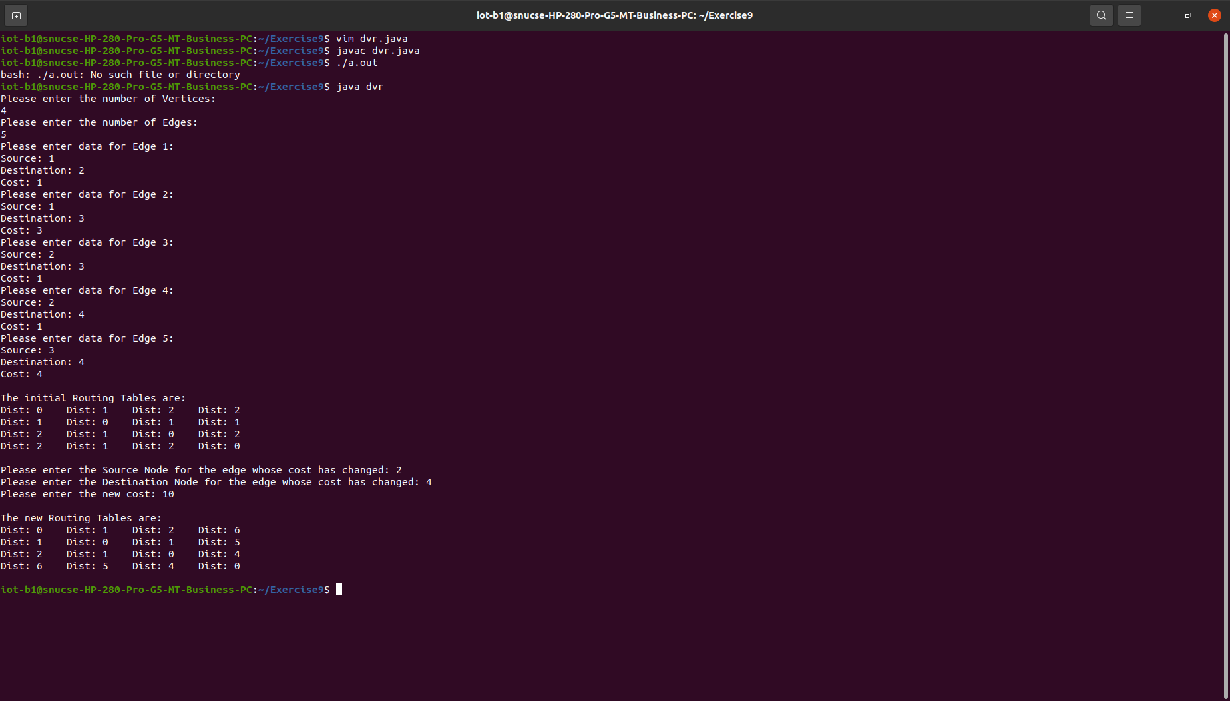
LINK STATE ROUTING
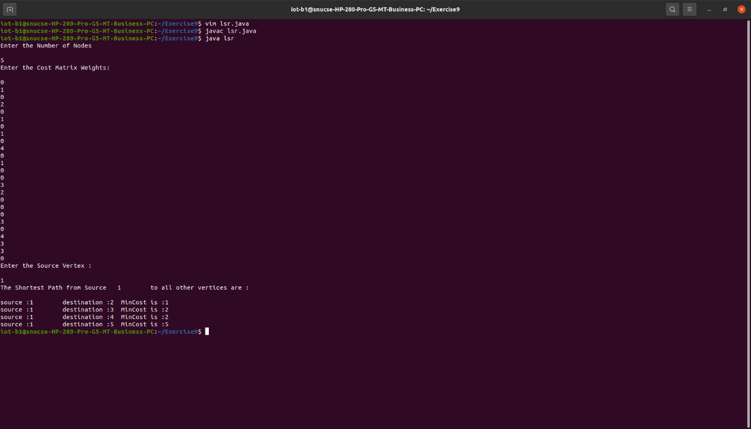

Result:
Link State Routing and Distance Vector Routing Algorithms were implemented on Java.
Ex. No.: 10 | ROUTING ALGORITHMS IN NS2
21.03.2023 | ROUTING ALGORITHMS IN NS2

Aim:
To evaluate routing algorithms on Network Simulation Tool.
Algorithm:

Code:
set val(chan) Channel/WirelessChannel;
set val(prop) Propagation/TwoRayGround;
set val(netif) Phy/WirelessPhy;
set val(mac) Mac/802_11;
set val(ifq) Queue/DropTail/PriQueue;
set val(ll) LL;
set val(ant) Antenna/OmniAntenna;
set val(ifqlen) 50;
set val(rp) AODV;
set val(nn) 11;
set val(x) 500;
set val(y) 400;
set val(stop) 3;

set val(energymodel) EnergyModel;
set val(initialenergy) 1000;
set ns [new Simulator]

set tf [open ns_aodv.tr w]
$ns trace-all $tf

set nf [open ns_aodv.nam w]
$ns namtrace-all-wireless $nf $val(x) $val(y)

set topo [new Topography]
$topo load_flatgrid $val(x) $val(y)

create-god $val(nn)

set chan_1_ [new $val(chan)]
$ns node-config -adhocRouting $val(rp) \
-llType $val(ll) \
-macType $val(mac) \
-ifqType $val(ifq) \
-ifqLen $val(ifqlen) \
-antType $val(ant) \
-propType $val(prop) \
-phyType $val(netif) \
-channel $chan_1_ \
-topoInstance $topo \
-agentTrace ON \
-routerTrace ON \
-macTrace OFF \
-movementTrace ON \
-energyModel $val(energymodel) \
-initialEnergy $val(initialenergy) \
-rxPower 0.4 \
-txPower 1.0 \
-idlePower 0.6 \
-sleepPower 0.1 \
-transitionPower 0.4 \
-transitionTime 0.1
for {set i 0} {$i < $val(nn)} {incr i} {
set node_($i) [$ns node]
$node_($i) set X_ [ expr 10+round(rand()*480) ]
$node_($i) set Y_ [ expr 10+round(rand()*380) ]
$node_($i) set Z_ 0.0
}

for {set i 0} {$i < $val(nn)} {incr i} {
$ns at [ expr 0.2+round(rand()) ] "$node_($i) setdest [ expr 10+round(rand()*480) ] [expr 10+round(rand()*380) ] [expr 60+round(rand()*30) ]"
}
set udp [new Agent/UDP]
$ns attach-agent $node_(5) $udp
set null [new Agent/Null]
$ns attach-agent $node_(2) $null
set cbr [new Application/Traffic/CBR]
$cbr attach-agent $udp
$cbr set packetSize_ 512
$cbr set interval_ 0.1
$cbr set rate_ 1mb
$cbr set maxpkts_ 10000
$ns connect $udp $null
$ns at 0.4 "$cbr start"
for {set i 0} {$i < $val(nn)} {incr i} {
$ns initial_node_pos $node_($i) 30
}

for {set i 0} {$i < $val(nn)} {incr i} {
$ns at $val(stop) "$node_($i) reset";
}
$ns at $val(stop) "finish"
$ns at 3.1 "puts \"end simulation\"; $ns halt"

proc finish {} {
global ns tf nf
$ns flush-trace
close $tf
close $nf
exec nam ns_aodv.nam &
exit 0
}

puts "CBR packet size = [$cbr set packetSize_]"
puts "CBR interval = [$cbr set interval_]"

$ns run

Input/Output:
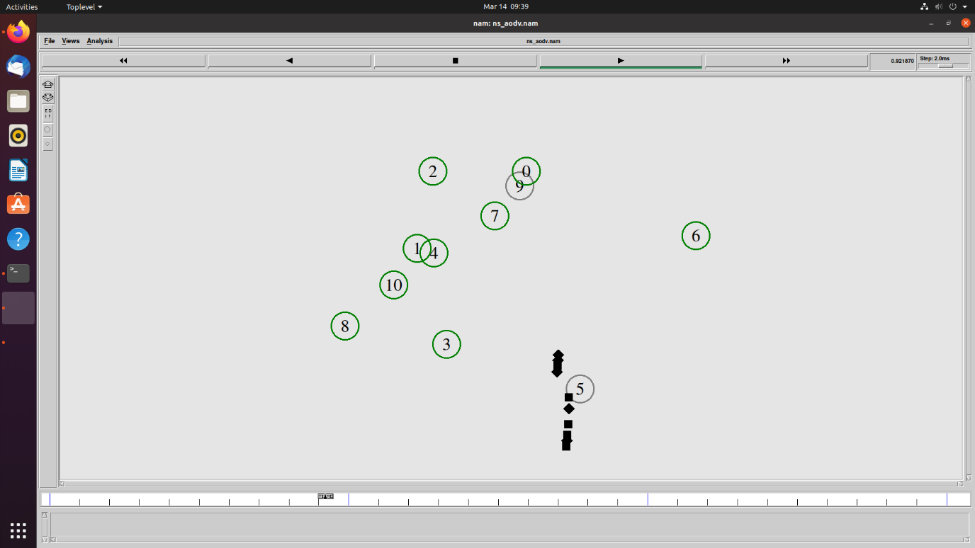
Result:
Routing algorithms were evaluated using a network simulation tool.

