Toothwise: A YOLO-Based Multi-Condition Dental Screening System with KNN-Based Recommendation for CodiSmile Dental Clinic
A Capstone Project Presented to the College of
Computing Studies
Universidad de Manila
In Partial Fulfillment
of the Requirements for the Course
CAPSTONE 2
Brayan Axel L. Tubillas
Keith Ashly V. Sales
Reizen S. Arreola
Robin C. Ponce
Rizelle Carla N. Magpantay
Prof. Francis Arlando L. Atienza
Professor
September 2026

TABLE OF CONTENTS
CHAPTER I: INTRODUCTION
1.1 Background of the Study 4
1.2 Statement of the Problem 7
1.3 Objectives of the Study 8
1.3.1 General Objective 8
1.3.2 Specific Objectives 9
1.4 Scope, Delimitation and Limitation of the Study 9
1.5 Significance of the Study 11
1.6 Definition of Terms 13
CHAPTER II: REVIEW OF RELATED LITERATURE AND STUDIES
2.1 Related Literature 15
2.2 Related Studies 19
2.3 Synthesis 23
CHAPTER III: METHODOLOGY
3.1 Development Methodology 25
3.2 Project Planning 26
3.3 Roles and Responsibilities of the Five-Member Development Team 28
3.4 Requirements Analysis 30
3.5 System Design 32
3.5.1 Use Case Diagram 32
3.5.2 Entity Relationship Diagram (ERD) 32
3.5.3 Data Flow Diagram Level 0 36
3.5.4 Data Flow Diagram Level 1 36
3.5.5 Gantt Chart 40
3.6 Software Specifications 41
3.7 Hardware Specifications 44
3.8 System Development 45
3.9 System Testing 47
3.10 Full Current System Screenshots 48
CHAPTER IV: RESULTS AND DISCUSSION
4.1 Results of the Trained Datasets 56
4.2 Specialization and Technical Results 67
4.3 Software Quality Evaluation Based on ISO/IEC 25010 73
4.4 Screening Consistency and Screening Time 83
CHAPTER V: SUMMARY OF FINDINGS, CONCLUSIONS, AND RECOMMENDATIONS
5.1 Summary of Findings 86
5.2 Conclusions 87
5.3 Recommendations 88
References 91

CHAPTER I
INTRODUCTION

1.1 Background of the Study
CodiSmile Dental Clinic currently relies on manual visual examination and professional judgment to identify dental caries and other visible dental conditions from patient examinations and intraoral images. Although this approach is essential to dental practice, manually reviewing images may be time-consuming and can result in variations in assessment and documentation. To support the existing process, the proponents propose Toothwise: A YOLO-Based Multi-Condition Dental Screening System with KNN-Based Recommendation for CodiSmile Dental Clinic, an AI-assisted system that analyzes intraoral images and detects possible dental conditions — tartar, plaque, cavity, gum inflammation, and healthy tooth — using the YOLOv12 and YOLOv8 object detection models. The system provides visual detection results, condition labels, descriptions, a computed risk classification, and preventive recommendations to assist dentists and improve patient understanding. Toothwise is intended to serve as a supplementary screening and documentation tool, while final interpretation and clinical decisions remain the responsibility of licensed dental professionals.
Dental caries, commonly referred to as tooth decay or cavities, remains one of the most prevalent non-communicable diseases in the world. The World Health Organization (2025) estimates that oral diseases affect nearly 3.7 billion people globally, with untreated dental caries in permanent teeth identified as the single most widespread health condition based on Global Burden of Disease 2021 data. Despite its prevalence, a significant portion of the population, particularly those in geographically isolated or economically disadvantaged communities, continues to face substantial barriers in accessing timely and adequate dental care. In the Philippines, Mendoza et al. (2025) note that an estimated 29 million Filipinos have untreated dental caries and that outpatient dental services were not covered by the PhilHealth benefit package at the time of their analysis. The financial cost of consultations, the distance to dental facilities, and low oral health literacy frequently result in delayed care-seeking, by which point cavities have often advanced beyond their most treatable stages. Untreated caries does not just cause physical pain; Almajed et al. (2023) found that children with untreated caries had higher rates of poor oral-health-related quality of life.
A critical dimension of the current dental care challenge lies in the inconsistency of manual cavity screening practices. Wang et al. (2026), in a review on the clinical translation of AI-based caries diagnosis, noted that traditional diagnostic methods suffer from limited sensitivity and high variability between examiners, particularly for early-stage lesions. This inter-examiner variability is particularly problematic in high-volume clinic settings where practitioner fatigue and time pressure can further compromise screening reliability. Research has shown that deep learning models are capable of detecting dental cavities with accuracy that is on par with, or sometimes even better than, trained clinicians, as reported in the reviews by Schwendicke et al. (2019) and Mohammad-Rahimi et al. (2022). This makes AI a genuinely useful tool for supplementing human judgment during screenings.
Standard digital cameras and smartphone cameras have also changed the way dental screening can be supported outside specialized clinical equipment. Instead of relying purely on what a dentist can see with a mirror and a light, or requiring dedicated intraoral camera hardware, clear intraoral photographs can now be captured using widely available consumer devices. Park et al. (2022), for example, improved caries classification on intraoral camera photographs by first segmenting the tooth surfaces, and studies such as those by Moharrami et al. (2025) and Askar et al. (2021) show that RGB photographs captured under ordinary imaging conditions are detailed enough to support reliable artificial intelligence-based detection of dental conditions. It is this still-image, standard-camera modality that serves as the primary data source for Toothwise during patient screenings at CodiSmile Dental Clinic, since the system is designed to work from photographs taken with an ordinary device camera, such as a smartphone, and uploaded to the system, rather than requiring a dedicated intraoral camera.
The AI model powering the primary detection module of this system is YOLOv12, which was introduced by Tian et al. (2025) as an attention-centric object detection framework. Compared to previous versions in the YOLO family, YOLOv12 uses area attention mechanisms that help it focus selectively on spatially relevant regions, something that happens regularly in dental images where carious lesions appear as small, low-contrast areas across multiple tooth surfaces simultaneously. Its combination of speed and accuracy makes it well-suited for efficient use during clinical consultations, where screening results need to be generated quickly enough to fit within a standard patient visit.
To evaluate whether YOLOv12's architectural improvements translate into meaningful gains for this specific screening task, this study also trains and evaluates YOLOv8, an earlier and widely adopted model in the YOLO family (Jocher et al., 2023). YOLOv8 has been applied in several prior dental imaging studies with strong results; de Brito et al. (2025) used YOLOv8 together with EfficientNet-B0 to diagnose caries in interproximal radiographic images of young permanent molars, and other work has applied YOLOv8's anchor-free detection mechanism to interproximal caries detection with improved accuracy and speed over earlier YOLO versions. This makes it a stable, well-benchmarked baseline for object detection tasks. While YOLOv12 and YOLOv8 are formally compared against each other using precision, recall, mAP, and inference speed on a held-out labeled test set, both models are also deployed together in the operational system, where their independent detection outputs are fused into a single clinical detection set. This dual approach allows the study to identify which architecture performs better on this specific task while still taking advantage of both models' detections in the deployed screening workflow.
Beyond detection, Toothwise also generates a personalized prevention plan for each patient based on their screening results. This is done using the K-Nearest Neighbors (KNN) algorithm, a supervised learning method originally introduced by Cover and Hart (1967), which classifies a new case by comparing it against the most similar cases in a reference dataset. In this study, KNN classifies each screening into a risk tier (low, medium, or high) based on the patient's detected findings — condition type, number of affected areas, and severity indicators derived from the detection output — and this risk classification, together with condition-specific rules, is used to compose an ordered, patient-friendly prevention plan, while the 0–100 risk score itself comes from a separate rule-based formula. Since no dentist-labeled cases exist before deployment, the KNN is first trained on synthetic cases derived from the clinical severity rule, and each tier the dentist confirms or corrects is added as a real case for retraining.
While AI-assisted dental screening has grown internationally, its application in the Philippine setting remains an emerging area of research. Wu et al. (2025), in collaboration with Ateneo de Manila University's Laboratory for Intelligent Visual Environments, applied a deep learning model to identify tooth and sinus structures in dental panoramic radiographs, illustrating the early but growing interest in AI-assisted dental diagnostics locally. This study seeks to build on that emerging interest by applying AI-assisted screening directly within a clinic setting through Toothwise.
This project was created in partnership with CodiSmile Dental Clinic, which serves as the deployment site and clinical reference point throughout the study. The goal is not to take the place of the dentist but to give them a more efficient and objective tool to work with. With Toothwise integrated into the clinic's workflow, screenings can be documented more consistently, and patients can walk away with a clearer understanding of their oral health through the system's risk classification and personalized prevention plan features.

1.2 Statement of the Problem
Dental screening at CodiSmile Dental Clinic relies on visual inspection. Early-stage tartar, plaque, cavity, and gum inflammation are small, look similar to one another, and vary with lighting, angle, and stage, so visual assessment is subjective and findings can differ between examinations. The clinic has no standardized visual record of findings to compare across visits, and patients are rarely given finding-specific preventive guidance. Undetected conditions can progress to pain, tooth loss, and costlier treatment, which makes consistent early screening a challenge of the method itself.
This study seeks to answer the following:
1. What limitations of visual-only screening make early-stage tartar, plaque, cavity, and gum inflammation and healthy tooth, as well as their relative severity, difficult to detect and distinguish consistently at CodiSmile Dental Clinic?
2. What gaps exist in how screening findings are recorded and made accessible to dentists and patients, given the absence of a standardized visual record and a way for patients to review their own history?
3. What barriers prevent patients from receiving timely, finding-specific preventive guidance after screening?
4. What is the level of acceptability of the Toothwise system in terms of the six ISO/IEC 25010 quality characteristics evaluated in this study (security, privacy, usability, reliability, performance efficiency, and data protection), as evaluated by IT experts and patient respondents?
5. What is the difference on the use of Toothwise to improve screening consistency and reduce screening time compared with the current manual process?

1.3 Objectives of the Study

1.3.1 General Objective:
To design, develop, and evaluate Toothwise, a dental screening support system that uses YOLO-based detection on still intraoral photographs, a KNN-based risk classification and recommendation feature, to provide consistent and accessible screening support for licensed dentists and patients at CodiSmile Dental Clinic.

1.3.2 Specific Objectives:
1. To train YOLOv12 and YOLOv8 on annotated still intraoral images to detect tartar, plaque, cavity, gum inflammation, and healthy tooth and compute an associated risk score and risk classification (low, medium, high) from the detected findings, and compare the two models by precision, recall, mAP, and inference speed.
2. To develop a results interface showing bounding boxes, condition labels, plain-language descriptions, and risk classification, with a per-patient record of findings across visits accessible to dentists and, through a self-service patient portal, to patients themselves.
3. To develop a KNN-based feature that generates a personalized prevention plan from the detected findings and computed risk classification.
4. To evaluate Toothwise using six ISO/IEC 25010 quality characteristics with IT experts and patient respondents.
5. To measure changes in screening consistency and time with Toothwise versus the manual process, using the dentist's findings as the reference.

1.4 Scope, Delimitation and Limitation of the Study

Scope
This study covers the design, development, training, and evaluation of Toothwise, an AI-assisted dental screening support system for CodiSmile Dental Clinic. Using still photographs taken with a standard device camera, such as a smartphone, and uploaded to the system as JPEG, PNG, or WebP files, Toothwise analyzes the patient's teeth and gums to detect five classes: tartar, plaque, cavity, gum inflammation, and healthy tooth. YOLOv12 and YOLOv8 models are trained on publicly available annotated dental image datasets and compared in terms of precision, recall, mean average precision (mAP), and inference speed; both models are also used together in the deployed system, with their outputs fused into a single clinical detection set. After training, the system is tested at CodiSmile Dental Clinic to assess how it performs in an actual clinical environment. Detection results are displayed through a results interface that shows bounding boxes, condition labels, plain-language descriptions, and a computed risk classification for licensed dentists, and findings are saved in a per-patient record that can be reviewed across visits. Based on the detected findings, a recommendation feature that uses the K-Nearest Neighbors (KNN) algorithm classifies the screening into a risk tier and generates a personalized prevention plan for each patient. The system also generates a downloadable PDF screening report for clinical recordkeeping and maintains an audit log of sensitive staff actions for administrative review. Toothwise is a browser-based web application; for the study it is deployed on cloud hosting (the React frontend on Vercel, the FastAPI backend on Render, and the PostgreSQL database on Neon), so clinic staff and patients can open it from any device with a modern web browser and an Internet connection. The intended users are licensed dentists and clinic personnel at CodiSmile Dental Clinic; in addition, patients may register for a self-service portal to view their own screening history and past findings. The system is evaluated by IT experts and patient respondents through an online questionnaire based on six ISO/IEC 25010 quality characteristics, and the respondents also assess its effect on screening consistency and screening time compared with the current manual process.

Delimitations
Toothwise is a support tool and not a replacement for a licensed dentist. The dentist at CodiSmile Dental Clinic always has the final say on any diagnosis or treatment decision. The prevention plan is meant to guide the patient and is not a formal medical prescription, so it does not include medication, treatment procedures, or dosages. The system works only with still photographs that are uploaded as image files (for example, a photograph taken with a smartphone camera); it does not analyze live video, does not process X-rays or any other radiographic input, and does not require specialized intraoral camera hardware. It is limited to the five classes named above and does not detect oral cancer, bone loss, impacted teeth, orthodontic issues, or other conditions that surface-level visual detection cannot reliably identify. The comparison of detection models is limited to YOLOv12 and YOLOv8 and does not include other detection architectures. The system is developed and tested only at CodiSmile Dental Clinic and does not integrate with billing or appointment scheduling systems. The evaluation covers software performance, quality, and acceptability, and does not measure long-term clinical outcomes such as changes in caries rates over time.

Limitations
The accuracy of the detection models depends on image quality, lighting, camera positioning, and the patient's cooperation when the photograph is taken, and may vary more than it would with specialized intraoral camera hardware since a standard device camera is used instead. Because the models are trained on public datasets, performance in the clinic may differ from training results if the clinic's captured images look different from the dataset images. The quality of the KNN-generated risk classification and recommendations depends on its reference data, which starts as synthetic cases and grows as the dentist confirms tiers. Findings may not generalize to other clinics, camera devices, or patient populations.
The quality of the KNN-generated risk classification and recommendations depends on its reference data, which starts as synthetic cases and grows as the dentist confirms tiers. Findings may not generalize to other clinics, camera devices, or patient populations. Finally, the study deployment uses free hosting tiers: the backend sleeps after 15 minutes without requests, so the first request after a quiet period can take about a minute while the service starts again, and the backend has 512 MB of memory, which is why the deployed models run on ONNX Runtime and are loaded one at a time for each screening.

1.5 Significance of the Study
This study is expected to benefit the following groups:
Patients. Patients of CodiSmile Dental Clinic may benefit from a more consistent screening experience, in which findings such as tartar, plaque, cavities, gum inflammation, and healthy tooth are shown visually, explained in plain language, and accompanied by a risk classification. The personalized prevention plan gives them specific guidance based on their own findings, which can support earlier preventive action and better awareness of their oral health, and the patient portal allows them to review their own screening history at any time.
Dentists and CodiSmile Dental Clinic. Toothwise serves as a screening support tool that gives licensed dentists a consistent, image-based reference during consultations, while diagnosis and treatment decisions remain with them. The per-patient record of images, findings, and risk classifications gives the clinic a standardized documentation of screenings that can be reviewed and compared across visits, which the clinic currently lacks, and the PDF reporting and audit logging features support clinical recordkeeping and administrative oversight.
IT Practitioners and Software Developers. The comparison of YOLOv12 and YOLOv8, the use of KNN for risk classification and recommendations, and the ISO/IEC 25010 evaluation provide a documented example of building and assessing an AI-based health support system in a real clinic setting.
Future Researchers. Students and researchers interested in AI in dentistry can use the methodology, dataset preparation, model comparison, and system design of this study as a basis for further work, such as expanding the detectable conditions, testing other clinics, or studying long-term clinical outcomes.
The Research Community. There are relatively few local studies that apply AI-based detection to dental screening in the Philippine setting. This project contributes to that growing body of work and may serve as a reference for similar initiatives at other clinics across the country.

1.6 Definition of Terms
For clarity and common understanding, the following terms are defined based on how they are used in this study.
Calculus (Tartar). A hardened deposit of mineralized plaque that forms on the tooth surface and along the gumline. In this study, it refers to one of the five conditions detected by the Toothwise system.
Dental Caries (Cavity). The decay and structural breakdown of tooth enamel and underlying tissue caused by bacterial activity. In this study, it refers to one of the five conditions detected by the Toothwise system.
Gum Inflammation (Gingival Inflammation). A visible reddening, swelling, or irritation of the gum tissue, often an early indicator of gingivitis. In this study, it refers to one of the five conditions detected by the Toothwise system.
Inference Speed. The amount of time a trained detection model takes to process an input image and produce a detection result. In this study, it is one of the metrics used to compare the performance of YOLOv12 and YOLOv8.
K-Nearest Neighbors (KNN). A supervised machine learning algorithm introduced by Cover and Hart (1967), which classifies a new case by identifying and comparing it to the most similar cases in a reference dataset. In this study, KNN is used to classify each screening into a risk tier and generate a personalized prevention plan based on a patient's detected findings.
Mean Average Precision (mAP). A standard evaluation metric for object detection models that summarizes a model's precision and recall performance across all detected classes. In this study, it is one of the metrics used to compare YOLOv12 and YOLOv8.
ONNX Runtime. An open-source engine for running machine learning models saved in the Open Neural Network Exchange (ONNX) format. In this study, the deployed system uses ONNX exports of the trained YOLOv8 and YOLOv12 models so that both can run on a small cloud server without PyTorch.
Plaque. A soft, sticky film of bacteria that forms on the surface of teeth. In this study, it refers to one of the five conditions detected by the Toothwise system.
Precision. A performance metric that measures the proportion of correctly identified detections out of all detections made by the model. In this study, it is used to evaluate and compare the performance of YOLOv12 and YOLOv8.
Recall. A performance metric that measures the proportion of actual conditions in an image that were correctly identified by the model. In this study, it is used to evaluate and compare the performance of YOLOv12 and YOLOv8.
Risk Score. A numerical value from 0 to 100, classified as low, medium, or high, generated by the system from a patient's detected findings to indicate the overall severity of a screening result. In this study, the risk score is computed by a rule-based formula.
Toothwise. The AI-assisted dental screening support system developed in this study, which uses YOLOv12 and YOLOv8 for detection and KNN for risk classification and generating personalized prevention plans.
YOLOv8 (You Only Look Once, version 8). An object detection model architecture in the YOLO family, used in this study as a baseline for comparison against YOLOv12 in detecting dental conditions.
YOLOv12 (You Only Look Once, version 12). An attention-centric object detection model architecture introduced by Tian et al. (2025), used in this study as the primary detection model for identifying dental conditions from intraoral images.

CHAPTER II
REVIEW OF RELATED LITERATURE AND STUDIES
This chapter presents the related literature and studies that have been gathered by the proponents. It introduces many ideas linked to the topic, which includes the research's principal focus. The study's synthesis is offered to analyze the previous research that the researchers have gathered.

2.1 Related Literature
Convolutional Neural Networks for Dental Image Diagnostics. Schwendicke et al. (2019) carried out a scoping review of 36 studies, published from 2015 to 2019, that applied convolutional neural networks (CNNs) to dental images. Most of the studies detected, segmented, or classified anatomical structures such as teeth, jaw bone, and skeletal landmarks, and only a few targeted pathologies such as caries. The authors noted that CNNs have shown the potential to detect structures and pathologies on medical images with accuracy similar to, or even higher than, that of professionals, but they also warned of possible bias in the underlying algorithms and of limited robustness and generalizability. These cautions carry directly into Toothwise, where the models are evaluated on a held-out test split and all detected findings at CodiSmile Dental Clinic are reviewed by a licensed dentist before being communicated to any patient. The review also shows that the field has concentrated on detection and segmentation tasks, which is the gap that the personalized prevention plan feature of Toothwise was built to address.
Deep Learning for Caries Detection: A Systematic Review. Mohammad-Rahimi et al. (2022) reviewed 42 studies that used machine learning and deep learning to detect caries across different image types, including intraoral photographs. Their main takeaway was that deep learning, particularly convolutional neural networks, worked reliably for identifying both early and more advanced carious lesions. They also raised a concern that is very relevant to this project: there are not many large, standardized, and publicly available dental datasets out there, which makes it harder to train models that perform well across different clinical settings. For Toothwise, this limitation was addressed by combining publicly available annotated datasets with data augmentation techniques during model training. The studies they reviewed covered classification, object detection, and segmentation only, with image, object, or pixel accuracy between 68% and 99%, and the authors concluded that deep learning models can serve as an assistant for decisions on the presence or absence of carious lesions. None of the reviewed models went on to produce a recommendation, which reinforces why the prevention plan feature of Toothwise fills a genuine gap in the existing body of work.
Deep Learning for Detecting Dental Plaque and Gingivitis from Oral Photographs. Moharrami et al. (2025) conducted a systematic review evaluating deep learning models specifically for detecting dental plaque and gingivitis from RGB intraoral photographs, including images captured through standard consumer devices rather than specialized dental equipment. Across the studies they reviewed, models showed stronger and more consistent performance for plaque detection than for gingivitis, where the certainty of evidence was rated lower due to the more subtle and gradual visual presentation of early gingival inflammation. This finding is directly relevant to Toothwise, since gum inflammation is one of the five conditions the system is trained to detect from standard-camera photographs; it signals that this class may require more careful dataset curation and potentially larger sample sizes than the other conditions to reach comparable performance during training.
Oral Screening of Dental Calculus, Gingivitis, and Dental Caries through Segmentation on Intraoral Photographic Images. Liu et al. (2024) developed a deep learning segmentation system, Oral-Mamba, capable of simultaneously detecting three conditions — dental caries, dental calculus, and gingivitis — from a single set of intraoral photographic images, achieving accuracy rates above 0.81 for each condition. This study is one of the few in the literature that approaches multi-condition detection from a single intraoral image source rather than treating each condition as a separate, isolated detection task. It directly supports the feasibility of the multi-class detection approach used in Toothwise, which similarly trains a single model to identify several distinct conditions — tartar, plaque, cavity, and gum inflammation — from one still-image source.
Oral Health Philippines Country Profile. The World Health Organization (2022) released a country-specific oral health profile for the Philippines as part of its Global Oral Health Status Report. The numbers are difficult to ignore. Dental caries was listed as one of the most prevalent health concerns in the country, with high rates of untreated cases across all age groups. The report also pointed out something that many Filipinos already know from experience: access to dental care is not evenly distributed. People in rural and community settings have significantly fewer options, and the limited dental workforce makes it harder to reach those who need care the most. This profile is the most authoritative reference for understanding the national oral health landscape that Toothwise seeks to contribute to. Deploying an artificial intelligence-assisted screening system at CodiSmile Dental Clinic is a concrete step toward addressing the access and consistency gaps that the WHO profile describes.
Pediatrician Knowledge, Attitude and Practices on Children's Oral Health in a Tertiary Public Hospital in the Philippines. Oliveros-Villarico et al. (2023) looked at the role of pediatricians in preventing dental caries among Filipino children, a role that often goes undiscussed. Their survey of 122 pediatricians at a tertiary public hospital found that most had high oral health knowledge (67.8%) and a positive attitude toward caries prevention (85.0%), but that their reported practices, such as caries risk assessment and preventive oral health education, varied. The authors describe dental caries as a tolerated and overlooked chronic disease in the Philippines, with untreated caries in the primary teeth of 85.18% of five-year-olds. For this project, this literature helps explain why a tool like Toothwise matters at the clinic level: knowledge alone has not translated into consistent early detection, and an AI-assisted screening system that flags dental conditions during a regular consultation at CodiSmile Dental Clinic can help catch problems before they get worse.
Guiding Responsible AI in Healthcare in the Philippines. Sarmiento et al. (2025) reviewed the barriers to the safe and effective deployment of AI in Philippine healthcare and drew on lessons from other Southeast Asian nations, the European Union, and the United States to propose directions for a national strategy. They noted that the Philippines lags behind fellow ASEAN member states in governmental AI readiness, and they pointed to structural constraints, such as connectivity, data stewardship, and workforce capacity, together with governance requirements, such as bias and safety monitoring, transparency, and accountability, that must accompany any deployment. These points shaped several decisions in how Toothwise was designed, particularly the requirement that all AI detection results at CodiSmile Dental Clinic are reviewed and confirmed by a licensed dentist before they are communicated to patients, that every sensitive action is written to an audit log, and that patient data is stored securely with authenticated access in line with the Data Privacy Act of 2012.
An Overview of Recommendation Techniques and Their Applications in Healthcare. Yue et al. (2021) reviewed the major recommendation approaches used in healthcare contexts, namely content-based, collaborative filtering, and hybrid methods, and mapped their application across five scenarios: dietary recommendation, lifestyle recommendation, training recommendation, decision-making support for patients and physicians, and disease-related prediction. Their review positions K-Nearest Neighbors-based approaches as a foundational technique underlying several of these healthcare recommendation scenarios, particularly where recommendations are generated by classifying a case according to its similarity to previously seen cases. This framework directly informs how the KNN-based risk classification and prevention plan feature of Toothwise was conceptualized, positioning it within the "decision-making support for patients" category identified in their review, an application area that, per their analysis, remains comparatively underexplored relative to dietary and lifestyle recommendation systems.

2.2 Related Studies
Detecting White Spot Lesions on Dental Photography Using Deep Learning. Askar et al. (2021) worked on detecting white spot lesions in intraoral dental photos captured with standard consumer cameras, using deep learning. White spot lesions are early stage demineralization, essentially the very beginning of a cavity before it becomes a visible hole. What made this study particularly useful is that it was done with a small dataset, which is a realistic constraint for many research projects, including this one. Despite that limitation, the model still managed to detect subtle surface level changes that would be easy to miss in a routine visual check. For Toothwise, this matters because it shows that even with limited annotated data and images from standard, non-specialized cameras, deep learning can pick up early, crucial changes from photographs, which is the same image modality the system uses at CodiSmile Dental Clinic. It also gave the team confidence that training a YOLOv12 model for early cavity detection is achievable even when the training dataset is not massive and specialized imaging hardware is not required.
Ultralytics YOLO (Version 8.0.0). Jocher et al. (2023) released YOLOv8 as an open source framework under the Ultralytics platform. Compared to older YOLO versions, YOLOv8 came with a cleaner training pipeline, an anchor free detection head, and support for multiple tasks like detection, segmentation, and classification all in one package. It became one of the most widely used detection frameworks in both academic and applied settings because it was relatively easy to work with while still delivering strong results. Understanding YOLOv8 matters for this project because YOLOv12 was built on the same foundation. The training tools, dataset formats, and evaluation methods used in YOLOv8 largely carry over to YOLOv12, so much of what Jocher et al. (2023) established applies directly to how the Toothwise models were trained and tested. YOLOv8 also serves as the direct comparison baseline against YOLOv12 in this study's model evaluation.
Accuracy in Diagnosing Caries in Young Permanent Molars Using Interproximal Radiographic Imaging and Validation by Artificial Intelligence. de Brito et al. (2025) compared the caries diagnoses of calibrated dentists on interproximal radiographs of the first permanent molars of children aged 6 to 9 with an AI pipeline in which YOLOv8 located the teeth and a pre-trained EfficientNet-B0 model classified each tooth as carious or sound. Agreement between the examiners was excellent (97.4%, kappa 0.88); YOLOv8 detected the carious teeth with 91% accuracy and 98% precision, and EfficientNet-B0 classified teeth with and without caries lesions with 89% accuracy. This study provides evidence that YOLOv8 is a credible baseline for caries-related detection tasks, supporting its selection as the comparison model against YOLOv12 in this study.
Deep Learning in Oral Hygiene: Automated Dental Plaque Detection via YOLO Frameworks and Quantification Using the O'Leary Index. Ramírez-Pedraza et al. (2025) trained and compared several YOLO model variants, including YOLOv11, specifically for detecting dental plaque in varied imaging conditions, using the O'Leary Index as a clinical benchmark for plaque quantification. Their results showed that YOLO-based models could reliably distinguish plaque at different stages of maturity, though newer, less mineralized plaque was harder to detect than older, more visually distinct plaque, since it tends to blend with surrounding gingival tissue. This finding is directly relevant to Toothwise, since it identifies a specific detection challenge, distinguishing early plaque from gum tissue, that the model must account for during training and dataset annotation for the plaque class.
Diagnostic Accuracy of Dental Caries Detection Using Ensemble Deep Learning with Intraoral Camera Images. Kang et al. (2024) took a different approach from most dental AI studies by using an ensemble of deep learning models rather than a single model for caries detection. By combining multiple detectors, they were able to reduce false positives while keeping sensitivity high, which is especially important in a clinical setting where unnecessary alarms can make dentists lose trust in the system. Their work confirmed that photographic intraoral images, rather than radiographs, are a sufficient and practical input for reliable AI-based detection, validated against annotations made by an experienced dentist. This finding supports the still-image, standard-camera approach used in Toothwise, and gave the team confidence that deep learning for photographic dental screening is not just theoretically possible but has already been shown to work efficiently in a clinical environment similar to CodiSmile Dental Clinic.
AI-Assisted Detection of Interproximal, Occlusal, and Secondary Caries on Bite-Wing Radiographs: A Single-Shot Deep Learning Approach. Karakuş et al. (2024) applied YOLOv8 to the task of detecting different types of dental caries from bitewing radiographs. One thing that stood out in their findings was how well YOLOv8 handled small and overlapping lesions, which is a tricky problem in dental imaging because caries can be close together or partially hidden. Even though Toothwise uses standard photographic images rather than radiographs, the core detection challenge is similar. The model needs to find and correctly label multiple small, carious areas within a single image. The performance of YOLOv8 in this study, combined with the architectural improvements introduced in YOLOv12, provided the team with a strong technical basis for believing that YOLOv12 can handle the multi-condition detection demands of Toothwise.
YOLOv12: Attention-Centric Real-Time Object Detectors. Tian et al. (2025) introduced YOLOv12 in a preprint that gained significant attention in the computer vision community. The paper presents a new approach to the YOLO architecture centered around area attention mechanisms, which allow the model to focus on relevant regions of an image rather than processing everything equally. The results were impressive. The YOLOv12 N configuration achieved 40.6% mean average precision at an inference latency of just 1.64 milliseconds on a T4 GPU, outperforming comparable YOLOv10 and YOLOv11 models. For a system like Toothwise, where detection results need to be produced quickly enough to fit within a standard dental consultation, that combination of accuracy and speed is exactly what is needed. This paper is the primary technical reference for the detection model used in this project, and its findings directly justify choosing YOLOv12 for evaluation against YOLOv8 for deployment at CodiSmile Dental Clinic. At the time of this review, no widely published study had applied YOLOv12 specifically to multi-condition dental screening from standard photographic images, positioning Toothwise among the earliest efforts to explore this architecture in that context.
Feedback Collection and Nearest-Neighbor Profiling for Recommendation Systems in Healthcare Scenarios. António et al. (2024) developed a physical activity recommendation system for patients in rehabilitation using a K-Nearest Neighbors sampling strategy combined with feedback collection, generating activity recommendations by identifying patients with the highest similarity to a given case based on their health profile. Their system was shown to outperform traditional collaborative filtering and purely human-constrained recommendation methods in producing recommendations suited to a patient's specific therapeutic needs, physical capacity, and stage of recovery. This is one of the few studies to apply a KNN-based approach directly to generating personalized, condition-specific health guidance rather than general product or content recommendations, and it provides a close technical parallel for how Toothwise's KNN-based feature classifies a screening into a risk tier and composes a prevention plan by matching a patient's findings against similar synthetic and dentist-confirmed cases.
Bridging the Gap or Widening the Divide: A Call for Capacity-Building in Artificial Intelligence for Healthcare in the Philippines. Gutierrez and Viacrusis (2023) took a critical look at AI readiness in Philippine healthcare. When they asked GPT-4, GPT-3, Bard, and Claude about isoniazid dosing for Filipinos compared with other ethnic groups, three of the four models produced convincing but false content. The authors argued that regions with lower medical research output risk bias and misrepresentation in AI-generated content, and they called on Filipino clinicians and researchers to begin capacity-building, including locally representative data, quality assurance, and early AI education in medical schools, before relying on such tools in clinical practice. This study speaks directly to a design decision in Toothwise. The system does not allow AI detection results to be shown to patients without going through a dentist first. At CodiSmile Dental Clinic, the dentist reviews every output before it becomes part of the clinical record or is communicated to the patient, which reflects the caution that Gutierrez and Viacrusis called for.

2.3 Synthesis
The literature and studies reviewed in this chapter come together to build a clear and well-supported case for the approach that Toothwise has taken. Schwendicke et al. (2019) and Mohammad-Rahimi et al. (2022) showed through separate reviews that deep learning models are genuinely reliable for dental caries detection, often performing at the level of trained clinicians or better. Moharrami et al. (2025) and Liu et al. (2024) extended this evidence beyond caries alone, showing that plaque, calculus, and gingivitis can also be reliably detected from standard intraoral photographs, with the work of Liu et al. in particular demonstrating that multiple conditions can be detected from a single image source using one model, directly supporting the five-class detection approach used in Toothwise. Kang et al. (2024) and Askar et al. (2021) further confirmed that photographic images captured without specialized intraoral camera hardware are a sufficient and practical input modality for AI-based detection in an actual clinical setting, closely paralleling the still-image, standard-camera acquisition approach of Toothwise at CodiSmile Dental Clinic.
The most important gap identified across the reviewed works is that existing dental AI systems detect conditions but stop there; the photograph-based reviews by Moharrami et al. (2024, 2025) cover detection only. None of the detection-focused studies reviewed generated recommendations or patient-facing guidance after detection. At the same time, Yue et al. (2021) and António et al. (2024) show that KNN-based recommendation approaches have been successfully applied in other healthcare domains, such as physical rehabilitation, but remain comparatively unexplored in dental screening specifically. Toothwise fills this gap by embedding a KNN-based risk classification and recommendation engine into a multi-condition detection pipeline, pairing YOLO-based detection with an actionable, personalized prevention plan, a combination not found together in the literature reviewed.
On the technical side, Tian et al. (2025) established YOLOv12 as a highly accurate and efficient real-time object detection architecture, while Jocher et al. (2023), de Brito et al. (2025), Ramírez-Pedraza et al. (2025), and Karakuş et al. (2024) documented the strong and well-validated performance of YOLOv8 specifically across caries and plaque detection tasks, supporting its selection as this study's comparison baseline. Askar et al. (2021) further showed that deep learning-based detection is achievable even under limited dataset conditions, supporting the training strategy used in this project.
The Philippine context literature from the WHO (2022) and Oliveros-Villarico et al. (2023) grounds all of this in a concrete public health reality. Dental conditions are widespread among Filipinos, they often go undetected until they have already progressed, and access to professional dental care remains out of reach for many due to cost and geography. Sarmiento et al. (2025) and Gutierrez and Viacrusis (2023) shaped responsible design decisions around human oversight, data privacy, and clinical transparency. What no existing work reviewed has done is bring together YOLO-based multi-condition detection from standard photographic images, a KNN-based risk classification and personalized prevention plan generator, and a full-stack clinical system deployed at an actual Philippine dental clinic. That is the specific contribution of Toothwise.

CHAPTER III
METHODOLOGY
This chapter presents the methodology used in the development of Toothwise: A YOLO-Based Multi-Condition Dental Screening System with KNN-Based Recommendation for CodiSmile Dental Clinic. It describes the development methodology, the composition and responsibilities of the five-member development team, the project planning and requirements analysis process, the major system design diagrams required for the capstone examination, and the development, testing, and screenshot documentation of the current system.

3.1 Development Methodology
Toothwise was developed using the Agile Software Development Life Cycle (Agile SDLC). Agile was selected because the system integrates several interconnected components, including a React.js web interface, a FastAPI REST backend, a PostgreSQL database, a dual-model YOLOv8/YOLOv12 detection pipeline, a KNN-based risk classification and recommendation engine, authentication and authorization, audit logging, a separate patient self-service portal, and a cloud deployment of all three tiers. These components benefit from incremental development, continuous testing, regular review, and repeated refinement rather than a single sequential build.
Instead of completing the entire system in one long development cycle, the project was carried out through manageable iterations in which requirements were prioritized, features were implemented, tested, reviewed, and improved before the next set of features was developed. Each iteration followed the same general cycle of planning, requirements analysis, system design, development, testing, evaluation, and refinement, illustrated in Figure 1.
The cycle in Figure 1 was applied repeatedly across the project's documented iterations. Planning and requirements analysis identified the features required for the clinic workflow; system design translated those requirements into frontend routes, API endpoints, and database structures; development implemented the corresponding React, FastAPI, and machine-learning components; testing verified the implemented behavior; evaluation compared the result against the intended requirements; and refinement corrected any issues found before the next iteration began.
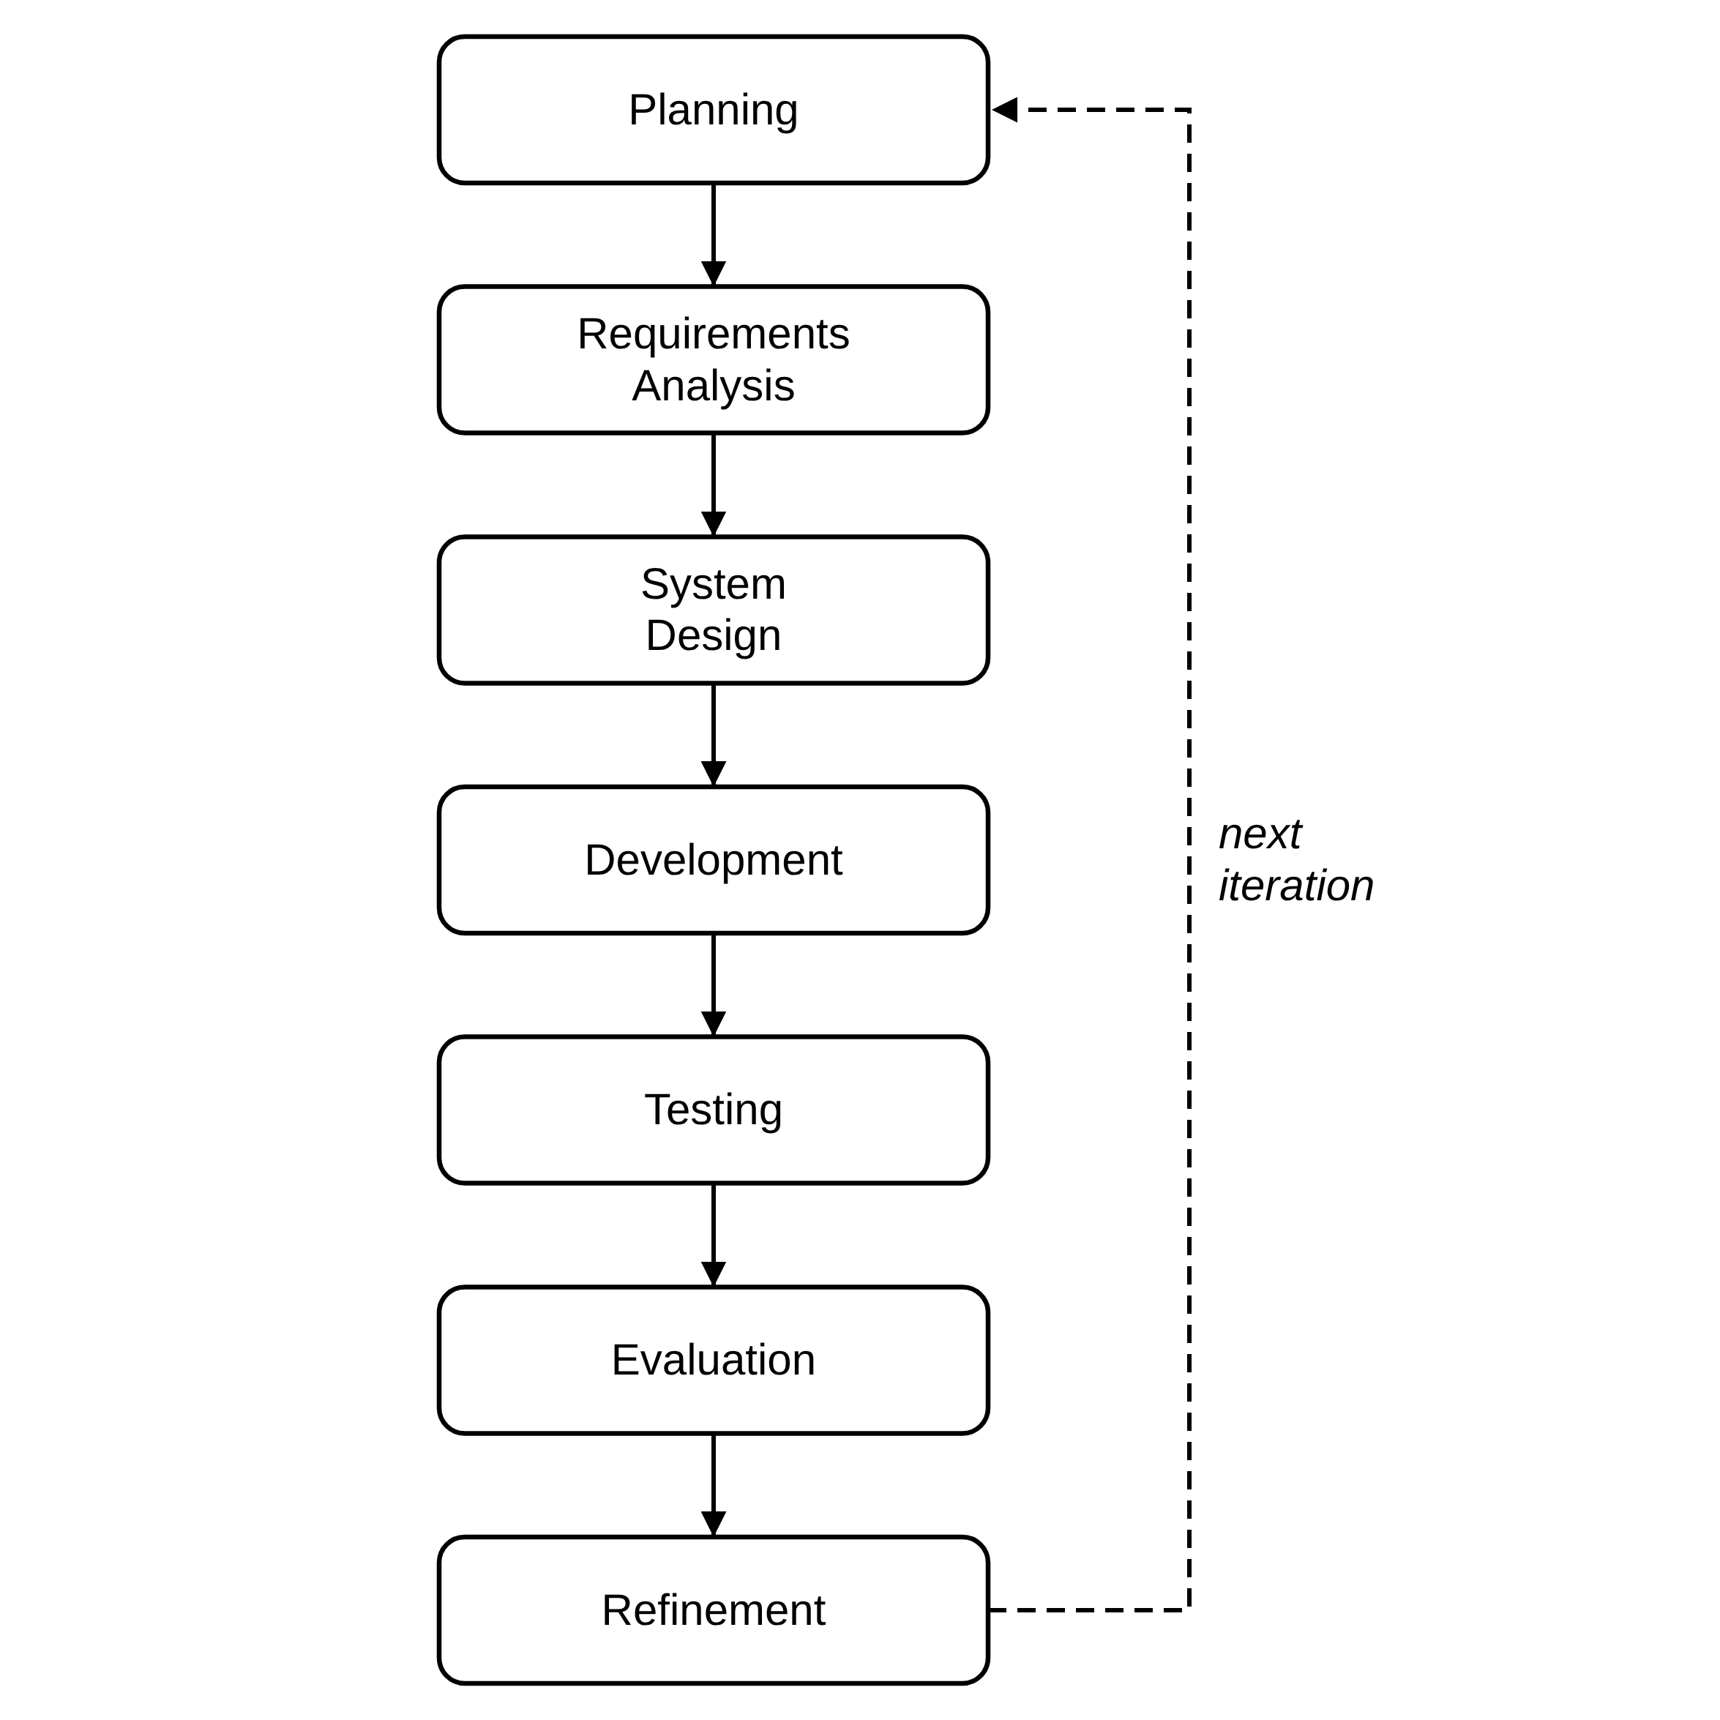
Figure 1 Agile Development Methodology.

3.2 Project Planning
The Toothwise project was planned around the screening and record-keeping workflow of CodiSmile Dental Clinic. The following considerations guided the planning of the system:
• Project Objectives — to provide CodiSmile Dental Clinic with an AI-assisted dental screening system that detects tartar, plaque, cavity, gum inflammation, and healthy tooth from a still photograph, estimates a risk level, and generates a recommendation/prevention plan, while also supporting day-to-day clinic record-keeping.
• Project Scope — the system covers staff authentication, patient management, dental screening and AI detection from uploaded still images, risk assessment, recommendation generation, password recovery, clinical notes, PDF reporting, audit logging, a self-service patient portal, a public AI assistant, and cloud deployment.
• Target Users — CodiSmile Dental Clinic staff (dentist, receptionist, and assistant roles) and the clinic's patients through the patient portal.
• Clinic Workflow — a patient is registered or already on file, a still intraoral photograph taken with a standard device camera is uploaded during a screening, the system produces detection, risk, and recommendation results for the dentist to review, and the dentist may confirm the risk tier, add clinical notes, or generate a PDF report.
• Functional Requirements — detailed in Section 3.4.
• Non-Functional Requirements — detailed in Section 3.4, covering security, privacy, usability, reliability, performance efficiency, and data protection.
• AI Screening Requirements — the system was planned to use two independent detection models (YOLOv8 and YOLOv12) whose outputs are fused into a single clinical detection set, rather than relying on a single model.
• Database Requirements — a relational PostgreSQL schema was planned to store staff accounts, patients, screenings and their photographs, detections, recommendations, clinical notes, and audit logs with referential integrity between related records.
• Security Requirements — JWT-based authentication, hashed passwords, rate-limited login endpoints, secure password recovery, authenticated (non-public) image access, and audit logging were planned from the outset given the clinical and personal nature of the data involved.
• Deployment Requirements — the system had to run on free cloud hosting without a payment card, which limits the backend to 512 MB of memory and a disk that is cleared whenever the service restarts.
The requirements and technical decisions behind this planning were drawn directly from the current Toothwise project package rather than from separate interview transcripts or survey forms, since the project does not maintain those as separate dated records. Table 1 summarizes the actual sources used.
Table 1 Sources of Requirements and Technical Data
Source | Use in the Study
System and code review | The frontend routes, pages, API client, FastAPI routers, schemas, security module, ML modules, and database models were reviewed to identify actual implemented functions and data flows.
Database and schema review | The PostgreSQL schema, SQLAlchemy models, and migration scripts were reviewed to verify entities, relationships, enumerated values, detection sets, stored screening photos, and audit logs.
Testing and debugging records | The automated backend test suite (117 test cases) and the project's version history document API contract reconciliation, enum and image-path fixes, smoke testing, security validation, and feature verification.
AI evaluation procedure | The evaluate_models.py utility defines how precision, recall, F1, mAP50, mAP50-95, and average inference time are obtained from a labeled test set. The trained YOLOv8 and YOLOv12 weights are installed, and the measured results are reported in Chapter IV.
Deployment configuration | The Render blueprint (render.yaml), the Vercel configuration, the backend Dockerfile, and the deployment guide (docs/DEPLOYMENT.md) were reviewed to document the hosting environment and its limits.

3.3 Roles and Responsibilities of the Five-Member Development Team
Toothwise was developed by a five-member capstone development team. Table 2 presents each member's assigned role and corresponding responsibilities based on the work represented in the current project package. A member may carry more than one responsibility.
Table 2 Roles and Responsibilities of the Development Team
Group Member | Assigned Role | Responsibilities
Arreola, Reizen S. | Project Manager / System Analyst / Programmer | Coordinated the activities of the development team, monitored the project schedule, translated clinic workflow requirements into system requirements, and ensured that project deliverables remained aligned with the objectives of the Toothwise system; developed and integrated the YOLOv8/YOLOv12 dental image detection pipeline and the KNN recommendation engine.
Magpantay, Rizelle Carla N. | Backend Developer | Implemented and integrated the FastAPI REST API, authentication and authorization logic, and database operations and connected the frontend with the backend API; resolved programming and integration issues identified during testing.
Sales, Keith Ashly V. | Frontend Developer | Implemented the React.js user interface, including the dashboard, patient and dentist management screens, screening workflow, patient portal, and the visual design and layout of the system.
Tubillas, Brayan Axel L. | Database Developer / Documentation Lead | Designed and maintained the PostgreSQL database schema and relationships; and conducted functional, security, and integration testing of the system; responsible for organizing, compiling, and standardizing all documents into a cohesive capstone paper that complies with formatting, style, and academic guidelines.
Ponce, Robin C. | UI-UX Designer | Responsible for defining information architecture, and creating accessible design system for Toothwise, to ensure the capstone deliverable delivers an intuitive, user-centered experience.

The specific division of responsibilities above reflects the major components of the current system — project coordination and requirements, backend/API development, frontend/interface development, database/documentation, and interface design work.

3.4 Requirements Analysis
The requirements of Toothwise were analyzed from the intended clinic workflow and the functions represented in the current system and its API. Toothwise has two authenticated user groups: clinic staff (dentist, receptionist, and assistant roles) and patients using the self-service portal. Tables 3 and 4 present the functional and non-functional requirements that are currently implemented in the application.
Table 3 Functional Requirements
ID | Requirement | Specification
FR-01 | Staff authentication | Authenticate staff (dentist, receptionist, assistant) by email and password and issue a JWT bearer token for API access; an optional “Remember me” keeps the device signed in for 30 days.
FR-02 | Role-based access | Distinguish dentist, receptionist, assistant, and patient scopes and restrict functions.
FR-03 | Patient management | Create, view, update, and delete patient records and view screening history and risk trends.
FR-04 | Dental screening | Upload a still intraoral photograph (JPEG, PNG, or WebP, up to 15 MB) taken with a standard device camera in a single multipart screening request and receive detection, risk, recommendation, and screening-record results.
FR-05 | AI detection | Run the configured YOLOv8 and YOLOv12 detectors, retain raw model outputs, and produce a fused clinical detection set.
FR-06 | Risk assessment | Calculate a 0–100 risk score with a rule-based formula and classify the screening as LOW, MEDIUM, or HIGH.
FR-07 | Recommendation generation | Use the KNN recommender and condition-specific rules to generate an ordered prevention plan.
FR-08 | Screening review | View screening images, fused detections, risk information, recommendations, clinical notes, and model-comparison information; let the dentist confirm or correct the risk tier.
FR-09 | PDF report | Generate an authenticated PDF screening report containing patient/screening information, findings, prevention plan, and clinical notes.
FR-10 | Patient portal | Patients register, log in (with optional “Remember me”), and view their latest results, a risk-over-time chart, their next check-up date, their screening history, and screening details.
FR-11 | Audit logging | Record relevant authentication and create/update/delete actions for administrative review.
FR-12 | Health monitoring | Expose a health endpoint that checks database connectivity without exposing internal errors.
FR-13 | Database backup | Provide a pg_dump-based backup utility that creates timestamped, retained backups.
FR-14 | Photo persistence | Keep a database copy of every screening photograph and restore the file automatically when the host's disk has been cleared.
FR-15 | AI assistant | Answer general dental-care and clinic questions on the public website and patient portal without reading patient records.
FR-16 | Password recovery and change | Staff and patients can request a password reset link by email and set a new password, and signed-in users can change their password.

Table 4 Non-Functional Requirements
ID | Quality Area | Specification
NFR-01 | Security | Passwords hashed with bcrypt; protected operations require JWT authentication; login, registration, and password-reset endpoints rate-limited to 5 requests per minute per IP; password reset links are single-use, expire after 30 minutes, and the response is the same whether or not the email exists.
NFR-02 | Privacy | Screening images are not publicly exposed; authenticated and ownership-checked image endpoints are used instead of a public upload route.
NFR-03 | Usability | Browser-based workflows for dashboard monitoring, patient records, screening, dentist management, audit review, and patient self-service.
NFR-04 | Reliability | Backend returns a generic response for unhandled errors while recording diagnostic detail server-side; screening photos survive host restarts through their database copies.
NFR-05 | Performance Efficiency | YOLOv8 and YOLOv12 inference times are recorded per screening; model-comparison views report runtime and detection statistics; the deployed backend runs both models through ONNX Runtime within 512 MB of memory.
NFR-06 | Data Protection | Relational constraints, enumerated status/risk values, foreign keys, and transactions preserve consistent, valid records.

3.5 System Design
This section presents the major design diagrams required for the capstone preliminary examination: the Use Case Diagram, the Entity Relationship Diagram, the Data Flow Diagrams at Level 0 and Level 1, and the development Gantt Chart. Each diagram was produced from the actual implemented system roles, database schema, and documented development sequence.

3.5.1 Use Case Diagram
Figure 2 presents the use case diagram of Toothwise. It shows the four system roles – Dentist (Administrator), Receptionist, Dental Assistant, and Patient – and the functions each role can perform, verified against the implemented routes and authorization checks. A screening always includes uploading an intraoral image, and the dentist may extend the review of findings by confirming the risk tier, adding a clinical note, or generating a PDF report. Any signed-in user may also reset a forgotten password or change it, which extends Authenticate User. The diagram represents system user roles, not the development team in Section 3.3.

3.5.2 Entity Relationship Diagram (ERD)
Figure 3 presents the Entity Relationship Diagram of the Toothwise PostgreSQL database, verified against the current database/schema.sql and backend/app/models.py. The database contains eight tables: dentists, patients, screenings, screening_images, detections, recommendations, clinical_notes, and audit_logs, related through foreign keys as shown below. The screening_images table was added for the cloud deployment: it keeps a copy of each screening photograph in the database, because the hosting service clears its local disk whenever it restarts. Every field of each table is listed in the diagram.
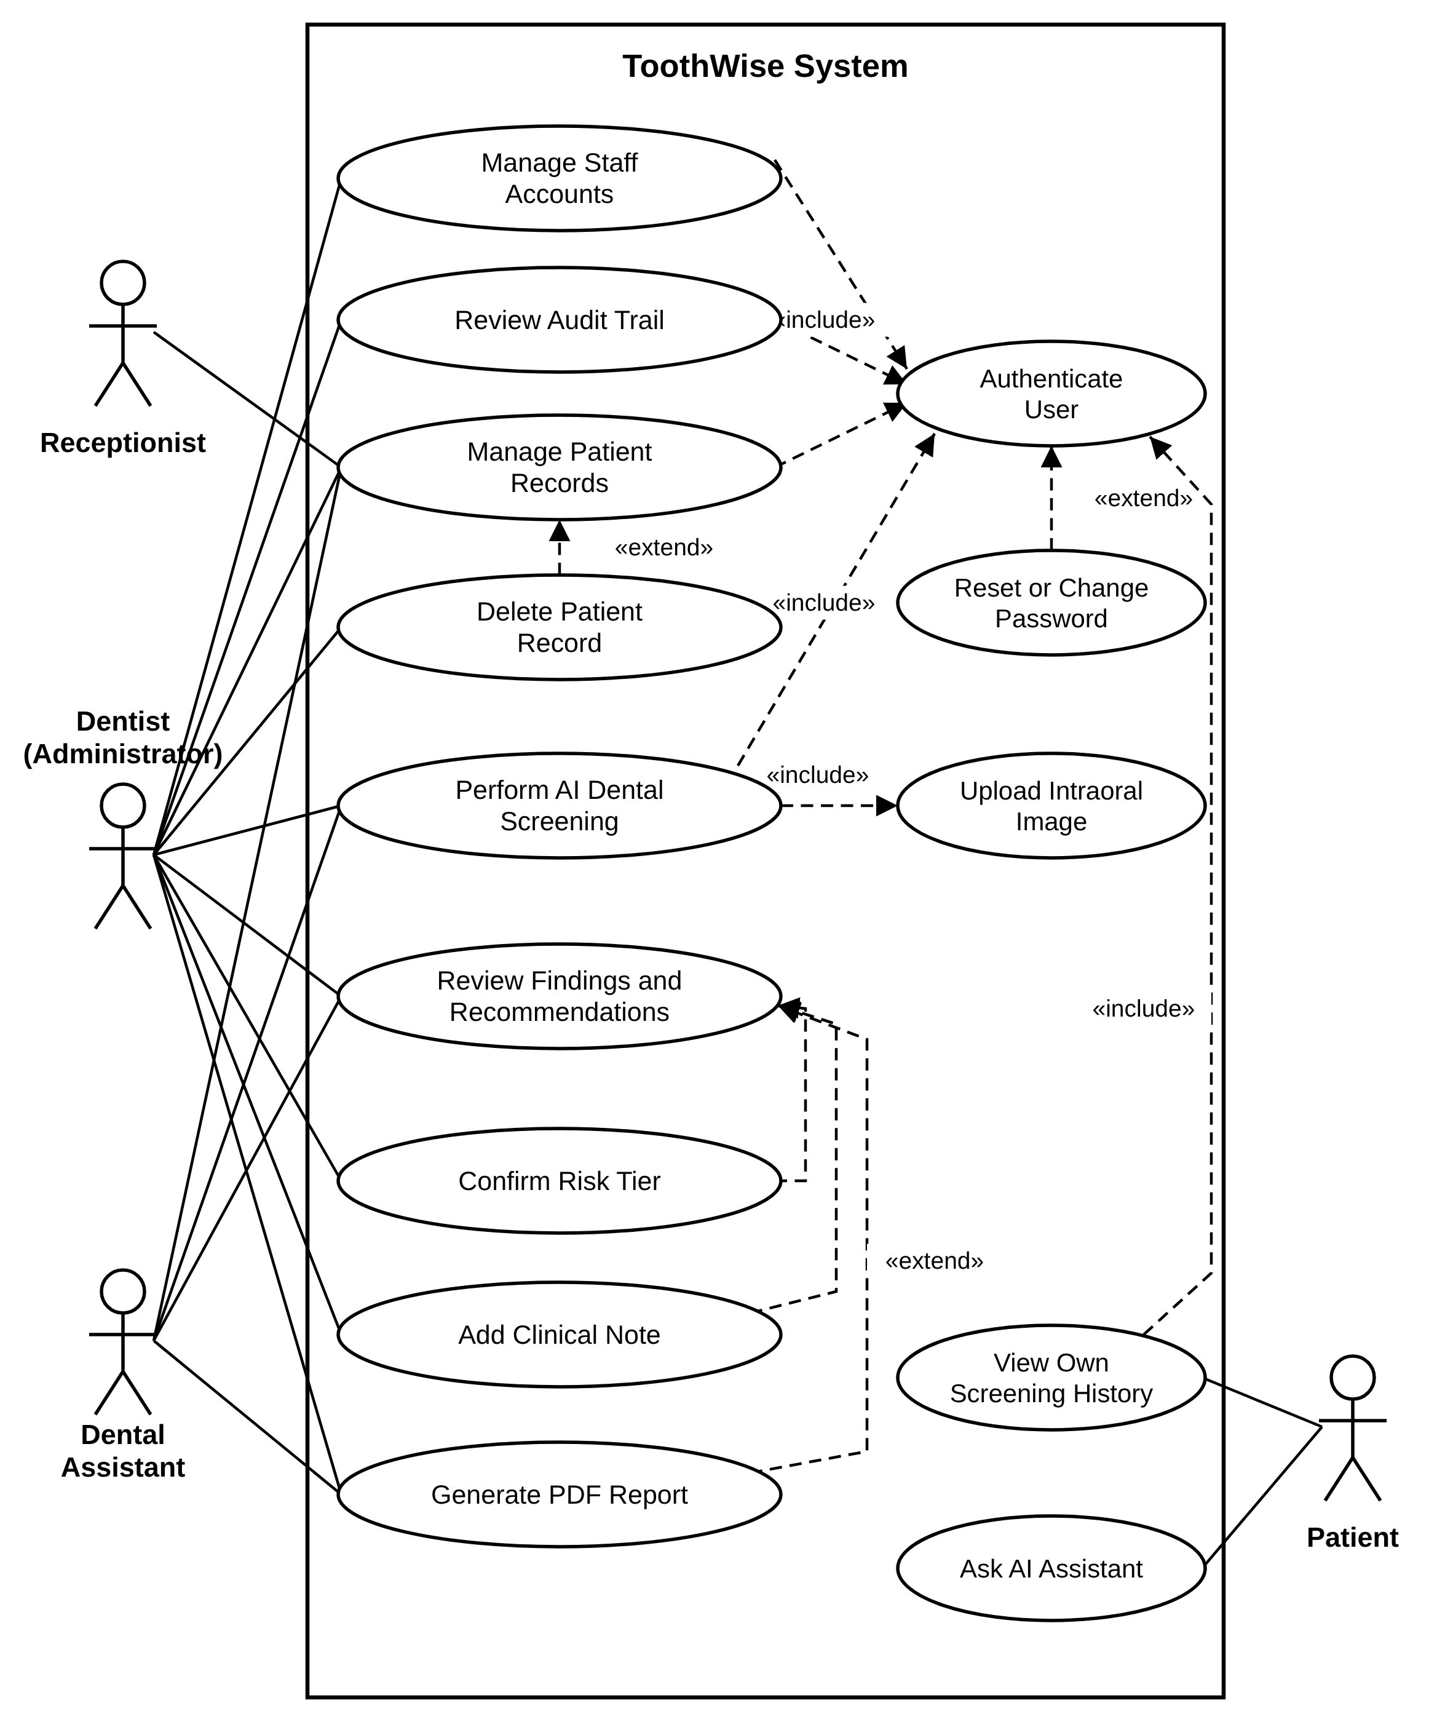
Figure 2 Use Case Diagram.
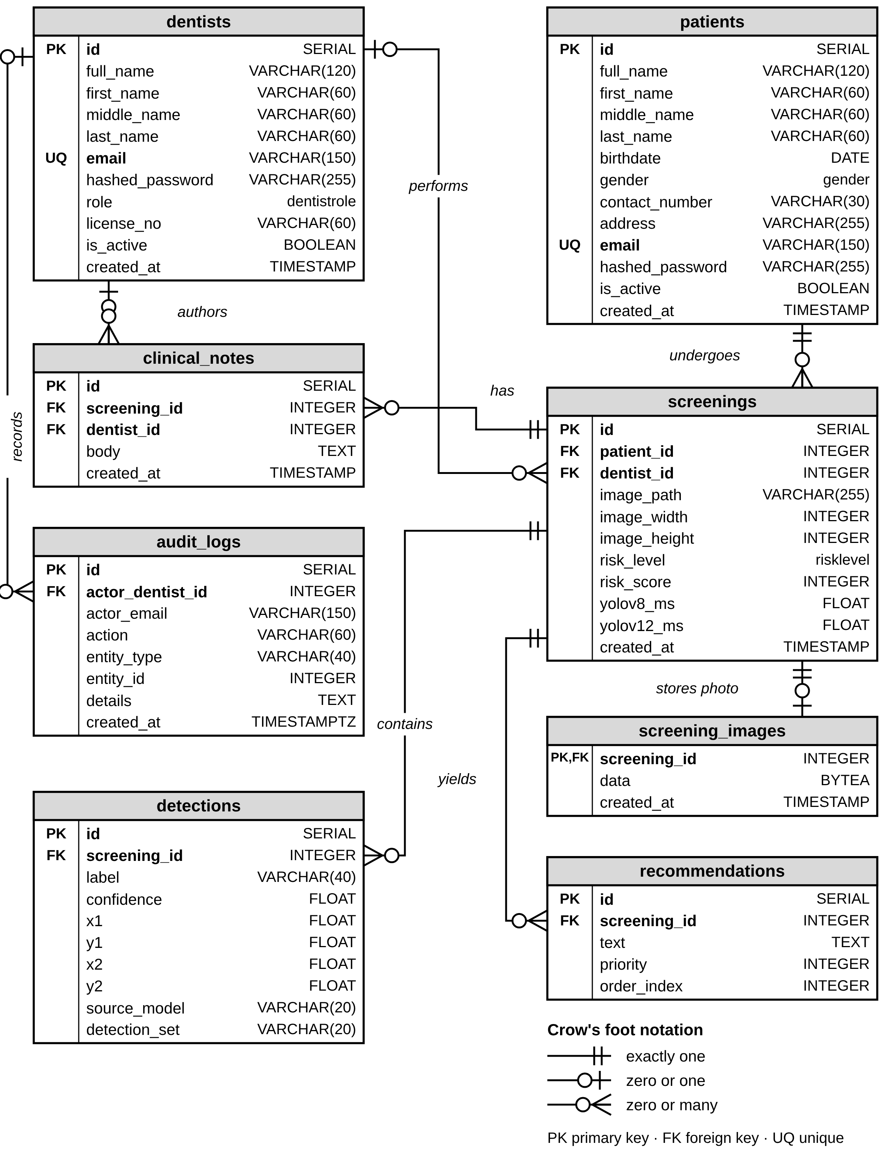
Figure 3 Entity Relationship Diagram (ERD).
Table 5 consolidates the eight entities of the Toothwise database into a single database schema, summarizing each table's primary key, purpose, classification, and relationships to the other entities.
Table 5 Toothwise Database Schema Data Dictionary
Table | Primary Key | Role/ Classification | Purpose | Related Tables
dentists | id | Dimension Table | Stores staff accounts (dentist, receptionist, or assistant) used for login and access control. | screenings, clinical_notes, audit_logs
patients | id | Dimension Table | Stores patient demographic information and, optionally, patient-portal login credentials. | screenings
screenings | id | Fact Table | Central record of one AI-assisted dental image screening event, including risk level and model timing. | patients, dentists, detections, recommendations, clinical_notes, screening_images
screening_images | screening_id | Fact Detail Table | Database copy of a screening photograph, used to restore the image file after the host's disk is cleared. | screenings
detections | id | Fact Detail Table | Stores each bounding-box finding produced by the YOLOv8/YOLOv12 ensemble for a screening (5-label taxonomy). | screenings
recommendations | id | Fact Detail Table | Stores the risk classification and prevention/advice text generated by the KNN recommender for a screening. | screenings
clinical_notes | id | Fact Detail Table | Stores dentist-authored clinical notes attached to a screening. | screenings, dentists
audit_logs | id | System Table | Append-only record of sensitive staff actions, kept for administrative review. | dentists

3.5.3 Data Flow Diagram Level 0
Figure 4 presents the Level 0 (context) Data Flow Diagram of Toothwise, drawn in Gane and Sarson notation. It shows the system as a single process exchanging data with its four external entities – Dentist (Administrator), Receptionist, Dental Assistant, and Patient – verified against the authenticated routes each role can reach.
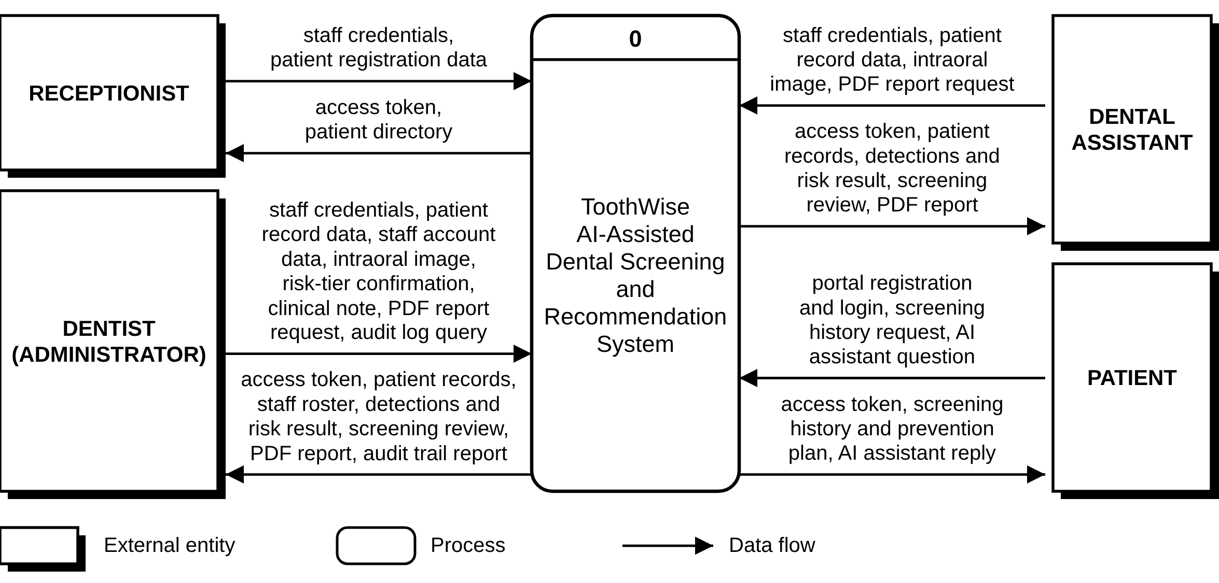
Figure 4 Data Flow Diagram Level 0.

3.5.4 Data Flow Diagram Level 1
Figure 5 decomposes the Toothwise system, in Gane and Sarson notation, into seven major processes: 1.0 Authenticate Users, 2.0 Manage Patient Records, 3.0 Manage Staff Accounts, 4.0 Perform AI Dental Screening (YOLOv8/YOLOv12 detection, risk scoring, and KNN recommendation), 5.0 Review Findings and Generate Report, 6.0 Serve Patient Portal and AI Assistant, and 7.0 Review Audit Trail. So that it remains legible in print, the diagram is drawn on two sheets: Sheet 1 covers processes 1.0, 2.0, 3.0, and 7.0, and Sheet 2 covers processes 4.0, 5.0, and 6.0. Each process is drawn in its own band with its external entities on the left and its data stores on the right, so no data flows cross. The seven data stores, D1 to D7, correspond to the database tables in Figure 3 (D3 Screenings covers both the screenings and screening_images tables), and the external data flows match the Level 0 diagram in Figure 4.
Table 6 describes each Level 1 process, with its main inputs and outputs and the data stores it reads or writes.
Table 6 Level 1 Process Descriptions
Process | Description | Main inputs | Main outputs and data stores
1.0 Authenticate Users | Checks staff and patient credentials and issues a JWT access token for the matching scope (30 days with “Remember me”); registers new patient-portal accounts; emails password reset links and changes passwords. | Credentials; portal registration; reset and change-password requests | Access token; reads D1 and D2, writes new portal accounts to D2 and login events to D7
2.0 Manage Patient Records | Creates, lists, and updates patient records; only the dentist can delete one. | Patient registration and record data | Patient directory and records; D2; record change events to D7
3.0 Manage Staff Accounts | Lets the dentist add, edit, reset, deactivate, and delete staff accounts and assign the dentist, receptionist, or assistant role. | Staff account data | Staff roster; D1; staff change events to D7
4.0 Perform AI Dental Screening | Validates the uploaded photograph, runs YOLOv8 and YOLOv12, fuses their detections, computes the risk score and tier, and builds the KNN prevention plan. | Intraoral image; patient reference from D2 | Detections and risk result; writes D3, D4, and D5; screening event to D7
5.0 Review Findings and Generate Report | Shows the screening for review, records the dentist's tier confirmation and clinical notes, and produces the PDF report. | Tier confirmation, clinical note, report request; D2 to D6 | Screening review and PDF report; confirmed tier to D3; notes to D6; review event to D7
6.0 Serve Patient Portal and AI Assistant | Shows patients only their own screenings, latest results, risk trend, and prevention plans and answers general questions through the AI assistant. | History request, assistant question; D2, D3, D5 | Screening history, prevention plan, assistant reply
7.0 Review Audit Trail | Lets the dentist search and filter the audit log. | Audit log query; D7 | Audit trail report

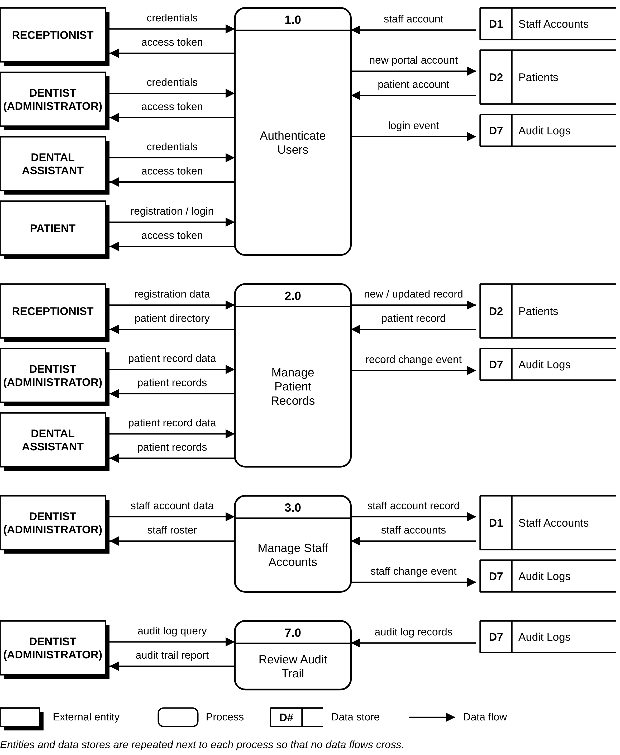
Figure 5 Data Flow Diagram Level 1 (Sheet 1 of 2: Processes 1.0, 2.0, 3.0, and 7.0).
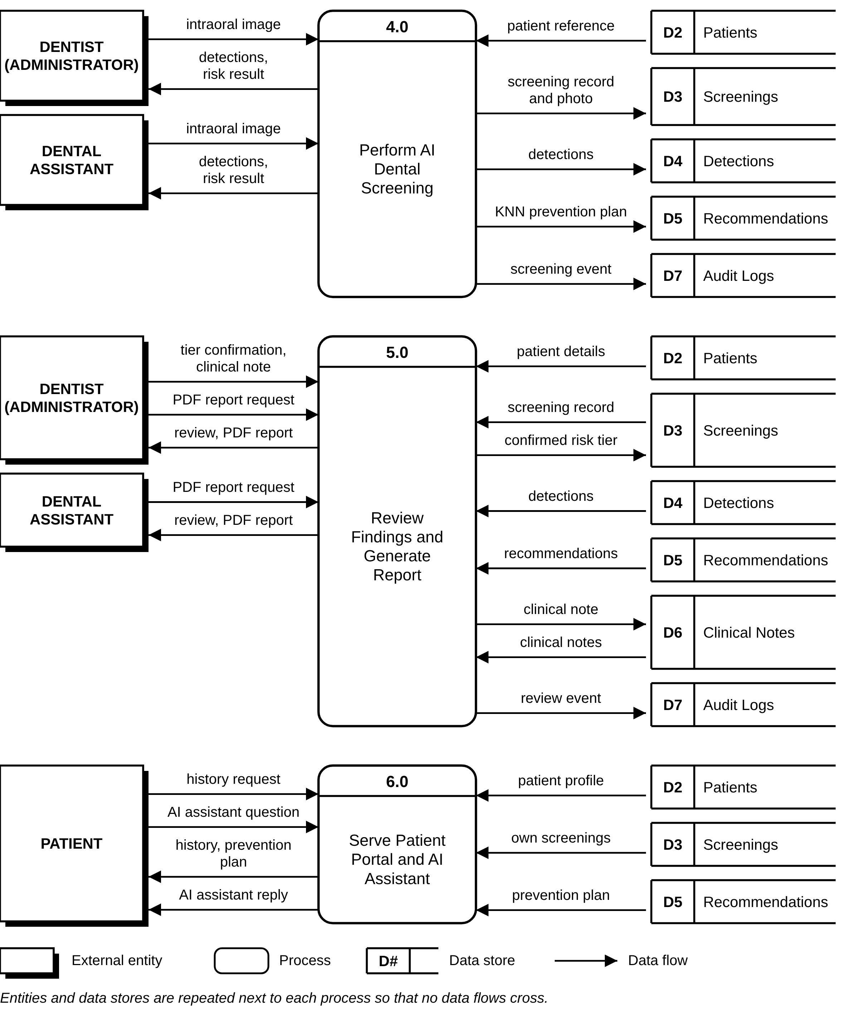
Figure 6 Data Flow Diagram Level 1 (Sheet 2 of 2: Processes 4.0, 5.0, and 6.0).

3.5.5 Gantt Chart
Figure 7 presents the Toothwise development schedule from July 12 to October 30, organized into the five Agile iterations summarized in Table 12. Each bar shows the working period of one task, the black band shows the span of each iteration, and the diamonds mark the 30%, 60%, and 100% system completion milestones that the documentation followed. The final iteration includes the cloud deployment of the system and the move of the deployed models to ONNX Runtime.
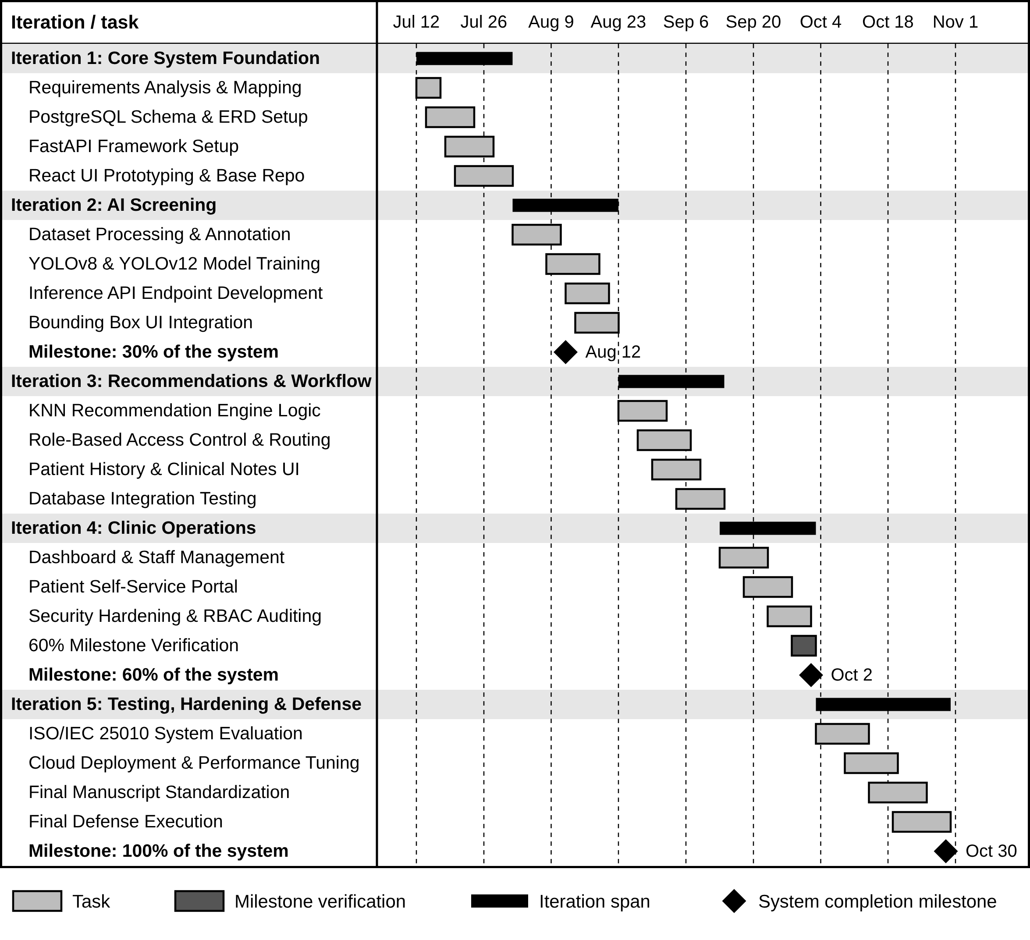
Figure 7 Toothwise Development Gantt Chart.

3.6 Software Specifications
The software requirements of Toothwise cover the programming languages, frameworks, libraries, services, and development tools represented in the current project package, distinguishing development-environment resources (Table 7) from implementation/deployment-environment resources (Table 8).
Table 7 Software Development Requirements
Software | Specification | Description
Operating System | Windows 10 or 11, 64-bit | Primary development environment for the frontend, backend, database administration, and system testing.
Runtime / Backend Language | Python 3.11 | Used for the FastAPI backend, AI inference, KNN-based recommendation engine, database integration, testing, and utility scripts.
Frontend Language | JavaScript (ES6+) | Used to implement the React.js user interface and client-side application logic.
Frontend Framework | React 18.2.0 (Create React App, react-scripts 5.0.1) | Provides the component-based web interface for dentists, administrators, clinic staff, and the patient portal.
Routing | React Router DOM 6.21.1 | Provides client-side routing for login, dashboard, patient records, screening, staff management, audit logs, and the patient portal.
HTTP Client | Axios 1.6.5 | Handles authenticated communication between the React frontend and the FastAPI REST API.
UI Feedback and Icons | React Hot Toast 2.4.1, Lucide React 0.383.0 | Provide success and error notifications and the interface icons.
Image Upload | Browser file input (drag and drop) | Accepts JPEG, PNG, or WebP photographs up to 15 MB; on phones and tablets the same control can open the device camera.
Charting | Recharts 2.10.3 | Renders the patient risk trend and dashboard trend visualizations.
Backend Framework | FastAPI 0.111.0, Uvicorn 0.30.1 | Implements the REST API, request validation, authentication dependencies, routing, health checks, and integration with AI and PostgreSQL.
ORM / Database Driver | SQLAlchemy 2.0.30 and psycopg 3.1.19 | Provide ORM-based database access and PostgreSQL connectivity.
Validation / Configuration | Pydantic 2.7.4 and pydantic-settings 2.3.4 | Validate API payloads and load environment-based configuration.
AI Framework (training) | Ultralytics 8.4.116 with PyTorch | Trains and runs the YOLOv8 and YOLOv12 object-detection models during development.
AI Runtime (deployment) | ONNX Runtime 1.31.0 | Runs the ONNX exports of both models in production, without PyTorch.
Computer Vision | OpenCV 4.10.0.84 (headless), Pillow 10.3.0, NumPy 1.26.4 | Support image processing, validation, letterboxing, and preparation of uploaded still images.
Recommendation / ML | scikit-learn 1.5.0, joblib 1.4.2 | Support the KNN risk classification and recommendation model and persistence of the trained recommender artifact.
Database | PostgreSQL 15 | Stores patient, staff, screening, photo, detection, recommendation, clinical note, and audit-log records.
Authentication / Security | python-jose 3.3.0, bcrypt 4.2.0, SlowAPI 0.1.9 | Provide JWT authentication, password hashing, password reset tokens, and rate limiting.
Email | SMTP (Python smtplib) | Sends password reset links; without an SMTP server the link is written to the server log for testing.
PDF Reporting | ReportLab 4.2.2 | Generates authenticated PDF screening reports.
AI Assistant | Google Gemini API (gemini-3.6-flash) | Answers general dental-care and clinic questions for the public AI assistant.
Testing | pytest 8.2.2, HTTPX 0.27.0 | Support automated and API-level testing of the FastAPI application.
Version Control | Git and GitHub | Used for source-code versioning, collaboration, and project traceability; pushes to the main branch redeploy the hosted system.
IDE | Visual Studio Code | Primary editor for frontend, backend, database, and AI development.
Package Managers | npm and pip | Manage JavaScript and Python project dependencies.

Table 8 Implementation Software Requirements
Software | Specification | Description
Frontend Hosting | Vercel (Hobby plan) | Serves the React production build over HTTPS and runs the /api/chatbot serverless function for the AI assistant.
Backend Hosting | Render free web service, Python 3.11.9, Singapore region | Runs the FastAPI backend with Uvicorn; it is rebuilt automatically after every push and checked through /api/health.
Database Hosting | Neon serverless PostgreSQL (AWS Asia Pacific, Singapore) | Stores persistent clinical and administrative records, including the database copies of screening photos.
Client Platform | Any operating system with a modern web browser | Dentists, clinic staff, and patients access the system without installing a separate application.
Browser | Google Chrome 110+ or Mozilla Firefox 110+ | Supported browser environment for the React.js interface.
Authentication | JWT Bearer tokens | Separates staff and patient access scopes and protects authenticated API routes.
AI Runtime | YOLOv8 + YOLOv12 ensemble on ONNX Runtime (CPU) | Runs both detection models and fuses their outputs. Each model is loaded only while it runs so the service fits in 512 MB; its boxes, labels, and confidences are identical to the PyTorch checkpoints (checked on 22 test images).
Recommendation Runtime | KNN, K = 5 | Classifies the screening into a risk tier used to compose the prevention plan.
Upload Limit | 15 MB; JPEG, PNG, or WebP | Limits the size and type of uploaded screening images before processing.
Photo Storage | Local upload folder plus database copy (STORE_IMAGES_IN_DB) | Keeps screening photos available after the free host restarts and clears its disk.
Alternative Deployment | Docker image (backend/Dockerfile) with PyTorch | For hosts with at least about 1.5 GB of memory, such as a Hugging Face Docker Space or a paid Render plan.
API Documentation | FastAPI Swagger UI / ReDoc | Provides developer-facing documentation for the REST API.

3.7 Hardware Specifications
Table 9 Hardware Development Requirements
Hardware | Specification | Description
Processor | Intel Core i7 or AMD Ryzen 7, 8 cores, 2.5 GHz or above | Recommended for concurrent frontend, backend, image-processing, and model-development workloads.
RAM | 16 GB minimum; 32 GB recommended | Supports model training, dataset preprocessing, database services, and development tools.
GPU | NVIDIA GPU with CUDA support, at least 6 GB VRAM | Recommended for practical YOLO training and accelerated inference during model development (the final models were trained on a Google Colab NVIDIA Tesla T4).
Storage | 512 GB SSD or higher | Stores source code, datasets, model weights, Python environments, PostgreSQL data, and generated artifacts.
Display | 1920 × 1080 or higher | Supports development, image review, detection overlays, and responsive interface testing.
Network | Stable Internet connection, 10 Mbps or higher | Supports dependency installation, dataset access, repository synchronization, and cloud deployment.

Table 10 Implementation Hardware Requirements
Hardware | Specification | Description
Server | Cloud web service (Render free tier): shared CPU, 512 MB RAM | Runs the FastAPI API and the YOLO and KNN inference; measured at about 210 MB of memory at rest and 400 MB at peak during a screening.
Client Workstation | Computer, tablet, or phone with at least 4 GB RAM and a modern browser | Used by dentists, clinic staff, and patients to access the web application.
Device Camera | Smartphone or digital camera capable of capturing still images | Takes the patient's still intraoral photograph, which is then uploaded to the screening page; no specialized intraoral camera hardware is required.
Internet Connection | Broadband or mobile data, 10 Mbps or higher recommended | Connects the clinic's devices to the cloud-hosted frontend, backend, and database.
Uninterruptible Power Supply | 600 VA minimum recommended | Keeps the clinic workstation and router running during short power interruptions.

3.8 System Development
Toothwise was developed iteratively, following the six development phases in Table 11, applied repeatedly across the five documented iterations in Table 12 rather than as a single sequential build.
Table 11 Development Phase Activities
Phase | Activities
1. Planning and Requirements | Define the clinic workflow, user roles, screening objectives, AI detection needs, risk assessment, recommendation output, patient portal functions, security requirements, and reporting needs.
2. System Analysis | Translate the requirements into frontend routes, FastAPI endpoints, database entities, AI modules, authentication dependencies, and data flows.
3. System Design | Design the three-layer architecture, relational schema, JWT authentication model, detection-set structure, risk classification and recommendation flow, patient ownership checks, and cloud deployment.
4. Development | Implement React pages and API services, FastAPI routers and schemas, SQLAlchemy models, PostgreSQL schema, YOLO detector integration, KNN risk classifier and recommender, reports, audit logs, and patient portal.
5. Integration and Testing | Reconcile frontend requests with the actual backend contract, validate database enum labels and image paths, smoke-test API workflows, test security controls, and verify the frontend build.
6. Deployment and Maintenance | Prepare the Neon PostgreSQL database, the Render backend service (which rebuilds the ONNX models from the repository at build time), the Vercel frontend build, environment secrets, database copies of screening photos, backups, and health monitoring. Continue maintenance through versioned changes, automatic redeploys on each push, and database migration scripts.

Table 12 Agile Iteration Summary
Iteration / Focus | Major Activities | Output
Iteration 1 – Core System Foundation | Initial React.js frontend, FastAPI backend, PostgreSQL schema, authentication, and core patient/dentist structures. | Working application foundation and authenticated API.
Iteration 2 – AI Screening | Integration of still-image upload, YOLO detection workflow, detection storage, risk scoring, and screening results. | End-to-end dental screening workflow.
Iteration 3 – Recommendations and Clinical Workflow | KNN risk classification and recommendation logic, prevention plans, clinical notes, screening details, and PDF reporting. | Expanded clinical screening and recommendation workflow.
Iteration 4 – Clinic Operations | Dashboard functions, staff management, audit logs, and patient portal features. | Broader clinic and patient workflows.
Iteration 5 – Testing, Hardening, and Deployment | API contract reconciliation, database and enum corrections, image access controls, rate limiting, validation, security headers, frontend integration fixes, cloud deployment on Vercel, Render, and Neon, ONNX Runtime inference, and database copies of screening photos. | Hardened, verified, and deployed system.

Each iteration in Table 12 was carried through the full cycle shown earlier in Figure 1: the corresponding requirements were planned and analyzed, the affected parts of the system were designed, the frontend and backend components were developed and integrated, the iteration's features were tested, the result was evaluated against the intended requirement, and any issue found was corrected before the next iteration began. The Gantt chart in Figure 7 visualizes this same sequence.
The system was implemented as a three-tier web application: a React.js single-page frontend, a FastAPI REST backend exposing versioned JSON endpoints, and a PostgreSQL relational database. The AI detection pipeline (YOLOv8 and YOLOv12) and the KNN-based risk classification and recommendation engine were developed as backend modules invoked synchronously by the screening endpoint. Each tier is deployed on its own free cloud service: the frontend on Vercel, the backend on Render, and the database on Neon. The complete technical specification of this architecture is presented in Section 4.2.

3.9 System Testing
Toothwise was tested through functional, integration, and security testing conducted against the running backend using FastAPI's TestClient, in an automated suite of 117 test cases (Section 4.2.5), supplemented by manual and code-review verification for checks that are not easily exercised through an automated client alone.
To confirm that Toothwise satisfies its intended functional requirements, a systematic software testing phase was conducted. This process evaluated module-level correctness, system-wide component interaction, and user acceptance, while specifically validating the accuracy of the YOLOv8/YOLOv12 detection pipeline and the KNN risk classification and recommendation engine in producing appropriate detections, risk classifications, and prevention plans based on patient screening data.
The system was evaluated using three structured testing tiers: Unit Testing (utilizing a white-box approach), Integration Testing (utilizing a gray-box approach), and User Acceptance Testing (utilizing a black-box approach). Structured test case matrices recorded the function under test, input parameters, expected behavior, actual results, and overall pass/fail status.

3.10 Full Current System Screenshots
This section documents the current Toothwise system as implemented, one screen per numbered figure, in the order a user would encounter them: the public landing page, the staff and patient sign-in pages, password recovery and change, the dashboard, patient management, the screening workflow and results, staff management, the audit log, the rest of the patient portal, and the PDF screening report. The screenshots were captured from a running instance of the current system in light mode, using demonstration accounts, demonstration patients, and sample intraoral photographs taken from CodiSmile Dental Clinic's own published before-and-after images; no patient records are shown.
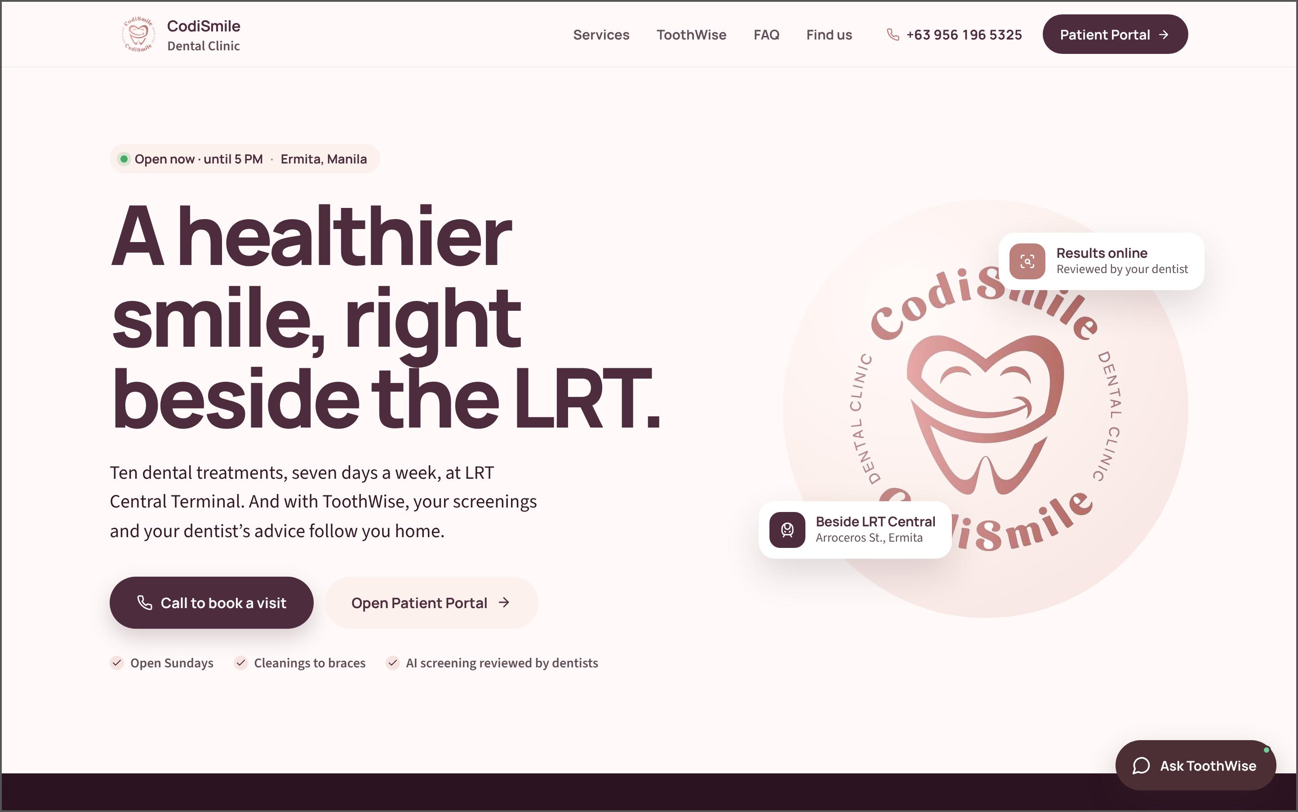
Figure 8 Public Landing Page. This is the first page guests see. It introduces CodiSmile Dental Clinic and ToothWise, gives the clinic's location and opening hours, links to the patient portal, and opens the AI assistant.

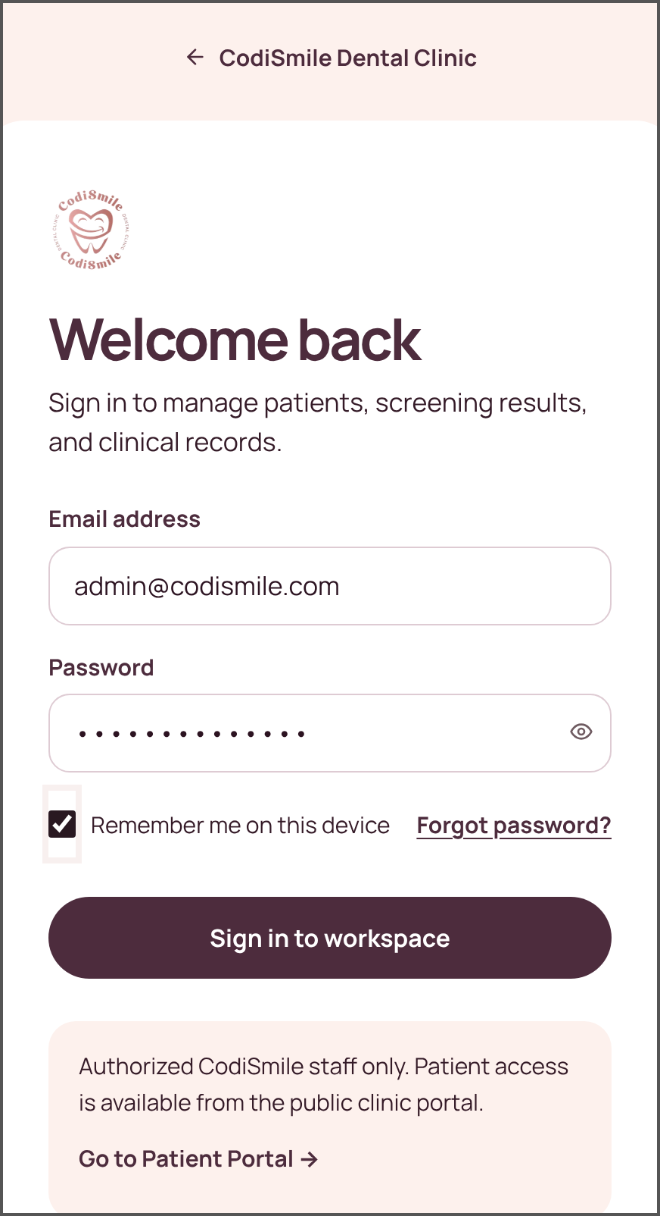 | 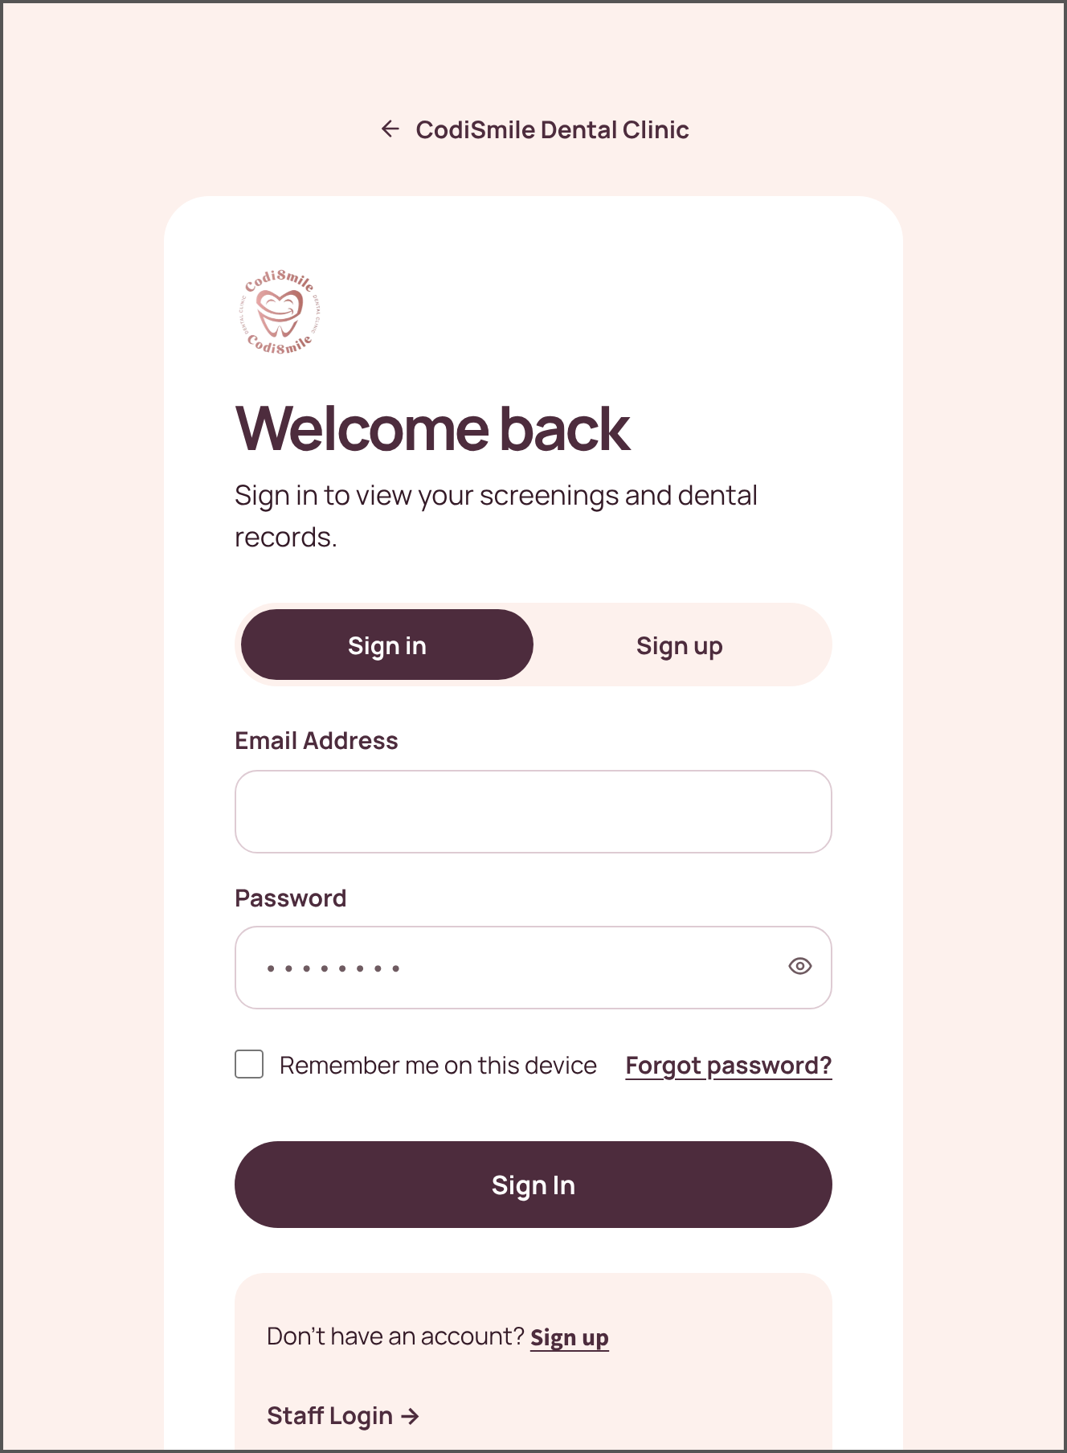 | 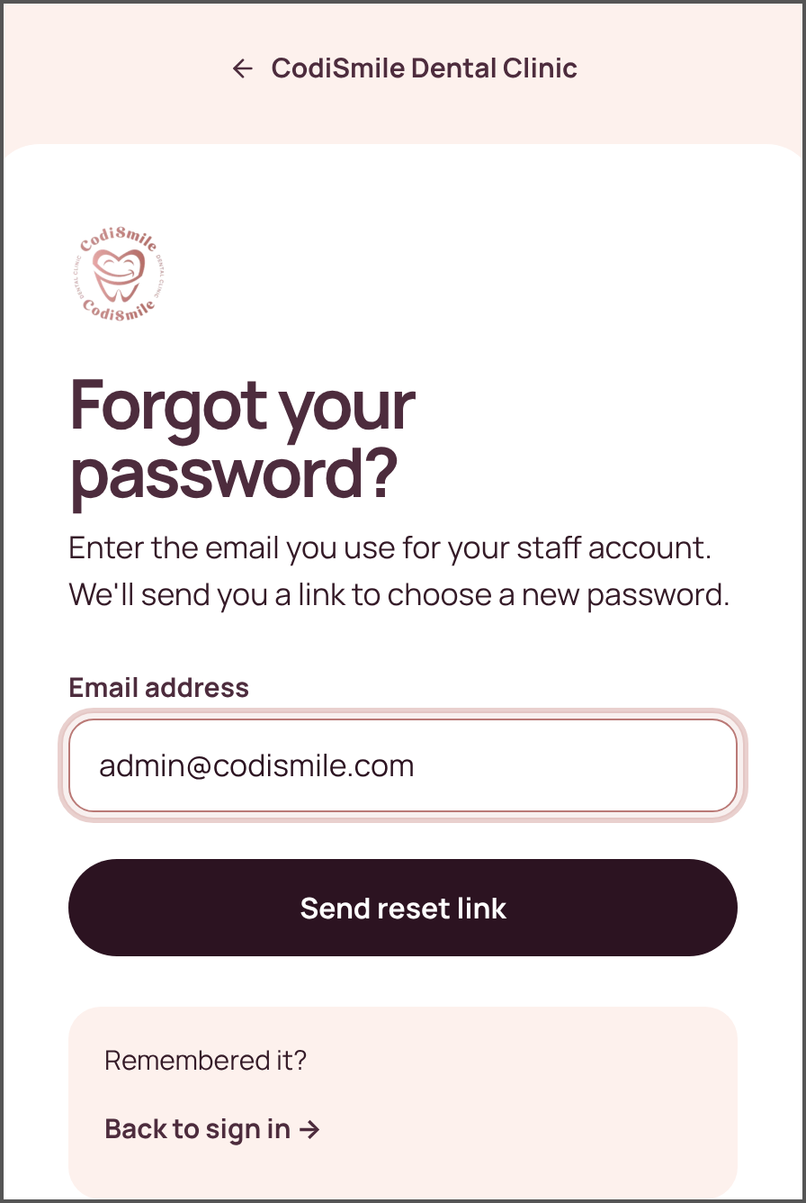
Figure 9 Staff Login Page. Staff sign-in with “Remember me on this device” (30 days). | Figure 10 Patient Portal — Sign In. Patients sign in to see only their own records. | Figure 11 Forgot Password. Users enter their email to receive a reset link.

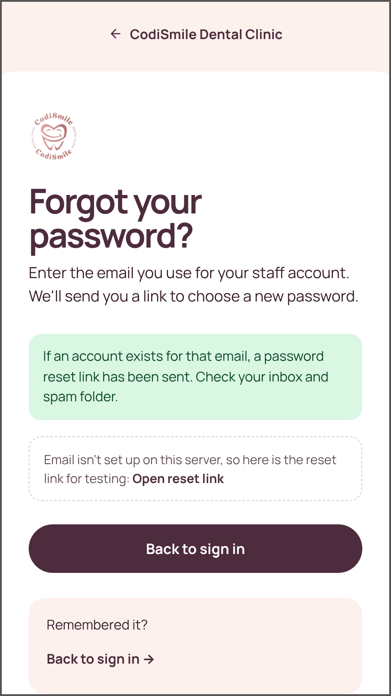 | 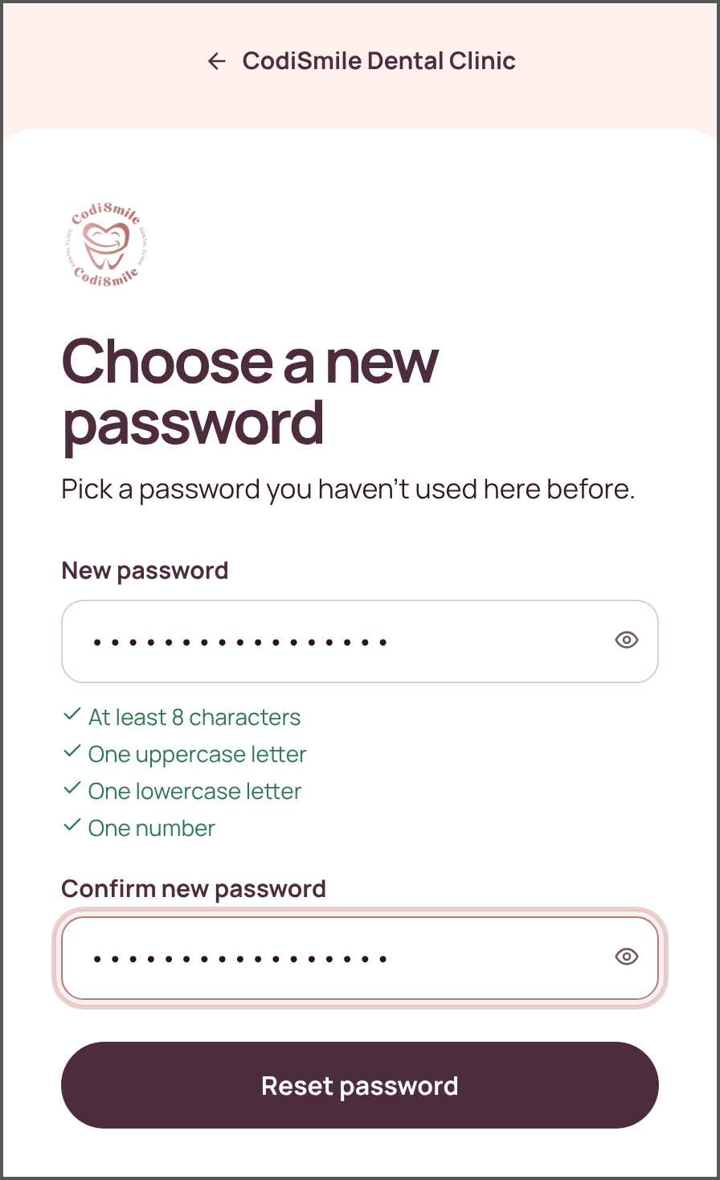 | 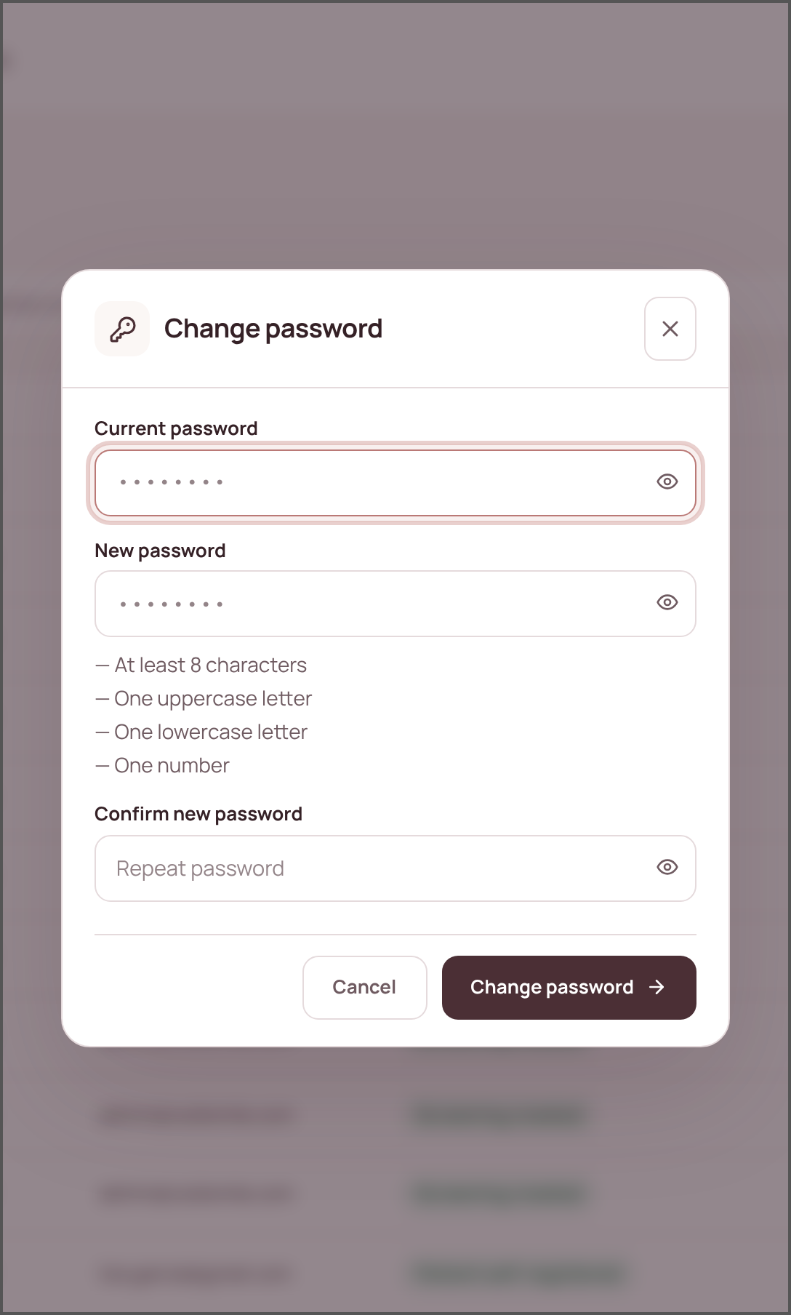
Figure 12 Reset Link Sent. The same message appears whether or not the email is registered. | Figure 13 Choose a New Password. The emailed link opens this page; a checklist shows the password rules. | Figure 14 Change Password. Opened from the sidebar or portal header; needs the current password.

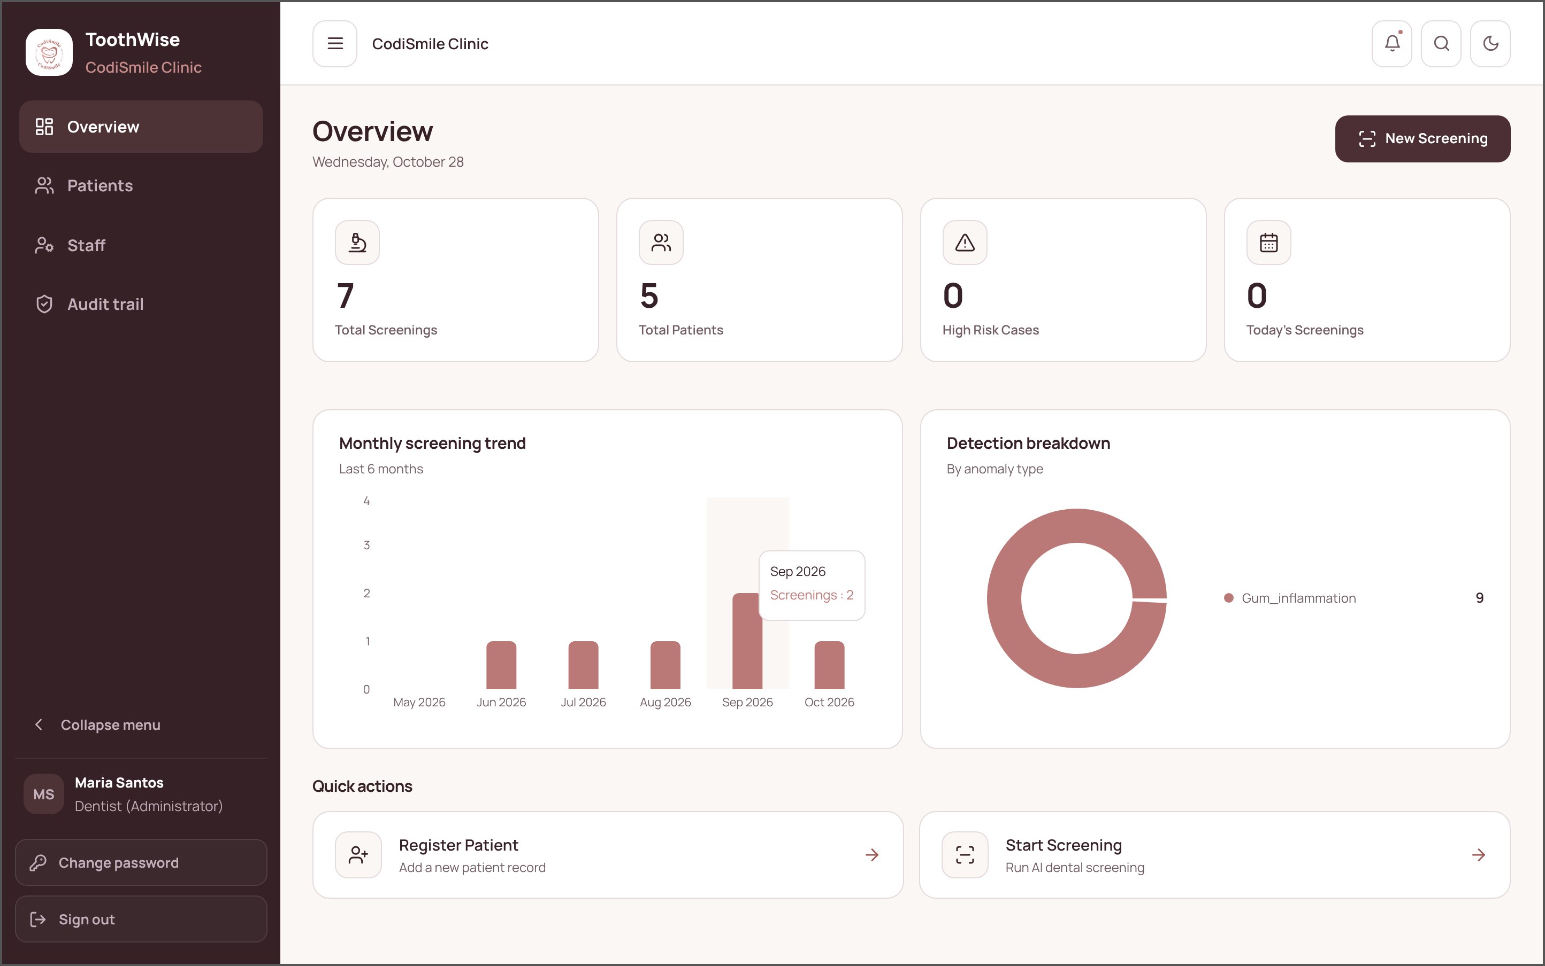
Figure 15 Dashboard. The first screen staff see after signing in. It summarizes total screenings, patients, high-risk cases, and today's screenings, and shows the monthly screening trend and the breakdown of detected conditions.

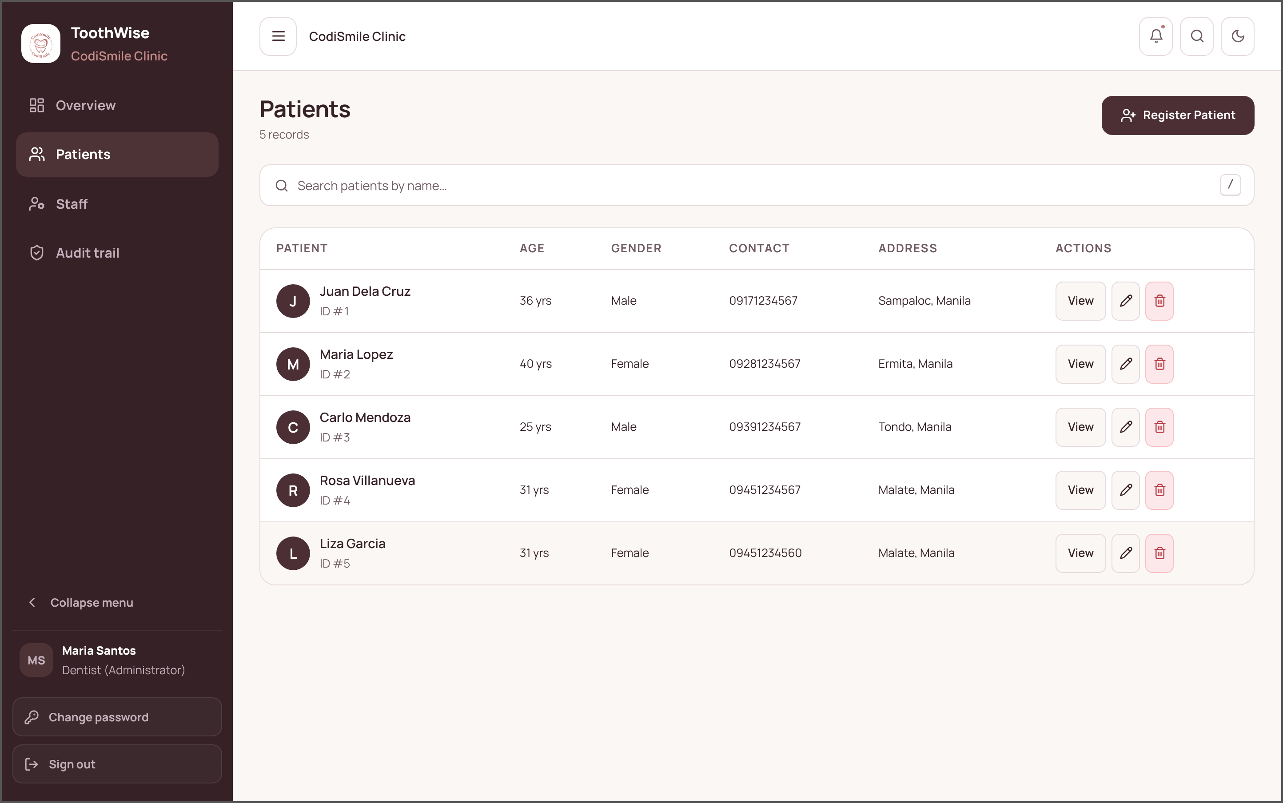
Figure 16 Patient List. Lists every registered patient with age, gender, contact number, and address. Staff can search, register a patient, open a record, edit it, or (as dentist) delete it.
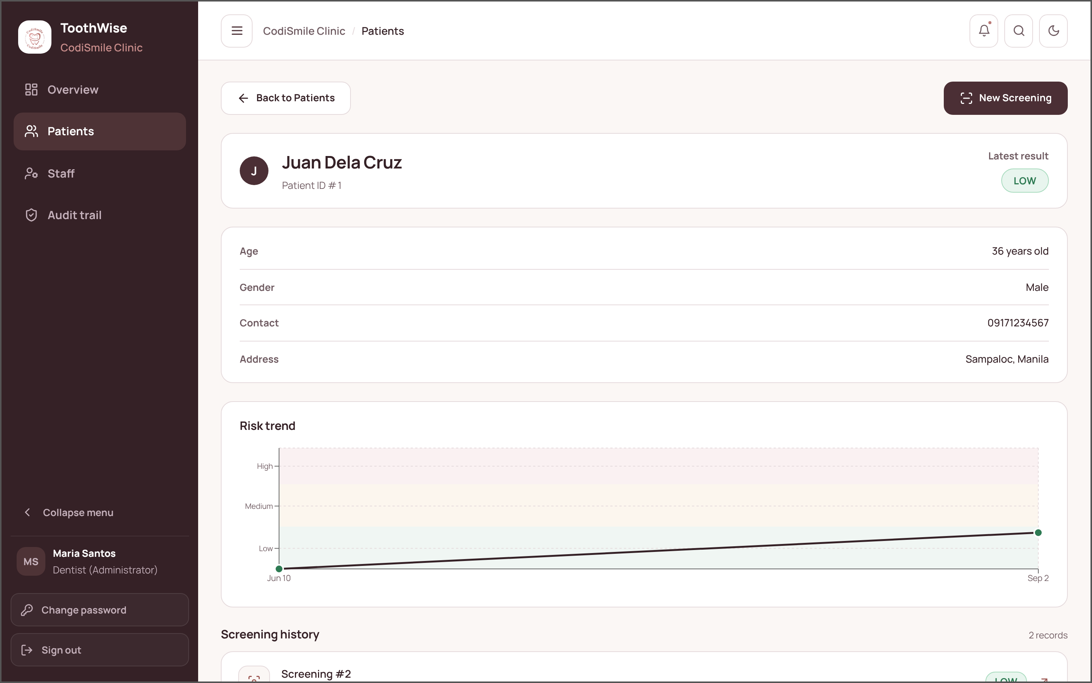
Figure 17 Patient Details. The record of one patient: demographic details, the latest risk result, the risk trend across visits, and the screening history.

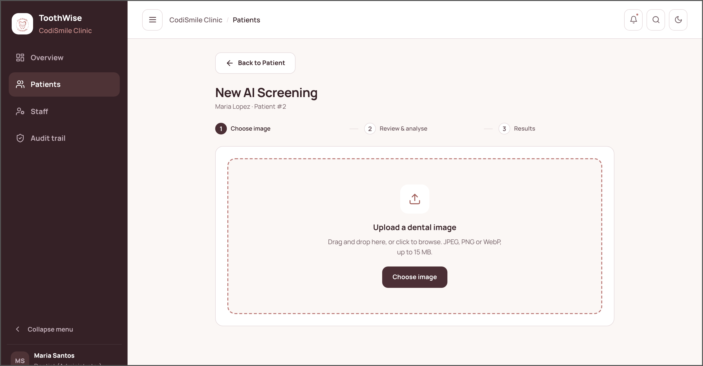
Figure 18 New Screening (Step 1: Choose Image). Staff drag and drop or browse for the patient's intraoral photograph (JPEG, PNG, or WebP, up to 15 MB).
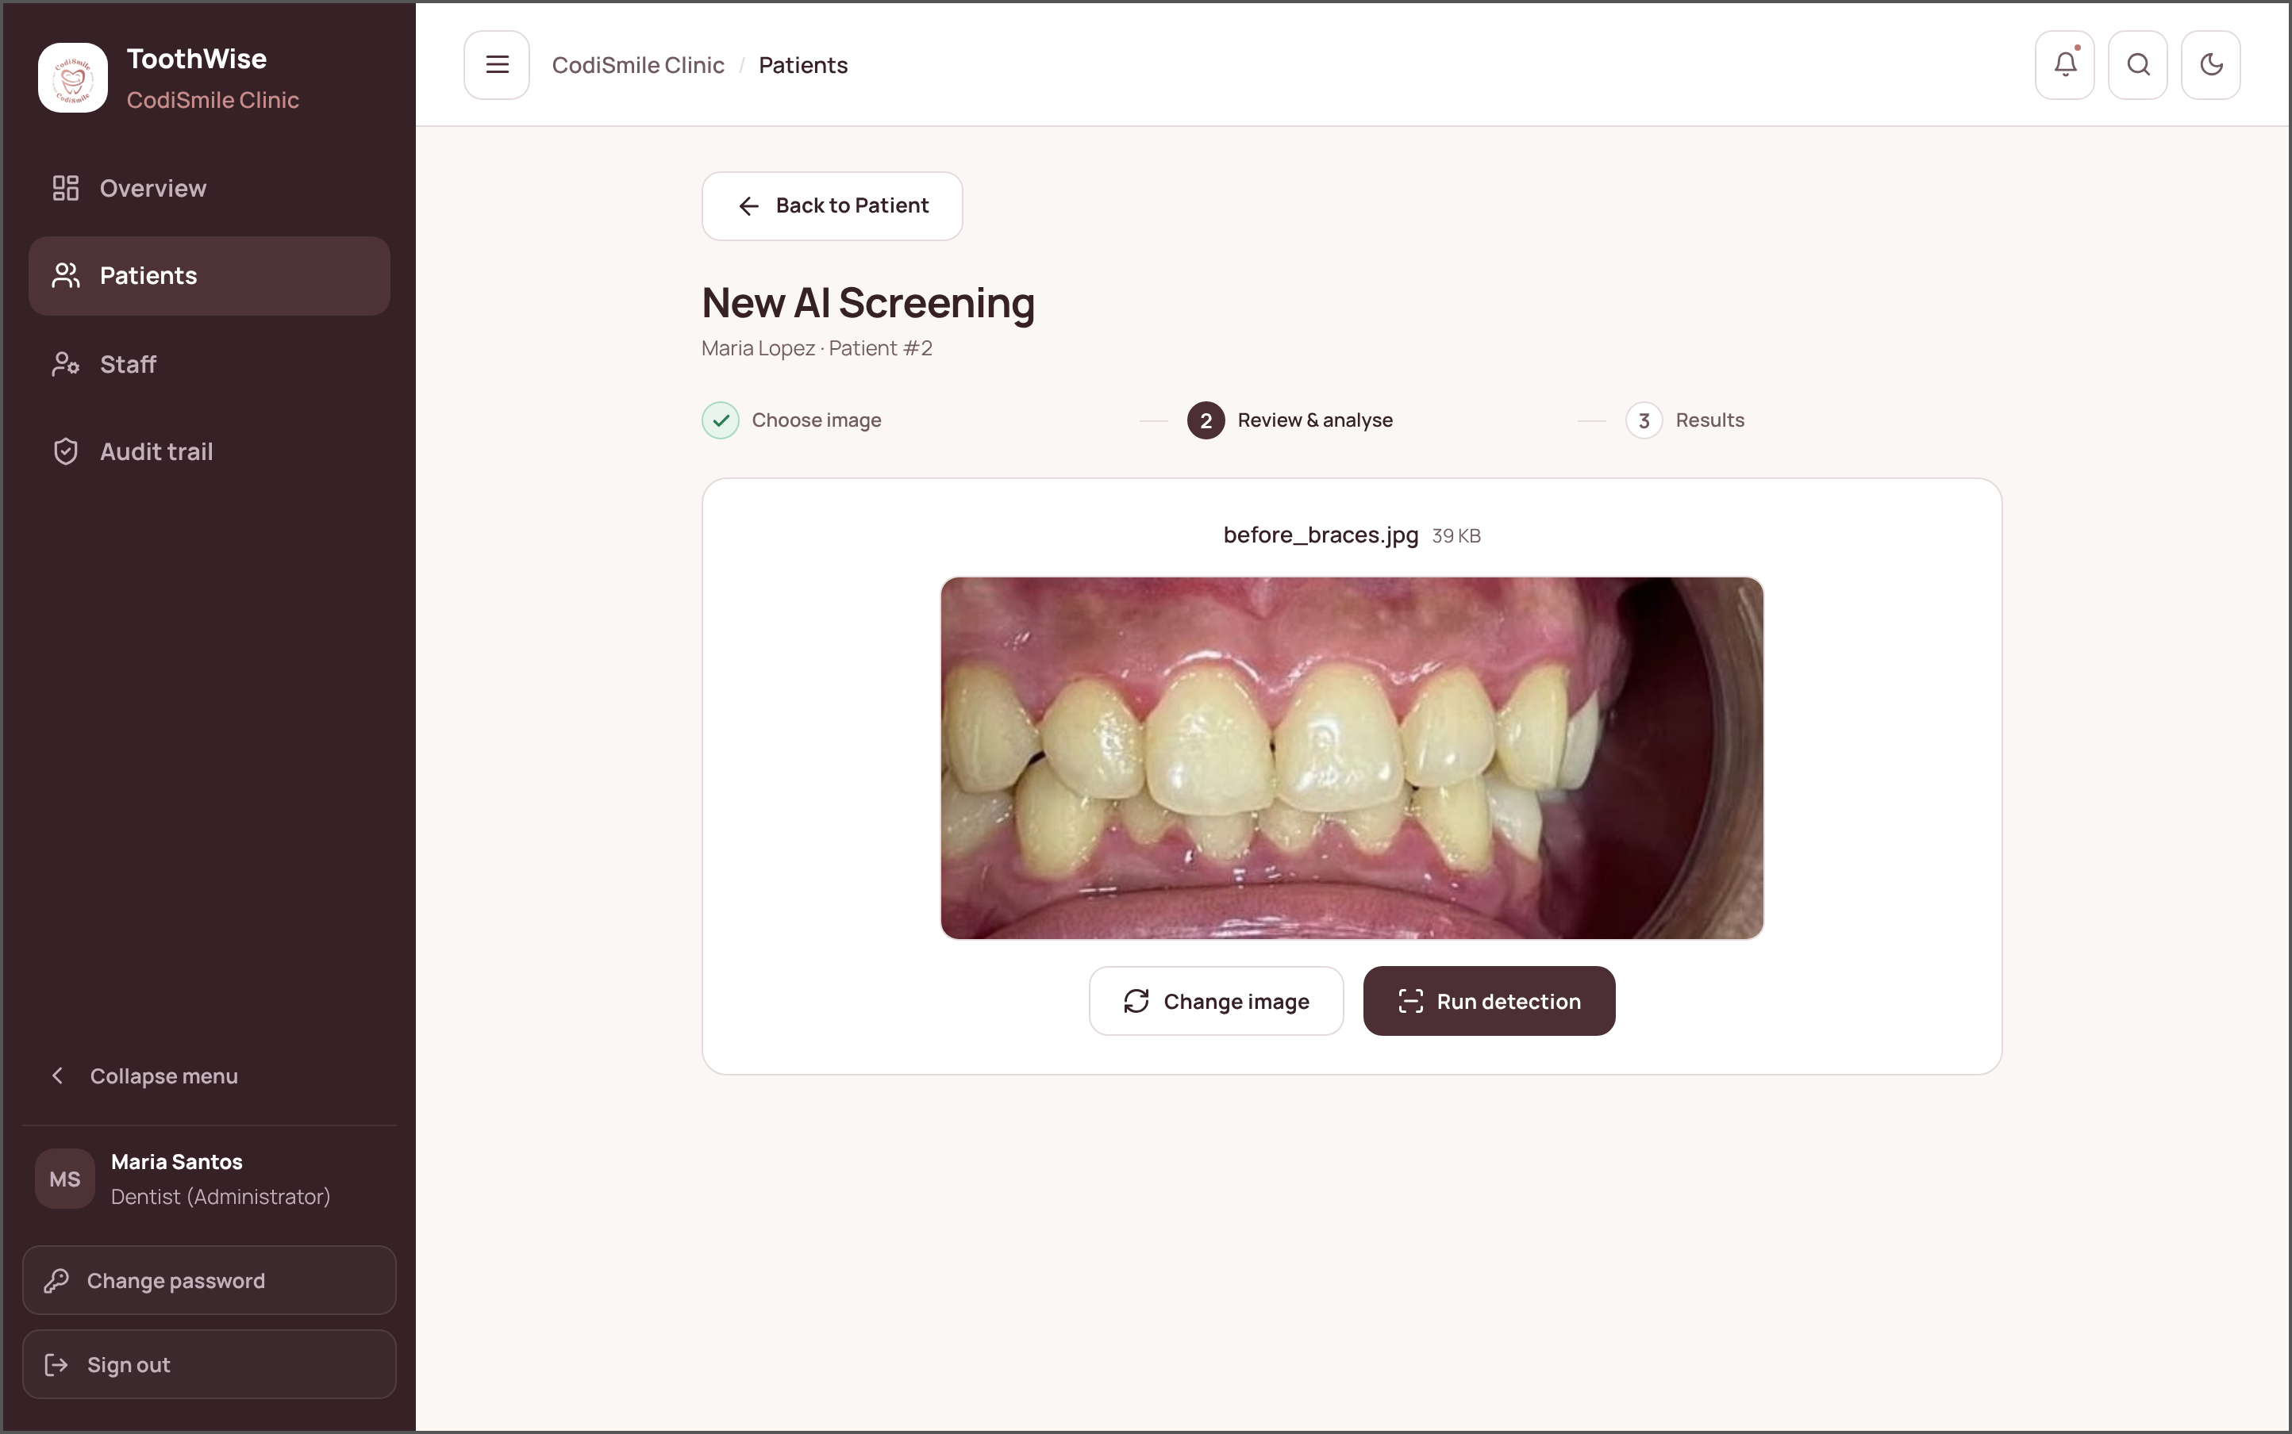
Figure 19 New Screening (Step 2: Review and Analyse). The selected photograph is shown for checking before the YOLOv8 and YOLOv12 ensemble is run.

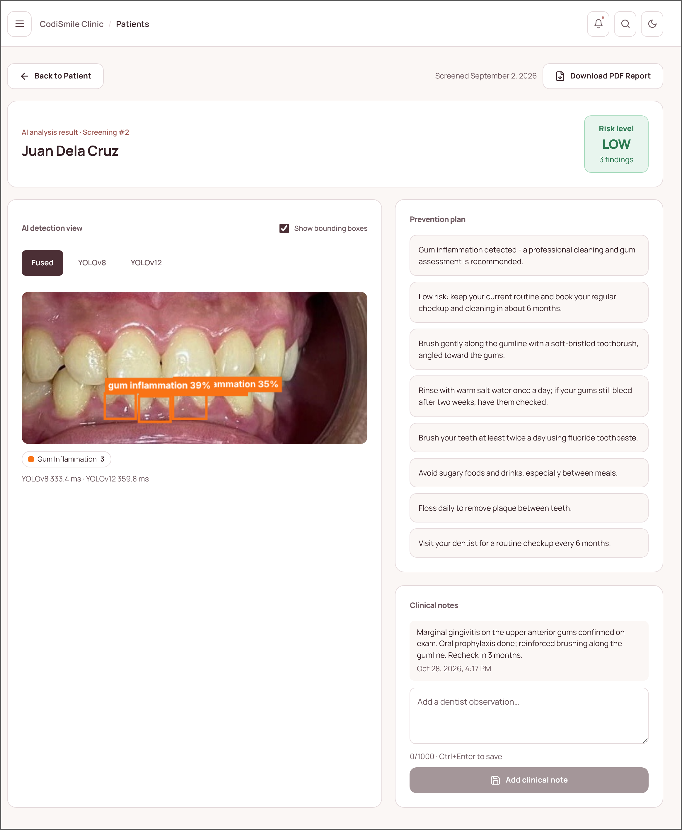
Figure 20 Screening Results. The analysis of the uploaded photograph: color-coded bounding boxes for the fused, YOLOv8, and YOLOv12 detections (here, gum inflammation), the risk level, the prevention plan, the dentist's clinical notes, and the button that downloads the PDF report.
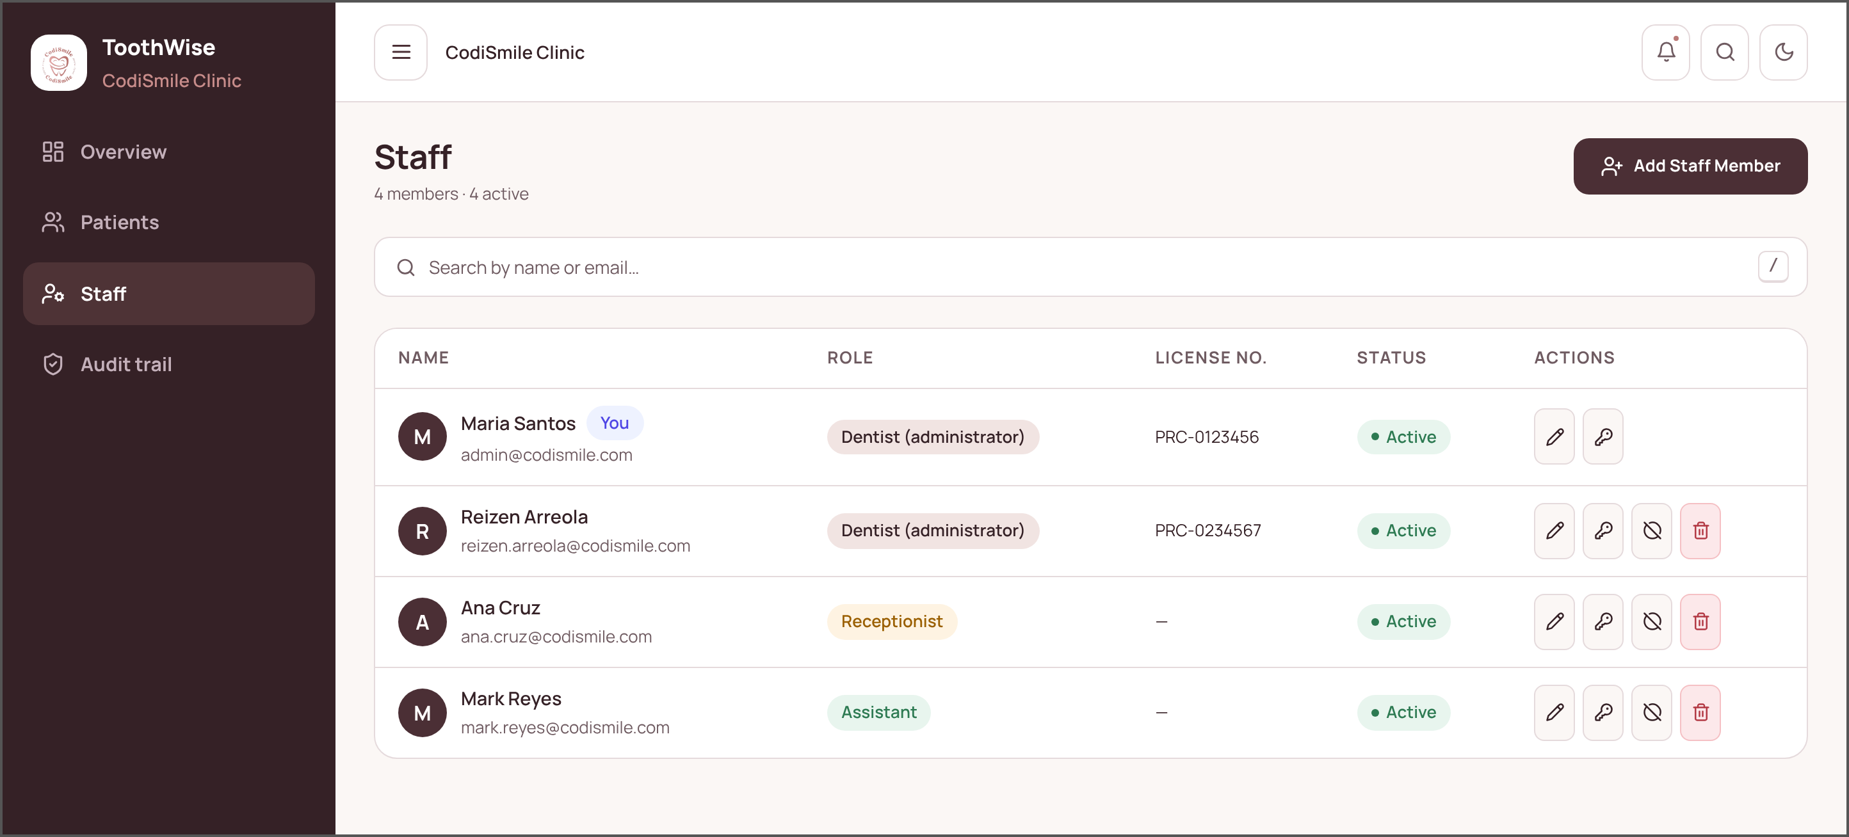
Figure 21 Staff Management (Dentist/Administrator). Lets the dentist add staff members, assign the dentist, receptionist, or assistant role, edit details, reset passwords, and deactivate or delete accounts.

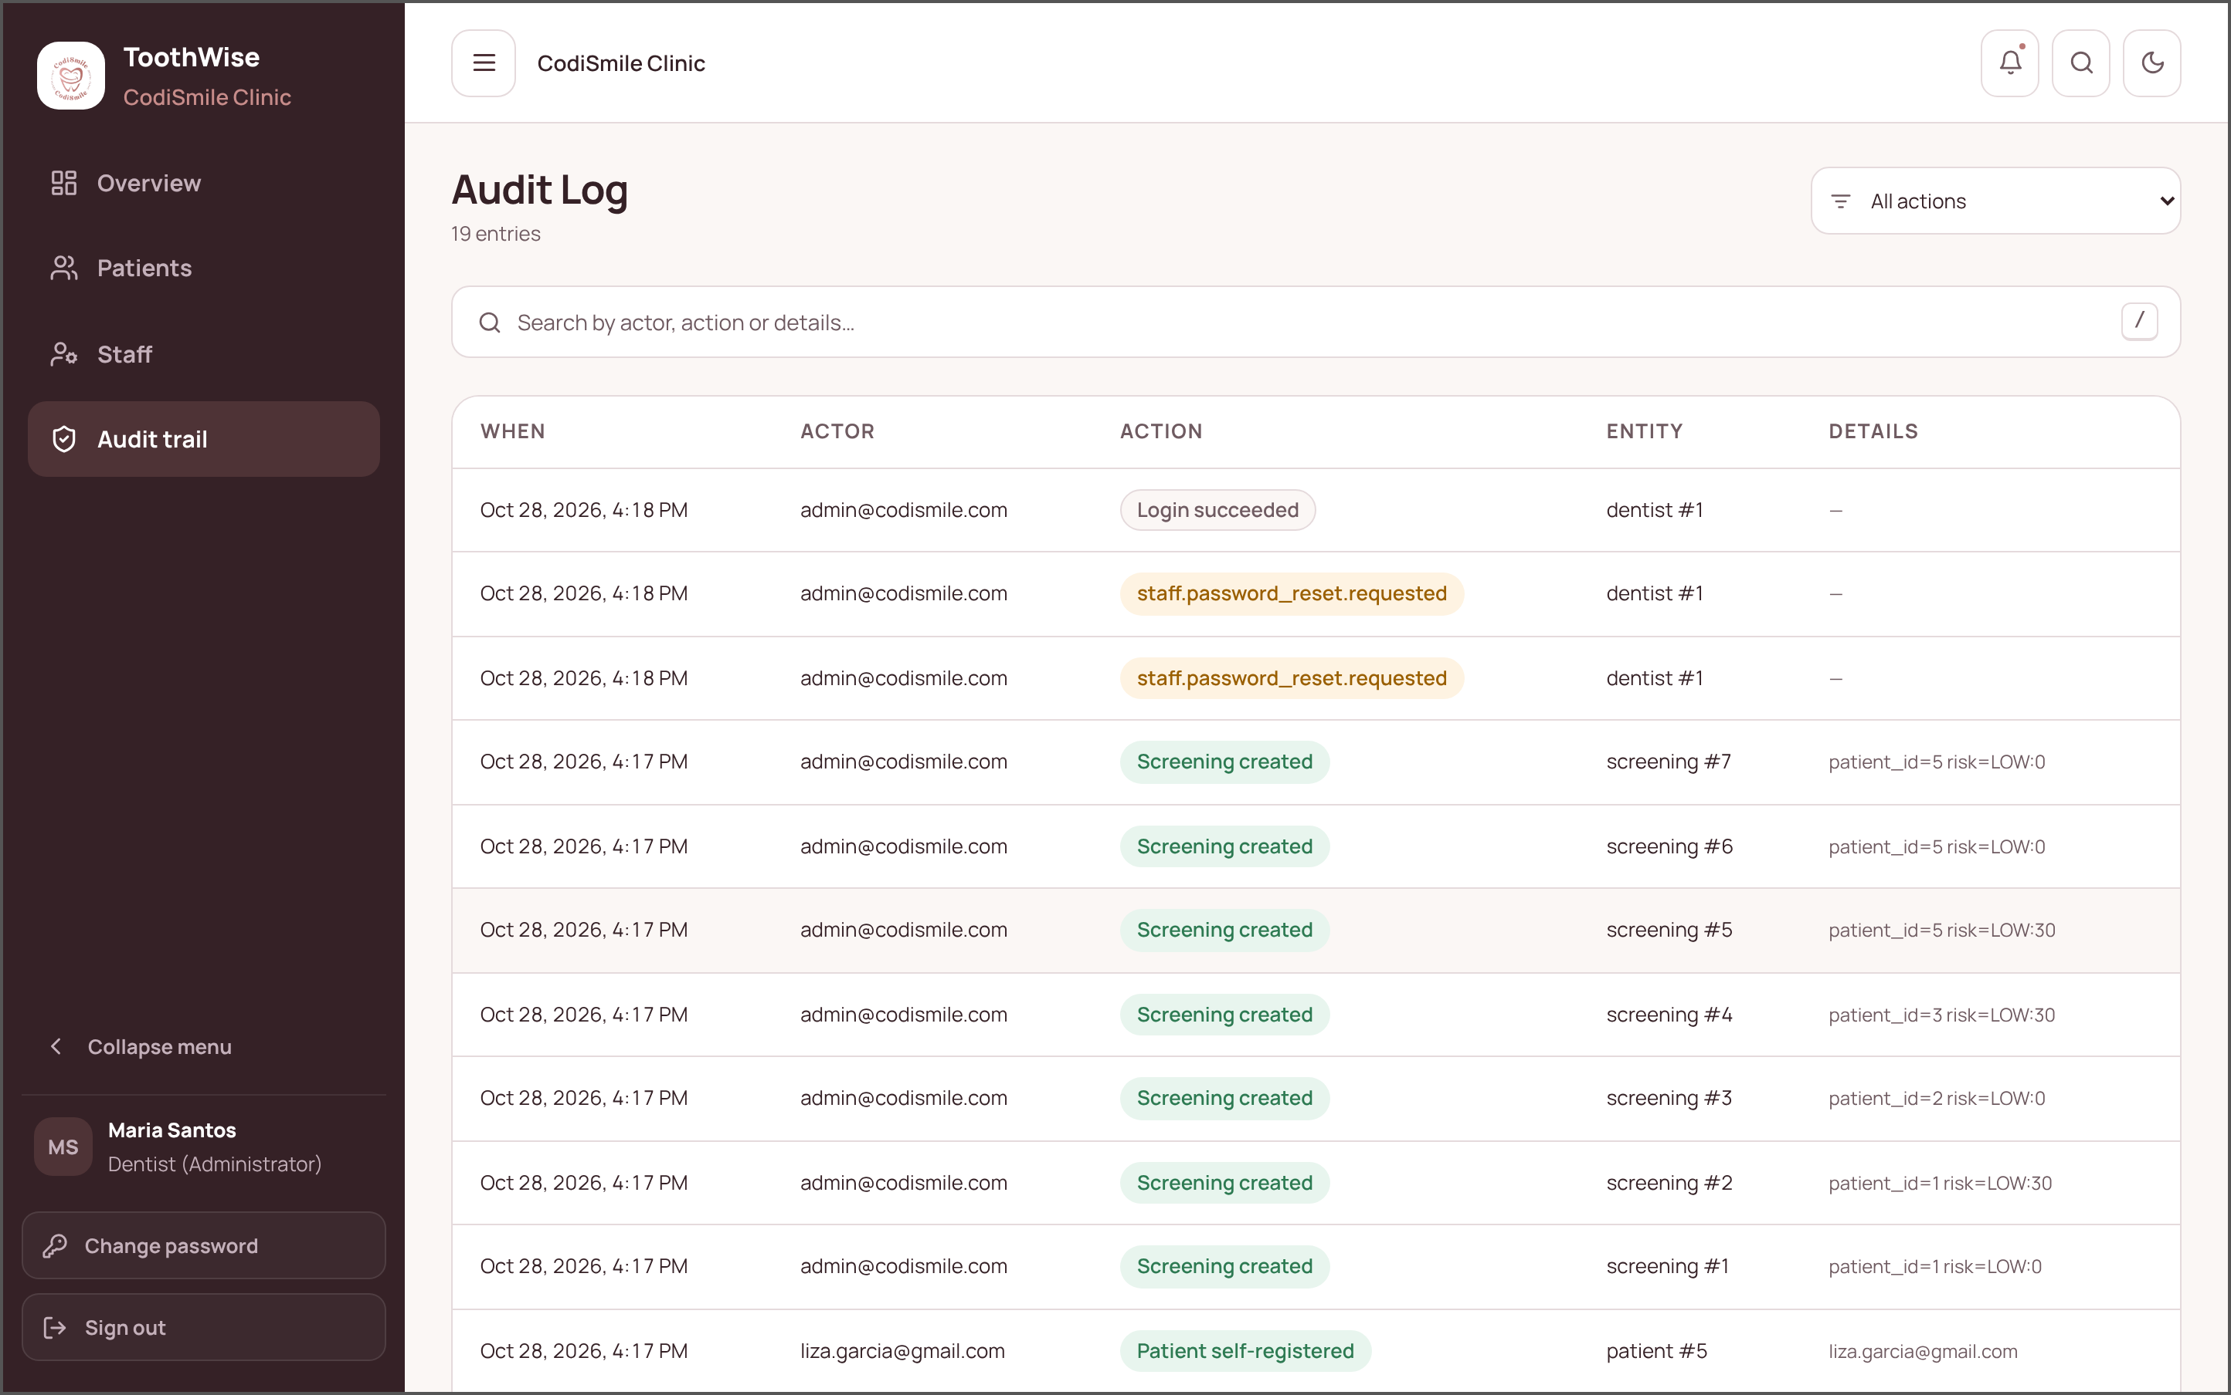
Figure 22 Audit Log (Dentist/Administrator). A permanent, filterable timeline of who signed in, requested a password reset, and created, changed, or deleted records, and when.
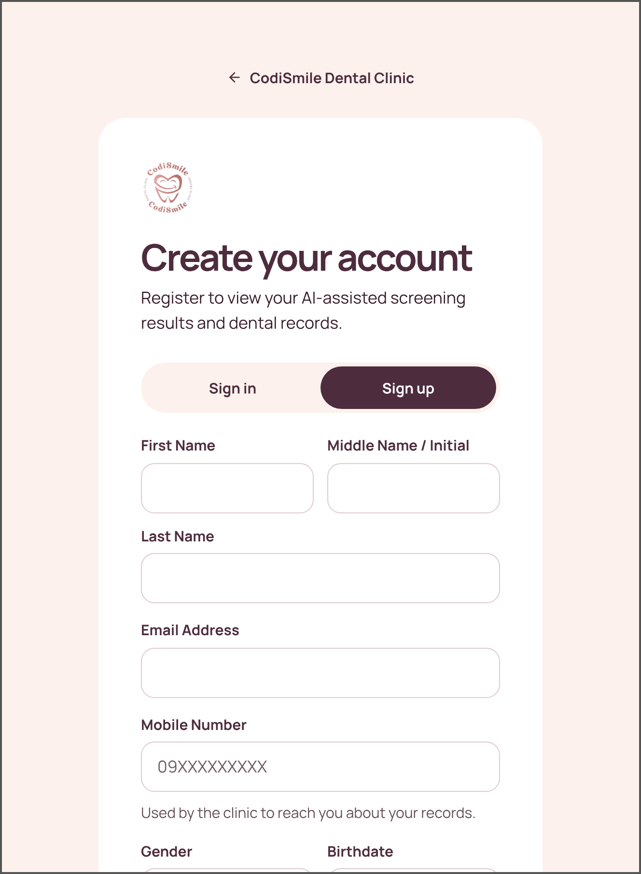 | 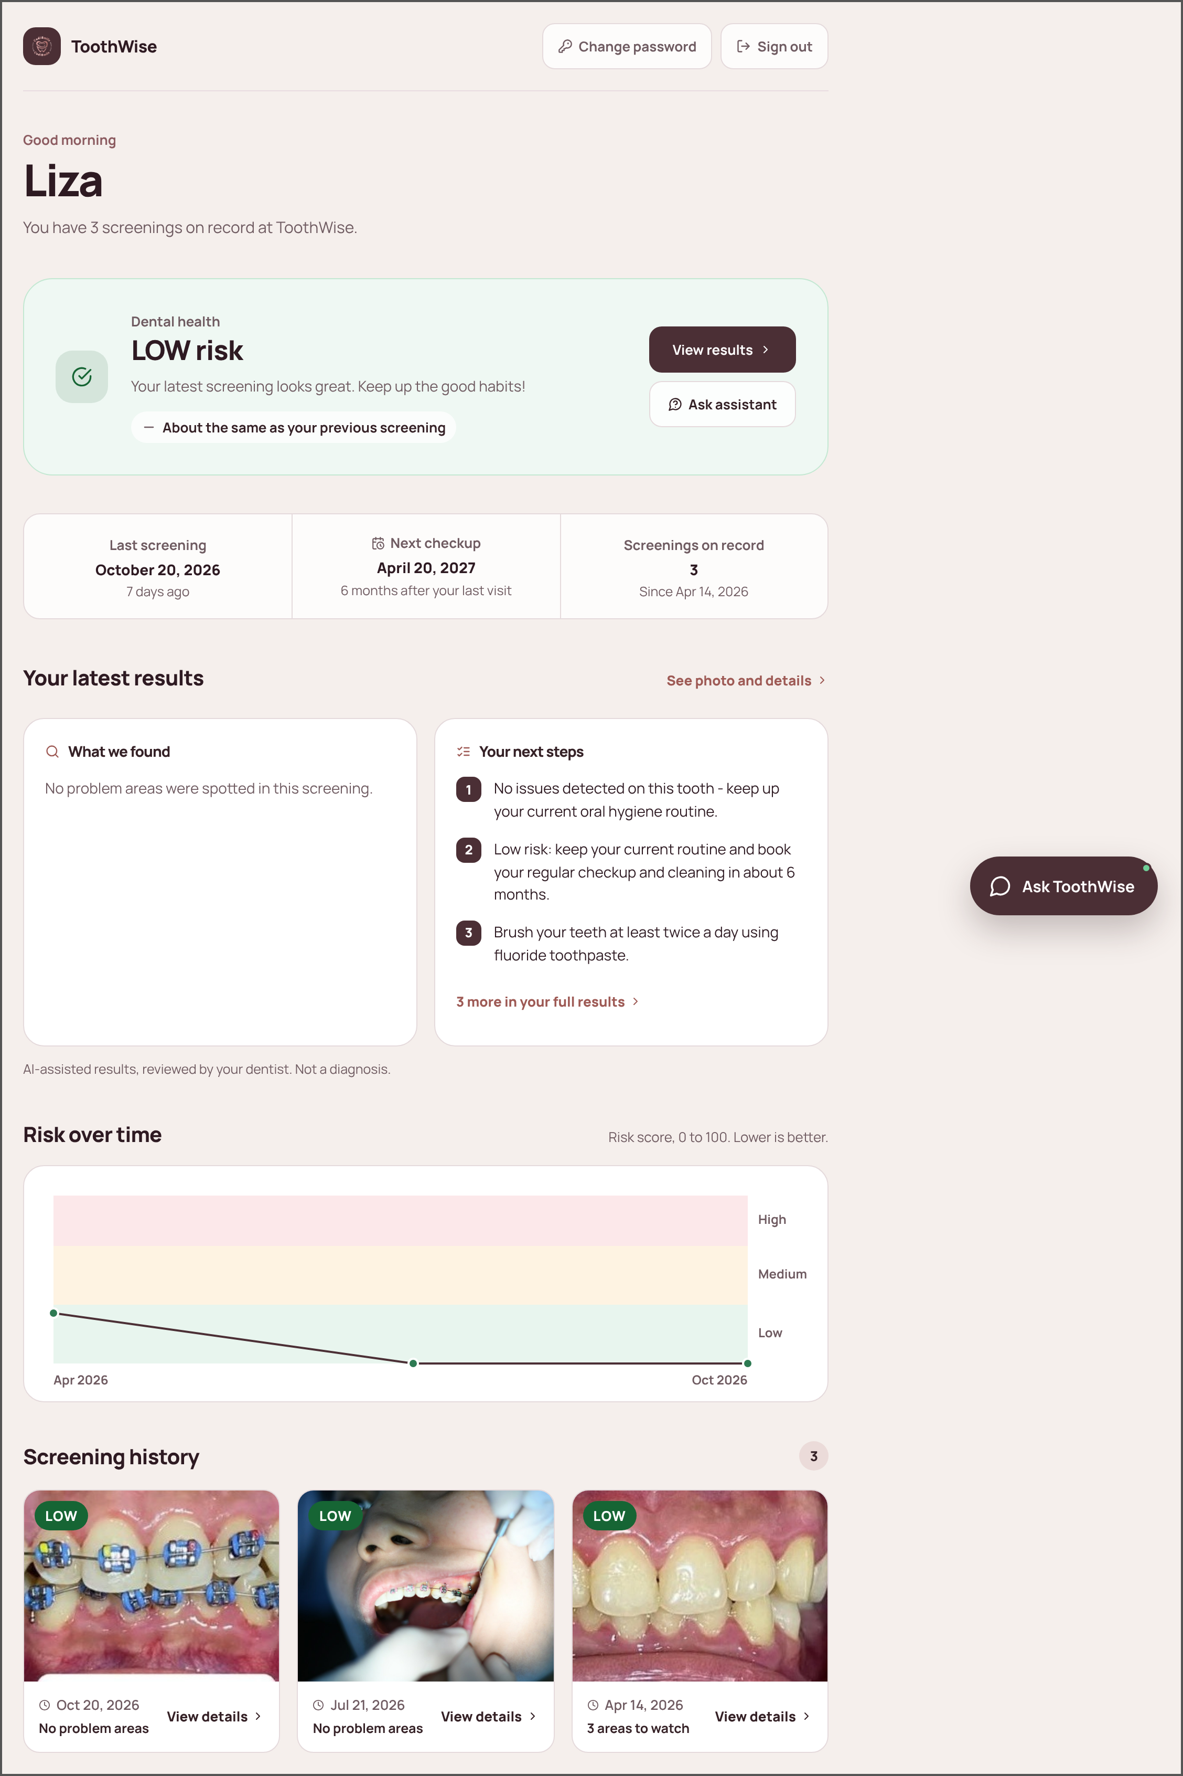
Figure 23 Patient Portal — Sign Up. New patients create an account with their contact details and a password. | Figure 24 Patient Portal — Home. Latest risk level and change since the last visit, next check-up date, latest findings and next steps, risk over time, and screening history.

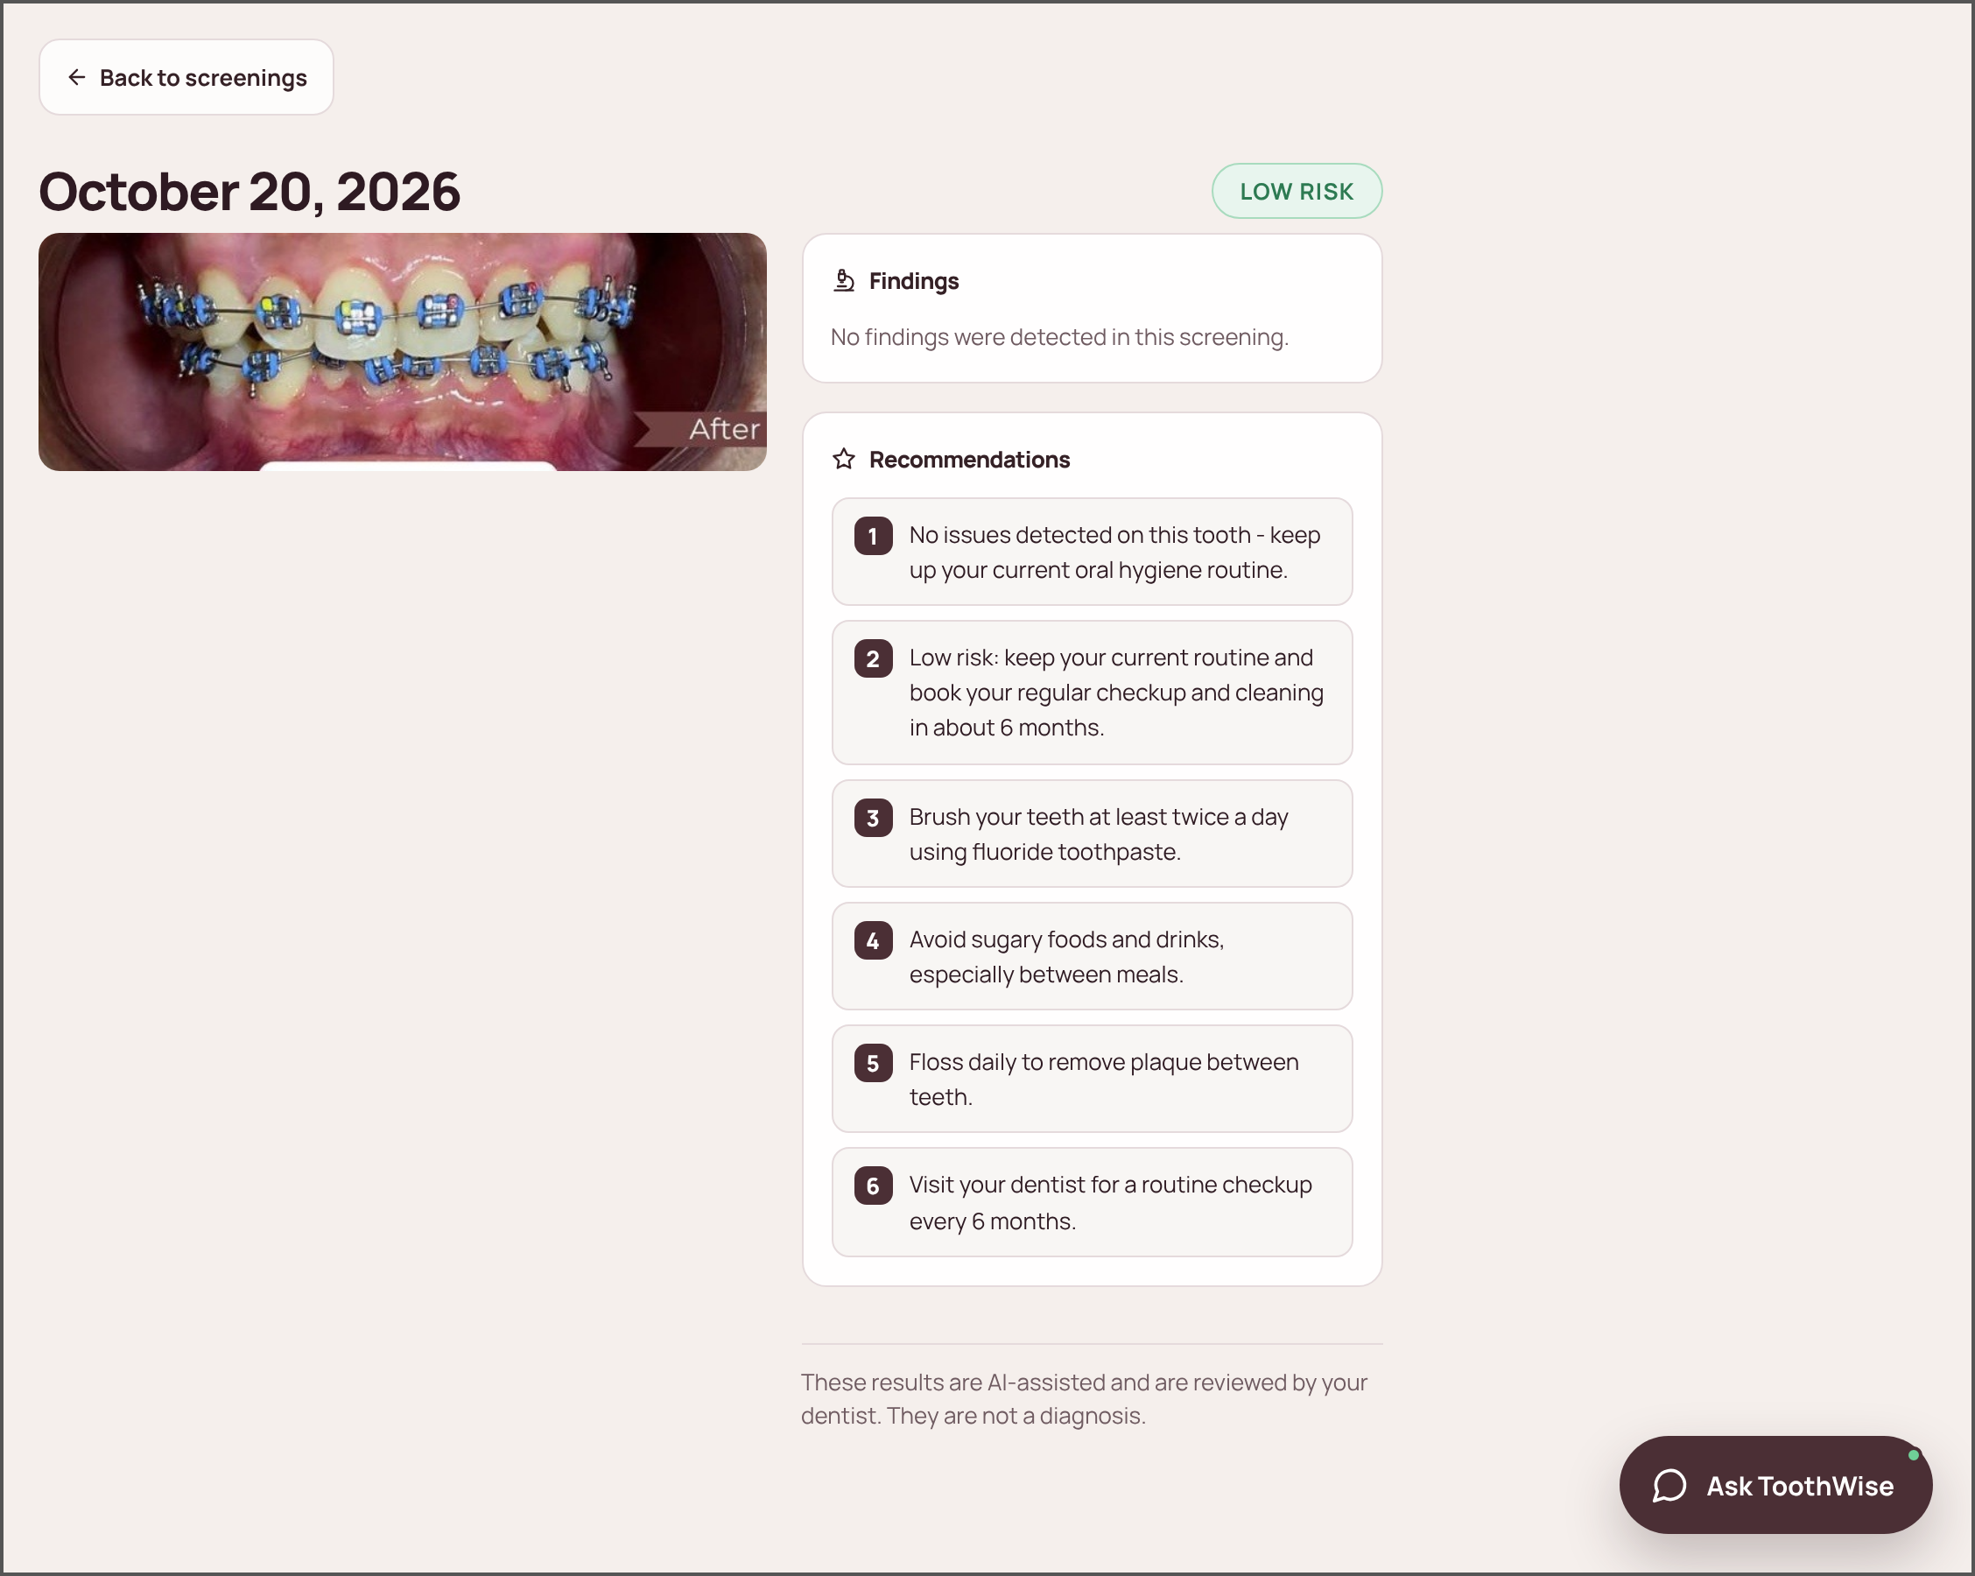 | 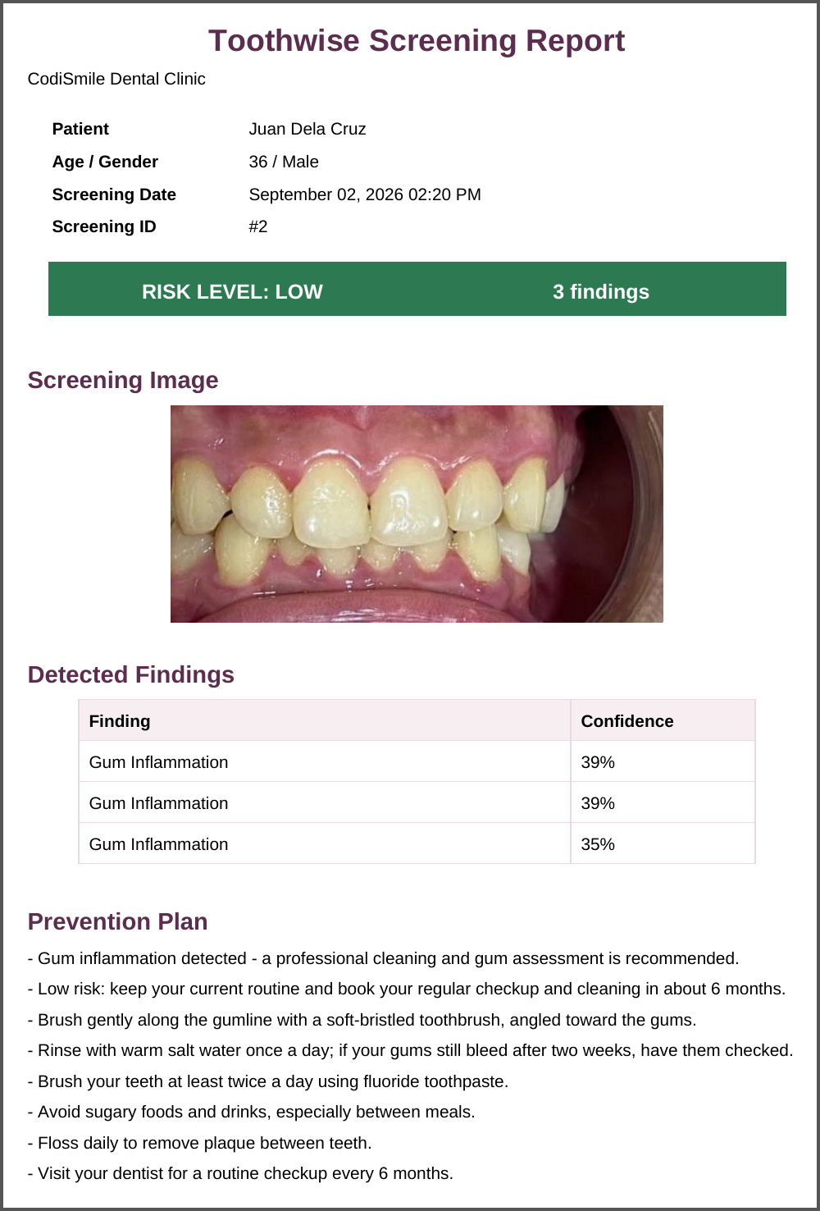
Figure 25 Patient Portal — Screening Details. One screening: the photograph with its findings and the prevention plan. | Figure 26 PDF Screening Report. First page of the report: patient details, risk level, image, findings, and prevention plan.

CHAPTER IV
RESULTS AND DISCUSSION
This chapter presents the results obtained from the development, training, testing, and evaluation of Toothwise. The results are organized according to the Statement of the Problem and the Specific Objectives in Chapter I: the results of the trained detection models (Specific Objective 1), the specialization and technical results of the implemented system (Specific Objectives 2 and 3), the software quality evaluation based on ISO/IEC 25010 (Specific Objective 4), and the comparison of screening consistency and screening time against the manual process (Specific Objective 5). The evaluation in Sections 4.3 and 4.4 is based on the responses of 103 respondents to the evaluation questionnaire.

4.1 Results of the Trained Datasets
This section answers the first problem of the study by reporting how accurately the trained models detect tartar, plaque, cavity, gum inflammation, and healthy tooth on still intraoral photographs, and how YOLOv8 and YOLOv12 compare in precision, recall, mAP, and inference speed.

4.1.1 Dataset Preparation
Four publicly available, annotated dental image datasets exported in YOLOv8 format were merged into a single training corpus. Because each source used a different class list, every source class was remapped to one of the five Toothwise classes or dropped when it fell outside the scope of the study (for example, missing teeth, malalignment, spacing, ulcers, and hypodontia). Segmentation polygons in the source labels were converted into bounding boxes so that all annotations share the same detection format. Table 13 presents the class mapping applied to each source.
After merging, the dataset was divided into training, validation, and test splits, as shown in Table 14. Images that contained only dropped classes were kept as background (negative) images, which teach the models not to raise false detections on unremarkable regions.
Table 13 Source Datasets and Class Remapping to the Toothwise Taxonomy
Source dataset (export) | Original classes | Mapped to Toothwise class | Dropped classes
dadad12 (v3) | calculus, cavities, maligned, missing, plaque, spacing, stains | calculus → tartar; cavities → cavity; plaque → plaque | maligned, missing, spacing, stains
DenPal (v8) | Caries, Missing Tooth, Tartar | Caries → cavity; Tartar → tartar | Missing Tooth
oral-diseases (v2) | calculus, caries, gingivitis, hypodontia, tooth_discolation, ulcer | calculus → tartar; caries → cavity; gingivitis → gum_inflammation | hypodontia, tooth_discolation, ulcer
Teeth 2 (v1) | Caries, Cavity, Healthy | Caries → cavity; Cavity → cavity; Healthy → healthy_tooth | None
Source: class lists and remap printed by the YOLOv12 training notebook (train_dental_yolov12_5class_2.ipynb).
Table 14 Merged Dataset Split
Split | Images | Background images (no target label) | Share of images
Training | 40,271 | 10,791 | 83.0%
Validation | 5,299 | 2,833 | 10.9%
Test | 2,930 | 1,067 | 6.0%
Total | 48,500 | 14,691 | 100.0%
Label rows written during the merge: 86,028 bounding boxes and 7,457 polygons converted to boxes (93,485 in total). Test background count taken from the rebuilt test split.
Table 15 presents the number of labeled findings per class in the held-out test split, which was used for the per-class evaluation in Section 4.1.4. The classes are clearly unbalanced, ranging from 42 labeled healthy tooth instances to 2,716 cavity instances.
Table 15 Labeled Instances per Class (Test Split, 2,930 Images)
Class | Images containing the class | Labeled instances | Share of instances
Healthy tooth | 39 | 42 | 0.6%
Cavity | 1,190 | 2,716 | 39.6%
Gum inflammation | 297 | 1,544 | 22.5%
Plaque | 147 | 554 | 8.1%
Tartar | 558 | 2,009 | 29.3%
Total | — | 6,865 | 100.0%
Counted from the rebuilt test split (same source order, class remap, and polygon-to-box conversion as the training notebook).

4.1.2 Training Configuration
Both models were trained with the Ultralytics framework on Google Colab using an NVIDIA Tesla T4 GPU, with identical hyperparameters and the same merged dataset so that the comparison is fair. Training was resumed from the last saved checkpoint whenever a Colab session disconnected. Table 16 summarizes the configuration, which was read directly from the saved model checkpoints.
Table 16 Training Configuration of the Two Detection Models
Parameter | YOLOv8 | YOLOv12
Model scale | YOLOv8m (medium; depth 0.67, width 0.75) | YOLOv12m (medium)
Trainable parameters | 25,859,215 | 19,662,111
Pretrained starting weights | Yes (COCO) | Yes (COCO)
Classes | 5 | 5
Epochs | 60 | 60
Image size | 640 × 640 px | 640 × 640 px
Batch size | 12 | 12
Optimizer | auto (selected by Ultralytics) | auto (MuSGD, lr 0.01, momentum 0.9)
Early-stopping patience | 15 epochs | 15 epochs
Random seed | 0 | 0
Ultralytics version | 8.4.146 | 8.4.160
Training hardware | Google Colab, NVIDIA Tesla T4 (15 GB) | Google Colab, NVIDIA Tesla T4 (15 GB)
Checkpoint date (UTC) | 2026-09-10 | 2026-09-23

4.1.3 Overall Detection Performance of YOLOv8 and YOLOv12
The models were evaluated with the standard object-detection metrics. Precision is the share of predicted boxes that are correct, and recall is the share of actual findings that the model detected. The F1-score is the harmonic mean of precision and recall. mAP@50 is the mean average precision across the five classes when a predicted box must overlap the labeled box by at least 50% (IoU 0.50), and mAP@50-95 averages this over stricter overlaps from 0.50 to 0.95. Detection accuracy, which is not a single built-in metric for object detection, is reported separately in Section 4.1.5.
Table 17 presents the overall results on two splits: the validation split (5,299 images), which was scored automatically at the end of training, and the held-out test split (2,930 images), which neither model saw during training and which is the primary basis for the comparison.
Table 17 Overall Detection Performance of YOLOv8 and YOLOv12
Metric | YOLOv8 (validation) | YOLOv12 (validation) | YOLOv8 (test) | YOLOv12 (test)
Precision | 53.96% | 49.43% | 54.32% | 52.94%
Recall | 49.73% | 49.05% | 52.34% | 50.06%
F1-score | 51.76% | 49.24% | 53.31% | 51.46%
mAP@50 | 46.83% | 45.02% | 51.91% | 48.11%
mAP@50-95 | 26.80% | 25.87% | 28.53% | 26.28%
Validation: train_metrics stored in the checkpoints (epoch 60). Test: one prediction pass over the held-out test split (confidence 0.001, NMS IoU 0.70, image size 640), scored with the Ultralytics matching rule.
On the validation split, YOLOv8 obtained a slightly higher score than YOLOv12 on every overall metric, with an mAP@50 of 46.83% against 45.02%. On the held-out test split, YOLOv8 obtained the higher mAP@50 (51.91% against 48.11%) and mAP@50-95 (28.53% against 26.28%). Test precision was 54.32% for YOLOv8 and 52.94% for YOLOv12, and test recall was 52.34% and 50.06%, respectively. YOLOv12 reached its results with about 24% fewer parameters (19.66 million against 25.86 million).
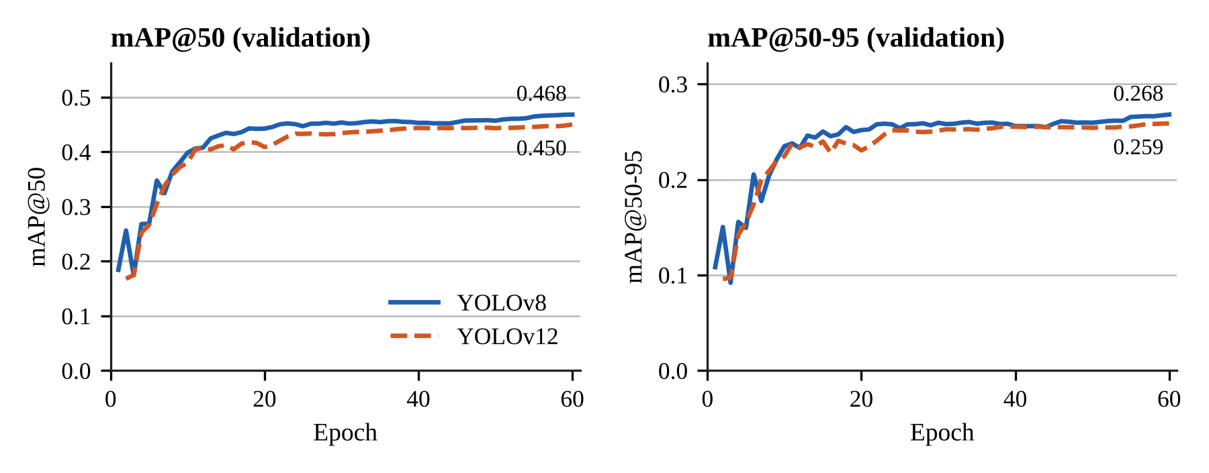
Figure 27 mAP@50 and mAP@50-95 per Training Epoch for YOLOv8 and YOLOv12.
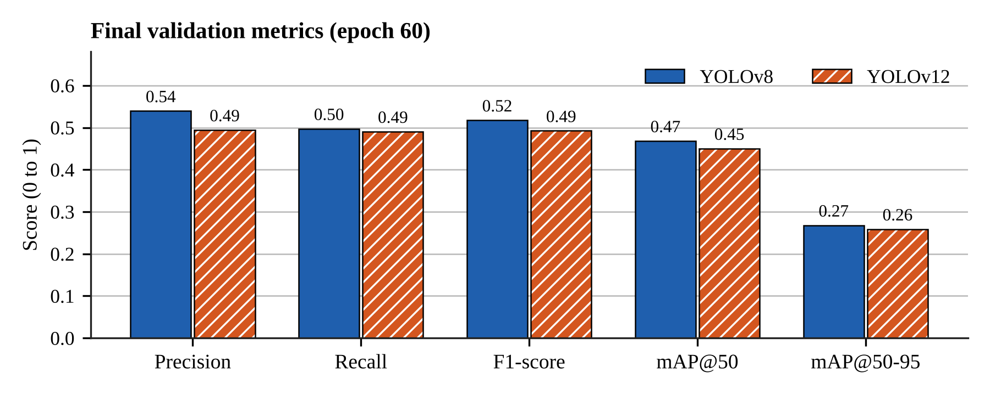
Figure 28 Final Validation Metrics of YOLOv8 and YOLOv12.
Figure 27 shows that both models improved quickly during the first ten epochs and then levelled off: after roughly epoch 25, validation mAP@50 rose by only about two percentage points for either model. Additional epochs alone are therefore unlikely to produce large gains; further improvement depends more on the training data than on longer training.

4.1.4 Per-Class Detection Results
Tables 18 and 19 present the precision, recall, F1-score, mAP@50, and mAP@50-95 of each class on the test split, and Figure 29 compares the per-class mAP@50 of the two models and the fused ensemble.
Table 18 Per-Class Detection Performance of YOLOv8 (Test Split)
Class | Instances | Precision | Recall | F1-score | mAP@50 | mAP@50-95
Healthy tooth | 42 | 42.86% | 83.33% | 56.60% | 80.54% | 62.37%
Cavity | 2,716 | 65.55% | 69.43% | 67.43% | 66.33% | 33.11%
Gum inflammation | 1,544 | 61.01% | 49.85% | 54.87% | 52.35% | 21.97%
Plaque | 554 | 42.84% | 7.04% | 12.09% | 7.36% | 3.06%
Tartar | 2,009 | 59.33% | 52.07% | 55.46% | 52.97% | 22.15%
All classes | 6,865 | 54.32% | 52.34% | 53.31% | 51.91% | 28.53%
Source: test-split evaluation pass, scored with the Ultralytics matching rule.
Table 19 Per-Class Detection Performance of YOLOv12 (Test Split)
Class | Instances | Precision | Recall | F1-score | mAP@50 | mAP@50-95
Healthy tooth | 42 | 43.40% | 78.57% | 55.91% | 70.13% | 54.83%
Cavity | 2,716 | 62.82% | 69.26% | 65.88% | 64.50% | 32.27%
Gum inflammation | 1,544 | 60.59% | 45.60% | 52.04% | 48.95% | 20.16%
Plaque | 554 | 39.55% | 8.30% | 13.73% | 7.15% | 3.52%
Tartar | 2,009 | 58.34% | 48.59% | 53.03% | 49.82% | 20.62%
All classes | 6,865 | 52.94% | 50.06% | 51.46% | 48.11% | 26.28%
Source: test-split evaluation pass, scored with the Ultralytics matching rule.
Performance differed strongly between classes. Among the well-represented classes, both models detected cavity best (mAP@50 of 66.33% for YOLOv8 and 64.50% for YOLOv12, from 2,716 labeled instances) and plaque worst (7.36% and 7.15%). In descending order of mean mAP@50, the classes ranked as follows: healthy tooth, cavity, tartar, gum inflammation, plaque. The healthy tooth class scored 80.54% and 70.13%, but the test split contains only 42 labeled healthy tooth instances in 39 images, so this result is less certain than the others.
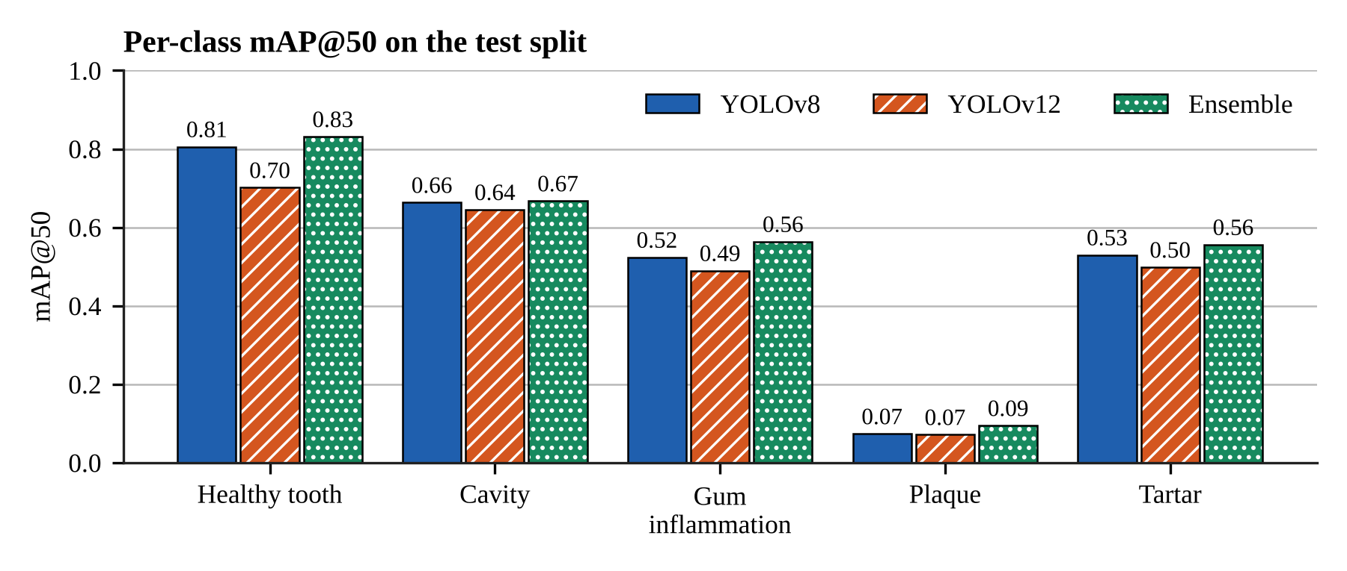
Figure 29 Per-Class mAP@50 on the Test Split.
The weakest class, plaque, is the main limitation of the trained models. Of the 554 labeled plaque instances in the test split, YOLOv8 found 7.04% and YOLOv12 8.30% at the confidence that gives each model its best F1-score. Plaque appears as a thin, low-contrast film that is hard to separate from the tooth surface and from tartar in an ordinary photograph, and its boundaries are hard to annotate consistently, which makes an overlap of 0.50 with the labeled box difficult to reach. In addition, the plaque labels come from only one of the four source datasets. Class frequency also matters: the test split contains 554 plaque instances against 2,716 cavity instances. These are the same difficulties that the first problem of the study identifies in visual-only screening.

4.1.5 Detection Accuracy and Confusion Matrix
Object detection does not have a single built-in accuracy measure, because a model can be wrong in three ways: it can label a finding with the wrong class, raise a box where there is no finding (false alarm), or miss a finding entirely. This study therefore defines detection accuracy as the number of correctly located and correctly labeled findings divided by the total of correct, wrongly labeled, false-alarm, and missed findings. The counts were taken from the confusion matrix at the confidence threshold used by the deployed system (0.25) and an IoU of 0.45. Tables 20 and 21 present the result, and Figure 30 shows the confusion matrices.
Table 20 Detection Accuracy on the Test Split (Confidence 0.25, IoU 0.45)
Model | Correct | Wrong class | False alarms | Missed | Detection accuracy
YOLOv8 | 3,877 | 114 | 1,992 | 2,874 | 43.77%
YOLOv12 | 3,726 | 119 | 2,039 | 3,020 | 41.85%
Fused ensemble | 4,491 | 158 | 3,574 | 2,216 | 43.02%
Detection accuracy = Correct / (Correct + Wrong class + False alarms + Missed).
Table 21 Detection Accuracy per Class on the Test Split
Class | YOLOv8 | YOLOv12 | Fused ensemble
Healthy tooth | 38.20% | 39.29% | 33.94%
Cavity | 52.87% | 51.38% | 49.83%
Gum inflammation | 40.53% | 37.16% | 42.25%
Plaque | 6.46% | 7.58% | 10.46%
Tartar | 40.52% | 38.01% | 39.54%
Per class: correct detections of the class divided by all detections and labels of that class (correct + wrong + false alarms + missed).
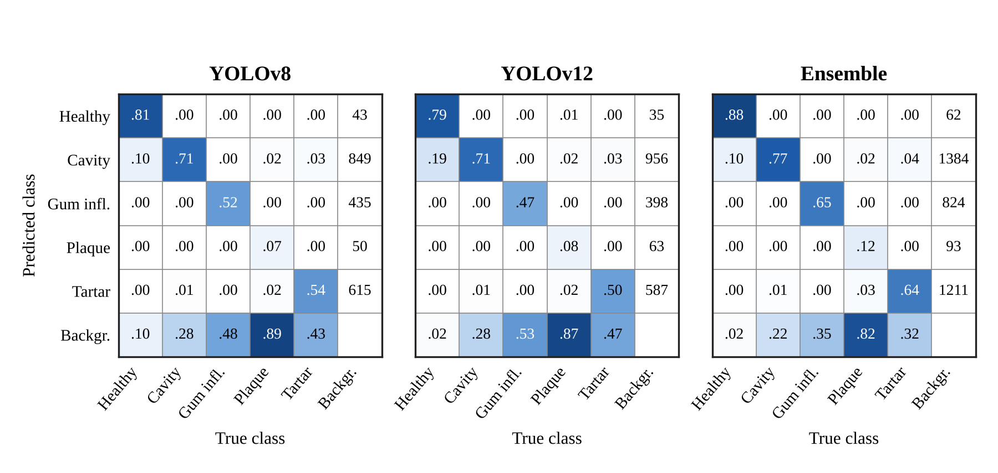
Figure 30 Confusion Matrices on the Test Split (Columns Normalized by True Class).
At the deployed confidence threshold, YOLOv8 reached a detection accuracy of 43.77%, YOLOv12 41.85%, and the fused ensemble 43.02%; the highest was obtained by YOLOv8. For both single models, the most common error type was missed findings. Wrong-class detections were comparatively rare, which means that when a model does locate a finding it usually names the condition correctly; most errors come from findings that are not detected at all or from boxes raised on unremarkable areas. The most frequent confusion between two conditions was a true tartar labeled as cavity.
The fused ensemble had a slightly lower detection accuracy than YOLOv8 even though its mAP@50 was higher (Section 4.1.7). The ensemble keeps a finding reported by either model, so it missed fewer findings (2,216 against 2,874) but raised more false alarms (3,574 against 1,992). Detection accuracy weighs both errors equally, whereas mAP rewards ranking correct findings above false ones across all confidence levels.
Two cautions apply to these counts. First, the four source datasets were not all annotated for the same conditions; for example, a photograph from a source without a gum inflammation class may show inflamed gums that were never labeled. A correct detection on such an image is counted as a false alarm, so the false-alarm counts, and therefore the accuracy, are conservative. Second, the counts depend on the confidence threshold: a lower threshold finds more findings but raises more false alarms.
For a screening support tool, missed findings are the more serious error because a false alarm is reviewed and dismissed by the dentist, whereas a missed finding may not be examined. This supports keeping the dentist's visual examination as the reference and presenting the detections as suggestions.

4.1.6 Inference Speed
Inference speed was measured on the deployment-class workstation without a GPU, which reflects the clinic setting described in Chapter III. Each model processed four clinic screening images five times at 640 × 640 pixels after a warm-up pass. Table 22 reports the mean time per image.
Table 22 Inference Time per Image on CPU
Configuration | Mean time per image | Standard deviation | Model forward pass only
YOLOv8 | 215.9 ms | 8.9 ms | 203.7 ms
YOLOv12 | 206.5 ms | 7.6 ms | 198.9 ms
Both models (ensemble, run in sequence) | 506.8 ms | 138.7 ms | —
Machine: Intel Core i7-13620H, 16 GB RAM, CPU only (PyTorch 2.14 CPU, Ultralytics 8.4.116); n = 20 timed predictions per configuration.
Both models analyzed a photograph in about one fifth of a second, with YOLOv12 about 4% faster than YOLOv8 on the same hardware. Running both models for the ensemble took about half a second per image. This is well within an interactive response time for a screening workflow, in which the dentist uploads a photograph and reviews the results on the same screen.
The deployed system runs on a smaller machine. On the free Render web service (shared CPU, 512 MB of memory), the backend runs the ONNX exports of the same two models with ONNX Runtime and loads each model only for the time it runs, because keeping both PyTorch models in memory would exceed the 512 MB limit. Measured on that service, a complete screening with both models took about 3 to 4 seconds, and the backend used about 210 MB of memory at rest and about 400 MB at its peak. The ONNX models returned the same boxes, labels, and confidences as the PyTorch checkpoints on 22 test images, so the accuracy results in this chapter apply to the deployed system. The delay of a few seconds remains acceptable for a workflow in which a photograph is uploaded once per screening.

4.1.7 Ensemble Fusion
In the deployed system, both models analyze each image and their outputs are combined into a single clinical detection set. Boxes from both models are grouped when they share a label and overlap with an IoU of at least 0.50; each group is merged into one box whose coordinates are the confidence-weighted average of its members (weighted box fusion). A finding confirmed by both models receives a confidence increase of 0.08, capped at 0.98, because agreement between two independently trained models is stronger evidence than either model alone.
To measure the effect of fusion, the test split was passed once through both models, and the YOLOv8 output, the YOLOv12 output, and the fused output were scored with the same matching code. Table 23 presents the result.
Table 23 YOLOv8, YOLOv12, and the Fused Ensemble on the Test Split
Metric | YOLOv8 | YOLOv12 | Fused ensemble
Precision | 54.32% | 52.94% | 53.51%
Recall | 52.34% | 50.06% | 55.77%
F1-score | 53.31% | 51.46% | 54.62%
mAP@50 | 51.91% | 48.11% | 54.24%
mAP@50-95 | 28.53% | 26.28% | 29.31%
mAP@50 – healthy tooth | 80.54% | 70.13% | 83.11%
mAP@50 – cavity | 66.33% | 64.50% | 66.72%
mAP@50 – gum inflammation | 52.35% | 48.95% | 56.36%
mAP@50 – plaque | 7.36% | 7.15% | 9.45%
mAP@50 – tartar | 52.97% | 49.82% | 55.58%
Same prediction pass as Tables 17 to 19; the single-model columns repeat those results.
The fused ensemble obtained an mAP@50 of 54.24%, against 51.91% for the better single model (YOLOv8) in the same evaluation, a difference of +2.34 percentage points, and it scored higher than YOLOv8 on all five classes. Its recall was 55.77% against 52.34%, and its precision 53.51% against 54.32%. At the deployed confidence threshold, the ensemble missed 2,216 findings against 2,874 for YOLOv8, but raised 3,574 false alarms against 1,992, because a box from either model is kept.
Fusion therefore improved on both single models: findings that one model misses are often detected by the other, and agreement between the two raises the confidence of the findings that both models report. This result supports the design decision to run both models in the deployed system rather than choosing one.

4.1.8 Summary of the Model Comparison
In answer to the first problem, both models learned to detect the five target classes. On the held-out test split, YOLOv8 obtained the higher mAP@50 (YOLOv8 51.91%, YOLOv12 48.11%), while YOLOv12 was lighter and slightly faster (about 206 ms against 216 ms per image on CPU). The difference between the two models is small compared with the difference between classes: cavity was detected reliably, while plaque remained difficult for both. The fused ensemble reached an mAP@50 of 54.24% and a detection accuracy of 43.02%. These results support the delimitation in Chapter I that Toothwise is a screening support tool and not a diagnostic replacement: detections are presented to the dentist as suggestions, and the dentist confirms or corrects the findings and the risk tier.

4.2 Specialization and Technical Results
This section presents the technical results of the implemented system: the detection pipeline, the risk scoring engine, the KNN recommendation feature, the results interface and patient records, role-based access, the patient-facing chatbot, and the measured quality of the web application.

4.2.1 AI Detection Pipeline
The FastAPI backend exposes the screening workflow through authenticated REST endpoints. During development it runs the PyTorch checkpoints with Ultralytics; in the deployed system it runs ONNX exports of the same models with ONNX Runtime, which give identical detections and need about four times less memory. For each uploaded intraoral photograph the pipeline (1) validates the file type and size (JPEG, PNG, or WebP, maximum 15 MB), (2) runs YOLOv8 and YOLOv12, (3) fuses their detections as described in Section 4.1.7 and removes orthodontic brackets that the models mistake for findings, (4) computes a risk score and risk tier, (5) generates a prevention plan, and (6) stores the image, every detection with its bounding box and confidence, the risk result, and the plan in the patient's record. In the deployed system a copy of the photograph is also saved in the database; when the hosting service has restarted and cleared its disk, the image routes and the PDF report restore the file from that copy. The response includes the fused detections and the raw output of each model.
Neither model was trained with a braces class, so in early pilot use the metal brackets of patients with braces were reported as urgent cavities. The deployed pipeline therefore drops any cavity, plaque, or tartar box whose pixels are mostly metal-grey (at least 8%), requires a cavity to have a confidence of at least 0.50, and keeps a cavity in the fused set only when both YOLOv8 and YOLOv12 report it. When two or more brackets are found, the prevention plan adds a note that braces were detected and that the dentist or orthodontist should check those teeth in person. These rules were added after the test-split evaluation in Section 4.1, so Tables 20, 21, and 23 report the ensemble without them.

4.2.2 Risk Scoring Engine
The risk score is rule-based so that every score can be explained to the patient and audited by the dentist. Each non-healthy detection contributes its class severity multiplied by its confidence; the score is the highest such value plus 6 points for every additional finding (up to 5 additional findings), capped at 100. Table 24 lists the severity weights and the tier thresholds.
Table 24 Risk Scoring Weights and Tier Thresholds
Class | Severity weight | Highest possible score from one finding
Healthy tooth | 0 | 0 (no risk contribution)
Plaque | 25 | 25 (LOW)
Tartar | 35 | 35 (MEDIUM)
Gum inflammation | 45 | 45 (MEDIUM)
Cavity | 70 | 70 (HIGH)
Tiers: LOW 0–34, MEDIUM 35–69, HIGH 70–100. Source: backend/app/ml/labels.py (SEVERITY_WEIGHT) and backend/app/ml/risk_engine.py.

4.2.3 KNN-Based Recommendation Feature
A K-Nearest Neighbors classifier (K = 5, distance-weighted) assigns each screening to a LOW, MEDIUM, or HIGH tier from its detection profile, and the prevention plan is composed from that tier and the specific conditions found. The classifier was first trained on synthetic reference cases generated from the clinical scoring rule. Every tier that a dentist confirms or corrects in the system is stored as a real labeled case and added to the reference data on retraining.
Table 25 presents the result of the evaluation script on 2,000 synthetic cases that were not used in training. Because these cases follow the same rule as the training cases, the result measures how faithfully the classifier reproduces the rule, not its clinical accuracy.
Table 25 KNN Tier Classification on Unseen Synthetic Cases
Risk tier | Precision | Recall | F1-score | Cases
LOW | 98.35% | 96.30% | 97.31% | 864
MEDIUM | 90.18% | 95.47% | 92.75% | 971
HIGH | 76.19% | 58.18% | 65.98% | 165
Overall (weighted) | — | — | 92.51% | 2,000
Overall accuracy: 92.75%. Source: python -m app.ml.evaluate_knn (re-run on the current code with the same result).
The classifier agreed with the rule on 92.75% of the unseen cases. Most errors occurred at tier boundaries; the weakest tier was HIGH, where 69 of 165 cases were classified as MEDIUM (recall 58.18%). No LOW case was classified as HIGH and no HIGH case as LOW. Because a missed HIGH tier is the most consequential error, the dentist's confirmation step remains part of the workflow. Because the study did not screen the clinic's patients, no dentist-confirmed tiers had been recorded by the end of the study, so the classifier's accuracy against real clinical cases could not yet be measured; it is recommended in Chapter V.

4.2.4 Results Interface and Patient Records
In answer to the second problem, every screening is saved as a standardized visual record: the original photograph, color-coded bounding boxes with the condition label and confidence, a plain-language description of each condition, the risk score and tier, the prevention plan, and the dentist's clinical notes. The patient record lists all screenings in chronological order with a risk trend chart, so findings can be compared across visits. Each screening can be exported as a PDF report (Figure 26). Figures 17, 20, and 24 to 26 in Section 3.10 show these screens. Patients can register for the self-service portal, where a dashboard shows their latest risk level and how it changed since the previous screening, their latest findings in plain language with the top next steps, a risk-over-time chart, the date of their next check-up (six months after the last screening), and their full screening history, but no other patient's data.

4.2.5 Role-Based Web Application
The staff side of the system enforces three roles. The dentist acts as administrator and can manage staff accounts and view the audit log; the receptionist manages patient registration and records; and the dental assistant performs screenings. Patients use a separate login scope. Access is enforced by the backend on every request, not only by hiding menu items. Passwords are hashed with bcrypt, sessions use JSON Web Tokens, login and chatbot requests are rate-limited, and sensitive staff actions are written to an append-only audit log.
Staff and patients sign in with their email address and password. Ticking “Remember me on this device” issues a 30-day token kept in the browser's local storage; otherwise the session ends when the browser is closed. A user who forgets the password requests a reset link by email; the link can be used once, expires after 30 minutes, and stops working as soon as the password changes, and the system gives the same answer whether or not the email address is registered so that it cannot be used to discover accounts. Signed-in staff and patients can also change their password from the sidebar or the portal header.
The backend has an automated test suite of 117 test cases covering authentication, password recovery, the braces filter, the AI assistant, staff management, the class labels, the ONNX Runtime detector, patients, the recommender, the risk engine, role permissions, and screenings, including the restoration of screening photos from the database. All 117 tests passed in the final run (Table 26).
Table 26 Automated Backend Test Results
Test module | Area tested | Test cases | Result
test_auth.py | Staff and patient login, tokens | 11 | Passed
test_braces_filter.py | Removal of orthodontic brackets from detections | 4 | Passed
test_chatbot.py | AI assistant retries, fallbacks, and verified clinic facts | 6 | Passed
test_dentists.py | Staff account management | 14 | Passed
test_labels.py | Class list consistency | 11 | Passed
test_onnx_yolo.py | ONNX Runtime letterboxing, NMS, and model loading | 4 | Passed
test_password_recovery.py | Remember me, forgot, reset, and change password | 13 | Passed
test_patients.py | Patient records | 10 | Passed
test_recommender.py | KNN tier and prevention plan | 12 | Passed
test_risk_engine.py | Risk score and tier | 9 | Passed
test_roles.py | Three-role access control | 11 | Passed
test_screenings.py | Screening workflow, storage, and photo restore | 12 | Passed
Total |  | 117 | 117 passed, 0 failed
Source: python -m pytest in backend/ (run with YOLO_BACKEND=onnx on 28 October 2026).

4.2.6 AI Chatbot
The public website includes an AI assistant for general dental-care questions and questions about the clinic and the Toothwise service. It is powered by the Google Gemini API. Before a message is sent to the model, e-mail addresses, phone numbers, and record identifiers are removed, and any request for a personal record or screening result is answered with a referral to the secure patient portal instead of being forwarded. Requests are limited to 12 per minute per client. In the deployed system the assistant runs as a Vercel serverless function. When the free Gemini quota is used up, questions about the clinic (hours, location, services, and prices) are still answered from verified clinic facts, and other questions receive a "temporarily unavailable" message.

4.2.7 Web Performance and Accessibility
The production build of the frontend was audited with Google Lighthouse 12 on the public pages at a mobile width (simulated slow 4G) and a desktop width. Because the landing page was redesigned after the first audit, all six audits were run again on 20 October 2026 against a local production build. Table 27 presents the scores.
Table 27 Lighthouse Audit Results
Page | Viewport | Performance | Accessibility | Best practices | Largest Contentful Paint
Landing | Desktop | 100 | 100 | 100 | 0.7 s
Landing | Mobile | 86 | 100 | 100 | 2.5 s
Staff login | Desktop | 99 | 100 | 100 | 0.9 s
Staff login | Mobile | 98 | 100 | 100 | 2.2 s
Patient portal | Desktop | 99 | 100 | 100 | 0.9 s
Patient portal | Mobile | 97 | 100 | 100 | 2.4 s
Landing (mobile) is the median of three runs (67, 86, 92); other rows are single runs. Cumulative Layout Shift was at most 0.014 on every page.
Accessibility and best practices scored 100 on every audited page, and performance ranged from 99 to 100 on desktop and from 86 to 98 on mobile. The lowest score, the landing page on mobile, comes from the amount of JavaScript and imagery the redesigned page loads before it becomes interactive; its score also varied the most between runs. Splitting the application by route reduced the main JavaScript bundle from 231 KB to 95 KB (compressed). The signed-in staff pages, which Lighthouse cannot reach, were audited with axe-core 4.14 against WCAG 2.0 and 2.1 Level A and AA rules on all eight staff routes and five dialogs in both light and dark mode; the final audit found zero violations.

4.3 Software Quality Evaluation Based on ISO/IEC 25010
This section answers the fourth problem of the study. The evaluation questionnaire was answered online through Google Forms between 2026-10-19 and 2026-10-28 by 103 respondents who gave their informed consent. None of the respondents was a patient of CodiSmile Dental Clinic, and no clinic records were used.

4.3.1 Respondents
The respondents fall into two groups: 98 patient respondents, who evaluated the system from a patient's point of view after using it, and 5 IT experts (IT practitioners). Table 28 presents their distribution. The questionnaire's parts were written for different respondent groups, so the number of respondents differs per section, as shown in Table 29.
Table 28 Distribution of Respondents
Respondent group | Frequency | Percentage
Patient respondents | 98 | 95.15%
IT experts / IT practitioners | 5 | 4.85%
Total | 103 | 100.00%

Table 29 Respondents per Questionnaire Section
Questionnaire section | Patient respondents | IT experts | Total
Current Manual Screening Process | 2 | 0 | 2
Screening Consistency and Time | 2 | 0 | 2
Security | 7 | 5 | 12
Privacy | 7 | 5 | 12
Usability | 7 | 5 | 12
Reliability | 7 | 5 | 12
Performance Efficiency | 7 | 5 | 12
Data Protection | 7 | 5 | 12
AI Detection and Risk Classification | 98 | 5 | 103
Results Interface and Patient Records | 98 | 5 | 103
KNN-Based Personalized Prevention Plan | 98 | 5 | 103

All 103 respondents answered the three sections on the system's features (AI detection and risk classification, the results interface and patient records, and the prevention plan). The six ISO/IEC 25010 quality sections (Part B3 of the instrument) were written for dentists, clinic staff, and IT experts, as the instructions of that part state, because many of their statements concern staff-side and technical features that a patient using the portal does not see, such as role-based access, the staff audit log, and data consistency between related records. All 5 IT experts answered them; since no dentist or clinic staff member took part, the only other answers came from 7 patient respondents who completed the part although it was not meant for them, for a total of 12. The two sections on the manual screening process and on screening consistency and time by 2. Of the respondents who gave their experience in their current field, 8 reported less than 1 year, 2 reported 1-3 years.

4.3.2 Research Instrument
The instrument has eleven sections with 46 statements, listed in Table 30, plus three open-ended questions on what respondents liked, the difficulties they met, and the improvements they suggest. Six sections follow the quality characteristics named in the fourth problem of the study, three evaluate the system's main features, and two concern the current manual screening process and Toothwise's effect on screening consistency and time (the fifth problem).
Table 30 Sections of the Evaluation Instrument
Section | Item codes | Items | Problem addressed
Security | SE1–SE4 | 4 | Problem 4 (quality characteristic)
Privacy | PR1–PR3 | 3 | Problem 4 (quality characteristic)
Usability | US1–US4 | 4 | Problem 4 (quality characteristic)
Reliability | RE1–RE3 | 3 | Problem 4 (quality characteristic)
Performance Efficiency | PE1–PE3 | 3 | Problem 4 (quality characteristic)
Data Protection | DP1–DP3 | 3 | Problem 4 (quality characteristic)
AI Detection and Risk Classification | AD1–AD5 | 5 | Problems 1 and 4
Results Interface and Patient Records | RI1–RI5 | 5 | Problems 2 and 4
KNN-Based Personalized Prevention Plan | PP1–PP4 | 4 | Problems 3 and 4
Current Manual Screening Process | MS1–MS7 | 7 | Problem 1 (current process)
Screening Consistency and Time | SC1–SC5 | 5 | Problem 5
Total |  | 46

4.3.3 Rating Scale and Interpretation
Each statement is rated on a four-point Likert scale with no neutral option, so every respondent states either agreement or disagreement. The weighted mean of each statement and section is interpreted using the ranges in Table 31, which divide the 1-to-4 range into four equal intervals of 0.75.
Table 31 Four-Point Likert Scale and Verbal Interpretation
Scale | Mean range | Verbal interpretation | Acceptability
4 | 3.26 – 4.00 | Strongly Agree | Highly Acceptable
3 | 2.51 – 3.25 | Agree | Acceptable
2 | 1.76 – 2.50 | Disagree | Slightly Acceptable
1 | 1.00 – 1.75 | Strongly Disagree | Not Acceptable

4.3.4 Statistical Treatment
The weighted mean of each statement is computed as WM = Σ(f × x) / N, where f is the number of respondents who chose a rating, x is the rating (1 to 4), and N is the number of respondents who answered the statement. The mean of a section is the average of its statement means, and the overall mean is the average of the section means. The standard deviation (SD) of the ratings shows how closely the respondents agreed with one another: the smaller the SD, the more uniform the ratings.

4.3.5 Evaluation Results per Quality Characteristic
Tables 32 to 37 present the results for the six quality characteristics, answered by 12 respondents.
Table 32 Evaluation Results for Security
Code | Statement | WM | SD | Verbal interpretation
SE1 | Only authorized users can log in and access the system's functions. | 3.67 | 0.47 | Strongly Agree
SE2 | Each role (Dentist, Receptionist, Dental Assistant, Patient) can only access the features permitted for that role. | 3.67 | 0.47 | Strongly Agree
SE3 | Passwords and login sessions are handled securely. | 3.75 | 0.43 | Strongly Agree
SE4 | Sensitive staff actions are recorded in the audit log for administrative review. | 3.67 | 0.47 | Strongly Agree
 | Security — mean | 3.69 | 0.46 | Strongly Agree
N = 12 (5 IT experts, 7 patient respondents). WM = weighted mean; SD = standard deviation.
Security obtained a mean of 3.69 (SD 0.46), interpreted as Strongly Agree. The highest-rated statement was SE3, “Passwords and login sessions are handled securely” (3.75), and the lowest was SE4, “Sensitive staff actions are recorded in the audit log for administrative review” (3.67), which was still rated Strongly Agree. The IT experts were more critical than the patient respondents (3.45 against 3.86). No respondent disagreed with any statement in this section. One respondent suggested an additional security measure for authorized personnel, which is taken up in the recommendations.
Table 33 Evaluation Results for Privacy
Code | Statement | WM | SD | Verbal interpretation
PR1 | Screening images are not publicly exposed and can only be viewed by authorized users. | 3.75 | 0.43 | Strongly Agree
PR2 | Patients can only view their own records through the patient portal. | 3.75 | 0.43 | Strongly Agree
PR3 | The system handles personal and health information in line with the Data Privacy Act of 2012. | 3.67 | 0.47 | Strongly Agree
 | Privacy — mean | 3.72 | 0.45 | Strongly Agree
N = 12 (5 IT experts, 7 patient respondents). WM = weighted mean; SD = standard deviation.
Privacy obtained a mean of 3.72 (SD 0.45), interpreted as Strongly Agree. The highest-rated statement was PR1, “Screening images are not publicly exposed and can only be viewed by authorized users” (3.75), and the lowest was PR3, “The system handles personal and health information in line with the Data Privacy Act of 2012” (3.67), which was still rated Strongly Agree. The IT experts were more critical than the patient respondents (3.53 against 3.86). No respondent disagreed with any statement in this section.
Table 34 Evaluation Results for Usability
Code | Statement | WM | SD | Verbal interpretation
US1 | The system is easy to learn and use, even for first-time users. | 3.67 | 0.47 | Strongly Agree
US2 | Navigation between the dashboard, patient records, and screening pages is clear and logical. | 3.67 | 0.47 | Strongly Agree
US3 | Labels, buttons, and messages are easy to understand. | 3.83 | 0.37 | Strongly Agree
US4 | The layout and design of the interface are visually pleasing and organized. | 3.67 | 0.47 | Strongly Agree
 | Usability — mean | 3.71 | 0.45 | Strongly Agree
N = 12 (5 IT experts, 7 patient respondents). WM = weighted mean; SD = standard deviation.
Usability obtained a mean of 3.71 (SD 0.45), interpreted as Strongly Agree. The highest-rated statement was US3, “Labels, buttons, and messages are easy to understand” (3.83), and the lowest was US4, “The layout and design of the interface are visually pleasing and organized” (3.67), which was still rated Strongly Agree. The IT experts were more critical than the patient respondents (3.50 against 3.86). No respondent disagreed with any statement in this section. In the open-ended answers, ease of use and the interface were the most often mentioned strengths, while a few respondents found some pages long or some features hard to find.
Table 35 Evaluation Results for Reliability
Code | Statement | WM | SD | Verbal interpretation
RE1 | The system runs consistently without unexpected crashes or failures. | 3.50 | 0.50 | Strongly Agree
RE2 | When an error occurs, the system shows a clear message and recovers without losing data. | 3.75 | 0.43 | Strongly Agree
RE3 | The system produces consistent results when the same image is screened again. | 3.58 | 0.49 | Strongly Agree
 | Reliability — mean | 3.61 | 0.49 | Strongly Agree
N = 12 (5 IT experts, 7 patient respondents). WM = weighted mean; SD = standard deviation.
Reliability obtained a mean of 3.61 (SD 0.49), interpreted as Strongly Agree. The highest-rated statement was RE2, “When an error occurs, the system shows a clear message and recovers without losing data” (3.75), and the lowest was RE1, “The system runs consistently without unexpected crashes or failures” (3.50), which was still rated Strongly Agree. The IT experts were more critical than the patient respondents (3.27 against 3.86). No respondent disagreed with any statement in this section. RE1 was also the statement the IT experts rated lowest. In the open-ended answers, two respondents mentioned slow first loading and performance bugs that had to be patched; the free hosting tier used for the study sleeps after 15 minutes without requests (Chapter I, Limitations).
Table 36 Evaluation Results for Performance Efficiency
Code | Statement | WM | SD | Verbal interpretation
PE1 | The system analyzes an uploaded image and displays the results within an acceptable time. | 3.67 | 0.47 | Strongly Agree
PE2 | Pages and patient records load quickly. | 3.67 | 0.47 | Strongly Agree
PE3 | The system remains responsive while performing AI detection. | 3.67 | 0.47 | Strongly Agree
 | Performance Efficiency — mean | 3.67 | 0.47 | Strongly Agree
N = 12 (5 IT experts, 7 patient respondents). WM = weighted mean; SD = standard deviation.
Performance Efficiency obtained a mean of 3.67 (SD 0.47), interpreted as Strongly Agree. All statements in this section were rated equally. The IT experts were more critical than the patient respondents (3.40 against 3.86). No respondent disagreed with any statement in this section.
Table 37 Evaluation Results for Data Protection
Code | Statement | WM | SD | Verbal interpretation
DP1 | Patient, screening, and detection records are stored accurately and completely. | 3.75 | 0.43 | Strongly Agree
DP2 | Related records (patients, screenings, findings, recommendations, notes) remain consistent with one another. | 3.58 | 0.49 | Strongly Agree
DP3 | The system prevents invalid or incomplete data from being saved. | 3.75 | 0.43 | Strongly Agree
 | Data Protection — mean | 3.69 | 0.46 | Strongly Agree
N = 12 (5 IT experts, 7 patient respondents). WM = weighted mean; SD = standard deviation.
Data Protection obtained a mean of 3.69 (SD 0.46), interpreted as Strongly Agree. The highest-rated statement was DP1, “Patient, screening, and detection records are stored accurately and completely” (3.75), and the lowest was DP2, “Related records (patients, screenings, findings, recommendations, notes) remain consistent with one another” (3.58), which was still rated Strongly Agree. The IT experts were more critical than the patient respondents (3.47 against 3.86). No respondent disagreed with any statement in this section.

4.3.6 Evaluation Results for the System Features
Tables 38 to 40 present the results for the three sections on the system's main features, answered by all 103 respondents.
Table 38 Evaluation Results for AI Detection and Risk Classification
Code | Statement | WM | SD | Verbal interpretation
AD1 | Toothwise accurately detects tartar, plaque, cavity, gum inflammation, and healthy tooth from a still intraoral photograph. | 3.48 | 0.54 | Strongly Agree
AD2 | Combining the YOLOv8 and YOLOv12 outputs produces dependable detection results. | 3.43 | 0.53 | Strongly Agree
AD3 | The computed risk score and risk classification (Low, Medium, High) reflect the detected findings appropriately. | 3.50 | 0.50 | Strongly Agree
AD4 | The system works well with photos taken using a standard device camera such as a smartphone or webcam. | 3.47 | 0.52 | Strongly Agree
AD5 | The detection results are a helpful reference that supports, but does not replace, the dentist's judgment. | 3.40 | 0.56 | Strongly Agree
 | AI Detection and Risk Classification — mean | 3.45 | 0.53 | Strongly Agree
N = 103 (5 IT experts, 98 patient respondents). WM = weighted mean; SD = standard deviation.
AI Detection and Risk Classification obtained a mean of 3.45 (SD 0.53), interpreted as Strongly Agree. The highest-rated statement was AD3, “The computed risk score and risk classification (Low, Medium, High) reflect the detected findings appropriately” (3.50), and the lowest was AD5, “The detection results are a helpful reference that supports, but does not replace, the dentist's judgment” (3.40). Only 9 of the 515 ratings in this section were Disagree or Strongly Disagree. Although the respondents rated detection highly, this is a perception measure taken while using the system, not a measure of accuracy; the measured accuracy in Section 4.1 is moderate, and plaque in particular is often missed. One respondent noted that results may be wrong when the photograph is blurry and should still be checked by a dentist, which agrees with the design of the system.
Table 39 Evaluation Results for Results Interface and Patient Records
Code | Statement | WM | SD | Verbal interpretation
RI1 | The bounding boxes and condition labels clearly show where each finding is located on the image. | 3.49 | 0.50 | Strongly Agree
RI2 | The plain-language descriptions make the findings easy to understand. | 3.45 | 0.52 | Strongly Agree
RI3 | The per-patient record makes it easy to review and compare findings across visits. | 3.48 | 0.54 | Strongly Agree
RI4 | The downloadable PDF screening report is complete and useful for clinical recordkeeping. | 3.47 | 0.55 | Strongly Agree
RI5 | The self-service patient portal lets patients conveniently view their own screening history and past findings. | 3.48 | 0.59 | Strongly Agree
 | Results Interface and Patient Records — mean | 3.47 | 0.54 | Strongly Agree
N = 103 (5 IT experts, 98 patient respondents). WM = weighted mean; SD = standard deviation.
Results Interface and Patient Records obtained a mean of 3.47 (SD 0.54), interpreted as Strongly Agree. The highest-rated statement was RI1, “The bounding boxes and condition labels clearly show where each finding is located on the image” (3.49), and the lowest was RI2, “The plain-language descriptions make the findings easy to understand” (3.45). Only 7 of the 515 ratings in this section were Disagree or Strongly Disagree. Respondents singled out the plain-language descriptions and the clear presentation of the results in their open-ended answers.
Table 40 Evaluation Results for KNN-Based Personalized Prevention Plan
Code | Statement | WM | SD | Verbal interpretation
PP1 | The prevention plan is relevant to the patient's detected findings and risk classification. | 3.54 | 0.50 | Strongly Agree
PP2 | The recommendations are clear and easy for patients to follow. | 3.47 | 0.52 | Strongly Agree
PP3 | The prevention plan encourages earlier preventive action and better oral health awareness. | 3.51 | 0.52 | Strongly Agree
PP4 | The prevention plan appropriately serves as guidance and not as a formal medical prescription. | 3.49 | 0.50 | Strongly Agree
 | KNN-Based Personalized Prevention Plan — mean | 3.50 | 0.51 | Strongly Agree
N = 103 (5 IT experts, 98 patient respondents). WM = weighted mean; SD = standard deviation.
KNN-Based Personalized Prevention Plan obtained a mean of 3.50 (SD 0.51), interpreted as Strongly Agree. The highest-rated statement was PP1, “The prevention plan is relevant to the patient's detected findings and risk classification” (3.54), and the lowest was PP2, “The recommendations are clear and easy for patients to follow” (3.47). Only 2 of the 412 ratings in this section were Disagree or Strongly Disagree. This was the highest-rated of the three feature sections. Respondents wrote that the tips were clear and helped them remember to care for their teeth, and several asked for more dental health tips, check-up reminders, and short videos.

4.3.7 Summary of the Evaluation
Table 41 Summary of Evaluation Results
Section | IT experts (WM) | Patient respondents (WM) | Overall WM | SD | Interpretation
Security | 3.45 | 3.86 | 3.69 | 0.46 | Highly Acceptable
Privacy | 3.53 | 3.86 | 3.72 | 0.45 | Highly Acceptable
Usability | 3.50 | 3.86 | 3.71 | 0.45 | Highly Acceptable
Reliability | 3.27 | 3.86 | 3.61 | 0.49 | Highly Acceptable
Performance Efficiency | 3.40 | 3.86 | 3.67 | 0.47 | Highly Acceptable
Data Protection | 3.47 | 3.86 | 3.69 | 0.46 | Highly Acceptable
AI Detection and Risk Classification | 3.36 | 3.46 | 3.45 | 0.53 | Highly Acceptable
Results Interface and Patient Records | 3.36 | 3.48 | 3.47 | 0.54 | Highly Acceptable
KNN-Based Personalized Prevention Plan | 3.35 | 3.51 | 3.50 | 0.51 | Highly Acceptable
Quality characteristics (mean of six) |  |  | 3.68 | 0.47 | Highly Acceptable
System features (mean of three) |  |  | 3.48 | 0.53 | Highly Acceptable
Quality characteristics: N = 12; system features: N = 103.
All nine sections were rated Strongly Agree and are therefore interpreted as Highly Acceptable. The six quality characteristics obtained an overall mean of 3.68 and the three feature sections 3.48. Among the quality characteristics, Privacy was rated highest (3.72) and Reliability lowest (3.61). The IT experts rated every section lower than the patient respondents, but still within Strongly Agree, which is expected of evaluators who judge the system against technical standards. Disagreement was rare: 0 of 240 quality ratings and 18 of 1442 feature ratings were Disagree or Strongly Disagree.
Two cautions apply. First, the six quality sections were answered by only 12 of the 103 respondents, and only 5 of the respondents were IT experts, so the quality ratings rest on a small group. This follows from the design of the instrument, which directed the quality evaluation to dentists, clinic staff, and IT experts, and from the absence of dentists and clinic staff among the respondents. Second, the ratings express how the respondents perceived the system, and are read together with the measured results in Sections 4.1 and 4.2. In the open-ended answers, the respondents most often praised the system's ease of use, clear interface, and understandable explanations; the difficulties they reported were slow first loading, pages with much information at once, some features being hard to find, and inaccurate results from blurry photographs; and their suggestions were reminders for brushing and check-ups, more dental tips and short videos, a faster and easier search, more detectable conditions with better accuracy, and an additional security measure for authorized personnel.

4.4 Screening Consistency and Screening Time
This section answers the fifth problem of the study. The planned controlled comparison, in which the same patients would be screened and timed with and without Toothwise against the dentist's findings, could not be carried out because the study did not involve the clinic's patients. The fifth problem is therefore answered through the respondents' assessment of the current manual process and of Toothwise's effect on screening consistency and time (Tables 42 and 43), together with the measured processing time in Section 4.1.6.
Table 42 Respondents' Assessment of the Current Manual Screening Process
Code | Statement | WM | SD | Verbal interpretation
MS1 | Early-stage tartar, plaque, cavity, and gum inflammation are difficult to detect consistently through visual inspection alone. | 3.00 | 0.00 | Agree
MS2 | Findings from visual-only screening can differ between examinations of the same patient. | 3.50 | 0.50 | Strongly Agree
MS3 | Lighting, viewing angle, and condition stage affect how reliably dental conditions are identified by eye. | 3.50 | 0.50 | Strongly Agree
MS4 | The clinic lacks a standardized visual record of screening findings that can be compared across visits. | 3.00 | 0.00 | Agree
MS5 | Patients currently have no convenient way to review their own screening history. | 3.50 | 0.50 | Strongly Agree
MS6 | Patients rarely receive preventive guidance that is specific to their own screening findings. | 2.50 | 0.50 | Disagree
MS7 | A tool that supports consistent early screening would be useful to the clinic. | 3.50 | 0.50 | Strongly Agree
 | Current Manual Screening Process — mean | 3.21 | 0.56 | Agree
N = 2. These two sections were optional and were answered by only 2 respondents, so the results are reported for completeness and are not generalized.
Table 43 Respondents' Assessment of Screening Consistency and Time with Toothwise
Code | Statement | WM | SD | Verbal interpretation
SC1 | Toothwise makes screening results more consistent than the manual visual-only process. | 3.50 | 0.50 | Strongly Agree
SC2 | Toothwise reduces the time needed to complete and document a screening. | 3.50 | 0.50 | Strongly Agree
SC3 | Toothwise's findings agree well with the dentist's own findings. | 3.50 | 0.50 | Strongly Agree
SC4 | Toothwise fits smoothly into the clinic's existing screening workflow. | 3.00 | 0.00 | Agree
SC5 | I would recommend the continued use of Toothwise at CodiSmile Dental Clinic. | 3.50 | 0.50 | Strongly Agree
 | Screening Consistency and Time — mean | 3.40 | 0.49 | Strongly Agree
N = 2. These two sections were optional and were answered by only 2 respondents, so the results are reported for completeness and are not generalized.
The 2 respondents agreed that the current visual-only process has the limitations identified in the first problem (mean 3.21): findings can differ between examinations, lighting and angle affect what can be seen, and a tool that supports consistent early screening would be useful. The only statement rated Disagree was MS6, “Patients rarely receive preventive guidance that is specific to their own screening findings” (2.50). They also agreed that Toothwise makes results more consistent, reduces the time needed to complete and document a screening, and agrees with the dentist's own findings (mean 3.40), and they would recommend its continued use. Because only 2 respondents answered these sections and no screening was timed, these results indicate a direction rather than a measured effect. The measured part of the answer is the processing time: the deployed system completes a screening, with both models, in about 3 to 4 seconds (Section 4.1.6), and it records every finding, the risk result, and the prevention plan automatically, so the documentation of a screening no longer has to be written by hand.

CHAPTER V
SUMMARY OF FINDINGS, CONCLUSIONS, AND RECOMMENDATIONS
This chapter summarizes the findings of the study, states the conclusions drawn from them, and presents recommendations for CodiSmile Dental Clinic, for the further development of Toothwise, and for future researchers.

5.1 Summary of Findings
The findings are summarized according to the five problems stated in Chapter I.
1. Detection of the five conditions (Problem 1). YOLOv8 and YOLOv12 were trained on 40,271 images merged from four public datasets and tested on 2,930 unseen images. On the test split, YOLOv8 obtained a precision of 54.32%, a recall of 52.34%, and an mAP@50 of 51.91%; YOLOv12 obtained 52.94%, 50.06%, and 48.11%, with about 24% fewer parameters and slightly faster inference (about 206 ms against 216 ms per image on CPU). Fusing the two models raised the mAP@50 to 54.24%. Healthy tooth and cavity were detected best, and plaque worst (mAP@50 below 10%). Detection accuracy at the deployed threshold was 43.77% for YOLOv8, 41.85% for YOLOv12, and 43.02% for the ensemble. In the deployed system, a screening takes about 3 to 4 seconds, and metal brackets are filtered out so that they are not reported as cavities. The respondents who evaluated the current manual process agreed that it has the limitations described in the first problem (mean 3.21).
2. Recording and access to findings (Problem 2). Every screening is saved as a standardized visual record with the photograph, labeled bounding boxes, the risk result, the prevention plan, and the dentist's notes; it can be compared across visits, exported as a PDF report, and viewed by the patient through the self-service portal, which now also shows the latest results, a risk-over-time chart, and the next check-up date. Respondents rated the results interface and patient records 3.47, Strongly Agree.
3. Finding-specific preventive guidance (Problem 3). The rule-based risk engine and the KNN classifier (K = 5) produce a risk tier and an ordered prevention plan for every screening. On 2,000 unseen synthetic cases, the classifier reproduced the clinical rule with 92.75% accuracy; its weakest tier was HIGH (recall 58.18%). Respondents rated the prevention plan 3.50, Strongly Agree, the highest of the three feature sections.
4. Acceptability (Problem 4). On the six quality characteristics, answered by 12 respondents, the overall mean was 3.68 (Highly Acceptable), with Privacy highest (3.72) and Reliability lowest (3.61). The three feature sections, answered by all 103 respondents, obtained an overall mean of 3.48 (Highly Acceptable). IT experts rated every section lower than patient respondents, but still Strongly Agree. Technically, the web application scored 100 in Lighthouse accessibility and best practices on all audited pages and passed all 117 automated backend tests.
5. Screening consistency and time (Problem 5). A controlled, timed comparison against the dentist's findings was not conducted. The 2 respondents who answered the related section agreed that Toothwise makes screening more consistent and faster to document (mean 3.40), and the measured processing time of the deployed system is about 3 to 4 seconds per screening.

5.2 Conclusions
Based on the findings, the following conclusions are drawn.
1. YOLO-based detection on ordinary intraoral photographs can locate and label tartar, plaque, cavity, gum inflammation, and healthy tooth, but with an mAP@50 of about 52% to 54% on unseen images and large differences between conditions, it is suitable as a screening aid that directs the dentist's attention, not as an independent diagnosis. This confirms the delimitation set in Chapter I.
2. The difference between YOLOv8 and YOLOv12 is small compared with the differences between conditions, so the quality, balance, and consistency of the training data matter more than the choice of architecture. Combining both models improved detection over either model alone, which supports the ensemble design.
3. Storing each screening as a standardized visual record, with patient portal access, addresses the absence of comparable records across visits identified in the second problem.
4. Finding-specific prevention plans can be generated automatically for every screening without adding to the dentist's work, and the respondents found them relevant and easy to follow.
5. Toothwise is highly acceptable to its evaluators on all six quality characteristics and on its main features (overall means of 3.68 and 3.48 on a four-point scale). Because the quality characteristics were intended for dentists, clinic staff, and IT experts and were rated by 12 respondents, of whom 5 were IT experts, this conclusion should be confirmed with a larger group of IT experts, dentists, and clinic staff.
6. Toothwise shortens the documentation of a screening, since results, risk, and the prevention plan are produced and recorded in seconds, and the respondents expect it to make screening more consistent. Whether it improves agreement with the dentist and shortens the whole screening in practice could not be established without a controlled comparison.

5.3 Recommendations
In light of the findings and conclusions, the following are recommended.
For CodiSmile Dental Clinic
1. Use Toothwise as a screening and documentation aid, always with the dentist's review of the detections and confirmation of the risk tier, and take clear, well-lit photographs, since blurry images reduce accuracy.
2. Confirm or correct the risk tier of every screening so that the KNN classifier is retrained on real, dentist-labeled cases.
3. Move the system from the free hosting tier to a plan that does not sleep, so that the first page load is not delayed, before using it in daily operations.
For the further development of Toothwise
1. Improve detection of plaque and other weak classes by adding more and better-annotated photographs, including consented photographs from the clinic, and add a braces class instead of filtering brackets.
2. Add the features requested by respondents: reminders for brushing and check-ups, more dental health tips and short videos, a faster and simpler search, and lighter pages for slow Internet connections.
3. Add a second authentication factor for staff accounts, as one respondent suggested, and keep the audit and privacy controls aligned with the Data Privacy Act of 2012.
4. Simplify pages that present much information at once and make less-used features easier to find.
For future researchers
1. Conduct the controlled comparison planned for the fifth problem: time the same screenings with and without Toothwise and measure agreement with the dentist's findings (for example, with Cohen's kappa).
2. Repeat the ISO/IEC 25010 evaluation with a larger and more balanced group of IT experts, dentists, and clinic staff, the groups for which the quality evaluation was designed.
3. Validate the models on photographs from other clinics and devices, and compare them with newer detection architectures and with segmentation-based approaches.

REFERENCES
Almajed, O. S., Alayadi, H., & Sabbah, W. (2023). Inequalities in the oral health-related quality of life among children in Saudi Arabia. Cureus, 15(11), e49456. https://doi.org/10.7759/cureus.49456
António, J., Malheiro, R., & Jardim, S. (2024). Feedback collection and nearest-neighbor profiling for recommendation systems in healthcare scenarios. Technologies, 12(8), 127. https://doi.org/10.3390/technologies12080127
Askar, H., Krois, J., Rohrer, C., Mertens, S., Elhennawy, K., Ottolenghi, L., Mazur, M., Paris, S., & Schwendicke, F. (2021). Detecting white spot lesions on dental photography using deep learning: A pilot study. Journal of Dentistry, 107, 103615. https://doi.org/10.1016/j.jdent.2021.103615
Cover, T. M., & Hart, P. E. (1967). Nearest neighbor pattern classification. IEEE Transactions on Information Theory, 13(1), 21–27. https://doi.org/10.1109/TIT.1967.1053964
de Brito, D. H. S., dos Santos, T. G. F. T., Costa, S. G. A., dos Santos, A. S., da Silva, I. L. B., da Silva, N. R. C., Fernandes, B. J. T., Niederman, R., Mota, C. C. B. O., da Silveira, M. M. F., Heimer, M. V., & Rosenblatt, A. (2025). Accuracy in diagnosing caries in young permanent molars using interproximal radiographic imaging and validation by artificial intelligence. Journal of Clinical and Experimental Dentistry, 17(6), e648–e655. https://doi.org/10.4317/jced.62396
Gutierrez, K. L. T., & Viacrusis, P. M. L. (2023). Bridging the gap or widening the divide: A call for capacity-building in artificial intelligence for healthcare in the Philippines. Journal of Medicine, University of Santo Tomas, 7(2). https://doi.org/10.35460/2546-1621.2023-0081
Jocher, G., Chaurasia, A., & Qiu, J. (2023). Ultralytics YOLOv8 (Version 8.0.0) [Computer software]. https://github.com/ultralytics/ultralytics
Kang, S., Shon, B., Park, E. Y., Jeong, S., & Kim, E.-K. (2024). Diagnostic accuracy of dental caries detection using ensemble techniques in deep learning with intraoral camera images. PLOS ONE, 19(9), e0310004. https://doi.org/10.1371/journal.pone.0310004
Karakuş, R., Öziç, M. Ü., & Tassoker, M. (2024). AI-assisted detection of interproximal, occlusal, and secondary caries on bite-wing radiographs: A single-shot deep learning approach. Journal of Imaging Informatics in Medicine, 37, 3146–3159. https://doi.org/10.1007/s10278-024-01113-x
Liu, Y., Cheng, Y., Song, Y., Cai, D., & Zhang, N. (2024). Oral screening of dental calculus, gingivitis and dental caries through segmentation on intraoral photographic images using deep learning. BMC Oral Health, 24(1), 1287. https://doi.org/10.1186/s12903-024-05072-1
Mendoza, M. F., Yacapin, C. P., Alfaro, A. C. A., Ulitin, A. R., Valverde, H. A., Medina, V. O., & Lam, H. Y. (2025). Cost-effectiveness analysis of oral health care package of services within a comprehensive PhilHealth benefit package. Acta Medica Philippina, 59(14), 49–59. https://doi.org/10.47895/amp.v59i14.9619
Mohammad-Rahimi, H., Motamedian, S. R., Rohban, M. H., Krois, J., Uribe, S. E., Mahmoudinia, E., Rokhshad, R., Nadimi, M., & Schwendicke, F. (2022). Deep learning for caries detection: A systematic review. Journal of Dentistry, 122, 104115. https://doi.org/10.1016/j.jdent.2022.104115
Moharrami, M., Farmer, J., Singhal, S., Watson, E., Glogauer, M., Johnson, A. E. W., Schwendicke, F., & Quiñonez, C. (2024). Detecting dental caries on oral photographs using artificial intelligence: A systematic review. Oral Diseases, 30(4), 1765–1783. https://doi.org/10.1111/odi.14659
Moharrami, M., Vahab, E., Bagherianlemraski, M., Hemmati, G., Singhal, S., Quiñonez, C., Schwendicke, F., & Glogauer, M. (2025). Deep learning for detecting dental plaque and gingivitis from oral photographs: A systematic review. Community Dentistry and Oral Epidemiology, 53(6), 617–632. https://doi.org/10.1111/cdoe.70001
Oliveros-Villarico, M., Flores, K. K. R., de Guzman, J. C. Z., Manrique, A. L. V., Millo, G. A., & Estrera, K. R. P. (2023). Pediatrician knowledge, attitude and practices on children's oral health in a tertiary public hospital in the Philippines: A descriptive study. Acta Medica Philippina, 57(7), 56–63. https://doi.org/10.47895/amp.vi0.5323
Park, E. Y., Cho, H., Kang, S., Jeong, S., & Kim, E.-K. (2022). Caries detection with tooth surface segmentation on intraoral photographic images using deep learning. BMC Oral Health, 22(1), 573. https://doi.org/10.1186/s12903-022-02589-1
Ramírez-Pedraza, A., Salazar-Colores, S., Cardenas-Valle, C., Terven, J., González-Barbosa, J.-J., Ornelas-Rodriguez, F.-J., Hurtado-Ramos, J.-B., Ramírez-Pedraza, R., Córdova-Esparza, D.-M., & Romero-González, J.-A. (2025). Deep learning in oral hygiene: Automated dental plaque detection via YOLO frameworks and quantification using the O'Leary index. Diagnostics, 15(2), 231. https://doi.org/10.3390/diagnostics15020231
Sarmiento, R. F. R., Overgaard, S. M., Gai, C., Overgaard, J. D., & Ohde, J. W. (2025). Guiding responsible AI in healthcare in the Philippines. npj Digital Medicine, 8, 338. https://doi.org/10.1038/s41746-025-01755-3
Schwendicke, F., Golla, T., Dreher, M., & Krois, J. (2019). Convolutional neural networks for dental image diagnostics: A scoping review. Journal of Dentistry, 91, 103226. https://doi.org/10.1016/j.jdent.2019.103226
Tian, Y., Ye, Q., & Doermann, D. (2025). YOLOv12: Attention-centric real-time object detectors (arXiv:2502.12524). arXiv. https://doi.org/10.48550/arXiv.2502.12524
Wang, Z., Zhu, Z., Jiang, T., & Gu, Y. (2026). Artificial intelligence for dental caries diagnosis: Translating algorithms to clinical practice. Frontiers in Medicine, 13, 1879708. https://doi.org/10.3389/fmed.2026.1879708
World Health Organization. (2022). Oral health Philippines 2022 country profile. https://www.who.int/publications/m/item/oral-health-phl-2022-country-profile
World Health Organization. (2025, March 17). Oral health [Fact sheet]. https://www.who.int/news-room/fact-sheets/detail/oral-health
Wu, P.-Y., Lin, Y.-J., Chang, Y.-J., Wei, S.-T., Chen, C.-A., Li, K.-C., Tu, W.-C., & Abu, P. A. R. (2025). Deep learning-assisted diagnostic system: Apices and odontogenic sinus floor level analysis in dental panoramic radiographs. Bioengineering, 12(2), 134. https://doi.org/10.3390/bioengineering12020134
Yue, W., Wang, Z., Zhang, J., & Liu, X. (2021). An overview of recommendation techniques and their applications in healthcare. IEEE/CAA Journal of Automatica Sinica, 8(4), 701–717. https://doi.org/10.1109/JAS.2021.1003919

