CHAPTER IV

RESULTS AND DISCUSSION
This chapter presents the results obtained from the development, training, testing, and evaluation of Toothwise. The results are organized according to the Statement of the Problem and the Specific Objectives in Chapter I: the results of the trained detection models (Specific Objective 1), the specialization and technical results of the implemented system (Specific Objectives 2 and 3), the software quality evaluation based on ISO/IEC 25010 (Specific Objective 4), and the comparison of screening consistency and screening time against the manual process (Specific Objective 5). Values marked [TBD] are placeholders for data that had not yet been collected when this chapter was drafted; they are not results.

4.1 Results of the Trained Datasets
This section answers the first problem of the study by reporting how accurately the trained models detect tartar, plaque, cavity, gum inflammation, and healthy tooth on still intraoral photographs, and how YOLOv8 and YOLOv12 compare in precision, recall, mAP, and inference speed.

4.1.1 Dataset Preparation
Four publicly available, annotated dental image datasets exported in YOLOv8 format were merged into a single training corpus. Because each source used a different class list, every source class was remapped to one of the five Toothwise classes or dropped when it fell outside the scope of the study (for example, missing teeth, malalignment, spacing, ulcers, and hypodontia). Segmentation polygons in the source labels were converted into bounding boxes so that all annotations share the same detection format. Table 12 presents the class mapping applied to each source.
Table 12 Source Datasets and Class Remapping to the Toothwise Taxonomy
Source dataset (export) | Original classes | Mapped to Toothwise class | Dropped classes
dadad12 (v3) | calculus, cavities, maligned, missing, plaque, spacing, stains | calculus → tartar; cavities → cavity; plaque → plaque | maligned, missing, spacing, stains
DenPal (v8) | Caries, Missing Tooth, Tartar | Caries → cavity; Tartar → tartar | Missing Tooth
oral-diseases (v2) | calculus, caries, gingivitis, hypodontia, tooth_discolation, ulcer | calculus → tartar; caries → cavity; gingivitis → gum_inflammation | hypodontia, tooth_discolation, ulcer
Teeth 2 (v1) | Caries, Cavity, Healthy | Caries → cavity; Cavity → cavity; Healthy → healthy_tooth | None
Source: class lists and remap printed by the YOLOv12 training notebook (train_dental_yolov12_5class_2.ipynb).
After merging, the dataset was divided into training, validation, and test splits, as shown in Table 13. Images that contained only dropped classes were kept as background (negative) images, which teach the models not to raise false detections on unremarkable regions.
Table 13 Merged Dataset Split
Split | Images | Background images (no target label) | Share of images
Training | 40,271 | 10,791 | 83.0%
Validation | 5,299 | 2,833 | 10.9%
Test | 2,930 | 1,067 | 6.0%
Total | 48,500 | 14,691 | 100.0%
Label rows written during the merge: 86,028 bounding boxes and 7,457 polygons converted to boxes (93,485 in total). Test background count taken from the rebuilt test split.
Table 14 presents the number of labeled findings per class in the held-out test split, which was used for the per-class evaluation in Section 4.1.4. The classes are clearly unbalanced, ranging from 42 labeled healthy tooth instances to 2,716 cavity instances.
Table 14 Labeled Instances per Class (Test Split, 2,930 Images)
Class | Images containing the class | Labeled instances | Share of instances
Healthy tooth | 39 | 42 | 0.6%
Cavity | 1,190 | 2,716 | 39.6%
Gum inflammation | 297 | 1,544 | 22.5%
Plaque | 147 | 554 | 8.1%
Tartar | 558 | 2,009 | 29.3%
Total | — | 6,865 | 100.0%
Counted from the rebuilt test split (same source order, class remap, and polygon-to-box conversion as the training notebook).

4.1.2 Training Configuration
Both models were trained with the Ultralytics framework on Google Colab using an NVIDIA Tesla T4 GPU, with identical hyperparameters and the same merged dataset so that the comparison is fair. Training was resumed from the last saved checkpoint whenever a Colab session disconnected. Table 15 summarizes the configuration, which was read directly from the saved model checkpoints.
Table 15 Training Configuration of the Two Detection Models
Parameter | YOLOv8 | YOLOv12
Model scale | YOLOv8m (medium; depth 0.67, width 0.75) | YOLOv12m (medium)
Trainable parameters | 25,859,215 | 19,662,111
Pretrained starting weights | Yes (COCO) | Yes (COCO)
Classes | 5 | 5
Epochs | 60 | 60
Image size | 640 × 640 px | 640 × 640 px
Batch size | 12 | 12
Optimizer | auto (selected by Ultralytics) | auto (MuSGD, lr 0.01, momentum 0.9)
Early-stopping patience | 15 epochs | 15 epochs
Random seed | 0 | 0
Ultralytics version | 8.4.146 | 8.4.160
Training hardware | Google Colab, NVIDIA Tesla T4 (15 GB) | Google Colab, NVIDIA Tesla T4 (15 GB)
Checkpoint date (UTC) | 2026-09-10 | 2026-09-23

4.1.3 Overall Detection Performance of YOLOv8 and YOLOv12
The models were evaluated with the standard object-detection metrics. Precision is the share of predicted boxes that are correct, and recall is the share of actual findings that the model detected. The F1-score is the harmonic mean of precision and recall. mAP@50 is the mean average precision across the five classes when a predicted box must overlap the labeled box by at least 50% (IoU 0.50), and mAP@50-95 averages this over stricter overlaps from 0.50 to 0.95. Detection accuracy, which is not a single built-in metric for object detection, is reported separately in Section 4.1.5.
Table 16 presents the overall results on two splits: the validation split (5,299 images), which was scored automatically at the end of training, and the held-out test split (2,930 images), which neither model saw during training and which is the primary basis for the comparison.
Table 16 Overall Detection Performance of YOLOv8 and YOLOv12
Metric | YOLOv8 (validation) | YOLOv12 (validation) | YOLOv8 (test) | YOLOv12 (test)
Precision | 53.96% | 49.43% | 54.32% | 52.94%
Recall | 49.73% | 49.05% | 52.34% | 50.06%
F1-score | 51.76% | 49.24% | 53.31% | 51.46%
mAP@50 | 46.83% | 45.02% | 51.91% | 48.11%
mAP@50-95 | 26.80% | 25.87% | 28.53% | 26.28%
Validation: train_metrics stored in the checkpoints (epoch 60). Test: one prediction pass over the held-out test split (confidence 0.001, NMS IoU 0.70, image size 640), scored with the Ultralytics matching rule.
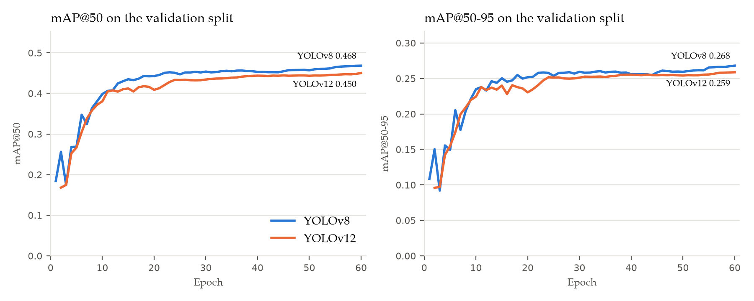
Figure 19 mAP@50 and mAP@50-95 per Training Epoch for YOLOv8 and YOLOv12
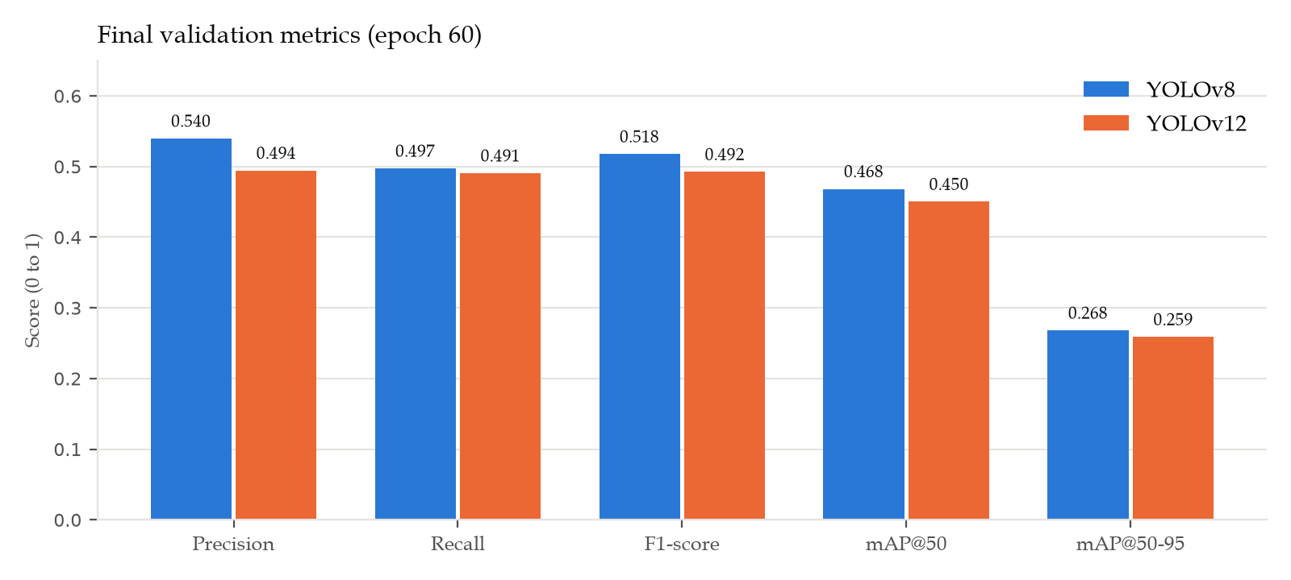
Figure 20 Final Validation Metrics of YOLOv8 and YOLOv12
On the validation split, YOLOv8 obtained a slightly higher score than YOLOv12 on every overall metric, with an mAP@50 of 46.83% against 45.02%. On the held-out test split, YOLOv8 obtained the higher mAP@50 (51.91% against 48.11%) and mAP@50-95 (28.53% against 26.28%). Test precision was 54.32% for YOLOv8 and 52.94% for YOLOv12, and test recall was 52.34% and 50.06%, respectively. YOLOv12 reached its results with about 24% fewer parameters (19.66 million against 25.86 million).
Figure 19 shows that both models improved quickly during the first ten epochs and then levelled off: after roughly epoch 25, validation mAP@50 rose by only about two percentage points for either model. Additional epochs alone are therefore unlikely to produce large gains; further improvement depends more on the training data than on longer training.

4.1.4 Per-Class Detection Results
Tables 17 and 18 present the precision, recall, F1-score, mAP@50, and mAP@50-95 of each class on the test split, and Figure 21 compares the per-class mAP@50 of the two models and the fused ensemble.
Table 17 Per-Class Detection Performance of YOLOv8 (Test Split)
Class | Instances | Precision | Recall | F1-score | mAP@50 | mAP@50-95
Healthy tooth | 42 | 42.86% | 83.33% | 56.60% | 80.54% | 62.37%
Cavity | 2,716 | 65.55% | 69.43% | 67.43% | 66.33% | 33.11%
Gum inflammation | 1,544 | 61.01% | 49.85% | 54.87% | 52.35% | 21.97%
Plaque | 554 | 42.84% | 7.04% | 12.09% | 7.36% | 3.06%
Tartar | 2,009 | 59.33% | 52.07% | 55.46% | 52.97% | 22.15%
All classes | 6,865 | 54.32% | 52.34% | 53.31% | 51.91% | 28.53%
Source: test-split evaluation pass, scored with the Ultralytics matching rule.
Table 18 Per-Class Detection Performance of YOLOv12 (Test Split)
Class | Instances | Precision | Recall | F1-score | mAP@50 | mAP@50-95
Healthy tooth | 42 | 43.40% | 78.57% | 55.91% | 70.13% | 54.83%
Cavity | 2,716 | 62.82% | 69.26% | 65.88% | 64.50% | 32.27%
Gum inflammation | 1,544 | 60.59% | 45.60% | 52.04% | 48.95% | 20.16%
Plaque | 554 | 39.55% | 8.30% | 13.73% | 7.15% | 3.52%
Tartar | 2,009 | 58.34% | 48.59% | 53.03% | 49.82% | 20.62%
All classes | 6,865 | 52.94% | 50.06% | 51.46% | 48.11% | 26.28%
Source: test-split evaluation pass, scored with the Ultralytics matching rule.
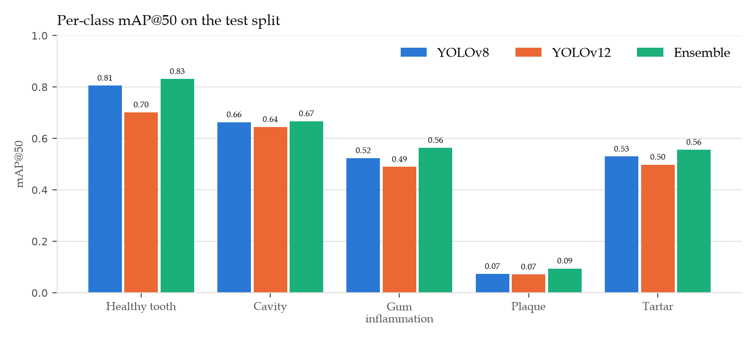
Figure 21 Per-Class mAP@50 on the Test Split
Performance differed strongly between classes. Among the well-represented classes, both models detected cavity best (mAP@50 of 66.33% for YOLOv8 and 64.50% for YOLOv12, from 2,716 labeled instances) and plaque worst (7.36% and 7.15%). In descending order of mean mAP@50, the classes ranked as follows: healthy tooth, cavity, tartar, gum inflammation, plaque. The healthy tooth class scored 80.54% and 70.13%, but the test split contains only 42 labeled healthy tooth instances in 39 images, so this result is less certain than the others.
The weakest class, plaque, is the main limitation of the trained models. Of the 554 labeled plaque instances in the test split, YOLOv8 found 7.04% and YOLOv12 8.30% at the confidence that gives each model its best F1-score. Plaque appears as a thin, low-contrast film that is hard to separate from the tooth surface and from tartar in an ordinary photograph, and its boundaries are hard to annotate consistently, which makes an overlap of 0.50 with the labeled box difficult to reach. In addition, the plaque labels come from only one of the four source datasets. Class frequency also matters: the test split contains 554 plaque instances against 2,716 cavity instances. These are the same difficulties that the first problem of the study identifies in visual-only screening.

4.1.5 Detection Accuracy and Confusion Matrix
Object detection does not have a single built-in accuracy measure, because a model can be wrong in three ways: it can label a finding with the wrong class, raise a box where there is no finding (false alarm), or miss a finding entirely. This study therefore defines detection accuracy as the number of correctly located and correctly labeled findings divided by the total of correct, wrongly labeled, false-alarm, and missed findings. The counts were taken from the confusion matrix at the confidence threshold used by the deployed system (0.25) and an IoU of 0.45. Tables 19 and 20 present the result, and Figure 22 shows the confusion matrices.
Table 19 Detection Accuracy on the Test Split (Confidence 0.25, IoU 0.45)
Model | Correct | Wrong class | False alarms | Missed | Detection accuracy
YOLOv8 | 3,877 | 114 | 1,992 | 2,874 | 43.77%
YOLOv12 | 3,726 | 119 | 2,039 | 3,020 | 41.85%
Fused ensemble | 4,491 | 158 | 3,574 | 2,216 | 43.02%
Detection accuracy = Correct / (Correct + Wrong class + False alarms + Missed).
Table 20 Detection Accuracy per Class on the Test Split
Class | YOLOv8 | YOLOv12 | Fused ensemble
Healthy tooth | 38.20% | 39.29% | 33.94%
Cavity | 52.87% | 51.38% | 49.83%
Gum inflammation | 40.53% | 37.16% | 42.25%
Plaque | 6.46% | 7.58% | 10.46%
Tartar | 40.52% | 38.01% | 39.54%
Per class: correct detections of the class divided by all detections and labels of that class (correct + wrong + false alarms + missed).
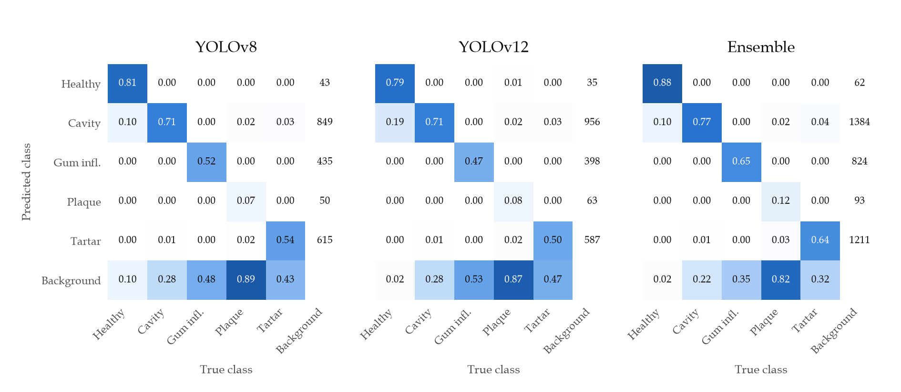
Figure 22 Confusion Matrices on the Test Split (Columns Normalized by True Class)
At the deployed confidence threshold, YOLOv8 reached a detection accuracy of 43.77%, YOLOv12 41.85%, and the fused ensemble 43.02%; the highest was obtained by YOLOv8. For both single models, the most common error type was missed findings. Wrong-class detections were comparatively rare, which means that when a model does locate a finding it usually names the condition correctly; most errors come from findings that are not detected at all or from boxes raised on unremarkable areas. The most frequent confusion between two conditions was a true tartar labeled as cavity.
The fused ensemble had a slightly lower detection accuracy than YOLOv8 even though its mAP@50 was higher (Section 4.1.7). The ensemble keeps a finding reported by either model, so it missed fewer findings (2,216 against 2,874) but raised more false alarms (3,574 against 1,992). Detection accuracy weighs both errors equally, whereas mAP rewards ranking correct findings above false ones across all confidence levels.
Two cautions apply to these counts. First, the four source datasets were not all annotated for the same conditions; for example, a photograph from a source without a gum inflammation class may show inflamed gums that were never labeled. A correct detection on such an image is counted as a false alarm, so the false-alarm counts, and therefore the accuracy, are conservative. Second, the counts depend on the confidence threshold: a lower threshold finds more findings but raises more false alarms.
For a screening support tool, missed findings are the more serious error because a false alarm is reviewed and dismissed by the dentist, whereas a missed finding may not be examined. This supports keeping the dentist's visual examination as the reference and presenting the detections as suggestions.

4.1.6 Inference Speed
Inference speed was measured on the deployment-class workstation without a GPU, which reflects the clinic setting described in Chapter III. Each model processed four clinic screening images five times at 640 × 640 pixels after a warm-up pass. Table 21 reports the mean time per image.
Table 21 Inference Time per Image on CPU
Configuration | Mean time per image | Standard deviation | Model forward pass only
YOLOv8 | 215.9 ms | 8.9 ms | 203.7 ms
YOLOv12 | 206.5 ms | 7.6 ms | 198.9 ms
Both models (ensemble, run in sequence) | 506.8 ms | 138.7 ms | —
Machine: Intel Core i7-13620H, 16 GB RAM, CPU only (PyTorch 2.14 CPU, Ultralytics 8.4.116); n = 20 timed predictions per configuration.
Both models analyzed a photograph in about one fifth of a second, with YOLOv12 about 4% faster than YOLOv8 on the same hardware. Running both models for the ensemble took about half a second per image. This is well within an interactive response time for a screening workflow, in which the dentist uploads a photograph and reviews the results on the same screen.

4.1.7 Ensemble Fusion
In the deployed system, both models analyze each image and their outputs are combined into a single clinical detection set. Boxes from both models are grouped when they share a label and overlap with an IoU of at least 0.50; each group is merged into one box whose coordinates are the confidence-weighted average of its members (weighted box fusion). A finding confirmed by both models receives a confidence increase of 0.08, capped at 0.98, because agreement between two independently trained models is stronger evidence than either model alone.
To measure the effect of fusion, the test split was passed once through both models, and the YOLOv8 output, the YOLOv12 output, and the fused output were scored with the same matching code. Table 22 presents the result.
Table 22 YOLOv8, YOLOv12, and the Fused Ensemble on the Test Split
Metric | YOLOv8 | YOLOv12 | Fused ensemble
Precision | 54.32% | 52.94% | 53.51%
Recall | 52.34% | 50.06% | 55.77%
F1-score | 53.31% | 51.46% | 54.62%
mAP@50 | 51.91% | 48.11% | 54.24%
mAP@50-95 | 28.53% | 26.28% | 29.31%
mAP@50 – healthy tooth | 80.54% | 70.13% | 83.11%
mAP@50 – cavity | 66.33% | 64.50% | 66.72%
mAP@50 – gum inflammation | 52.35% | 48.95% | 56.36%
mAP@50 – plaque | 7.36% | 7.15% | 9.45%
mAP@50 – tartar | 52.97% | 49.82% | 55.58%
Same prediction pass as Tables 16 to 18; the single-model columns repeat those results.
The fused ensemble obtained an mAP@50 of 54.24%, against 51.91% for the better single model (YOLOv8) in the same evaluation, a difference of +2.34 percentage points, and it scored higher than YOLOv8 on all five classes. Its recall was 55.77% against 52.34%, and its precision 53.51% against 54.32%. At the deployed confidence threshold, the ensemble missed 2,216 findings against 2,874 for YOLOv8, but raised 3,574 false alarms against 1,992, because a box from either model is kept.
Fusion therefore improved on both single models: findings that one model misses are often detected by the other, and agreement between the two raises the confidence of the findings that both models report. This result supports the design decision to run both models in the deployed system rather than choosing one.

4.1.8 Summary of the Model Comparison
In answer to the first problem, both models learned to detect the five target classes. On the held-out test split, YOLOv8 obtained the higher mAP@50 (YOLOv8 51.91%, YOLOv12 48.11%), while YOLOv12 was lighter and slightly faster (about 206 ms against 216 ms per image on CPU). The difference between the two models is small compared with the difference between classes: cavity was detected reliably, while plaque remained difficult for both. The fused ensemble reached an mAP@50 of 54.24% and a detection accuracy of 43.02%. These results support the delimitation in Chapter I that Toothwise is a screening support tool and not a diagnostic replacement: detections are presented to the dentist as suggestions, and the dentist confirms or corrects the findings and the risk tier.

4.2 Specialization and Technical Results
This section presents the technical results of the implemented system: the detection pipeline, the risk scoring engine, the KNN recommendation feature, the results interface and patient records, role-based access, the patient-facing chatbot, and the measured quality of the web application.

4.2.1 AI Detection Pipeline
The FastAPI backend loads both trained checkpoints when the server starts and exposes the screening workflow through authenticated REST endpoints. For each uploaded intraoral photograph the pipeline (1) validates the file type and size (maximum 15 MB), (2) runs YOLOv8 and YOLOv12, (3) fuses their detections as described in Section 4.1.6, (4) computes a risk score and risk tier, (5) generates a prevention plan, and (6) stores the image, every detection with its bounding box and confidence, the risk result, and the plan in the patient's record. The response includes the fused detections and the raw output of each model.

4.2.2 Risk Scoring Engine
The risk score is rule-based so that every score can be explained to the patient and audited by the dentist. Each non-healthy detection contributes its class severity multiplied by its confidence; the score is the highest such value plus 6 points for every additional finding (up to 5 additional findings), capped at 100. Table 23 lists the severity weights and the tier thresholds.
Table 23 Risk Scoring Weights and Tier Thresholds
Class | Severity weight | Highest possible score from one finding
Healthy tooth | 0 | 0 (no risk contribution)
Plaque | 25 | 25 (LOW)
Tartar | 35 | 35 (MEDIUM)
Gum inflammation | 45 | 45 (MEDIUM)
Cavity | 70 | 70 (HIGH)
Tiers: LOW 0–34, MEDIUM 35–69, HIGH 70–100. Source: backend/app/ml/labels.py (SEVERITY_WEIGHT) and backend/app/ml/risk_engine.py.

4.2.3 KNN-Based Recommendation Feature
A K-Nearest Neighbors classifier (K = 5, distance-weighted) assigns each screening to a LOW, MEDIUM, or HIGH tier from its detection profile, and the prevention plan is composed from that tier and the specific conditions found. The classifier was first trained on synthetic reference cases generated from the clinical scoring rule. Every tier that a dentist confirms or corrects in the system is stored as a real labeled case and added to the reference data on retraining.
Table 24 presents the result of the evaluation script on 2,000 synthetic cases that were not used in training. Because these cases follow the same rule as the training cases, the result measures how faithfully the classifier reproduces the rule, not its clinical accuracy.
Table 24 KNN Tier Classification on Unseen Synthetic Cases
Risk tier | Precision | Recall | F1-score | Cases
LOW | 98.35% | 96.30% | 97.31% | 864
MEDIUM | 90.18% | 95.47% | 92.75% | 971
HIGH | 76.19% | 58.18% | 65.98% | 165
Overall (weighted) | — | — | 92.51% | 2,000
Overall accuracy: 92.75%. Source: python -m app.ml.evaluate_knn.
The classifier agreed with the rule on 92.75% of the unseen cases. Most errors occurred at tier boundaries; the weakest tier was HIGH, where 69 of 165 cases were classified as MEDIUM (recall 58.18%). No LOW case was classified as HIGH and no HIGH case as LOW. Because a missed HIGH tier is the most consequential error, the dentist's confirmation step remains part of the workflow. The accuracy of the classifier against dentist-confirmed tiers is [TBD – number of dentist-confirmed cases and accuracy; none were recorded when this chapter was drafted].

4.2.4 Results Interface and Patient Records
In answer to the second problem, every screening is saved as a standardized visual record: the original photograph, color-coded bounding boxes with the condition label and confidence, a plain-language description of each condition, the risk score and tier, the prevention plan, and the dentist's clinical notes. The patient record lists all screenings in chronological order with a risk trend chart, so findings can be compared across visits. Each screening can be exported as a PDF report. Patients can register for the self-service portal and view their own screening history, findings, and prevention plans, but no other patient's data.

4.2.5 Role-Based Web Application
The staff side of the system enforces three roles. The dentist acts as administrator and can manage staff accounts and view the audit log; the receptionist manages patient registration and records; and the dental assistant performs screenings. Patients use a separate login scope. Access is enforced by the backend on every request, not only by hiding menu items. Passwords are hashed with bcrypt, sessions use JSON Web Tokens, login and chatbot requests are rate-limited, and sensitive staff actions are written to an append-only audit log.
The backend has an automated test suite of 84 test cases covering authentication, staff management, patients, screenings, labels, the risk engine, the recommender, and role permissions. All 84 tests passed in the final run (Table 25).
Table 25 Automated Backend Test Results
Test module | Area tested | Test cases | Result
test_auth.py | Staff and patient login, tokens | 11 | Passed
test_dentists.py | Staff account management | 14 | Passed
test_patients.py | Patient records | 10 | Passed
test_screenings.py | Screening workflow and storage | 9 | Passed
test_labels.py | Class list consistency | 11 | Passed
test_risk_engine.py | Risk score and tier | 9 | Passed
test_recommender.py | KNN tier and prevention plan | 9 | Passed
test_roles.py | Three-role access control | 11 | Passed
Total |  | 84 | 84 passed, 0 failed
Source: python -m pytest in backend/.

4.2.6 AI Chatbot
The public website includes an AI assistant for general dental-care questions and questions about the clinic and the Toothwise service. It is powered by the Google Gemini API. Before a message is sent to the model, e-mail addresses, phone numbers, and record identifiers are removed, and any request for a personal record or screening result is answered with a referral to the secure patient portal instead of being forwarded. Requests are limited to 12 per minute per client.

4.2.7 Web Performance and Accessibility
The production build of the frontend was audited with Google Lighthouse 12 on the public pages at a mobile width (390 px, simulated slow 4G) and a desktop width (1440 px). Table 26 presents the scores.
Table 26 Lighthouse Audit Results
Page | Viewport | Performance | Accessibility | Best practices | Largest Contentful Paint
Landing | Desktop | 99 | 100 | 100 | 0.8 s
Landing | Mobile | 83 | 100 | 100 | 4.0 s
Staff login | Desktop | 100 | 100 | 100 | 0.7 s
Staff login | Mobile | 92 | 100 | 100 | 2.9 s
Patient portal | Desktop | 100 | 100 | 100 | 0.7 s
Patient portal | Mobile | 91 | 100 | 100 | 3.0 s
Cumulative Layout Shift was 0 on every page. Source: docs/frontend_polish_plan.md.
Accessibility and best practices scored 100 on every audited page, and performance ranged from 99 to 100 on desktop and from 83 to 92 on mobile. The lowest score, the landing page on mobile, is due to the hero photograph being discovered late in page loading. Splitting the application by route reduced the main JavaScript bundle from 231 KB to 95 KB (compressed). The signed-in staff pages, which Lighthouse cannot reach, were audited with axe-core 4.14 against WCAG 2.0 and 2.1 Level A and AA rules on all eight staff routes and five dialogs in both light and dark mode; the final audit found zero violations.

4.3 Software Quality Evaluation Based on ISO/IEC 25010
This section answers the fourth problem of the study. [TBD – the evaluation survey is scheduled for administration; every number in this section is a placeholder to be replaced with the tallied responses.]

4.3.1 Respondents
The evaluation targets 100 respondents in two groups: 30 IT experts (software developers, systems analysts, database administrators, and IT educators) and 70 clinical end users (licensed dentists, dental assistants, receptionists, and patients of CodiSmile Dental Clinic). Table 27 presents the planned and actual distribution of respondents.
Table 27 Distribution of Respondents
Respondent group | Planned (n) | Actual (n) | Percentage
IT experts | 30 | [TBD] | [TBD]
Licensed dentists | 10 | [TBD] | [TBD]
Dental assistants | 10 | [TBD] | [TBD]
Receptionists | 5 | [TBD] | [TBD]
Patients | 45 | [TBD] | [TBD]
Total | 100 | [TBD] | 100%

Table 28 Demographic Profile of Respondents
Profile | Category | Frequency | Percentage
Age | 18–25 / 26–35 / 36–45 / 46–55 / 56 and above | [TBD] | [TBD]
Gender | Male / Female / Prefer not to say | [TBD] | [TBD]
Experience with digital health or IT systems | Less than 1 year / 1–3 years / 4–7 years / 8 years or more | [TBD] | [TBD]
Expand each row into one row per category when the responses are tallied.

4.3.2 Research Instrument
The instrument (Appendix A) contains 26 statements grouped under six quality characteristics of the ISO/IEC 25010 software product quality model, as listed in Table 29. Respondents rate each statement after using the system.
Table 29 ISO/IEC 25010 Characteristics Evaluated
Characteristic | Item codes | Items | What is evaluated
Functional Suitability | FS1–FS5 | 5 | Patient records, AI detection, risk scoring, KNN plan, PDF report
Performance Efficiency | PE1–PE4 | 4 | Detection response time, page loading, resource use, concurrency
Usability | US1–US5 | 5 | Layout, result presentation, screening workflow, patient portal, legibility
Reliability | RE1–RE4 | 4 | Error handling, availability, data integrity, backups
Security and Privacy | SP1–SP4 | 4 | Authentication and roles, password hashing, image protection, audit log
Compatibility and Portability | CP1–CP4 | 4 | Browsers, screen sizes, cameras, deployment
Total |  | 26

4.3.3 Rating Scale and Interpretation
Each statement is rated on a five-point Likert scale. The weighted mean of each item and characteristic is interpreted using the ranges in Table 30.
Table 30 Likert Scale and Verbal Interpretation
Scale | Mean range | Verbal interpretation | Acceptability
5 | 4.21 – 5.00 | Strongly Agree | Highly Acceptable
4 | 3.41 – 4.20 | Agree | Acceptable
3 | 2.61 – 3.40 | Neutral | Moderately Acceptable
2 | 1.81 – 2.60 | Disagree | Slightly Acceptable
1 | 1.00 – 1.80 | Strongly Disagree | Not Acceptable

4.3.4 Statistical Treatment
The weighted mean of each item is computed as WM = Σ(f × x) / N, where f is the number of respondents who chose a rating, x is the rating (1 to 5), and N is the number of respondents. The mean of a characteristic is the average of its item means, and the overall mean is the average of the six characteristic means. The standard deviation is reported to show how much the respondents agreed with one another.

4.3.5 Evaluation Results per Characteristic
Tables 31 to 36 present the weighted mean, standard deviation, and verbal interpretation of each statement, grouped by characteristic. The statements are abbreviated; the full wording is in Appendix A.
Table 31 Evaluation Results for Functional Suitability
Code | Statement | WM | SD | Verbal interpretation
FS1 | The system accurately captures and maintains patient information and records. | [TBD] | [TBD] | [TBD]
FS2 | The AI detection module correctly identifies and localizes dental conditions. | [TBD] | [TBD] | [TBD]
FS3 | The risk score (0–100) and risk tier classification are appropriate to the findings. | [TBD] | [TBD] | [TBD]
FS4 | The KNN recommendation feature generates relevant, condition-specific prevention plans. | [TBD] | [TBD] | [TBD]
FS5 | The system generates complete PDF screening reports. | [TBD] | [TBD] | [TBD]
 | Functional Suitability — mean | [TBD] | [TBD] | [TBD]

[TBD – one paragraph interpreting the Functional Suitability results: the highest- and lowest-rated statements and what respondents' comments say about them.]
Table 32 Evaluation Results for Performance Efficiency
Code | Statement | WM | SD | Verbal interpretation
PE1 | The AI model returns detection results within an acceptable time. | [TBD] | [TBD] | [TBD]
PE2 | Pages, patient lists, and images load quickly. | [TBD] | [TBD] | [TBD]
PE3 | The system runs smoothly without using excessive computer resources. | [TBD] | [TBD] | [TBD]
PE4 | Concurrent requests and database transactions are handled reliably. | [TBD] | [TBD] | [TBD]
 | Performance Efficiency — mean | [TBD] | [TBD] | [TBD]

[TBD – one paragraph interpreting the Performance Efficiency results: the highest- and lowest-rated statements and what respondents' comments say about them.]
Table 33 Evaluation Results for Usability
Code | Statement | WM | SD | Verbal interpretation
US1 | The interface layout is well-structured, intuitive, and easy to navigate. | [TBD] | [TBD] | [TBD]
US2 | Detection results, color-coded labels, and risk badges are easy to understand. | [TBD] | [TBD] | [TBD]
US3 | The four-step screening workflow is easy to follow. | [TBD] | [TBD] | [TBD]
US4 | The patient portal is accessible and patient-friendly. | [TBD] | [TBD] | [TBD]
US5 | Contrast, typography, and light and dark themes make the text easy to read. | [TBD] | [TBD] | [TBD]
 | Usability — mean | [TBD] | [TBD] | [TBD]

[TBD – one paragraph interpreting the Usability results: the highest- and lowest-rated statements and what respondents' comments say about them.]
Table 34 Evaluation Results for Reliability
Code | Statement | WM | SD | Verbal interpretation
RE1 | The system handles invalid inputs and interruptions gracefully. | [TBD] | [TBD] | [TBD]
RE2 | The system remains available for continuous use. | [TBD] | [TBD] | [TBD]
RE3 | Data integrity is maintained across all records. | [TBD] | [TBD] | [TBD]
RE4 | Database backups run reliably to protect patient data. | [TBD] | [TBD] | [TBD]
 | Reliability — mean | [TBD] | [TBD] | [TBD]

[TBD – one paragraph interpreting the Reliability results: the highest- and lowest-rated statements and what respondents' comments say about them.]
Table 35 Evaluation Results for Security and Privacy
Code | Statement | WM | SD | Verbal interpretation
SP1 | Authentication uses secure tokens and role-based access. | [TBD] | [TBD] | [TBD]
SP2 | Passwords are stored using secure hashing. | [TBD] | [TBD] | [TBD]
SP3 | Patient photographs are protected from unauthorized access. | [TBD] | [TBD] | [TBD]
SP4 | An audit trail records sensitive administrative and clinical actions. | [TBD] | [TBD] | [TBD]
 | Security and Privacy — mean | [TBD] | [TBD] | [TBD]

[TBD – one paragraph interpreting the Security and Privacy results: the highest- and lowest-rated statements and what respondents' comments say about them.]
Table 36 Evaluation Results for Compatibility and Portability
Code | Statement | WM | SD | Verbal interpretation
CP1 | The application works consistently across mainstream browsers. | [TBD] | [TBD] | [TBD]
CP2 | The system adapts to desktop, laptop, and tablet screens. | [TBD] | [TBD] | [TBD]
CP3 | The system works with standard device cameras for image capture. | [TBD] | [TBD] | [TBD]
CP4 | The system can be deployed on standard clinic computers. | [TBD] | [TBD] | [TBD]
 | Compatibility and Portability — mean | [TBD] | [TBD] | [TBD]

[TBD – one paragraph interpreting the Compatibility and Portability results: the highest- and lowest-rated statements and what respondents' comments say about them.]

4.3.6 Summary of the ISO/IEC 25010 Evaluation
Table 37 Summary of ISO/IEC 25010 Evaluation Results
Characteristic | IT experts (WM) | Clinical users (WM) | Overall WM | SD | Interpretation
Functional Suitability | [TBD] | [TBD] | [TBD] | [TBD] | [TBD]
Performance Efficiency | [TBD] | [TBD] | [TBD] | [TBD] | [TBD]
Usability | [TBD] | [TBD] | [TBD] | [TBD] | [TBD]
Reliability | [TBD] | [TBD] | [TBD] | [TBD] | [TBD]
Security and Privacy | [TBD] | [TBD] | [TBD] | [TBD] | [TBD]
Compatibility and Portability | [TBD] | [TBD] | [TBD] | [TBD] | [TBD]
Overall | [TBD] | [TBD] | [TBD] | [TBD] | [TBD]

[TBD – discussion of the overall result: the overall weighted mean and its interpretation, the highest- and lowest-rated characteristics, any difference between IT experts and clinical users, and the main themes of the qualitative feedback in Section D of the instrument.]

4.4 Screening Consistency and Screening Time
This section answers the fifth problem of the study by comparing Toothwise-assisted screening with the current manual process, using the dentist's findings as the reference. [TBD – this comparison had not been conducted when this chapter was drafted.]
Table 38 Screening Time: Manual Process versus Toothwise
Measure | Manual process | With Toothwise | Difference
Number of screenings timed | [TBD] | [TBD] | —
Mean screening and documentation time per patient | [TBD] | [TBD] | [TBD]
Standard deviation | [TBD] | [TBD] | —
Statistical test (e.g., paired t-test) and p-value | — | — | [TBD]

Table 39 Screening Consistency against the Dentist's Findings
Measure | Manual process | With Toothwise
Agreement with the dentist's findings (%) | [TBD] | [TBD]
Cohen's kappa against the dentist's findings | [TBD] | [TBD]
Findings missed (false negatives) | [TBD] | [TBD]

[TBD – interpretation of the time and consistency results.]

CHAPTER V

SUMMARY OF FINDINGS, CONCLUSIONS, AND RECOMMENDATIONS
This chapter summarizes the findings of the study, states the conclusions drawn from them, and presents recommendations for CodiSmile Dental Clinic, for the further development of Toothwise, and for future researchers.

5.1 Summary of Findings
The findings are summarized according to the five problems stated in Chapter I.
1. Detection of the five classes (Problem 1). Two detection models were trained on 40,271 images merged from four public datasets and evaluated on a held-out test split of 2,930 images. On the test split, YOLOv8 obtained a precision of 54.32%, a recall of 52.34%, an mAP@50 of 51.91%, and an mAP@50-95 of 28.53%; YOLOv12 obtained 52.94%, 50.06%, 48.11%, and 26.28%, respectively, with 24% fewer parameters. The detection accuracy at the deployed threshold was 43.77% for YOLOv8, 41.85% for YOLOv12, and 43.02% for the fused ensemble, whose mAP@50 was 54.24%, the highest of the three. Among the well-represented classes, cavity was detected best; plaque was detected worst, with at most 8.30% of its 554 test instances found. On CPU, the models analyzed an image in 216 ms and 206 ms, and both together in about 507 ms.
2. Recording and access to findings (Problem 2). Every screening is stored as a standardized visual record with the photograph, labeled bounding boxes, risk result, prevention plan, and dentist's notes, viewable across visits by staff, exportable as a PDF, and viewable by the patient through the self-service portal.
3. Finding-specific preventive guidance (Problem 3). The rule-based risk engine and the KNN classifier (K = 5) produce a risk tier and a prevention plan for every screening. On 2,000 unseen synthetic cases the classifier reproduced the clinical rule with 92.75% accuracy; its weakest tier was HIGH (recall 58.18%).
4. Acceptability based on ISO/IEC 25010 (Problem 4). [TBD – overall weighted mean, interpretation, and highest- and lowest-rated characteristics from the survey of 100 respondents.] Technically, the web application scored 100 in Lighthouse accessibility and best practices on all audited pages, had zero WCAG A/AA violations on the staff pages, and passed all 84 automated backend tests.
5. Screening consistency and time (Problem 5). [TBD – mean screening time and agreement with the dentist's findings, manual process versus Toothwise.]

5.2 Conclusions
Based on the findings, the following conclusions are drawn.
1. YOLO-based detection on ordinary intraoral photographs can locate and label tartar, plaque, cavity, gum inflammation, and healthy tooth, but with an mAP@50 on unseen images of 51.91% for the better single model and 54.24% for the fused ensemble, and with large differences between classes (cavity reliable, plaque weak), it is suitable as a screening aid that directs the dentist's attention, not as an independent diagnosis. This confirms the delimitation set in Chapter I.
2. The difference between YOLOv8 and YOLOv12 on this dataset is small compared with the differences between classes, so the quality, balance, and consistency of the training data matter more than the choice of architecture. Combining both models improved detection over either model alone, which supports the ensemble design.
3. Storing each screening as a standardized visual record and giving patients portal access addresses the absence of comparable records across visits identified in the second problem.
4. Finding-specific prevention plans can be generated automatically for every screening without adding to the dentist's workload, while the dentist's confirmation of the risk tier keeps the guidance clinically supervised and gradually improves the KNN reference data.
5. [TBD – conclusion on acceptability, to be written after the survey: whether IT experts and clinical users rated Toothwise as acceptable on the six ISO/IEC 25010 characteristics.]
6. [TBD – conclusion on screening consistency and screening time, to be written after the comparison with the manual process.]

5.3 Recommendations
In light of the findings and conclusions, the following are recommended.
For CodiSmile Dental Clinic
- Use Toothwise as a screening aid during intake and follow-up visits, with the dentist reviewing and confirming every finding and risk tier before it is shared with the patient.
- Standardize image capture (camera, lighting, distance, and angle) so that clinic photographs resemble the training images as closely as possible.
- Confirm or correct the risk tier on every screening so that the KNN feature learns from real clinic cases.
- Encourage patients to register for the patient portal so they can follow their prevention plans between visits.
For the improvement of the detection models
- Collect and annotate photographs from CodiSmile Dental Clinic, with labels reviewed by the clinic's dentist, and fine-tune both models on them; this is expected to give the largest accuracy gain because the current models learned only from public datasets.
- Give priority to plaque, the weakest class (Tables 17 and 18): collect close-up photographs in which it is clearly visible, label it with tight, consistent boxes, and consider a higher input resolution so that thin deposits remain visible to the model.
- Re-annotate the merged sources so that every image is labeled for all five conditions. The healthy tooth, gum inflammation, and plaque labels each come from a single source, so other images may show these conditions without a label, which both confuses training and inflates the false-alarm counts in evaluation.
- Enlarge the healthy tooth test set; with only 42 labeled instances its high score cannot yet be relied upon.
- Tune the confidence threshold and fusion settings of the ensemble on the validation split. The ensemble missed fewer findings than the better single model (2,216 against 2,874) but raised more false alarms (3,574 against 1,992); a slightly higher threshold for findings reported by only one model may keep most of the gain with fewer false alarms.
- Experiment with larger model variants, higher input resolution for small findings, and longer training only after the data improvements above, since validation accuracy had levelled off after about 25 epochs.
For the further development of the system
- Evaluate the KNN feature against dentist-confirmed tiers once enough real cases are recorded, and retrain it periodically on those cases.
- Improve mobile loading of the public landing page (currently a Lighthouse performance score of 83 on mobile) by loading the hero image earlier.
- Add appointment reminders and follow-up notifications in the patient portal, and consider integration with the clinic's appointment and billing processes, which were outside the scope of this study.
For future researchers
- Test the system in other clinics and with other camera devices to measure how well the results generalize.
- Extend the classes to other conditions visible in photographs, such as discoloration or fractured teeth, with adequately annotated data.
- Study long-term outcomes, such as whether patients who receive finding-specific prevention plans show fewer new cavities over time, which this study did not measure.

