**Nama : Ahmad Zain Azharul Falah**

**No. Peserta : JVSB001ONL004**

**Requirement 1:**

**Database PT. Melodi Indah**

|  |
| --- |
| -- Adminer 4.8.1 MySQL 5.5.5-10.4.24-MariaDB dump  SET NAMES utf8;  SET time_zone = '+00:00';  SET foreign_key_checks = 0;  SET sql_mode = 'NO_AUTO_VALUE_ON_ZERO';  DROP VIEW IF EXISTS `all_data`;  CREATE TABLE `all_data` (`id_ssn` int(2) unsigned zerofill, `nama_pemusik` varchar(50), `alamat_pemusik` text, `notelp_pemusik` varchar(13), `nama_album` varchar(20), `tanggal_copyright` date, `format_album` enum('CD','MC'), `judul_lagu` varchar(30), `pengarang_lagu` varchar(20), `nama_instrumen` varchar(20), `kunci_musik` enum('A','B','C','A#','B#','C#'));  SET NAMES utf8mb4;  DROP TABLE IF EXISTS `tb_album`;  CREATE TABLE `tb_album` (  `id_album` int(5) NOT NULL AUTO_INCREMENT,  `nama_album` varchar(20) NOT NULL,  `tanggal_copyright` date NOT NULL,  `format_album` enum('CD','MC') NOT NULL,  `id_combine_musik` int(2) unsigned zerofill NOT NULL,  PRIMARY KEY (`id_album`),  KEY `id_combine_musik` (`id_combine_musik`),  CONSTRAINT `tb_album_ibfk_1` FOREIGN KEY (`id_combine_musik`) REFERENCES `tb_pemusik` (`id_ssn`)  ) ENGINE=InnoDB DEFAULT CHARSET=utf8mb4;  INSERT INTO `tb_album` (`id_album`, `nama_album`, `tanggal_copyright`, `format_album`, `id_combine_musik`) VALUES  (111, 'Air', '2001-01-01', 'CD', 11),  (222, 'Api', '2002-02-02', 'MC', 22),  (333, 'Udara', '2003-03-03', 'CD', 33),  (444, 'Bumi', '2004-04-04', 'CD', 11);  DROP TABLE IF EXISTS `tb_combine_musik`;  CREATE TABLE `tb_combine_musik` (  `id_combine_musik` int(2) unsigned zerofill NOT NULL,  `id_ssn` int(2) unsigned zerofill NOT NULL,  `id_instrumen` int(5) NOT NULL,  KEY `id_ssn` (`id_combine_musik`),  KEY `id_ssn_2` (`id_ssn`),  KEY `id_instrumen` (`id_instrumen`),  CONSTRAINT `tb_combine_musik_ibfk_1` FOREIGN KEY (`id_combine_musik`) REFERENCES `tb_pemusik` (`id_ssn`),  CONSTRAINT `tb_combine_musik_ibfk_2` FOREIGN KEY (`id_ssn`) REFERENCES `tb_pemusik` (`id_ssn`),  CONSTRAINT `tb_combine_musik_ibfk_3` FOREIGN KEY (`id_instrumen`) REFERENCES `tb_instrumen` (`id_instrumen`)  ) ENGINE=InnoDB DEFAULT CHARSET=utf8mb4;  INSERT INTO `tb_combine_musik` (`id_combine_musik`, `id_ssn`, `id_instrumen`) VALUES  (11, 11, 1),  (22, 22, 2),  (33, 33, 1);  DROP TABLE IF EXISTS `tb_instrumen`;  CREATE TABLE `tb_instrumen` (  `id_instrumen` int(5) NOT NULL AUTO_INCREMENT,  `nama_instrumen` varchar(20) NOT NULL,  `kunci_musik` enum('A','B','C','A#','B#','C#') NOT NULL,  PRIMARY KEY (`id_instrumen`)  ) ENGINE=InnoDB DEFAULT CHARSET=utf8mb4;  INSERT INTO `tb_instrumen` (`id_instrumen`, `nama_instrumen`, `kunci_musik`) VALUES  (1, 'Piano', 'A'),  (2, 'Suling', 'A#'),  (3, 'Gitar', 'C#'),  (4, 'Gendang', 'B'),  (5, 'Harpa', 'C');  DROP TABLE IF EXISTS `tb_lagu`;  CREATE TABLE `tb_lagu` (  `id_lagu` int(11) NOT NULL AUTO_INCREMENT,  `judul_lagu` varchar(30) NOT NULL,  `pengarang_lagu` varchar(20) NOT NULL,  `id_album` int(5) NOT NULL,  PRIMARY KEY (`id_lagu`),  KEY `id_album` (`id_album`),  CONSTRAINT `tb_lagu_ibfk_2` FOREIGN KEY (`id_album`) REFERENCES `tb_album` (`id_album`)  ) ENGINE=InnoDB DEFAULT CHARSET=utf8mb4;  INSERT INTO `tb_lagu` (`id_lagu`, `judul_lagu`, `pengarang_lagu`, `id_album`) VALUES  (1, 'Easy On Me', 'Adele', 111),  (2, 'Friends', 'Anne Marie', 222),  (3, 'Lay All Your Love On Me', 'ABBA', 444),  (4, 'R U Mine?', 'Arctic Monkeys', 333),  (6, 'Beautiful', 'Bazzi', 444),  (7, 'Build a Bitch', 'Bella Poarch', 333),  (8, 'Happier Than Ever', 'Bille Eilish', 333),  (9, 'Dejavu', 'Olivia R', 222);  DROP TABLE IF EXISTS `tb_pemusik`;  CREATE TABLE `tb_pemusik` (  `id_ssn` int(2) unsigned zerofill NOT NULL AUTO_INCREMENT,  `nama_pemusik` varchar(50) NOT NULL,  `alamat_pemusik` text NOT NULL,  `notelp_pemusik` varchar(13) NOT NULL,  PRIMARY KEY (`id_ssn`)  ) ENGINE=InnoDB DEFAULT CHARSET=utf8mb4;  INSERT INTO `tb_pemusik` (`id_ssn`, `nama_pemusik`, `alamat_pemusik`, `notelp_pemusik`) VALUES  (11, 'Olivia R', 'Bandung', '081201010101'),  (22, 'Bella Poarch', 'Tangerang', '081202020202'),  (33, 'Arctic Monkeys', 'Depok', '081203030303'),  (44, 'Billie Eilish', 'Sukabumi', '081204040404');  DROP TABLE IF EXISTS `all_data`;  CREATE ALGORITHM=UNDEFINED SQL SECURITY DEFINER VIEW `all_data` AS select `tpe`.`id_ssn` AS `id_ssn`,`tpe`.`nama_pemusik` AS `nama_pemusik`,`tpe`.`alamat_pemusik` AS `alamat_pemusik`,`tpe`.`notelp_pemusik` AS `notelp_pemusik`,`ta`.`nama_album` AS `nama_album`,`ta`.`tanggal_copyright` AS `tanggal_copyright`,`ta`.`format_album` AS `format_album`,`tl`.`judul_lagu` AS `judul_lagu`,`tl`.`pengarang_lagu` AS `pengarang_lagu`,`ti`.`nama_instrumen` AS `nama_instrumen`,`ti`.`kunci_musik` AS `kunci_musik` from (`tb_pemusik` `tpe` join (((`tb_combine_musik` `tc` join `tb_album` `ta` on(`tc`.`id_ssn` = `ta`.`id_combine_musik`)) join `tb_lagu` `tl` on(`ta`.`id_album` = `tl`.`id_album`)) join `tb_instrumen` `ti` on(`tc`.`id_instrumen` = `ti`.`id_instrumen`)));  -- 2022-06-26 08:47:57 |

Database yang dibuat dalam beberapa tabel, di antaranya :

1. tb_pemusik untuk memasukkan id_ssn, nama pemusik, alamat pemusik, dan notelp pemusik
2. tb_lagu untuk memasukkan lagu beserta di album mana lagu tersebut diletakkan
3. tb_instrumen untuk memasukkan jenis instrumen
4. tb_album untuk memasukkan detail album
5. combine_musik, untuk menggabungkan id_ssn dan id_instrumen

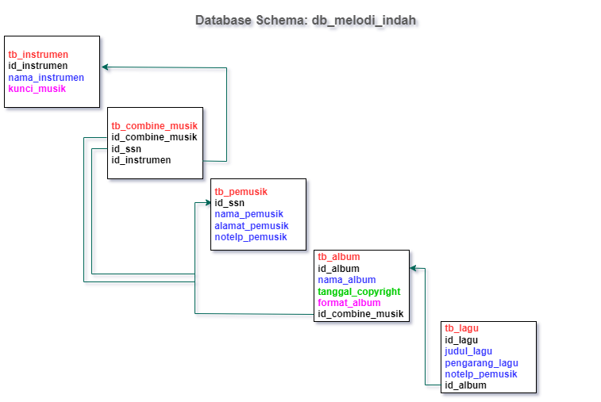

**Requirement 2:**

**Database Company**

|  |
| --- |
| -- Adminer 4.8.1 MySQL 5.5.5-10.4.24-MariaDB dump  SET NAMES utf8;  SET time_zone = '+00:00';  SET foreign_key_checks = 0;  SET sql_mode = 'NO_AUTO_VALUE_ON_ZERO';  DROP VIEW IF EXISTS `req2_soal_a`;  CREATE TABLE `req2_soal_a` (`nama_tanggungan` varchar(20), `hubungan_tanggungan` varchar(20));  DROP VIEW IF EXISTS `req2_soal_b`;  CREATE TABLE `req2_soal_b` (`id_proyek` int(11), `total_proyek_1` bigint(21));  DROP VIEW IF EXISTS `req2_soal_c`;  CREATE TABLE `req2_soal_c` (`gaji_pegawai_diatas_3juta500` bigint(21));  DROP VIEW IF EXISTS `req2_soal_d`;  CREATE TABLE `req2_soal_d` (`total_proyek_departemen_2` bigint(21));  DROP VIEW IF EXISTS `req2_soal_e`;  CREATE TABLE `req2_soal_e` (`nama_departemen` varchar(20), `rata_rata_gaji` double);  DROP VIEW IF EXISTS `req2_soal_f`;  CREATE TABLE `req2_soal_f` (`nama_departemen` varchar(20), `banyak_pegawai` bigint(21));  DROP VIEW IF EXISTS `req2_soal_g`;  CREATE TABLE `req2_soal_g` (`nama_proyek` varchar(20), `total_jam_kerja_perminggu` decimal(32,0));  DROP VIEW IF EXISTS `req2_soal_h`;  CREATE TABLE `req2_soal_h` (`nama_pegawai` varchar(20), `total_waktu_kerja` decimal(32,0));  DROP VIEW IF EXISTS `req2_soal_i`;  CREATE TABLE `req2_soal_i` (`nama_pegawai` varchar(20), `total_waktu_kerja` decimal(32,0), `bonus_kinerja` varchar(9));  DROP VIEW IF EXISTS `req2_soal_j`;  CREATE TABLE `req2_soal_j` (`nama_pegawai` varchar(20), `jumlah_proyek` bigint(21));  DROP VIEW IF EXISTS `req2_soal_k`;  CREATE TABLE `req2_soal_k` (`nama_pegawai` varchar(20), `jumlah_proyek` bigint(21));  DROP VIEW IF EXISTS `req2_soal_l`;  CREATE TABLE `req2_soal_l` (`nama_pegawai` varchar(20), `rata_rata_waktu_kerja` decimal(14,4), `jumlah_proyek` bigint(21));  DROP VIEW IF EXISTS `req2_soal_m`;  CREATE TABLE `req2_soal_m` (`hubungan_tanggungan` varchar(20), `banyaknya_tanggungan` bigint(21));  SET NAMES utf8mb4;  DROP TABLE IF EXISTS `tb_departemen`;  CREATE TABLE `tb_departemen` (  `id_departemen` int(11) NOT NULL AUTO_INCREMENT,  `nama_departemen` varchar(20) NOT NULL,  `tanggal_mulai_manager` date NOT NULL,  `id_manager` int(11) NOT NULL,  PRIMARY KEY (`id_departemen`)  ) ENGINE=InnoDB DEFAULT CHARSET=utf8mb4;  INSERT INTO `tb_departemen` (`id_departemen`, `nama_departemen`, `tanggal_mulai_manager`, `id_manager`) VALUES  (1, 'HRD', '2021-01-01', 111),  (2, 'Sales & Marketing', '2021-02-02', 221),  (3, 'Production', '2021-03-03', 331),  (4, 'Qaulity Assurance', '2021-04-04', 441),  (5, 'Information & Technology', '2021-05-05', 551),  (6, 'Accounting', '2021-06-06', 661);  DROP TABLE IF EXISTS `tb_lokasi_departemen`;  CREATE TABLE `tb_lokasi_departemen` (  `id_departemen` int(11) NOT NULL,  `lokasi_departemen` varchar(20) NOT NULL,  KEY `id_departemen` (`id_departemen`),  CONSTRAINT `tb_lokasi_departemen_ibfk_1` FOREIGN KEY (`id_departemen`) REFERENCES `tb_departemen` (`id_departemen`)  ) ENGINE=InnoDB DEFAULT CHARSET=utf8mb4;  INSERT INTO `tb_lokasi_departemen` (`id_departemen`, `lokasi_departemen`) VALUES  (1, 'Jakarta Selatan'),  (2, 'Banten'),  (3, 'Tangerang'),  (4, 'Depok'),  (5, 'Bogor'),  (6, 'Bekasi');  DROP TABLE IF EXISTS `tb_pegawai`;  CREATE TABLE `tb_pegawai` (  `id_pegawai` int(11) NOT NULL AUTO_INCREMENT,  `id_departemen` int(11) NOT NULL,  `nama_depan` varchar(20) NOT NULL,  `nama_tengah` varchar(20) NOT NULL,  `nama_belakang` varchar(20) NOT NULL,  `tanggal_lahir` date NOT NULL,  `alamat_pegawai` text NOT NULL,  `jenis_kelamin` enum('Laki-laki','Perempuan') NOT NULL,  `gaji_pegawai` float NOT NULL,  `SuperSSN` int(11) NOT NULL,  PRIMARY KEY (`id_pegawai`),  KEY `id_departemen` (`id_departemen`),  CONSTRAINT `tb_pegawai_ibfk_1` FOREIGN KEY (`id_departemen`) REFERENCES `tb_departemen` (`id_departemen`)  ) ENGINE=InnoDB DEFAULT CHARSET=utf8mb4;  INSERT INTO `tb_pegawai` (`id_pegawai`, `id_departemen`, `nama_depan`, `nama_tengah`, `nama_belakang`, `tanggal_lahir`, `alamat_pegawai`, `jenis_kelamin`, `gaji_pegawai`, `SuperSSN`) VALUES  (111, 1, 'Tomas', 'Shelby', 'Gipsy', '1972-10-10', 'Birmingham', 'Laki-laki', 15000000, 1),  (112, 1, 'Arthur', 'Shelby', 'Gipsy', '1970-08-07', 'Birmingham', 'Laki-laki', 33000000, 1),  (221, 2, 'John', 'Shelby', 'Gipsy', '1974-07-07', 'Birmingham', 'Laki-laki', 14000000, 1),  (222, 2, 'Polly', 'Gray', 'Gipsy', '1965-06-09', 'Birmingham', 'Perempuan', 2300000, 2),  (331, 3, 'Finn', 'Shelby', 'Gipsy', '1979-11-11', 'Birmingham', 'Laki-laki', 16000000, 2),  (332, 3, 'Michael', 'Gray', 'Gipsy', '1980-03-07', 'Birmingham', 'Laki-laki', 2200000, 3),  (441, 4, 'Grace', '', 'Burgess', '1975-04-04', 'London', 'Perempuan', 13000000, 3),  (443, 4, 'Charlie', '', 'Strong', '1965-07-07', 'Birmingham', 'Laki-laki', 5000000, 4),  (551, 5, 'Aberama', '', 'Gold', '1967-05-05', 'London', 'Laki-laki', 10000000, 5),  (661, 6, 'Bonnie', '', 'Gold', '1979-07-07', 'London', 'Laki-laki', 17000000, 6);  DROP TABLE IF EXISTS `tb_proyek`;  CREATE TABLE `tb_proyek` (  `id_proyek` int(11) NOT NULL AUTO_INCREMENT,  `nama_proyek` varchar(20) NOT NULL,  `lokasi_proyek` text NOT NULL,  `id_departemen` int(11) NOT NULL,  PRIMARY KEY (`id_proyek`),  KEY `id_departemen` (`id_departemen`),  CONSTRAINT `tb_proyek_ibfk_1` FOREIGN KEY (`id_departemen`) REFERENCES `tb_departemen` (`id_departemen`)  ) ENGINE=InnoDB DEFAULT CHARSET=utf8mb4;  INSERT INTO `tb_proyek` (`id_proyek`, `nama_proyek`, `lokasi_proyek`, `id_departemen`) VALUES  (1, 'Pembangunan Gedung Cabang', 'Jakarta Selatan', 1),  (2, 'Training Tech Staff', 'Bekasi', 2),  (3, 'Yearly Run Fest', 'Banten', 3),  (4, 'Training Digital Marketing', 'Online', 4),  (5, 'Pemeliharaan Kesehatan Karyawan', 'Bogor', 5),  (6, 'Programming Certfication', 'Tangerang', 6),  (7, 'Ms. Excel Workshop', 'Online', 2);  DROP TABLE IF EXISTS `tb_tanggungan`;  CREATE TABLE `tb_tanggungan` (  `id_pegawai` int(11) NOT NULL,  `nama_tanggungan` varchar(20) NOT NULL,  `jenis_kelamin` enum('Laki-laki','Perempuan') NOT NULL,  `tanggal_lahir_tanggungan` date NOT NULL,  `hubungan_tanggungan` varchar(20) NOT NULL,  KEY `id_pegawai` (`id_pegawai`),  CONSTRAINT `tb_tanggungan_ibfk_1` FOREIGN KEY (`id_pegawai`) REFERENCES `tb_pegawai` (`id_pegawai`)  ) ENGINE=InnoDB DEFAULT CHARSET=utf8mb4;  INSERT INTO `tb_tanggungan` (`id_pegawai`, `nama_tanggungan`, `jenis_kelamin`, `tanggal_lahir_tanggungan`, `hubungan_tanggungan`) VALUES  (111, 'Qory', 'Laki-laki', '1997-06-05', 'Anak'),  (221, 'Bill', 'Laki-laki', '1997-08-23', 'Ayah'),  (332, 'Kanaya', 'Perempuan', '1997-07-06', 'Anak'),  (332, 'Fanny', 'Perempuan', '1997-01-11', 'Istri'),  (443, 'Balmond', 'Laki-laki', '1997-07-18', 'Suami'),  (441, 'Karina', 'Perempuan', '1997-05-02', 'Istri'),  (441, 'Bambang', 'Laki-laki', '1997-12-22', 'Anak'),  (441, 'Ucup', 'Laki-laki', '1997-11-25', 'Anak'),  (331, 'Tika', 'Perempuan', '1997-11-27', 'Istri'),  (661, 'Risti', 'Perempuan', '1997-09-16', 'Istri'),  (661, 'Sahal', 'Laki-laki', '1997-05-14', 'Anak'),  (661, 'Rama', 'Laki-laki', '1997-12-21', 'Anak');  DROP TABLE IF EXISTS `tb_waktu_kerja`;  CREATE TABLE `tb_waktu_kerja` (  `id_proyek` int(11) NOT NULL,  `id_pegawai` int(11) NOT NULL,  `waktu_kerja` int(11) NOT NULL,  KEY `id_proyek` (`id_proyek`),  KEY `id_pegawai` (`id_pegawai`),  KEY `waktu_kerja` (`waktu_kerja`),  CONSTRAINT `tb_waktu_kerja_ibfk_1` FOREIGN KEY (`id_proyek`) REFERENCES `tb_proyek` (`id_proyek`),  CONSTRAINT `tb_waktu_kerja_ibfk_2` FOREIGN KEY (`id_pegawai`) REFERENCES `tb_pegawai` (`id_pegawai`)  ) ENGINE=InnoDB DEFAULT CHARSET=utf8mb4;  INSERT INTO `tb_waktu_kerja` (`id_proyek`, `id_pegawai`, `waktu_kerja`) VALUES  (1, 111, 150),  (2, 221, 130),  (3, 331, 250),  (4, 441, 160),  (1, 221, 100),  (1, 331, 210),  (1, 441, 160),  (2, 221, 10),  (2, 221, 30),  (2, 221, 40),  (2, 221, 14),  (2, 221, 50),  (7, 551, 10),  (7, 551, 20),  (7, 551, 30),  (7, 551, 20),  (6, 551, 20),  (4, 551, 30),  (5, 441, 20);  DROP TABLE IF EXISTS `req2_soal_a`;  CREATE ALGORITHM=UNDEFINED SQL SECURITY DEFINER VIEW `req2_soal_a` AS select `tt`.`nama_tanggungan` AS `nama_tanggungan`,`tt`.`hubungan_tanggungan` AS `hubungan_tanggungan` from (`tb_tanggungan` `tt` join `tb_pegawai` `tpe` on(`tt`.`id_pegawai` = `tpe`.`id_pegawai`)) where `tpe`.`nama_depan` like 'R%';  DROP TABLE IF EXISTS `req2_soal_b`;  CREATE ALGORITHM=UNDEFINED SQL SECURITY DEFINER VIEW `req2_soal_b` AS select `twak`.`id_proyek` AS `id_proyek`,count(`twak`.`id_proyek`) AS `total_proyek_1` from `tb_waktu_kerja` `twak` where `twak`.`id_proyek` = 1;  DROP TABLE IF EXISTS `req2_soal_c`;  CREATE ALGORITHM=UNDEFINED SQL SECURITY DEFINER VIEW `req2_soal_c` AS select count(`tpe`.`gaji_pegawai`) AS `gaji_pegawai_diatas_3juta500` from `tb_pegawai` `tpe` where `tpe`.`gaji_pegawai` > 3500000;  DROP TABLE IF EXISTS `req2_soal_d`;  CREATE ALGORITHM=UNDEFINED SQL SECURITY DEFINER VIEW `req2_soal_d` AS select count(`tpr`.`id_departemen`) AS `total_proyek_departemen_2` from `tb_proyek` `tpr` where `tpr`.`id_departemen` = 2;  DROP TABLE IF EXISTS `req2_soal_e`;  CREATE ALGORITHM=UNDEFINED SQL SECURITY DEFINER VIEW `req2_soal_e` AS select `td`.`nama_departemen` AS `nama_departemen`,avg(`tpe`.`gaji_pegawai`) AS `rata_rata_gaji` from (`tb_pegawai` `tpe` join `tb_departemen` `td` on(`tpe`.`id_departemen` = `td`.`id_departemen`)) group by `td`.`id_departemen`;  DROP TABLE IF EXISTS `req2_soal_f`;  CREATE ALGORITHM=UNDEFINED SQL SECURITY DEFINER VIEW `req2_soal_f` AS select `td`.`nama_departemen` AS `nama_departemen`,count(`tpe`.`id_pegawai`) AS `banyak_pegawai` from (`tb_pegawai` `tpe` join `tb_departemen` `td` on(`tpe`.`id_departemen` = `td`.`id_departemen`)) group by `td`.`id_departemen`;  DROP TABLE IF EXISTS `req2_soal_g`;  CREATE ALGORITHM=UNDEFINED SQL SECURITY DEFINER VIEW `req2_soal_g` AS select `tpr`.`nama_proyek` AS `nama_proyek`,sum(`twak`.`waktu_kerja`) AS `total_jam_kerja_perminggu` from (`tb_waktu_kerja` `twak` join `tb_proyek` `tpr` on(`tpr`.`id_proyek` = `twak`.`id_proyek`)) group by `twak`.`id_proyek` order by sum(`twak`.`waktu_kerja`) desc;  DROP TABLE IF EXISTS `req2_soal_h`;  CREATE ALGORITHM=UNDEFINED SQL SECURITY DEFINER VIEW `req2_soal_h` AS select `tpe`.`nama_depan` AS `nama_pegawai`,sum(`twak`.`waktu_kerja`) AS `total_waktu_kerja` from (`tb_pegawai` `tpe` join `tb_waktu_kerja` `twak` on(`tpe`.`id_pegawai` = `twak`.`id_pegawai`)) group by `twak`.`id_pegawai` having sum(`twak`.`waktu_kerja`) > 140 order by sum(`twak`.`waktu_kerja`) desc;  DROP TABLE IF EXISTS `req2_soal_i`;  CREATE ALGORITHM=UNDEFINED SQL SECURITY DEFINER VIEW `req2_soal_i` AS select `tpe`.`nama_depan` AS `nama_pegawai`,sum(`twak`.`waktu_kerja`) AS `total_waktu_kerja`,case when sum(`twak`.`waktu_kerja`) > 200 then 'Bonus 50%' when sum(`twak`.`waktu_kerja`) > 150 then 'Bonus 25%' else 'Bonus 10%' end AS `bonus_kinerja` from (`tb_pegawai` `tpe` join `tb_waktu_kerja` `twak` on(`tpe`.`id_pegawai` = `twak`.`id_pegawai`)) group by `twak`.`id_pegawai` order by sum(`twak`.`waktu_kerja`) desc;  DROP TABLE IF EXISTS `req2_soal_j`;  CREATE ALGORITHM=UNDEFINED SQL SECURITY DEFINER VIEW `req2_soal_j` AS select `tpe`.`nama_depan` AS `nama_pegawai`,count(`twak`.`id_proyek`) AS `jumlah_proyek` from (`tb_pegawai` `tpe` join `tb_waktu_kerja` `twak` on(`tpe`.`id_pegawai` = `twak`.`id_pegawai`)) group by `tpe`.`id_pegawai` order by count(`twak`.`id_proyek`) desc;  DROP TABLE IF EXISTS `req2_soal_k`;  CREATE ALGORITHM=UNDEFINED SQL SECURITY DEFINER VIEW `req2_soal_k` AS select `tpe`.`nama_depan` AS `nama_pegawai`,count(`twak`.`id_proyek`) AS `jumlah_proyek` from (`tb_pegawai` `tpe` join `tb_waktu_kerja` `twak` on(`tpe`.`id_pegawai` = `twak`.`id_pegawai`)) group by `tpe`.`id_pegawai` having `jumlah_proyek` >= 4 order by count(`twak`.`id_proyek`) desc;  DROP TABLE IF EXISTS `req2_soal_l`;  CREATE ALGORITHM=UNDEFINED SQL SECURITY DEFINER VIEW `req2_soal_l` AS select `tpe`.`nama_depan` AS `nama_pegawai`,avg(`twak`.`waktu_kerja`) AS `rata_rata_waktu_kerja`,count(`twak`.`id_proyek`) AS `jumlah_proyek` from (`tb_pegawai` `tpe` join `tb_waktu_kerja` `twak` on(`tpe`.`id_pegawai` = `twak`.`id_pegawai`)) group by `tpe`.`id_pegawai` having `rata_rata_waktu_kerja` > 70 and `jumlah_proyek` >= 2;  DROP TABLE IF EXISTS `req2_soal_m`;  CREATE ALGORITHM=UNDEFINED SQL SECURITY DEFINER VIEW `req2_soal_m` AS select `tt`.`hubungan_tanggungan` AS `hubungan_tanggungan`,count(`tt`.`hubungan_tanggungan`) AS `banyaknya_tanggungan` from (`tb_pegawai` `tpe` join `tb_tanggungan` `tt` on(`tpe`.`id_pegawai` = `tt`.`id_pegawai`)) group by `tt`.`hubungan_tanggungan` order by count(`tt`.`hubungan_tanggungan`) desc;  -- 2022-06-21 21:10:26 |

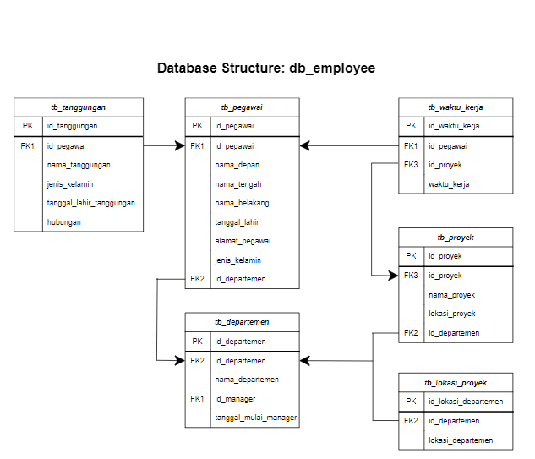

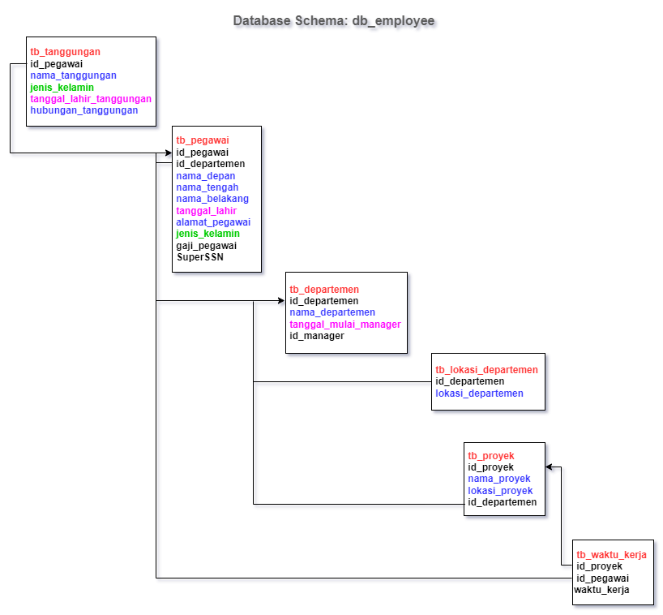

**Database Company**

1. Dependent_name dan relationship dengan employee yang namanya diawali huruf R

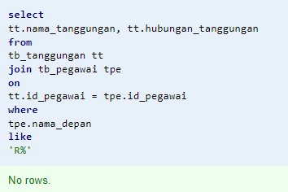

1. Banyaknya yang mengerjakan PNum = 1

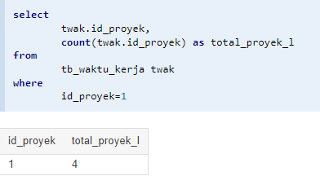

1. Banyaknya employee yang memiliki salary lebih dari 3500000

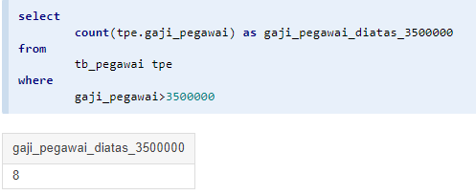

1. Banyak project yang dikerjakan DNum = 2

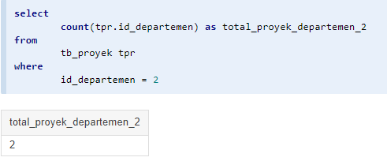

1. Hitung total dan rata-rata salary tiap departemen

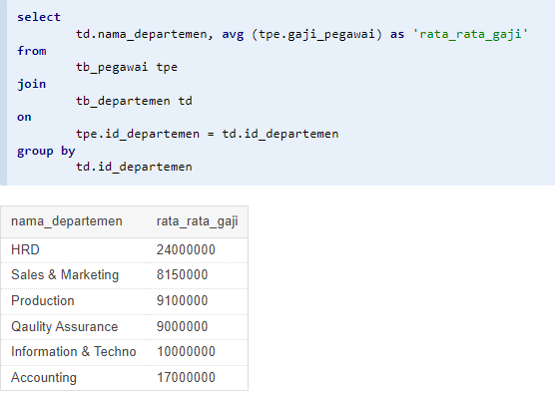

1. Banyaknya employee dari setiap departemen dan urutkan berdasarkan employee terbanyak

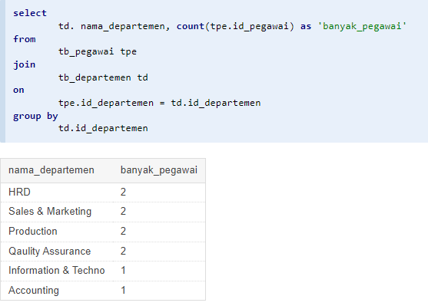

1. Total hours per week dari semua employee untuk setiap project

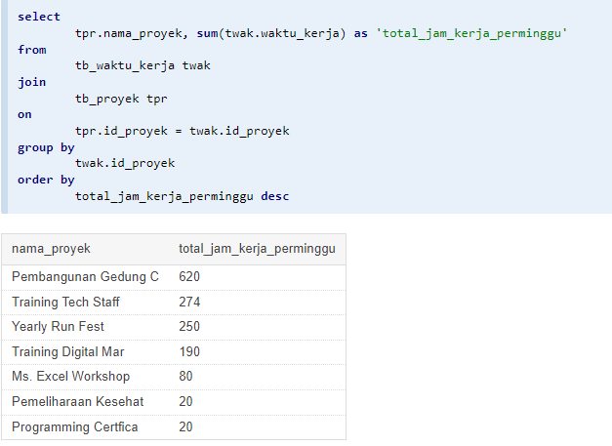

1. Employee yang memiliki total hours per week lebih besar dari 140 hours dan urutkan berdasarkan jumlah jam kerja terbanyak

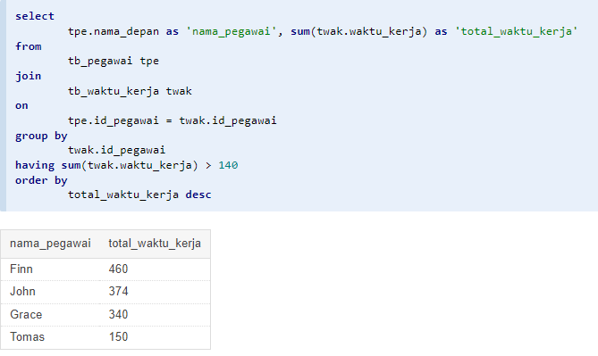

1. Kelompokkan bonus employee berdasarkan jumlah jam kerjanya ? (Jika >= 200 hours, maka bonus = 50%; Jika >= 150 hours, maka bonus = 25%, Selainnya bonus = 10%)

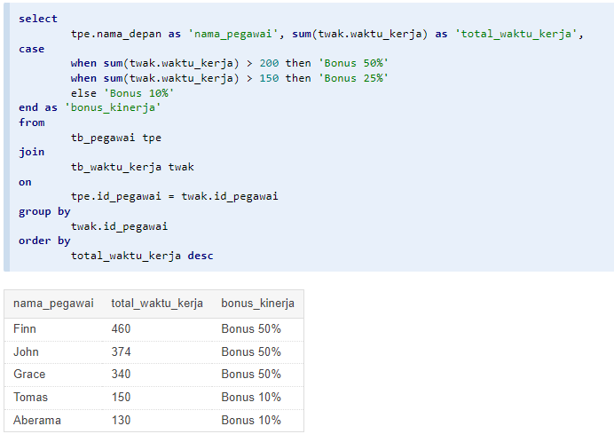

1. Banyaknya project yang dikerjakan tiap employee dan urutkan dari yang terbanyak ?

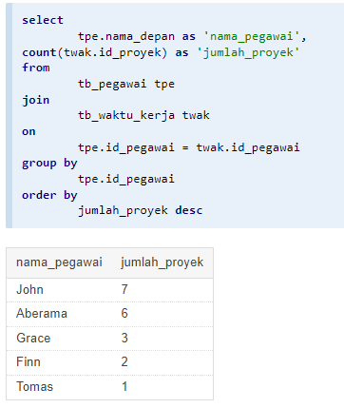

1. Employee yang bekerja pada 4 project

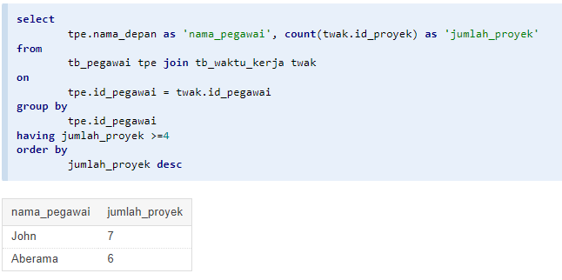

1. Employee yang memiliki rata-rata hours perweek = 70 jam dan bekerja pada 2 project ?

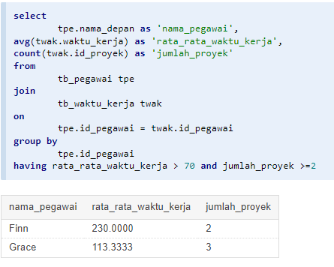

1. Banyaknya Dependent berdasarkan relationship dengan employee ?

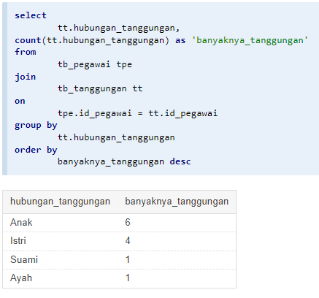

1. Berapa lama Manager tiap Department sudah menjabat?

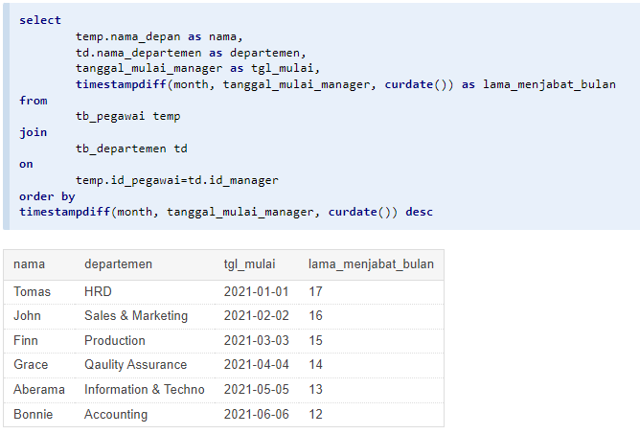

1. Lokasi project yang menjadi tempat lebih dari satu department?

