

ASSIGNMENT #1: Performance Benchmarking of Cryptographic Mechanisms

Course: Security and Privacy
Year: 2026
Credits (PL4G5):
- José Sousa (up202405046)
- Duarte Gomes (up202409386)
- Tiago Sousa (up202405406)
Table of concepts
Introduction 2
The baseline for the project (details that matter) 3
Statistics used 4
Encryption and decryption with AES in Counter Mode 4
Implementation of the RSA function and its inverse with a key with 2048 bits 6

Introduction

When analysing and comparing different algorithms its important to do benchmarking, that’s exactly what this project is about, the goal is to analyse the performance of three different cryptography mechanisms AES in Counter Mode, RSA-based encryption scheme (with SHA-256) and SHA-256 (digest generation). In order to compare and obtain the real results and comparisons we used benchmarking.

The execution that had the results used in this report took place in a computer with the following characteristics
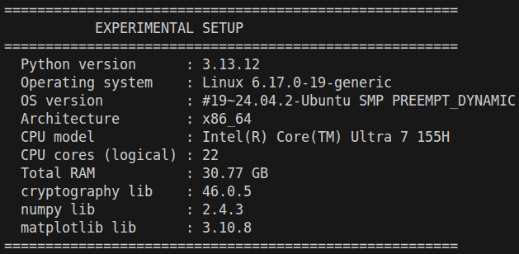

The baseline for the project (details that matter)

In this project we applied different methodologies in all the benchmarking (according to the benchmarking standards), so that, no matter the algorithm, the results are correctly measured and not affected by other factors.

In the first place, before any benchmark execution, we read the files to the memory so that the reading time does not count to the real execution time.
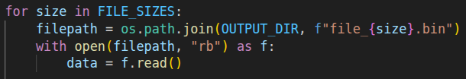
The second thing was using warmup, one run that doesn’t count. This eliminates the "cold start" bias (library startup, memory allocation, CPU cache filling).

Another point that is important is that each operation is repeated 200 times to ensure statistical significance. This number is sufficient for the distribution of sample averages to approach a normal distribution (by the Central Limit Theorem), allowing the valid calculation of the confidence interval.

The last global aspect is that all the time measurements are reported in microseconds (µs). The timing is performed with Python's timeit.default_timer(), which uses the highest-resolution clock available on the platform. File I/O and key/nonce generation are performed outside the timed region to measure only the cryptographic operation.

In order to actually compare results we used confidence intervals, and all the algorithms are tested using files with fixed sizes (8, 64, 512, 4096, 32768, 262144, 2097152).

Statistics used
- Mean — arithmetic average of the N timing samples.
- Sample standard deviation (s) — unbiased estimator with Bessel's correction (ddof=1).
- 95 % Confidence Interval (CI₉₅) — based on the normal approximation:

$CI{}_{95\%}= 1.96 × \frac{s}{\sqrt{N}}$

Encryption and decryption with AES in Counter Mode
We implemented the encryption and decryption in the file (crypto.py) using functions from the cryptography library.
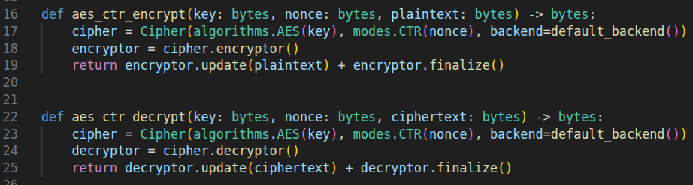
The benchmarking is done by the function run_aes_benchmark() (from benchmark.py).

In each of the 200 repetitions a random 256-bit key (os.urandom(32)) and a new 128-bit nonce (os.urandom(16)) is generated. This simulates a realistic scenario where each operation uses distinct cryptographic parameters and prevents the processor from optimizing by caching repeated results. In addition to this as said earlier, we do a warmup encrypting and decrypting once.
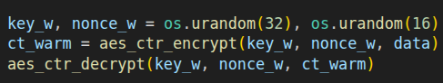
Then we run 200 times (per file) evaluating the time used to encrypt and decrypt each time and in the end calculate statistics (mean, standard deviation or confidence interval).

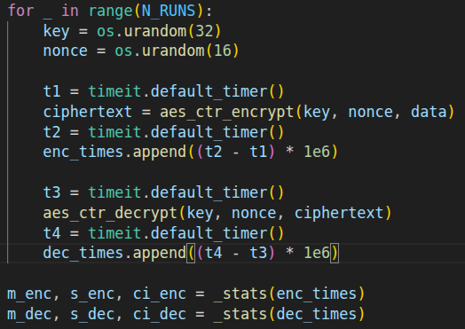
Results(B)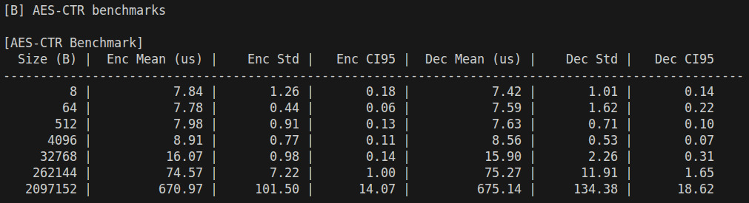
“Do results change if you run a fixed algorithm over the same file multiple times? And what if you run an algorithm over multiple randomly generated files of fixed size?"

In order to answer these questions we need to do different scenarios, before that lets define some things. Unlike the main benchmark, here the key and nonce are generated once and reused in all iterations. The objective is to isolate the variable "input data" as the only variation factor. In addition to this we will simplify using only encryption and not decryption.

With this being said, we have two scenarios:
- Same file repeated 200 times, measures the inherent system variability (OS scheduling, caches, etc.) when the input data is identical.
- Fixed size random files, we generate for each size 200 different files that encrypt one time and analyse the results with statistics (it’s important to note that the files generation is not included in the results time).

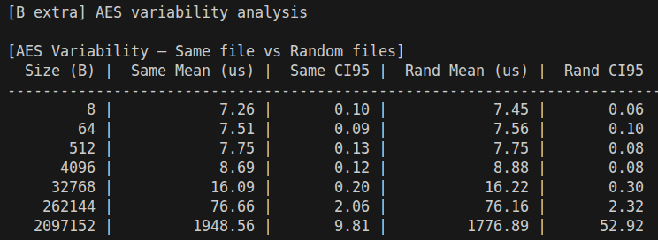
The results provide useful insights to answer the questions asked. Running the same fixed algorithm over the same file multiple times produces stable, low-variance results, while running it over multiple randomly generated files of the same fixed size produces statistically equivalent means but with slightly wider confidence intervals, particularly at larger file sizes.
The small fluctuations in both scenarios reflect only system-level noise such as OS scheduling effects, not any property of the algorithm or the data. The new key and nonce generated on each iteration prevent the processor from caching repeated cryptographic results, though the input data itself remains hot in memory by design, isolating the measurement to the cryptographic operation alone. This is expected, since AES-CTR processes all data uniformly regardless of content, making its timing data-independent. We therefore conclude that results do not change significantly between the two scenarios, which also validates our main benchmark methodology.

Implementation of the RSA function and its inverse with a key with 2048 bits

This implementation uses the cryptography library to implement the RSA algorithm (key generation, encryption and decryption) with a 2048-bit key size.

We use three different functions:

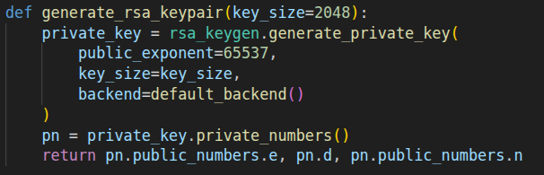
The first function we use aims to generate a key pair.
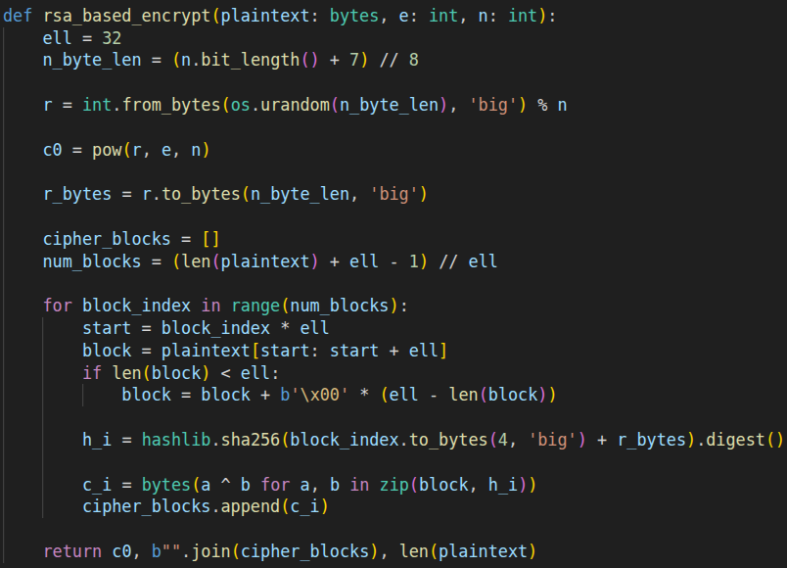
The second function performs a "custom" encryption on bytes using RSA only to protect a random value.
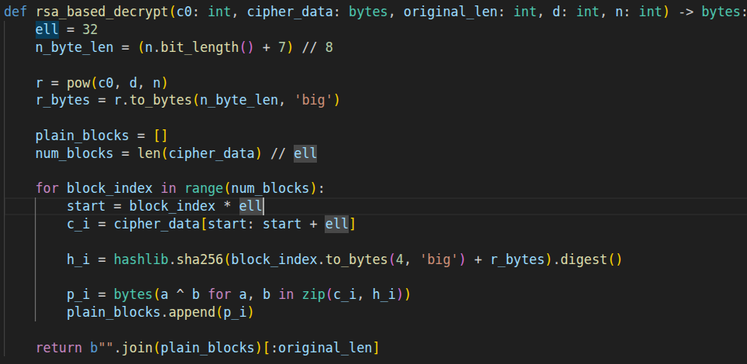
The third function reverses the rsa_based_encryption process. Retrieves r using the private key and undos the XOR to retrieve the plaintext.
Unlike the AES benchmark, the RSA key pair (e, d, n) is generated once before the timed loop, since key generation is not the operation being measured. As with the other benchmarks, a warmup run (one encryption and one decryption, not counted) is performed before the 200 timed repetitions.
In each of the 200 repetitions, encryption and decryption are timed separately. The internal random value r is regenerated on each encryption call, so each run uses fresh randomness. Statistics (mean, standard deviation, confidence interval) are computed at the end for each file size.

Results(C)
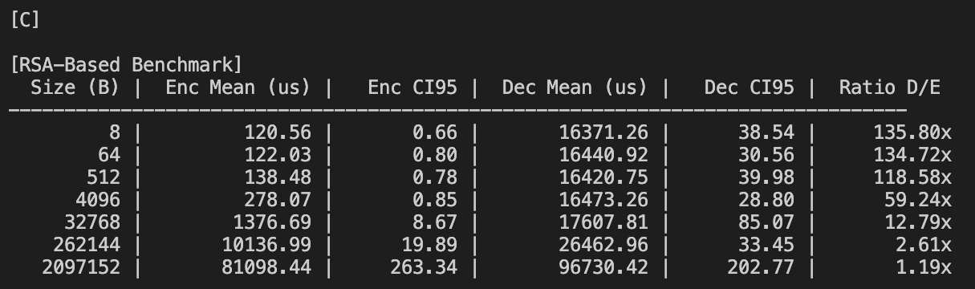

For smaller files, we can clearly see that decryption takes a lot longer than encryption. This is because the private exponent, d, is 2048 bits long while the public exponent, e=65537, has only 17 significant bits. Consequently, the modular exponentiation for decryption,(c0, d, n), requires vastly more squaring and multiplication steps than the encryption part,(r, e, n). However, as the files get bigger, the time spent on the simple linear hashing (which is the same for both operations) starts to take over. This is why, with the very largest files, the time for decryption and encryption becomes almost equal, and their ratio nears 1.

SHA-256 hash genetration

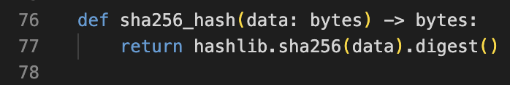
We implemented the SHA-256 hash function using the hashlib library.

This function takes a bytes object and returns its 32-byte (256-bit) digest. Also, this function is a one-way, deterministic hash function: it always produces the same fixed-size output regardless of input size.

The benchmarking starts by, for each file size, call one warm-up. Then 200 timed repetitions are measured. Only the hashing operation itself is inside the timed region; file I/O is performed once before the loop.
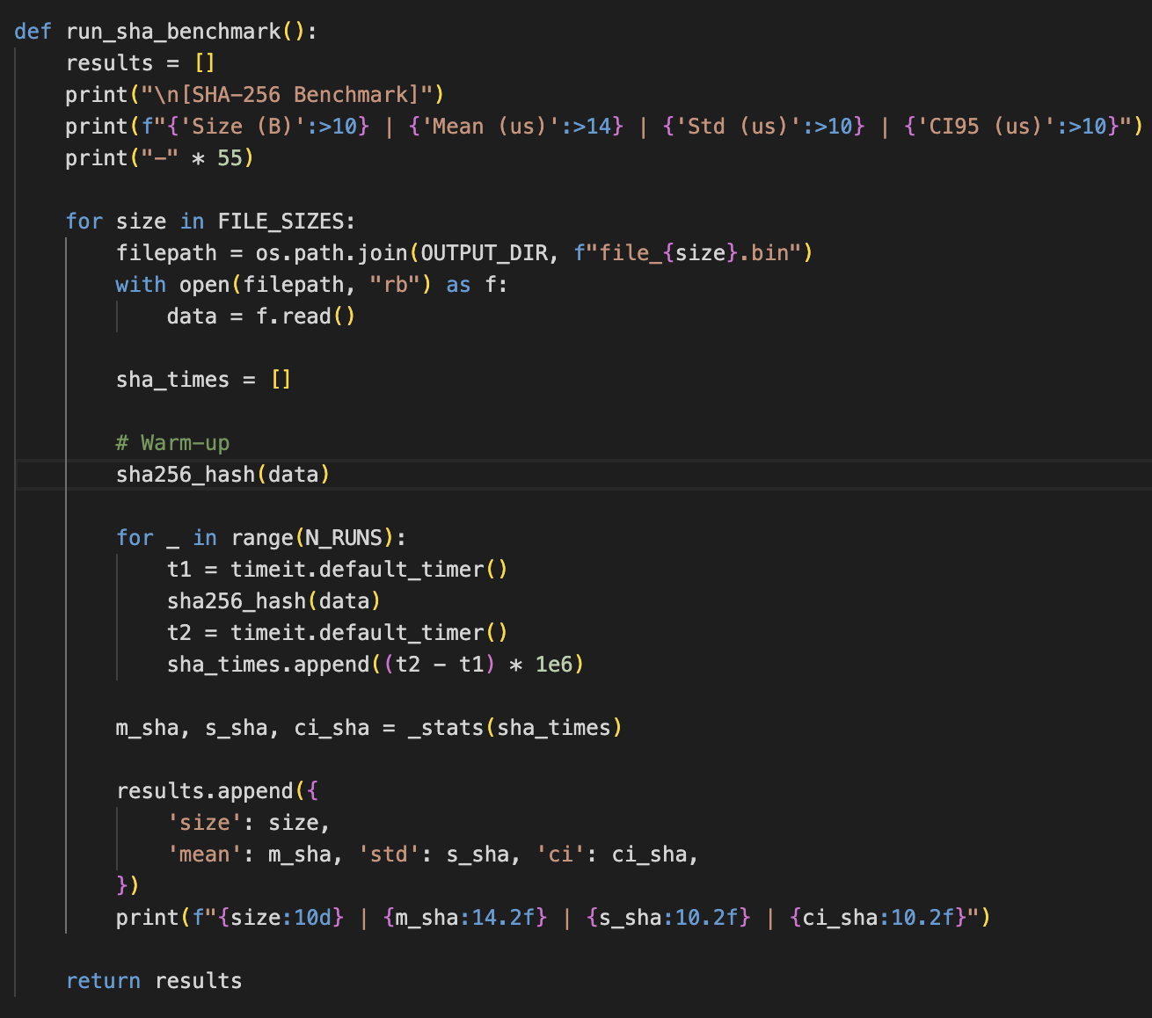

Unlike AES-CTR or the RSA-based scheme, SHA-256 has only one direction (digest generation), so only one timing column is collected.

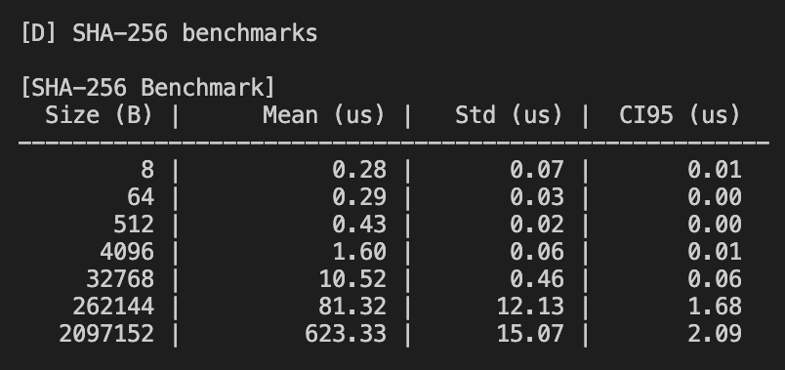
Results(D)

SHA-256 performance scales linearly with the file size: processing time grows proportionally to the number of 64-byte compression-function blocks needed.

