SAP EDNAR Integration Specification

CMD-L

Employee Data Extract from SAP to EDNAR

Document Control

|  |  |
| --- | --- |
| CR / Project Number: | IM/002240 |
| Version No: | 1.1 |
| Created On: | 25th September 2018 |
| Last Updated: | 13th November 2018 |
| Status: | Final |
| Author/s: | Liz Ryan |

Reviewer Identification

Each stake holder must sign of on the final version before approval to continue can be granted. If the approval is via email the email should be inserted in the signature field.

|  |  |  |
| --- | --- | --- |
| Position | Stakeholder Name | Date |
| Zepben Lead | Suv Brahma | 26th Sept 2018 |
| Project Manager | Priscilla Mottal | 26th Sept 2018 |
| Full Stack Technical Specialist | Wayne Hanrahan | 25th Sept 2018 |
| Network Operations Delivery Lead | Vibol Kim | <> |
| OT Integration Lead | Steve Kerr | <> |
| SCADA Systems Analyst | Sallyanne Christie Goss |  |
| Improvement Specialist | Scott Young |  |

Document Purpose

The purpose of this document is to describe the functional requirements for the integration between SAP HR and EDNAR. The interface will comprise a new procedure to extract SAP HR personnel data for all employees and load it into EDNAR . This document will be used by the SAP and EDNAR project teams to build and test the integration.

Methodology

**P**lanning **O**ur **I**mplementations for **N**ew **T**echnology (POINT)

The IT POINT Methodology is a tailored version of PRINCE2 project methodology. POINT Methodology reflects our operational business approach and provides a process that can be applied to all IT projects. The “Development Release Notes” is part of the “Controlling and Managing Delivery - Build” stage.

Further information on the POINT Methodology can be found on myConnect (internal Intranet site):

[Home → Projects & Initiatives → Project Methodologies → IT Project Management](http://myconnect/Projects_and_Initiatives/Project_Centre/IT_Project_Management/Pages/default.aspx)

Related Documents

This section will list related documents. Please note that if this document is updated these related documents may also need to be changed.

|  |  |  |
| --- | --- | --- |
| Document | Filename | Input/Output/Reference  Describes the relationship between the documents. |
| EDNAR Functional Business Requirements | EDNAR Functional Business Requirements V0.1.xls | Input |
| EDNAR Interface Specification | \\Corp\IT\MKT\INTER-DEPT\BIP\IT Projects - 2018\EDNAR\04 Controlling and Managing Delivery\11 Integration\02 ednar_interface_documentation | Reference |
| Zepben EDNAR Technical Proposal | Zepben_EDNAR_ TechnicalProposal_v1.9.docx | Reference |

List the relevant reviewers who are responsible for the deliverables defined in this document.

Contents

1. Overview 3

2. SAP Extract Requirements 4

3. SAP Data Definition 6

4. EDNAR Data Model 10

5. Appendix A: System Access Scenarios 11

6. Appendix B: SAP Qualification Hierarchy 13

7. Terms of Reference 14

8. Revision 15

# Overview

A new procedure needs to be developed to run a nightly batch process to update the employee information in EDNAR from SAP. SAP HR is the master source for employee data.

The current SAP SRR interface will not be used as the interface needs to be re-factored to take account of new business requirements. The interface will still be triggered once a day at 3 am where an SAP initiated process will delete and insert data into a group of Oracle tables in the EDNAR database.

The data will be used to:

* Enable EDNAR system access for Powercor , CitiPower employees/contractors and external users. A user has to be included in the SAP extract to have access to EDNAR
* Potentially automatically control access to the system for Authorised Applicants
* Populate participant data
* Monitor when Applicant and Operator qualifications expire so that system access can be modified/removed accordingly
* Potentially maintain Operators’ qualifications to ensure only qualified operators are selected

Unlike the existing SAP SRR extract the data will not be limited to resources with the “Make Application for” qualification and users with dummy qualifications. See Appendix A for a description of the various system access scenarios and their current treatment in SRR and potential treatment in EDNAR.

**Figure 1** below provides a context diagram of the integration:



Figure 1

# SAP Extract Requirements

The following detailed requirements cover the extraction and loading of the SAP employee data into EDNAR. This document does not cover the requirements for how the SAP data will be used in EDNAR, as these are documented in the EDNAR Functional Business Requirements’ matrix.

The numbering of each requirement - EDNAR FBR <number>, provides traceability to the EDNAR Functional Business Requirements’ matrix.

**2.1 EDNAR FBR 80**

The solution requires a nightly extract from SAP of data for all employees (contract and permanent). Data includes names, contact details and network authorities' qualifications. This is to support:

* Participant selection
* Notifications
* Enabling access to the system for any users. (User must be in SAP extract to access the system).

Refer to Section 3 of this document for the SAP extract data definition.

**Note**: the current SAP extract for SRR runs nightly at 3 am.

Data for all employees is to be included in the extract regardless of qualifications but qualification specific data is to be limited to the following **Network Authorities** Qualification Group qualifications:

| **Object Id** | **Qualification Description** |
| --- | --- |
| 50003330 | VESI - MAKE APPLICATION FOR |
| 50003367 | VESI - ENTER ENCLOSURES |
| 50003444 | PAL - SUPPRESSION OF ACR |
| 50003445 | VESI - DSO-DISTRIBUTION SWITCHING OVERHEAD* |
| 50003446 | VESI - RSO-RESTRICTED SWITCHING OPERATOR* |
| 50003448 | VESI - ZSS - ZONE SUBSTATION SWITCHING* |
| 50003449 | VESI - TSF - TERMINAL SWITCHING FEEDERS* |
| 50003451 | VESI - DS - DISTRIBUTION SWITCHING* |
| 50003453 | VESI - RECEIVE ACCESS PERMITS |
| 50003455 | VESI - RECEIVE SANCTION FOR TESTING |
| 50012952 | INSTALL MOB GEN SET FOR HV - UETTDRIS64A |
| 50012953 | INSTALL MOB GEN SET FOR LV - UETTDRIS61A |
| 50041813 | VESI - TS - TERMINAL STATION* |
| 50056253 | RSO-RESTRICTED SWITCHING OPERATOR (EP&T)* |
| 50056254 | LV SWITCHING* |
| 50056255 | DSU-DISTRIBUTION SWITCHING UNDERGROUND* |

##### *indicates HV switching qualifications/authorisations.

Refer to Appendix B for an understanding of the SAP qualification hierarchy and relationships.

##### Developer Note: Each time the extract is run the contents of the EDNAR SAP external tables needs to be deleted before the new extract data is inserted.

**2.2 EDNAR FBR 80b**

The SAP to SRR and SAP to EDNAR interfaces will need to run in parallel until SRR is de-commissioned, post EDNAR Release 2 expected late 2019

# SAP Data Definition

The following spreadsheet contains the data definition that comprises the SAP to EDNAR interface.



# EDNAR Data Model

The SAP data must be loaded into the following EDNAR tables each night:

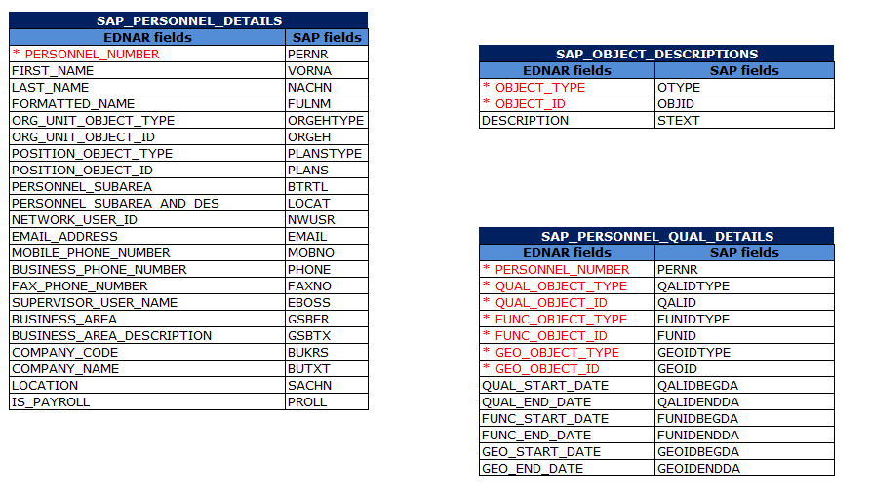

# Appendix A: System Access Scenarios

The following table describes the various system access scenarios and how they could be handled by EDNAR. Business processes will be documented and communicated for the following scenarios.

| **#** | **Scenario** | **SRR - Current** | **EDNAR - Future** | **Comment** |
| --- | --- | --- | --- | --- |
| 1 | New internal user – Authorised Applicant | Business rep manually assigns Applicant role to user in SRR or UAR is raised for access.  Supposed to be email from tech training to advise operations of newly authorised Applicants. | EDNAR identifies new Authorised Applicants in SAP extract and automatically provides access via the “Authorised Applicant” role and email automatically generated to user. | Need to confirm with Steve Rigoni that users are automatically given system access before being trained in the system. Project CR may be required. |
| 2 | Existing user – expired “Make Application for” qualification | User is not included in SAP extract when Make Application for expires and therefore automatically loses access to system. | EDNAR identifies users with the “Authorised Applicant” role with expired qualifications and automatically changes access to “Read Only”. Email automatically generated to user to advise them of change in access. | Project Change Request maybe required. |
| 3 | Temporary suspension of access for Authorised Applicants. | Manually remove access. | 1. Raise UAR to manually remove or change access to a role that is not updated by SAP data. 2. Suspend qualification in SAP. | Email request should be made to App Support to check override flag to provide an audit trail to support system access audits. |
| 4 | New internal user – no network authorisation | Raise UAR to assign user to role in SRR and add user with dummy qualification in SAP. | To provide audit trail a UAR is raised to the SCADA team to assign user to role in EDNAR.  Adding dummy qualifications in SAP will not be required as the SAP extract will contain all PAL/CP employees. | There will be a role called “Create NAR” which will allow users to create but not submit a NAR. E.g. A “Construction Project Planner”.  There will also be a Read Only role.  User privileges will not be provided at a field level but at a function level, Create NAR, Submit NAR etc. |
| 5 | New user – external, e.g. Jemena planner | Powercor Planner raises NAR in SRR on behalf of external users. External users do not have access to SRR. | Raise UAR to assign user to EDNAR role (assuming resource is set up in SAP as per BAU process). | Solution design allows for external access via a web URL (Admin pages will not be exposed externally). |
| 6 | Internal user leaves the business | Line manager completes exit form which removes user from SAP and therefore prevents access to SRR. | Line manager completes exit form which removes user from relevant AD group therefore prevents access to EDNAR. | If user comes back into the business they may be given a new different network login which will be applicable for EDNAR access. |
| 7 | External user no longer needs access to system | N/A | Operations to monitor and review system access every 6 months and change access levels via UAR process as required or terminate resource in SAP. | A report would enable monitoring of system access. Check with Jacob if network access automatically removed if you don’t log in to network for 6 months. |

# Appendix B: SAP Qualification Hierarchy

The following diagram depicts the SAP qualification hierarchy.



# Terms of Reference

The table below outlines definitions, acronyms and abbreviations used in this document as well as associated documentation.

|  |  |
| --- | --- |
| Reference | Description |
| Electricity Distribution Network Access Register (EDNAR) | A new application being built by Zepben in partnership with Powercor CitiPower to manage planned work on the electricity distribution network. The application will replace the current Switching Request Register (SRR) application. |
| SAP HR | The Powercor CitiPower application that is the source system for maintaining employee data, e.g. Names, contact details, qualifications. |
| Zepben | Australian based software company contracted to build EDNAR. |
| Authorised Applicant | An approved person who has been assessed as competent against an approved training standard to make application for specified types of Access Authorities, e.g. Electricity Access Permit |
| Authorised Electrical Operator (Electrical Operator) | An approved person who has been assessed as competent against an approved training standard to carry out switching operations on HV electrical apparatus. |

# Revision

Version Control

|  |  |  |  |
| --- | --- | --- | --- |
| Version | Date | Updated by | Comments |
| 0.1 | 25th September 2018 | Liz Ryan | Initial version |
| 0.2 | 1st Oct 2018 | Liz Ryan | Data model updated |
| 0.3 | 15th October 2018 | Liz Ryan | PNS and EN filter criteria removed to ensure that when a new non-network authorized user is set up a dummy qualification record will not need to be set up in SAP. |
| 1.0 | 5th November 2018 | Liz Ryan | Minor updates and added Appendix B. |
| 1.1 | 13th November 2018 | Liz Ryan | New version of data model including additional SAP fields. |