# SAP to EDNAR (Electrical Distribution Network Access Register) Interface – Technical Documentation.

The EDNAR Interface is a replacement for the SRR (Switching Request Register) Interface.

The development objects for the EDNAR project are all encapsulated in the Package /CHED/EDNAR.

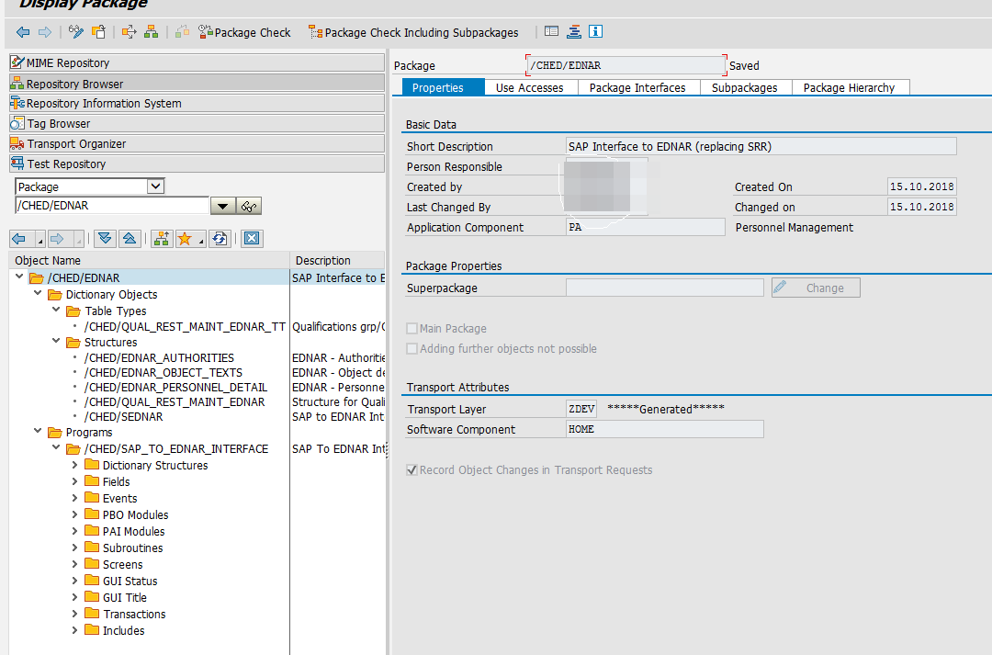

## Program Selection Screen and Documentation.

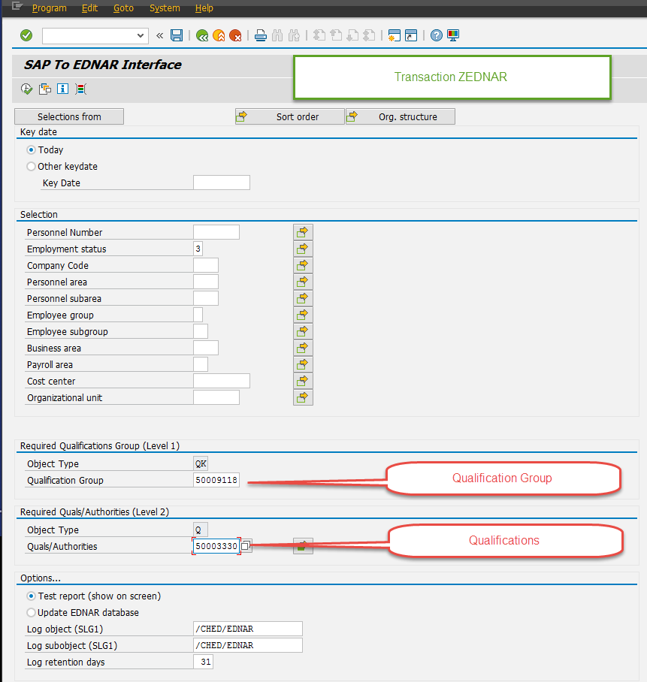

### Short Text

SAP To EDNAR Interface

### Purpose

Interface to EDNAR (Electrical Distribution Network Access Register).

Transaction ZEDNAR.

### Integration

EDNAR is the replacement of SRR.

This program will serve a dual-purpose, to report, and run the update

process to the EDNAR database. It will be set up to run in batch at

regular intervals.

If for any reason the scheduled run is cancelled (as a result of a

system outage), transaction ZEDNAR can be run adhoc using the 'Update'

option.

### Prerequisites

Only active employees are included.

NGN personnel are excluded.

Qualification Group and Qualifications are mandatory selections.

### Features

If run in 'Test' mode, the program will show the output on screen in an

ALV display (no updates performed).

If run in 'Update' mode in the foreground, a warning message is

displayed requiring the user to confirm performing the update.

If the update to EDNAR is performed, logs are written to the standard

ABAP application log. These logs can be viewed by running transaction

SLG1 and entering '/CHED/EDNAR' in the Object and Sub-object fields.

Logs are retained for the nominated number of days, and deleted after

that. In transaction SM37 the data is output to the spool and can be

checked here as well.

### Selection

Standard selections from the PNP database. Custom selections as well.

### Standard Variants

A Variant will be set up and can be changed as the filter requirements

change. Example: If the list of Qualifications changes, the Variant could

be adjusted.

### Output

In ALV format and downloadable in most formats to a Network drive.

## List Output format (Screen Output)

|  |  |
| --- | --- |
| **Field** | **Description** |
| PERNR | Personnel Number |
| VORNA | First Name |
| NACHN | Last Name |
| FULNM | Formatted Name of Employee or Applicant |
| ORGEH | Organizational Unit |
| ORGTX | Object Name |
| PLANS | Position |
| PLTXT | Object Name |
| BTRTL | Personnel Subarea |
| LOCAT | Personnel Subarea and description |
| NWUSR | Network User ID |
| EMAIL | Email Address |
| MOBNO | Mobile Phone Number |
| PHONE | Business Ph. No. |
| FAXNO | Fax Phone Number |
| EBOSS | User name of the manager/supervisor of the employee |
| GSBER | Business Area |
| GSBTX | Business area description |
| BUKRS | Company Code |
| BUTXT | Name of Company Code or Company |
| SACHN | Name of administrator |
| PROLL | Control SA Payroll indicator |
| QLGIDTYPE | Object Type |
| QLGID | Qualification Object ID |
| QLGTX | Qualification Object Description |
| QALIDTYPE | Object Type |
| QUALO | Qualification Object ID |
| QUALT | Qualification Object Description |
| QUALB | Qualification Begin Date |
| QUALE | Qualification End Date |
| FUNIDTYPE | Object Type |
| FUNCO | Functional Restriction Object ID |
| FUNCT | Functional Restriction Description |
| FUNCB | Function Restriction Begin Date |
| FUNCE | Function Restriction End Date |
| GEOIDTYPE | Object Type |
| LOCRO | Geographical Restriction Object ID |
| LOCRT | Geographical Restriction Description |
| LOCBD | Geographical Restriction Begin Date |
| LOCED | Geographical Restriction End Date |
| RATING | Proficiency of a Quality Scale |
| RATING_TEXT | Scale Proficiency Text |

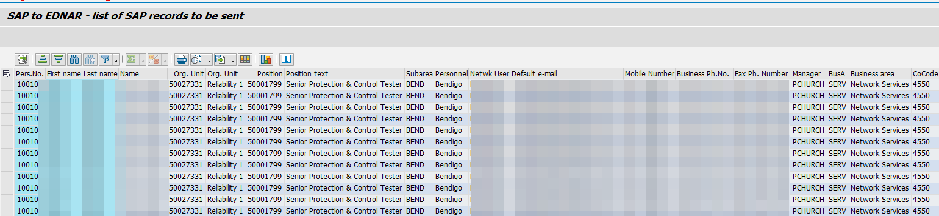

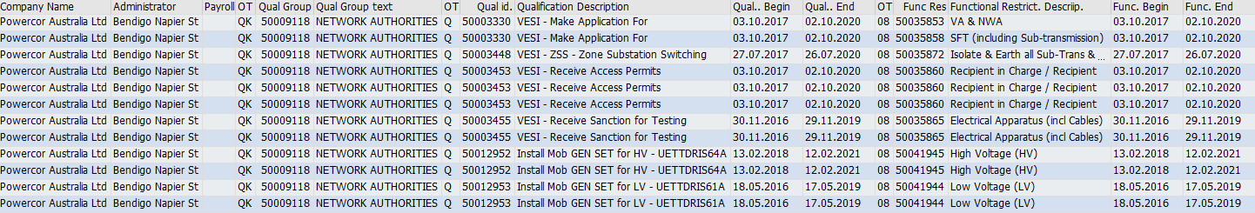

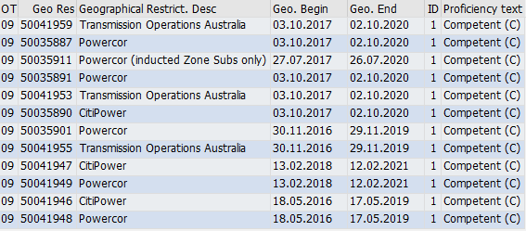

## Logs (SLG1)

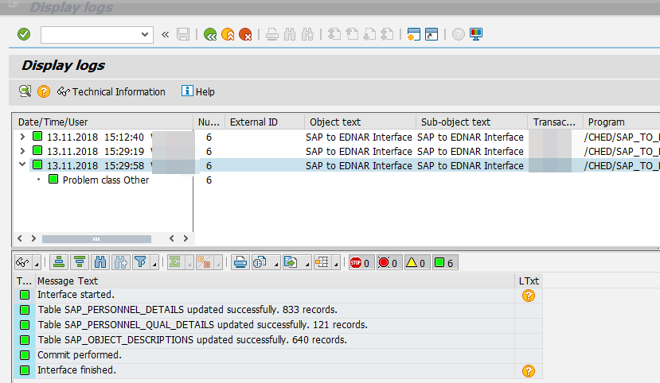

## General Information

The program /CHED/SAP_TO_EDNAR_INTERFACE will be set up to run at a periodic time.

The logs can also be found In Transaction SM37.