**# About**

PofHistorianService runs as a windows service that communicates with the client to get the SCADA history data from the history data file. The server is built using .Net and can run only on windows.

When reading from the history data file, the service will create the index file if it does not exist.

**# Technology used to build it**

PofHistorianService is written in C# and targets .Net Framework 4.5.1.

**# Dependencies**

* .Net Framework 4.5.1 is required.

* Windows 7 operating system with SP 1 or above is required.

**# How to install PofHistorianService**

* Login to the windows machine in which PofHistorianService needs to be installed.

* Create a folder PofHistorianService, (For example: C:\PofHistorianService). You can create other folder name if you wish.

* Copy all the PofHistorianService binaries from the .zip file of the release to this folder.

* Change the config file to make sure it is correct in the running environment

* Make sure you have administrator privileges.

* Navigate to C:\PofHistorianService

* Run the command .\pof-historian-api.exe install

* You should get the installed successfully message.

* The PofHistorianService windows service is installed at this point.

* Go to the Services console in windows.

* Make sure the service is running. If not, start it.

* Check the properties of the service to ensure that it is configured to start automatically.

**# How to uninstall PofHistorianService**

* Login to the windows machine in which PofHistorianService is installed.

* Make sure you have administrator privileges.

* Navigate to C:\PofHistorianService.

* Run the command .\pof-historian-api.exe uninstall

* You should get an uninstall successful message.

**# How to run as a console app**

The service can also be run as a console app without installing the service. When debugging the service or testing, you may need to simply run the service as a console app.

* Navigate to C:\PofHistorianService

* Right click the app file “pof-historian-api.exe”, select “Run as administrator”.

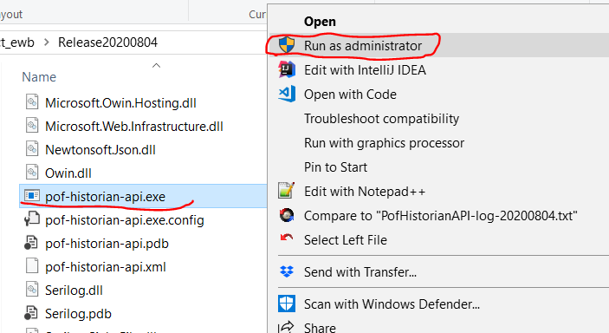

**# How to configure PofHistorianService parameters - pof-historian-api.exe.config**

* Navigate to C:\PofHistorianService.

* Open the file pof-historian-api.exe.config in the text editor of choice.

* Update the configuration items as specified below, save and close the file. Restart the service for the new configuration to take effect.

**# pof-historian-api.exe.config explained**

<add key="ServicePort" value="8888" />

<add key="ServerBaseUrl" value="http://+:" />

<add key="LogFileRelativePath" value="Logs\" />

<add key="LocalRequestOnly" value="false" />

<add key="FileLocation" value="D:\sincal-get-scada\file" />

<add key="FileLocationSecond" value="D:\sincal-get-scada\altfile" />

<add name="ConfigSqlite" connectionString="Data Source=.\config\config.sqlite" />

* ServicePort: Service port number

* ServerBaseUrl: Base server URL that will be used by the client to send http requests e.g. https://+:.

* LogFileRelativePath: Path of the log files relative to the deployment directory. A path of Logs\ will create the log file in C:\PofHistorianService\Logs if the deployment directory is C:\PofHistorianService. Log file is created in text format and the rolling interval is set to a day.

* LocalRequestOnly: The flag to set if only the local request is valid.

* FileLocation: The folder name to contain the data file and index file, including the path name.

* FileLocationSecond: The second folder name to contain the data file and index file, including the path name.

* Connection String - `ConfigSqlite` - Specify the connection string for the config database in SQLITE.

**# The configure database in SQLITE: config.sqlite**

**\* table tblNameMapping**

The mapping between feeder name and alias/attribute

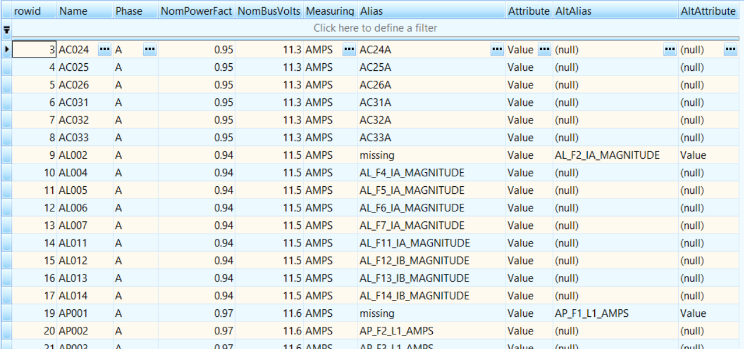

**Columns:**

Name: Feeder name for the service API input parameter

Phase: Phase information of the measurement

NomPowerFact: Power factor to calculate the power via formula: P = √3 × pf × I × V

NomBusVolts: Bus voltage to calculate the power via formula: P = √3 × pf × I × V

Measuring: Measurement type

Alias: Measurement alias

Attribute: Measurement attribute name

AltAlias: Alternative alias for the measurement.

AltAttribute: Alternative attribute name for the measurement

**Note:**

1. When getting power data, if alias with measuring “MW” does not exist as SCADA value, we will calculate it using the current value with measuring “AMPS” with the formula: P = √3 × pf × I × V

2. When the first alias can not be found in the data file, the alternative alias will be used to get the data.