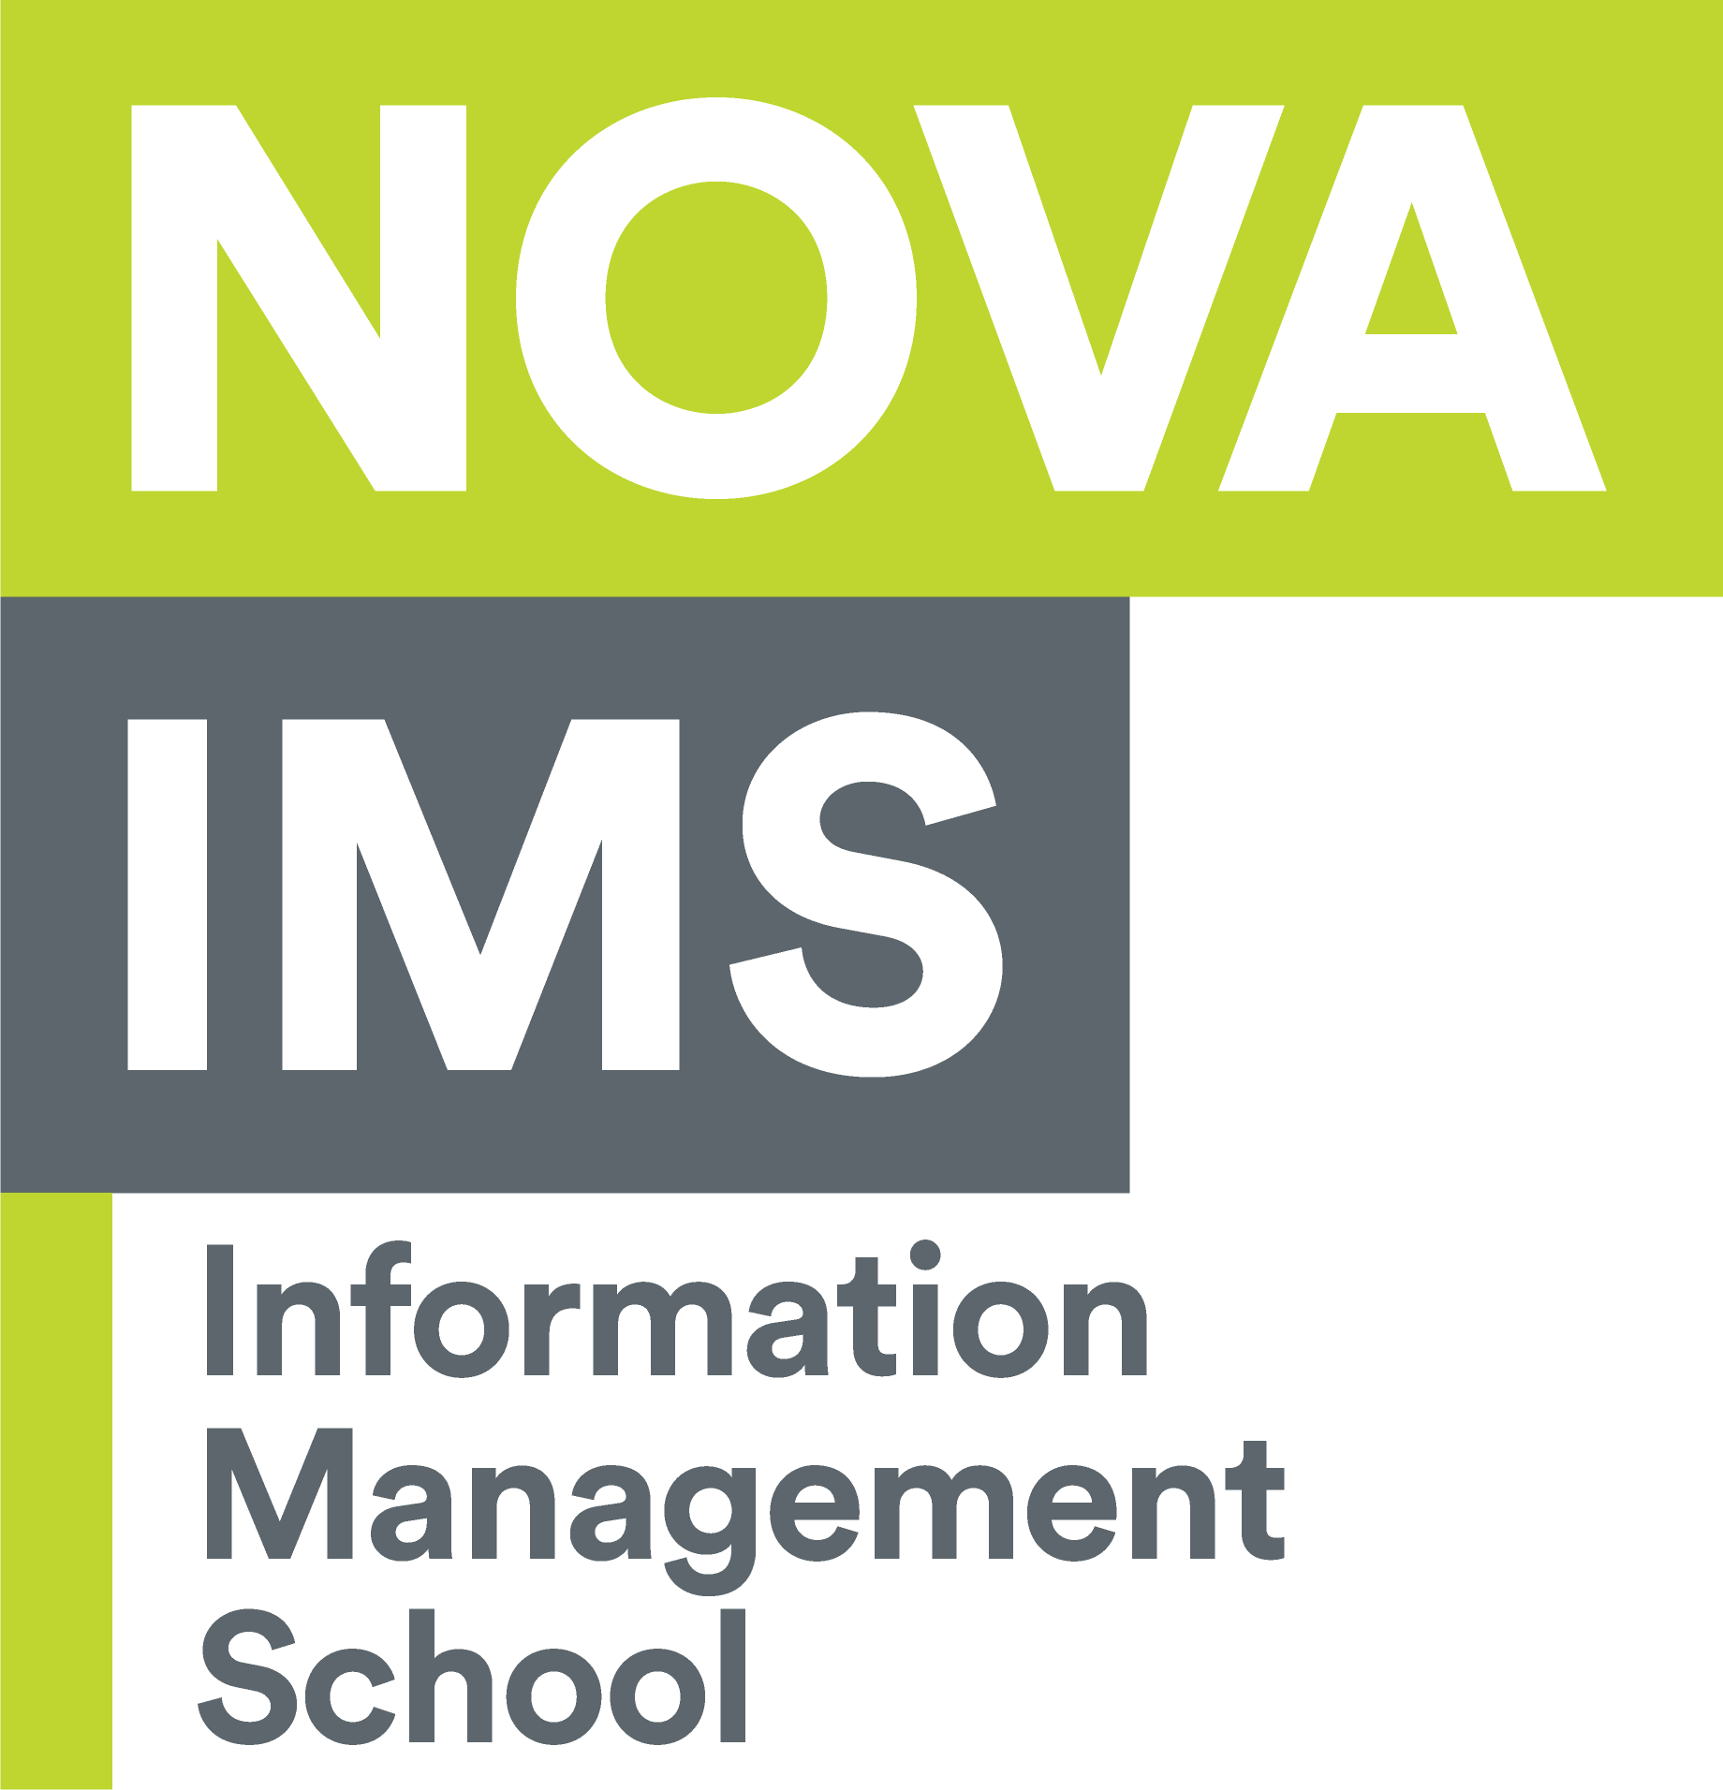

**Master Degree in Information Management, with a specialization in Information Systems and Technologies Management**

Introducing Blockchain in inter-organizational cooperation between Business Process Management systems - Case Study in a financial institution

José Pedro Jesus 20210358

**Supervisors:** Pedro Maia Malta & João Costa

**Context:** When we address the Blockchain technology in the context of Business Process Management, with Business Processes that involve more than one company, there is information that needs to be shared across companies. And as Garcia-Garcia, Sanchez-Gomez, Lizcano, Escalona, and Wojdynski (2020) state, a “centralized architecture is appropriate for single companies, but it is not efficient when it is necessary to collaboratively involve multiple entities or companies into

the same process”. This data needs to be accessed in a secure manner, but it also needs to be easily available to both parties without compromising its integrity or security.

**Research gap and objectives:** With this dissertation, we hope to better understand how a disruptive technology such as Blockchain can change the management of Business Processes between various companies by providing a decentralized and secure way to share data between parties, and as stated by Mendling (2018) provide the “ potential to realize execution without a central party serving as a single point of trust (and failure). ”, meaning without the use of a third party to hold the shared data between the involved companies.

**Methodological approach:** The initial approach for this dissertation will consist in the research of use cases for the Blockchain technology for Business Process Management. After identifying a specific use case, using a small existing process inside a financial institution a Blockchain system would be implemented and used in said process. Then, a case study would be put in place using qualitative analysis (for example, through interviews) to determine the success of the implementation of said Blockchain system.

**Expected results and contributions:** This dissertation aims to show the benefits and use cases of the Blockchain in Business Processes Management. Our aim is to show the use of this disruptive in order to hold data and information that various companies need access when managing *inter*-relational Business Processes (without relying in a truster third-party) and guarantying data integrity and security when accessing said data.

**Bibliographical references:**

Garcia-Garcia J, Sanchez-Gomez N, Lizcano D, Escalona M, Wojdynski T. (2020). Using Blockchain to Improve Collaborative Business Process Management: Systematic Literature Review

Mendling J, Weber I, Van Der Aalst W, Brocke J, Cabanillas C, Daniel F, Debois S, Di Ciccio C, Dumas M, Dustdar S, Gal A, García-Bañuelos L, Governatori G, Hull R, La Rosa M, Leopold H, Leymann F, Recker J, Reichert M, Reijers H, Rinderlema S, Solti A, Rosemann M, Schulte S, Singh M, Slaats T, Staples M, Weber B, Weidlich M, Weske M, Xu X, Zhu L. (2018). Blockchains for business process management - Challenges and opportunities

Härer, Felix. (2018) Decentralized business process modeling and instance tracking secured by a blockchain