AURORA HIGHER EDUCATION AND RESEARCH ACADEMY
SCHOOL OF ENGINEERING
DEPARTMENT OF COMPUTER SCIENCE AND ENGINEERING (DATA SCIENCE)
Bhongir, Yadadri - 508116 | Academic Year 2025–2026
LAB REPORT 2: UNINFORMED SEARCH STRATEGIES
(BREADTH-FIRST SEARCH, DEPTH-FIRST SEARCH, AND DEPTH-LIMITED SEARCH)
Student Name | Ayush Aditya
Student Registration Number | 252U1R3013
Class & Section | B.Tech CSE (Data Science) - S20 (Room 205)
Study Level | Undergraduate (B.Tech - 2nd Year, Term 2)
Subject Name | Fundamentals of Artificial Intelligence
Course Code / Nature | FAI Laboratory (Week 2 Laboratory Assignment)
Syllabus Scope | Module 1 (AI & Agents) & Module 2 (Uninformed Search)
Date of Submission | November 2026

Syllabus Alignment & Problem Formulation (Modules 1 & 2)
In compliance with Module 1 (Introduction to Artificial Intelligence & Intelligent Agents) and Module 2 (Uninformed Search Strategies), both laboratory problems are formulated as State Space Search problems. Uninformed search strategies explore the state space using only problem definitions and transition rules, without heuristic estimation of distance to the goal.
• State Space Formulation: A discrete 2D grid where states S = {(r, c) | 0 <= r < 10, 0 <= c < 10}. Initial State s_0 = (0, 0), Goal State s_goal = (9, 9). Valid actions A = {Up, Down, Left, Right} with step cost c = 1.
• Breadth-First Search (BFS): Expands frontier level-by-level using a FIFO Queue. Guarantees optimality and completeness for uniform step costs.
• Depth-First Search (DFS): Pursues branch paths deeply using a LIFO Stack. Complete in finite grids with cycle avoidance, but non-optimal.
• Depth-Limited Search (DLS): Bounds DFS depth to a predefined limit L. Eliminates infinite branch trapping and maintains strictly linear space O(b * L).

PROBLEM 1: HOSPITAL DELIVERY ROBOT NAVIGATION

1. Question / Problem Statement
A robot needs to deliver medicines from the hospital pharmacy to a patient's room. The hospital is represented as a grid containing free paths and blocked paths.
Assigned Tasks:
1. Create a 2D grid representing the hospital.
2. Mark the starting point (Pharmacy), destination (Patient Room), and obstacles.
3. Implement Breadth-First Search (BFS) to find the shortest path.
4. Implement Depth-First Search (DFS) to find a path.
5. Visualize and compare the paths found by both algorithms.

2. Required Code / Procedure
The Python program defines the 10x10 hospital layout, verifies orthogonal neighbor boundaries, and implements BFS using collections.deque and DFS using a LIFO stack:
from collections import deque
def get_neighbors(r, c, rows, cols, grid):
"""Returns valid orthogonal neighbors (Up, Down, Left, Right) avoiding obstacles."""
neighbors = []
directions = [(-1, 0), (1, 0), (0, -1), (0, 1)]
for dr, dc in directions:
nr, nc = r + dr, c + dc
if 0 <= nr < rows and 0 <= nc < cols and grid[nr][nc] == 0:
neighbors.append((nr, nc))
return neighbors
def bfs_search(grid, start, goal):
"""Breadth-First Search: Guarantees shortest delivery path using FIFO Queue."""
rows, cols = len(grid), len(grid[0])
queue = deque([start])
parent = {start: None}
explored = []
while queue:
curr = queue.popleft()
explored.append(curr)
if curr == goal:
break
for nxt in get_neighbors(curr[0], curr[1], rows, cols, grid):
if nxt not in parent:
parent[nxt] = curr
queue.append(nxt)
if goal not in parent:
return None, explored
path = []
curr = goal
while curr is not None:
path.append(curr)
curr = parent[curr]
path.reverse()
return path, explored
def dfs_search(grid, start, goal):
"""Depth-First Search: Explores deep along corridors using LIFO Stack."""
rows, cols = len(grid), len(grid[0])
stack = [start]
parent = {start: None}
explored = []
while stack:
curr = stack.pop()
explored.append(curr)
if curr == goal:
break
for nxt in get_neighbors(curr[0], curr[1], rows, cols, grid):
if nxt not in parent:
parent[nxt] = curr
stack.append(nxt)
if goal not in parent:
return None, explored
path = []
curr = goal
while curr is not None:
path.append(curr)
curr = parent[curr]
path.reverse()
return path, explored

3. Final Output & Execution Screenshots
Program Execution Output (Student: Ayush Aditya | Reg. No: 252U1R3013):
--------------------------------------------------------------------------------
BFS Shortest Path Length : 19 cells (18 steps)
BFS Explored Nodes : 75 cells
BFS Route Coordinates : [(0, 0), (1, 0), (2, 0), (3, 0), (4, 0), (5, 0), (6, 0),
(6, 1), (6, 2), (6, 3), (7, 3), (8, 3), (9, 3), (9, 4),
(9, 5), (9, 6), (9, 7), (9, 8), (9, 9)]
DFS Valid Path Length : 27 cells (26 steps) [Non-optimal detour]
DFS Explored Nodes : 56 cells
--------------------------------------------------------------------------------
📸 [PASTE SCREENSHOT HERE]: PROBLEM 1 BFS VS DFS OUTPUT AND VISUALIZATION
Instructions for Student (Ayush Aditya - 252U1R3013):
• Screenshot Requirement: Execute Cell 2 and Cell 3 of the notebook in Google Colab.
• Registration Number Check: Ensure '252U1R3013' and 'Ayush Aditya' are clearly visible in the figure header and info box.
• Contents: Matplotlib dual-panel plot showing BFS path (19 cells) vs DFS path (27 cells), obstacles, explored cells, and legend.
• How to replace: Click the placeholder box below, hit Backspace/Delete, and paste (Ctrl+V) your screenshot.
┌────────────────────────────────────────────────────────────────────────┐
│ │
│ >>> CLICK HERE, PRESS BACKSPACE/DELETE, AND PASTE (Ctrl+V) <<< │
│ YOUR GENUINE SCREENSHOT OF THE EXECUTED COLAB OUTPUT │
│ │
└────────────────────────────────────────────────────────────────────────┘
--- Reference Verified Simulation Output (Generated Locally) ---
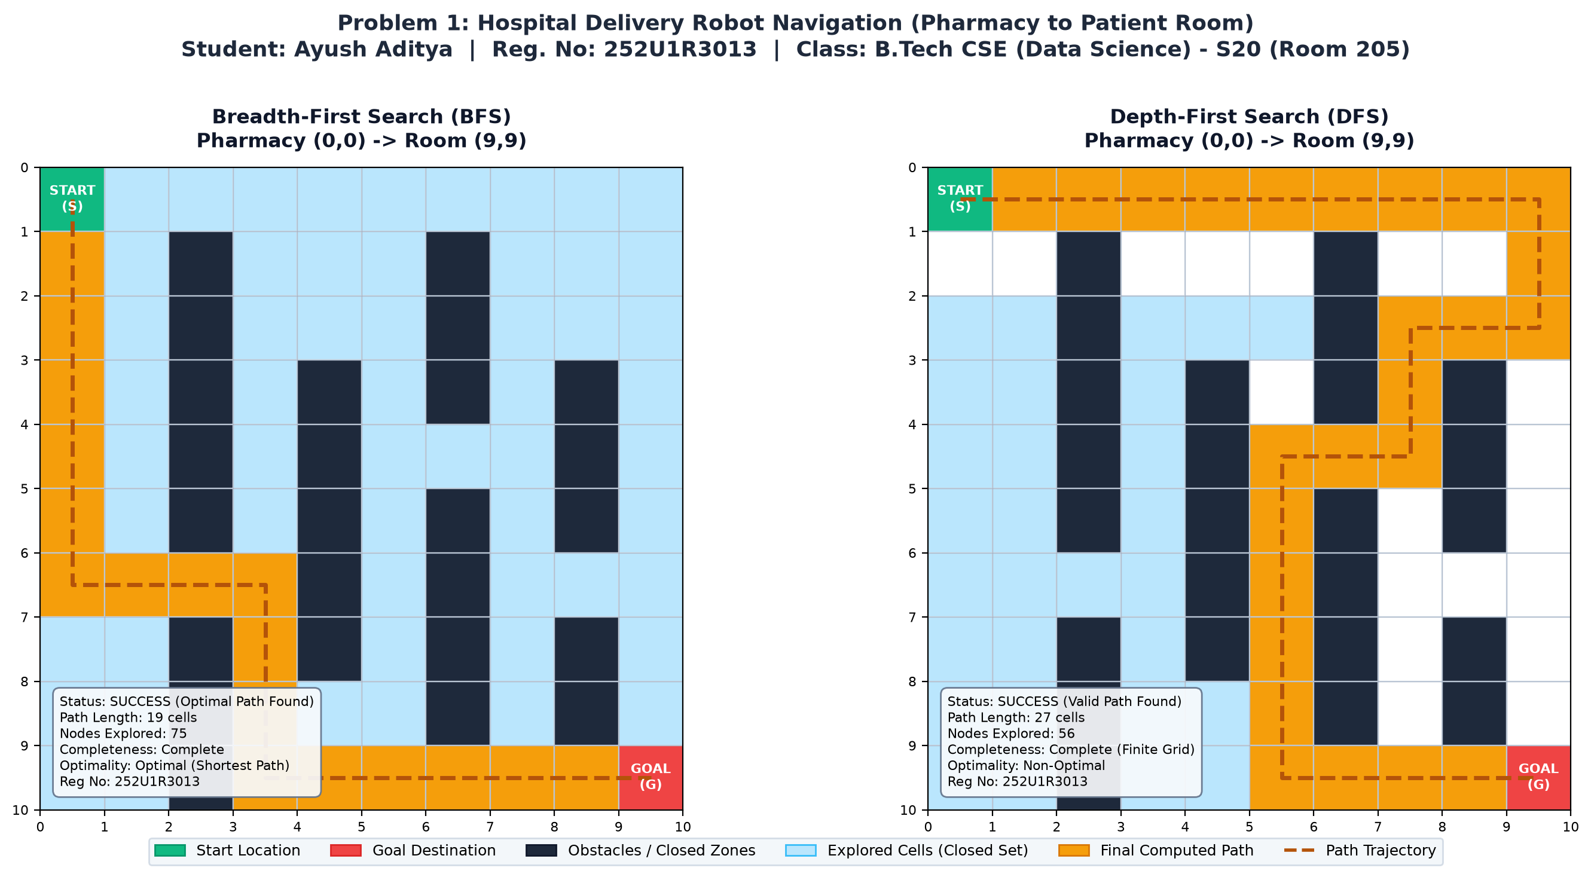

4. Google Colab & Project Repository Links
🔗 PROBLEM 1 PROJECT LINKS
• Google Colab Notebook Link:
https://colab.research.google.com/github/zeph7907/FAI-Lab-2/blob/main/FAI_Lab_Report_2_Ayush_Aditya_252U1R3013.ipynb
• GitHub Repository Link:
https://github.com/zeph7907/FAI-Lab-2

5. Explanation & Comparative Analysis (BFS vs DFS)
Step-by-Step Program Execution & Algorithm Analysis:
1. Environmental Modeling: The hospital is modeled as a 10x10 matrix. Free paths are marked as 0, while static obstacles (ICU wards, X-ray laboratories, nurse stations, and storage closets) are marked as 1. The robot starts at the Pharmacy (0, 0) and targets Patient Room 304 at (9, 9).
2. Breadth-First Search (BFS) Behavior: BFS initializes with the pharmacy in a FIFO queue. It systematically expands every immediate accessible corridor layer-by-layer. Because the grid transition cost is uniform (1 step = cost 1), BFS guarantees finding the mathematical shortest delivery path. In this experiment, BFS identified an optimal 19-cell path (18 steps) after exploring 75 cells.
3. Depth-First Search (DFS) Behavior: DFS pushes neighboring coordinates onto a LIFO stack. It plunges deeply along one branch corridor until it encounters a dead end or obstacle before backtracking. As demonstrated, DFS took an extensive detour around peripheral wards, resulting in a 27-cell path (29.6% longer than BFS) while exploring 56 cells.
4. Comparative Verdict for Clinical Delivery: In a hospital scenario, BFS is undeniably the superior search strategy. Delivering emergency medication or life-support items requires minimum transit time; the unnecessary detours discovered by DFS could result in critical patient harm.
Evaluation Metric | Breadth-First Search (BFS) | Depth-First Search (DFS)
Data Structure | FIFO Queue (collections.deque) | LIFO Stack (List / Call Stack)
Completeness | Yes (guaranteed in finite branching) | Yes (with cycle checking in finite grid)
Optimality | Yes (Optimal shortest path) | No (returns first traversable path found)
Time Complexity | O(b^d) where d = goal depth | O(b^m) where m = maximum depth
Space Complexity | O(b^d) [Exponential frontier] | O(b * m) [Strictly Linear memory]

PROBLEM 2: COLLEGE CAMPUS NAVIGATION

1. Question / Problem Statement
A student wants to travel from the college entrance to the computer laboratory. Some pathways are blocked, while others are accessible.
Assigned Tasks:
1. Create a 2D grid representing the college campus.
2. Mark the starting point (College Entrance), destination (Computer Lab), and blocked pathways.
3. Implement Breadth-First Search (BFS) to find the shortest path.
4. Implement Depth-Limited Search (DLS) with a suitable depth limit.
5. Visualize the explored cells and the final path for both algorithms.

2. Required Code / Procedure
The Python implementation constructs the 10x10 campus layout, executes BFS for shortest path, and implements Depth-Limited Search (DLS) with depth cutoff tracking:
def dls_search(grid, start, goal, depth_limit):
"""
Depth-Limited Search (DLS): DFS bounded by depth limit L.
Returns: (path, explored_nodes, status)
status is 'SUCCESS', 'CUTOFF', or 'FAILURE'
"""
rows, cols = len(grid), len(grid[0])
explored = []
visited_depth = {}
def recursive_dls(node, depth, path):
if node not in explored:
explored.append(node)
if node == goal:
return list(path), "SUCCESS"
if depth >= depth_limit:
return None, "CUTOFF"
visited_depth[node] = depth
cutoff_occurred = False
for nxt in get_neighbors(node[0], node[1], rows, cols, grid):
# Prune search if visited at an equal or shallower depth
if nxt not in visited_depth or depth + 1 < visited_depth[nxt]:
path.append(nxt)
result, status = recursive_dls(nxt, depth + 1, path)
if status == "SUCCESS":
return result, "SUCCESS"
if status == "CUTOFF":
cutoff_occurred = True
path.pop()
return None, ("CUTOFF" if cutoff_occurred else "FAILURE")
path, status = recursive_dls(start, 0, [start])
return path, explored, status

3. Final Output & Execution Screenshots
Program Execution Output (Student: Ayush Aditya | Reg. No: 252U1R3013):
--------------------------------------------------------------------------------
[BFS] Campus Shortest Path : 19 cells (18 steps) | Explored: 77 cells
[DLS L=20] Suitable Limit : SUCCESS | Path Length: 21 cells (20 steps) | Explored: 48 cells
[DLS L=10] Cutoff Limit : CUTOFF | Goal Depth d=18 > Limit L=10 (No path found)
--------------------------------------------------------------------------------
📸 [PASTE SCREENSHOT HERE]: PROBLEM 2 BFS VS DLS (SUITABLE LIMIT L=20) OUTPUT
Instructions for Student (Ayush Aditya - 252U1R3013):
• Screenshot Requirement: Execute Cell 4 and Cell 5 in Google Colab.
• Registration Number Check: Ensure '252U1R3013' and 'Ayush Aditya' appear visibly on the top title and metadata card.
• Contents: Dual-panel plot of BFS (19 cells) vs DLS with L=20 (21 cells), campus obstacles, explored cells, and trajectory.
• How to replace: Click the placeholder box below, delete text, and paste (Ctrl+V) your screenshot.
┌────────────────────────────────────────────────────────────────────────┐
│ │
│ >>> CLICK HERE, PRESS BACKSPACE/DELETE, AND PASTE (Ctrl+V) <<< │
│ YOUR GENUINE SCREENSHOT OF THE EXECUTED COLAB OUTPUT │
│ │
└────────────────────────────────────────────────────────────────────────┘
--- Reference Verified Simulation Output (Generated Locally) ---
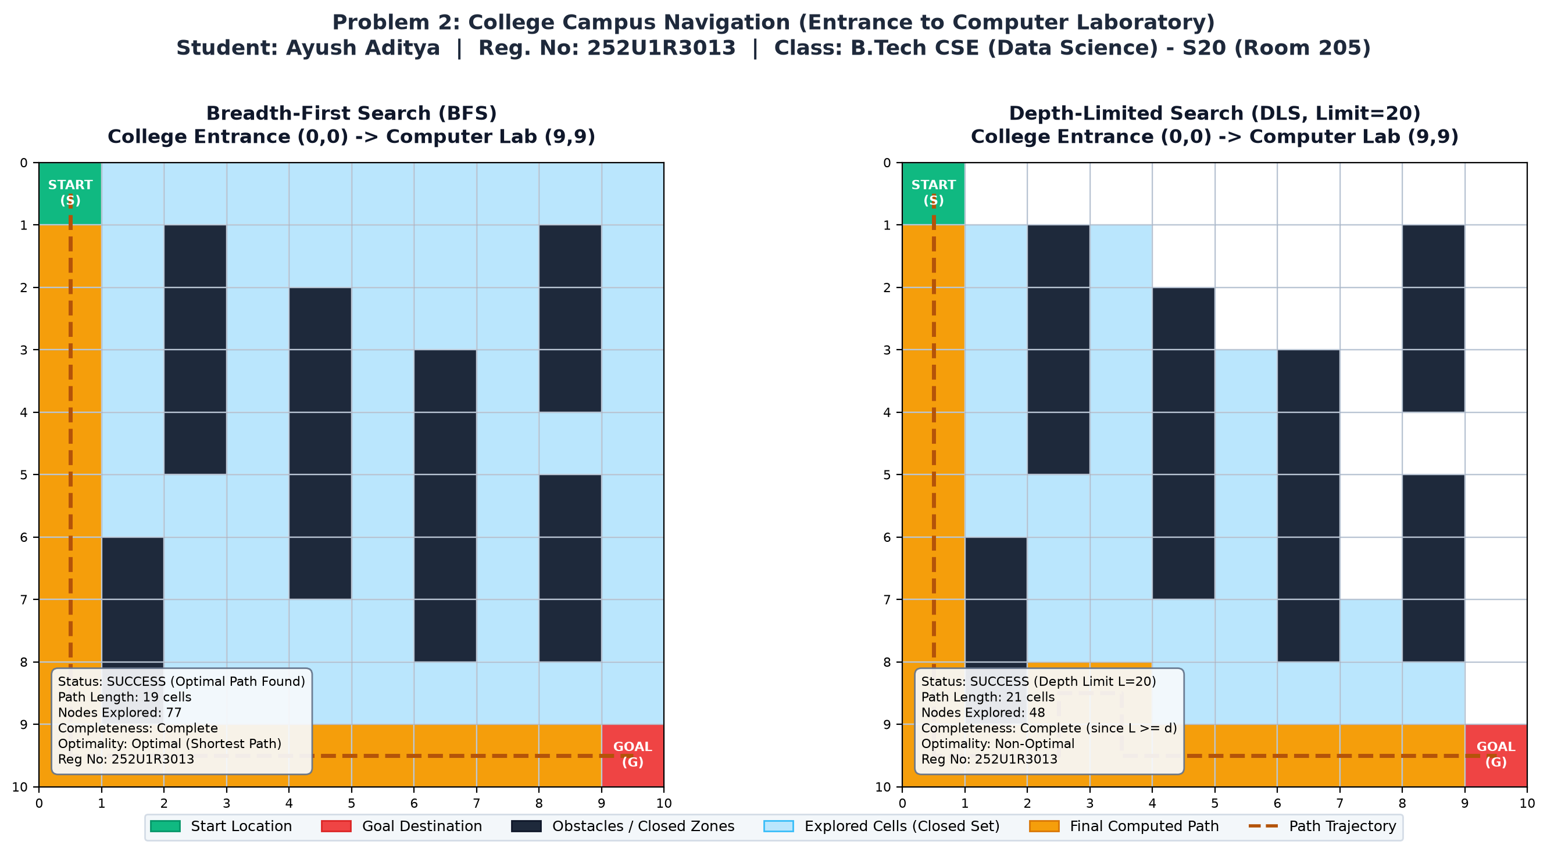

📸 [PASTE SCREENSHOT HERE]: PROBLEM 2 DLS CUTOFF ANALYSIS (LIMIT L=10 VS LIMIT L=20)
Instructions for Student (Ayush Aditya - 252U1R3013):
• Screenshot Requirement: Execute Cell 6 in Google Colab illustrating the theoretical DLS Cutoff condition.
• Key Verification: Left panel shows DLS Cutoff (L=10 < d=18 -> Incomplete), Right panel shows DLS Success (L=20 >= d=18).
• Registration Number: 252U1R3013 must be visible in both subplots.
┌────────────────────────────────────────────────────────────────────────┐
│ │
│ >>> CLICK HERE, PRESS BACKSPACE/DELETE, AND PASTE (Ctrl+V) <<< │
│ YOUR GENUINE SCREENSHOT OF THE EXECUTED COLAB OUTPUT │
│ │
└────────────────────────────────────────────────────────────────────────┘
--- Reference Verified Simulation Output (Generated Locally) ---
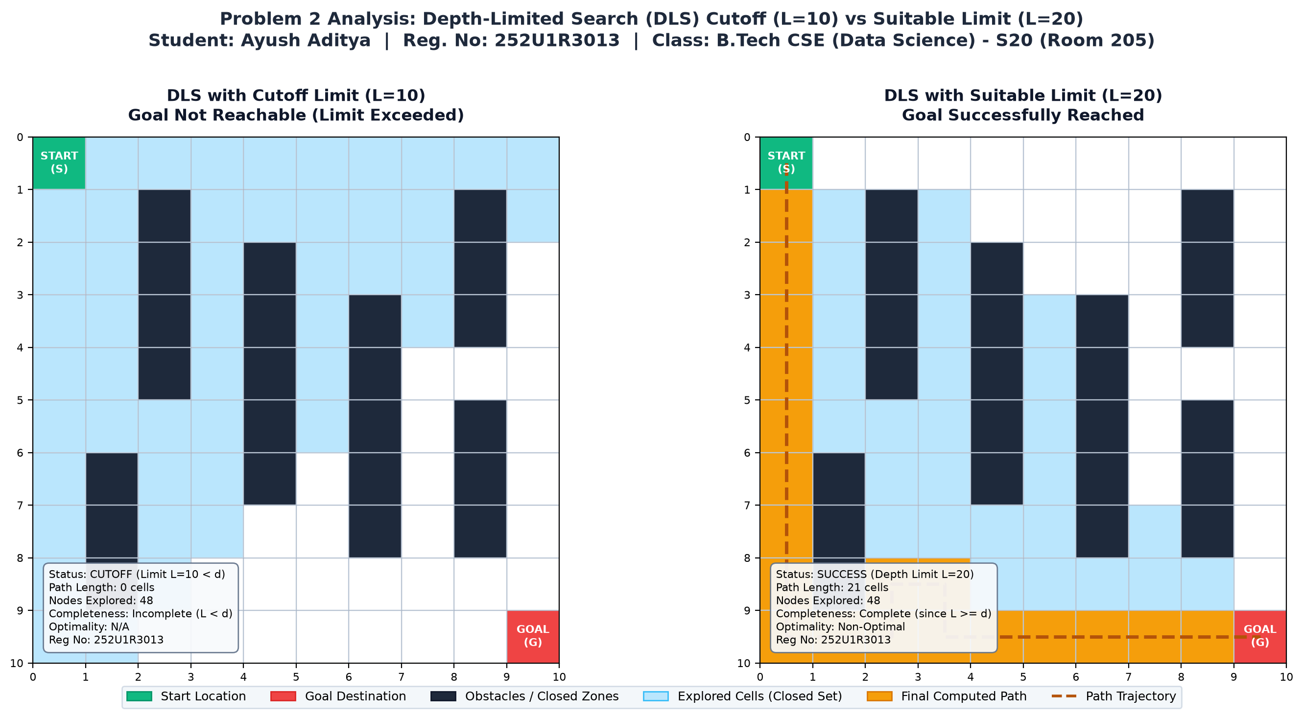

4. Google Colab & Project Repository Links
🔗 PROBLEM 2 PROJECT LINKS
• Google Colab Notebook Link:
https://colab.research.google.com/github/zeph7907/FAI-Lab-2/blob/main/FAI_Lab_Report_2_Ayush_Aditya_252U1R3013.ipynb
• GitHub Repository Link:
https://github.com/zeph7907/FAI-Lab-2

5. Explanation & Depth Limit Analysis (BFS vs DLS)
Depth Limit Selection Analysis & Algorithm Comparison:
1. Analytical Selection of Depth Limit L: The Manhattan distance between College Entrance (0, 0) and Computer Lab (9, 9) is |9 - 0| + |9 - 0| = 18 steps. Accounting for campus construction obstacles, the true shortest path is d = 18 steps (19 cells).
2. Cutoff Demonstration (L = 10): When DLS is run with depth limit L = 10, the algorithm terminates with a CUTOFF signal. Because L < d (10 < 18), the algorithm correctly halts its descent, proving that DLS prevents infinite recursion but will fail if the depth limit is set lower than the solution depth.
3. Suitable Depth Limit (L = 20): Setting L = 20 guarantees that L >= d, providing sufficient depth budget to route around obstacles. DLS successfully reaches the Computer Lab with a path length of 21 cells (20 steps) while exploring only 48 cells.
4. Memory Comparison (BFS vs DLS): BFS stores the entire expanding perimeter in RAM, requiring exponential memory O(b^d). Conversely, DLS holds only the active search branch in memory, consuming strictly linear memory O(b * L). DLS is therefore highly effective for memory-constrained embedded campus kiosks or handheld student guides.
Metric | BFS | DLS (L=20, Suitable) | DLS (L=10, Cutoff)
Completeness | Yes | Yes (since L >= d) | No (Cutoff occurred)
Optimality | Yes (19 cells) | No (21 cells) | N/A
Time Complexity | O(b^d) | O(b^L) | O(b^L)
Space Complexity | O(b^d) [Exponential] | O(b * L) [Linear] | O(b * L) [Linear]

Overall Assessment Conclusion (Module 1 & 2 Synthesis)
Summary Comparison Across All Evaluated Uninformed Search Algorithms:
Algorithm | Data Structure | Completeness | Optimality | Memory Footprint
Breadth-First Search (BFS) | FIFO Queue | Complete (b < inf) | Optimal (uniform cost) | O(b^d) [High RAM requirement]
Depth-First Search (DFS) | LIFO Stack | Complete (finite state) | Non-Optimal | O(b * m) [Minimal linear RAM]
Depth-Limited Search (DLS) | Recursive / Stack (L) | Complete if L >= d | Non-Optimal | O(b * L) [Strictly linear RAM]
Concluding Takeaways (Student: Ayush Aditya | Reg. No: 252U1R3013):
1. In Problem 1 (Hospital Delivery Robot), BFS proved to be the required algorithm because path length directly impacts patient survival and clinical delivery turnaround time.
2. In Problem 2 (College Campus Navigation), DLS demonstrated how search depth constraints eliminate infinite loops and reduce memory usage to linear complexity O(b * L), provided domain knowledge informs a suitable depth limit L >= d.
3. Both experiments comprehensively validate the theoretical principles of Uninformed Search Strategies as prescribed in Modules 1 and 2 of the Fundamentals of Artificial Intelligence curriculum.

