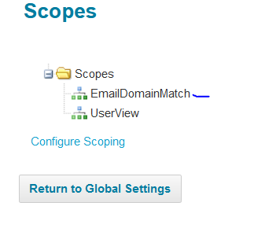

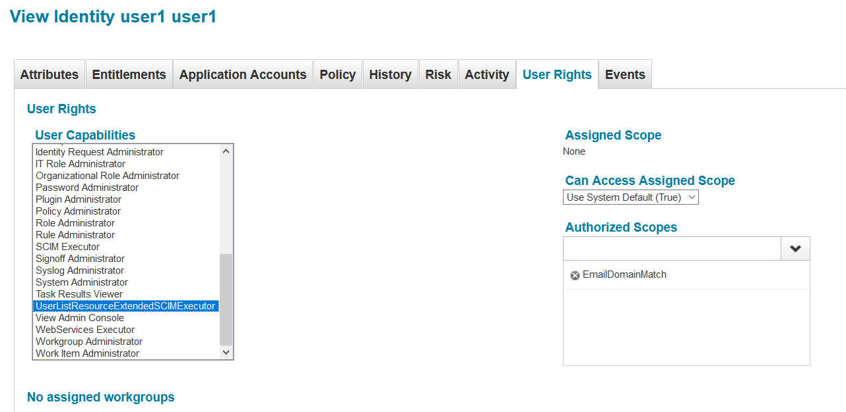

|  |
| --- |
| <?xml version='1.0' encoding='UTF-8'?>  <!DOCTYPE Capability PUBLIC "sailpoint.dtd" "sailpoint.dtd">  <Capability displayName="UserListResourceExtendedSCIMExecutor" name="UserListResourceExtendedSCIMExecutor">  <Description>UserListResourceExtendedSCIMExecutor</Description>  <RightRefs>  <Reference class="sailpoint.object.SPRight" name="UserListResourceExtendedSCIMExecutor"/>  </RightRefs>  </Capability> |
| |  | | --- | | <?xml version='1.0' encoding='UTF-8'?>  <!DOCTYPE SPRight PUBLIC "sailpoint.dtd" "sailpoint.dtd">  <SPRight displayName="UserListResourceExtendedSCIMExecutor" name="UserListResourceExtendedSCIMExecutor">  <Description>UserListResourceExtendedSCIMExecutor</Description>  </SPRight> | |

|  |
| --- |
| <?xml version='1.0' encoding='UTF-8'?>  <!DOCTYPE Scope PUBLIC "sailpoint.dtd" "sailpoint.dtd">  <Scope assignedScopePath="7f000001763d14ac81763e49c6b500c6" displayName="EmailDomainMatch" name="EmailDomainMatch" path="7f000001763d14ac81763e49c6b500c6">  <AssignedScope>  <Reference class="sailpoint.object.Scope" name="EmailDomainMatch"/>  </AssignedScope>  </Scope> |