Predicting Smartwatch Adoption
A supervised classification project — Logistic, Ridge, Lasso, and Random Forest models
compared on 120,000 customer records
─────────────────────────────────────────────────────────────────────────────────────────────────────────
1. Project Overview
This project builds a binary classifier to predict whether a customer adopts (purchases) a newly launched smartwatch, using a dataset of 120,000 customers and 40 variables covering demographics, purchase history, health metrics, and marketing exposure. Four models were trained and compared on a held-out test set: unregularized Logistic Regression, Ridge (L2) Logistic Regression, Lasso (L1) Logistic Regression, and a Random Forest Classifier (100 trees).
2. Dataset
120,000 rows × 40 columns, no missing values. Target variable Adopt is close to balanced (53.2% did not adopt / 46.8% adopted). Predictors include:
• Demographics: Age, Gender
• Relationship history: Recency, Tenure, TreatCampaign (marketing email exposure)
• Purchase behavior: value/number/quantity of health purchases and returns (online & overall), QtyPerOrder, BOGOUsed, Discounts
• Geography: Ngyms (gyms in zip code), Areapopl, DistGym
• Health & lifestyle: GymMemberOrNot, CardiacRisk, NonSmoker, BMI, DoctorFam, Adfootsteps, ADSleep, ADCal, ADBPM, OtherHealthDevices
• Noise controls: 9 random variables (RP1–RP9) with no real relationship to adoption, included to test whether the models pick up on spurious features
Data was split 70/30 into training (84,000 rows) and test (36,000 rows) sets. Models were fit on the training set and evaluated only on the held-out test set.
3. Model Results
All figures below are test-set metrics from this run of the notebook.
Model | Accuracy | Precision | Recall | F1 | ROC AUC
Logistic (no penalty) | 72.9% | 72.5% | 68.7% | 70.6% | 0.810
Ridge (L2) | 73.1% | 72.5% | 69.0% | 70.7% | 0.811
Lasso (L1) | 72.9% | 72.1% | 69.0% | 70.5% | 0.808
Random Forest | 84.2% | 82.5% | 84.1% | 83.3% | 0.926

Figure 1: Test accuracy by model. Random Forest is the clear top performer.
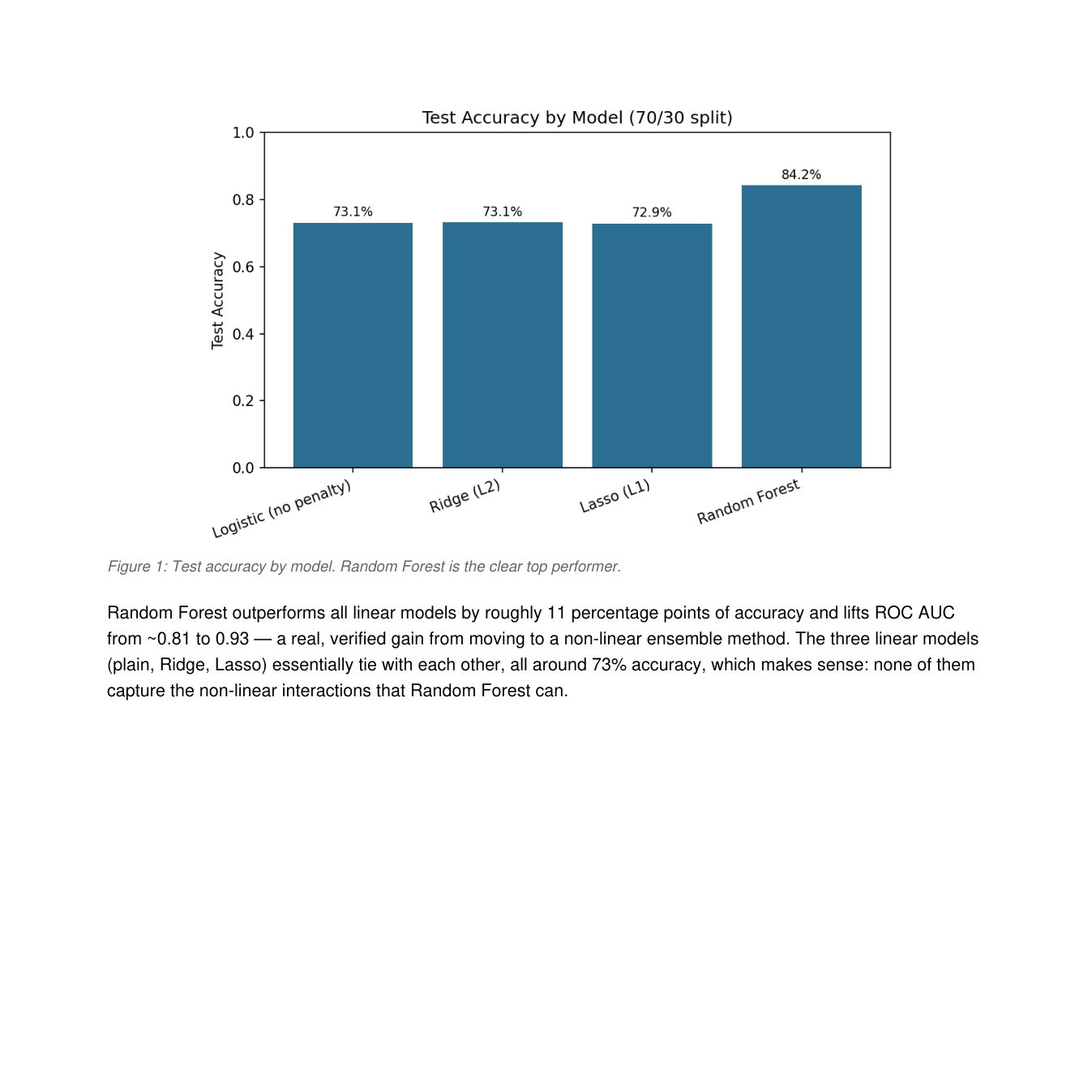
Figure 1: Test accuracy by model. Random Forest is the clear top performer.
Random Forest outperforms all linear models by roughly 11 percentage points of accuracy and lifts ROC AUC from ~0.81 to 0.93 — a real, verified gain from moving to a non-linear ensemble method. The three linear models (plain, Ridge, Lasso) essentially tie with each other, all around 73% accuracy, which makes sense: none of them capture the non-linear interactions that Random Forest can.

4. What the Regularization & Feature Importance Analysis Actually Shows
A common claim in write-ups of projects like this is that Lasso "automatically selects features by driving irrelevant coefficients to exactly zero." This was checked directly against the fitted model, and it did not hold here:
Finding: none of Lasso's 39 coefficients were driven to zero. All coefficients remained non-zero, just small in magnitude (the largest, Age, was −0.008). This is expected given the features were used on their raw, unscaled ranges (e.g. Areapopl in the tens of thousands vs. NonSmoker as 0/1) — L1 regularization is scale-sensitive, and without standardizing inputs first, its default penalty strength doesn't zero anything out. So Lasso should not be described as having performed automatic feature selection on this run.

Figure 2: Random Forest feature importances (top 15). Noise variables (RP…) shown in red where they appear.
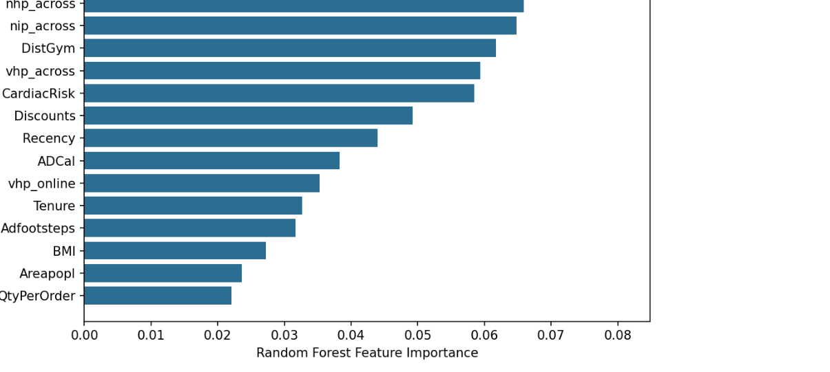
The Random Forest's top drivers of predicted adoption were NonSmoker, purchase-history variables (nhp_across, nip_across, vhp_across), DistGym, and CardiacRisk — a plausible, health-and-purchase-behavior-driven picture consistent with the business narrative.
Finding: the 9 injected noise variables (RP1–RP9) were not cleanly pushed to the bottom of the importance ranking. They landed across ranks 17 through 35 of 39 features — mostly in the lower half, but four of them (RP1, RP7, RP8, RP9) ranked above several genuine predictors such as Age, QtyPerOrder, ADBPM, and Ngyms. This is a fair and expected result for a default, untuned Random Forest (some noise features will out-rank weak real signals by chance), but it means the claim that Random Forest "robustly filters out noisy features" should be stated more carefully — it is better here than the linear models, but not a clean separation.
5. Methodology Notes & Limitations
• No hyperparameter tuning was performed — all models use library defaults (e.g. Random Forest: 100 trees, no max-depth limit). Accuracy may improve further with tuning.
• Features were not scaled/standardized before fitting Logistic, Ridge, or Lasso, which affects how their coefficients (and Lasso's shrinkage in particular) should be interpreted.
• No exploratory data analysis (distributions, correlations, outlier checks) beyond confirming there are no missing values and checking the class balance.
• SVM (SVC) was imported in the working notebook but not yet trained or evaluated.
• Single train/test split (random_state=42), not cross-validated, so metrics carry some sampling variance.

