1. Project Team Name and #. List of team members. Vision. Project description.
2. Project Team Name: Schoodle
3. Team Members: Ahmed Al Hasani, Erik Holbrook
4. Vision: Create an application that requires numerous classes to incorporate Object-Oriented Principles and the course’s concepts.
5. Description: a web-based application for college course-related tasks, like tracking grades, sharing content and submitting assignments.
6. List the features that were implemented (table with ID and title).

|  |  |
| --- | --- |
| ID | Description |
| 1 | An administrator can create a new Course and populates it with at least 1student and 1instructor |
| 2 | An administrator can add students and instructor to a course |
| 3 | An instructor can upload multiple students’ grades |
| 4 | An instructor can upload course content |
| 6 | A student can view course content |
| 7 | A student can view their course grades |
| 9 (Partially) | Students can take automatically-graded quizzes. Our current implementation shows only the view of the quiz but without the questions (model) and the control. |

1. List the features were not implemented from Part 2 (table with ID and title).

|  |  |
| --- | --- |
| ID | Description |
| 5 | An instructor can download students’ assignments and grade them |
| 8 | Students can submit assignment content (PDFs) for grading |

1. Show your Part 2 class diagram and your final class diagram.   
   What changed? Why? If it did not change much, then discuss how doing the design up front helped in the development.

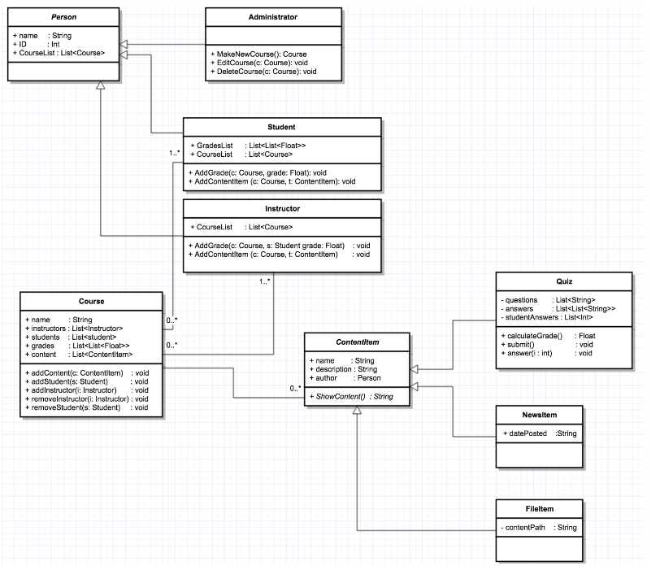

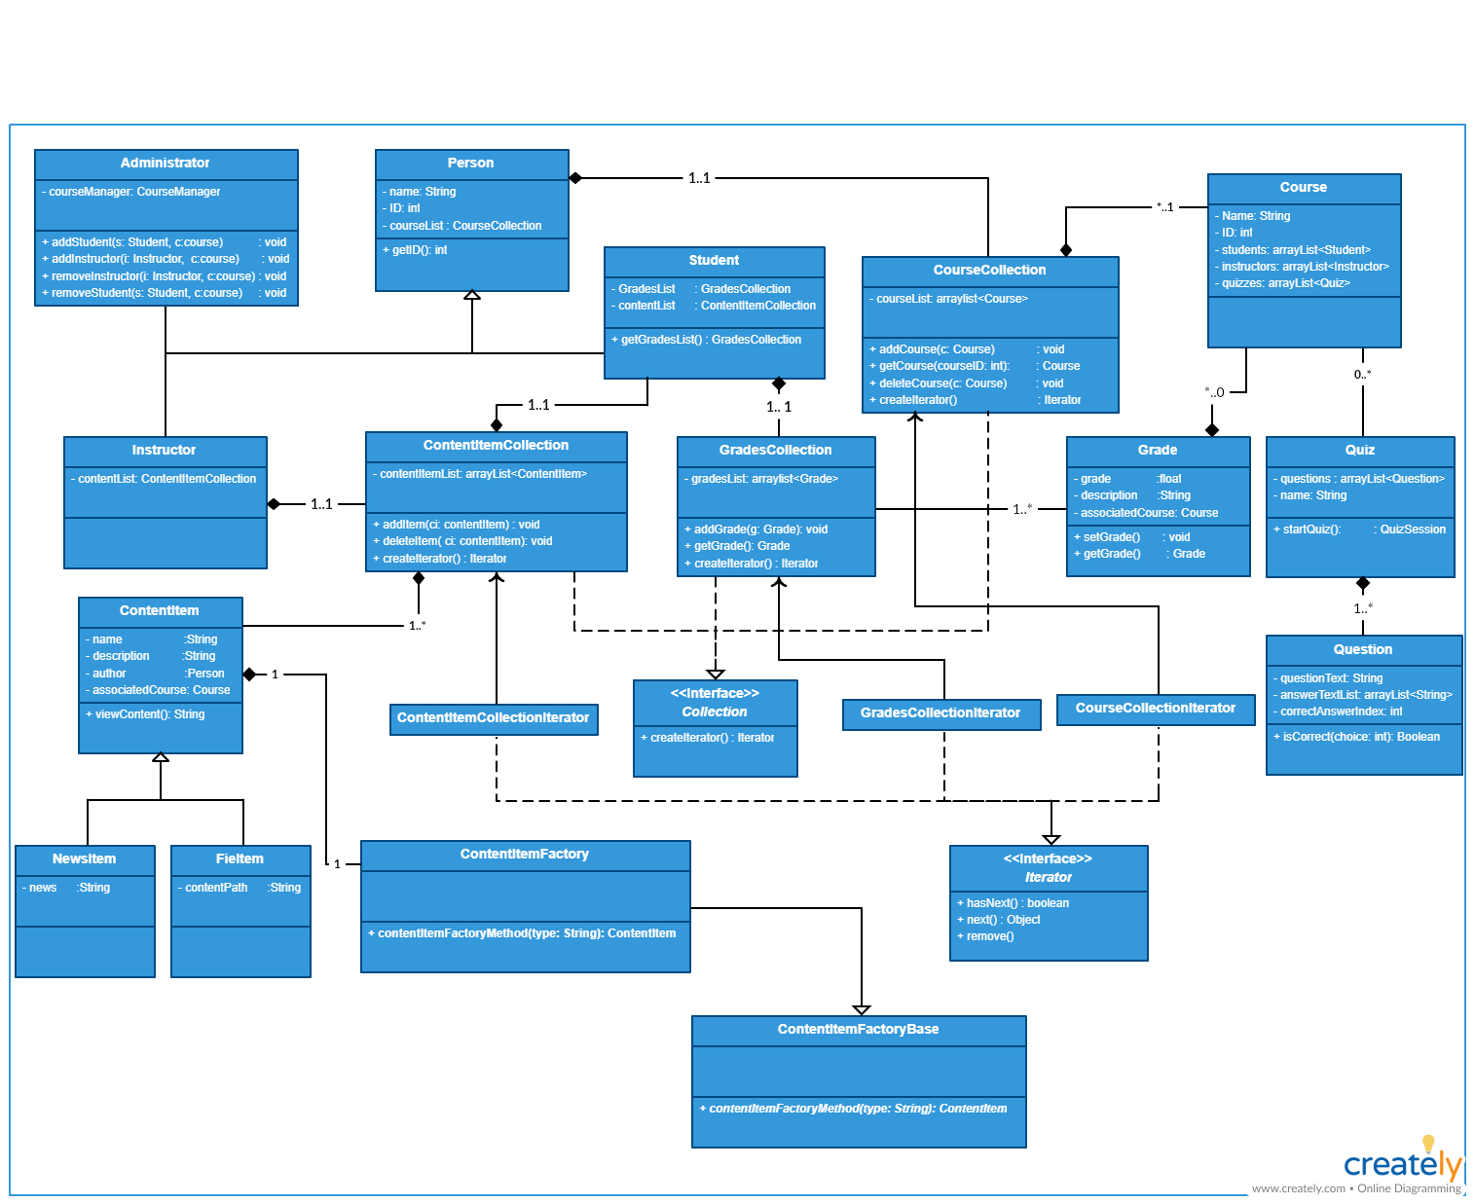

1. Show the classes from your class diagram that implement each design pattern (each design pattern as a separate image in the .PDF).
   1. Iterator

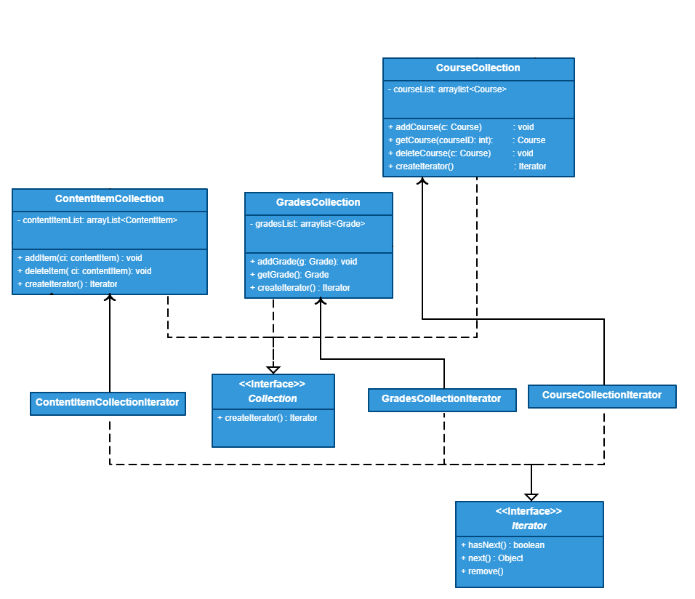

* 1. 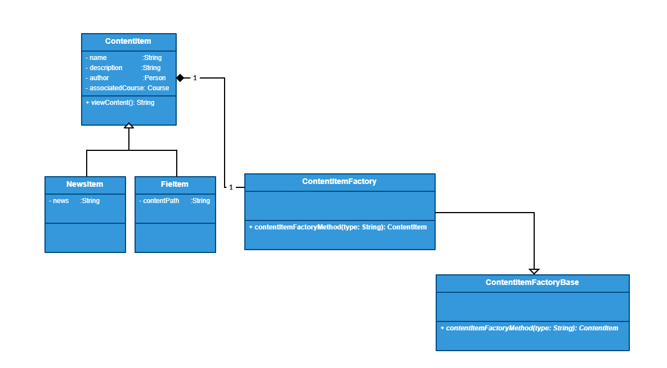Factory

1. What have you learned about the process of analysis and design now that you have stepped through the process to create, design and implement a system