# Slide preparation summary

The sample production protocol is similar to normal DAPI staining with an additional RNAse treatment. A typical protocol would be:

1. 3× PBS wash
2. Settle on slides
3. Fix with 1% PFA (10 min)
4. Permeabilise in -20°C MeOH (30 min)
5. Rehydrate with 1× PBS wash
6. Add RNAse A (50 μg/ml) (1 hr, room temp)
7. Add DAPI (1 μg/ml) and SYBR green (1:10000) or PI (40 μg/ml), 2 min
8. 3× PBS wash
9. Mount in DABCO

For more information about sample preparation see <http://users.ox.ac.uk/~path0493/>

The sample preparation should be relatively insensitive to fixing conditions and precise fluorescent stain concentration etc.

Cells should be seeded at a suitable slide density and prepared with care – these analysis tools are much less “clever” than a person - fluorescence background (both from poor RNAse digestion and sample contamination) will interfere with colour deconvolution and debris on the slide, very high cell density and out of focus cells will confuse the DAPI counter.

# Image capture summary

**Phase contrast**, **DAPI** and **PI/SYBR green** images are required, DIC is not suitable. Images are best captured at 40-60× magnification. Many images will be needed (typically 10 or more) so tiled arrays of images are advisable. Key points to remember are:

* Colour deconvolution requires quantitative capture of the fluorescence images:
  + Do not pre-expose cells as this will result in photobleaching
  + Do not over-expose (saturate) the fluorescence image.
  + Make sure the fluorescence field stop is correctly adjusted so as not to overexpose regions around the field you are currently capturing.
* Fluorescence channels:
  + DAPI – blue
  + SYBR green – green (FITC/GFP)
  + Propidium iodide – near or mid red (TRITC, RFP)

For more information about image capture see <http://users.ox.ac.uk/~path0493/>

# Image analysis

The image analysis tools are for use in ImageJ. ImageJ is free and open source software and is available for Windows, Linux and Mac operating systems. For more information and downloads visit <http://rsbweb.nih.gov/ij/>

## Installing the tool set

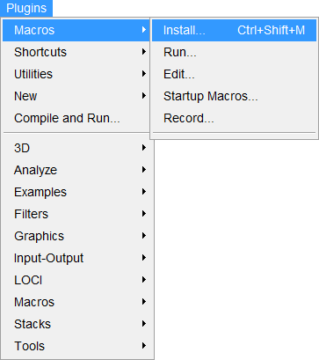

Open ImageJ and go to “Plugins>Macros>Install”, navigate to the location of the text file containing the analysis macros and click “Open”.

You can download the macro tool set from <http://users.ox.ac.uk/~path0493/>

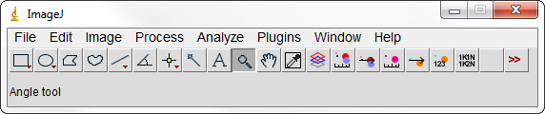

Once installed the analysis tools appear as 7 icons on the right side of the toolbar. These are the tools for image setup, measurement of chromatic aberration, correction of chromatic aberration, measurement of K/N signal, colour deconvolution, K/N counting and summarising the K/N count results.

**The 7 tools should be used in order left to right. To use each tool simply click on their icon.**

For each tool default values for various settings are already in place. These should work for many analyses however they may also need optimising for you microscope setup or cell type. Tips for optimising some of the values are given at the end of the instructions.

**Each tool takes some time to run. Once the image preparation/analysis is complete a message box will pop up; interacting with the images before this has happened can disrupt the preparation/analysis step.**

## Preparing for the analysis

All images you want to analyse should be open in ImageJ. Make sure that any images you do not want analysed are closed.

All images have to be in the form of **16-bit image stacks** with each channel (phase, DAPI and PI/SYBR green) in a different slice. The order of the channels must be the same in all images.

Merged images (e.g. an RGB jpeg) with all the image channels combined into a single image are not suitable.

## Image setup

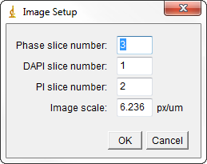

The tool expects images in the form of multi-slice 16 bit images as the input. Image setup requires you to enter the numbers of the slices which contain the phase contrast image, the DAPI image and the PI image. The image scale (in pixels per micrometre) also has to be entered.

## Measure chromatic aberration

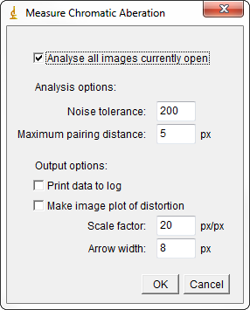

This measures the chromatic aberration in the images which results in the slight misalignment of the DAPI and PI images.

* “Noise tolerance” is the noise tolerance used in maxima finding. It should be set to a value which results in recognition of around one point per kinetoplast and nucleus in both fluorescence images (see *troubleshooting of maxima point finding*).
* “Maximum pairing distance” is the maximum separation (in pixels) between two points in the two fluorescence images which will be accepted as a valid pairing. Larger values increase noise in the measurement of aberration but allow measurement of greater aberration.

There are optional extra data outputs which are not required but may be useful for further analysis:

* Print data to log writes all the point location and displacement data to the ImageJ log window.
* Make an image plot of distortion creates a visual view of the distortion due to chromatic aberration. The shift of every point between the two fluorescence images is illustrated by an arrow.

If this tool functions correctly the output should be:

* Scale factor: between 1.000 and 1.005. If under 1.000 it is likely the DAPI and PI channels are set the wrong way round.
* Origin: a location within the image (i.e. greater than 0 and under the image width/height). If far outside the image is it likely the analysis has not worked correctly.

## Correct chromatic aberration

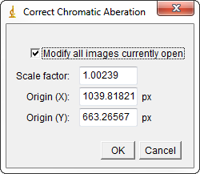

This distorts the PI image to correct for chromatic aberration. The scale factor and origin are remembered from the measurement of chromatic aberration. Alternatively they can be manually entered.

## Measure K/N signal

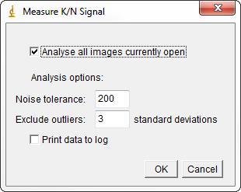

This measures the typical intensity in the DAPI and PI channels of bright points in the image and uses them to calculate the reference intensity values of kinetoplasts and nuclei for colour deconvolution.

* “Noise tolerance” is the noise tolerance used in maxima finding. It should be set to a value which results in recognition of around one point per kinetoplast and nucleus in both fluorescence images (see *troubleshooting of maxima point finding*).
* “Exclude outliers” is an exclusion filter used when analysing the points and clustering them into the kinetoplasts and nuclei groups. Any points which lie more than this number of standard deviations from the mean are excluded from the analysis. Lower numbers exclude more points and can help with samples which have fluorescent debris or similar contamination.

There is an optional extra data output which is not required but may be useful for further analysis:

* “Print data to log” writes all the point intensity data to the ImageJ log window.

If this tool functions correctly the output will be the nucleus, kinetoplast and background vectors; which indicate the brightness of kinetoplasts, nuclei and the background in the DAPI and PI channels. There are two “quality control” measures.

* Points in each cluster: These two numbers should be similar indicating a roughly equal number of kinetoplasts and nuclei have been detected. (200, 350) would be a good result while (20, 530) would indicate either kinetoplasts or nuclei have not been recognised or the clustering has been unsuccessful.
* Ratio ratio: The further from 1 this is the better. A value of 0.1 indicates a large difference in the colour of kinetoplasts and nuclei, a value of 1 indicates no difference. If close to 1 then colour deconvolution will not be possible. A typical good value is 0.3.

## Colour deconvolution

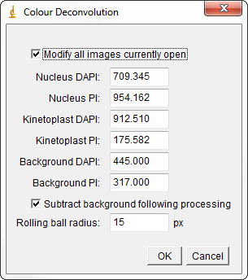

This performs colour deconvolution to split the DAPI and PI signal into kinetoplast and nucleus signal. The reference DAPI and PI values for the nucleus, kinetoplast and background are remembered from the measurement of chromatic aberration. Alternatively they can be manually entered. Note that “Nucleus DAPI” referrs the average maximum DAPI signal seen in a nucleus.

* “Subtract background following processing” uses a rolling ball filter to remove any background signal following colour deconvolution.
  + “Rolling ball radius” defines the radius of the ball used for rolling ball background subtraction (see *troubleshooting rolling ball background subtraction*).

## K/N count

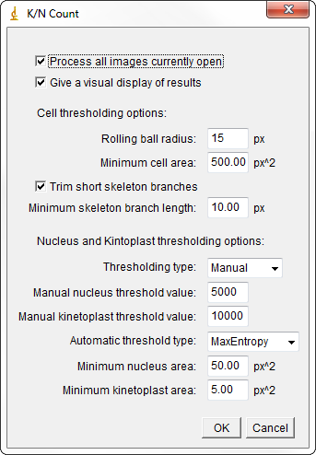

This performs the DAPI count on the deconvolved images currently open. The data collected is all written to the ImageJ results table.

Note that this step is by far the slowest and will take at least 10 sec per image.

* “Give a visual display of results” provides an image output illustrating the masks used for detecting the cells and measuring K/N number, intensity and area.
* Cell thresholding is a two-step process:
  + “Rolling ball radius” defines the radius of the ball used for rolling ball background subtraction (see *troubleshooting rolling ball background subtraction*).
  + “Minimum cell area” defines the minimum particle area accepted as a cell. Anything under this area is ignored.
* Cell detection uses a skeletonisation step to generate the cell shape skeletons for use in excluding cells which are actually multiple cells lying in contact.
  + “Trim short skeleton branches” trims off short branches in the skeleton which are likely to form due to irregularities in cell shape.
  + “Minimum branch length” is the minimum branch length allowed to remain following trimming of short branches.
* Nuclei and kinetoplasts are detected by thresholding.
  + “Thresholding type” defines whether manually set thresholds are used or if automatic thresholding is used.
    - “Manual nucleus threshold value” is the thresholding value used for detecting nuclei if manual thresholding is selected (see *troubleshooting thresholding*).
    - “Manual kinetoplast threshold value” is the thresholding value used for detecting kinetoplasts if manual thresholding is selected (see *troubleshooting thresholding*).
    - “Automatic threshold type” is the thresholding method used of automatic thresholding is selected (see *troubleshooting thresholding*).
  + “Minimum nucleus area” defines the minimum particle area accepted as a nucleus. Anything under this area is ignored.
  + “Minimum kinetoplast area” defines the minimum particle area accepted as a kinetoplast. Anything under this area is ignored.

## Results table

The data from the automated analysis is placed into the results table. Each row represents a cell (or potential cell) and each column is corresponds to a piece of data collected. **All data about every cell is recorded in the table; absolutely nothing is filtered out.**

Properties relating to the whole cell:

* *Cell area (um2)*
  + The cell area in square microns
* *Total kinetoplast/nuclear DNA*
  + The total kinetoplast/nuclear DNA within the cell outline, in arbitrary units
    - The DNA content of a nucleus can be compared to another nucleus accurately
    - The DNA content of a kinetoplast can be compared to another kinetoplast accurately
    - The DNA content of a kinetoplast cannot be directly compared to that of a nucleus, and vice versa.
* *Touching edge*
  + A Boolean (1=true, 0=false) indicating whether any part of the cell outline touches an edge of the image
* *Kinetoplast/nucleus number*
  + The number of kinetoplasts/nuclei detected in the cell
* *Cell OX/Y*
  + The location of the topmost pixel in the leftmost column of pixels in the cell outline
* *Cell X/Y*
  + The location of the top left corner of the cell outline’s bounding box
* *Cell W/H*
  + The width and height of the cell outline’s bounding box

Properties relating to the analysis of cell shape:

* *Skeleton length*
  + The number of pixels in the skeleton
    - Gives a measure of total cell length where every branch in the skeleton is added up and taken as a contribution to overall cell length
* *Skeleton termini/branches*
  + - Two statistics used in detecting branched skeletons
      * Termini are the branch ends. An unbranched skeleton should have two
      * Branches are the branch points in a skeleton. An unbranched skeleton should have zero
* *Cell length*
  + Skeleton length converted to microns
* *Cell width*
  + Maximum cell width, as inferred from the skeleton, in microns

Image and analysis identifiers:

* *Image no*
  + The unique number of the image as assigned by the analysis
* *Year/month/day/hour/minute/second*
  + The date and time of the analysis

Kinetoplast and nuclei properties:

Each of the following column names is preceded by kinetoplast or nucleus (indicating whether they are a statistic of the kinetoplast or nucleus) and the number of the kinetoplast or nucleus. i.e. for a 2K1N cell there will be data for “Kinetoplast 1”, “Kinetoplast 2” and “Nucleus 1”.

* *Area (um2)*
  + The area in square microns of the organelle
* *Sum Intensity*
  + The total DNA content of the organelle in arbitrary units
    - This measurement is comparable to the the total kinetoplast/nucleus (respectively) DNA content of the cell
* *Centroid X/Y*
  + The location of the “centre of mass” of the organelle based on its signal
* *Terminus distance (um)*
  + The distance of the organelle from a cell skeleton terminus, this corresponds to the distance of the organelle from one end of the cell
    - minimumOf(terminusDistance, cellLength-terminusDistance) gives the distance from the organelle to the nearest end of the cell
* *Skeleton distance (um)*
  + The distance of the organelle from the cell skeleton, this corresponds to the distance of the organelle from the centre-line of the cell

## K/N count summary

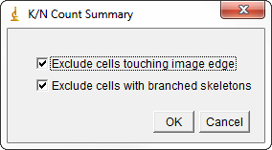

This analyses the data in the results table and produces a summary of the K/N number of cells present in the images. **This is an *extremely* simple analysis of the data; far more information can be extracted by analysing the results table directly.**

* “Exclude cells touching image edge” filters out cells which are touching the image edge (which may have cut nuclei or kinetoplasts off the image).
* “Exclude cells with branched skeletons” filters out cells which have a branched skeleton. This will mostly consist of “cells” which are actually multiple cells number although this filter generally has a high false positive rate.

# Troubleshooting

## Maxima point finding

Maxima point finding uses the built-in ImageJ maxima finding tool. If there seem to be problems with measurement of chromatic aberration or K/N signals it is worth manually optimising the noise tolerance.

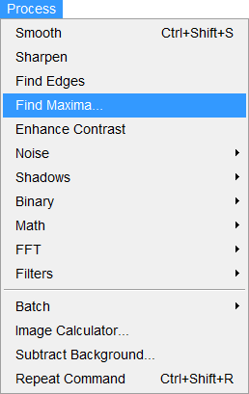

The noise tolerance should be adjusted so that there is approximately one point recognised per kinetoplast and nucleus. The points recognised can be seen using the “Preview point selection” option.

It does not matter if more than one point per kinetoplast and/or nucleus is identified so long as the number of points found in kinetoplasts and nuclei respectively is similar.

## Rolling ball background subtraction

Background subtraction is performed by the built-in ImageJ background subtraction tool. If there are problems with background subtraction following colour deconvolution or detecting cells from the phase image then it is worth manually optimising the rolling ball radius.

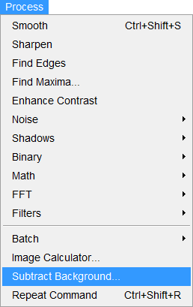

The rolling ball radius should be adjusted so that it subtracts the background effectively without removing too much detail on the details of interest (e.g. faint kinetoplasts or small cells).

## Thresholding

Manual and automatic thresholding are performed by the built-in ImageJ thresholding tools.

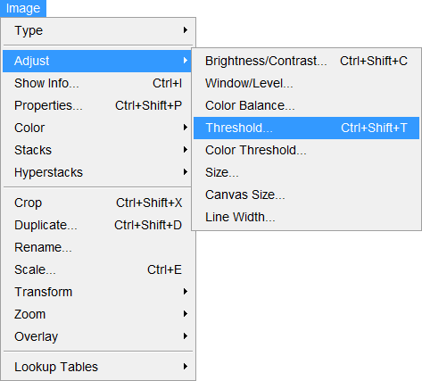

The manual thresholding values or the automatic thresholding algorithm choice should be chosen so that the particles of interest are effectively recognised while features in the background are omitted.

Source image Thresholding level too high

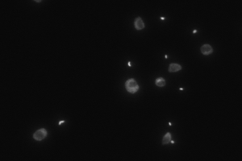 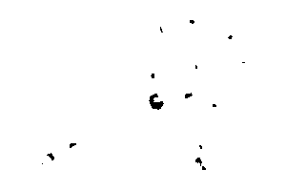

Thresholding level too low Thresholding level ok

