# Slide preparation

For this approach to automated analysis samples need to be prepared where cell morphology is preserved well and the DNA is stained with two stains.

Sample preparation is similar to a normal DAPI stain protocol except with an additional RNAse step as PI and SYBR green both bind RNA. The sample preparation is relatively insensitive to fixing conditions, although cells must be permeabilised by MeOH or detergent to ensure good access of RNAse. Fluorescent stain concentrations are optimised and should not be altered without good reason.

Cells should be seeded at a suitable slide density and prepared with care, these analysis tools are fast and can extract a lot of data but are much less “clever” than a person. For example fluorescence background (from poor RNAse digestion or from fluorescent debris in the sample) will interfere with colour deconvolution. High cell density will prevent accurate identification of cells and cells which are not lying flat on the slide, so are partially or wholly out of focus, can also not be accurately analysed.

## For analysing a single sample

This protocol is optimised for photostability of the fluorescent DNA stains. There will be some variation in staining across the slide so this protocol is not suitable for quantitative comparison of multiple samples.

1. Wash cells
   1. Take a sample of an appropriate number of cells from the culture
   2. Centrifuge at 800 g for 3 min
   3. Resuspend in an equal volume of PBS
   4. Repeat 3×
   5. Resuspend in a final volume of 50 μl
2. Settle on slides and fix
   1. Add 50 μl of cells in PBS to the slide
   2. Allow cells to settle for 5 to 10 min
   3. Fix by adding 50 μl 2% PFA and incubate at room temperature for 10 min
3. Permeabilise with MeOH
   1. Gently remove excess liquid from the slide
   2. Immerse in -20°C MeOH
   3. Incubate at -20°C for 30 min
   4. Rehydrate by immersion in PBS
4. RNAse treat and stain cells
   1. Add RNAse A (100 μl, 50 μg/ml in PBS)
   2. Incubate for 1 h at room temperature
   3. Add DAPI (1 μg/ml) and SYBR green (1:10,000) or PI (40 μg/ml), made up in PBS
   4. Incubate at room temperature for 2 min
5. Mounting
   1. Wash the slides 3× by immersion in PBS
   2. Mount by adding ~100 μl glycerol with 1% DABCO and 10% 50 mM sodium phosphate pH 8.0
   3. Add a coverslip and seal

## For quantitative comparison of multiple samples

This protocol is optimised for consistency of staining across a slide. High consistency of staining allows quantitative comparison of multiple samples. This protocol does not include photoprotective chemicals so fluorescent DNA stains will photobleach far more rapidly.

1. Wash cells
   1. As above
2. Settle on slides and fix
   1. As above
3. Permeabilise with MeOH
   1. As above
4. RNAse treat and stain cells
   1. Add RNAse A (100 μl, 50 μg/ml in PBS)
   2. Incubate for 1 h at room temperature
   3. Stain slides by immersion in DAPI (200 ng/ml) and SYBR green (1:10,000,000) or PI (40 ng/ml), made up in PBS
   4. Incubate at room temperature for 2 min
5. Mounting
   1. Do not wash the slides
   2. Ensure approximately 10 μl of staining solution is still present on the sample
   3. Add a coverslip and seal

# Image capture

For this approach to automated analysis 3 images are needed; a phase contrast image of the cells and the DAPI and PI (or SYBR green) fluorescence images. Moderate magnification is best, around 40 to 60×.

For colour deconvolution and quantitation of DNA content of organelles to work images must be captured with care. Any photobleaching of the sample or overexposure of the fluorescence images will make colour deconvolution and quantitation of DNA content impossible.

A good approach to capturing the images is as follows:

1. Determining capture settings
   1. Load the slide and focus the sample
   2. Using a live preview adjust the exposure time for the phase contrast, DAPI and PI fluorescence channels to get a clear picture while ensuring that no part of the image saturates
   3. Ensure the fluorescence field diaphragm is set to the smallest size possible while still maintaining even illumination across the field of view of the camera
2. Test the capture settings
   1. Find a new region of the sample which has not previously been exposed to fluorescence illumination
   2. Use phase contrast to focus the sample then capture the phase and fluorescence images
   3. Check the fluorescence images are not overexposed, refine the exposure times and repeat if necessary
3. Capturing images
   1. Find a new region of the sample which has not previously been exposed to fluorescence illumination
   2. Use phase contrast to focus the sample then capture the phase and fluorescence images
   3. Proceed in a logical pattern to capture a set of images for analysis
   4. Avoid biased collection of images; i.e. do not just pick cells which “look nice”

# Image analysis summary

Images have to be loaded into ImageJ in the form of **16-bit image stacks** with each channel (phase, DAPI and PI/SYBR green) in a different slice. The order of the channels must be the same in all images.

For more information about using ImageJ to get a 16-bit stack set up see <http://rsbweb.nih.gov/ij/>

The LOCI Bioformats plugin to support more microscopy file types is also of use <http://www.loci.wisc.edu/bio-formats/imagej>

For more information about loading images for analysis and for performing the analysis itself see <http://users.ox.ac.uk/~path0493/>

# Example problems with images

### DAPI

Good DAPI image DAPI overexposed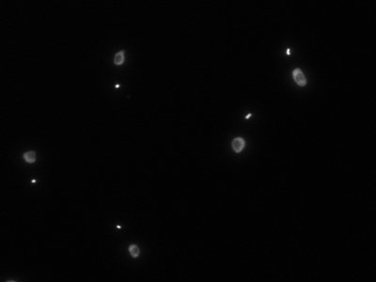 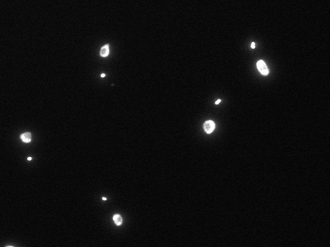

Speckled background fluorescence Uneven illumination/partial photobleaching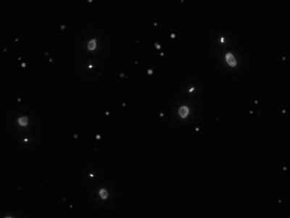 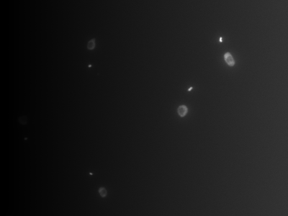

### PI

Good PI image RNA not correctly digested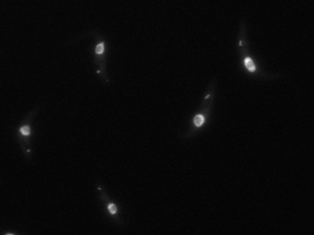 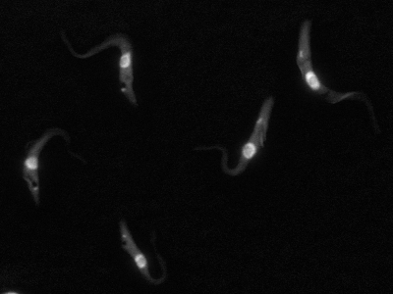

### Phase contrast

Good phase contrast image Uneven illumination/microscope misalignment 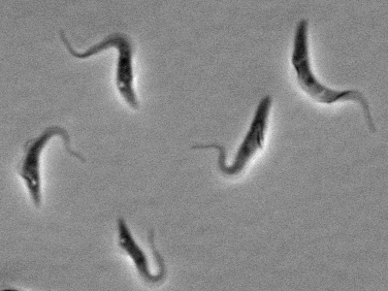 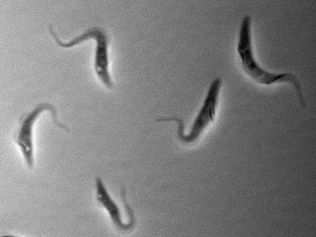

Debris in sample Dust and/or scratches in optics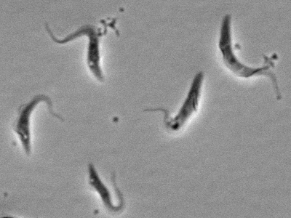 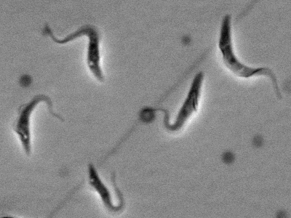

Cells too dense on slide Cells out of focus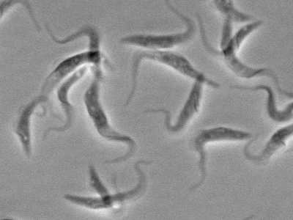 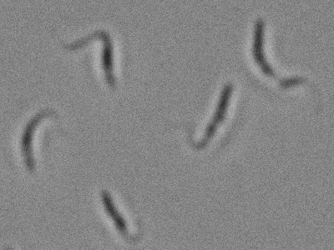

## Image quality

Good quality images are vital for automated analysis. Computers are far faster and better at making quantitative analyses than a person but are far less “clever”. Any of the issues above will cause problems with the automated analysis:

* DAPI overexposed
  + If either the DAPI or PI images are overexposed colour deconvolution to separate the kinetoplasts and nuclei will not work
* Speckled background fluorescence
  + Bright spots in either the DAPI or PI image which are not kinetoplasts or nuclei will disrupt automated measurement of reference values for colour deconvolution. They may also be recognised as kinetoplasts or nuclei later in the analysis
* Uneven illumination/partial photobleaching
  + Uneven illumination and photobleaching completely prevent colour deconvolution from working. Later in the analysis they would also disrupt quantitation of DNA in the kinetoplasts and nuclei
* RNA not correctly digested
  + Partial digestion of RNA will prevent accurate quantitation of nuclear DNA
* Uneven illumination/microscope misalignment
  + Uneven illumination in the phase contrast image will prevent accurate identification of cells from the phase contrast image
* Debris in sample
  + Debris particles in the sample will be recognised as cells and included in the analysis. Debris particles which touch a cell prevent accurate thresholding of that cell and will disrupt analysis of that cell’s morphology
* Dust and/or scratches in optics
  + Problems with dirty optics have a similar effect to debris in the sample
* Cells too dense on slide
  + Cells which lie touching each other will be analysed as a single cell. These can be filtered out at later stages of the data analysis but there is a major risk of biasing the sample. Well-spaced cells will give far higher quality data.
* Cells out of focus
  + Out of focus cells cannot be identified accurately; the phase halo may be recognised instead of the cell body and kinetoplasts and nuclei are unlikely to be identified correctly