Effects of an 8-Week Integrated Neuromuscular Training Program on Lower-Limb Explosive Power and Swimming Start Performance in Adolescent Swimmers
Lina Xiao¹, Yifei Wang*, Xiaobin Wu*
1 Chengdu Sport University, School of Physical Education, Chengdu, Sichuan Province, China.
Corresponding author: Xiaobin Wu 38754105@qq.com; Yifei Wang 18683897986@163.com
Clinical trial number: not applicable.
Ethics approval and consent to participate: in supplementary
This study was approved by the Ethics Committee of Chengdu Sports University. All procedures were conducted in accordance with the Declaration of Helsinki.
Abstract
Background: Early specialization in competitive swimming involves repetitive, buoyancy-supported training that may limit neuromuscular development and ground-based movement competence. Integrated Neuromuscular Training (INT) has emerged as a strategy to address these deficits, yet its efficacy in adolescent swimmers remains insufficiently explored.
Objective: This study aimed to investigate the effects of an 8-week INT program on lower-limb explosive power, swimming start performance, and functional movement quality in adolescent swimmers.
Methods: Seventeen competitive adolescent swimmers (age: 11.1 ± 1.0 years) were randomly assigned to either an INT group (INTG, n = 9) or a conventional training group (CON, n = 8). The INTG performed a progressive INT program (twice weekly, 60 min/session) focusing on movement quality, stability, and plyometrics, while the CON followed traditional strength and conditioning. Intervention assessments included the Functional Movement Screen (FMS), squat jump, counter movement jump, standing long jump, and swimming start parameters (15 m time, entry distance, and horizontal hip velocity (VxH)).
Results: After 8 weeks, the INTG demonstrated significant improvements in 15 m start time (p < 0.01), entry distance (p < 0.001), and VxH (p < 0.001). Between-group analysis revealed that INTG was significantly superior to CON in enhancing VxH (p < 0.001) and total FMS score (p < 0.05). Although within-group improvements in jump performance were more consistent in the INTG, no significant between-group differences were observed for explosive power metrics.
Conclusion: An 8-week INT program is more effective than conventional training for enhancing swimming start performance and functional movement quality in youth swimmers. These findings suggest that INT facilitates better transfer of land-based power to sport-specific explosive actions.
Keywords: Adolescent; Competitive swimming; Integrated neuromuscular training; Start performance

1. Introduction
Childhood and adolescence represent a critical "window of opportunity" for motor coordination and neural adaptation, characterized by heightened nervous system plasticity(1). According to the Youth Physical Development (YPD) model, the pre-pubertal stage (ages 9–12) is optimal for developing fundamental movement skills and neuromuscular control(2,3). The debate over early specialization remains a focal point in youth athletic development(4). While intensive focus on a single sport is often pursued as a pathway to elite performance, many researchers argue that premature specialization can compromise long-term physical literacy and limit an athlete’s motor repertoire(5,6). Competitive swimming is agreed as an early specialization sport, in which athletes are exposed to highly repetitive, water-based training from an early developmental stage(7). Although such specialization facilitates technical refinement, prolonged adaptation to an aquatic, buoyancy-supported environment provides limited exposure to neuromuscular control demands associated with gravitational loading, impact absorption, and high ground reaction forces. During critical periods of neuromotor development, this narrow training stimulus may constrain the development of fundamental movement skills(8,9), lower-limb force production, rate of force development, and other critical specializations. As a consequence, young swimmers may exhibit imbalances between water-specific proficiency and land-based movement competence, leading to suboptimal force transmission across the kinetic chain(10). These limitations contribute to a reduced ability to transfer general strength and power capacities into sport-specific actions, particularly during performance phases requiring rapid and forceful propulsion.
To address the neuromuscular deficits associated with early specialization, Integrative Neuromuscular Training (INT) has emerged as a developmentally appropriate and evidence-based strategy for youth athletes(11). Unlike traditional strength training that emphasizes isolated muscle groups, INT integrates fundamental movement patterns with targeted strength, balance, coordination, agility, and plyometric exercises to create a comprehensive neuromotor stimulus that more closely reflects the dynamic demands of sport participation and long-term athletic development(12). This approach places a strong emphasis on movement quality, proprioceptive feedback, and inter-muscular coordination, thereby optimizing motor unit recruitment and force production across the kinetic chain. By challenging the neuromuscular system with varied sensory inputs and movement contexts, INT enhances postural control, dynamic stability, and overall movement(13). Evidence from systematic reviews and randomized controlled trials indicates that INT interventions significantly improve key performance outcomes—including explosive power(14,15), sprint and jump performance(16), balance ability(17,18), and agility(19). In addition, INT has been shown to reduce injury risk and correct biomechanical deficits by improving proprioception, dynamic stabilization, and load distribution, which are critical factors in preventing overuse injuries and acute lower-limb trauma among developing athletes(20,21). However, most of this evidence has been derived from land-based sports characterized by frequent ground contacts and multidirectional movements.
Despite its widespread recognition in sports such as soccer and basketball, the systematic application of INT within competitive swimming remains limited. Current dry-land practices in swimming are still dominated by isolated strength drills or standalone plyometric exercises, which often fail to integrate dynamic stability and motor control into a unified training framework. However, emerging evidence suggests that neuromuscular-focused dry-land training can meaningfully enhance swimming performance. Core training interventions have been shown to improve 50m freestyle times and enhance neuromuscular parameters of key swimming muscles such as the erector spinae and latissimus dorsi(22). Systematic reviews indicate that plyometric, ballistic, and strength training targeting neural enhancement of leg-extensor muscles can effectively improve turn performance(23). Importantly, research indicates that transfer of dry-land adaptations to swimming is maximized when training programs incorporate sport-specific elements(24). INT provides a unique advantage by optimizing the lower-limb kinetic chain and enhancing the recruitment of motor units during explosive movements(25). By fostering a stiffer and coordinated transmission of force from the core to the lower extremities, INT can mitigate energy dissipation during the push-off phase, which is critical for maximizing horizontal power. Despite its potential, INT has not yet been systematically integrated into swimming start protocols.
Therefore, the purpose of this study was to investigate the effects of an INT-based program on lower-limb explosive performance and movement quality in youth swimmers. It was hypothesized that INT would significantly enhance explosive capacity while improving neuromuscular control and reducing movement asymmetries, thereby providing a superior biomechanical foundation for swimming-specific explosive actions.

2. Methods

2.1 Participants
Seventeen competitive adolescent swimmers (6 males, 11 females; age: 11.1 ± 1.0 years; height: 148.2 ± 13.4 cm; body mass: 37.8 ± 10.5 kg) were recruited from DY Olympic School on 31st, March, 2025, which is a government supported adolescent training department. All participants met the following inclusion criteria: (i) a minimum of one year of systematic swimming training; (ii) All participants were categorized as Tier 2 (Developmental athletes) based on the five-tier classification framework(26); (iii) proficiency in all four competitive swimming strokes; and (iv) participation in at least three aquatic training sessions per week under the supervision of the same head coach. Athletes were free from any musculoskeletal, neurological, or orthopedic disorders within the last six months and did not take any form of nutritional supplements or medications that could influence physical performance. A priori sample size estimation was conducted using GPower (version 3.1.9; Heinrich Heine University, Düsseldorf, Germany). To align the power analysis with the final analytic framework, the calculation was based on an F test for ANOVA: repeated measures, within-between interaction, corresponding to a 2 × 2 mixed ANOVA assessing the Group × Time interaction. Based on a previous 8-week intervention study in adolescent athletes, the effect size was specified as Cohen’s f = 0.40, with α = 0.05, power (1 − β) = 0.80, two groups, and two measurements. The estimated minimum total sample size was 16 participants. Accordingly, the final sample of 17 participants was considered sufficient for the present study.
Before the commencement of the study, all participants and their legal guardians were fully informed of the study's purpose, procedures, and potential risks. Written informed consent was obtained from all guardians, and the study protocol was approved by the institutional ethics committee of the Chengdu Sport University, Sichuan, China in accordance with the latest version of the Declaration of Helsinki.

2.2 Integrated Neuromuscular Training Testing Procedures
Before the experiment, participants completed the Functional Movement Screen (FMS) to assess fundamental movement patterns and identify potential functional deficits, thereby providing individualized baseline information for the subsequent training intervention. Participants were then randomly allocated by computer into either an integrated neuromuscular training group (INTG; n = 9) or a control group (CON; n = 8). Baseline testing was conducted one week before the intervention, and post-intervention testing was conducted one week after the completion of training. Subjects of the INT group performed INT with 2 sessions per week for 8 weeks, whereas the CON completed a traditional strength and conditioning program over the same duration.
The training protocol was developed based on previous studies(27–29), which mostly focus on general youth fitness and land-based sports. Following consultation with experienced swimming coaches and physical training experts, the training protocol was refined to better align with the biomechanical and neuromuscular demands of swimming. (Table 1). The primary difference between the two programs lay in their training focus. The INT program emphasized movement integration and proprioceptive development through multi-planar, unstable-surface exercises to enhance neuromuscular control. In contrast, the CON program primarily focused on increasing absolute muscle strength through traditional, stable-surface exercises. The INT program primarily consisted of modules targeting warm-up, strength training, plyometric training, speed and agility training, balance training, and core stability. Training sessions were conducted on Wednesday and Friday afternoons. Since the athletes continued their routine aquatic training during this period to maintain neuromuscular adaptations, the 4-day interval between sessions would not lead to a loss of accumulated training effects. After a standardized 15-min warm-up, the INTG completed 45 min of INT, while the CON completed 45 min of traditional physical conditioning after the same warm-up (Table 2). Rest intervals were 1–2 min between sets. Adequate recovery was provided between agility, plyometric, and resistance components to ensure training quality. To keep overall training load comparable between groups, internal load was monitored each session using the Borg Rating of Perceived Exertion (RPE) scale. Mann–Whitney U tests indicated no significant difference in mean RPE between the INTG and CON across the 8-week intervention (p = 0.837), suggesting that between-group differences were primarily attributable to training content rather than training volume or effort (Supplementary 1).
To maximize neuromuscular recruitment, the 8-week intervention was divided into two progressive phases. The first 4 weeks focused on standardizing fundamental movement patterns and correcting functional deficits, including bodyweight squats, BOSU-based stability exercises, and basic landing/attenuation techniques (Table 1). The final 4 weeks emphasized sport-specific transfer by incorporating higher-intensity stretch–shortening cycle (SSC) activities and progressively increasing external load to further enhance sport-specific performance.
To minimize assessment bias, all physical performance tests and the FMS were conducted by independent assessors who were not involved in the training intervention and were blinded to the group allocation.
Table 1 Progression of the 8-week Integrated Neuromuscular Training (INT) program.
 | Weeks 1–4 | Weeks 5–8
Plyometrics & Explosive Power | Drop jump (30 cm);  3 sets of 8 reps  Single-leg drop landing (30 cm)  2 sets of 8 reps | Depth jumps to broad jump  3 sets of 6 reps  Jump to single-leg support  3 sets of 8 reps
Lower-limb Strength | Squat  3 sets of 6 reps, 0–10 kg  Bulgarian split squat  2 sets of 8 reps each, 0–5 kg  Wall sit  3 sets of 30 sec, bodyweight | Squat (0–20 kg)  3 sets of 10 reps  Bulgarian split squat (0–6 kg)  3 sets of 4 reps each  Wall sit (0–10 kg)  3 sets of 30 sec
Core Stability | BOSU plank  3 sets of 60 sec  BOSU side plank  3 sets of 30 sec each  Plank shoulder taps  3 sets of 12 reps | BOSU plank  3 sets of 30 sec  BOSU side plank  3 sets of 30 sec each  BOSU push-up  3 sets of 10 reps  Back extension + hold (0–5 kg)  3 sets of (10 reps + 10 sec)
Balance & Mobility | Single-leg balance press on balance pad  3 sets of 4 reps each | Single-leg balance press on balance pad (0-5kg)  3 sets of 4 reps each
Note: In the last training session of the 4th week, subjects tested whether they could have performed 2 more repetitions for each set or one more set. Once this is achieved, the absolute intensity or difficulty of exercise was increased.
Table 2 Progression of Training programs for control group
Component | Weeks 1–4: Standard Phase | Weeks 5–8: Progression Phase
Plyometrics & Explosive Power | Squat jump  3 sets of 10 reps;  Medicine ball overhead throw (Squat jump)  3 sets of 5 reps | Medicine ball slam & side throw (3 kg)  3 sets of (8+4) reps;  Medicine ball chop slam (3 kg)  3 sets of 4 reps each;  Medicine ball overhead throw (Kneeling jump)  3 sets of 5 reps
Lower-limb Strength | Squat (0–10 kg)  3 sets of 6 reps;  Bulgarian split squat  3 sets of 4 reps each;  Wall sit (Bodyweight)  3 sets of 30 sec | Squat (0–20 kg)  3 sets of 15 reps;  Bulgarian split squat  3 sets of 4 reps each;  Wall sit (Bodyweight)  3 sets of 30 sec
Core Stability & Strength | Dead bug  4 sets of 12 reps;  Back extension (0–5 kg)  3 sets of 12 reps;  Russian twists (0–5 kg)  3 sets of 14 reps;  Side-lying crunches  3 sets of 8 reps each | Standard plank  3 sets of 1 min;  Russian twists  3 sets of 15 reps each;  Crunches  4 sets of 12 reps;  8-level abdominal bridge circuit  2 sets (20 s + 10 s per variation);  Back extension + isometric hold  3 sets of (10 reps + 10 sec)
Warm-up & Coordination | Agility ladder drills  2 sets each session;  Straight-leg jumps  2 sets each session | Agility ladder drills  2 sets each session;  Straight-leg jumps  2 sets each session

2.3 Tests

2.3.1 FMS test
FMS is a screening tool comprising seven specific tests used to evaluate overall functional movement capacity(30). Each item is scored on a 0–3 scale, including the squat, hurdle step, forward lunge, shoulder mobility, ASLR, push-up, and rotary stability. A score of 3 indicates that the participant can perform the movement correctly without pain; a score of 2 indicates that the movement can be completed without pain but with some compensation; and a score of 1 indicates inability to complete the movement as instructed. If pain occurs at any point during the movement, the score is 0. The total standard FMS score was derived using the 7-item scoring algorithm by summing Squat, Push-Up, and the lower score from each bilateral task, ranged from 0 to 21.

2.3.2 Lower-limb explosive power
Lower-limb explosive power was assessed using SJ, CMJ, and SLJ. Jump performance was measured using an OptoGait optical measurement system (OptoGait, Microgate, Bolzano, Italy). For SJ and CMJ, participants initiated the jumps from a standing position. SJ required a static hold at a self-selected squat depth prior to take-off, whereas CMJ incorporated a rapid downward movement followed immediately by an upward propulsion to maximize elastic energy utilization. For SLJ, participants performed a maximal horizontal jump from a static standing position; jump distance was measured using a tape measure. All tests were performed with maximal effort. Three trials were completed for each test, and the best performance was retained for analysis.

2.3.3 Start performance
Start performance was evaluated using three outcomes: 15 m start time, entry distance, and mean horizontal hip velocity. The 15 m start test was conducted in a standard 50 m indoor swimming pool with water temperature maintained at 27 °C. All participants used a grab start and were instructed to perform the start, water entry, and initial acceleration phase with maximal effort following the starting signal. Timing began at the start signal and ended when the participant's head crossed the vertical plane of the 15 m mark. Performance was recorded using an automatic timing system. Each participant completed two trials separated by a 10-min rest period, and the best time was used for statistical analysis.
To further examine the biomechanical mechanisms underlying differences in start performance, two-dimensional kinematic analysis was used to quantify key parameters during the take-off and flight phase. Video data were captured using a high-speed camera (GoPro 7; GoPro Inc., USA) operating at a sampling frequency of 120 Hz and a resolution of 1080p, positioned at poolside 5 m from the centerline of the starting block and at a height of 120 cm. The optical axis was aligned perpendicular to the pool's longitudinal axis to ensure full capture of the movement from take-off to complete water entry (Figure 1). All videos were processed in Kinovea to calculate horizontal displacement and flight time from toe-off to initial head contact with the water, from which mean horizontal hip velocity (V × H) was derived(31). To minimize the influence of fatigue, all in-water tests were performed 48 h after the final dry-land test session and were supervised by the same experienced swimming coach to ensure consistency of testing procedures and technique.
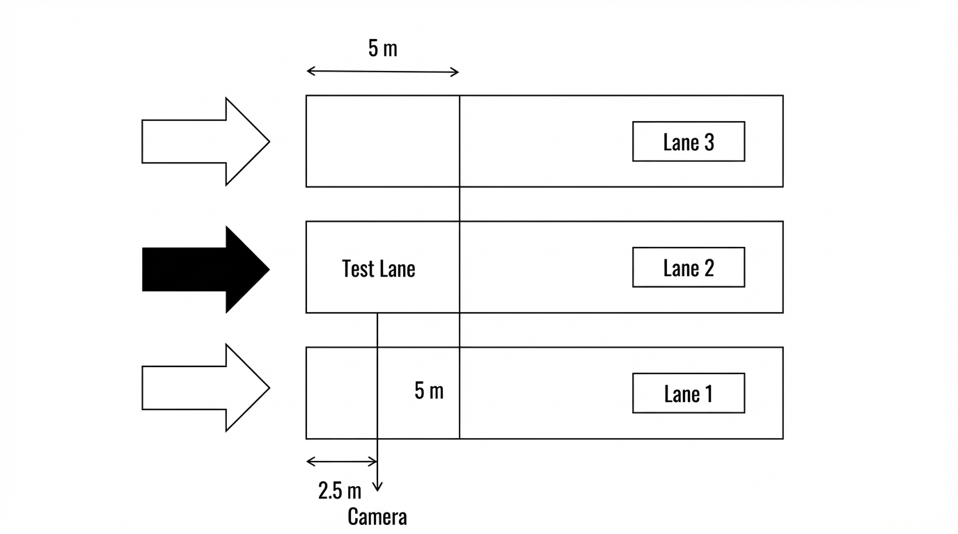
Figure 1 Schematic diagram of the experimental swimming lane configuration
Note: The start performance was evaluated in the Test Lane (Lane 2). A high-speed camera was positioned at the poolside, 5 m perpendicular to the centerline of the test lane and 2.5 m longitudinally from the starting wall. The optical axis was aligned perpendicular to the pool's longitudinal axis.

2.4 Statistical analysis
All data are presented as mean (SD). Data distribution was assessed using the Shapiro-Wilk test. To evaluate training effects, the primary analysis was performed using a 2 × 2 mixed repeated-measures ANOVA, with Group (CON vs. INTG) as the between-subject factor and Visit (Pre vs. Post) as the within-subject factor. The Group × Visit interaction was considered the main effect of interest. When a significant interaction was detected, Holm-adjusted post hoc comparisons were used to examine within-group changes over time and between-group differences at each visit. For each outcome, F values, degrees of freedom, p values, and partial eta squared were reported.
Because pre-intervention differences may influence post-intervention comparisons even in randomized designs, ANCOVA was additionally performed as a sensitivity analysis, with post-test values entered as the dependent variable, group as the fixed factor, and the corresponding pre-test values as covariates. This analysis was used to determine whether the main findings remained consistent after adjustment for baseline values. Assumptions of normality and homogeneity were checked before model fitting, and potential outliers were screened before analysis. All analyses were performed using R (version 4.5.2; R Foundation for Statistical Computing, Vienna, Austria), with statistical significance set at p < 0.05.

3. Results

3.1 Baseline characteristics and group comparability
No sports-related injuries occurred during testing or training. Training compliance was high in both groups (INTG: 95.5%; CON: 96.0%). All 17 participants completed the intervention (INTG: n = 9; CON: n = 8). Baseline comparisons revealed no significant between-group differences in age, height, or body mass (all P > 0.05; Table 3). Similarly, no significant baseline differences were observed in lower-limb explosive performance (SJ, CMJ, SLJ), start performance variables (15 m time, take-off distance, VxH), or functional movement quality as assessed by the FMS total score (all P > 0.05). Normality testing indicated that variables related to lower-limb explosive power, start performance, and the FMS total score were normally distributed, whereas individual FMS component scores violated the assumption of normality; therefore, nonparametric statistical methods were applied for analyses of FMS component scores.
Table 3 Baseline characteristics and physical performance variables
Characteristics | INTG (n = 9) | CON (n = 8) | t | P
Age (years) | 11.2 ± 0.9 | 11.0 ± 1.1 | 0.412 | 0.686
Height (cm) | 147.5 ± 12.8 | 149.0 ± 14.2 | −0.229 | 0.821
Body mass (kg) | 37.2 ± 9.8 | 38.5 ± 11.3 | −0.254 | 0.803
TE (years) | 2.33 ± 1.1 | 2.71 ± 1.39 | -0.38 | 0.544
BMI (kg/m²) | 16.01 ± 1.63 | 17.38 ± 2.53 | -1.37 | 0.198
Note: Data are presented as mean ± standard deviation (M ± SD). No significant between-group differences were observed at baseline (all p > 0.05). INTG = integrative neuromuscular training group; CON = control group; BMI = body mass index; TE = training experience. SJ = squat jump; CMJ = countermovement jump; SLJ = standing long jump; VxH = horizontal velocity; FMS = Functional Movement Screen.

3.2 Effects of INT on lower-limb explosive power, start performance, and functional movement

3.2.1 Lower-limb explosive power
Lower-limb explosive power results are presented in Table 4 and Figure 1. No significant Group × Visit interactions were observed for squat jump (SJ: p = 0.097, partial eta squared = 0.172), countermovement jump (CMJ: p = 0.408, partial eta squared = 0.046), or standing long jump (SLJ: p = 0.081, partial eta squared = 0.189). Although both groups showed numerically higher post-test values across these jump-based outcomes, the magnitude of change did not differ significantly between INTG and CON. Within-group standardized changes ranged from trivial to small in CON (d = 0.13-0.39) and from small to moderate in INTG (d = 0.34-0.77), indicating a tendency toward larger pre-to-post improvements in INTG despite the absence of statistically significant interaction effects.
Table 4 Physical performance test results
Outcome | Metric | CON | INTG | P | Partial η²
Lower limb explosive power
Squat jump (SJ, cm) | Pre | 18.40 (4.18) | 19.17 (4.92) | 0.097 | 0.172
 | Post | 20.04 (5.16)** | 22.16 (3.96)***
 | Post-pre difference (%) | +8.9% | +15.6%
 | Post-pre ES (d) | 0.35 (small) | 0.67 (moderate)
Countermovement jump (CMJ, cm) | Pre | 24.34 (6.80) | 24.46 (6.34) | 0.408 | 0.046
 | Post | 26.54 (4.33) | 28.95 (5.21)*
 | Post-pre difference (%) | +9.1% | +18.4%
 | Post-pre difference (%) | +9.1% | +18.4%
Standing long jump (SLJ, cm) | Pre | 176.97 (20.86) | 167.58 (26.59) | 0.081 | 0.189
 | Post | 179.81 (23.66) | 176.70 (27.28)**
 | Post-pre difference (%) | +1.6% | +5.4%
 | Post-pre ES (d) | 0.13 (trivial) | 0.34 (small)
Start performance
15-m sprint time (s) | Pre | 8.54 (1.04) | 8.86 (1.40) | 0.001 | 0.565
 | Post | 8.97 (1.11)** | 8.58 (1.26)*
 | Post-pre difference (%) | +5.0% | -3.1%
 | Post-pre ES (d) | 0.40 (small) | -0.21 (small)
Water-entry distance (cm) | Pre | 188.79 (33.43) | 175.56 (31.57) | 0.001 | 0.667
 | Post | 193.68 (33.20) | 208.55 (28.56)***
 | Post-pre difference (%) | +2.6% | +18.8%
 | Post-pre ES (d) | 0.15 (trivial) | 1.10 (large)
Horizontal velocity (m/s) | Pre | 3.60 (0.41) | 3.54 (0.32) | 0.001 | 0.638
 | Post | 3.32 (0.31)*# | 3.97 (0.23)***#
 | Post-pre difference (%) | -7.8% | +11.9%
 | Post-pre ES (d) | -0.77 (moderate) | 1.51 (large)
FMS Total (score) | Pre | 13.12 (2.75) | 13.67 (2.87) | 0.016 | 0.328
 | Post | 12.38 (2.92)# | 15.56 (1.81)*#
 | Post-pre difference (%) | -5.7% | +13.8%
 | Post-pre ES (d) | -0.26 (small) | 0.79 (moderate)
Note: Data are presented as mean (SD). CON = control group; INTG = intervention group; Pre = pre-intervention; Post = post-intervention; Post-pre difference (%) = percentage change from pre- to post-intervention. Group × Visit P indicates the p value for the group-by-visit interaction. Partial η² indicates partial eta squared and reflects the effect size of the interaction. SJ = squat jump; CMJ = countermovement jump; SLJ = standing long jump; Delta x = horizontal displacement. For 15-m sprint time and horizontal velocity, negative percentage values indicate a reduction from pre- to post-intervention, whereas positive percentage values indicate an increase. * p < 0.05, ** p < 0.01, *** p < 0.001 versus Pre within the same group. # p < 0.05 for the between-group comparison at Post.
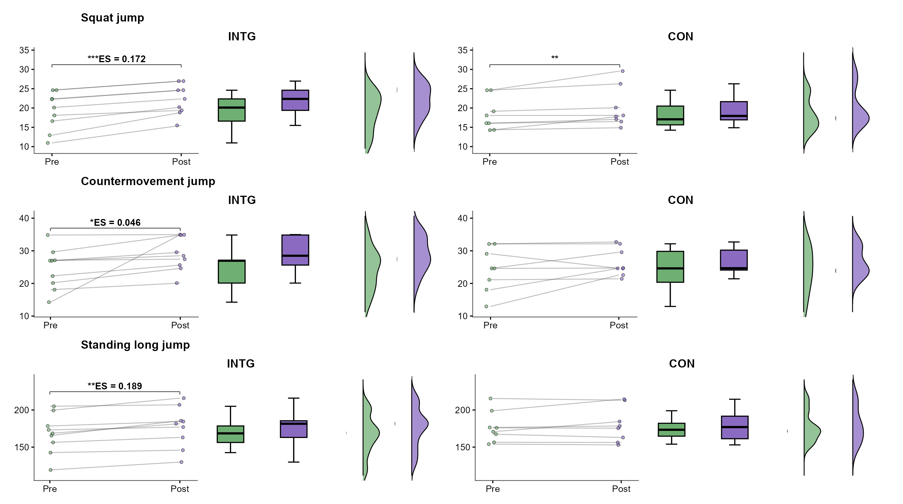
Figure 2 Within-group variations in lower-limb explosive power across pre- and post-intervention evaluations in the integrated neuromuscular training group (INTG) and conventional training group (CON).

3.2.2 Start performance
The primary start-performance results are summarized in Table 5 and Figure 2. Significant Group × Visit interactions were detected for 15-m sprint time (p = 0.001, partial eta squared = 0.565), water-entry distance (p = 0.001, partial eta squared = 0.667), and horizontal velocity (p = 0.001, partial eta squared = 0.638), with all interaction patterns favoring INTG. Specifically, INTG reduced 15-m sprint time from 8.86 (1.40) s to 8.58 (1.26) s, whereas CON increased from 8.54 (1.04) s to 8.97 (1.11) s. Water-entry distance increased slightly in CON, from 188.79 (33.43) cm to 193.68 (33.20) cm, but showed a markedly greater gain in INTG, from 175.56 (31.57) cm to 208.55 (28.56) cm. A similarly divergent pattern was observed for horizontal velocity, which decreased in CON from 3.60 (0.41) m/s to 3.32 (0.31) m/s but increased in INTG from 3.54 (0.32) m/s to 3.97 (0.23) m/s. Consistent with these interaction effects, within-group standardized changes were small or moderate in CON (d = -0.77 to 0.40) but small to large in INTG (d = -0.21 to 1.51), with the largest improvement observed for water-entry distance and horizontal velocity. Holm-adjusted post hoc comparisons further showed significant pre-to-post improvements in INTG across all three start-performance outcomes, whereas the clearest post-test between-group separation was observed for horizontal velocity..

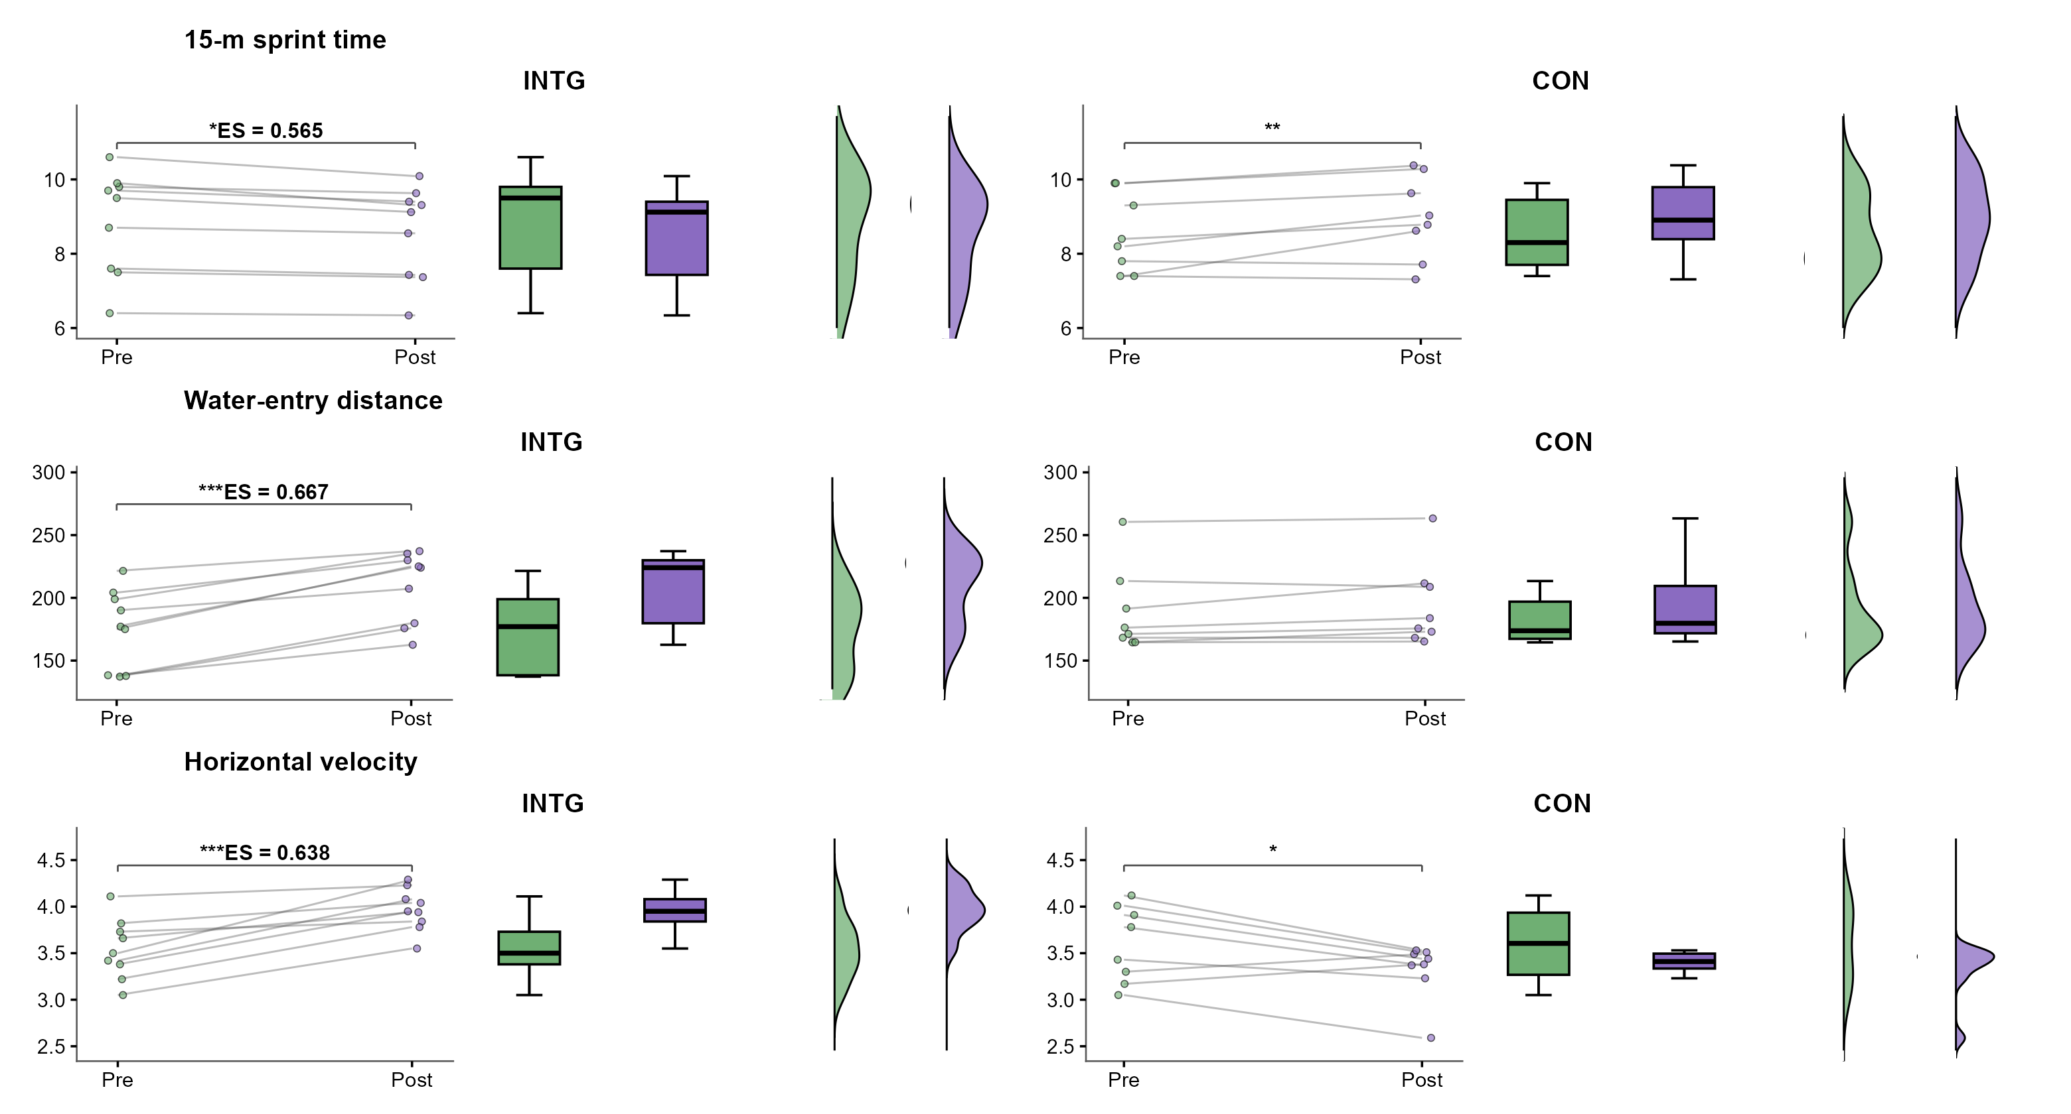
Figure 3 Within-group variations in starting performance, including 15-m sprint time, water-entry distance, and horizontal velocity, across pre- and post-intervention evaluations in the integrated neuromuscular training group (INTG) and conventional training group (CON).

3.2.3 Functional movement
Functional movement outcomes are presented in Table 4 and Figure 4. A significant interaction was observed for FMS total score (F(1,15) = 6.82, p = 0.016, partial eta squared = 0.328). The INTG showed a significant increase in FMS total score from 13.67 (2.87) to 15.56 (1.81), whereas the CON showed a significant decrease from 13.12 (2.75) to 12.38 (2.92). The percentage change favored the INTG (+13.8% vs. -5.7%), and FMS total score was significantly higher in the INTG than in the CON at post-test.
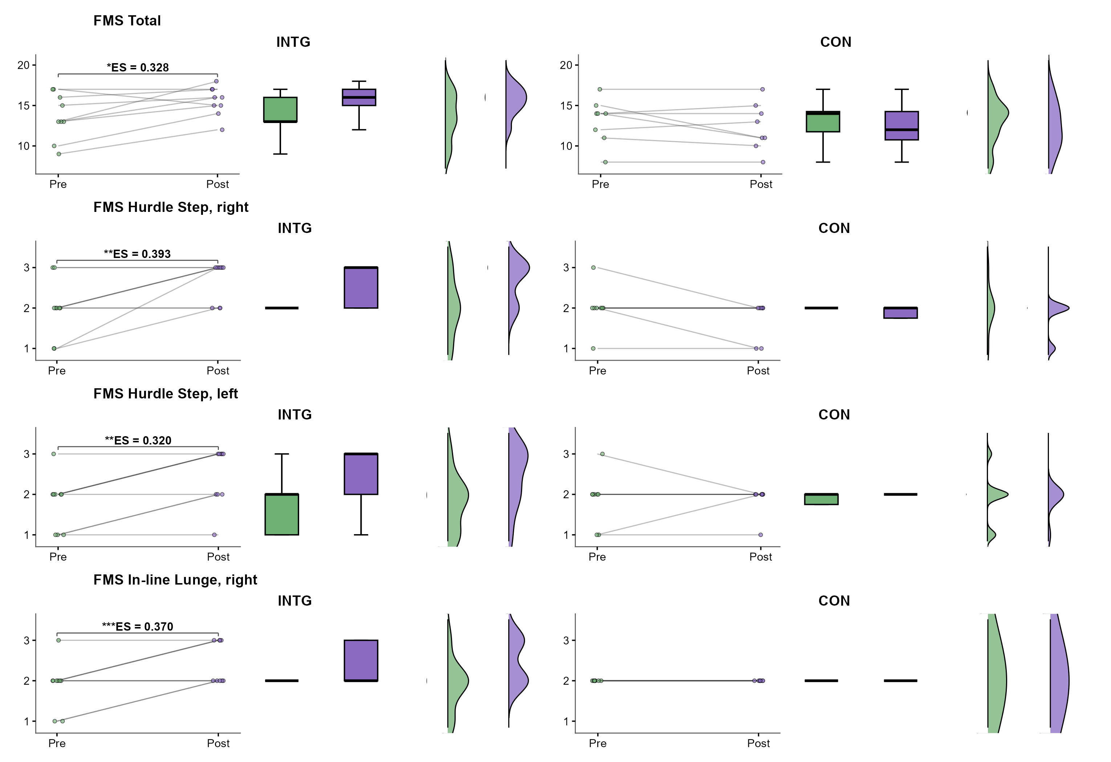
Figure 4 Pre-to-post changes in FMS Total score in the INTG and CON groups.

4. Discussion
The purpose of this study was to examine the effects of an 8-week integrated neuromuscular training (INT) program on start performance, functional movement quality, and lower-limb explosive performance in competitive swimmers. The main findings indicate that INT provides clear advantages in enhancing start-related performance. Compared with the CON group, the INTG demonstrated significantly greater improvements in key start parameters, including 15 m start time, total start distance, and post-takeoff horizontal hip velocity (P < 0.05). These results suggest that INT may promote an effective task-specific transfer of neuromuscular adaptations to the swimming start, a performance phase characterized by rapid force production, horizontal impulse generation, and coordinated multi-joint actions.
With respect to movement quality, the INTG showed significant improvements in the total Functional Movement Screen (FMS) score, along with favorable changes in selected components associated with dynamic stability, single-leg support, and trunk control. In contrast, the CON group did not exhibit meaningful improvements in either total FMS score or individual components, with several measures demonstrating a slight declining trend over time. These findings indicate that INT is effective in enhancing fundamental movement patterns, likely by improving neuromuscular coordination and postural control rather than isolated strength capacity.
Although within-group improvements in lower-limb explosive performance were observed in both groups, no significant between-group differences were detected. This finding contrasts with some previous studies reporting pronounced INT-induced gains in lower-limb explosive power(33,34). These discrepancies across studies may be partly explained by differences in participant characteristics, training background, intervention design, and the specificity of outcome measures. In the present study, the INT program placed greater emphasis on dynamic stability, unilateral loading, and movement integration, which may favor improvements in movement quality and task-specific performance transfer rather than maximal vertical power output. Consequently, the present findings suggest that swimming start performance may be more closely related to enhanced movement efficiency and force application quality than to isolated gains in lower-limb explosive strength.

4.1 Effect of INT Training on start performance
Our results demonstrate that the 8-week INT intervention conferred substantial advantages in enhancing start-specific performance in competitive swimmers. The INT group exhibited marked improvements across all key start-related outcomes, significantly reducing the 15 m start time and achieving large-magnitude increases in VxH and total entry distance. In contrast, the CON group displayed divergent response patterns, including paradoxical performance decrements in horizontal velocity and 15 m start time. Consequently, significant between-group differences were observed, strongly favoring the INT protocol.
From a biomechanical perspective, the swimming start represents a complex multi-joint movement requiring the rapid generation of horizontal impulse within a severely constrained temporal window. Unlike vertical jumping activities where ground contact duration permits progressive force development, the swimming start demands near-maximal force production within approximately 300-400 milliseconds of block contact, followed immediately by aerial transition(29,35). These specific demands are highly consistent with the principle of force-vector specificity highlighted in recent literature. A meta-analysis proved that horizontally-oriented plyometric exercises are significantly more effective at enhancing forward acceleration than vertical exercises(36). Specifically, an 8-week intervention demonstrated that horizontal-vector resistance training yielded superior improvements in swim start performance compared to traditional vertical-vector training(37). This explains the divergent adaptations observed in our study. By incorporating horizontally-oriented SSC activities, the INT program closely imitating the activities on the starting block, resulting the increases in VxH and entry distance. In contrast, the CON relied primarily on exercises that primarily promote increases in maximal strength and muscle force production, failed to exhibit meaningful transfer to the demands of the start.
When training on unstable surfaces, the neuromuscular system must continuously modulate muscle activation patterns to maintain dynamic equilibrium, thereby enhancing proprioceptive sensitivity and feedforward control mechanisms(38). Such adaptations are particularly critical during the swimming start, where the absence of prolonged ground contact time constrains the window for force application and amplifies the importance of force directionality and whole-body coordination(39). This improved force transfer efficiency allows swimmers to maintain a more streamlined body alignment at takeoff, thereby reducing energy dissipation and maximizing the conversion of lower-limb power into forward displacement(40). Furthermore, the integration of horizontally-oriented plyometric exercises within the INT protocol likely facilitated sport-specific adaptations in SSC function and tendon stiffness. Unlike vertical jumping tasks that emphasize bilateral, symmetric force application, exercises such as bounding and single-leg hops require rapid unilateral force production with substantial horizontal momentum(41). These movement patterns selectively enhance the series elastic component's ability to store and release elastic energy during rapid transition phases, a mechanical property particularly relevant to the swimming start where the stretch reflex contributes substantially to propulsive force generation(42). The observed improvements in FMS subcomponents reflecting dynamic stability and single-leg control provide indirect evidence for enhanced inter-muscular coordination and segmental control during unilateral, reactive movements(43).
Overall, the present findings indicate that by systematically integrating strength, stability, and speed components, INT can substantially enhance start-specific performance in competitive swimmers. These advantages appear to be attributable to improvements in maximizing efficiency and task-specific force transfer, rather than isolated gains in single physical fitness components.

4.2 Effect of INT training on functional movement
Our results indicate that INT confers clear advantages in improving functional movement quality in competitive swimmers. The total FMS score increased in the INT group with a moderate-to-large effect size (ES = 0.79), whereas the CON group exhibited a decline (ES = −0.26). At the component level, the INT group demonstrated consistent positive changes across most FMS subtests, particularly those reflecting unilateral control and dynamic stability. Notable improvements were observed in the Hurdle Step, Deep Squat, and In-Line Lunge. In contrast, changes in the CON group were trivial or negative. These findings suggest that strength training is insufficient to elicit spontaneous improvements in movement quality, and targeted neuromuscular interventions are important in not only strengthening proprioception but also correcting muscle asymmetries.
First, the INT program significantly enhanced proprioception and core stability. Functional balance relies heavily on multi-sensory integration and proprioceptive feedback(44). Prolonged water-based training provides limited proprioceptive stimulation, often leading to poor postural control on land. By utilizing unstable surfaces (e.g., BOSU planks) and core stabilization drills, the INT protocol directly challenged the sensorimotor system. Previous studies demonstrate that core stability training on unstable surfaces significantly enhances dynamic balance and shortens neuromuscular reaction times(45–47). This mechanism directly explains the substantial improvements observed in the Rotary Stability and Deep Squat components, confirming that INT optimizes central motor control and postural coordination.
Second, the INT program effectively addressed muscular control asymmetries. Repetitive swimming strokes often promote compensatory load redistribution, which is a primary risk factor for overuse injuries. Research indicates that athletes with superior unilateral movement proficiency exhibit higher overall movement quality and lower injury incidence(48). Our INT protocol added asymmetrical and single-leg loading tasks to correct these imbalances. Studies have shown that targeted neuromuscular interventions focusing on postural control and unilateral stability can reduce joint injury rates by up to 60%(49,50). The significant gains in the Hurdle Step and In-Line Lunge tests confirm that INT successfully enhanced unilateral dynamic control, thereby correcting functional asymmetries in these swimmers.
Additionally, the age-specific responsiveness to neuromuscular training explains the divergent results between the two groups. Adolescent athletes are undergoing rapid musculoskeletal growth, which frequently outpaces neuromuscular adaptation, leading to abnormal joint loading and increased injury risk(51). Traditional strength training—as performed by the CON group—primarily targets muscular output but lacks the coordinative stimulus required to optimize neuro-motor pathways. By integrating balance, speed, plyometric, and coordinative elements, INT provides the necessary neural activation to match physical growth(44,52). Consequently, traditional resistance or strength training is insufficient; targeted neuromuscular interventions are essential for youth swimmers to optimize fundamental movement patterns, thereby establishing a robust biomechanical foundation for long-term injury prevention.

4.3 Effect of INT training on lower limbs explosive power
The INT intervention showed significant within-group improvements in the squat jump (ES = 0.67) and standing long jump (ES = 0.34), along with a non-significant increase in the countermovement jump (P > 0.05, ES = 0.77). Although between-group differences were not statistically significant, the INT group exhibited consistently larger effect sizes across all three measures compared to the CON group, suggesting a positive training response. This lack of within-group significant improvement in the CMJ contrasts with previous studies reporting marked vertical power(12,53) and team sports(27,54), but appears consistent when considering the biomechanical demands and training-specific characteristics of swimming start, which differ substantially from those of land-based and team sports. This divergence indicates that the neuromuscular adaptations elicited by our INT protocol are highly direction-specific, prioritizing horizontal force production over vertical jumping ability.(55,56).
Our INT protocol implemented in the present study primarily emphasized unstable support, unilateral loading, and dynamic postural control, and incorporated partially task-specific drills. Such training characteristics are more associated with horizontal acceleration and force vector orientation than with maximal vertical force production(57). This approach aligns with the principle of force-direction specificity(58). Previous research has demonstrated that athletes whose performance relies heavily on horizontal force application—such as in sprinting(59), sled pushing(60,61), and collision-based team sports—derive greater benefit from training modalities that include substantial horizontal force components, rather than purely vertical power exercises. Similarly, the swimming start requires athletes to generate a large impulse against the starting block to maximize horizontal velocity and forward displacement prior to water entry(62).Therefore, the neuromuscular adaptations elicited by INT were specifically directed toward horizontally oriented force production and whole-body coordination, rendering standard vertical jump tests insufficient to fully capture these sport-specific gains.
An alternative explanation for the observed pattern of results lies in the neurodevelopmental characteristics of the study population. All participants were competitive adolescent swimmers undergoing significant biological maturation, a developmental window characterized by heightened neural plasticity and inter-individual variability in neuromuscular responsiveness(63,64). During adolescence, the neuromuscular system undergoes rapid refinement, optimizing motor unit recruitment and neural efficiency in response to coordinative training stimuli(65). These developmental processes render young athletes particularly responsive to coordinative and skill-acquisition training stimuli, potentially producing performance enhancements through neural efficiency mechanisms distinct from peripheral morphological adaptations(66). This rapid, generalized adaptation across both groups likely created a ceiling effect within the short 8-week timeframe. Combined with the considerable inter-individual variability inherent to the adolescent growth spurt(67) these concurrent improvements in basic explosive metrics constrained the magnitude of detectable statistical differences between the two groups(68).

4.4 Limitations
Several limitations of the present study should be acknowledged. First, the relatively small sample size may limit the statistical power to detect subtle between-group differences, particularly for secondary performance outcomes. Second, due to the nature of the exercise intervention, double-blinding was not possible, although rigorous blinding of outcome assessors was implemented. Third, while neurodevelopmental characteristics were considered in the interpretation of results, biological maturation was not objectively measured, which could confound inter-individual variability. Fourth, conventional vertical jump tests (CMJ and SJ) may lack the sensitivity to capture neuromuscular adaptations specific to the horizontal demands of the swimming start, potentially underestimating task-specific training effects. Fifth, this study focused on short-term adaptations following an 8-week intervention; therefore, the long-term retention of these improvements and their actual impact on injury incidence remain unclear. Finally, although the FMS provides a practical assessment of movement quality, it remains a composite screening tool and does not directly quantify underlying biomechanical or neuromuscular mechanisms.

5. Conclusion
This study demonstrates that an 8-week integrated neuromuscular training (INT) program effectively enhances start performance and movement quality in youth swimmers. Compared with traditional training, INT resulted in significantly greater improvements in horizontal hip velocity and overall Functional Movement Screen scores. Although between-group differences in generic explosive strength measures were not statistically significant, effect size estimates consistently favored the INT group. These findings suggest that INT is an effective, sport-specific dry-land training method for improving start-related performance and functional movement capacity in young swimmers.

Declarations
- Competing Interests
The authors declare that they have no competing interests.
- Funding
This research received no external funding.
- Ethical Approval
This study was approved by the Ethics Committee of Chengdu Sport University. The study was conducted in accordance with the relevant guidelines and regulations.
- Consent to Participate
Written informed consent was obtained from all participants prior to their participation in the study. The consent forms are provided in the supplementary materials.
- Consent for Publication
Not applicable.
- Availability of data and materials

The datasets generated and analyzed during the current study are available from the corresponding author upon reasonable request.
- CONSORT statement
This study was conducted and reported in accordance with the CONSORT (Consolidated Standards of Reporting Trials) guidelines for randomized controlled trials.
- Ethics approval and consent to participate
This study was approved by the Ethics Committee of Chengdu Sport University, Sichuan, China, and all procedures were conducted in accordance with the principles of the Declaration of Helsinki.
Because the participants were adolescents, written informed consent was obtained from all participants and their parents or legal guardians prior to participation in the study.

Reference
1. Trost SG, Sallis JF, Pate RR, Freedson PS, Taylor WC, Dowda M. Evaluating a model of parental influence on youth physical activity. Am J Prev Med (2003) 25:277–282. doi: 10.1016/S0749-3797(03)00217-4
2. Lloyd RS, Oliver JL. The youth physical development model: a new approach to long-term athletic development. Strength Cond J (2012) 34:61–72. doi: 10.1519/SSC.0b013e31825760ea
3. Pichardo AW, Oliver JL, Harrison CB, Maulder PS, Lloyd RS. Integrating models of long-term athletic development to maximize the physical development of youth. Int J Sports Sci Coach (2018) 13:1189–1199. doi: 10.1177/1747954118785503
4. LaPrade RF, Agel J, Baker J, Brenner JS, Cordasco FA, Côté J, Engebretsen L, Feeley BT, Gould D, Hainline B, et al. AOSSM early sport specialization consensus statement. Orthop J Sports Med (2016) 4:2325967116644241. doi: 10.1177/2325967116644241
5. Côté J, Lidor R, Hackfort D. ISSP position stand: to sample or to specialize? Seven postulates about youth sport activities that lead to continued participation and elite performance. Int J Sport Exercise Psychol (2009) 7:7–17. doi: 10.1080/1612197X.2009.9671889
6. Feeley BT, Agel J, LaPrade RF. When is it too early for single sport specialization? Am J Sports Med (2016) 44:234–241. doi: 10.1177/0363546515576899
7. Yustres I, Santos del Cerro J, Martín R, González-Mohíno F, Logan O, González-Ravé JM. Influence of early specialization in world-ranked swimmers and general patterns to success. PLOS One (2019) 14:e0218601. doi: 10.1371/journal.pone.0218601
8. Haywood KM, Getchell N. Life span motor development. Human kinetics. (2024). https://books.google.com/books?hl=zh-CN&lr=&id=uRwnEQAAQBAJ&oi=fnd&pg=PR1&dq=During+critical+periods+of+neuromotor+development,+this+narrow+training+stimulus+may+constrain+the+development+of+fundamental+movement+skills&ots=lUbfYoqtNU&sig=NxiBbnYDUSttlnOs63_PtyxDIP0 [Accessed February 3, 2026]
9. Van Hooren B, Croix MDS. Sensitive periods to train general motor abilities in children and adolescents: do they exist? A critical appraisal. Strength Cond J (2020) 42:7–14. doi: 10.1519/SSC.0000000000000545
10. Bullock GS, Brookreson N, Knab AM, Butler RJ. Examining fundamental movement competency and closed-chain upper-extremity dynamic balance in swimmers. J Strength Cond Res (2017) 31:1544–1551. doi: 10.1519/JSC.0000000000001627
11. Myer GD, Faigenbaum AD, Ford KR, Best TM, Bergeron MF, Hewett TE. When to initiate integrative neuromuscular training to reduce sports-related injuries and enhance health in youth? Curr Sports Med Rep (2011) 10:155–166. doi: 10.1249/JSR.0b013e31821b1442
12. Fort-Vanmeerhaeghe A, Romero-Rodriguez D, Montalvo AM, Kiefer AW, Lloyd RS, Myer GD. Integrative neuromuscular training and injury prevention in youth athletes. Part I: identifying risk factors. Strength Cond J (2016) 38:36–48. doi: 10.1519/SSC.0000000000000229
13. Fort-Vanmeerhaeghe A, Romero-Rodriguez D, Lloyd RS, Kushner A, Myer GD. Integrative neuromuscular training in youth athletes. Part II: strategies to prevent injuries and improve performance. Strength Cond J (2016) 38:9–27. doi: 10.1519/SSC.0000000000000234
14. Maniazhagu D. Effect of two modes of integrative neuromuscular training on explosive power. Int J Phys Educ Sports Manag Yogic Sci (2022) 12:18–26. doi: 10.5958/2278-795X.2022.00024.8
15. Singh LS, Singh NR, Singh WJ, Singh OR, Mola DW. Optimizing the speed and explosive power performance of football players: the effect of a six-week neuromuscular training. Phys Educ Theory Methodol (2024) 24:697–703. doi: 10.17309/tmfv.2024.5.03
16. Mendiguchia J, Martinez-Ruiz E, Morin JB, Samozino P, Edouard P, Alcaraz PE, Esparza-Ros F, Mendez-Villanueva A. Effects of hamstring-emphasized neuromuscular training on strength and sprinting mechanics in football players. Scand J Med Sci Sports (2015) 25: doi: 10.1111/sms.12388
17. Shi K, Xiang M, Shi H, Duan R. Effects of neuromuscular training on athletes’ balance ability: a meta-analysis. Sports Med (2025) doi: 10.1007/s40279-025-02335-x
18. Wang P, Liu Y, Chen C. Effects of neuromuscular training on dynamic balance ability in athletes: a systematic review and meta-analysis. Heliyon (2024) 10: https://www.cell.com/heliyon/fulltext/S2405-8440(24)11854-3 [Accessed February 3, 2026]
19. Zouhal H, Abderrahman AB, Dupont G, Truptin P, Le Bris R, Le Postec E, Sghaeir Z, Brughelli M, Granacher U, Bideau B. Effects of neuromuscular training on agility performance in elite soccer players. Front Physiol (2019) 10:947. doi: 10.3389/fphys.2019.00947
20. Emery CA, Roy T-O, Whittaker JL, Nettel-Aguirre A, Van Mechelen W. Neuromuscular training injury prevention strategies in youth sport: a systematic review and meta-analysis. Br J Sports Med (2015) 49:865–870. doi: 10.1136/bjsports-2015-094639
21. Zech A, Huebscher M, Vogt L, Banzer W, Hänsel F, Pfeifer K. Neuromuscular training for rehabilitation of sports injuries: a systematic review. Med Sci Sports Exercise (2009) 41:1831–1841. doi: 10.1249/MSS.0b013e3181a3cf0d
22. Sadowski J, Mastalerz A, Gromisz W. Transfer of dry-land resistance training modalities to swimming performance. J hum kinet (2020) 74:195. doi: 10.2478/hukin-2020-0025
23. Hermosilla F, Sanders R, Gonzalez-Mohino F, Yustres I, Gonzalez-Rave JM. Effects of dry-land training programs on swimming turn performance: a systematic review. Int J Environ Res Public Health (2021) 18:9340. doi: 10.3390/ijerph18179340
24. Crowley E, Harrison AJ, Lyons M. Dry-land resistance training practices of elite swimming strength and conditioning coaches. J Strength Cond Res (2018) 32:2592–2600. doi: 10.1519/JSC.0000000000002599
25. Wang X, Lv C, Qin X, Ji S, Dong D. Effectiveness of plyometric training vs. complex training on the explosive power of lower limbs: a systematic review. Front Physiol (2023) 13:1061110. doi: 10.3389/fphys.2022.1061110
26. McKay AK, Stellingwerff T, Smith ES, Martin DT, Mujika I, Goosey-Tolfrey VL, Sheppard J, Burke LM. Defining training and performance caliber: a participant classification framework. Int J Sports Physiol Perform (2021) 17:317–331. doi: 10.1123/ijspp.2021-0451
27. 何鹏飞, 董范, 姜自立. 整合性神经肌肉训练对提高女子运动员运动表现及预防运动损伤的影响. 体育科学 (2017) 37:66–75.
28. Zhao W, Wang C, Bi Y, Chen L. Effect of integrative neuromuscular training for injury prevention and sports performance of female badminton players. Biomed Res Int (2021) 2021:5555853. doi: 10.1155/2021/5555853
29. Faigenbaum AD, Farrell A, Fabiano M, Radler T, Naclerio F, Ratamess NA, Kang J, Myer GD. Effects of integrative neuromuscular training on fitness performance in children. Pediatr exerc sci (2011) 23:573–584. doi: 10.1123/pes.23.4.573
30. Frost DM, Beach TA, Callaghan JP, McGill SM. Using the functional movement screenTM to evaluate the effectiveness of training. J Strength Cond Res (2012) 26:1620–1630. doi: 10.1519/JSC.0b013e318234ec59
31. Tor E, Pease DL, Ball KA. Key parameters of the swimming start and their relationship to start performance. J Sports Sci (2015) 33:1313–1321. doi: 10.1080/02640414.2014.990486
32. Gignac GE, Szodorai ET. Effect size guidelines for individual differences researchers. Personal individ differ (2016) 102:74–78. doi: 10.1016/j.paid.2016.06.069
33. Hammami R, Negra Y, Nebigh A, Ramirez-Campillo R, Moran J, Chaabene H. Preseason integrative neuromuscular training improves selected measures of physical fitness in highly trained, youth, male soccer players. J Strength Cond Res (2023) 37:e384–e390. doi: 10.1519/JSC.0000000000004394
34. Panagoulis C, Chatzinikolaou A, Avloniti A, Leontsini D, Deli CK, Draganidis D, Stampoulis T, Oikonomou T, Papanikolaou K, Rafailakis L. In-season integrative neuromuscular strength training improves performance of early-adolescent soccer athletes. J Strength Cond Res (2020) 34:516–526. doi: 10.1519/JSC.0000000000002938
35. Breed RVP, Young WB. The effect of a resistance training programme on the grab, track and swing starts in swimming. J Sports Sci (2003) 21:213–220. doi: 10.1080/0264041031000071047
36. Moran J, Ramirez-Campillo R, Liew B, Chaabene H, Behm DG, García-Hermoso A, Izquierdo M, Granacher U. Effects of vertically and horizontally orientated plyometric training on physical performance: a meta-analytical comparison. Sports Med (2021) 51:65–79. doi: 10.1007/s40279-020-01340-6
37. Chen J-R, Ning Y-L, An T-Y, Tsai Y-L, Tseng K-W, Hsu C-C. Effects of horizontal and vertical vector resistance training on swim start performance: an eight-week intervention in division one collegiate swimmers in taiwan. J Funct Morphol Kinesiol (2025) 10:236. doi: 10.3390/jfmk10030236
38. Pasanen K, Parkkari J, Pasanen M, Kannus P. Effect of a neuromuscular warm-up programme on muscle power, balance, speed and agility: a randomised controlled study. Br J Sports Med (2009) 43:1073–1078. doi: 10.1136/bjsm.2009.061747
39. Alptekin A. Body composition and kinematic analysis of the grab start in youth swimmers. J hum kinet (2014) 42:15. doi: 10.2478/hukin-2014-0057
40. Slawson SE, Conway PP, Cossor J, Chakravorti N, West AA. The categorisation of swimming start performance with reference to force generation on the main block and footrest components of the omega OSB11 start blocks. J Sports Sci (2013) 31:468–478. doi: 10.1080/02640414.2012.736631
41. Loturco I, Pereira LA, Kobal R, Maldonado T, Piazzi AF, Bottino A, Kitamura K, Cal Abad CC, de Arruda M, Nakamura FY. Improving sprint performance in soccer: effectiveness of jump squat and olympic push press exercises. PLOS One (2016) 11:e0153958. doi: 10.1371/journal.pone.0153958
42. Komi PV. Stretch-shortening cycle: a powerful model to study normal and fatigued muscle. J Biomech (2000) 33:1197–1206. doi: 10.1016/S0021-9290(00)00064-6
43. Frohm A, Heijne A, Kowalski J, Svensson P, Myklebust G. A nine-test screening battery for athletes: a reliability study. Scand J Med Sci Sports (2012) 22:306–315. doi: 10.1111/j.1600-0838.2010.01267.x
44. Roberts D, Ageberg E, Andersson G, Fridén T. Clinical measurements of proprioception, muscle strength and laxity in relation to function in the ACL-injured knee. Knee Surg Sports Traumatol Arthrosc (2007) 15:9–16. doi: 10.1007/s00167-006-0128-4
45. Behm DG, Muehlbauer T, Kibele A, Granacher U. Effects of strength training using unstable surfaces on strength, power and balance performance across the lifespan: a systematic review and meta-analysis. Sports Med (2015) 45:1645–1669. doi: 10.1007/s40279-015-0384-x
46. Harati J, Daneshmandi H, Shahabi Kaseb MR. Comparing the effects of dry-land and in-water core stability training programs on swimmers’ upper body balance and performance. J Sport Biomech (2018) 4:17–29.
47. Riemann BL, Lephart SM. The sensorimotor system, part II: the role of proprioception in motor control and functional joint stability. J athl train (2002) 37:80.
48. Eckard T, Padua D, Mauntel T, Frank B, Pietrosimone L, Begalle R, Goto S, Clark M, Kucera K. Association between double-leg squat and single-leg squat performance and injury incidence among incoming NCAA division I athletes: a prospective cohort study. Phys Ther Sport (2018) 34:192–200. doi: 10.1016/j.ptsp.2018.10.009
49. Fort-Vanmeerhaeghe A, Gual G, Romero-Rodriguez D, Unnitha V. Lower limb neuromuscular asymmetry in volleyball and basketball players. J hum kinet (2016) 50:135. doi: 10.1515/hukin-2015-0150
50. Van Der Sluis A, Elferink-Gemser M, Coelho-e-Silva M, Nijboer J, Brink M, Visscher C. Sport injuries aligned to peak height velocity in talented pubertal soccer players. Int J Sports Med (2013) 35:351–355. doi: 10.1055/s-0033-1349874
51. Mersmann F, Bohm S, Arampatzis A. Imbalances in the development of muscle and tendon as risk factor for tendinopathies in youth athletes: a review of current evidence and concepts of prevention. Front Physiol (2017) 8:987. doi: 10.3389/fphys.2017.00987
52. Myer GD, Sugimoto D, Thomas S, Hewett TE. The influence of age on the effectiveness of neuromuscular training to reduce anterior cruciate ligament injury in female athletes: a meta-analysis. Am J Sports Med (2013) 41:203–215. doi: 10.1177/0363546512460637
53. 雷正方, 张瑛秋. 整合性神经肌肉训练对听障乒乓球运动员下肢功能性不对称与平衡能力的影响. 体育科学 (2018) 38:28–38.
54. Bonato M, Benis R, La Torre A. Neuromuscular training reduces lower limb injuries in elite female basketball players. A cluster randomized controlled trial. Scand J Med Sci Sports (2018) 28:1451–1460. doi: 10.1111/sms.13034
55. Vantorre J, Seifert L, Fernandes RJ, Boas JPV, Chollet D. Kinematical profiling of the front crawl start. Int J Sports Med (2010) 31:16–21. doi: 10.1055/s-0029-1241208
56. Vantorre J, Chollet D, Seifert L. Biomechanical analysis of the swim-start: a review. J sports sci med (2014) 13:223.
57. Fitzpatrick DA, Cimadoro G, Cleather DJ. The magical horizontal force muscle? A preliminary study examining the “force-vector” theory. Sports (2019) 7:30. doi: 10.3390/sports7020030
58. Randell AD, Cronin JB, Keogh JW, Gill ND. Transference of strength and power adaptation to sports performance—horizontal and vertical force production. Strength Cond J (2010) 32:100–106. doi: 10.1519/SSC.0b013e3181e91eec
59. Tano G, Bishop A, Climstein M, DeBeliso M. The reliability of the prowler in high school male football players. J Sports Sci (2016) 4:183–8.
60. Contreras B, Vigotsky AD, Schoenfeld BJ, Beardsley C, McMaster DT, Reyneke JH, Cronin JB. Effects of a six-week hip thrust vs. front squat resistance training program on performance in adolescent males: a randomized controlled trial. J Strength Cond Res (2017) 31:999–1008. doi: 10.1519/JSC.0000000000001510
61. Morin J-B, Petrakos G, Jiménez-Reyes P, Brown SR, Samozino P, Cross MR. Very-heavy sled training for improving horizontal-force output in soccer players. Int J Sports Physiol Perform (2017) 12:840–844. doi: 10.1123/ijspp.2016-0444
62. Thng S, Pearson S, Keogh JW. Pushing up or pushing out—an initial investigation into horizontal-versus vertical-force training on swimming start performance: a pilot study. PeerJ (2021) 9:e10937. doi: 10.7717/peerj.10937
63. Malina RM, Bouchard C, Bar-Or O. Growth, maturation, and physical activity. Human kinetics. (2004). https://books.google.com/books?hl=zh-CN&lr=&id=VqFcFsykj6EC&oi=fnd&pg=PA1&dq=Growth,+Maturation,+and+Physical+Activity.&ots=ylVLITmSL8&sig=evaoyW7CgEtSVWsIIsjU4RVHP0U [Accessed February 8, 2026]
64. Granacher U, Lesinski M, Büsch D, Muehlbauer T, Prieske O, Puta C, Gollhofer A, Behm DG. Effects of resistance training in youth athletes on muscular fitness and athletic performance: a conceptual model for long-term athlete development. Front Physiol (2016) 7:164. doi: 10.3389/fphys.2016.00164
65. Pangelinan MM, Zhang G, VanMeter JW, Clark JE, Hatfield BD, Haufler AJ. Beyond age and gender: relationships between cortical and subcortical brain volume and cognitive-motor abilities in school-age children. Neuroimage (2011) 54:3093–3100. doi: 10.1016/j.neuroimage.2010.11.021
66. Mitchell LJ, Rattray B, Saunders PU, Pyne DB. The relationship between talent identification testing parameters and performance in elite junior swimmers. J Sci Med Sport (2018) 21:1281–1285. doi: 10.1016/j.jsams.2018.05.006
67. Malina RM. Growth, maturation, physical activity, and sport. Human Kinetics. (2025). https://books.google.com/books?hl=zh-CN&lr=&id=6VBUEQAAQBAJ&oi=fnd&pg=PP1&dq=Growth,+Maturation,+and+Physical+Activity.&ots=gjImkbE4Qs&sig=xdSDcZqDD88NUJE4nwWBfTQgY_c [Accessed February 8, 2026]
68. Behringer M, Vom Heede A, Matthews M, Mester J. Effects of strength training on motor performance skills in children and adolescents: a meta-analysis. Pediatr exerc sci (2011) 23:186–206. doi: 10.1123/pes.23.2.186

