Statistical Analysis Report for the INT Study
Generated on 2026-04-12 17:06.

1. Statistical Methods
Pre- and post-test records were matched one-to-one using participant number, participant name, and group after standardizing spacing, full-width and half-width characters, letter case, and group codes. Descriptive statistics were summarized as mean (SD) for continuous variables and n (%) for categorical variables. The primary analytic framework was a 2 x 2 mixed repeated-measures ANOVA with Group (CON vs INTG) as the between-subject factor and Visit (Pre vs Post) as the within-subject factor, with the Group x Visit interaction treated as the primary effect of interest. Within-group pre-to-post standardized changes were additionally summarized using Cohen's d based on the pooled pre/post standard deviation. Holm-adjusted post hoc comparisons were computed for within-group pre-post contrasts and between-group contrasts at each visit, with the main text restricted to the prespecified primary outcomes. Assumption checks included normality and homogeneity assessments, while potential outliers were screened using studentized residuals from ANCOVA models with an absolute threshold greater than 3. Sensitivity analyses were performed with ANCOVA models specified as Post ~ Group + Pre. The significance threshold was set at p < 0.05.
Sample-size planning was aligned to the final mixed repeated-measures ANOVA framework. Using G*Power, the unified settings were F tests / ANOVA: Repeated measures, within-between interaction, with alpha = 0.05, power = 0.80, two groups, two measurements, and a medium effect size (f = 0.25). The 15-m sprint time outcome was used as the representative primary endpoint because it most directly reflects swimming-start performance and was therefore the most clinically relevant target for the intervention.

2. Results

2.1 Participant matching and data completeness
No sports-related injuries occurred during testing or training. Training compliance was high in both groups (INTG: 95.5%; CON: 96.0%), and all 17 participants completed the intervention (INTG: n = 9; CON: n = 8). All 21 prespecified outcomes had complete paired values, and no missing outcome data were identified; therefore, all analyses were conducted on complete cases. Baseline characteristics and pre-intervention performance measures are summarized in Table 1, and no statistically significant between-group differences were observed at baseline.
metric | value
Paired participants | 17
CON participants | 8
INTG participants | 9
Duplicate keys in pre-test file | 0
Duplicate keys in post-test file | 0
Unmatched pre-test records | 0
Unmatched post-test records | 0
Analyzable outcomes | 21
Outcomes with complete paired values | 21

2.2 Baseline characteristics
Table 1. Baseline characteristics and pre-intervention performance variables.
Variable | INTG | CON | P
Participant characteristics
Age (years) | 10.11 (1.54) | 10.88 (1.13) | 0.258
Height (cm) | 144.27 (13.79) | 154.22 (11.83) | 0.130
Weight (kg) | 34.20 (9.62) | 42.05 (10.79) | 0.137
Training experience (years) | 2.33 (1.10) | 2.71 (1.39) | 0.551
BMI (kg/m^2) | 16.01 (1.63) | 17.38 (2.53) | 0.215
Female, n (%) | 6 (66.7%) | 5 (62.5%) | 1.000
Lower-limb explosive performance
SJ (cm) | 19.17 (4.92) | 18.40 (4.18) | 0.730
CMJ (cm) | 24.46 (6.34) | 24.34 (6.80) | 0.971
SLJ (cm) | 167.58 (26.59) | 176.97 (20.86) | 0.429
Start performance
15-m sprint time (s) | 8.86 (1.40) | 8.54 (1.04) | 0.600
Water-entry distance (cm) | 175.56 (31.57) | 188.79 (33.43) | 0.417
Horizontal displacement (Delta x) (cm) | 68.28 (33.95) | 74.10 (39.36) | 0.750
Horizontal velocity (m/s) | 3.54 (0.32) | 3.60 (0.41) | 0.774
Functional movement
FMS Total (0-21) | 13.67 (2.87) | 13.12 (2.75) | 0.697
Note. Data are presented as mean (SD) or n (%). Baseline p values are descriptive rather than decisive evidence of comparability. BMI = body mass index; SJ = squat jump; CMJ = countermovement jump; SLJ = standing long jump; FMS = Functional Movement Screen.

2.3 Lower-limb explosive power outcomes
The lower-limb explosive power findings are included in Table 2 and Figure 1. No statistically significant Group x Visit interactions were observed for squat jump (F(1,15) = 3.12, p = 0.097, partial eta squared = 0.172), countermovement jump (F(1,15) = 0.72, p = 0.408, partial eta squared = 0.046), or standing long jump (F(1,15) = 3.50, p = 0.081, partial eta squared = 0.189). These findings indicate that changes over time did not differ significantly between INTG and CON. Detailed main-effect and post hoc results are provided in the Supplementary Materials.
Table 2. Lower-limb explosive power outcomes from the mixed repeated-measures ANOVA.

Outcome | Metric | CON | INTG | Group x Visit P | Partial eta squared
Squat jump (cm) | Pre | 18.40 (4.18) | 19.17 (4.92) | 0.097 | 0.172
 | Post | 20.04 (5.16)** | 22.16 (3.96)***
 | Post-pre difference (%) | +8.9% | +15.6%
 | Post-pre ES (d) | 0.35 (small) | 0.67 (moderate)
Countermovement jump (cm) | Pre | 24.34 (6.80) | 24.46 (6.34) | 0.408 | 0.046
 | Post | 26.54 (4.33) | 28.95 (5.21)*
 | Post-pre difference (%) | +9.1% | +18.4%
 | Post-pre ES (d) | 0.39 (small) | 0.77 (moderate)
Standing long jump (cm) | Pre | 176.97 (20.86) | 167.58 (26.59) | 0.081 | 0.189
 | Post | 179.81 (23.66) | 176.70 (27.28)**
 | Post-pre difference (%) | +1.6% | +5.4%
 | Post-pre ES (d) | 0.13 (trivial) | 0.34 (small)
Note. Data are presented as mean (SD). Post-pre difference (%) was calculated as ((Post - Pre) / Pre) x 100. Post-pre ES (d) represents the within-group standardized change from pre to post, calculated as (Post - Pre) / sqrt((SD_pre^2 + SD_post^2)/2). Cohen's d magnitudes were interpreted as trivial for |d| < 0.20, small for 0.20-0.49, moderate for 0.50-0.79, and large for >= 0.80. The primary inference is the Group x Visit interaction from the mixed repeated-measures ANOVA. * p < 0.05, ** p < 0.01, and *** p < 0.001 for Holm-adjusted within-group Pre vs Post comparisons; # indicates a Holm-adjusted between-group difference at Post. Full main effects, change scores, Holm-adjusted post hoc p values, and ANCOVA outputs are reported in the Supplementary Materials. SJ = squat jump; CMJ = countermovement jump; SLJ = standing long jump.
Figure 1. Lower-limb explosive power outcomes arranged by rows and groups by columns. Within each group cell, paired trajectories, boxplots, and half-violin distributions are displayed from left to right for the Pre and Post measurements. ES annotations are displayed above the trajectory panels, and asterisks denote significance levels based on Holm-adjusted within-group Pre vs Post comparisons. Inferential conclusions were based on the mixed repeated-measures ANOVA.
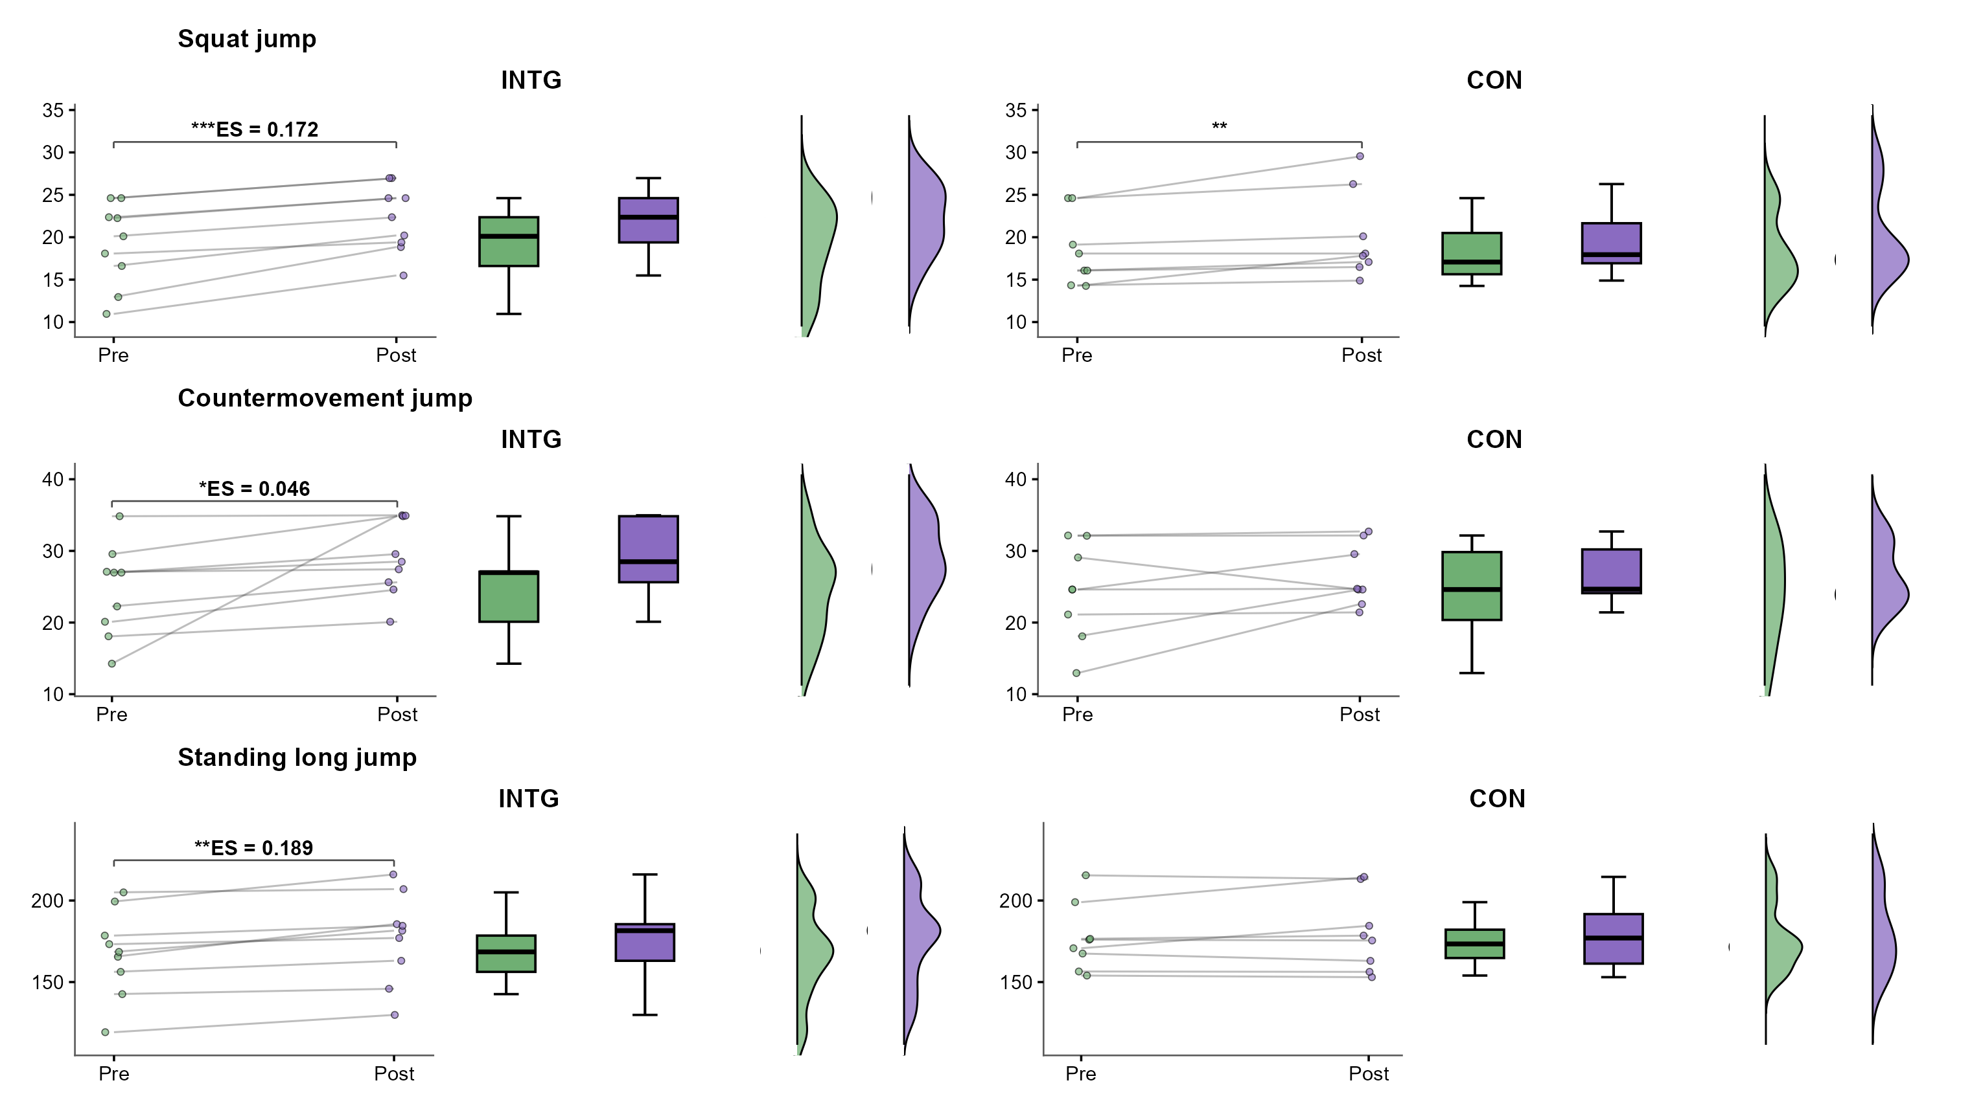

2.4 Start-performance and kinematic outcomes
The main start-performance and kinematic findings are summarized in Table 3 and Figure 2. Significant Group x Visit interactions were observed for water-entry distance (F(1,15) = 30.05, p = 0.001, partial eta squared = 0.667), horizontal velocity (F(1,15) = 26.41, p = 0.001, partial eta squared = 0.638), 15-m sprint time (F(1,15) = 19.48, p = 0.001, partial eta squared = 0.565), and horizontal displacement (Delta x) (F(1,15) = 5.29, p = 0.036, partial eta squared = 0.261). These interaction effects were in favor of INTG. INTG reduced 15-m sprint time from 8.86 (1.40) s to 8.58 (1.26) s, whereas CON changed from 8.54 (1.04) s to 8.97 (1.11) s. Water-entry distance increased from 175.56 (31.57) cm to 208.55 (28.56) cm in INTG, while the corresponding change in CON was small. A comparable pattern was observed for the kinematic outcomes. INTG showed larger gains in horizontal displacement (68.28 (33.95) cm to 104.83 (19.62) cm) and horizontal velocity (3.54 (0.32) m/s to 3.97 (0.23) m/s), whereas CON displayed only modest displacement changes together with a decline in horizontal velocity. Holm-adjusted post hoc comparisons showed significant pre-to-post improvements in INTG for the four primary start-performance outcomes, whereas the clearest post-test between-group separation was observed for horizontal velocity. Figure 2 displays, from left to right within each group cell, paired trajectories, boxplots, and half-violin summaries for the Pre and Post distributions; inferential conclusions were based on the mixed repeated-measures ANOVA rather than on the visual summaries alone.
Table 3. Start-performance and kinematic outcomes from the mixed repeated-measures ANOVA.

Outcome | Metric | CON | INTG | Group x Visit P | Partial eta squared
15-m sprint time (s) | Pre | 8.54 (1.04) | 8.86 (1.40) | 0.001 | 0.565
 | Post | 8.97 (1.11)** | 8.58 (1.26)*
 | Post-pre difference (%) | +5.0% | -3.1%
 | Post-pre ES (d) | 0.40 (small) | -0.21 (small)
Water-entry distance (cm) | Pre | 188.79 (33.43) | 175.56 (31.57) | 0.001 | 0.667
 | Post | 193.68 (33.20) | 208.55 (28.56)***
 | Post-pre difference (%) | +2.6% | +18.8%
 | Post-pre ES (d) | 0.15 (trivial) | 1.10 (large)
Horizontal displacement (Delta x) (cm) | Pre | 74.10 (39.36) | 68.28 (33.95) | 0.036 | 0.261
 | Post | 85.71 (33.26) | 104.83 (19.62)***
 | Post-pre difference (%) | +15.7% | +53.5%
 | Post-pre ES (d) | 0.32 (small) | 1.32 (large)
Horizontal velocity (m/s) | Pre | 3.60 (0.41) | 3.54 (0.32) | 0.001 | 0.638
 | Post | 3.32 (0.31)*# | 3.97 (0.23)***#
 | Post-pre difference (%) | -7.8% | +11.9%
 | Post-pre ES (d) | -0.77 (moderate) | 1.51 (large)
Note. Data are presented as mean (SD). Post-pre difference (%) was calculated as ((Post - Pre) / Pre) x 100. Post-pre ES (d) represents the within-group standardized change from pre to post, calculated as (Post - Pre) / sqrt((SD_pre^2 + SD_post^2)/2). Cohen's d magnitudes were interpreted as trivial for |d| < 0.20, small for 0.20-0.49, moderate for 0.50-0.79, and large for >= 0.80. The primary inference is the Group x Visit interaction from the mixed repeated-measures ANOVA. * p < 0.05, ** p < 0.01, and *** p < 0.001 for Holm-adjusted within-group Pre vs Post comparisons; # indicates a Holm-adjusted between-group difference at Post. Full main effects, change scores, Holm-adjusted post hoc p values, and ANCOVA outputs are reported in the Supplementary Materials.
Figure 2. Start-performance outcomes arranged by rows and groups by columns. Within each group cell, paired trajectories, boxplots, and half-violin distributions are displayed from left to right for the Pre and Post measurements. ES annotations are displayed above the trajectory panels, and asterisks denote significance levels based on Holm-adjusted within-group Pre vs Post comparisons. Horizontal displacement (Delta x) and Delta t are presented in the Supplementary Materials, and inferential conclusions were based on the mixed repeated-measures ANOVA.
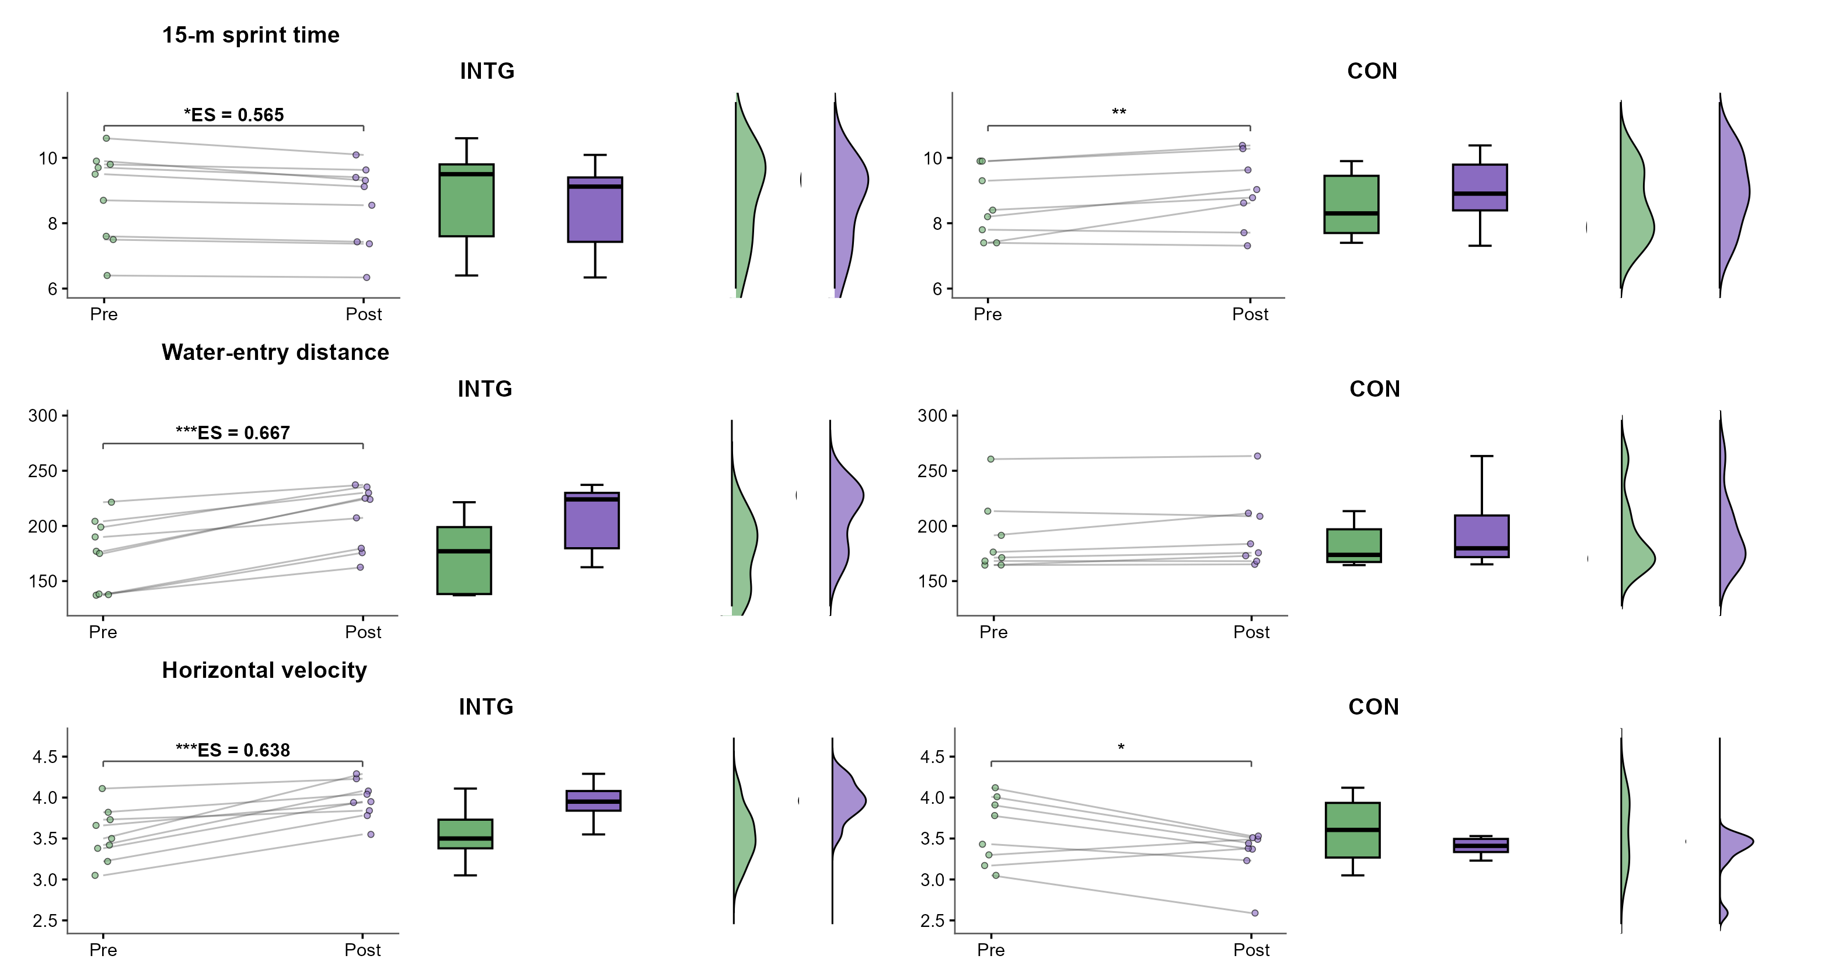

2.5 Functional movement outcomes
The functional movement findings are presented in Table 4 and Figure 3. Significant Group x Visit interactions were found for FMS Total (F(1,15) = 7.33, p = 0.016, partial eta squared = 0.328), FMS Hurdle Step, right (F(1,15) = 9.71, p = 0.007, partial eta squared = 0.393), FMS Hurdle Step, left (F(1,15) = 7.06, p = 0.018, partial eta squared = 0.320), and FMS In-line Lunge, right (F(1,15) = 8.82, p = 0.010, partial eta squared = 0.370). The pattern of change was more favorable in INTG than in CON. The standard FMS Total score increased from 13.67 (2.87) to 15.56 (1.81) in INTG, whereas CON changed from 13.12 (2.75) to 12.38 (2.92). Improvements were also apparent in unilateral control tasks, including FMS Hurdle Step, right (2.00 (0.71) to 2.67 (0.50)), FMS Hurdle Step, left (1.78 (0.67) to 2.44 (0.73)), and FMS In-line Lunge, right (1.89 (0.60) to 2.44 (0.53)). Only the outcomes with significant interaction effects are described in detail here; the full FMS panel is provided in Table 4. Figure 3 is restricted to the FMS outcomes with statistically significant interaction effects.
Table 4. Functional movement outcomes from the mixed repeated-measures ANOVA.

Outcome | Metric | CON | INTG | Group x Visit P | Partial eta squared
FMS Total (score) | Pre | 13.12 (2.75) | 13.67 (2.87) | 0.016 | 0.328
 | Post | 12.38 (2.92)# | 15.56 (1.81)*#
 | Post-pre difference (%) | -5.7% | +13.8%
 | Post-pre ES (d) | -0.26 (small) | 0.79 (moderate)
FMS Hurdle Step, right (score) | Pre | 2.00 (0.53) | 2.00 (0.71) | 0.007 | 0.393
 | Post | 1.75 (0.46)# | 2.67 (0.50)**#
 | Post-pre difference (%) | -12.5% | +33.3%
 | Post-pre ES (d) | -0.50 (moderate) | 1.09 (large)
FMS Hurdle Step, left (score) | Pre | 1.88 (0.64) | 1.78 (0.67) | 0.018 | 0.320
 | Post | 1.88 (0.35) | 2.44 (0.73)**
 | Post-pre difference (%) | +0.0% | +37.5%
 | Post-pre ES (d) | 0.00 (trivial) | 0.96 (large)
FMS In-line Lunge, right (score) | Pre | 2.00 (0.00) | 1.89 (0.60) | 0.010 | 0.370
 | Post | 2.00 (0.00)# | 2.44 (0.53)***#
 | Post-pre difference (%) | +0.0% | +29.4%
 | Post-pre ES (d) | NA | 0.98 (large)
FMS Deep Squat (score) | Pre | 2.12 (0.64) | 2.22 (0.83) | 0.109 | 0.162
 | Post | 2.00 (0.76)# | 2.67 (0.50)#
 | Post-pre difference (%) | -5.9% | +20.0%
 | Post-pre ES (d) | -0.18 (trivial) | 0.65 (moderate)
FMS In-line Lunge, left (score) | Pre | 2.00 (0.53) | 2.22 (0.44) | 0.336 | 0.062
 | Post | 1.75 (0.46) | 2.33 (0.71)
 | Post-pre difference (%) | -12.5% | +5.0%
 | Post-pre ES (d) | -0.50 (moderate) | 0.19 (trivial)
FMS Shoulder Mobility, left (score) | Pre | 1.25 (0.89) | 1.33 (0.71) | 0.527 | 0.027
 | Post | 1.50 (0.93) | 1.78 (0.83)*
 | Post-pre difference (%) | +20.0% | +33.3%
 | Post-pre ES (d) | 0.28 (small) | 0.58 (moderate)
FMS Shoulder Mobility, right (score) | Pre | 1.38 (1.06) | 1.67 (0.71) | 0.239 | 0.091
 | Post | 1.25 (1.04) | 2.00 (0.71)
 | Post-pre difference (%) | -9.1% | +20.0%
 | Post-pre ES (d) | -0.12 (trivial) | 0.47 (small)
FMS Active Straight-Leg Raise, left (score) | Pre | 2.25 (1.04) | 2.56 (0.53) | 0.464 | 0.036
 | Post | 2.25 (1.04) | 2.78 (0.44)
 | Post-pre difference (%) | +0.0% | +8.7%
 | Post-pre ES (d) | 0.00 (trivial) | 0.46 (small)
FMS Active Straight-Leg Raise, right (score) | Pre | 2.38 (1.06) | 2.67 (0.71) | 0.150 | 0.133
 | Post | 2.00 (1.07) | 2.67 (0.71)
 | Post-pre difference (%) | -15.8% | +0.0%
 | Post-pre ES (d) | -0.35 (small) | 0.00 (trivial)
FMS Trunk Stability Push-Up (score) | Pre | 2.25 (0.46) | 2.67 (0.50) | 0.955 | 0.001
 | Post | 2.12 (0.35) | 2.56 (0.53)
 | Post-pre difference (%) | -5.6% | -4.2%
 | Post-pre ES (d) | -0.30 (small) | -0.22 (small)
FMS Rotary Stability, left (score) | Pre | 1.75 (0.46) | 1.56 (0.53) | 0.626 | 0.016
 | Post | 1.88 (0.35) | 1.78 (0.44)
 | Post-pre difference (%) | +7.1% | +14.3%
 | Post-pre ES (d) | 0.30 (small) | 0.46 (small)
FMS Rotary Stability, right (score) | Pre | 1.75 (0.46) | 2.00 (0.00) | 0.304 | 0.070
 | Post | 1.62 (0.52)# | 2.00 (0.00)#
 | Post-pre difference (%) | -7.1% | +0.0%
 | Post-pre ES (d) | -0.25 (small) | NA
Note. Data are presented as mean (SD). Post-pre difference (%) was calculated as ((Post - Pre) / Pre) x 100. Post-pre ES (d) represents the within-group standardized change from pre to post, calculated as (Post - Pre) / sqrt((SD_pre^2 + SD_post^2)/2). Cohen's d magnitudes were interpreted as trivial for |d| < 0.20, small for 0.20-0.49, moderate for 0.50-0.79, and large for >= 0.80. The primary inference is the Group x Visit interaction from the mixed repeated-measures ANOVA. * p < 0.05, ** p < 0.01, and *** p < 0.001 for Holm-adjusted within-group Pre vs Post comparisons; # indicates a Holm-adjusted between-group difference at Post. Detailed change scores, Holm-adjusted post hoc p values, and ANCOVA outputs are reported in the Supplementary Materials. FMS = Functional Movement Screen.
Figure 3. FMS outcomes with statistically significant Group x Visit interactions displayed in the same row-by-column layout as Figures 1 and 2. Within each group cell, paired trajectories, boxplots, and half-violin distributions are displayed from left to right for the Pre and Post measurements. ES annotations are displayed above the trajectory panels, and asterisks denote significance levels based on Holm-adjusted within-group Pre vs Post comparisons. Inferential conclusions were based on the mixed repeated-measures ANOVA.
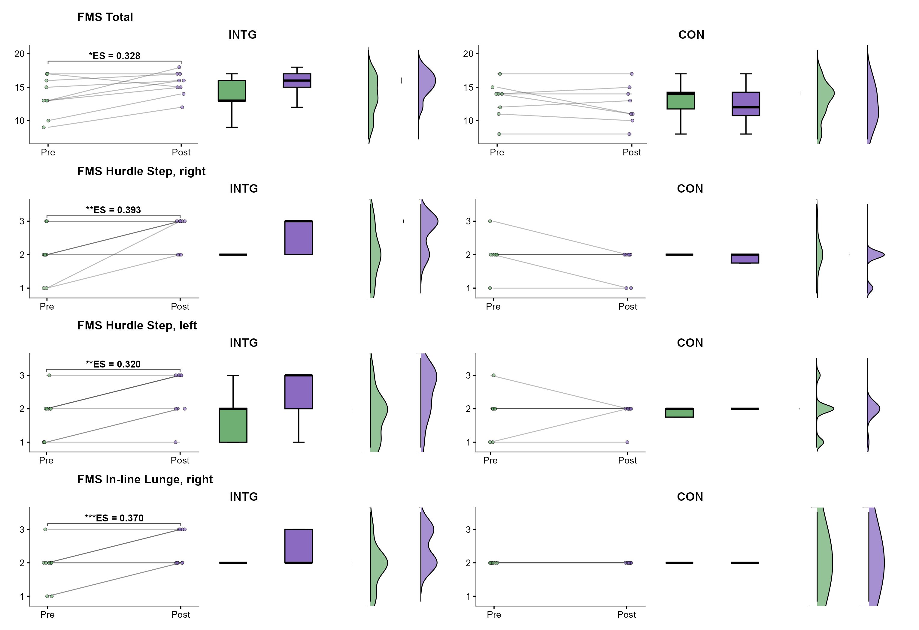

2.6 Sensitivity analyses
The ANCOVA sensitivity analyses were consistent with the primary mixed ANOVA findings. After baseline adjustment, statistically significant group effects remained evident for 15-m sprint time, Water-entry distance, Horizontal displacement (Delta x), Horizontal velocity, FMS Total. These models were treated as confirmatory sensitivity analyses rather than replacements for the interaction-based primary analyses.
Figure 4. Baseline-adjusted confirmatory analyses for the selected performance outcomes and FMS Total. Positive standardized effects indicate a direction favoring INTG after baseline adjustment, and horizontal lines denote 95% confidence intervals. These estimates were consistent with the primary mixed-ANOVA analyses.
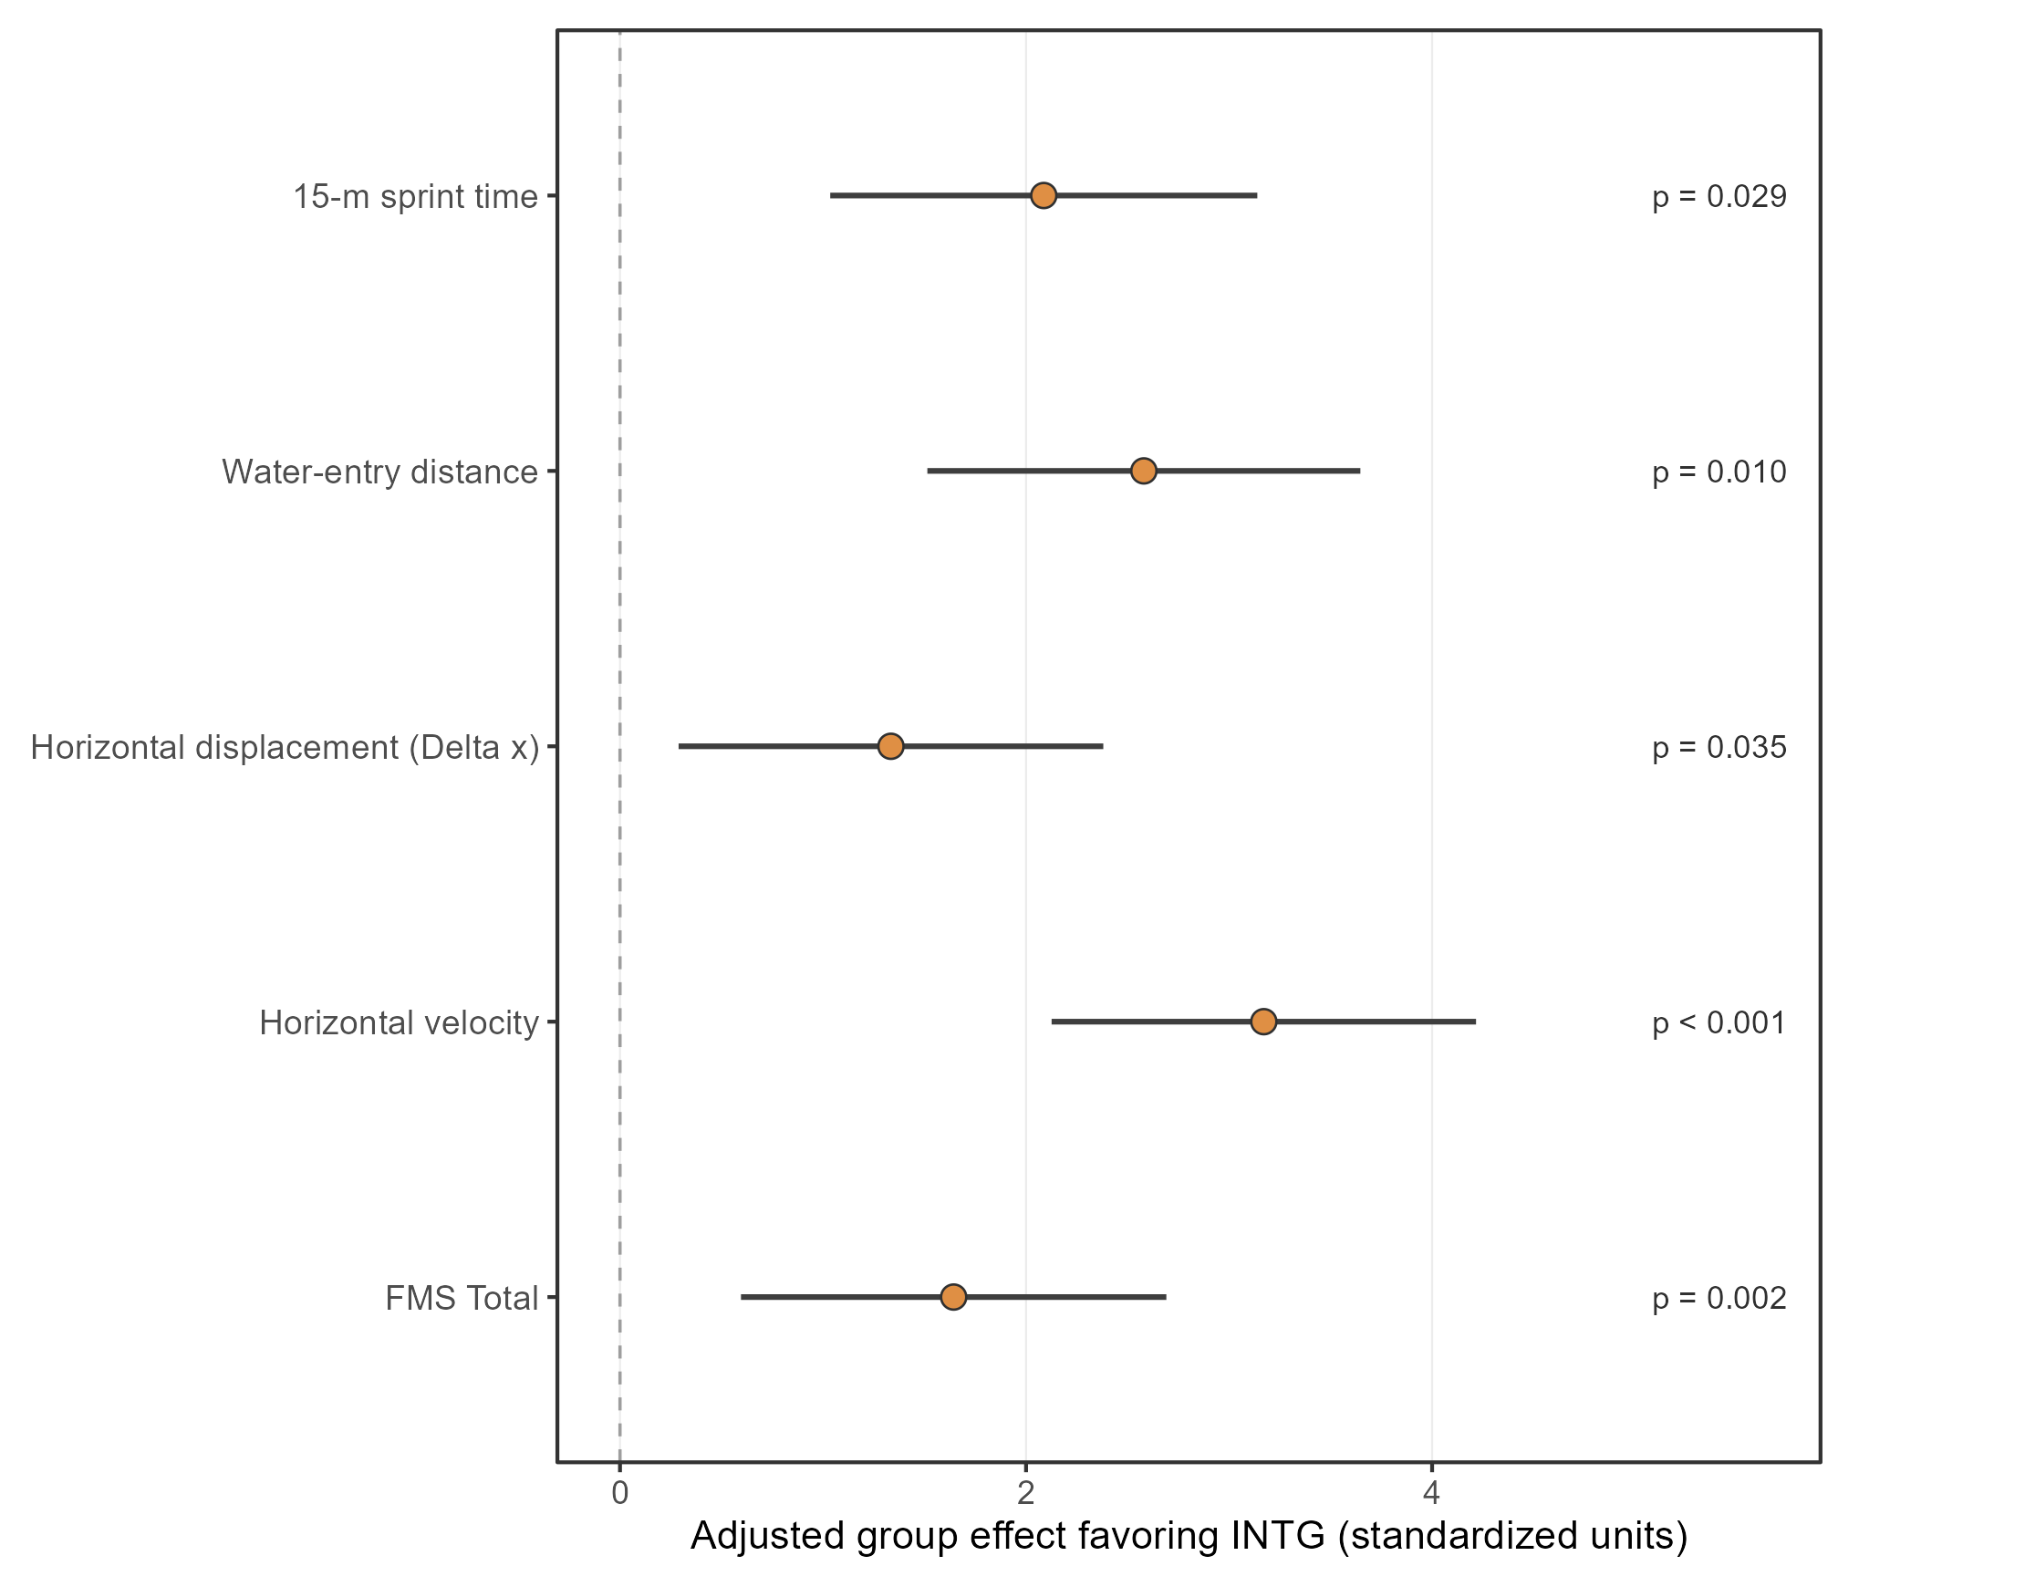

3. Supplementary statistical outputs
Supplementary Table S1. Full mixed ANOVA effects for all outcomes, including Group, Visit, and Group x Visit terms.

Outcome | Domain | Effect | Num df | Den df | F | P value | Partial eta squared
15-m sprint time | performance | group | 1 | 15 | 0.000 | 0.955 | 0.001
15-m sprint time | performance | visit | 1 | 15 | 0.970 | 0.341 | 0.061
15-m sprint time | performance | group:visit | 1 | 15 | 19.480 | 0.001 | 0.565
Water-entry distance | performance | group | 1 | 15 | 0.000 | 0.958 | 0.001
Water-entry distance | performance | visit | 1 | 15 | 54.600 | 0.001 | 0.784
Water-entry distance | performance | group:visit | 1 | 15 | 30.050 | 0.001 | 0.667
Horizontal displacement (Delta x) | performance | group | 1 | 15 | 0.210 | 0.656 | 0.014
Horizontal displacement (Delta x) | performance | visit | 1 | 15 | 19.750 | 0.001 | 0.568
Horizontal displacement (Delta x) | performance | group:visit | 1 | 15 | 5.290 | 0.036 | 0.261
Horizontal velocity | performance | group | 1 | 15 | 4.510 | 0.051 | 0.231
Horizontal velocity | performance | visit | 1 | 15 | 1.120 | 0.307 | 0.069
Horizontal velocity | performance | group:visit | 1 | 15 | 26.410 | 0.001 | 0.638
Countermovement jump | performance | group | 1 | 15 | 0.270 | 0.614 | 0.017
Countermovement jump | performance | visit | 1 | 15 | 6.200 | 0.025 | 0.293
Countermovement jump | performance | group:visit | 1 | 15 | 0.720 | 0.408 | 0.046
Squat jump | performance | group | 1 | 15 | 0.440 | 0.518 | 0.028
Squat jump | performance | visit | 1 | 15 | 36.740 | 0.001 | 0.710
Squat jump | performance | group:visit | 1 | 15 | 3.120 | 0.097 | 0.172
Standing long jump | performance | group | 1 | 15 | 0.270 | 0.610 | 0.018
Standing long jump | performance | visit | 1 | 15 | 12.680 | 0.003 | 0.458
Standing long jump | performance | group:visit | 1 | 15 | 3.500 | 0.081 | 0.189
Flight-time difference (Delta t) | performance | group | 1 | 15 | 0.010 | 0.942 | 0.001
Flight-time difference (Delta t) | performance | visit | 1 | 15 | 11.280 | 0.004 | 0.429
Flight-time difference (Delta t) | performance | group:visit | 1 | 15 | 0.230 | 0.640 | 0.015
FMS Total | FMS | group | 1 | 15 | 2.520 | 0.133 | 0.144
FMS Total | FMS | visit | 1 | 15 | 1.360 | 0.261 | 0.083
FMS Total | FMS | group:visit | 1 | 15 | 7.330 | 0.016 | 0.328
FMS Hurdle Step, right | FMS | group | 1 | 15 | 3.950 | 0.065 | 0.209
FMS Hurdle Step, right | FMS | visit | 1 | 15 | 2.010 | 0.177 | 0.118
FMS Hurdle Step, right | FMS | group:visit | 1 | 15 | 9.710 | 0.007 | 0.393
FMS Hurdle Step, left | FMS | group | 1 | 15 | 0.740 | 0.402 | 0.047
FMS Hurdle Step, left | FMS | visit | 1 | 15 | 7.060 | 0.018 | 0.320
FMS Hurdle Step, left | FMS | group:visit | 1 | 15 | 7.060 | 0.018 | 0.320
FMS In-line Lunge, right | FMS | group | 1 | 15 | 0.880 | 0.362 | 0.056
FMS In-line Lunge, right | FMS | visit | 1 | 15 | 8.820 | 0.010 | 0.370
FMS In-line Lunge, right | FMS | group:visit | 1 | 15 | 8.820 | 0.010 | 0.370
FMS Deep Squat | FMS | group | 1 | 15 | 1.700 | 0.212 | 0.102
FMS Deep Squat | FMS | visit | 1 | 15 | 0.910 | 0.354 | 0.057
FMS Deep Squat | FMS | group:visit | 1 | 15 | 2.900 | 0.109 | 0.162
FMS In-line Lunge, left | FMS | group | 1 | 15 | 4.240 | 0.057 | 0.220
FMS In-line Lunge, left | FMS | visit | 1 | 15 | 0.150 | 0.708 | 0.010
FMS In-line Lunge, left | FMS | group:visit | 1 | 15 | 0.990 | 0.336 | 0.062
FMS Shoulder Mobility, left | FMS | group | 1 | 15 | 0.230 | 0.640 | 0.015
FMS Shoulder Mobility, left | FMS | visit | 1 | 15 | 5.350 | 0.035 | 0.263
FMS Shoulder Mobility, left | FMS | group:visit | 1 | 15 | 0.420 | 0.527 | 0.027
FMS Shoulder Mobility, right | FMS | group | 1 | 15 | 1.820 | 0.197 | 0.108
FMS Shoulder Mobility, right | FMS | visit | 1 | 15 | 0.310 | 0.585 | 0.020
FMS Shoulder Mobility, right | FMS | group:visit | 1 | 15 | 1.500 | 0.239 | 0.091
FMS Active Straight-Leg Raise, left | FMS | group | 1 | 15 | 1.380 | 0.259 | 0.084
FMS Active Straight-Leg Raise, left | FMS | visit | 1 | 15 | 0.560 | 0.464 | 0.036
FMS Active Straight-Leg Raise, left | FMS | group:visit | 1 | 15 | 0.560 | 0.464 | 0.036
FMS Active Straight-Leg Raise, right | FMS | group | 1 | 15 | 1.330 | 0.267 | 0.081
FMS Active Straight-Leg Raise, right | FMS | visit | 1 | 15 | 2.310 | 0.150 | 0.133
FMS Active Straight-Leg Raise, right | FMS | group:visit | 1 | 15 | 2.310 | 0.150 | 0.133
FMS Trunk Stability Push-Up | FMS | group | 1 | 15 | 4.840 | 0.044 | 0.244
FMS Trunk Stability Push-Up | FMS | visit | 1 | 15 | 0.940 | 0.347 | 0.059
FMS Trunk Stability Push-Up | FMS | group:visit | 1 | 15 | 0.000 | 0.955 | 0.001
FMS Rotary Stability, left | FMS | group | 1 | 15 | 0.550 | 0.471 | 0.035
FMS Rotary Stability, left | FMS | visit | 1 | 15 | 3.150 | 0.096 | 0.174
FMS Rotary Stability, left | FMS | group:visit | 1 | 15 | 0.250 | 0.626 | 0.016
FMS Rotary Stability, right | FMS | group | 1 | 15 | 4.220 | 0.058 | 0.220
FMS Rotary Stability, right | FMS | visit | 1 | 15 | 1.130 | 0.304 | 0.070
FMS Rotary Stability, right | FMS | group:visit | 1 | 15 | 1.130 | 0.304 | 0.070
Supplementary Table S2. Detailed descriptive results, change scores, and Holm-adjusted post hoc comparisons for all outcomes.
Outcome | Domain | CON Pre | CON Post | INTG Pre | INTG Post | CON Change | INTG Change | CON Post-pre ES (d) | INTG Post-pre ES (d) | Group x Visit P | Partial eta squared | CON Pre-Post P | INTG Pre-Post P | Pre Between-Group P | Post Between-Group P | ANCOVA Group P
15-m sprint time | performance | 8.54 (1.04) | 8.97 (1.11) | 8.86 (1.40) | 8.58 (1.26) | 0.43 (0.44) | -0.27 (0.18) | 0.40 (small) | -0.21 (small) | 0.001 | 0.565 | 0.002 | 0.024 | 0.606 | 0.516 | 0.029
Water-entry distance | performance | 188.79 (33.43) | 193.68 (33.20) | 175.56 (31.57) | 208.55 (28.56) | 4.89 (7.45) | 33.00 (12.66) | 0.15 (trivial) | 1.10 (large) | 0.001 | 0.667 | 0.210 | <0.001 | 0.415 | 0.336 | 0.010
Horizontal displacement (Delta x) | performance | 74.10 (39.36) | 85.71 (33.26) | 68.28 (33.95) | 104.83 (19.62) | 11.62 (17.31) | 36.55 (25.89) | 0.32 (small) | 1.32 (large) | 0.036 | 0.261 | 0.161 | <0.001 | 0.748 | 0.164 | 0.035
Horizontal velocity | performance | 3.60 (0.41) | 3.32 (0.31) | 3.54 (0.32) | 3.97 (0.23) | -0.28 (0.32) | 0.42 (0.25) | -0.77 (moderate) | 1.51 (large) | 0.001 | 0.638 | 0.013 | <0.001 | 0.770 | <0.001 | <0.001
Countermovement jump | performance | 24.34 (6.80) | 26.54 (4.33) | 24.46 (6.34) | 28.95 (5.21) | 2.20 (4.49) | 4.49 (6.31) | 0.39 (small) | 0.77 (moderate) | 0.408 | 0.046 | 0.278 | 0.028 | 0.970 | 0.320 | 0.249
Squat jump | performance | 18.40 (4.18) | 20.04 (5.16) | 19.17 (4.92) | 22.16 (3.96) | 1.64 (1.72) | 2.99 (1.43) | 0.35 (small) | 0.67 (moderate) | 0.097 | 0.172 | 0.010 | <0.001 | 0.733 | 0.352 | 0.016
Standing long jump | performance | 176.97 (20.86) | 179.81 (23.66) | 167.58 (26.59) | 176.70 (27.28) | 2.84 (7.52) | 9.12 (6.33) | 0.13 (trivial) | 0.34 (small) | 0.081 | 0.189 | 0.263 | 0.001 | 0.435 | 0.807 | 0.385
Flight-time difference (Delta t) | performance | 0.21 (0.12) | 0.26 (0.10) | 0.20 (0.11) | 0.27 (0.06) | 0.05 (0.06) | 0.07 (0.08) | 0.45 (small) | 0.78 (moderate) | 0.640 | 0.015 | 0.066 | 0.014 | 0.837 | 0.901 | 0.848
FMS Total | FMS | 13.12 (2.75) | 12.38 (2.92) | 13.67 (2.87) | 15.56 (1.81) | -0.75 (1.83) | 1.89 (2.15) | -0.26 (small) | 0.79 (moderate) | 0.016 | 0.328 | 0.307 | 0.013 | 0.698 | 0.015 | 0.002
FMS Hurdle Step, right | FMS | 2.00 (0.53) | 1.75 (0.46) | 2.00 (0.71) | 2.67 (0.50) | -0.25 (0.46) | 0.67 (0.71) | -0.50 (moderate) | 1.09 (large) | 0.007 | 0.393 | 0.261 | 0.005 | 1.000 | 0.001 | <0.001
FMS Hurdle Step, left | FMS | 1.88 (0.64) | 1.88 (0.35) | 1.78 (0.67) | 2.44 (0.73) | 0.00 (0.53) | 0.67 (0.50) | 0.00 (trivial) | 0.96 (large) | 0.018 | 0.320 | 1.000 | 0.002 | 0.764 | 0.063 | 0.022
FMS In-line Lunge, right | FMS | 2.00 (0.00) | 2.00 (0.00) | 1.89 (0.60) | 2.44 (0.53) | 0.00 (0.00) | 0.56 (0.53) | NA | 0.98 (large) | 0.010 | 0.370 | 1.000 | <0.001 | 0.610 | 0.031 | 0.014
FMS Deep Squat | FMS | 2.12 (0.64) | 2.00 (0.76) | 2.22 (0.83) | 2.67 (0.50) | -0.12 (0.35) | 0.44 (0.88) | -0.18 (trivial) | 0.65 (moderate) | 0.109 | 0.162 | 0.615 | 0.072 | 0.793 | 0.047 | 0.028
FMS In-line Lunge, left | FMS | 2.00 (0.53) | 1.75 (0.46) | 2.22 (0.44) | 2.33 (0.71) | -0.25 (0.71) | 0.11 (0.78) | -0.50 (moderate) | 0.19 (trivial) | 0.336 | 0.062 | 0.359 | 0.662 | 0.362 | 0.066 | 0.075
FMS Shoulder Mobility, left | FMS | 1.25 (0.89) | 1.50 (0.93) | 1.33 (0.71) | 1.78 (0.83) | 0.25 (0.46) | 0.44 (0.73) | 0.28 (small) | 0.58 (moderate) | 0.527 | 0.027 | 0.270 | 0.047 | 0.832 | 0.525 | 0.372
FMS Shoulder Mobility, right | FMS | 1.38 (1.06) | 1.25 (1.04) | 1.67 (0.71) | 2.00 (0.71) | -0.12 (0.64) | 0.33 (0.87) | -0.12 (trivial) | 0.47 (small) | 0.239 | 0.091 | 0.652 | 0.213 | 0.510 | 0.098 | 0.048
FMS Active Straight-Leg Raise, left | FMS | 2.25 (1.04) | 2.25 (1.04) | 2.56 (0.53) | 2.78 (0.44) | 0.00 (0.76) | 0.22 (0.44) | 0.00 (trivial) | 0.46 (small) | 0.464 | 0.036 | 1.000 | 0.291 | 0.447 | 0.182 | 0.078
FMS Active Straight-Leg Raise, right | FMS | 2.38 (1.06) | 2.00 (1.07) | 2.67 (0.71) | 2.67 (0.71) | -0.38 (0.74) | 0.00 (0.00) | -0.35 (small) | 0.00 (trivial) | 0.150 | 0.133 | 0.054 | 1.000 | 0.510 | 0.146 | 0.017
FMS Trunk Stability Push-Up | FMS | 2.25 (0.46) | 2.12 (0.35) | 2.67 (0.50) | 2.56 (0.53) | -0.12 (0.35) | -0.11 (0.60) | -0.30 (small) | -0.22 (small) | 0.955 | 0.001 | 0.491 | 0.516 | 0.096 | 0.070 | 0.056
FMS Rotary Stability, left | FMS | 1.75 (0.46) | 1.88 (0.35) | 1.56 (0.53) | 1.78 (0.44) | 0.12 (0.35) | 0.22 (0.44) | 0.30 (small) | 0.46 (small) | 0.626 | 0.016 | 0.394 | 0.118 | 0.434 | 0.626 | 0.551
FMS Rotary Stability, right | FMS | 1.75 (0.46) | 1.62 (0.52) | 2.00 (0.00) | 2.00 (0.00) | -0.12 (0.35) | 0.00 (0.00) | -0.25 (small) | NA | 0.304 | 0.070 | 0.164 | 1.000 | 0.125 | 0.045 | 0.007
Supplementary Table S3. ANCOVA sensitivity analyses for the selected performance outcomes and FMS Total, with adjusted effect estimates and 95% confidence intervals.
Outcome | Domain | Adjusted effect favoring INTG | 95% CI | Group P
15-m sprint time | performance | 2.09 | 2.09 (1.04 to 3.14) | p = 0.029
Water-entry distance | performance | 2.58 | 2.58 (1.51 to 3.65) | p = 0.010
Horizontal displacement (Delta x) | performance | 1.33 | 1.33 (0.29 to 2.38) | p = 0.035
Horizontal velocity | performance | 3.17 | 3.17 (2.13 to 4.22) | p < 0.001
FMS Total | FMS | 1.64 | 1.64 (0.60 to 2.69) | p = 0.002
Outcome | Domain | Term | Df | Sum Sq | Mean Sq | F value | P value
15-m sprint time | performance | group | 1 | 0.629 | 0.629 | 5.931 | 0.029
15-m sprint time | performance | pre | 1 | 19.846 | 19.846 | 187.232 | <0.001
15-m sprint time | performance | Residuals | 14 | 1.484 | 0.106 | NA | NA
Water-entry distance | performance | group | 1 | 936.933 | 936.933 | 8.716 | 0.010
Water-entry distance | performance | pre | 1 | 12733.194 | 12733.194 | 118.452 | <0.001
Water-entry distance | performance | Residuals | 14 | 1504.955 | 107.497 | NA | NA
Horizontal displacement (Delta x) | performance | group | 1 | 1547.708 | 1547.708 | 5.439 | 0.035
Horizontal displacement (Delta x) | performance | pre | 1 | 6836.436 | 6836.436 | 24.024 | <0.001
Horizontal displacement (Delta x) | performance | Residuals | 14 | 3983.943 | 284.567 | NA | NA
Horizontal velocity | performance | group | 1 | 1.785 | 1.785 | 39.470 | <0.001
Horizontal velocity | performance | pre | 1 | 0.455 | 0.455 | 10.063 | 0.007
Horizontal velocity | performance | Residuals | 14 | 0.633 | 0.045 | NA | NA
FMS Total | FMS | group | 1 | 42.844 | 42.844 | 14.236 | 0.002
FMS Total | FMS | pre | 1 | 43.963 | 43.963 | 14.608 | 0.002
FMS Total | FMS | Residuals | 14 | 42.134 | 3.010 | NA | NA
Supplementary Table S4. Assumption checks and outlier screening for all outcomes.
Outcome | Domain | Test | Visit | Statistic | P value | Subject ID | Group | Studentized residual | Outlier flag
15-m sprint time | performance | Shapiro-Wilk test for change scores |  | NA | 0.411
15-m sprint time | performance | Shapiro-Wilk test for change scores |  | NA | 0.238
15-m sprint time | performance | Levene's test for change scores |  | 1.845 | 0.194
15-m sprint time | performance | Levene's test by visit | Pre | 0.362 | 0.556
15-m sprint time | performance | Levene's test by visit | Post | 0.079 | 0.783
Water-entry distance | performance | Shapiro-Wilk test for change scores |  | NA | 0.460
Water-entry distance | performance | Shapiro-Wilk test for change scores |  | NA | 0.491
Water-entry distance | performance | Levene's test for change scores |  | 3.095 | 0.099
Water-entry distance | performance | Levene's test by visit | Pre | 0.095 | 0.762
Water-entry distance | performance | Levene's test by visit | Post | 0.004 | 0.952
Horizontal displacement (Delta x) | performance | Shapiro-Wilk test for change scores |  | NA | 0.753
Horizontal displacement (Delta x) | performance | Shapiro-Wilk test for change scores |  | NA | 0.161
Horizontal displacement (Delta x) | performance | Levene's test for change scores |  | 0.367 | 0.553
Horizontal displacement (Delta x) | performance | Levene's test by visit | Pre | 0.017 | 0.899
Horizontal displacement (Delta x) | performance | Levene's test by visit | Post | 2.735 | 0.119
Horizontal velocity | performance | Shapiro-Wilk test for change scores |  | NA | 0.038
Horizontal velocity | performance | Shapiro-Wilk test for change scores |  | NA | 0.414
Horizontal velocity | performance | Levene's test for change scores |  | 0.042 | 0.840
Horizontal velocity | performance | Levene's test by visit | Pre | 1.722 | 0.209
Horizontal velocity | performance | Levene's test by visit | Post | 0.002 | 0.961
Countermovement jump | performance | Shapiro-Wilk test for change scores |  | NA | 0.489
Countermovement jump | performance | Shapiro-Wilk test for change scores |  | NA | <0.001
Countermovement jump | performance | Levene's test for change scores |  | 0.002 | 0.966
Countermovement jump | performance | Levene's test by visit | Pre | 0.019 | 0.893
Countermovement jump | performance | Levene's test by visit | Post | 0.288 | 0.599
Squat jump | performance | Shapiro-Wilk test for change scores |  | NA | 0.076
Squat jump | performance | Shapiro-Wilk test for change scores |  | NA | 0.063
Squat jump | performance | Levene's test for change scores |  | 0.142 | 0.712
Squat jump | performance | Levene's test by visit | Pre | 0.268 | 0.612
Squat jump | performance | Levene's test by visit | Post | 0.020 | 0.890
Standing long jump | performance | Shapiro-Wilk test for change scores |  | NA | 0.024
Standing long jump | performance | Shapiro-Wilk test for change scores |  | NA | 0.409
Standing long jump | performance | Levene's test for change scores |  | 0.002 | 0.968
Standing long jump | performance | Levene's test by visit | Pre | 0.326 | 0.577
Standing long jump | performance | Levene's test by visit | Post | 0.051 | 0.824
Flight-time difference (Delta t) | performance | Shapiro-Wilk test for change scores |  | NA | 0.812
Flight-time difference (Delta t) | performance | Shapiro-Wilk test for change scores |  | NA | 0.437
Flight-time difference (Delta t) | performance | Levene's test for change scores |  | 0.229 | 0.639
Flight-time difference (Delta t) | performance | Levene's test by visit | Pre | 0.020 | 0.888
Flight-time difference (Delta t) | performance | Levene's test by visit | Post | 4.397 | 0.053
FMS Total | FMS | Shapiro-Wilk test for change scores |  | NA | 0.092
FMS Total | FMS | Shapiro-Wilk test for change scores |  | NA | 0.949
FMS Total | FMS | Levene's test for change scores |  | 0.401 | 0.536
FMS Total | FMS | Levene's test by visit | Pre | 0.136 | 0.718
FMS Total | FMS | Levene's test by visit | Post | 2.473 | 0.137
FMS Hurdle Step, right | FMS | Shapiro-Wilk test for change scores |  | NA | NA
FMS Hurdle Step, right | FMS | Shapiro-Wilk test for change scores |  | NA | 0.024
FMS Hurdle Step, right | FMS | Levene's test for change scores |  | 1.594 | 0.226
FMS Hurdle Step, right | FMS | Levene's test by visit | Pre | 0.645 | 0.434
FMS Hurdle Step, right | FMS | Levene's test by visit | Post | 0.126 | 0.728
FMS Hurdle Step, left | FMS | Shapiro-Wilk test for change scores |  | NA | 0.005
FMS Hurdle Step, left | FMS | Shapiro-Wilk test for change scores |  | NA | NA
FMS Hurdle Step, left | FMS | Levene's test for change scores |  | 0.126 | 0.728
FMS Hurdle Step, left | FMS | Levene's test by visit | Pre | 0.075 | 0.788
FMS Hurdle Step, left | FMS | Levene's test by visit | Post | 2.310 | 0.149
FMS In-line Lunge, right | FMS | Shapiro-Wilk test for change scores |  | NA | NA
FMS In-line Lunge, right | FMS | Shapiro-Wilk test for change scores |  | NA | NA
FMS In-line Lunge, right | FMS | Levene's test for change scores |  | 5.647 | 0.031
FMS In-line Lunge, right | FMS | Levene's test by visit | Pre | 3.529 | 0.080
FMS In-line Lunge, right | FMS | Levene's test by visit | Post | 5.647 | 0.031
FMS Deep Squat | FMS | Shapiro-Wilk test for change scores |  | NA | NA
FMS Deep Squat | FMS | Shapiro-Wilk test for change scores |  | NA | 0.338
FMS Deep Squat | FMS | Levene's test for change scores |  | 3.824 | 0.069
FMS Deep Squat | FMS | Levene's test by visit | Pre | 1.395 | 0.256
FMS Deep Squat | FMS | Levene's test by visit | Post | 0.441 | 0.517
FMS In-line Lunge, left | FMS | Shapiro-Wilk test for change scores |  | NA | NA
FMS In-line Lunge, left | FMS | Shapiro-Wilk test for change scores |  | NA | 0.055
FMS In-line Lunge, left | FMS | Levene's test for change scores |  | 1.037 | 0.325
FMS In-line Lunge, left | FMS | Levene's test by visit | Pre | 0.016 | 0.901
FMS In-line Lunge, left | FMS | Levene's test by visit | Post | 1.594 | 0.226
FMS Shoulder Mobility, left | FMS | Shapiro-Wilk test for change scores |  | NA | NA
FMS Shoulder Mobility, left | FMS | Shapiro-Wilk test for change scores |  | NA | <0.001
FMS Shoulder Mobility, left | FMS | Levene's test for change scores |  | 0.420 | 0.527
FMS Shoulder Mobility, left | FMS | Levene's test by visit | Pre | 0.221 | 0.645
FMS Shoulder Mobility, left | FMS | Levene's test by visit | Post | 0.126 | 0.728
FMS Shoulder Mobility, right | FMS | Shapiro-Wilk test for change scores |  | NA | 0.037
FMS Shoulder Mobility, right | FMS | Shapiro-Wilk test for change scores |  | NA | 0.132
FMS Shoulder Mobility, right | FMS | Levene's test for change scores |  | 0.340 | 0.569
FMS Shoulder Mobility, right | FMS | Levene's test by visit | Pre | 1.582 | 0.228
FMS Shoulder Mobility, right | FMS | Levene's test by visit | Post | 1.037 | 0.325
FMS Active Straight-Leg Raise, left | FMS | Shapiro-Wilk test for change scores |  | NA | 0.093
FMS Active Straight-Leg Raise, left | FMS | Shapiro-Wilk test for change scores |  | NA | NA
FMS Active Straight-Leg Raise, left | FMS | Levene's test for change scores |  | 1.379 | 0.259
FMS Active Straight-Leg Raise, left | FMS | Levene's test by visit | Pre | 1.037 | 0.325
FMS Active Straight-Leg Raise, left | FMS | Levene's test by visit | Post | 3.500 | 0.081
FMS Active Straight-Leg Raise, right | FMS | Shapiro-Wilk test for change scores |  | NA | <0.001
FMS Active Straight-Leg Raise, right | FMS | Shapiro-Wilk test for change scores |  | NA | NA
FMS Active Straight-Leg Raise, right | FMS | Levene's test for change scores |  | 2.306 | 0.150
FMS Active Straight-Leg Raise, right | FMS | Levene's test by visit | Pre | 0.455 | 0.510
FMS Active Straight-Leg Raise, right | FMS | Levene's test by visit | Post | 1.471 | 0.244
FMS Trunk Stability Push-Up | FMS | Shapiro-Wilk test for change scores |  | NA | NA
FMS Trunk Stability Push-Up | FMS | Shapiro-Wilk test for change scores |  | NA | 0.012
FMS Trunk Stability Push-Up | FMS | Levene's test for change scores |  | 0.959 | 0.343
FMS Trunk Stability Push-Up | FMS | Levene's test by visit | Pre | 0.126 | 0.728
FMS Trunk Stability Push-Up | FMS | Levene's test by visit | Post | 2.093 | 0.169
FMS Rotary Stability, left | FMS | Shapiro-Wilk test for change scores |  | NA | NA
FMS Rotary Stability, left | FMS | Shapiro-Wilk test for change scores |  | NA | NA
FMS Rotary Stability, left | FMS | Levene's test for change scores |  | 0.247 | 0.626
FMS Rotary Stability, left | FMS | Levene's test by visit | Pre | 0.645 | 0.434
FMS Rotary Stability, left | FMS | Levene's test by visit | Post | 0.247 | 0.626
FMS Rotary Stability, right | FMS | Shapiro-Wilk test for change scores |  | NA | NA
FMS Rotary Stability, right | FMS | Shapiro-Wilk test for change scores |  | NA | NA
FMS Rotary Stability, right | FMS | Levene's test for change scores |  | 1.134 | 0.304
FMS Rotary Stability, right | FMS | Levene's test by visit | Pre | 2.647 | 0.125
FMS Rotary Stability, right | FMS | Levene's test by visit | Post | 4.765 | 0.045
15-m sprint time | performance | Outlier screening |  |  |  | 1__ZZW__CON | CON | -2.367 | No
15-m sprint time | performance | Outlier screening |  |  |  | 11__YZE__CON | CON | 0.509 | No
15-m sprint time | performance | Outlier screening |  |  |  | 12__QKN__CON | CON | 2.999 | No
15-m sprint time | performance | Outlier screening |  |  |  | 13__XXT__CON | CON | -0.138 | No
15-m sprint time | performance | Outlier screening |  |  |  | 15__HPP__CON | CON | 0.172 | No
15-m sprint time | performance | Outlier screening |  |  |  | 3__LXR__CON | CON | -2.147 | No
15-m sprint time | performance | Outlier screening |  |  |  | 5__MRX__CON | CON | -0.191 | No
15-m sprint time | performance | Outlier screening |  |  |  | 8__ZYY__CON | CON | 1.260 | No
15-m sprint time | performance | Outlier screening |  |  |  | 10__CXQ__INTG | INTG | -0.186 | No
15-m sprint time | performance | Outlier screening |  |  |  | 14__LYX__INTG | INTG | -0.363 | No
15-m sprint time | performance | Outlier screening |  |  |  | 16__WYX__INTG | INTG | 0.565 | No
15-m sprint time | performance | Outlier screening |  |  |  | 17__MKR__INTG | INTG | 0.116 | No
15-m sprint time | performance | Outlier screening |  |  |  | 2__ZZR__INTG | INTG | 0.353 | No
15-m sprint time | performance | Outlier screening |  |  |  | 4__SX__INTG | INTG | -0.788 | No
15-m sprint time | performance | Outlier screening |  |  |  | 6__ZJZH__INTG | INTG | 0.138 | No
15-m sprint time | performance | Outlier screening |  |  |  | 7__GJX__INTG | INTG | 0.031 | No
15-m sprint time | performance | Outlier screening |  |  |  | 9__THY__INTG | INTG | 0.111 | No
Water-entry distance | performance | Outlier screening |  |  |  | 1__ZZW__CON | CON | 0.667 | No
Water-entry distance | performance | Outlier screening |  |  |  | 11__YZE__CON | CON | -0.690 | No
Water-entry distance | performance | Outlier screening |  |  |  | 12__QKN__CON | CON | 1.703 | No
Water-entry distance | performance | Outlier screening |  |  |  | 13__XXT__CON | CON | 0.133 | No
Water-entry distance | performance | Outlier screening |  |  |  | 15__HPP__CON | CON | 0.104 | No
Water-entry distance | performance | Outlier screening |  |  |  | 3__LXR__CON | CON | -0.727 | No
Water-entry distance | performance | Outlier screening |  |  |  | 5__MRX__CON | CON | -0.734 | No
Water-entry distance | performance | Outlier screening |  |  |  | 8__ZYY__CON | CON | -0.228 | No
Water-entry distance | performance | Outlier screening |  |  |  | 10__CXQ__INTG | INTG | 0.172 | No
Water-entry distance | performance | Outlier screening |  |  |  | 14__LYX__INTG | INTG | -1.395 | No
Water-entry distance | performance | Outlier screening |  |  |  | 16__WYX__INTG | INTG | 0.541 | No
Water-entry distance | performance | Outlier screening |  |  |  | 17__MKR__INTG | INTG | -1.535 | No
Water-entry distance | performance | Outlier screening |  |  |  | 2__ZZR__INTG | INTG | 1.512 | No
Water-entry distance | performance | Outlier screening |  |  |  | 4__SX__INTG | INTG | 1.886 | No
Water-entry distance | performance | Outlier screening |  |  |  | 6__ZJZH__INTG | INTG | 0.582 | No
Water-entry distance | performance | Outlier screening |  |  |  | 7__GJX__INTG | INTG | -0.439 | No
Water-entry distance | performance | Outlier screening |  |  |  | 9__THY__INTG | INTG | -1.450 | No
Horizontal displacement (Delta x) | performance | Outlier screening |  |  |  | 1__ZZW__CON | CON | 0.931 | No
Horizontal displacement (Delta x) | performance | Outlier screening |  |  |  | 11__YZE__CON | CON | -0.984 | No
Horizontal displacement (Delta x) | performance | Outlier screening |  |  |  | 12__QKN__CON | CON | 2.045 | No
Horizontal displacement (Delta x) | performance | Outlier screening |  |  |  | 13__XXT__CON | CON | 0.177 | No
Horizontal displacement (Delta x) | performance | Outlier screening |  |  |  | 15__HPP__CON | CON | -1.109 | No
Horizontal displacement (Delta x) | performance | Outlier screening |  |  |  | 3__LXR__CON | CON | 0.158 | No
Horizontal displacement (Delta x) | performance | Outlier screening |  |  |  | 5__MRX__CON | CON | -1.096 | No
Horizontal displacement (Delta x) | performance | Outlier screening |  |  |  | 8__ZYY__CON | CON | 0.233 | No
Horizontal displacement (Delta x) | performance | Outlier screening |  |  |  | 10__CXQ__INTG | INTG | 3.084 | Yes
Horizontal displacement (Delta x) | performance | Outlier screening |  |  |  | 14__LYX__INTG | INTG | -0.363 | No
Horizontal displacement (Delta x) | performance | Outlier screening |  |  |  | 16__WYX__INTG | INTG | -0.758 | No
Horizontal displacement (Delta x) | performance | Outlier screening |  |  |  | 17__MKR__INTG | INTG | -1.010 | No
Horizontal displacement (Delta x) | performance | Outlier screening |  |  |  | 2__ZZR__INTG | INTG | 0.105 | No
Horizontal displacement (Delta x) | performance | Outlier screening |  |  |  | 4__SX__INTG | INTG | 0.600 | No
Horizontal displacement (Delta x) | performance | Outlier screening |  |  |  | 6__ZJZH__INTG | INTG | 0.416 | No
Horizontal displacement (Delta x) | performance | Outlier screening |  |  |  | 7__GJX__INTG | INTG | -0.543 | No
Horizontal displacement (Delta x) | performance | Outlier screening |  |  |  | 9__THY__INTG | INTG | -0.912 | No
Horizontal velocity | performance | Outlier screening |  |  |  | 1__ZZW__CON | CON | 1.727 | No
Horizontal velocity | performance | Outlier screening |  |  |  | 11__YZE__CON | CON | -0.171 | No
Horizontal velocity | performance | Outlier screening |  |  |  | 12__QKN__CON | CON | -0.041 | No
Horizontal velocity | performance | Outlier screening |  |  |  | 13__XXT__CON | CON | 1.465 | No
Horizontal velocity | performance | Outlier screening |  |  |  | 15__HPP__CON | CON | -0.022 | No
Horizontal velocity | performance | Outlier screening |  |  |  | 3__LXR__CON | CON | -0.194 | No
Horizontal velocity | performance | Outlier screening |  |  |  | 5__MRX__CON | CON | -0.133 | No
Horizontal velocity | performance | Outlier screening |  |  |  | 8__ZYY__CON | CON | -3.432 | Yes
Horizontal velocity | performance | Outlier screening |  |  |  | 10__CXQ__INTG | INTG | -1.093 | No
Horizontal velocity | performance | Outlier screening |  |  |  | 14__LYX__INTG | INTG | 0.853 | No
Horizontal velocity | performance | Outlier screening |  |  |  | 16__WYX__INTG | INTG | -0.033 | No
Horizontal velocity | performance | Outlier screening |  |  |  | 17__MKR__INTG | INTG | -0.975 | No
Horizontal velocity | performance | Outlier screening |  |  |  | 2__ZZR__INTG | INTG | 1.861 | No
Horizontal velocity | performance | Outlier screening |  |  |  | 4__SX__INTG | INTG | -0.163 | No
Horizontal velocity | performance | Outlier screening |  |  |  | 6__ZJZH__INTG | INTG | -0.287 | No
Horizontal velocity | performance | Outlier screening |  |  |  | 7__GJX__INTG | INTG | -0.399 | No
Horizontal velocity | performance | Outlier screening |  |  |  | 9__THY__INTG | INTG | 0.297 | No
Countermovement jump | performance | Outlier screening |  |  |  | 1__ZZW__CON | CON | 0.794 | No
Countermovement jump | performance | Outlier screening |  |  |  | 11__YZE__CON | CON | -0.991 | No
Countermovement jump | performance | Outlier screening |  |  |  | 12__QKN__CON | CON | 0.741 | No
Countermovement jump | performance | Outlier screening |  |  |  | 13__XXT__CON | CON | -1.034 | No
Countermovement jump | performance | Outlier screening |  |  |  | 15__HPP__CON | CON | 0.213 | No
Countermovement jump | performance | Outlier screening |  |  |  | 3__LXR__CON | CON | 0.641 | No
Countermovement jump | performance | Outlier screening |  |  |  | 5__MRX__CON | CON | 0.171 | No
Countermovement jump | performance | Outlier screening |  |  |  | 8__ZYY__CON | CON | -0.490 | No
Countermovement jump | performance | Outlier screening |  |  |  | 10__CXQ__INTG | INTG | -0.376 | No
Countermovement jump | performance | Outlier screening |  |  |  | 14__LYX__INTG | INTG | -0.650 | No
Countermovement jump | performance | Outlier screening |  |  |  | 16__WYX__INTG | INTG | -1.776 | No
Countermovement jump | performance | Outlier screening |  |  |  | 17__MKR__INTG | INTG | -0.607 | No
Countermovement jump | performance | Outlier screening |  |  |  | 2__ZZR__INTG | INTG | -0.108 | No
Countermovement jump | performance | Outlier screening |  |  |  | 4__SX__INTG | INTG | -0.662 | No
Countermovement jump | performance | Outlier screening |  |  |  | 6__ZJZH__INTG | INTG | 0.476 | No
Countermovement jump | performance | Outlier screening |  |  |  | 7__GJX__INTG | INTG | 0.993 | No
Countermovement jump | performance | Outlier screening |  |  |  | 9__THY__INTG | INTG | 4.416 | Yes
Squat jump | performance | Outlier screening |  |  |  | 1__ZZW__CON | CON | 3.709 | Yes
Squat jump | performance | Outlier screening |  |  |  | 11__YZE__CON | CON | -0.923 | No
Squat jump | performance | Outlier screening |  |  |  | 12__QKN__CON | CON | -1.122 | No
Squat jump | performance | Outlier screening |  |  |  | 13__XXT__CON | CON | -0.397 | No
Squat jump | performance | Outlier screening |  |  |  | 15__HPP__CON | CON | -0.515 | No
Squat jump | performance | Outlier screening |  |  |  | 3__LXR__CON | CON | 0.298 | No
Squat jump | performance | Outlier screening |  |  |  | 5__MRX__CON | CON | 1.145 | No
Squat jump | performance | Outlier screening |  |  |  | 8__ZYY__CON | CON | -0.932 | No
Squat jump | performance | Outlier screening |  |  |  | 10__CXQ__INTG | INTG | -0.438 | No
Squat jump | performance | Outlier screening |  |  |  | 14__LYX__INTG | INTG | 1.954 | No
Squat jump | performance | Outlier screening |  |  |  | 16__WYX__INTG | INTG | 0.751 | No
Squat jump | performance | Outlier screening |  |  |  | 17__MKR__INTG | INTG | -1.182 | No
Squat jump | performance | Outlier screening |  |  |  | 2__ZZR__INTG | INTG | 0.287 | No
Squat jump | performance | Outlier screening |  |  |  | 4__SX__INTG | INTG | -0.348 | No
Squat jump | performance | Outlier screening |  |  |  | 6__ZJZH__INTG | INTG | -0.185 | No
Squat jump | performance | Outlier screening |  |  |  | 7__GJX__INTG | INTG | -0.185 | No
Squat jump | performance | Outlier screening |  |  |  | 9__THY__INTG | INTG | -0.280 | No
Standing long jump | performance | Outlier screening |  |  |  | 1__ZZW__CON | CON | -1.029 | No
Standing long jump | performance | Outlier screening |  |  |  | 11__YZE__CON | CON | -0.491 | No
Standing long jump | performance | Outlier screening |  |  |  | 12__QKN__CON | CON | -0.483 | No
Standing long jump | performance | Outlier screening |  |  |  | 13__XXT__CON | CON | -0.119 | No
Standing long jump | performance | Outlier screening |  |  |  | 15__HPP__CON | CON | -0.383 | No
Standing long jump | performance | Outlier screening |  |  |  | 3__LXR__CON | CON | 2.089 | No
Standing long jump | performance | Outlier screening |  |  |  | 5__MRX__CON | CON | 1.794 | No
Standing long jump | performance | Outlier screening |  |  |  | 8__ZYY__CON | CON | -1.077 | No
Standing long jump | performance | Outlier screening |  |  |  | 10__CXQ__INTG | INTG | 1.744 | No
Standing long jump | performance | Outlier screening |  |  |  | 14__LYX__INTG | INTG | -0.792 | No
Standing long jump | performance | Outlier screening |  |  |  | 16__WYX__INTG | INTG | 0.474 | No
Standing long jump | performance | Outlier screening |  |  |  | 17__MKR__INTG | INTG | -0.294 | No
Standing long jump | performance | Outlier screening |  |  |  | 2__ZZR__INTG | INTG | -0.813 | No
Standing long jump | performance | Outlier screening |  |  |  | 4__SX__INTG | INTG | 0.561 | No
Standing long jump | performance | Outlier screening |  |  |  | 6__ZJZH__INTG | INTG | 1.069 | No
Standing long jump | performance | Outlier screening |  |  |  | 7__GJX__INTG | INTG | -0.496 | No
Standing long jump | performance | Outlier screening |  |  |  | 9__THY__INTG | INTG | -1.372 | No
Flight-time difference (Delta t) | performance | Outlier screening |  |  |  | 1__ZZW__CON | CON | 0.186 | No
Flight-time difference (Delta t) | performance | Outlier screening |  |  |  | 11__YZE__CON | CON | -1.063 | No
Flight-time difference (Delta t) | performance | Outlier screening |  |  |  | 12__QKN__CON | CON | 1.979 | No
Flight-time difference (Delta t) | performance | Outlier screening |  |  |  | 13__XXT__CON | CON | -0.224 | No
Flight-time difference (Delta t) | performance | Outlier screening |  |  |  | 15__HPP__CON | CON | -1.159 | No
Flight-time difference (Delta t) | performance | Outlier screening |  |  |  | 3__LXR__CON | CON | 0.205 | No
Flight-time difference (Delta t) | performance | Outlier screening |  |  |  | 5__MRX__CON | CON | -1.126 | No
Flight-time difference (Delta t) | performance | Outlier screening |  |  |  | 8__ZYY__CON | CON | 1.380 | No
Flight-time difference (Delta t) | performance | Outlier screening |  |  |  | 10__CXQ__INTG | INTG | 2.803 | No
Flight-time difference (Delta t) | performance | Outlier screening |  |  |  | 14__LYX__INTG | INTG | -0.341 | No
Flight-time difference (Delta t) | performance | Outlier screening |  |  |  | 16__WYX__INTG | INTG | -0.587 | No
Flight-time difference (Delta t) | performance | Outlier screening |  |  |  | 17__MKR__INTG | INTG | -0.726 | No
Flight-time difference (Delta t) | performance | Outlier screening |  |  |  | 2__ZZR__INTG | INTG | -0.280 | No
Flight-time difference (Delta t) | performance | Outlier screening |  |  |  | 4__SX__INTG | INTG | 0.518 | No
Flight-time difference (Delta t) | performance | Outlier screening |  |  |  | 6__ZJZH__INTG | INTG | 0.402 | No
Flight-time difference (Delta t) | performance | Outlier screening |  |  |  | 7__GJX__INTG | INTG | -0.328 | No
Flight-time difference (Delta t) | performance | Outlier screening |  |  |  | 9__THY__INTG | INTG | -0.961 | No
FMS Total | FMS | Outlier screening |  |  |  | 1__ZZW__CON | CON | -0.890 | No
FMS Total | FMS | Outlier screening |  |  |  | 11__YZE__CON | CON | 0.801 | No
FMS Total | FMS | Outlier screening |  |  |  | 12__QKN__CON | CON | -0.669 | No
FMS Total | FMS | Outlier screening |  |  |  | 13__XXT__CON | CON | 0.662 | No
FMS Total | FMS | Outlier screening |  |  |  | 15__HPP__CON | CON | 1.329 | No
FMS Total | FMS | Outlier screening |  |  |  | 3__LXR__CON | CON | -1.198 | No
FMS Total | FMS | Outlier screening |  |  |  | 5__MRX__CON | CON | -1.676 | No
FMS Total | FMS | Outlier screening |  |  |  | 8__ZYY__CON | CON | 1.592 | No
FMS Total | FMS | Outlier screening |  |  |  | 10__CXQ__INTG | INTG | -0.089 | No
FMS Total | FMS | Outlier screening |  |  |  | 14__LYX__INTG | INTG | 0.507 | No
FMS Total | FMS | Outlier screening |  |  |  | 16__WYX__INTG | INTG | -0.365 | No
FMS Total | FMS | Outlier screening |  |  |  | 17__MKR__INTG | INTG | 0.428 | No
FMS Total | FMS | Outlier screening |  |  |  | 2__ZZR__INTG | INTG | 1.902 | No
FMS Total | FMS | Outlier screening |  |  |  | 4__SX__INTG | INTG | 0.015 | No
FMS Total | FMS | Outlier screening |  |  |  | 6__ZJZH__INTG | INTG | -0.218 | No
FMS Total | FMS | Outlier screening |  |  |  | 7__GJX__INTG | INTG | -1.797 | No
FMS Total | FMS | Outlier screening |  |  |  | 9__THY__INTG | INTG | -0.479 | No
FMS Hurdle Step, right | FMS | Outlier screening |  |  |  | 1__ZZW__CON | CON | -1.110 | No
FMS Hurdle Step, right | FMS | Outlier screening |  |  |  | 11__YZE__CON | CON | 0.580 | No
FMS Hurdle Step, right | FMS | Outlier screening |  |  |  | 12__QKN__CON | CON | -1.953 | No
FMS Hurdle Step, right | FMS | Outlier screening |  |  |  | 13__XXT__CON | CON | 0.580 | No
FMS Hurdle Step, right | FMS | Outlier screening |  |  |  | 15__HPP__CON | CON | 0.580 | No
FMS Hurdle Step, right | FMS | Outlier screening |  |  |  | 3__LXR__CON | CON | 0.580 | No
FMS Hurdle Step, right | FMS | Outlier screening |  |  |  | 5__MRX__CON | CON | -0.212 | No
FMS Hurdle Step, right | FMS | Outlier screening |  |  |  | 8__ZYY__CON | CON | 0.580 | No
FMS Hurdle Step, right | FMS | Outlier screening |  |  |  | 10__CXQ__INTG | INTG | 1.899 | No
FMS Hurdle Step, right | FMS | Outlier screening |  |  |  | 14__LYX__INTG | INTG | 0.775 | No
FMS Hurdle Step, right | FMS | Outlier screening |  |  |  | 16__WYX__INTG | INTG | 0.000 | No
FMS Hurdle Step, right | FMS | Outlier screening |  |  |  | 17__MKR__INTG | INTG | -0.864 | No
FMS Hurdle Step, right | FMS | Outlier screening |  |  |  | 2__ZZR__INTG | INTG | 0.775 | No
FMS Hurdle Step, right | FMS | Outlier screening |  |  |  | 4__SX__INTG | INTG | 0.000 | No
FMS Hurdle Step, right | FMS | Outlier screening |  |  |  | 6__ZJZH__INTG | INTG | -1.669 | No
FMS Hurdle Step, right | FMS | Outlier screening |  |  |  | 7__GJX__INTG | INTG | -1.669 | No
FMS Hurdle Step, right | FMS | Outlier screening |  |  |  | 9__THY__INTG | INTG | 0.775 | No
FMS Hurdle Step, left | FMS | Outlier screening |  |  |  | 1__ZZW__CON | CON | -0.912 | No
FMS Hurdle Step, left | FMS | Outlier screening |  |  |  | 11__YZE__CON | CON | 0.118 | No
FMS Hurdle Step, left | FMS | Outlier screening |  |  |  | 12__QKN__CON | CON | 1.721 | No
FMS Hurdle Step, left | FMS | Outlier screening |  |  |  | 13__XXT__CON | CON | 0.118 | No
FMS Hurdle Step, left | FMS | Outlier screening |  |  |  | 15__HPP__CON | CON | 0.118 | No
FMS Hurdle Step, left | FMS | Outlier screening |  |  |  | 3__LXR__CON | CON | 0.118 | No
FMS Hurdle Step, left | FMS | Outlier screening |  |  |  | 5__MRX__CON | CON | -1.485 | No
FMS Hurdle Step, left | FMS | Outlier screening |  |  |  | 8__ZYY__CON | CON | 0.118 | No
FMS Hurdle Step, left | FMS | Outlier screening |  |  |  | 10__CXQ__INTG | INTG | -1.390 | No
FMS Hurdle Step, left | FMS | Outlier screening |  |  |  | 14__LYX__INTG | INTG | 0.026 | No
FMS Hurdle Step, left | FMS | Outlier screening |  |  |  | 16__WYX__INTG | INTG | -0.421 | No
FMS Hurdle Step, left | FMS | Outlier screening |  |  |  | 17__MKR__INTG | INTG | 0.026 | No
FMS Hurdle Step, left | FMS | Outlier screening |  |  |  | 2__ZZR__INTG | INTG | 0.997 | No
FMS Hurdle Step, left | FMS | Outlier screening |  |  |  | 4__SX__INTG | INTG | 0.997 | No
FMS Hurdle Step, left | FMS | Outlier screening |  |  |  | 6__ZJZH__INTG | INTG | 0.997 | No
FMS Hurdle Step, left | FMS | Outlier screening |  |  |  | 7__GJX__INTG | INTG | 0.997 | No
FMS Hurdle Step, left | FMS | Outlier screening |  |  |  | 9__THY__INTG | INTG | -3.102 | Yes
FMS In-line Lunge, right | FMS | Outlier screening |  |  |  | 1__ZZW__CON | CON | 0.000 | No
FMS In-line Lunge, right | FMS | Outlier screening |  |  |  | 11__YZE__CON | CON | 0.000 | No
FMS In-line Lunge, right | FMS | Outlier screening |  |  |  | 12__QKN__CON | CON | -0.000 | No
FMS In-line Lunge, right | FMS | Outlier screening |  |  |  | 13__XXT__CON | CON | -0.000 | No
FMS In-line Lunge, right | FMS | Outlier screening |  |  |  | 15__HPP__CON | CON | -0.000 | No
FMS In-line Lunge, right | FMS | Outlier screening |  |  |  | 3__LXR__CON | CON | -0.000 | No
FMS In-line Lunge, right | FMS | Outlier screening |  |  |  | 5__MRX__CON | CON | -0.000 | No
FMS In-line Lunge, right | FMS | Outlier screening |  |  |  | 8__ZYY__CON | CON | -0.000 | No
FMS In-line Lunge, right | FMS | Outlier screening |  |  |  | 10__CXQ__INTG | INTG | -1.737 | No
FMS In-line Lunge, right | FMS | Outlier screening |  |  |  | 14__LYX__INTG | INTG | 1.737 | No
FMS In-line Lunge, right | FMS | Outlier screening |  |  |  | 16__WYX__INTG | INTG | 1.737 | No
FMS In-line Lunge, right | FMS | Outlier screening |  |  |  | 17__MKR__INTG | INTG | 0.000 | No
FMS In-line Lunge, right | FMS | Outlier screening |  |  |  | 2__ZZR__INTG | INTG | -1.737 | No
FMS In-line Lunge, right | FMS | Outlier screening |  |  |  | 4__SX__INTG | INTG | -1.737 | No
FMS In-line Lunge, right | FMS | Outlier screening |  |  |  | 6__ZJZH__INTG | INTG | 1.737 | No
FMS In-line Lunge, right | FMS | Outlier screening |  |  |  | 7__GJX__INTG | INTG | 0.000 | No
FMS In-line Lunge, right | FMS | Outlier screening |  |  |  | 9__THY__INTG | INTG | 0.000 | No
FMS Deep Squat | FMS | Outlier screening |  |  |  | 1__ZZW__CON | CON | -1.075 | No
FMS Deep Squat | FMS | Outlier screening |  |  |  | 11__YZE__CON | CON | 0.100 | No
FMS Deep Squat | FMS | Outlier screening |  |  |  | 12__QKN__CON | CON | -1.984 | No
FMS Deep Squat | FMS | Outlier screening |  |  |  | 13__XXT__CON | CON | 0.100 | No
FMS Deep Squat | FMS | Outlier screening |  |  |  | 15__HPP__CON | CON | 1.275 | No
FMS Deep Squat | FMS | Outlier screening |  |  |  | 3__LXR__CON | CON | 0.100 | No
FMS Deep Squat | FMS | Outlier screening |  |  |  | 5__MRX__CON | CON | 0.100 | No
FMS Deep Squat | FMS | Outlier screening |  |  |  | 8__ZYY__CON | CON | 1.275 | No
FMS Deep Squat | FMS | Outlier screening |  |  |  | 10__CXQ__INTG | INTG | -0.276 | No
FMS Deep Squat | FMS | Outlier screening |  |  |  | 14__LYX__INTG | INTG | 0.805 | No
FMS Deep Squat | FMS | Outlier screening |  |  |  | 16__WYX__INTG | INTG | -0.009 | No
FMS Deep Squat | FMS | Outlier screening |  |  |  | 17__MKR__INTG | INTG | 0.805 | No
FMS Deep Squat | FMS | Outlier screening |  |  |  | 2__ZZR__INTG | INTG | -1.088 | No
FMS Deep Squat | FMS | Outlier screening |  |  |  | 4__SX__INTG | INTG | -0.009 | No
FMS Deep Squat | FMS | Outlier screening |  |  |  | 6__ZJZH__INTG | INTG | -0.009 | No
FMS Deep Squat | FMS | Outlier screening |  |  |  | 7__GJX__INTG | INTG | -2.252 | No
FMS Deep Squat | FMS | Outlier screening |  |  |  | 9__THY__INTG | INTG | 2.018 | No
FMS In-line Lunge, left | FMS | Outlier screening |  |  |  | 1__ZZW__CON | CON | -1.410 | No
FMS In-line Lunge, left | FMS | Outlier screening |  |  |  | 11__YZE__CON | CON | 0.415 | No
FMS In-line Lunge, left | FMS | Outlier screening |  |  |  | 12__QKN__CON | CON | 0.415 | No
FMS In-line Lunge, left | FMS | Outlier screening |  |  |  | 13__XXT__CON | CON | 0.415 | No
FMS In-line Lunge, left | FMS | Outlier screening |  |  |  | 15__HPP__CON | CON | 0.415 | No
FMS In-line Lunge, left | FMS | Outlier screening |  |  |  | 3__LXR__CON | CON | 0.415 | No
FMS In-line Lunge, left | FMS | Outlier screening |  |  |  | 5__MRX__CON | CON | -1.911 | No
FMS In-line Lunge, left | FMS | Outlier screening |  |  |  | 8__ZYY__CON | CON | 0.415 | No
FMS In-line Lunge, left | FMS | Outlier screening |  |  |  | 10__CXQ__INTG | INTG | 1.194 | No
FMS In-line Lunge, left | FMS | Outlier screening |  |  |  | 14__LYX__INTG | INTG | -0.520 | No
FMS In-line Lunge, left | FMS | Outlier screening |  |  |  | 16__WYX__INTG | INTG | 1.194 | No
FMS In-line Lunge, left | FMS | Outlier screening |  |  |  | 17__MKR__INTG | INTG | -2.704 | No
FMS In-line Lunge, left | FMS | Outlier screening |  |  |  | 2__ZZR__INTG | INTG | -0.520 | No
FMS In-line Lunge, left | FMS | Outlier screening |  |  |  | 4__SX__INTG | INTG | 1.132 | No
FMS In-line Lunge, left | FMS | Outlier screening |  |  |  | 6__ZJZH__INTG | INTG | 1.194 | No
FMS In-line Lunge, left | FMS | Outlier screening |  |  |  | 7__GJX__INTG | INTG | -0.755 | No
FMS In-line Lunge, left | FMS | Outlier screening |  |  |  | 9__THY__INTG | INTG | -0.520 | No
FMS Shoulder Mobility, left | FMS | Outlier screening |  |  |  | 1__ZZW__CON | CON | -0.937 | No
FMS Shoulder Mobility, left | FMS | Outlier screening |  |  |  | 11__YZE__CON | CON | -0.503 | No
FMS Shoulder Mobility, left | FMS | Outlier screening |  |  |  | 12__QKN__CON | CON | -0.503 | No
FMS Shoulder Mobility, left | FMS | Outlier screening |  |  |  | 13__XXT__CON | CON | -0.182 | No
FMS Shoulder Mobility, left | FMS | Outlier screening |  |  |  | 15__HPP__CON | CON | 1.239 | No
FMS Shoulder Mobility, left | FMS | Outlier screening |  |  |  | 3__LXR__CON | CON | -0.503 | No
FMS Shoulder Mobility, left | FMS | Outlier screening |  |  |  | 5__MRX__CON | CON | 1.239 | No
FMS Shoulder Mobility, left | FMS | Outlier screening |  |  |  | 8__ZYY__CON | CON | 0.184 | No
FMS Shoulder Mobility, left | FMS | Outlier screening |  |  |  | 10__CXQ__INTG | INTG | -0.248 | No
FMS Shoulder Mobility, left | FMS | Outlier screening |  |  |  | 14__LYX__INTG | INTG | 0.838 | No
FMS Shoulder Mobility, left | FMS | Outlier screening |  |  |  | 16__WYX__INTG | INTG | -0.870 | No
FMS Shoulder Mobility, left | FMS | Outlier screening |  |  |  | 17__MKR__INTG | INTG | 0.838 | No
FMS Shoulder Mobility, left | FMS | Outlier screening |  |  |  | 2__ZZR__INTG | INTG | 3.411 | Yes
FMS Shoulder Mobility, left | FMS | Outlier screening |  |  |  | 4__SX__INTG | INTG | -0.870 | No
FMS Shoulder Mobility, left | FMS | Outlier screening |  |  |  | 6__ZJZH__INTG | INTG | -0.542 | No
FMS Shoulder Mobility, left | FMS | Outlier screening |  |  |  | 7__GJX__INTG | INTG | -0.870 | No
FMS Shoulder Mobility, left | FMS | Outlier screening |  |  |  | 9__THY__INTG | INTG | -0.870 | No
FMS Shoulder Mobility, right | FMS | Outlier screening |  |  |  | 1__ZZW__CON | CON | -0.669 | No
FMS Shoulder Mobility, right | FMS | Outlier screening |  |  |  | 11__YZE__CON | CON | -0.031 | No
FMS Shoulder Mobility, right | FMS | Outlier screening |  |  |  | 12__QKN__CON | CON | -0.669 | No
FMS Shoulder Mobility, right | FMS | Outlier screening |  |  |  | 13__XXT__CON | CON | 0.551 | No
FMS Shoulder Mobility, right | FMS | Outlier screening |  |  |  | 15__HPP__CON | CON | 1.556 | No
FMS Shoulder Mobility, right | FMS | Outlier screening |  |  |  | 3__LXR__CON | CON | -0.966 | No
FMS Shoulder Mobility, right | FMS | Outlier screening |  |  |  | 5__MRX__CON | CON | -0.966 | No
FMS Shoulder Mobility, right | FMS | Outlier screening |  |  |  | 8__ZYY__CON | CON | 1.359 | No
FMS Shoulder Mobility, right | FMS | Outlier screening |  |  |  | 10__CXQ__INTG | INTG | -1.374 | No
FMS Shoulder Mobility, right | FMS | Outlier screening |  |  |  | 14__LYX__INTG | INTG | -0.295 | No
FMS Shoulder Mobility, right | FMS | Outlier screening |  |  |  | 16__WYX__INTG | INTG | -0.295 | No
FMS Shoulder Mobility, right | FMS | Outlier screening |  |  |  | 17__MKR__INTG | INTG | 2.523 | No
FMS Shoulder Mobility, right | FMS | Outlier screening |  |  |  | 2__ZZR__INTG | INTG | 1.215 | No
FMS Shoulder Mobility, right | FMS | Outlier screening |  |  |  | 4__SX__INTG | INTG | -0.295 | No
FMS Shoulder Mobility, right | FMS | Outlier screening |  |  |  | 6__ZJZH__INTG | INTG | -0.898 | No
FMS Shoulder Mobility, right | FMS | Outlier screening |  |  |  | 7__GJX__INTG | INTG | 0.606 | No
FMS Shoulder Mobility, right | FMS | Outlier screening |  |  |  | 9__THY__INTG | INTG | -0.898 | No
FMS Active Straight-Leg Raise, left | FMS | Outlier screening |  |  |  | 1__ZZW__CON | CON | -2.478 | No
FMS Active Straight-Leg Raise, left | FMS | Outlier screening |  |  |  | 11__YZE__CON | CON | 1.880 | No
FMS Active Straight-Leg Raise, left | FMS | Outlier screening |  |  |  | 12__QKN__CON | CON | 1.880 | No
FMS Active Straight-Leg Raise, left | FMS | Outlier screening |  |  |  | 13__XXT__CON | CON | -0.145 | No
FMS Active Straight-Leg Raise, left | FMS | Outlier screening |  |  |  | 15__HPP__CON | CON | 0.452 | No
FMS Active Straight-Leg Raise, left | FMS | Outlier screening |  |  |  | 3__LXR__CON | CON | -1.544 | No
FMS Active Straight-Leg Raise, left | FMS | Outlier screening |  |  |  | 5__MRX__CON | CON | -1.544 | No
FMS Active Straight-Leg Raise, left | FMS | Outlier screening |  |  |  | 8__ZYY__CON | CON | 0.452 | No
FMS Active Straight-Leg Raise, left | FMS | Outlier screening |  |  |  | 10__CXQ__INTG | INTG | 1.148 | No
FMS Active Straight-Leg Raise, left | FMS | Outlier screening |  |  |  | 14__LYX__INTG | INTG | -0.145 | No
FMS Active Straight-Leg Raise, left | FMS | Outlier screening |  |  |  | 16__WYX__INTG | INTG | -0.145 | No
FMS Active Straight-Leg Raise, left | FMS | Outlier screening |  |  |  | 17__MKR__INTG | INTG | 1.148 | No
FMS Active Straight-Leg Raise, left | FMS | Outlier screening |  |  |  | 2__ZZR__INTG | INTG | -0.145 | No
FMS Active Straight-Leg Raise, left | FMS | Outlier screening |  |  |  | 4__SX__INTG | INTG | -0.145 | No
FMS Active Straight-Leg Raise, left | FMS | Outlier screening |  |  |  | 6__ZJZH__INTG | INTG | -0.745 | No
FMS Active Straight-Leg Raise, left | FMS | Outlier screening |  |  |  | 7__GJX__INTG | INTG | -0.145 | No
FMS Active Straight-Leg Raise, left | FMS | Outlier screening |  |  |  | 9__THY__INTG | INTG | -0.745 | No
FMS Active Straight-Leg Raise, right | FMS | Outlier screening |  |  |  | 1__ZZW__CON | CON | 0.000 | No
FMS Active Straight-Leg Raise, right | FMS | Outlier screening |  |  |  | 11__YZE__CON | CON | 1.023 | No
FMS Active Straight-Leg Raise, right | FMS | Outlier screening |  |  |  | 12__QKN__CON | CON | 0.659 | No
FMS Active Straight-Leg Raise, right | FMS | Outlier screening |  |  |  | 13__XXT__CON | CON | 0.659 | No
FMS Active Straight-Leg Raise, right | FMS | Outlier screening |  |  |  | 15__HPP__CON | CON | 1.023 | No
FMS Active Straight-Leg Raise, right | FMS | Outlier screening |  |  |  | 3__LXR__CON | CON | -6.653 | Yes
FMS Active Straight-Leg Raise, right | FMS | Outlier screening |  |  |  | 5__MRX__CON | CON | -1.147 | No
FMS Active Straight-Leg Raise, right | FMS | Outlier screening |  |  |  | 8__ZYY__CON | CON | 1.023 | No
FMS Active Straight-Leg Raise, right | FMS | Outlier screening |  |  |  | 10__CXQ__INTG | INTG | 0.107 | No
FMS Active Straight-Leg Raise, right | FMS | Outlier screening |  |  |  | 14__LYX__INTG | INTG | 0.107 | No
FMS Active Straight-Leg Raise, right | FMS | Outlier screening |  |  |  | 16__WYX__INTG | INTG | 0.107 | No
FMS Active Straight-Leg Raise, right | FMS | Outlier screening |  |  |  | 17__MKR__INTG | INTG | 0.107 | No
FMS Active Straight-Leg Raise, right | FMS | Outlier screening |  |  |  | 2__ZZR__INTG | INTG | 0.107 | No
FMS Active Straight-Leg Raise, right | FMS | Outlier screening |  |  |  | 4__SX__INTG | INTG | 0.107 | No
FMS Active Straight-Leg Raise, right | FMS | Outlier screening |  |  |  | 6__ZJZH__INTG | INTG | -0.218 | No
FMS Active Straight-Leg Raise, right | FMS | Outlier screening |  |  |  | 7__GJX__INTG | INTG | 0.107 | No
FMS Active Straight-Leg Raise, right | FMS | Outlier screening |  |  |  | 9__THY__INTG | INTG | -0.629 | No
FMS Trunk Stability Push-Up | FMS | Outlier screening |  |  |  | 1__ZZW__CON | CON | 1.696 | No
FMS Trunk Stability Push-Up | FMS | Outlier screening |  |  |  | 11__YZE__CON | CON | -0.058 | No
FMS Trunk Stability Push-Up | FMS | Outlier screening |  |  |  | 12__QKN__CON | CON | -0.058 | No
FMS Trunk Stability Push-Up | FMS | Outlier screening |  |  |  | 13__XXT__CON | CON | -0.058 | No
FMS Trunk Stability Push-Up | FMS | Outlier screening |  |  |  | 15__HPP__CON | CON | -0.058 | No
FMS Trunk Stability Push-Up | FMS | Outlier screening |  |  |  | 3__LXR__CON | CON | -1.214 | No
FMS Trunk Stability Push-Up | FMS | Outlier screening |  |  |  | 5__MRX__CON | CON | -0.058 | No
FMS Trunk Stability Push-Up | FMS | Outlier screening |  |  |  | 8__ZYY__CON | CON | -0.058 | No
FMS Trunk Stability Push-Up | FMS | Outlier screening |  |  |  | 10__CXQ__INTG | INTG | 0.776 | No
FMS Trunk Stability Push-Up | FMS | Outlier screening |  |  |  | 14__LYX__INTG | INTG | -0.759 | No
FMS Trunk Stability Push-Up | FMS | Outlier screening |  |  |  | 16__WYX__INTG | INTG | -1.917 | No
FMS Trunk Stability Push-Up | FMS | Outlier screening |  |  |  | 17__MKR__INTG | INTG | -0.759 | No
FMS Trunk Stability Push-Up | FMS | Outlier screening |  |  |  | 2__ZZR__INTG | INTG | 2.167 | No
FMS Trunk Stability Push-Up | FMS | Outlier screening |  |  |  | 4__SX__INTG | INTG | 0.776 | No
FMS Trunk Stability Push-Up | FMS | Outlier screening |  |  |  | 6__ZJZH__INTG | INTG | 0.776 | No
FMS Trunk Stability Push-Up | FMS | Outlier screening |  |  |  | 7__GJX__INTG | INTG | 0.776 | No
FMS Trunk Stability Push-Up | FMS | Outlier screening |  |  |  | 9__THY__INTG | INTG | -1.917 | No
FMS Rotary Stability, left | FMS | Outlier screening |  |  |  | 1__ZZW__CON | CON | 0.000 | No
FMS Rotary Stability, left | FMS | Outlier screening |  |  |  | 11__YZE__CON | CON | -0.000 | No
FMS Rotary Stability, left | FMS | Outlier screening |  |  |  | 12__QKN__CON | CON | 0.000 | No
FMS Rotary Stability, left | FMS | Outlier screening |  |  |  | 13__XXT__CON | CON | -0.000 | No
FMS Rotary Stability, left | FMS | Outlier screening |  |  |  | 15__HPP__CON | CON | 1.972 | No
FMS Rotary Stability, left | FMS | Outlier screening |  |  |  | 3__LXR__CON | CON | -1.972 | No
FMS Rotary Stability, left | FMS | Outlier screening |  |  |  | 5__MRX__CON | CON | -0.000 | No
FMS Rotary Stability, left | FMS | Outlier screening |  |  |  | 8__ZYY__CON | CON | -0.000 | No
FMS Rotary Stability, left | FMS | Outlier screening |  |  |  | 10__CXQ__INTG | INTG | -1.841 | No
FMS Rotary Stability, left | FMS | Outlier screening |  |  |  | 14__LYX__INTG | INTG | -0.000 | No
FMS Rotary Stability, left | FMS | Outlier screening |  |  |  | 16__WYX__INTG | INTG | -0.000 | No
FMS Rotary Stability, left | FMS | Outlier screening |  |  |  | 17__MKR__INTG | INTG | -1.841 | No
FMS Rotary Stability, left | FMS | Outlier screening |  |  |  | 2__ZZR__INTG | INTG | 1.841 | No
FMS Rotary Stability, left | FMS | Outlier screening |  |  |  | 4__SX__INTG | INTG | -0.000 | No
FMS Rotary Stability, left | FMS | Outlier screening |  |  |  | 6__ZJZH__INTG | INTG | -0.000 | No
FMS Rotary Stability, left | FMS | Outlier screening |  |  |  | 7__GJX__INTG | INTG | -0.000 | No
FMS Rotary Stability, left | FMS | Outlier screening |  |  |  | 9__THY__INTG | INTG | 1.841 | No
FMS Rotary Stability, right | FMS | Outlier screening |  |  |  | 1__ZZW__CON | CON | 0.736 | No
FMS Rotary Stability, right | FMS | Outlier screening |  |  |  | 11__YZE__CON | CON | -0.000 | No
FMS Rotary Stability, right | FMS | Outlier screening |  |  |  | 12__QKN__CON | CON | 0.736 | No
FMS Rotary Stability, right | FMS | Outlier screening |  |  |  | 13__XXT__CON | CON | 0.736 | No
FMS Rotary Stability, right | FMS | Outlier screening |  |  |  | 15__HPP__CON | CON | 0.000 | No
FMS Rotary Stability, right | FMS | Outlier screening |  |  |  | 3__LXR__CON | CON | 0.736 | No
FMS Rotary Stability, right | FMS | Outlier screening |  |  |  | 5__MRX__CON | CON | NA
FMS Rotary Stability, right | FMS | Outlier screening |  |  |  | 8__ZYY__CON | CON | 0.736 | No
FMS Rotary Stability, right | FMS | Outlier screening |  |  |  | 10__CXQ__INTG | INTG | 0.000 | No
FMS Rotary Stability, right | FMS | Outlier screening |  |  |  | 14__LYX__INTG | INTG | 0.000 | No
FMS Rotary Stability, right | FMS | Outlier screening |  |  |  | 16__WYX__INTG | INTG | 0.000 | No
FMS Rotary Stability, right | FMS | Outlier screening |  |  |  | 17__MKR__INTG | INTG | 0.000 | No
FMS Rotary Stability, right | FMS | Outlier screening |  |  |  | 2__ZZR__INTG | INTG | 0.000 | No
FMS Rotary Stability, right | FMS | Outlier screening |  |  |  | 4__SX__INTG | INTG | 0.000 | No
FMS Rotary Stability, right | FMS | Outlier screening |  |  |  | 6__ZJZH__INTG | INTG | 0.000 | No
FMS Rotary Stability, right | FMS | Outlier screening |  |  |  | 7__GJX__INTG | INTG | 0.000 | No
FMS Rotary Stability, right | FMS | Outlier screening |  |  |  | 9__THY__INTG | INTG | 0.000 | No

Supplementary Figure S1. Performance outcomes across the full analyzed performance panel, including Flight-time difference (Delta t).
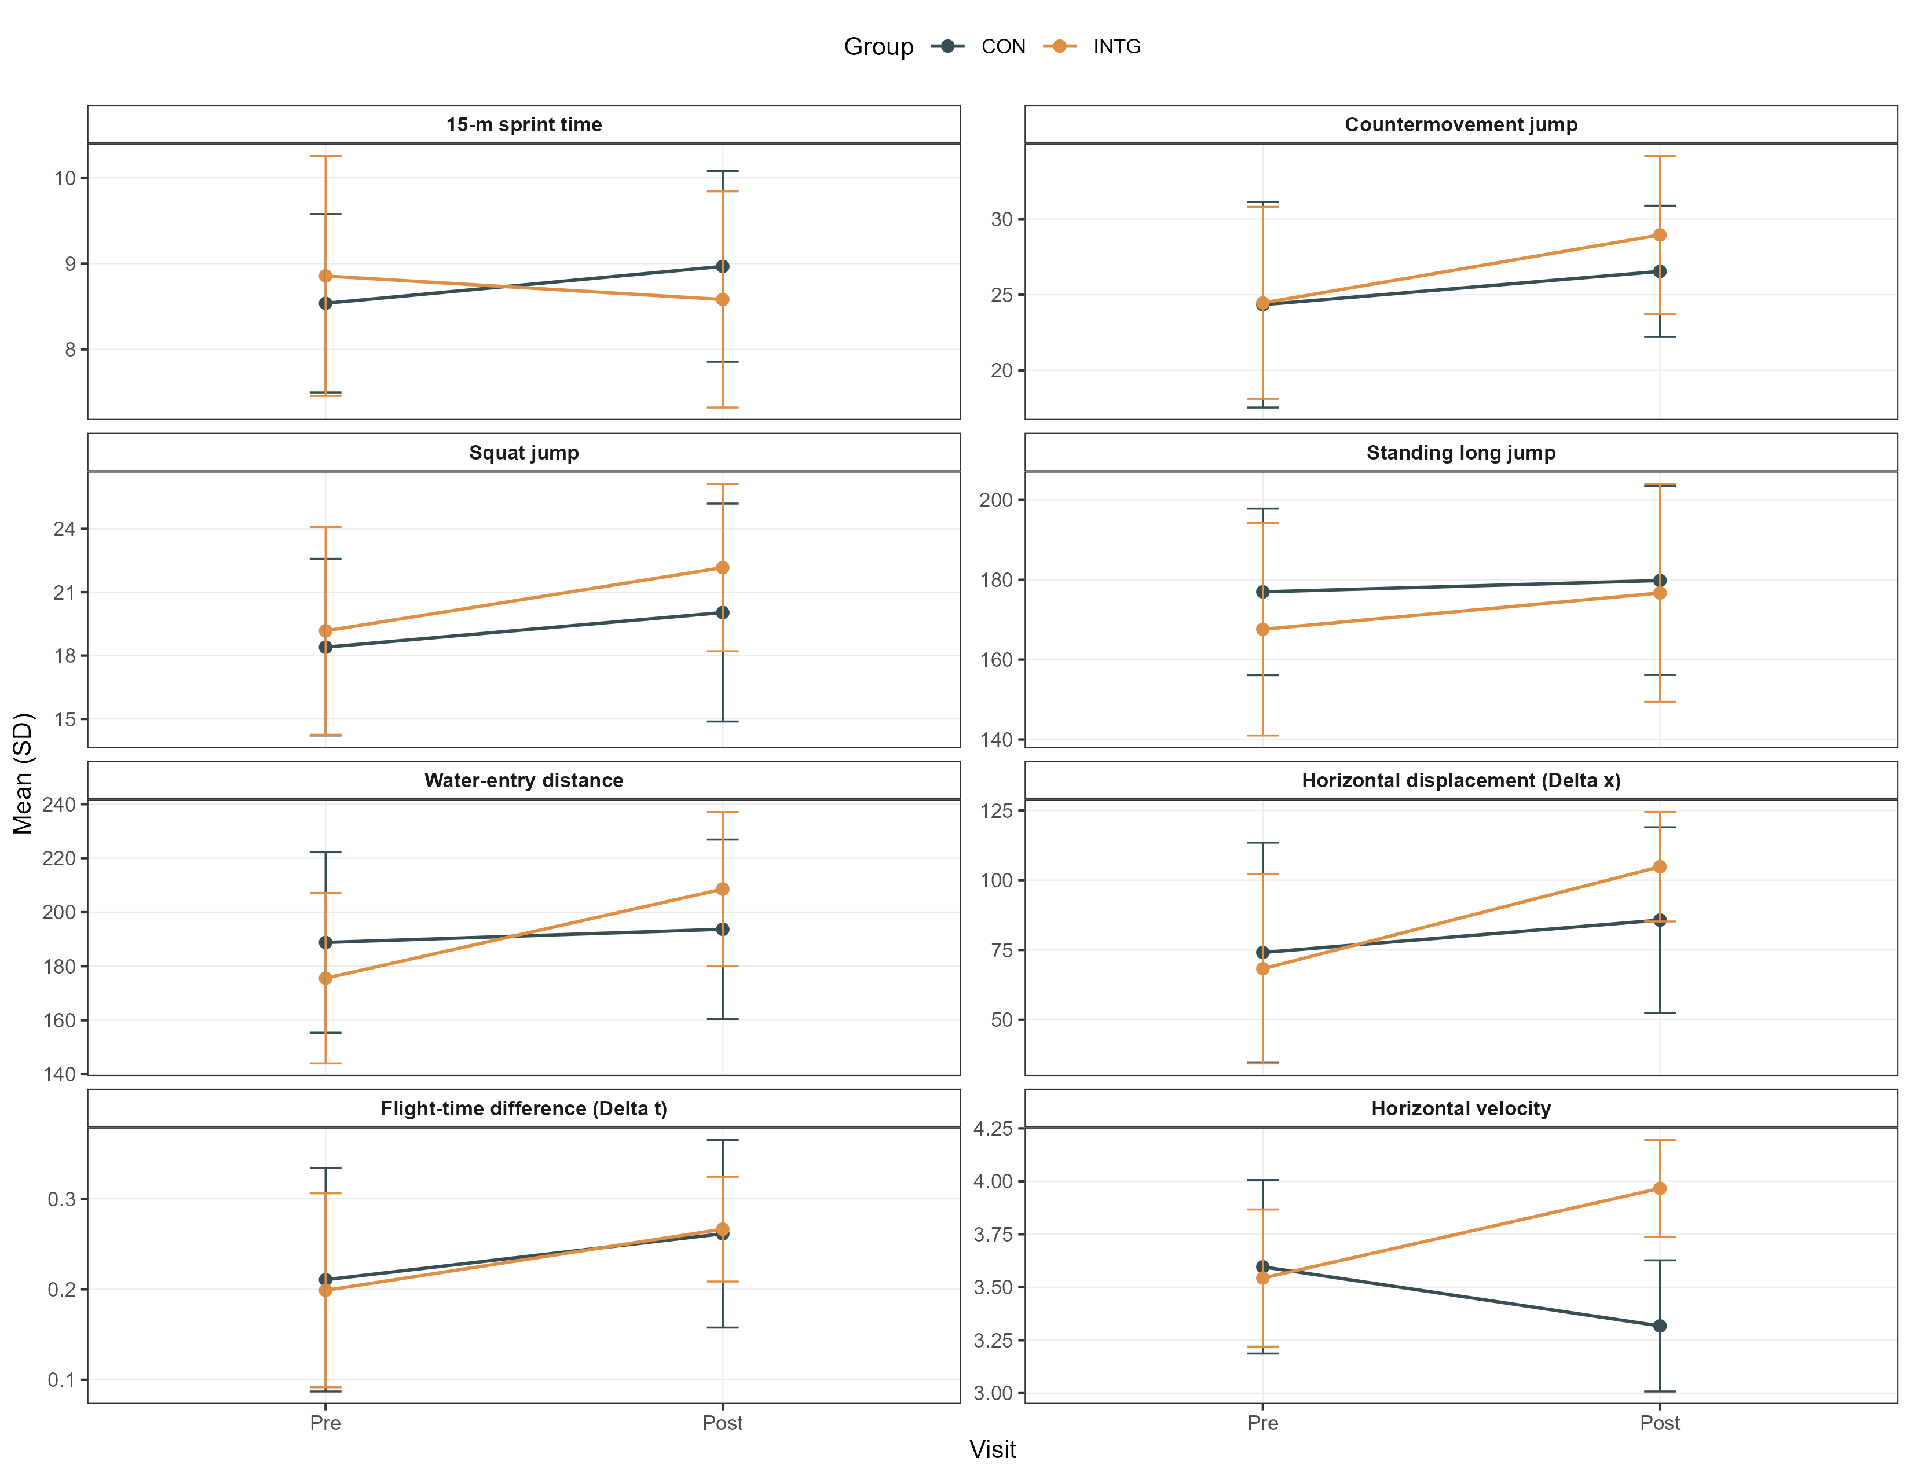
Supplementary Figure S2. FMS outcomes across all analyzed FMS variables.
