Raul Lopez

Rxl180020

Project Final

File in drive

The file to be deleted is “iCanWalk2.gif” The gif in the top right.

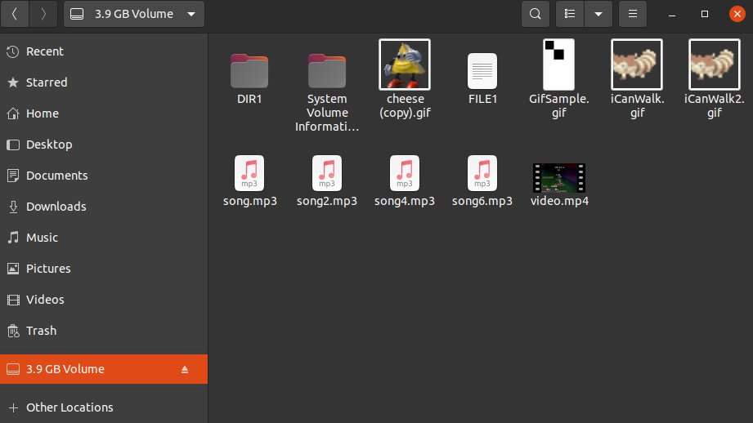

File Entry

The screentshot shows the gif is entry 83

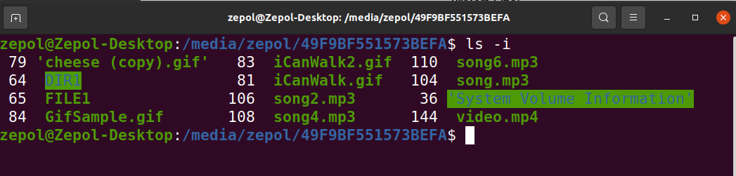

File deleted

The file has been deleted from the drive

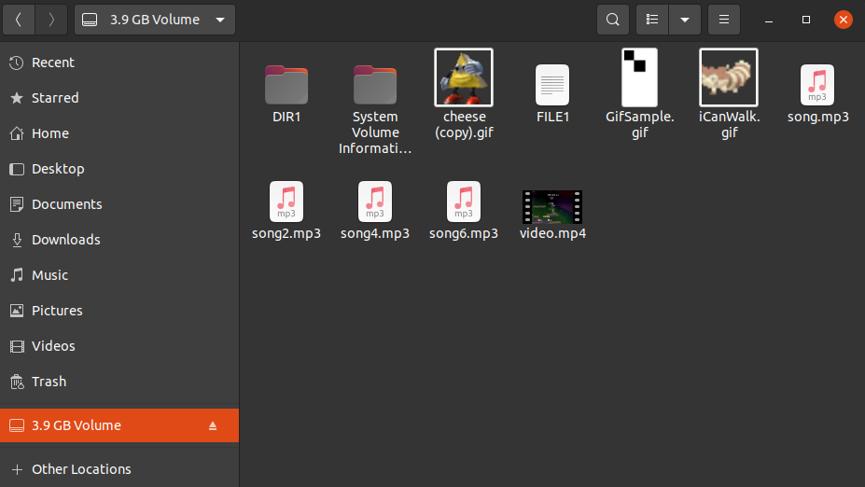

File before recovery

‘Recovery.gif’ is the recovery file. The screenshot shows that it is a different gif before the program is run.

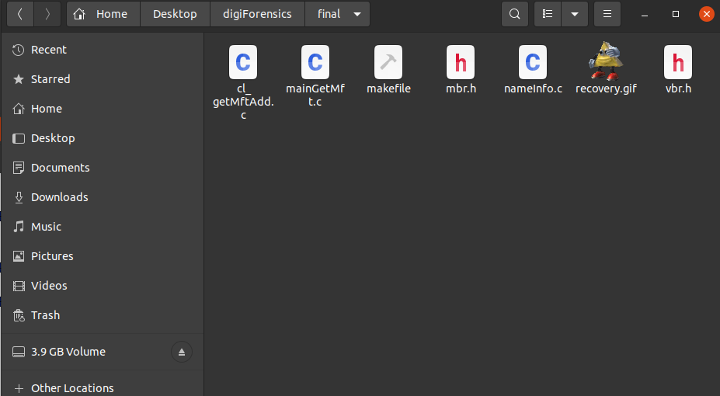

Program Run

The screenshot shows me running the program as well as the file marked as deleted.

In the run 83 is shown to be passed as the entry to recover and recovery.gif marked as the recovery file.

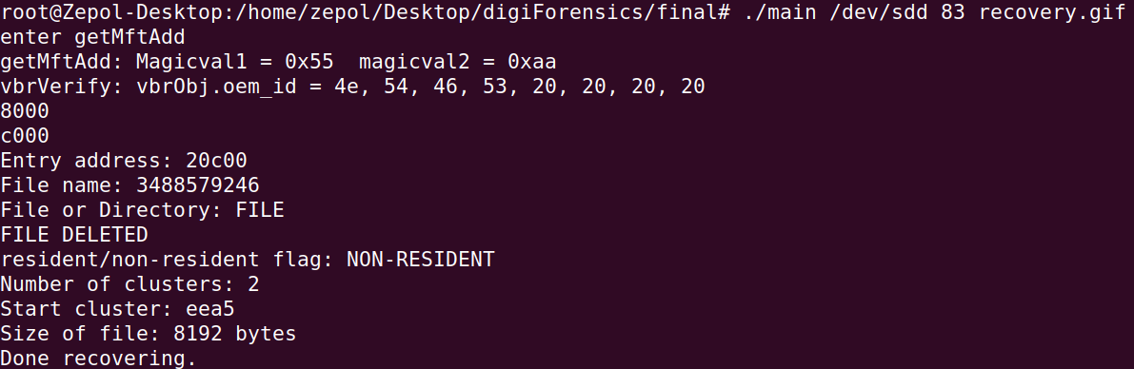

File Recovered

The following screenshots show the previews as well as the actual file displaying properly.

