Contents

1 Setup the virtual environment 2

2 Launching Jupyter Notebook 2

3 Kernels and Cells 4

4 Using and sharing Notebooks 5

# Setup the virtual environment

This approach is recommended. Create a virtual environment and install Jupyter using pip

# Launching Jupyter Notebook

From the command line, execute cmd> jupyter notebook

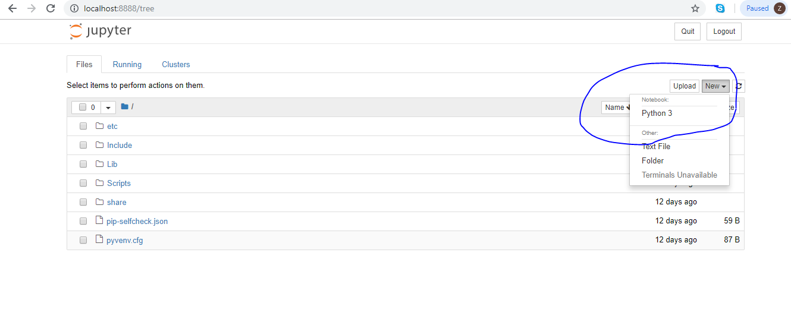

Figure 001a – Creating a new Notebook from the home/landing page

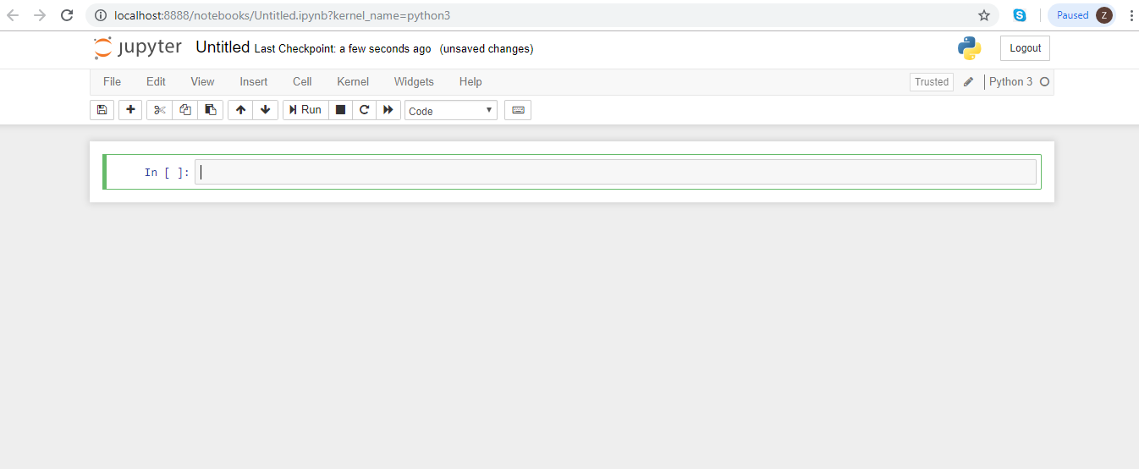

Figure 001b – Landing page of the untitled notebook [separate tab created]

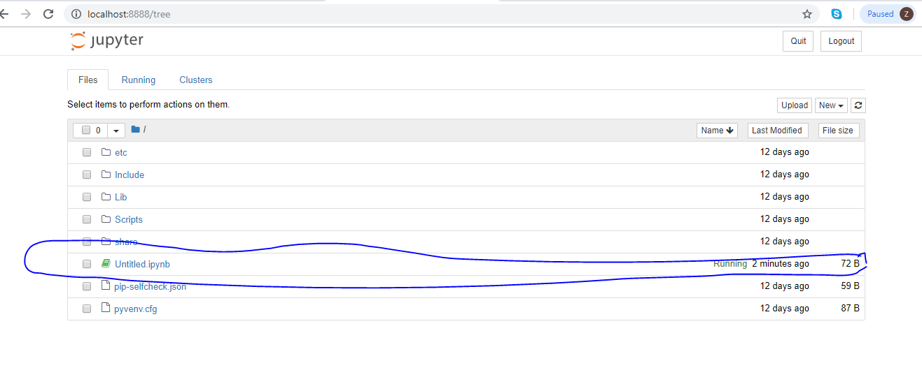

Figure 001c - Main landing page. The items list gets refreshed . You can create multiple notebooks

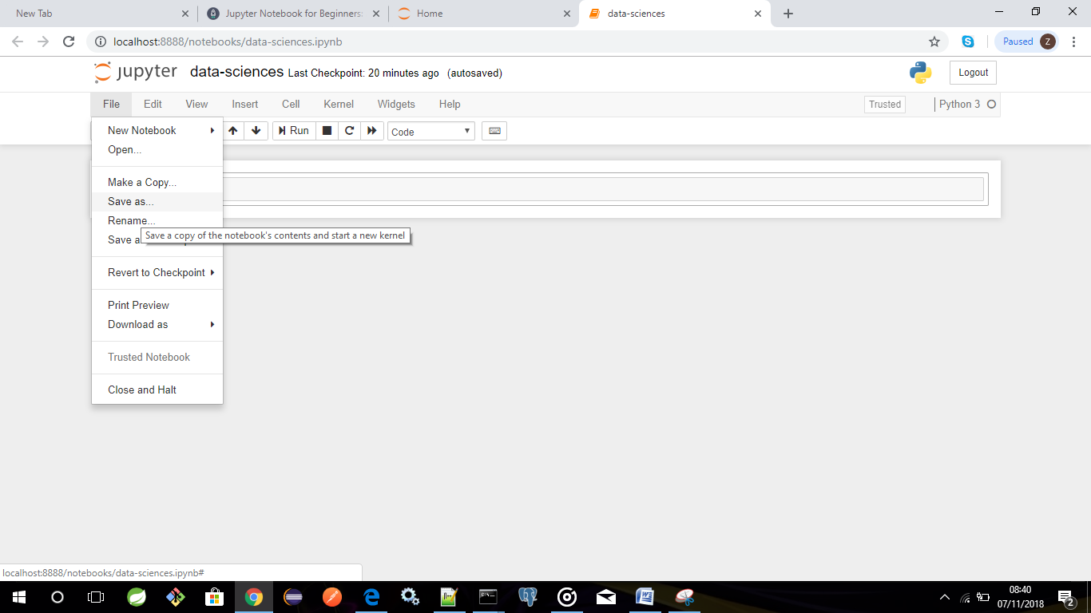

Figure 001d- Saving your untitled notebook [.ipynb extension]

# Kernels and Cells

There are two fairly prominent terms that you should notice, which are probably new to you: *cells* and *kernels* are key both to understanding Jupyter and to what makes it more than just a word processor. Fortunately, these concepts are not difficult to understand.

* A kernel is a "computational engine" that executes the code contained in a notebook document.
* A cell is a container for text to be displayed in the notebook or code to be executed by the notebook's kernel.

Cells

We'll return to kernels a little later, but first let's come to grips with cells. Cells form the body of a notebook. In the screenshot of a new notebook in the section above, that box with the green outline is an empty cell. There are two main cell types that we will cover:

* A **code cell** contains code to be executed in the kernel and displays its output below.
* A **Markdown cell** contains text formatted using Markdown and displays its output in-place when it is run.

The first cell in a new notebook is always a code cell.

# Using and sharing Notebooks