**DEVOPS**

**A**

**Practitioner’s**

**Approach**

Contents

1 General Introduction 3

2 Sources/Credits/Acknowledgements 3

3 The Evolution of DEVOPS 3

4 Navigating the DEVOPS MAZE 3

5 Terms and Fancy Jargon that are widely used 3

6 Skills Required for DevOPS 4

7 DevOPS - Hands On 4

# General Introduction

# Sources/Credits/Acknowledgements

# The Evolution of DEVOPS

# Navigating the DEVOPS MAZE

# Terms and Fancy Jargon that are widely used

|  |  |
| --- | --- |
|  |  |
|  |  |
|  |  |
|  |  |
|  |  |
|  |  |
|  |  |
|  |  |
|  |  |
|  |  |
|  |  |
|  |  |
|  |  |
|  |  |
|  |  |
|  |  |
|  |  |
|  |  |
|  |  |
|  |  |
|  |  |
|  |  |
|  |  |

# Skills Required for DevOPS

## GIT

## Linux

## Jenkins or its equivalent

## SonarQube

## Docker

## Kubernetes

## TravisCI/ Circle CI/ ……….

# DevOPS - Hands On

## GIT

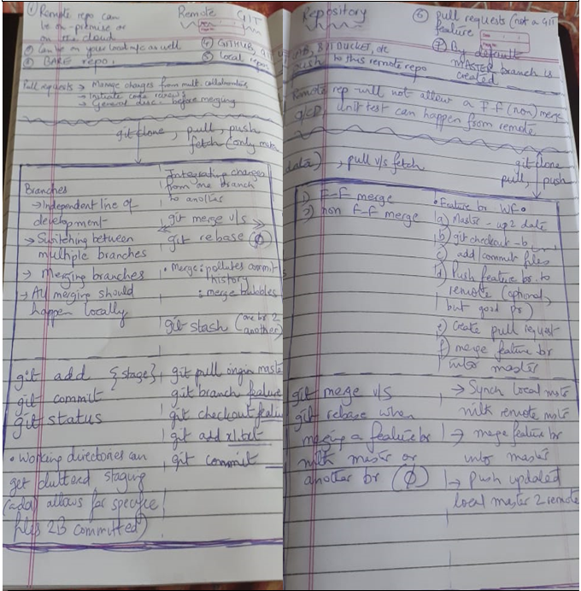

Figure - GIT notes. One page. Lots of important information.

### Living with multiple GIT providers

# APPENDIX I – SONARQUBE ECOSYSTEM

## Sonarlint

|  |
| --- |
| SonarLint, provided by Sonarsource [ <https://www.sonarsource.com/> ], is generally a free IDE extension that lets developers view and fix bugs and vulnerabilities as they write code.  Like Grammarly, SonarLint highlights coding issues on the fly, with clear guidance to rectify the fix before the code is even committed.  Available for popular IDEs, check that Sonarsource provides a plugin for the IDE that you are using and that the plugin can inspect the language that you are programming in.  If your project is analyzed on SonarQube or on SonarCloud, SonarLint can connect to the server to retrieve the appropriate quality profiles and settings for that project.  As a developer, you need to configure SonarLint to use SonarQube/SonarCloud [S1] profiles/settings or IDE/project (local) profile/settings [S2].  Code inspections results when using S1 or S2 can vary greatly.  **Technical pre-requisites**   * Java 8 is required to run SonarLint; * analysis of JavaScript and TypeScript requires Node.js >= 8. |

## SonarQube/SonarCloud