**I O T**

**Using**

**Python**

Table of Contents

1 Introduction 3

2 Important Definitions 3

2.1 Artificial Intelligence 3

2.2 Machine Learning 3

2.3 Deep Learning 3

2.4 Data Science 3

3 Glossary 3

4 Python’s IOT Ecosystem 4

# Introduction

# Glossary

|  |  |  |  |
| --- | --- | --- | --- |
|  | IOT |  |  |
|  | Sensor |  |  |
|  | Sockets |  |  |
|  | Rasbian |  |  |
|  | Raspberry |  |  |
|  |  |  |  |
|  |  |  |  |
|  |  |  |  |
|  |  |  |  |
|  |  |  |  |
|  |  |  |  |
|  |  |  |  |
|  |  |  |  |
|  |  |  |  |
|  |  |  |  |
|  |  |  |  |
|  |  |  |  |
|  |  |  |  |
|  |  |  |  |
|  |  |  |  |
|  |  |  |  |
|  |  |  |  |
|  |  |  |  |
|  |  |  |  |
|  |  |  |  |
|  |  |  |  |
|  |  |  |  |
|  |  |  |  |

# Python’s IOT Ecosystem

|  |  |  |  |
| --- | --- | --- | --- |
| # | Item |  |  |
| 1 | <https://github.com/adobe/SimpleSensor> |  |  |
| 2 | <https://www.element14.com/community/groups/internet-of-things/blog/2017/02/17/iot-with-python-essential-packages> |  |  |
| 3 | <https://iot.mozilla.org/framework/> |  |  |
| 4 | <https://www.hackster.io/bobbyleonard84/python-micropython-iot-framework-example-auto-irrigation-6286ae> |  |  |
| 5 | <https://pythonforundergradengineers.com/flask-iot-server-motivation.html> |  |  |
| 6 | <https://micropython.org/> |  |  |
| 7 | <https://pypi.org/project/google-cloud-iot/> |  |  |
| 8 | <https://pypi.org/project/azure-iot-device/> |  |  |
| 9 | <https://pythonprogramming.net/introduction-raspberry-pi-tutorials/> |  |  |
| 10 |  |  |  |
| 11 |  |  |  |
| 12 |  |  |  |

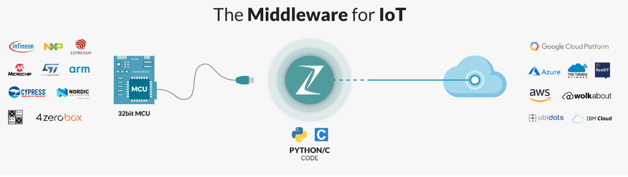

| **MAIN TOPIC** | **SUB TOPIC** | **DETAILS**  **/**  **(LINKS FOR FURTHER STUDY)**  **/**  **(FEEDBACK)**  **/**  **(SAMPLE PROGRAMS)** | **(CLASSROOM EXERCISES)**  **/**  **(ASSIGNMENTS)** | **TRACKING DATA** |
| --- | --- | --- | --- | --- |
| **OVERALL CONTEXT** | WHAT ARE YOU EXPECTING ? | <Update after feedback from the students> | **N/A** | DAY 1  (<=15 mins) |
|  | MY EXPECTATIONS FROM THE STUDENTS/YOU | * Be aware of the course content (*Have all of you gone through the course details [separate doc] ?)* * Do the class room exercises * Complete your assignments * Make notes *(I do it and it helps me)* * Don’t just nod your head to what I say. Digest it slowly. Stop me if I am going too fast | **N/A** | DAY 1  (<= 15 mins) |

## 