**Machine Learning**

**Using**

**Python**

Table of Contents

1 Introduction 3

2 Glossary 3

2.1 Artificial Intelligence 4

2.2 Machine Learning 4

2.3 Deep Learning 4

2.4 Data Science 4

2.5 Avoid falling in the “PIT OF UTTER CONFUSION” 7

3 Actual Uses Cases of ML 7

4 Python’s ML Ecosystem 7

5 DATA SCIENCES COURSE 8

6 MACHINE LEARNING COURSE 8

# Introduction

Today, everyone is feverishly talking about AI, ML and Data Sciences. This document is a very basic introduction to Machine Learning (ML), Deep Learning and Data Science.

These are complex and exhaustive topics. Readers are advised to carefully go through articles, books and various literature to get a complete grasp of these topics.

# IP

As an author, I will always strive to cite sources.

# Glossary

|  |  |  |  |
| --- | --- | --- | --- |
|  |  |  |  |
|  | Image classification |  |  |
|  | Supervised learning |  |  |
|  | Unsupervised learning |  |  |
|  | Reinforcement learning |  |  |
|  | Machine translation |  |  |
|  | Neural Network |  |  |
|  | Tensors |  |  |
|  | Named Tensors |  |  |
|  | Inference |  |  |
|  | Models |  |  |
|  | Trained |  |  |
|  | Untrained |  |  |
|  | Computer Vision |  |  |
|  | NLP |  |  |
|  | CPU |  |  |
|  | GPU |  |  |
|  | Bayesian Optimization |  |  |
|  | Gradient |  |  |
|  | Forward Pass |  |  |
|  | Backward Pass |  |  |
|  | Big Data |  |  |
|  | Analytics |  |  |
|  | Pipelines |  |  |
|  |  |  |  |
|  | Stochastic | having a random probability distribution or pattern that may be analysed statistically but may not be predicted precisely |  |
|  |  |  |  |
|  |  |  |  |
|  |  |  |  |

## Artificial Intelligence

AI is simply the broadest way to think about advanced, computer intelligence. Think of AI as the deep and broad science of mimicking human abilities.

[SOURCE ? ]

The reader is advised to treat ML and Data sciences as specific sub fields of AI.

## Machine Learning

“Machine learning is one subfield of AI. The core principle here is that machines take data and "learn" for themselves. It's currently the most promising tool in the AI kit for businesses. ML systems can quickly apply knowledge and training from large data sets to excel at facial recognition, speech recognition, object recognition, translation, and many other tasks. Unlike hand-coding a software program with specific instructions to complete a task, ML allows a system to learn to recognize patterns on its own and make predictions.”

The above extract is from - <https://www.goodworklabs.com/the-difference-between-artificial-intelligence-machine-learning/>

The above is the same as *“Machine learning is a set of algorithms that train on a data set to make predictions or take actions in order to optimize some systems. For instance, supervised classification algorithms are used to classify potential clients into good or bad prospects, for loan purposes, based on historical data.”*

The above extract is from - <https://www.datasciencecentral.com/profiles/blogs/difference-between-machine-learning-data-science-ai-deep-learning>

OR

*“Machine learning is a method of data analysis that automates analytical model building. It is a branch of artificial intelligence based on the idea that systems can learn from data, identify patterns and make decisions with minimal human intervention.”*

[The above is from - <https://www.sas.com/en_us/insights/analytics/machine-learning.html> ]

## Deep Learning

“Deep learning is a subset of ML. It uses some ML techniques to solve real-world problems by tapping into neural networks that simulate human decision-making. **Deep learning can be expensive, and requires massive datasets to train itself on**. That's because there are a huge number of parameters that need to be understood by a learning algorithm, which can initially produce a lot of false-positives. For instance, a deep learning algorithm could be instructed to "learn" what a cat looks like. It would take a very massive data set of images for it to understand the very minor details that distinguish a cat from, say, a cheetah or a panther or a fox. “

Extracted from - <https://www.techrepublic.com/article/understanding-the-differences-between-ai-machine-learning-and-deep-learning/>

## The Neural Network

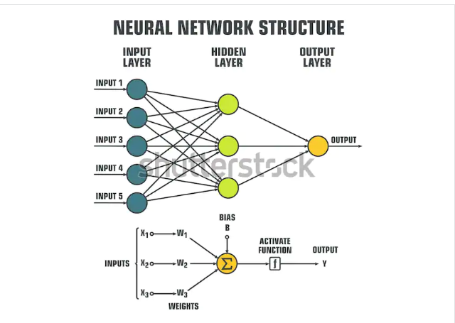

© <https://www.shutterstock.com/image-vector/icon-schematic-processing-data-inside-neural-1130525327>

### The Building Blocks of a Neural Network - Neurons (Nodes)

## Supervised, un-supervised and semi-supervised learning

### Supervised Learning

### Unsupervised learning

### Semi-supervised learning

### Comparison Matrix

|  |  |  |  |  |  |
| --- | --- | --- | --- | --- | --- |
|  | Supervised Learning | Unsupervised Learning | Semi-supervised Learning |  |  |
|  |  |  |  |  |  |
|  |  |  |  |  |  |
|  |  |  |  |  |  |
|  |  |  |  |  |  |
|  |  |  |  |  |  |
|  |  |  |  |  |  |
|  |  |  |  |  |  |

## Data Science

At its core, data science is a field of study that aims to use a scientific approach to extract meaning and insights from data. Dr. Thomas Miller of Northwestern University describes data science as “a combination of information technology, modeling, and business management”.

Note the focus on data. This brings Big Data into the picture. Big Data, which can mean many things, is not really covered in this introductory document.

Machine learning, on the other hand, refers to a group of techniques that allow computers to learn from data.

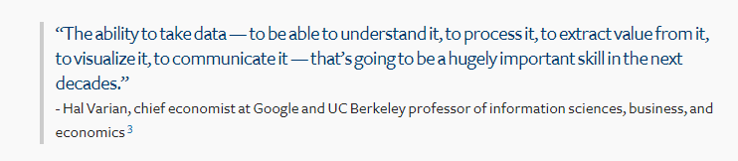

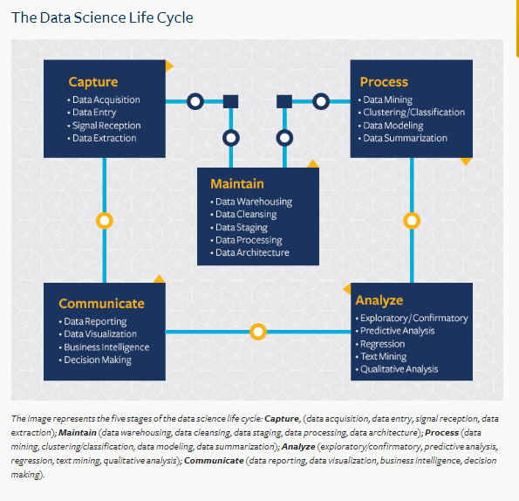

Figure – Source - <https://datascience.berkeley.edu/about/what-is-data-science/>

To be an expert in Data Sciences is no easy task.

<https://www.kdnuggets.com/2018/05/simplilearn-9-must-have-skills-data-scientist.html> - will give you an indication of what one needs to be good at. Please note that this article goes a bit overboard, but does emphasize that the skills are not trivial.

Plain Python programming knowledge will not be enough !.

## Avoid falling in the “PIT OF UTTER CONFUSION”

Everybody uses the word “AI”, so treat this as a generic all encompassing term used to describe how software/hardware is infused with advanced intelligence. Think twice before claiming to know AI !.

When learning about data sciences, remember that entities possess data and there are lots of benefits to be gained from analyzing this data to gain insights, make predictions.

Data science, without the frills, has been around from a long time. MS EXCEL itself can be used to perform basis analysis of data. PANDAS does data sciences as well.

A question often asked is – “Do I need BIG DATA for Data Sciences ?” . Actually, “No” . Depending upon the situation, having lots of data does help in better insights and analytics, but you can do data sciences even with small data sets.

Another question - “ML” creeps in as well, why ?. When doing data science, ML techniques can be used - REVISIT.

**Artificial Intelligence**

**Machine Learning**

**Deep Learning**

# Actual Uses Cases of ML

|  |  |  |  |  |
| --- | --- | --- | --- | --- |
| **#** | **Group** | **Description** | **Real World Applications** | **Algorithms** |
|  | Classification |  | * Classifying clothing related images (Shirts, Pants, etc.) |  |
|  | Categorization |  | * Photos on a particular web site * Production ticket data based on certain criteria ?   [NOTE : Classification and Categorization might be the same] |  |
|  | Clustering |  | * Customer Segmentation |  |
|  | Regression | A measure of the relation between the mean value of one variable (e.g. output) and corresponding values of other variables (e.g. time and cost) |  |  |
|  | Predictions (?) |  |  |  |
|  |  |  |  |  |
|  |  |  |  |  |
|  |  |  |  |  |
|  |  |  |  |  |

# Python’s ML Ecosystem

|  |  |  |  |
| --- | --- | --- | --- |
|  |  |  |  |
| 1 | Numpy |  |  |
| 2 | Pandas |  |  |
| 3 | Scikit-learn |  |  |
| 4 | Pytorch |  |  |
| 5 | Keras |  |  |
| 6 | Scikit-image |  |  |
| 7 | Tensorflow |  |  |
| 8 | Caffe |  |  |
| 9 | StatsModels |  |  |
| 10 | Pybrain |  |  |
| 11 | Skorch |  |  |
| 12 | Scipy |  |  |
| 13 | PySpark |  |  |

# COURSES

## Numpy and Pandas

Covered in <>

## Pytorch basics

| **MAIN TOPIC** | **SUB TOPIC** | **DETAILS**  **/**  **(LINKS FOR FURTHER STUDY)**  **/**  **(FEEDBACK)**  **/**  **(SAMPLE PROGRAMS)** | **(CLASSROOM EXERCISES)**  **/**  **(ASSIGNMENTS)** | **TRACKING DATA** |
| --- | --- | --- | --- | --- |
| **OVERALL CONTEXT** | WHAT ARE YOU EXPECTING ? | <Update after feedback from the students> | **N/A** | DAY 1  (<=15 mins) |
|  | MY EXPECTATIONS FROM THE STUDENTS/YOU | * Be aware of the course content (*Have all of you gone through the course details [separate doc] ?)* * Do the class room exercises * Complete your assignments * Make notes *(I do it and it helps me)* * Don’t just nod your head to what I say. Digest it slowly. Stop me if I am going too fast * Learning ML/Data science is a complex topic and even I am not an expert | **N/A** | DAY 1  (<= 15 mins) |
|  |  |  |  |  |
|  |  |  |  |  |
|  |  |  |  |  |
|  |  |  |  |  |
|  |  |  |  |  |
|  |  |  |  |  |
|  |  |  |  |  |
|  |  |  |  |  |
|  |  |  |  |  |

## 

## Pytorch Advanced

| **MAIN TOPIC** | **SUB TOPIC** | **DETAILS**  **/**  **(LINKS FOR FURTHER STUDY)**  **/**  **(FEEDBACK)**  **/**  **(SAMPLE PROGRAMS)** | **(CLASSROOM EXERCISES)**  **/**  **(ASSIGNMENTS)** | **TRACKING DATA** |
| --- | --- | --- | --- | --- |
| **OVERALL CONTEXT** | WHAT ARE YOU EXPECTING ? | <Update after feedback from the students> | **N/A** | DAY 1  (<=15 mins) |
|  | MY EXPECTATIONS FROM THE STUDENTS/YOU | * Be aware of the course content (*Have all of you gone through the course details [separate doc] ?)* * Do the class room exercises * Complete your assignments * Make notes *(I do it and it helps me)* * Don’t just nod your head to what I say. Digest it slowly. Stop me if I am going too fast | **N/A** | DAY 1  (<= 15 mins) |

## Scikit-Learn Course

| **MAIN TOPIC** | **SUB TOPIC** | **DETAILS**  **/**  **(LINKS FOR FURTHER STUDY)**  **/**  **(FEEDBACK)**  **/**  **(SAMPLE PROGRAMS)** | **(CLASSROOM EXERCISES)**  **/**  **(ASSIGNMENTS)** | **TRACKING DATA** |
| --- | --- | --- | --- | --- |
| **OVERALL CONTEXT** | WHAT ARE YOU EXPECTING ? | <Update after feedback from the students> | **N/A** | DAY 1  (<=15 mins) |
|  | MY EXPECTATIONS FROM THE STUDENTS/YOU | * Be aware of the course content (*Have all of you gone through the course details [separate doc] ?)* * Do the class room exercises * Complete your assignments * Make notes *(I do it and it helps me)* * Don’t just nod your head to what I say. Digest it slowly. Stop me if I am going too fast | **N/A** | DAY 1  (<= 15 mins) |