**Cloud**

**Native**

**Computing**

**and**

**Development**

Table of Contents

1 General Introduction 3

2 IP 3

3 Important Terms 3

# General Introduction

# IP

As an author, I will always strive to cite sources.

# Important Terms

|  |  |  |  |
| --- | --- | --- | --- |
|  | **Term** | **Description** | **Additional Reading** |
|  | Elastic Compute |  |  |
|  | Serverless computing |  |  |
|  | Public Cloud |  |  |
|  | Private Cloud |  |  |
|  | Hybrid Cloud |  |  |
|  | CNCF |  |  |
|  | FAAS |  |  |
|  | PAAS |  |  |
|  | SAAS |  |  |
|  |  |  |  |
|  |  |  |  |
|  |  |  |  |
|  |  |  |  |
|  |  |  |  |
|  |  |  |  |
|  |  |  |  |
|  |  |  |  |
|  |  |  |  |
|  |  |  |  |
|  |  |  |  |
|  |  |  |  |
|  |  |  |  |
|  |  |  |  |
|  |  |  |  |
|  |  |  |  |
|  |  |  |  |
|  |  |  |  |

# Leading Players in the Cloud Space

# AWS

# Azure

# GCP

# Tutorials

## AWS

| **MAIN TOPIC** | **SUB TOPIC** | **DETAILS**  **/**  **(LINKS FOR FURTHER STUDY)**  **/**  **(FEEDBACK)**  **/**  **(SAMPLE PROGRAMS)** | **(CLASSROOM EXERCISES)**  **/**  **(ASSIGNMENTS)** | **TRACKING DATA** |
| --- | --- | --- | --- | --- |
| **OVERALL CONTEXT** | WHAT ARE YOU EXPECTING ? | <Update after feedback from the students> | **N/A** | DAY 1  (<=15 mins) |
|  | MY EXPECTATIONS FROM THE STUDENTS/YOU | * Be aware of the course content (*Have all of you gone through the course details [separate doc] ?)* * Do the class room exercises * Complete your assignments * Make notes *(I do it and it helps me)* * Don’t just nod your head to what I say. Digest it slowly. Stop me if I am going too fast | **N/A** | DAY 1  (<= 15 mins) |
|  |  |  |  |  |
| Setting up a new AWS account |  | * Activating the account * Mobile Number verification * Interacting with the support team * The Free Tier * Can take a couple of days |  |  |
|  |  |  |  |  |
| **Managing the AWS Account** | Initial set of activities | * [My Account](https://console.aws.amazon.com/billing/home?#/account) * [My Organization](https://console.aws.amazon.com/organizations/home) * [My Service Quotas](https://console.aws.amazon.com/servicequotas/home) * [My Billing Dashboard](https://console.aws.amazon.com/billing/home) * [Orders and Invoices](https://console.aws.amazon.com/billing/home?#/paymenthistory) * [My Security Credentials](https://console.aws.amazon.com/iam/home#security_credential) |  |  |
|  |  |  |  |  |
| **More about your AWS account** | * [My Account](https://console.aws.amazon.com/billing/home?#/account) | * When you register, the email ID that is used is typically the ROOT account which should not be used for operational purposes * Remember your Account ID / Alias * Secure your ROOT user id credentials |  |  |
|  | * [My Organization](https://console.aws.amazon.com/organizations/home) |  |  |  |
|  | * [My Service Quotas](https://console.aws.amazon.com/servicequotas/home) |  |  |  |
|  | * [My Billing Dashboard](https://console.aws.amazon.com/billing/home) |  |  |  |
|  | * [Orders and Invoices](https://console.aws.amazon.com/billing/home?#/paymenthistory) |  |  |  |
|  | * [My Security Credentials](https://console.aws.amazon.com/iam/home#security_credential) |  |  |  |
|  |  |  |  |  |
| **Basic Technical Concepts** | AWS Regions | * AWS is a global cloud services provider * Services are typically tied to regions   + Example : A service that is available in Region 1 might not be available in Region 2 * Regions must be chosen carefully to ensure low latency * A specific set of services are GLOBAL i.e. not tied to any region   + Example : IAM |  |  |
|  | Availability Zones |  |  |  |
|  |  |  |  |  |
| **Global Services** | IAM | * New AWS customers are strongly recommended to use the Dashboard to get a view of the users that can operate the account * Enterprises, if required, can integrate IAM with their own Directories (AD, etc.) * Small customers can use IAM to create a list of users * Always create IAM Users * IAM allows you, the account/tenant, to properly manage access to resources from a billing and security perspective. Remember - AWS bills you for services | Further reading **-** <https://docs.aws.amazon.com/IAM/latest/UserGuide/introduction.html> |  |
|  |  |  |  |  |
| **IAM continued** | Dashboard |  |  |  |
|  | Groups | * These are collections of permissions/privileges/policies * Makes it easy for permissions to be granted to IAM users * Managed Policies * Inline Policies | **Further reading -** <https://docs.aws.amazon.com/IAM/latest/UserGuide/access_policies_managed-vs-inline.html> |  |
|  | Specific Groups | * Complete access (“CA”) to Amazon Elastic Compute Cloud (Amazon EC2) * CA to Amazon Simple Storage Service (Amazon S3) * CA to Amazon DynamoDB * CA Amazon Redshift * Read-only access to just some S3 buckets * Permission to administer just some EC2 instances * Access your billing information but nothing else * + Plus More | These are exercises that learners are encouraged to complete to improve their understanding of groups and to ensure that the AWS account is securely managed |  |
|  | Users | * Users can belong to multiple groups |  |  |
|  |  |  |  |  |
|  |  |  |  |  |
|  |  |  |  |  |
|  |  |  |  |  |
|  |  |  |  |  |
|  |  |  |  |  |
|  |  |  |  |  |

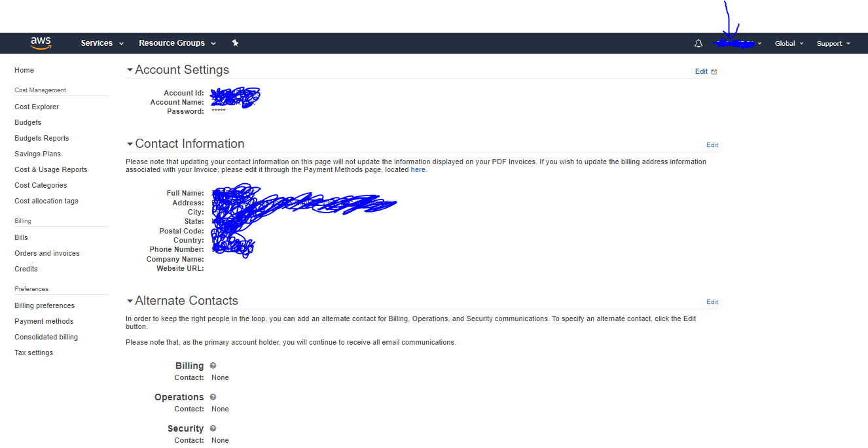

Figure 1 - Screen that a new AWS user should go through