Lab Report: Python ifs, loops, and modules
Author: Shuvalov Fjodor (https://github.com/zer0rbt/Development-Essentials)
Partner: Baranovskaya Aleksandriya Valerievna (https://github.com/alexbaranovskaya14-source/coolcool)

1. Sorting three integers
Three simple ifs, each swapping a neighbouring pair: the first two put the maximum into c, the third orders a and b.
lab10/task1_sort_three.py
"""Read three integers, sort them with three simple ifs and print them."""
a, b, c = map(int, input().split())
if a > b:
a, b = b, a
if b > c:
b, c = c, b
if a > b:
a, b = b, a
print(a, b, c)
Run
$ echo "7 -2 3" | python task1_sort_three.py
-2 3 7

2. Counting strings in a list
Final version: the partner's merged pull request (see section 4) plus style fixes. flake8 reports nothing, pylint rates the code 10.00/10.
lab10/task2_count_strings.py
"""Count the string elements in a list of mixed types."""
items = [list, "abba", "123", 123, "list", None, True, ["x"]]
checks = [isinstance(item, str) for item in items]
print(f"Number of strings: {checks.count(True)}")
Run
$ python task2_count_strings.py
Number of strings: 3

3. Modules
find_smallest.py holds find_two_smallest(), int_lists.py defines four lists, main.py imports both and writes the results to result.txt.
lab10/task3/find_smallest.py
"""Find the two smallest values of a list."""
def find_two_smallest(values: list[int]) -> tuple[int, ...]:
"""Return the two smallest values in ascending order."""
return tuple(sorted(values)[:2])
lab10/task3/int_lists.py
"""Four lists of random integers."""
from random import randint
a: list[int] = [randint(1, 100) for _ in range(10)]
b: list[int] = [randint(1, 100) for _ in range(10)]
c: list[int] = [randint(1, 100) for _ in range(10)]
d: list[int] = [randint(1, 100) for _ in range(10)]
lab10/task3/main.py
"""Find the two smallest values of each list and save them to result.txt."""
from find_smallest import find_two_smallest
from int_lists import a, b, c, d
if __name__ == "__main__":
with open("result.txt", "w", encoding="utf-8") as file:
file.write(f"{a} -> {find_two_smallest(a)}\n")
file.write(f"{b} -> {find_two_smallest(b)}\n")
file.write(f"{c} -> {find_two_smallest(c)}\n")
file.write(f"{d} -> {find_two_smallest(d)}\n")
lab10/task3/result.txt
[28, 30, 81, 25, 48, 61, 36, 67, 82, 98] -> (25, 28)
[1, 76, 60, 21, 80, 79, 44, 51, 81, 83] -> (1, 21)
[49, 57, 36, 70, 3, 54, 95, 49, 19, 96] -> (3, 19)
[12, 78, 24, 1, 35, 82, 32, 21, 13, 100] -> (1, 12)

4. GitHub collaboration
My repository: https://github.com/zer0rbt/Development-Essentials
Partner's repository: https://github.com/alexbaranovskaya14-source/coolcool
No collaborator access; all changes went through pull requests from forks.
PR | Author | Result | Reason
coolcool #1 | me | Rejected | Partner wants functions in separate modules; style needed work
coolcool #2 | me | Merged | Kept the module, added type hints, flake8/pylint clean
Development-Essentials #1 | partner | Rejected | Went against the goal of keeping the code as short as possible
Development-Essentials #2 | partner | Merged | Reworked according to my comment

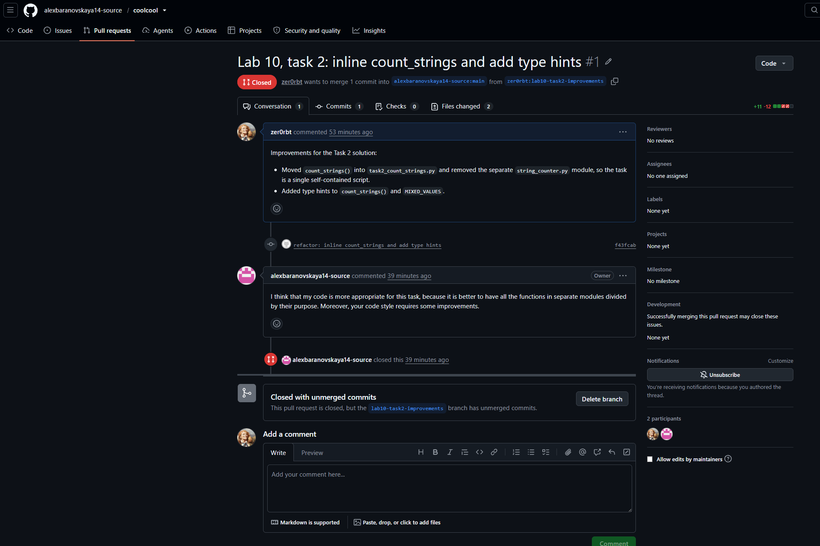
coolcool #1: rejected with the partner's comment
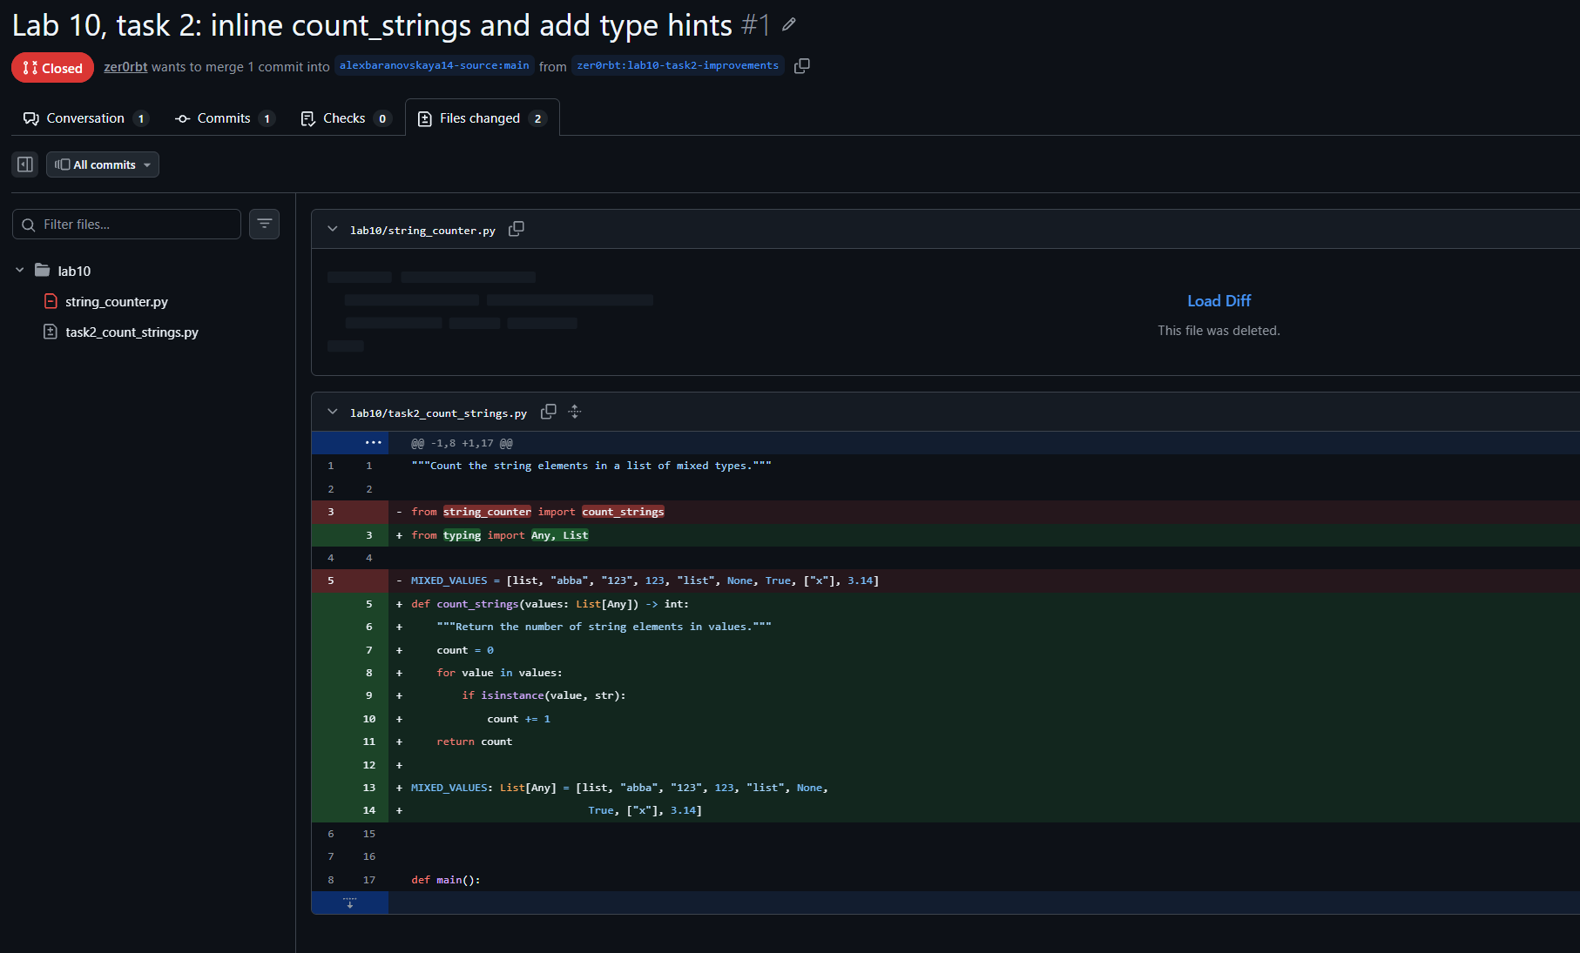
coolcool #1: changes
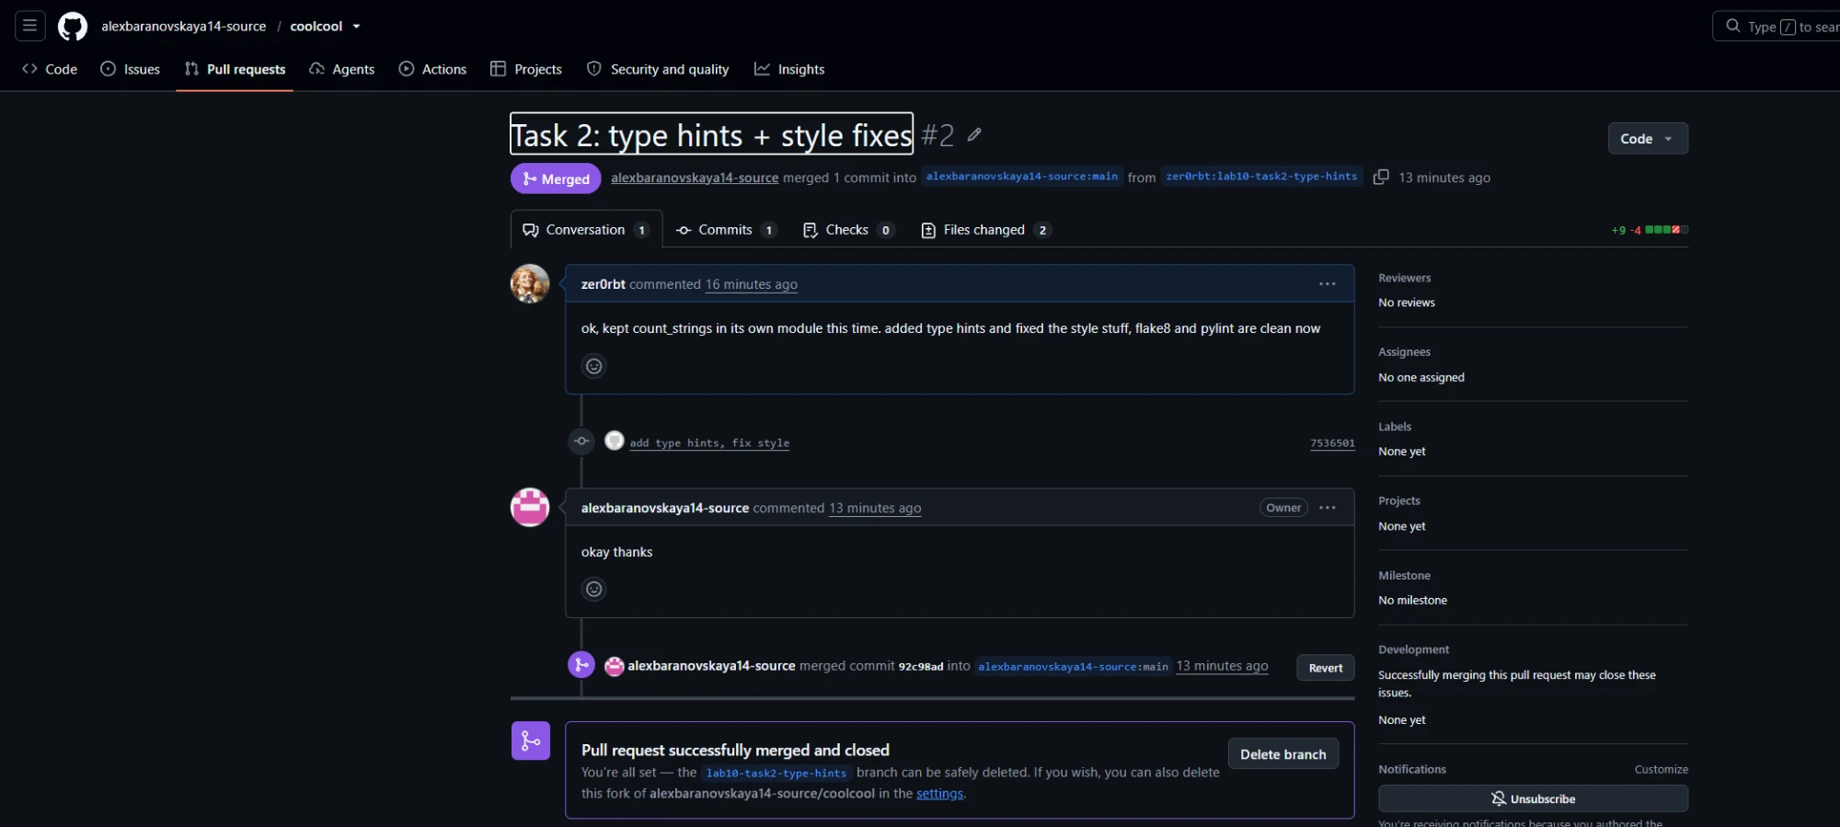
coolcool #2: merged
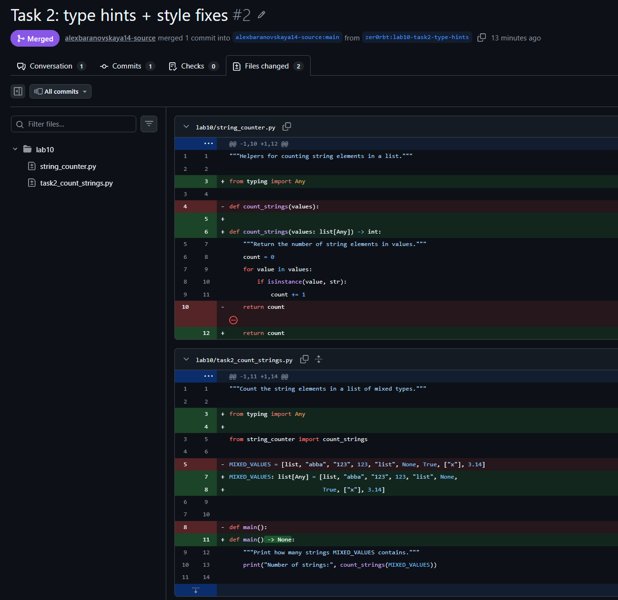
coolcool #2: changes
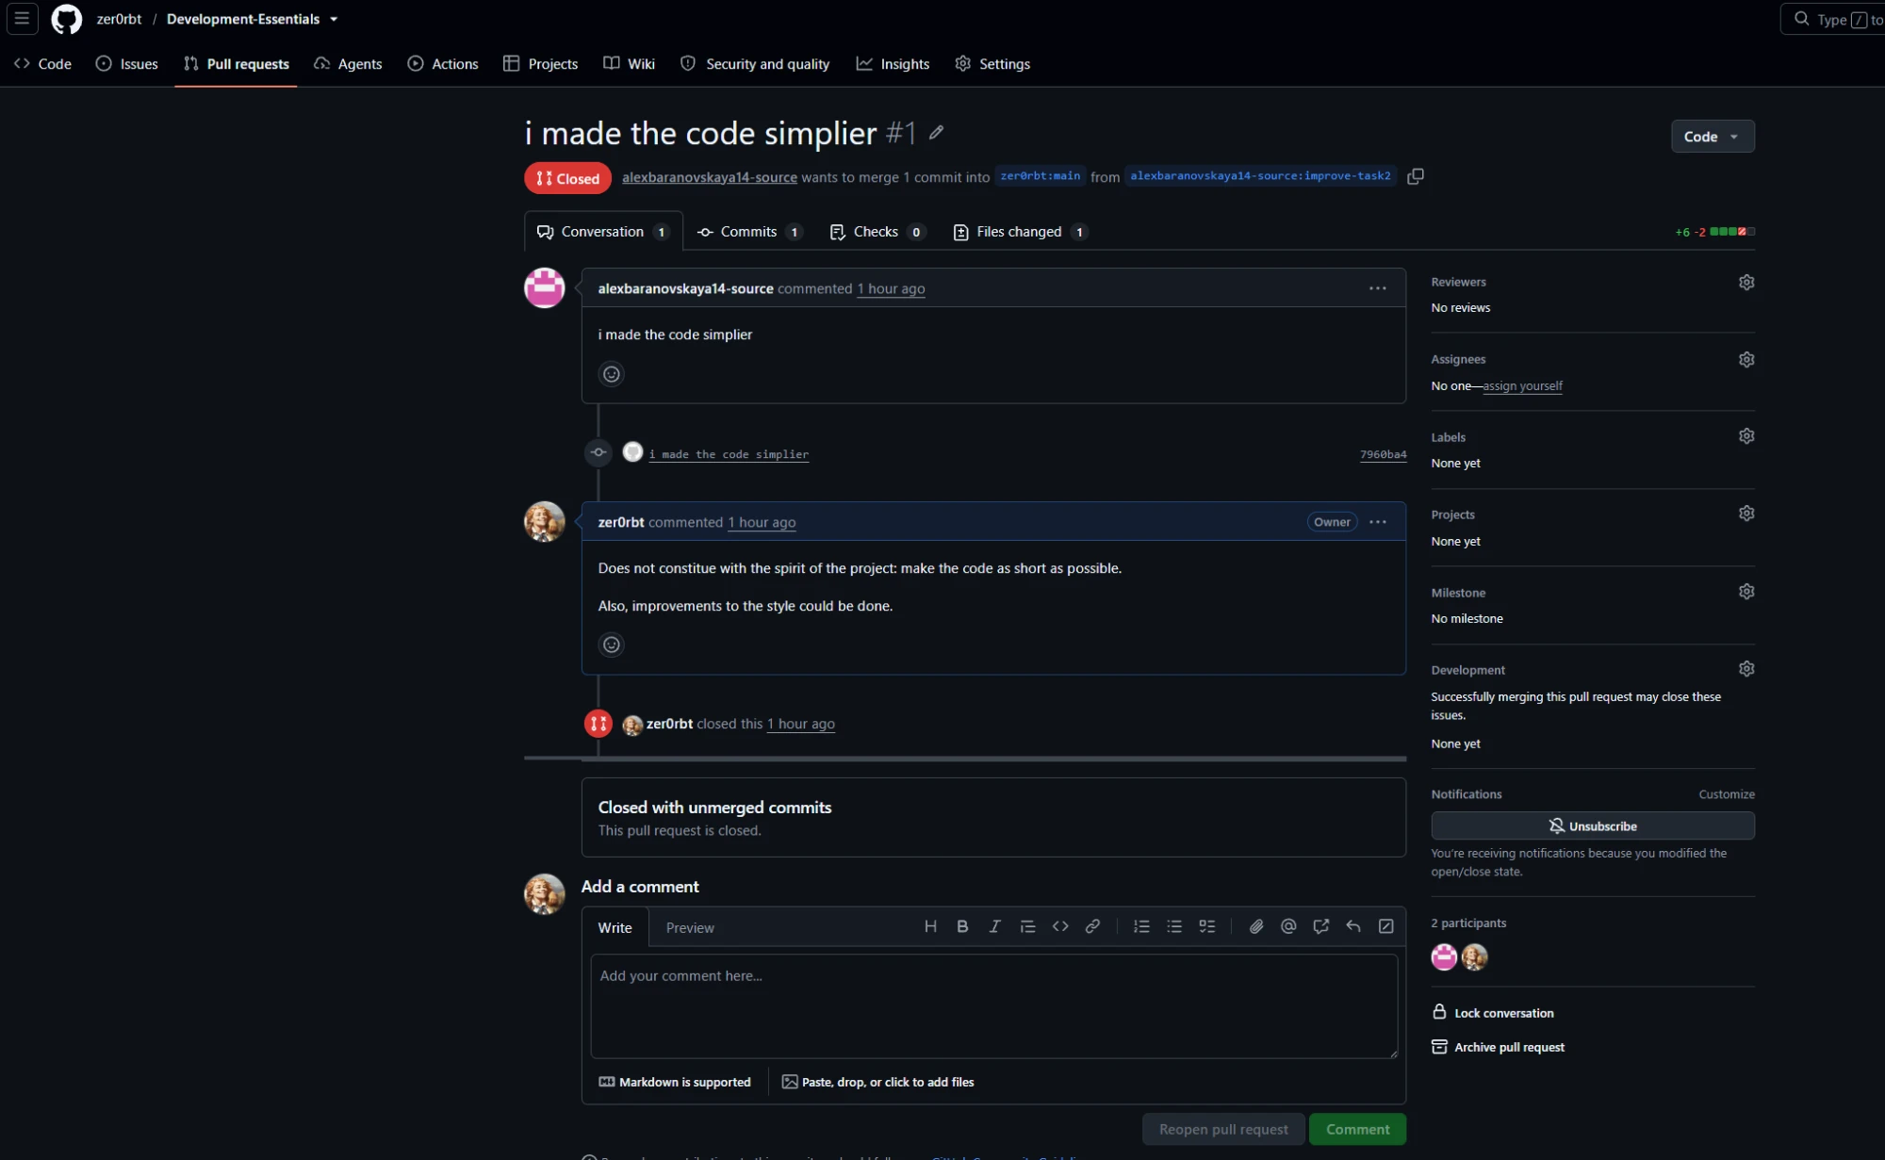
Development-Essentials #1: rejected with my comment
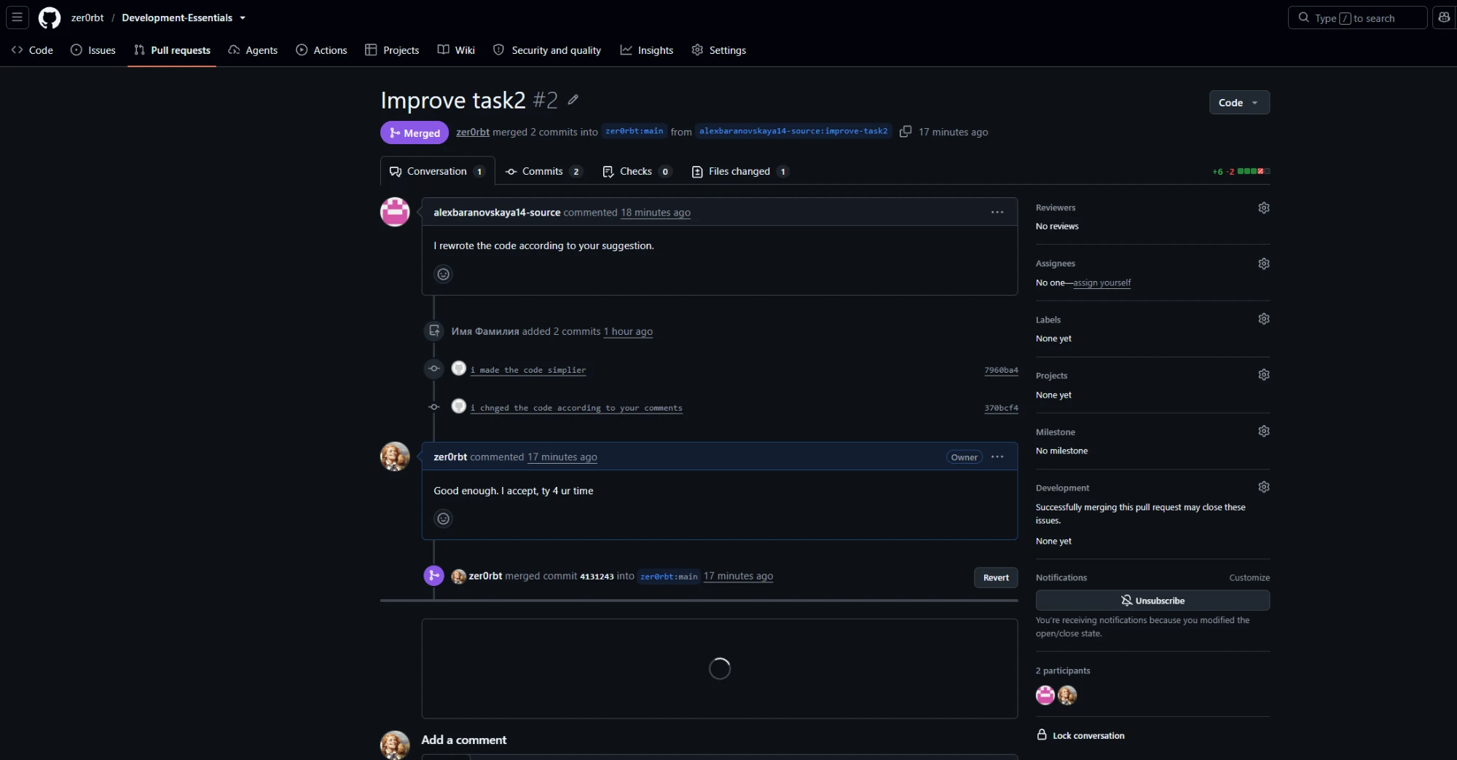
Development-Essentials #2: merged

5. Conclusions
- Sorting three values needs only three compare-and-swap steps, so else/elif/and/or are not required.
- Splitting code into modules keeps logic (find_two_smallest), data (lists) and I/O (main) separate and reusable.
- Without collaborator access, fork + pull request is the way to contribute; a rejection with a written reason is part of normal review, and both teams ended up merging a revised version.
- Short code and readable code are different goals; the partner and I disagreed on that, and review comments made the trade-off explicit.

