

SOCIAL SECURITY SYSTEM

R3 File Generator
USER’S MANUAL
VERSION 1.0
06 MAY 2009

PREPARED BY:

APPLICATIONS DEVELOPMENT & MAINTENANCE - 1
INFORMATION TECHNOLOGY MANAGEMENT GROUP

09 July 2009

C E R T I F I C A T I O N

This is to certify that the USER’S MANUAL for the R3 File Generator submitted by the Applications Development and Maintenance – 1 department, has been reviewed and has complied with the user’s specifications and requirements.

Signature
ANTONIO S. ARGABIOSO
AVP, PMS Contribution

09 July 2009

C E R T I F I C A T I O N

This is to certify that the USER’S MANUAL for the R3 File Generator submitted by the Applications Development and Maintenance – 1 department has been reviewed and has complied with ITMG standard documentation specifications and requirements.

Signature
MA. SALOME E. ROMANO
Officer-In-Charge, Planning and Standards Dept.

AUTHOR/S

Cynthia A. Duque
Acting Senior Specialist
Applications Development & Maintenance – 1

Allen Son Q. Reyes
Encoder
Pre Production Acceptance Team

PREFACE

PURPOSE : This User’s Guide contains information and instructions that will help the users in the operation of the SSS R-3 File Generator (Version 1.0).

AUDIENCE : This manual is intended for Employers who participate in the submission of electronic R-3 files.

MINIMUM HARDWARE REQUIREMENT:
- 166 MHZ Pentium IV or equivalent
- 256 MB memory
- 100 MB extra hard disk space
- VGA Display

MINIMUM SOFTWARE REQUIREMENT:
- JRE 6 for Windows OR
- JRE 6 for Linux
HOW TO USE THIS MANUAL/GUIDE

This guide is divided into six sections:

Chapter 1, “Getting Started”, describes how to get a copy, install and load the R3 File Generator program.

Chapter 2, “Generating The R3 File”, shows how to add, edit and delete the employer, employee, and payment information.

Chapter 3, “Report Generation”, shows how to generate reports.

Chapter 4, “System Maintenance”, shows how to save files, restore previously saved files and update program for new Contribution schedule.

REVISION HISTORY

R3 Diskette Version 1.0: The system was developed using Foxbase running in DOS environment.

R3 Diskette Version 2.0: The system was revised using Visual Basic Version 6.0 running in Windows 98/NT/2000/XP.

R3 File Generator : The system was converted using Java to run in different platforms/environment and to recognize other input devices.

YOUR COMMENTS ARE WELCOME

The Information Technology Management Group values and appreciates your comments as user and reader of this User’s Manual. It would greatly help in designing future enhancements

Please address all comments to: member_relations@sss.gov.ph

TABLE OF CONTENTS

AUTHOR/S i
PREFACE ii
TABLE OF CONTENTS vii
1 GETTING STARTED 1-1
1.1 GETTING A COPY OF R3 FILE GENERATOR 1-2
1.2 INSTALLING THE FILE GENERATOR 1-3
1.3 LOADING THE PROGRAM 1-4
2 GENERATING THE R3 FILE 2-1
2.1 EMPLOYER INFORMATION 2-3
2.2 EMPLOYEE INFORMATION 2-4
2.3 FILE AND PAYMENT INFORMATION 2-5
3 REPORT GENERATION 3-1
3.1 TRANSMITTAL REPORT 3-2
3.2 EMPLOYEE LIST 3-3
4 SYSTEM MAINTENANCE 4-1
4.1 DATA BACKUP 4-2
4.2 DATA RESTORE 4-3
4.3 PROGRAM UPDATE FOR NEW CONTRIBUTION SCHEDULE 4-3

CHAPTER

GETTING STARTED

This chapter instructs the user how to:

- Get a copy of the R3 File Generator
- Install the program
- Load the program

1.1 GETTING A COPY OF R3 FILE GENERATOR

From the Web
- Access the web site of the Social Security System (http://www.sss.gov.ph).
- At the SSS home page, click on the R3 Page icon.
- Click on the "R3 File Generator" link and save the file, R3FGComp_, into a dedicated folder in your computer. Rename the folder. (e.g. R3_Employer)
- Double click on the R3FGComp_ and uncompress the file in the same folder.
- Proceed to Installing the R3 File Generator.

From the SSS branch
- Ask the SSS-R3 processor for a copy of the compressed file, R3FGComp.
- Save the file into a dedicated folder in your computer. Rename the folder. (e.g R3_Employer)
- Double click on the R3FGComp and uncompress the file in the same folder.
- Proceed to Installing the R3 File Generator.

* For Multiple Employers:
- Copy the folder according to the number of employer participants. Rename each folder. (e.g. R3_Employer1, R3_Employer2, ... )

1.2 INSTALLING THE FILE GENERATOR

- Create a shortcut for the program
      - Right click on the R3FileGen.jar
      - Choose Send To
      - Choose Desktop (create shortcut)
      - Rename the shortcut. (e.g. R3_Employer)

* For Multiple Employers:
- Create a distinct shortcut for each employer folder. Rename each shortcut. (e.g. R3_Employer1, R3_Employer2,... )

1.3 LOADING THE PROGRAM

After successful installation:
- Clear the screen by minimizing/closing other windows.
- Load the program by clicking on the created desktop shortcut. The Main Menu will be displayed. On initial program execution, loading may be slow and employer information will be required.
If loading of R3FileGenerator fails, check if your machine is compliant with the program’s hardware requirement; (see Preface). If it is compliant, you may try one of the following options:
- Double click and install JRE 6 from the program folder (if available) OR
- Download and install JRE 6 or higher version from http://www.sun.com OR
- Refer to our documented problems and solutions by clicking the Error Handling link at http://sss.gov.ph R3 page OR email us at member_relations@sss.gov.ph

CHAPTER

GENERATING THE R3 FILE

This chapter instructs the user how to
- Encode the Employer information
- Encode the Employee information
- Encode the File/Payment information

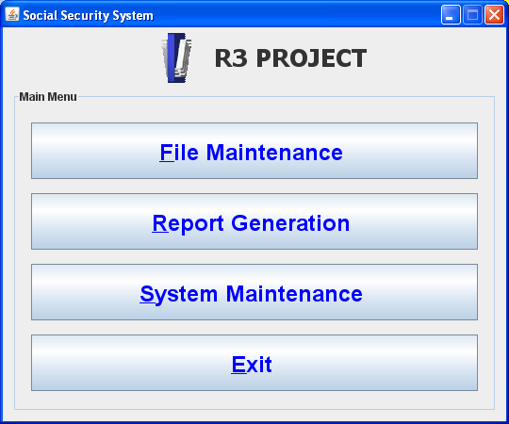
Screen 1. MAIN MENU

File Maintenance Screen
- This screen allows data entry/update and creation of the electronic R3 file.
- MENU PATH: Main Menu > File Maintenance Menu
- On the Main Menu, click on the [File Maintenance] button.

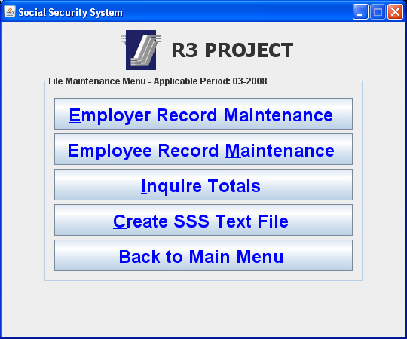
Screen 2: File Maintenance screen

2.1 EMPLOYER INFORMATION
- This module allows entry/update of employer’s information and R3 applicable period.
- MENU PATH: Main Menu > File Maintenance Menu
- On the File Maintenance screen, click on the [Employer Record Maintenance] button.
On the File

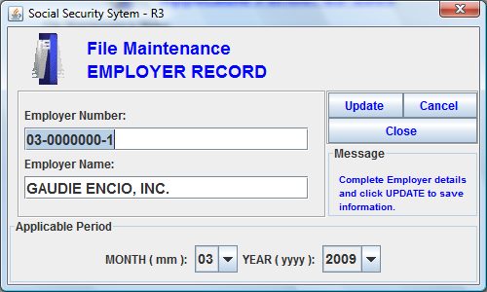
Screen 3: Employer Record Maintenance

Employer Number: | identifies the Social Security number of the employer. This field is mandatory
Employer Name: | identifies the name of the employer. This field is mandatory.
Applicable Period: | identifies the month and year for which contribution is intended to be posted.

.

2.2 EMPLOYEE INFORMATION

- This module allows entry and modification of an employee record.
- MENU PATH: Main Menu -> File Maintenance Menu
- On the File Maintenance screen, click on the [Employee Record Maintenance] button.

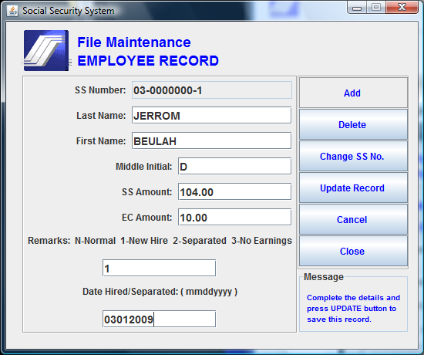
Screen 4: Employee Record Maintenance

SS Number: | identifies the Social Security number of the employee. This field is mandatory
Last Name: | identifies the surname of the employee. This field is mandatory.
First Name: | identifies the given name of the employee. This field is mandatory.
Middle Initial: | identifies the middle initial of the employee. This field is optional.
SS Amount: | identifies the SS contribution of the employee. Default value is 0.00.
EC Amount: | identifies the EC contribution of the employee. Default value is 0.00.
Remarks: | identifies the status of the employee. Valid values for this field are: ‘1’ (for newly hired), ‘2’ (for separated), ‘3’ (for no earnings) and ‘N’ (for Normal status). This field is mandatory.
Hire/SepDate: | identifies hire/separation date. Remarks field must have the value of “1” or “2”

2.3 FILE AND PAYMENT INFORMATION
- This module facilitates the generation of the R3 file.
- MENU PATH: Main Menu > File Maintenance Menu
- On the File Maintenance screen, click on the [Create SSS Text File] button.

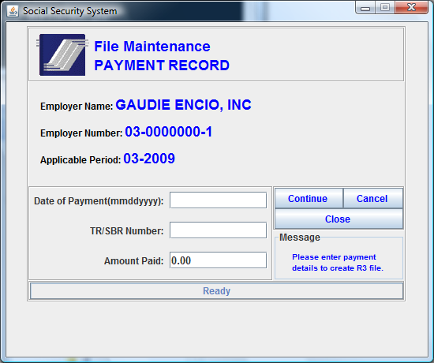
Screen 6: Payment Record

Date of Payment: | identifies the Date of Payment. Format is mmddyyyy.
Tr/SBR Number:  Amount Paid: | identifies the Payment Receipt Number.  identifies the Amount paid.

CHAPTER

REPORT GENERATION

This chapter instructs the user how to
- Generate the Transmittal Report
- Generate a List of Employee Information

TRANSMITTAL REPORT
- This module facilitates the generation of Transmittal Report and Employee Listing. Filename on each report corresponds to the name of the created R3 file.
- MENU PATH: Main Menu -> Report Generation
- On the Report Generation screen:
- Click on the [Print Transmittal Certificate] button to generate the Transmittal List for the Applicable period..

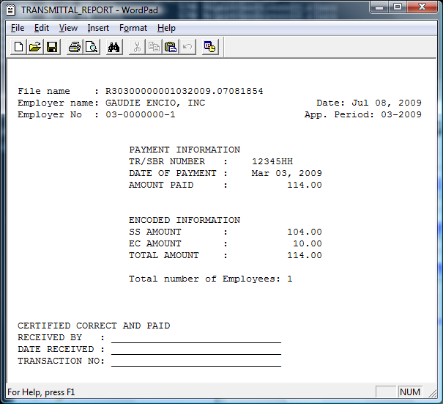
Screen 7a: Report Generation – Transmittal Report

3.2 EMPLOYEE LIST

- Click on the [Print Employee File] button to generate the List of employees in the current datafile.

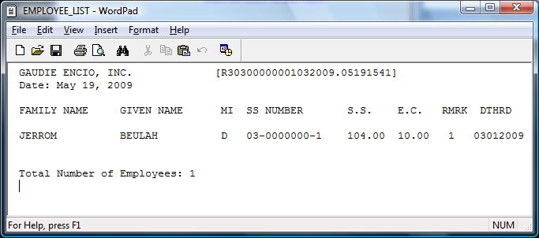
Screen 7b: Report Generation – Employee List

CHAPTER

4 SYSTEM MAINTENANCE

This chapter instructs the user how to
- Save Data into a folder/device
- Restore saved data from folder/device
- Update program for New Contribution Schedule

MENU PATH: Main Menu > Database Maintenance

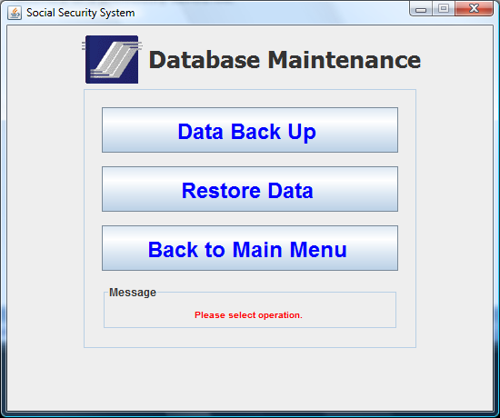
Screen 8: Database Maintenance

DATA BACKUP

- Click on the [Data Back Up] button to create a backup file on a selected folder or device

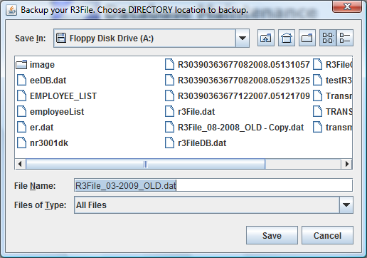
Screen 8a: Data Back Up

4.2 DATA RESTORE

- Click on the [Restore Data] button to recover a saved file from a selected folder or device

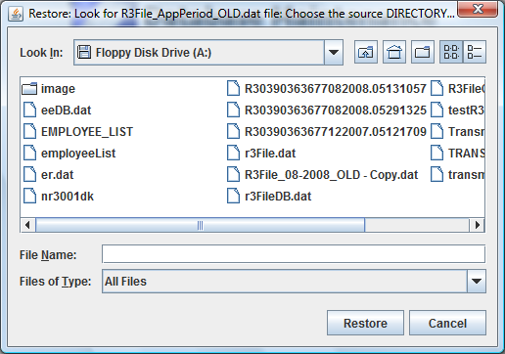
Screen 8a: Data Restore

4.3 PROGRAM UPDATE FOR NEW CONTRIBUTION SCHEDULE

- Download a program-update from http://www.sss.gov.ph /R3 page or get a copy from the SSS branch.

