|  |  |  |
| --- | --- | --- |
| **LAB 321Assignment** | **Type:** | **LongAssignment** |
| **Code:** | **J3.L.P0017** |
| **LOC:** | **500** |
| **Slot(s):** | **10** |

**Title:** Photographer

**Background**

### You are a photographer and you want to introduce your gallery to everyone in the internet !

Complete this assignment to khowhow to start ☺

Reference site:<http://us-123photo.simplesite.com/>

**Program Specifications**

Program a web site tointroduce your picture gallery, detail functions of this website is described below

**Features:**

This website contains 3 main functions

* Function 1 : Home page : ( see PIC 01)
  + Display introduction entry and short description of 3 galleries (
  + Each productcontains
    - Entry name
    - Description picture
    - Entry description
* Function 2 : Display detail of each gallery ( PIC 02)
  + Support slideshow when click to play button
  + Print out detail services
* Function 3 : Contact ( PIC 03)
  + Display address ( load from DB )

You do not need to write interface for admin control panel, you can add data manually (use SQL SERVER Management studio).

Note: All data or gallery images must be load from database or specific folder, not hard code in page.

***Expectation of User interface:***

Pic 01 : Home Page

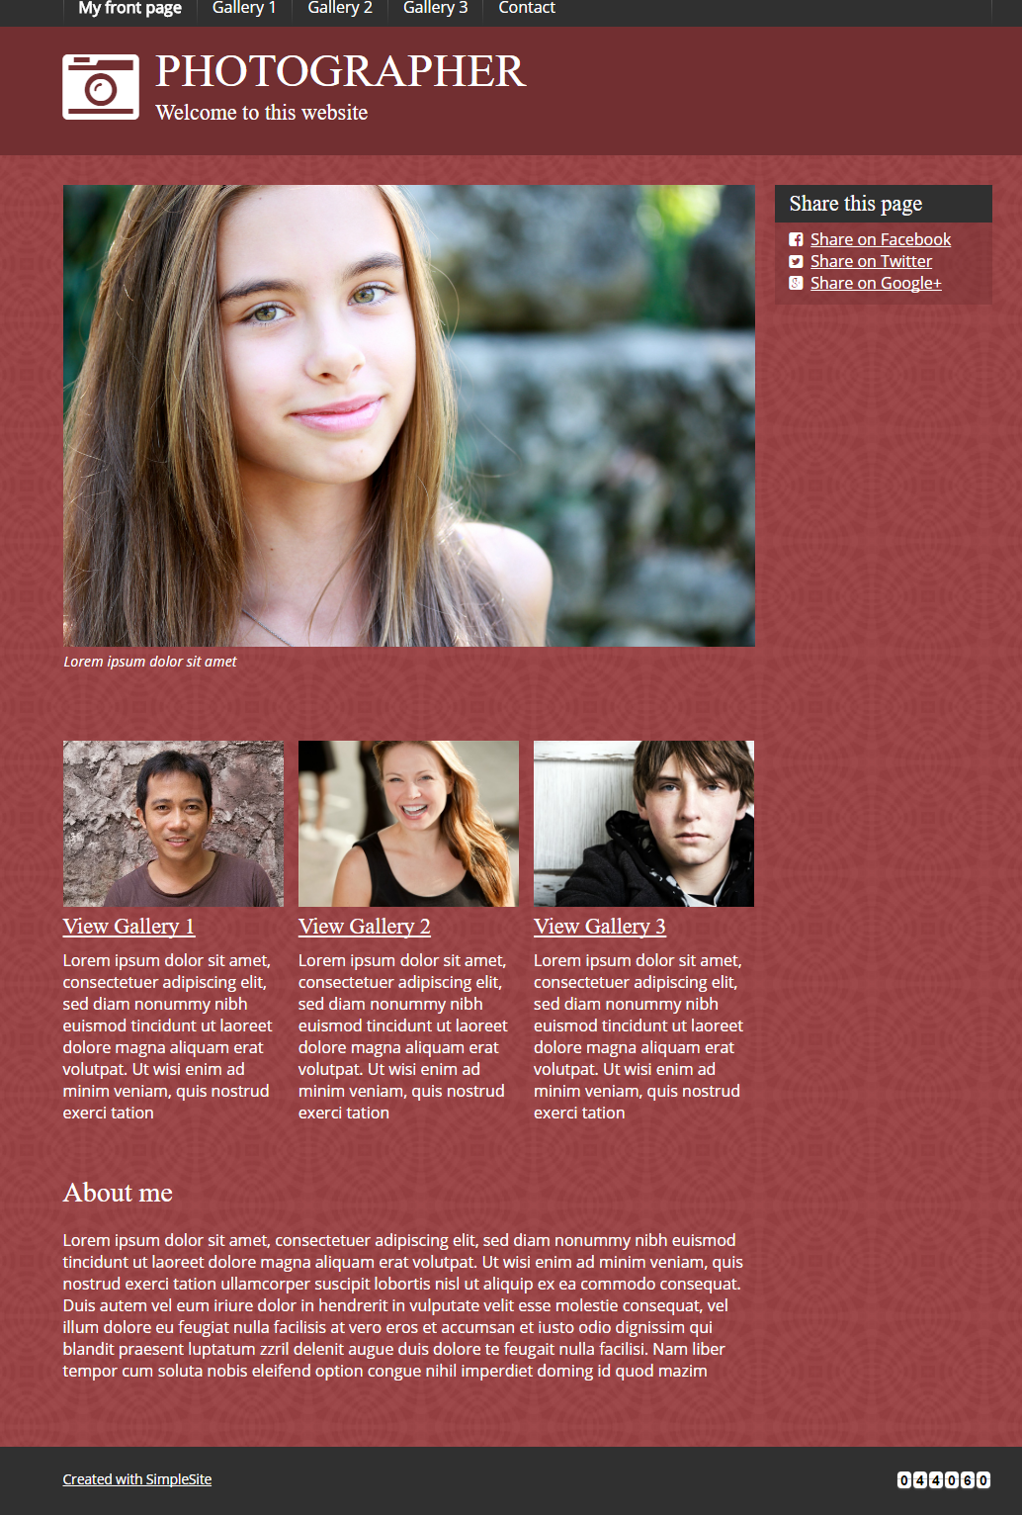

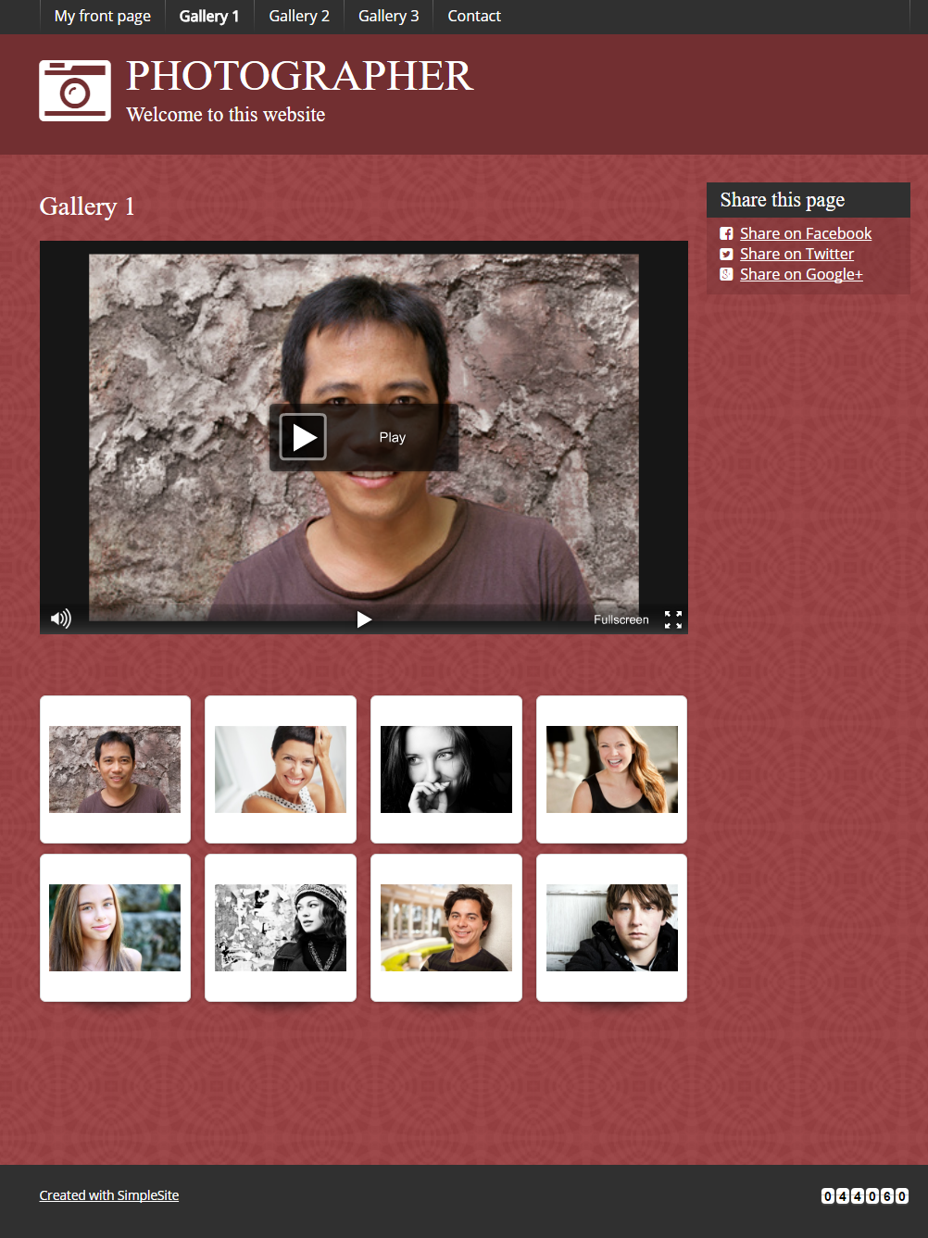

PIC 3 : Contact : allow user to submit message here

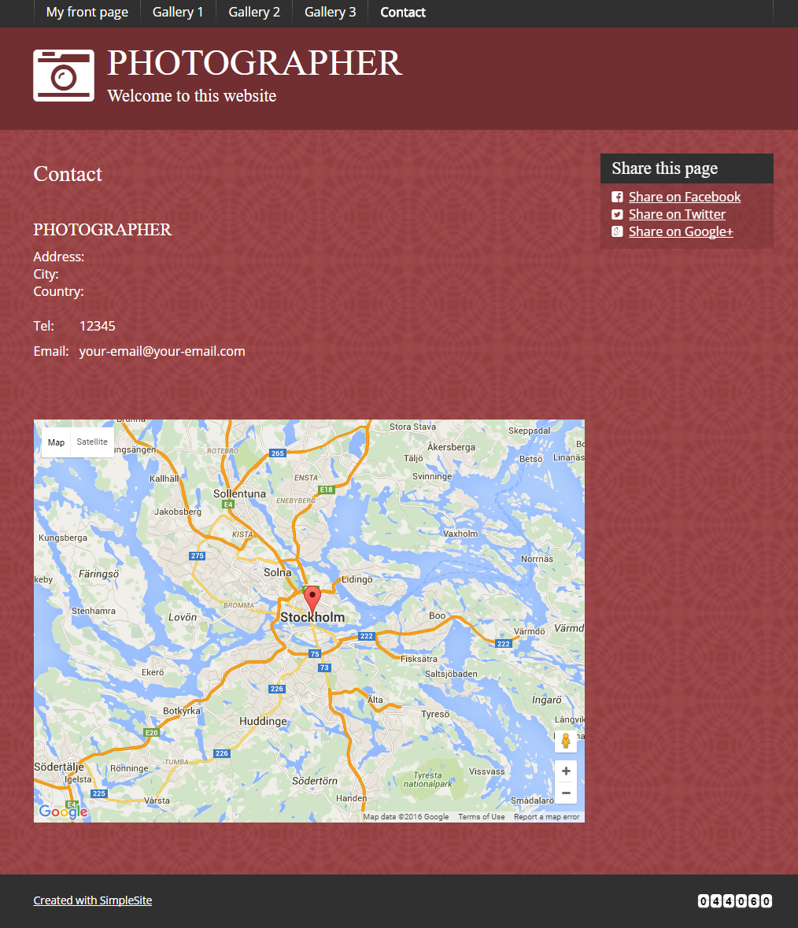

**Guidelines**

* Step 1 : Create web layout
* Step 2 : Create prototype
* Step 3 : Design database base on created prototype
* Step 4 : Code & Test