We are carrying out non-profit research at a university to help validate presence of technical aspects of electronic dance music tracks.

By accepting this HIT, you agree that:

* We may publish excerpts of your answers for scientific articles;
* We will NOT publish any information that could be linked to you.

Imagine you are John and you are an expert in electronic dance music. Being an expert in EDM, you are familiar with terms like “build”, “drop”, “synth” etc. We need John’s help to validate whether a term, as mentioned before, actually occurs at the indicated time in an EDM track. An example task is shown below:

|  |  |
| --- | --- |
| **Term** | Synth |
| **Time** | 02:30 |

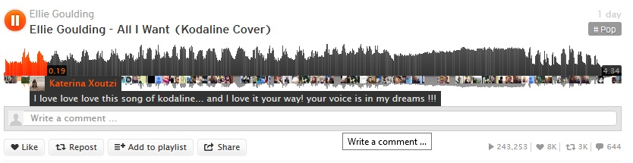

Now, John has to listen to the track at 02:30 and in the surroundings to answer whether a “Synth” is used at the indicated time 2 minutes, 30 seconds. John has to answer the following questions:

1. Does the ***Term*** occur at the indicated ***Time***?
   1. YES
   2. NO
2. If you answered “***NO***” to *1,* does the ***Term*** occur in the music surrounding the indicated ***Time***?
   1. YES
   2. NO
3. If you answered “***YES***” to *2*, indicate the time (in the format: **minutes:seconds**) at which the ***Term*** occurs. If you answered “***NO***” to *2*, write “0” in the response below.

Now, you have to assume the role of John and perform the next tasks. Please make sure you listen to the song before you answer the questions. Please feel free to play the song multiple times or move forward and backward to answer the questions.

<<soundcloud_widget>>

Questions:

1. Does the ***Term*** <term> occur at the indicated ***Time*** <time>?
   1. YES
   2. NO
2. If you answered “***NO***” to *1,* does the ***Term*** occur in the music surrounding the indicated ***Time*** <time>?
   1. YES
   2. NO
3. If you answered “***YES***” to *2*, indicate the time (in the format: **minutes:seconds**) at which the ***Term*** <term> occurs. If you answered “***NO***” to *2*, write “0” in the response below.
4. Please comment on your experience of doing this task.
5. Please indicate any problems you face while doing the task.