How to Create Setup.exe in Visual Studio 2019 using VS Installer Projects

1. Create C++ Project in Visual Studio 2019 by clicking VS 2019 as shown below.

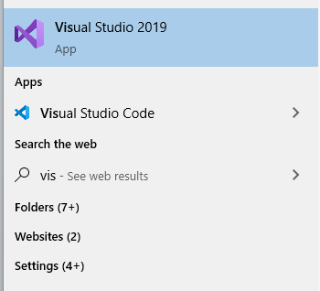

1. Click Create New Project as shown below.

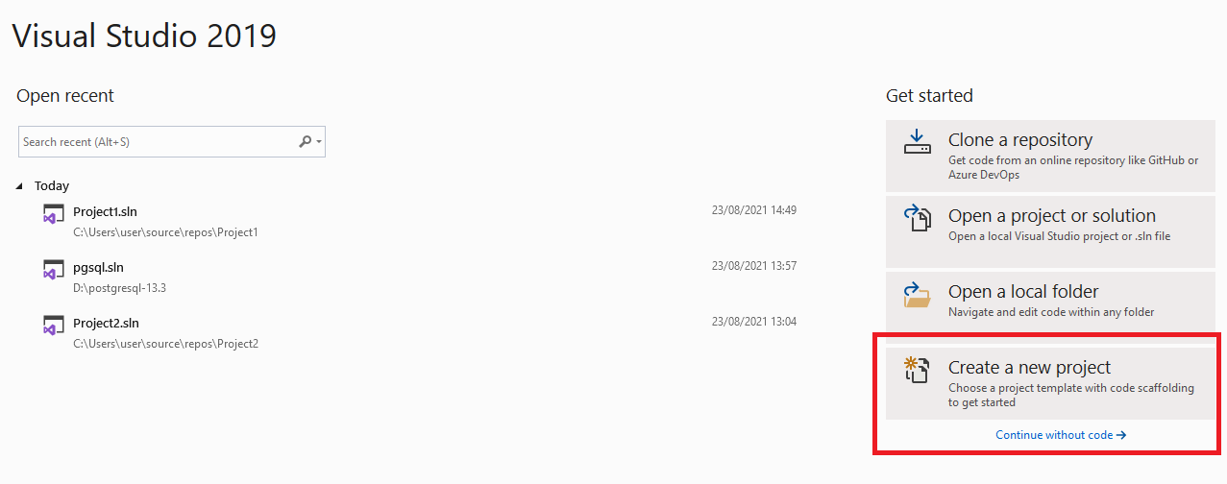

1. Select Empty Project in Left and Right hand sides and Click Next

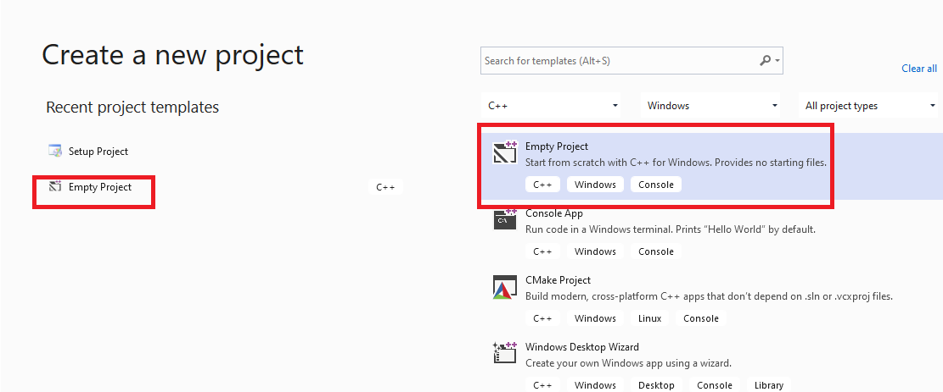



1. Enter Project name as shown below and click Create.

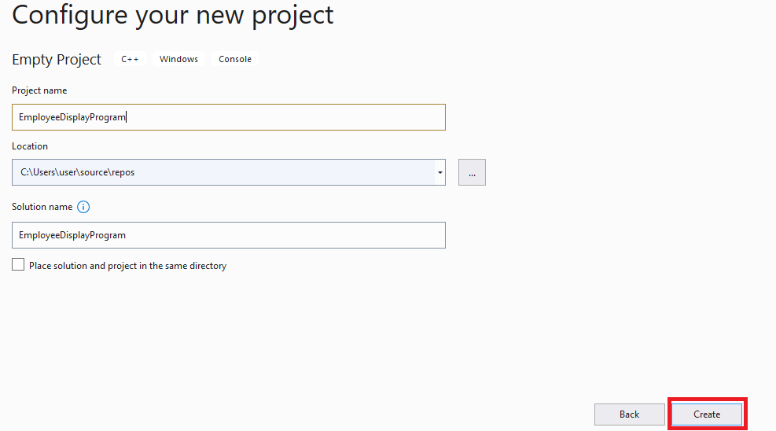

1. Project is created as shown below.

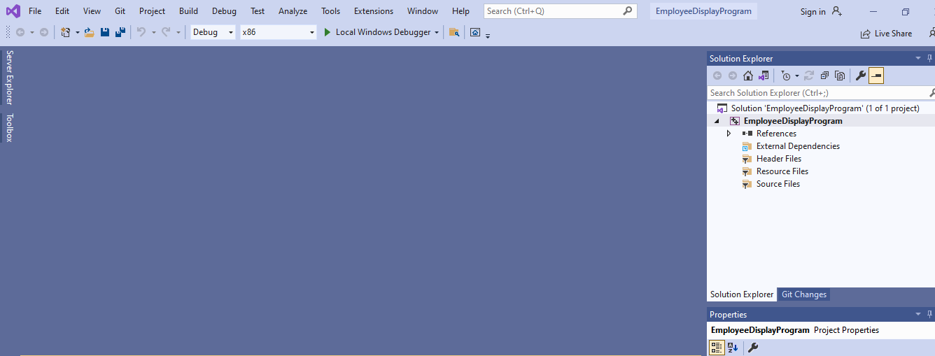

1. Right Click in Source Files under Project in the Right hand side

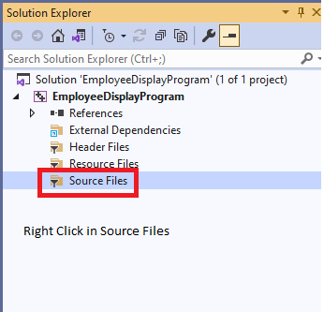

1. After right clicking Source Files, Click Add and then Click New Item as shown below.

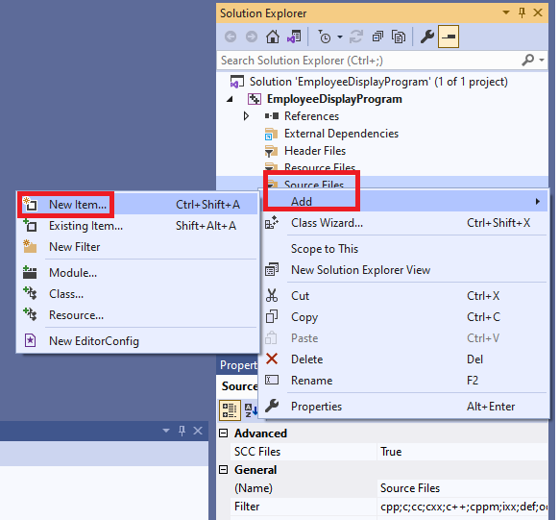

1. Perform the tasks as shown below and Click Add button to create a new C++ source file in your project

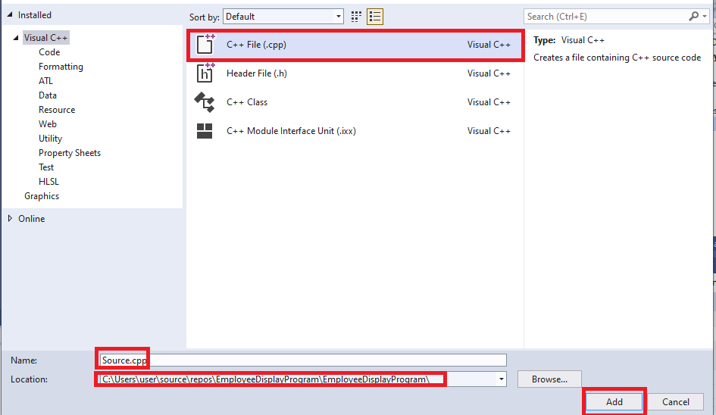

1. Add the following source code to your source file.

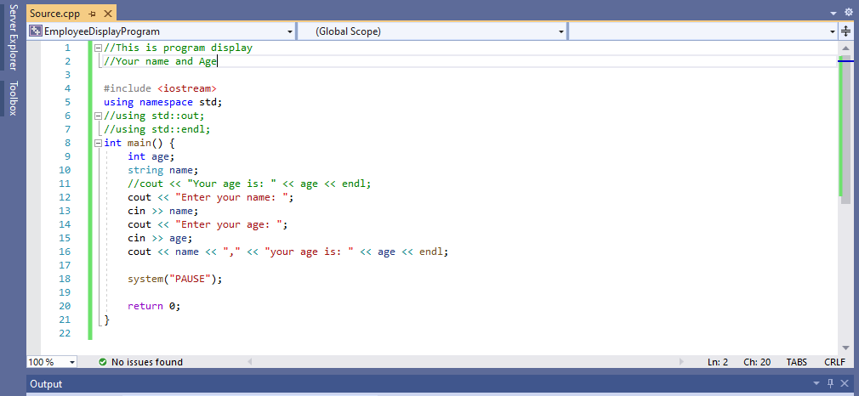

10.Build your program as shown below.

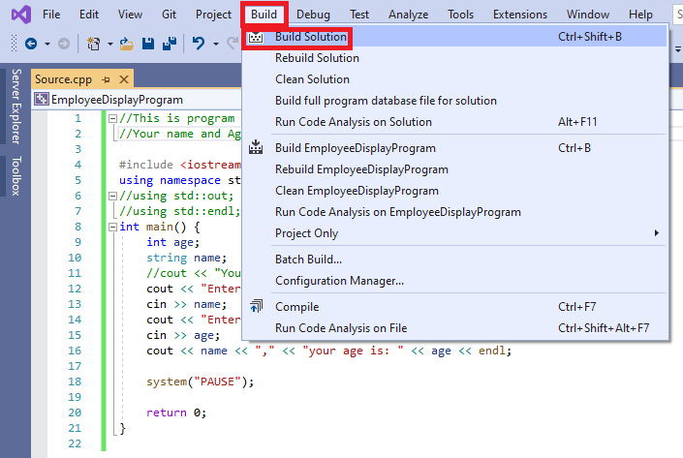

1. If nothing is wrong , your program must be successful as shown below.

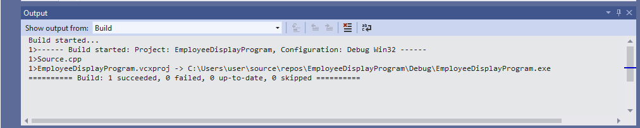

1. Enable Visual Studio 2019 Installer Projects Extension by doing as shown below

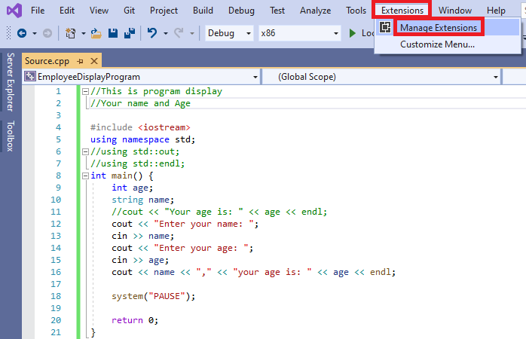

1. Install extension shown in the red rectangle below.

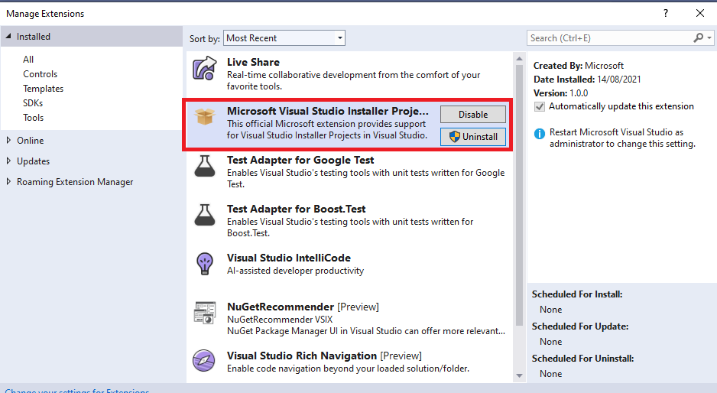

1. Create new project for Setup/Installer by doing as shown below.

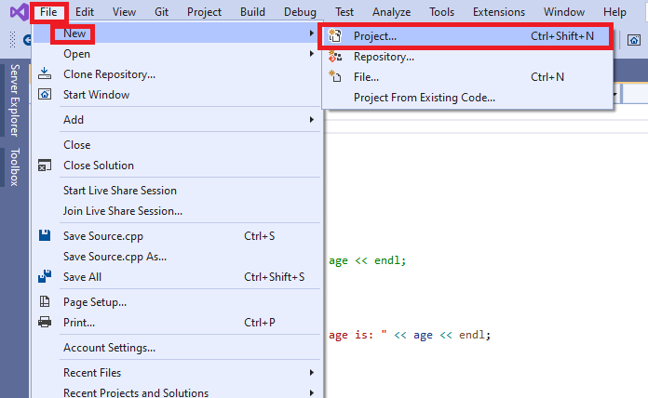

1. Create Setup Project as shown below.

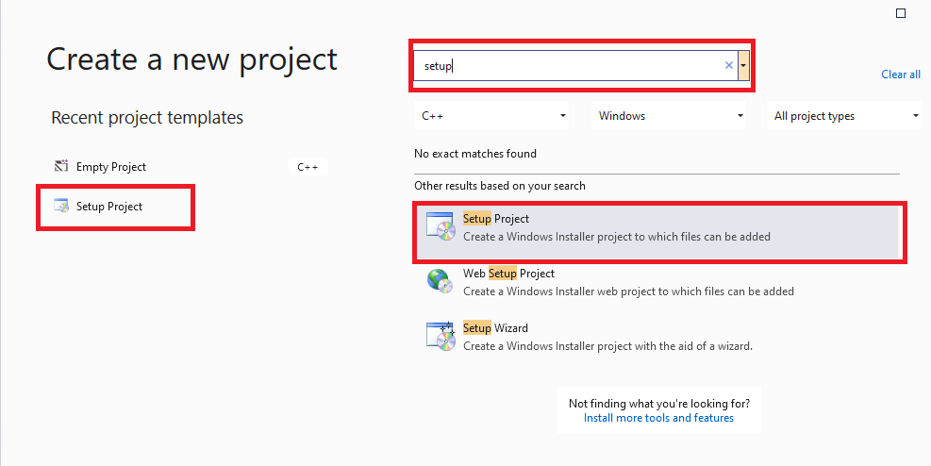

1. Finish creating your setup project as shown below.

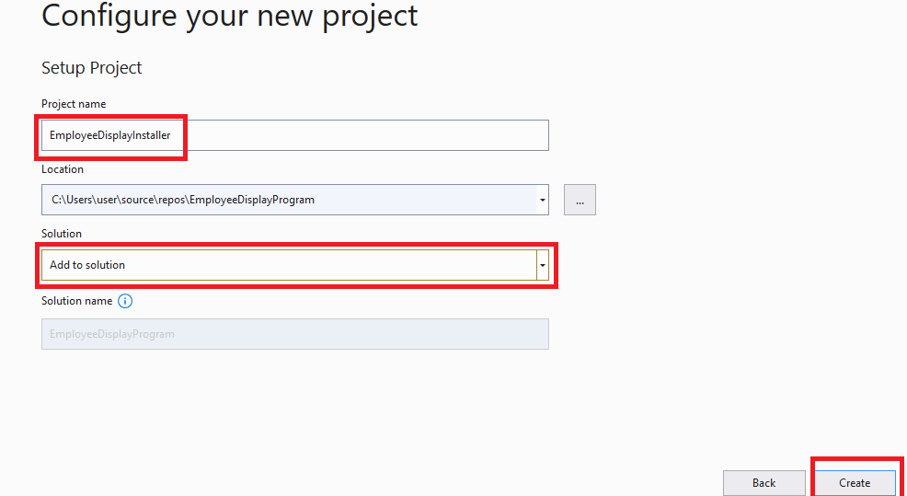

1. The setup/installer project is shown below

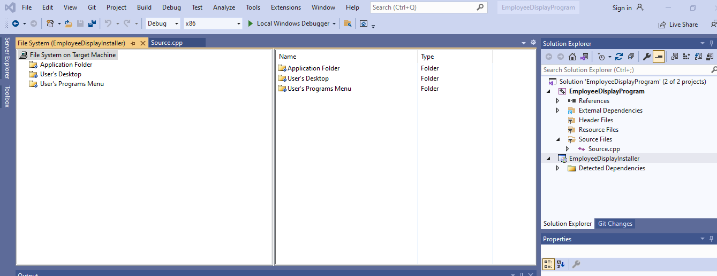

1. Right Click Application Folder and Right Click in empty space and follow the actions as shown below.

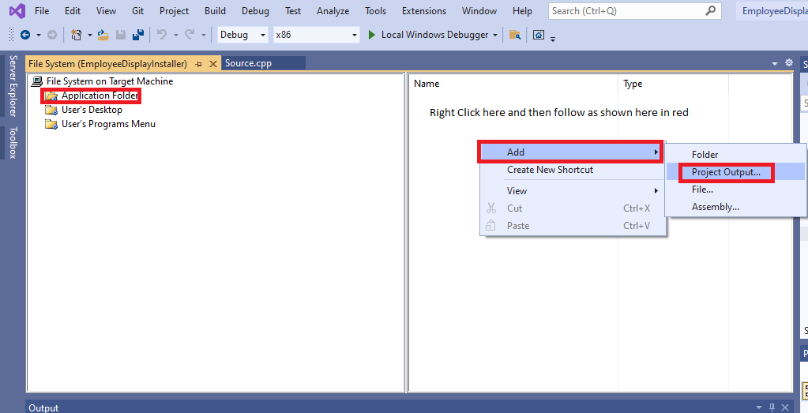

1. After Clicking Project Output shown in Steps 17, perform the following tasks.

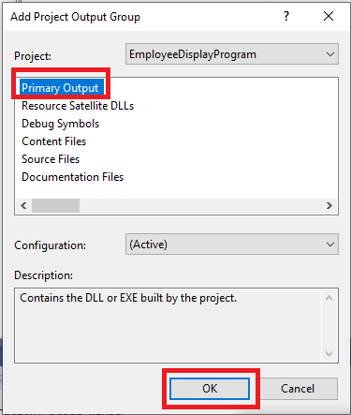

1. After step 18, the output shown below.

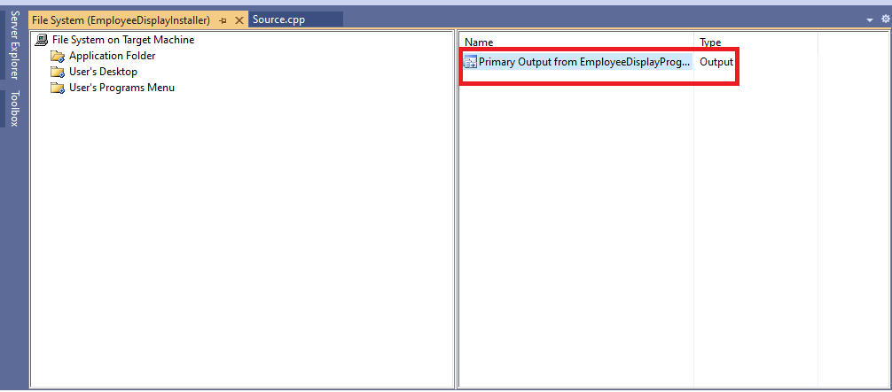

1. Right click Primary Output from EmployeeDisplayProgram and create shortcut as shown below.

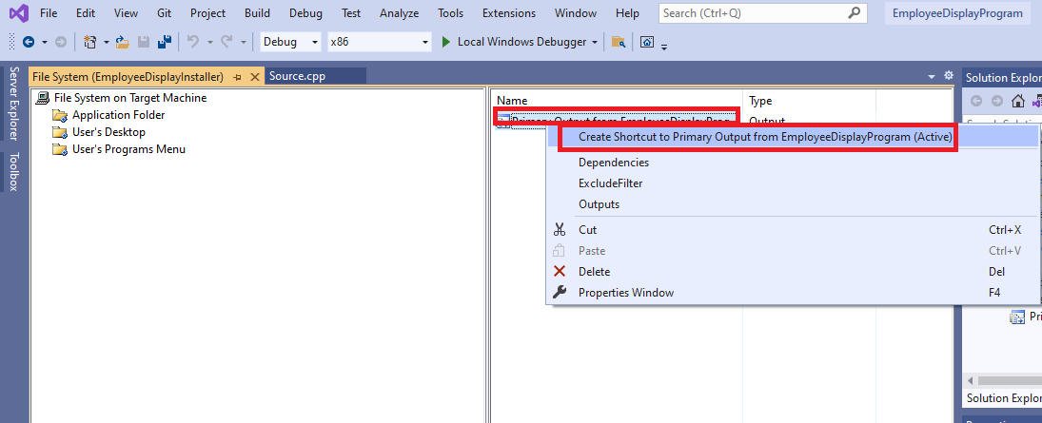

1. Rename the shortcut created in step 20.

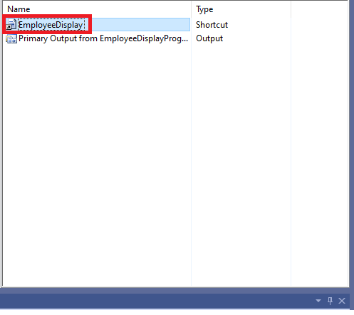

1. Move the shortcut to User’s Program Menu.

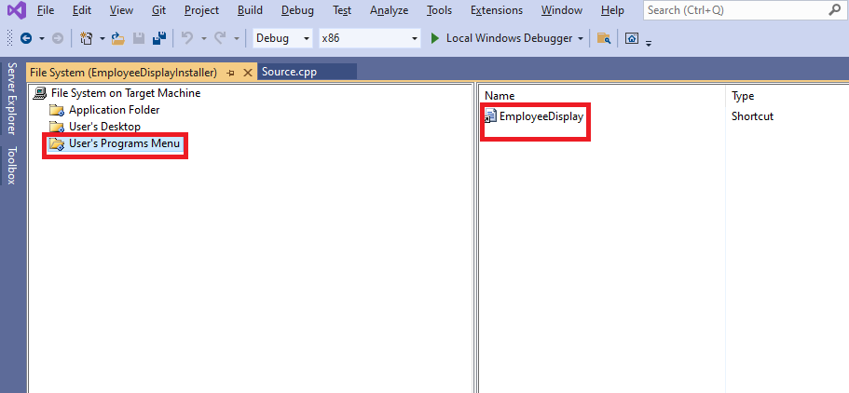

1. Perform the following to enable configuration for the Installer.

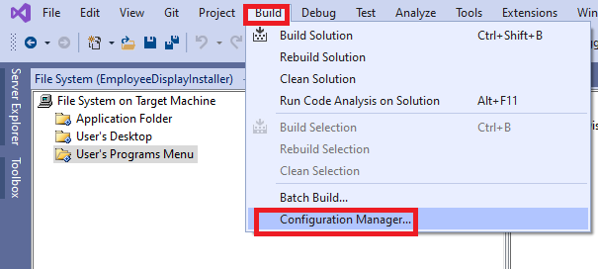

1. Enable Build for the Installer as shown below

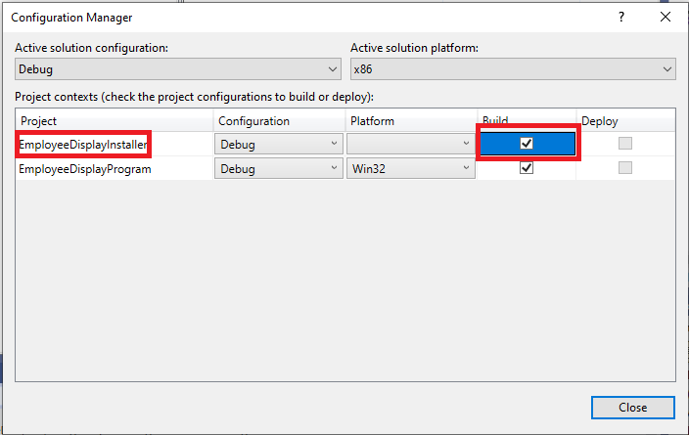

1. Build the Project as shown below.

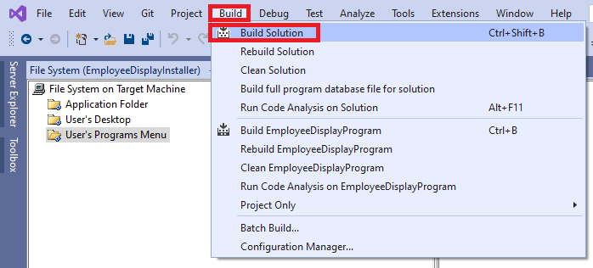

1. Build has started

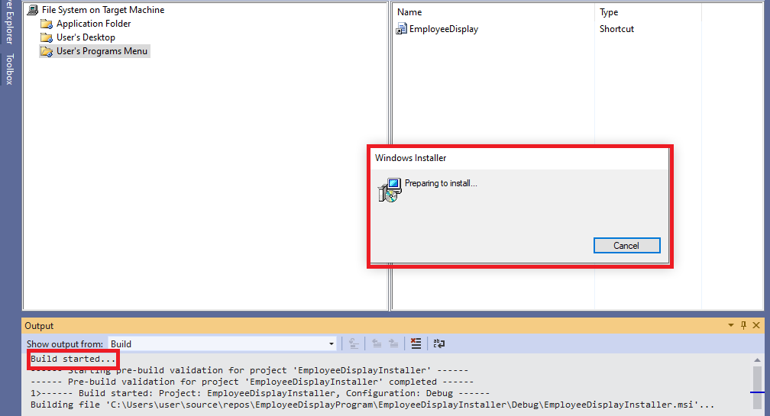

1. Please write the Product Manufacturer and its url

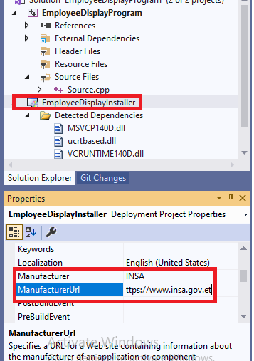

1. Build Succeeded

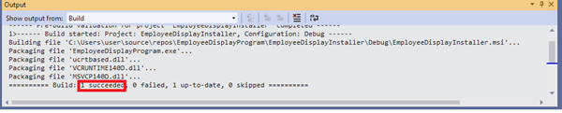

1. Go to the Application Folder to the Installer

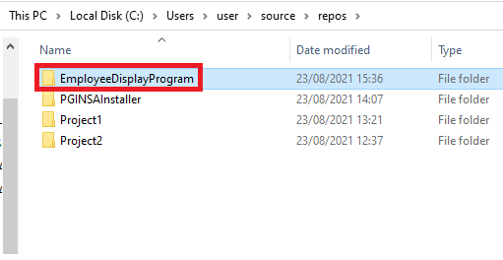

1. The following is the Installer/setup for our Program created above

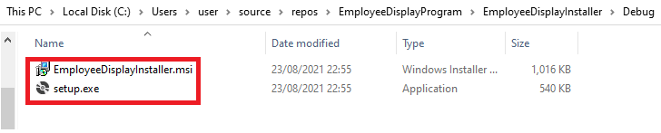

1. Right Click setup.exe to install it.

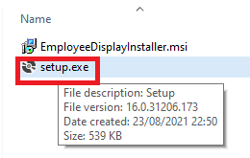

1. Preparing to Installer….

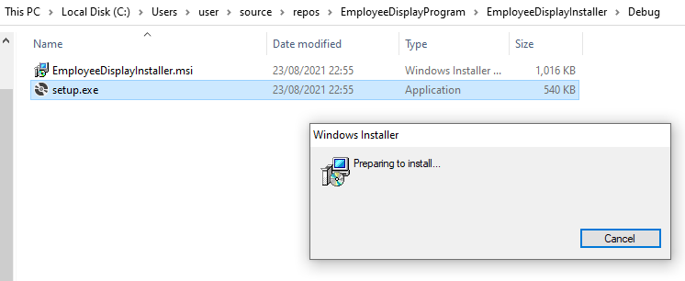

1. EmployeeDisplayInstaller Wizard

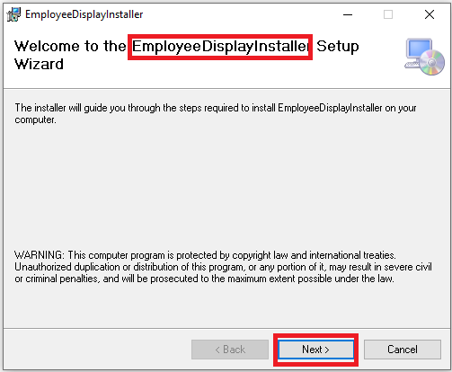

1. Select Installation Folder

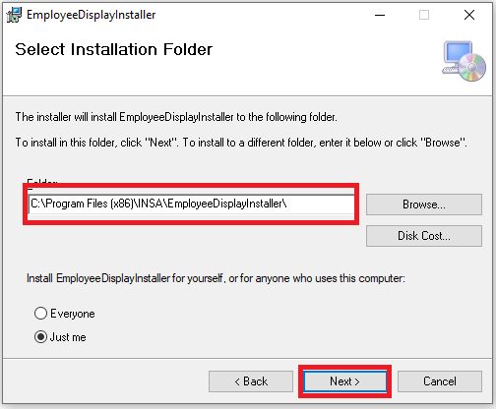

1. Confirm Installation

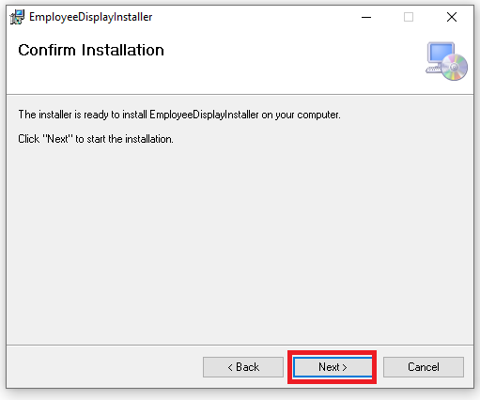

1. Installing EmployeeDisplayInstaller

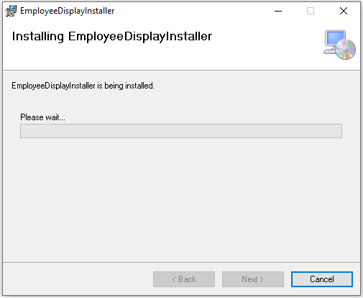

1. Installation Complete

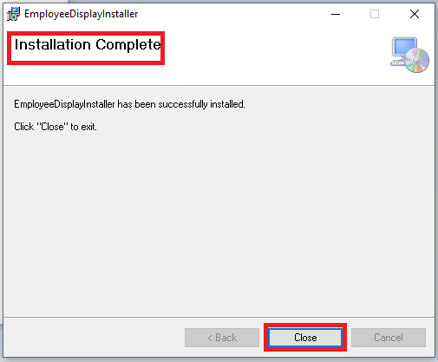

1. EmployeeDisplayInstaller installed

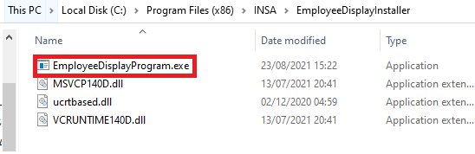

1. Installer in Control Panel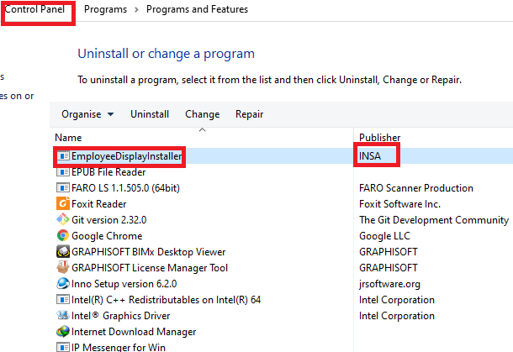
2. Double Click to run the program as shown below

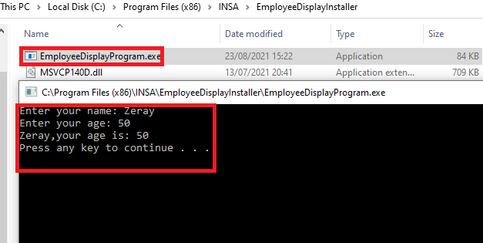

1. We can also search our application from Windows OS(10) Search box as shown below.



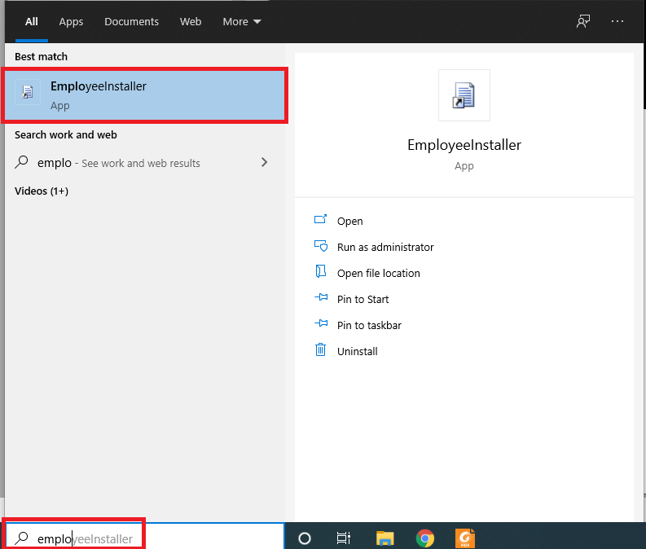

1. Application open as shown below

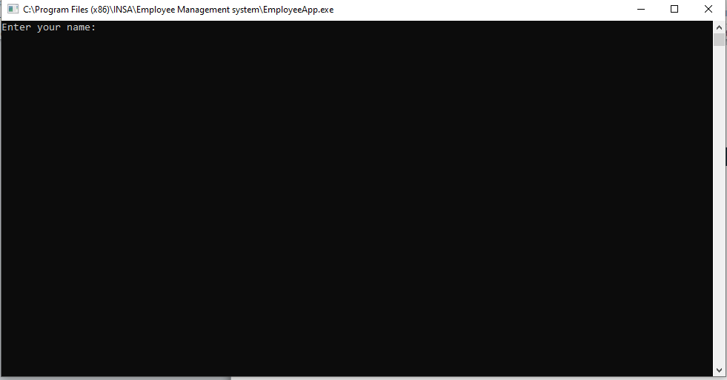

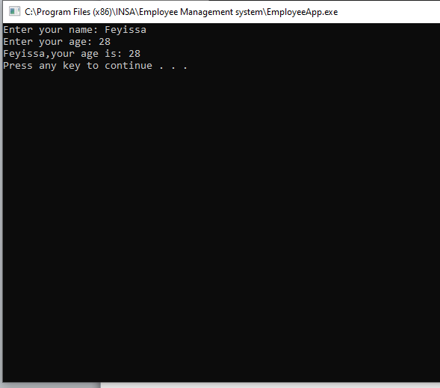

1. End of Demo!!