US Grocery and Gas Prices (2015–2026)
SIS 1 Project Report
Baizhan Zere | Individual Project | 9 October 2026

1. Project objective
This project investigates changes in selected US grocery and fuel prices between January 2015 and July 2026. It compares individual price movements with the US Consumer Price Index (CPI), explores relationships between monthly changes in gasoline and food prices, and describes price behavior during the 2020 COVID-19 recession.

2. Data collection
Three sources were used. The Kaggle file us_average_prices_monthly.csv supplied 8,869 observations for 74 products. The Bureau of Labor Statistics (BLS) Public Data API v1 supplied monthly CPI-U, all items (series CUUR0000SA0). A static page on the National Bureau of Economic Research (NBER) website supplied recession peak and trough dates through requests and BeautifulSoup.
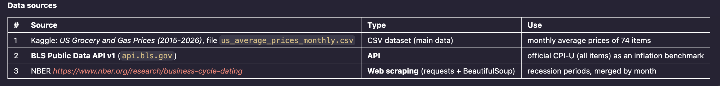
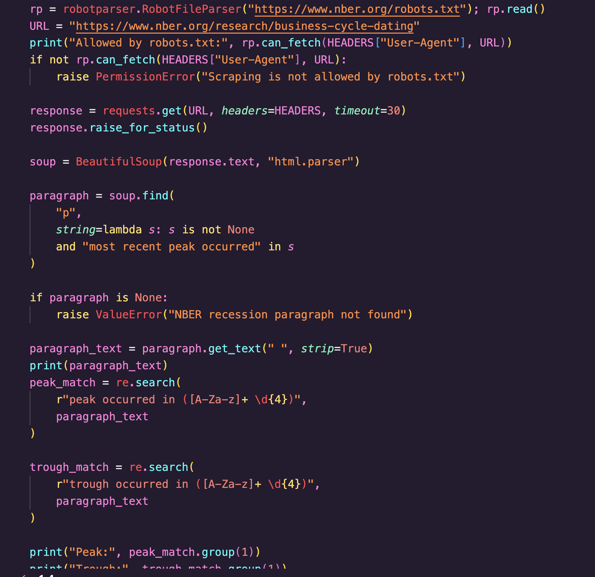
The scraping script checked robots.txt before requesting the page; the saved output reported “Allowed by robots.txt: True.”
NBER identifies February 2020 as the peak (the final expansion month) and April 2020 as the trough (the final recession month). The analysis therefore labels March and April 2020 as recession months.
3. Cleaning and preparation
The notebook standardized product labels, parsed dates and prices, checked missing values and duplicates, removed invalid records, normalized dates to the first day of each month, and prepared a monthly item-by-item price table. The cleaned price data retained 8,869 records and 74 items. CPI records were converted to monthly dates and merged by date. The recession indicator was added to the merged dataset, and item-level price indices and percentage changes were calculated.
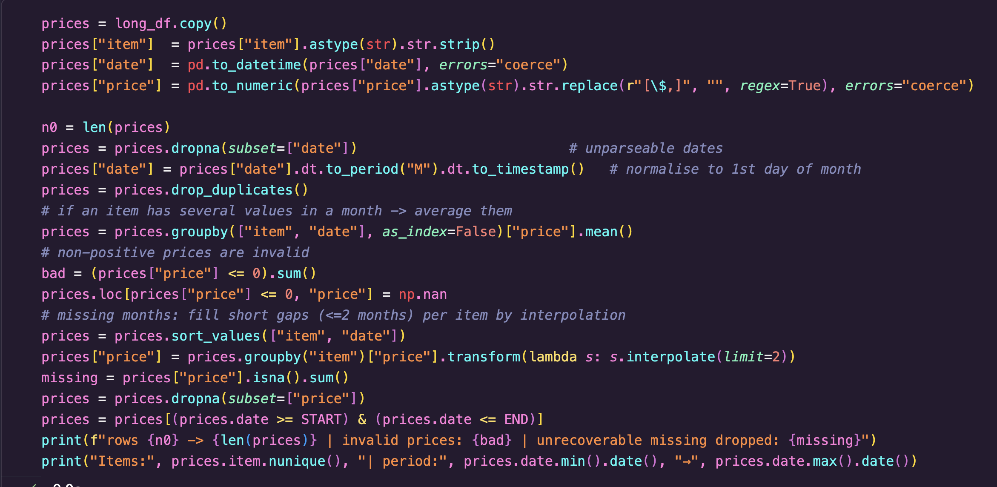
4. Exploratory analysis and findings
The Consumer Price Index (CPI) increased by 42.9% between January 2015 and July 2026 (from 233.707 to 333.918). Among the listed products, unleaded premium gasoline shows the largest first-to-last recorded price increase (+101.3%), followed by ground roast coffee (+96.6%). The largest reported decrease is for Thompson Seedless grapes (−26.5%). A total of 35 out of 74 items (47.3%) showed price increases exceeding the overall CPI inflation rate of 42.9% between January 2015 and July 2026.
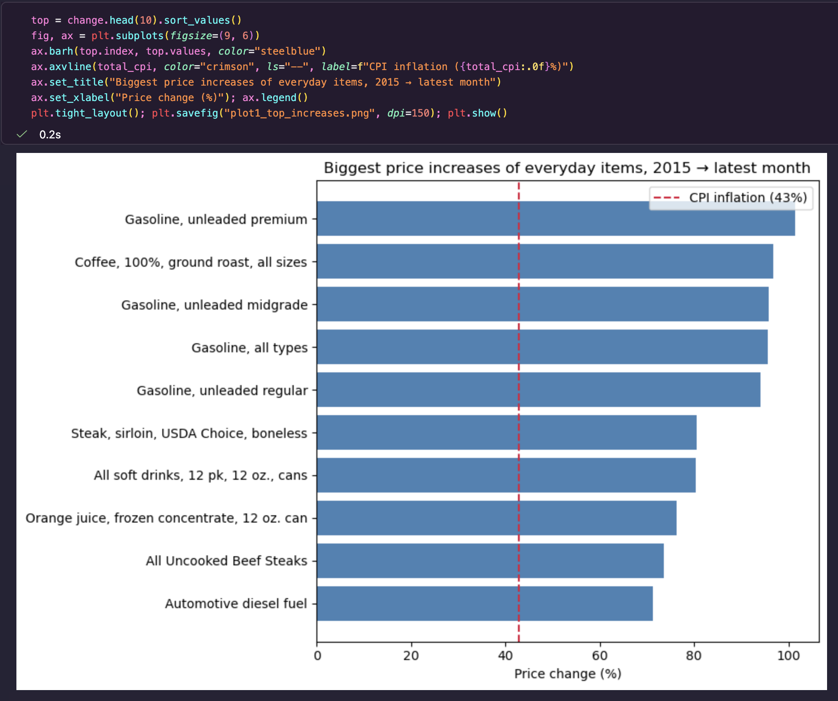
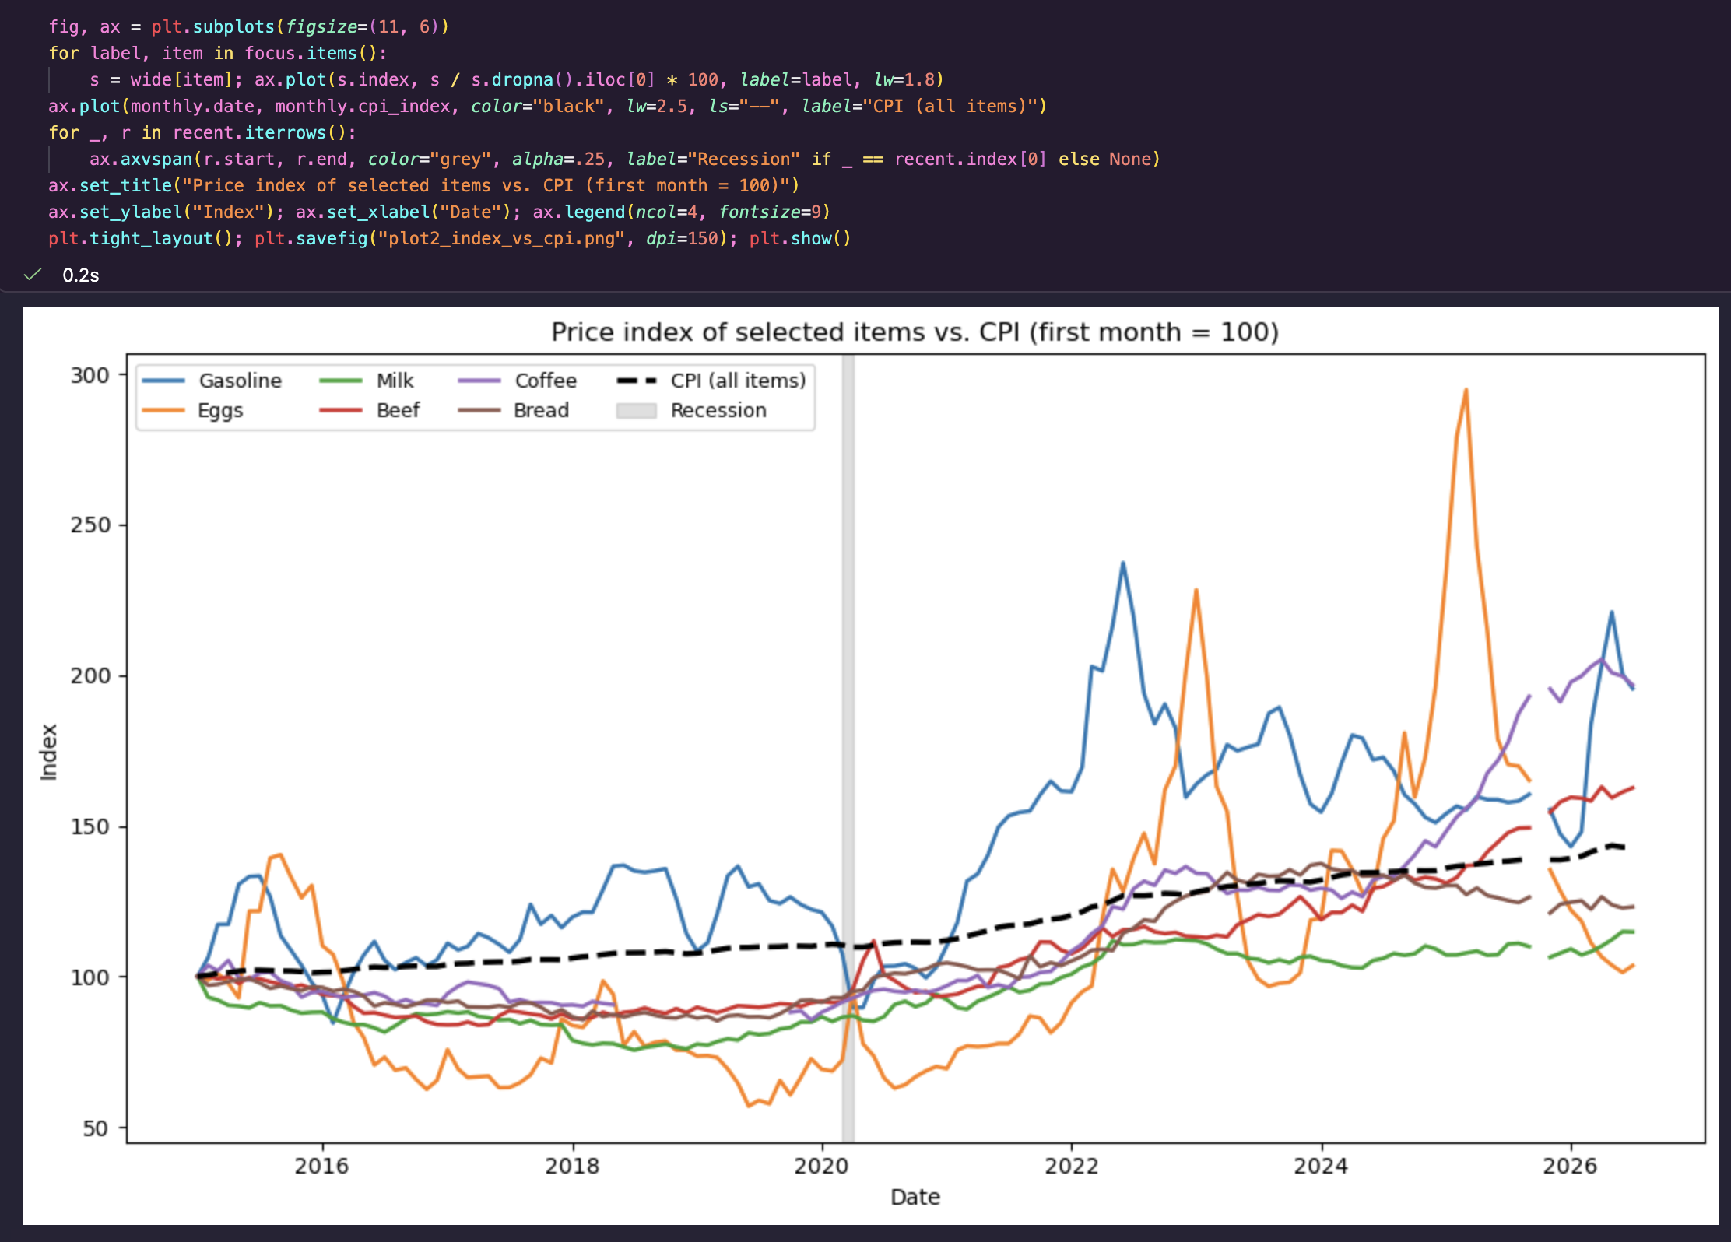
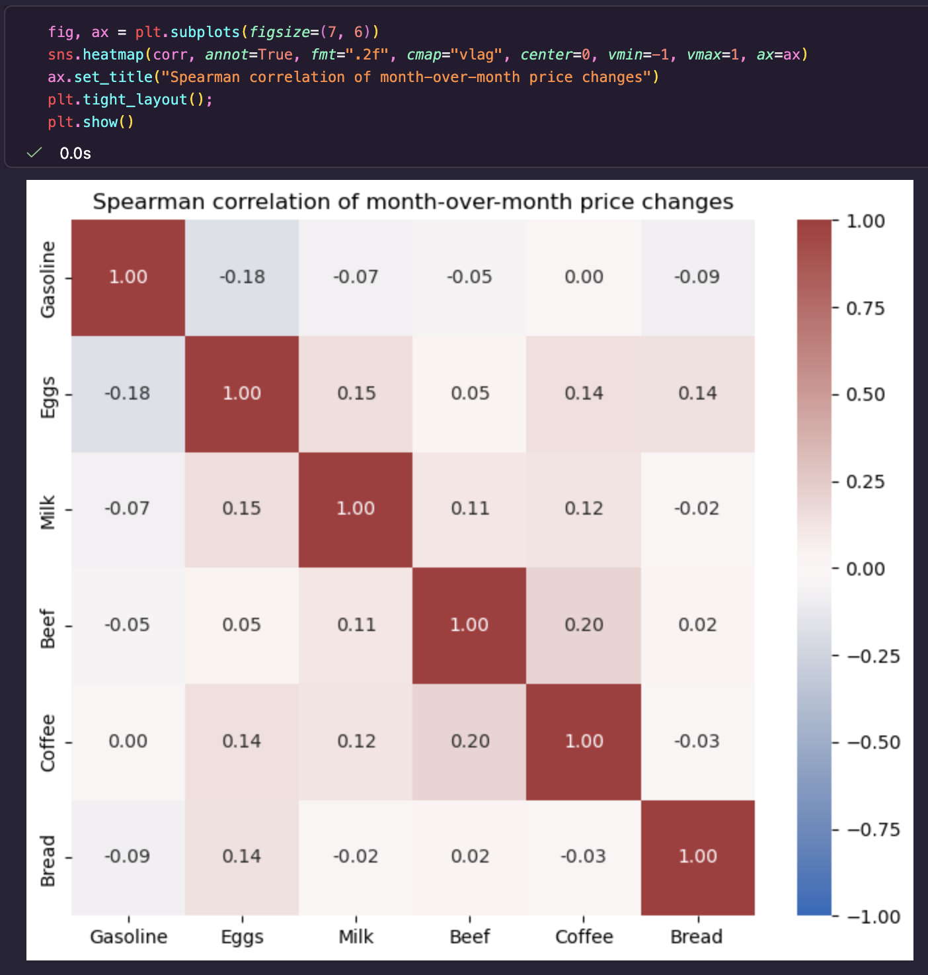
Spearman correlations of monthly percentage changes suggest little co-movement between gasoline and the selected foods. In the original notebook results, the gasoline–eggs correlation was −0.18, indicating a weak negative relationship; correlations with milk, beef, coffee, and bread were also close to zero. The correlation values should be checked after rerunning the updated notebook. The recession comparison covers only March–April 2020, so its results are descriptive rather than evidence of causation.
5. Limitations and conclusion
The source data represent US averages for selected products and do not capture regional variation. Individual products have different first and last available observations, so item-level first-to-last percentage changes are not always calculated over identical intervals. The CPI comparison uses the same January 2015–July 2026 endpoints as the overall price dataset, although individual product coverage can differ. Only one recession overlaps the study period.
Overall, the project demonstrates collection from an API and a robots.txt-permitted static webpage, data cleaning, date-based merging, exploratory statistics, and visualization. Gasoline and several food products experienced substantial changes, but monthly gasoline movements had only weak correlations with the selected food-price movements.
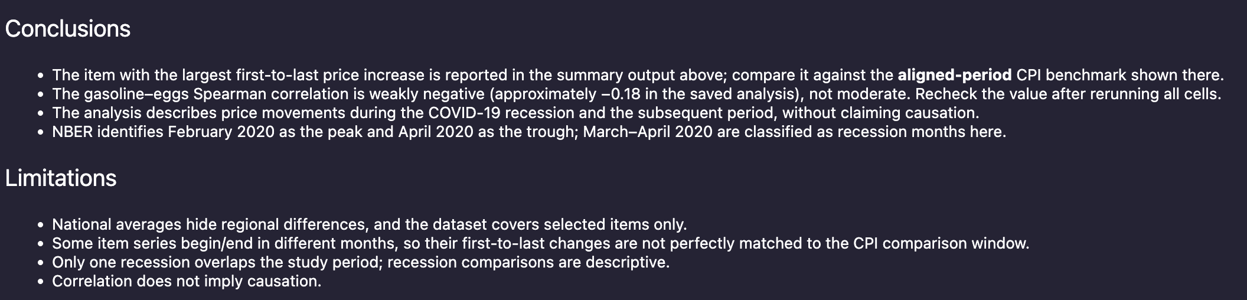
Data sources
Kaggle - Grocery and Gas Prices (2015–2026), us_average_prices_monthly.csv
BLS Public Data API v1 - https://api.bls.gov/publicAPI/v1/timeseries/data/
NBER Business Cycle Dating - https://www.nber.org/research/business-cycle-dating

