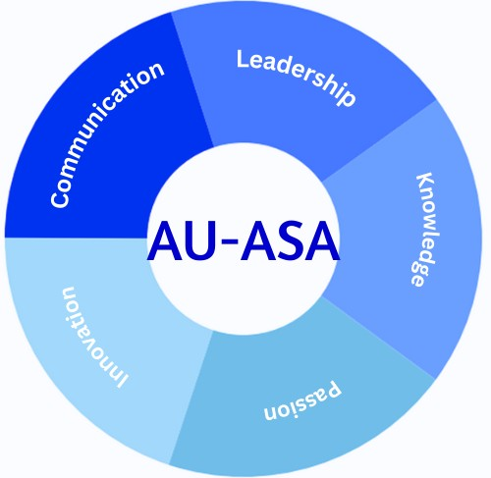
American Statistical Association @ American University
Join Us: Be part of an innovative community driving the future of data science, emerging technologies at AU.
Grow, Learn, Lead. Together🤝🌐🎓.
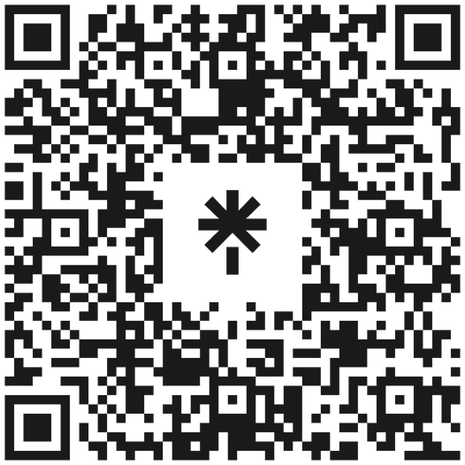
AU Statistics & Data Science Club Unlock Your Future in STEM 🔬💻🧬📊 Why Join🔗?
Empower Your Skills: Leadership, teamwork, and decision-making•🌟📈.
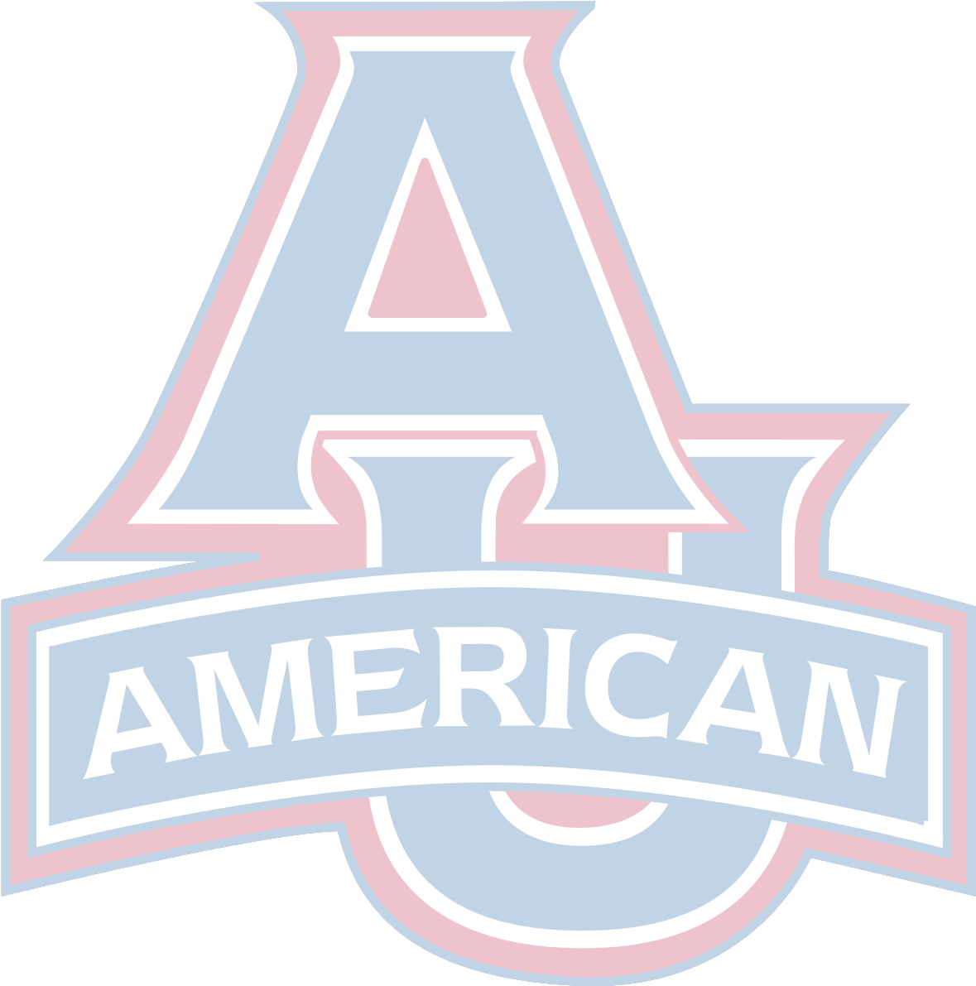
Expand Networks: Connect with industry professionals. Learn & Grow: Workshops and talks by industry experts. Build Your Career: Add valuable experience to your resume and build your portfolio.
About Us:
Founded in January 2022 by AU's brightest in Mathematics and Statistics.
The largest, most active STEM community at AU. What We Offer:
Expert Insights: Stay ahead with the latest trends and technologies, fostering out of your classroom.
Hands-On Experience: Real-world projects🛠📚🖥 with a tangible impact.
AU-ASA STEM community: An opportunity that serves as a hub to connect, exchange knowledge, and collaborate with other AU students.

A guide to interview preparation workshop
Internship Event

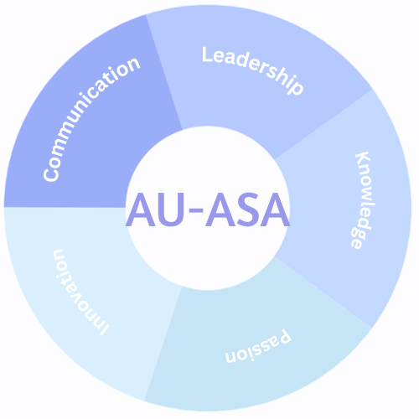
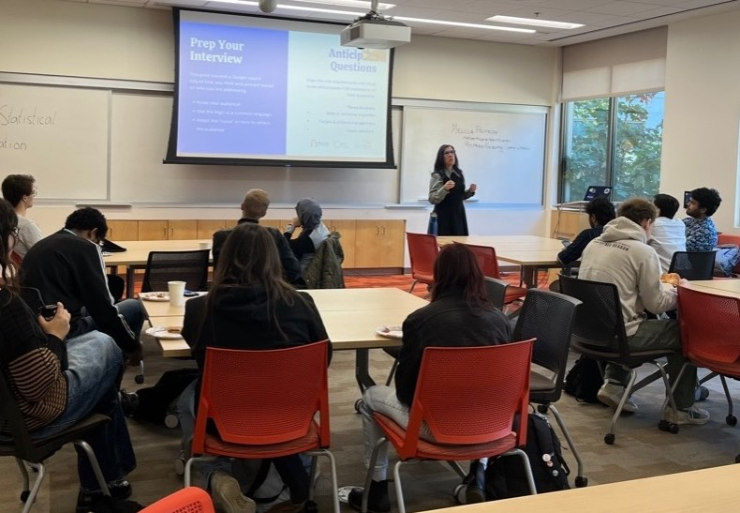
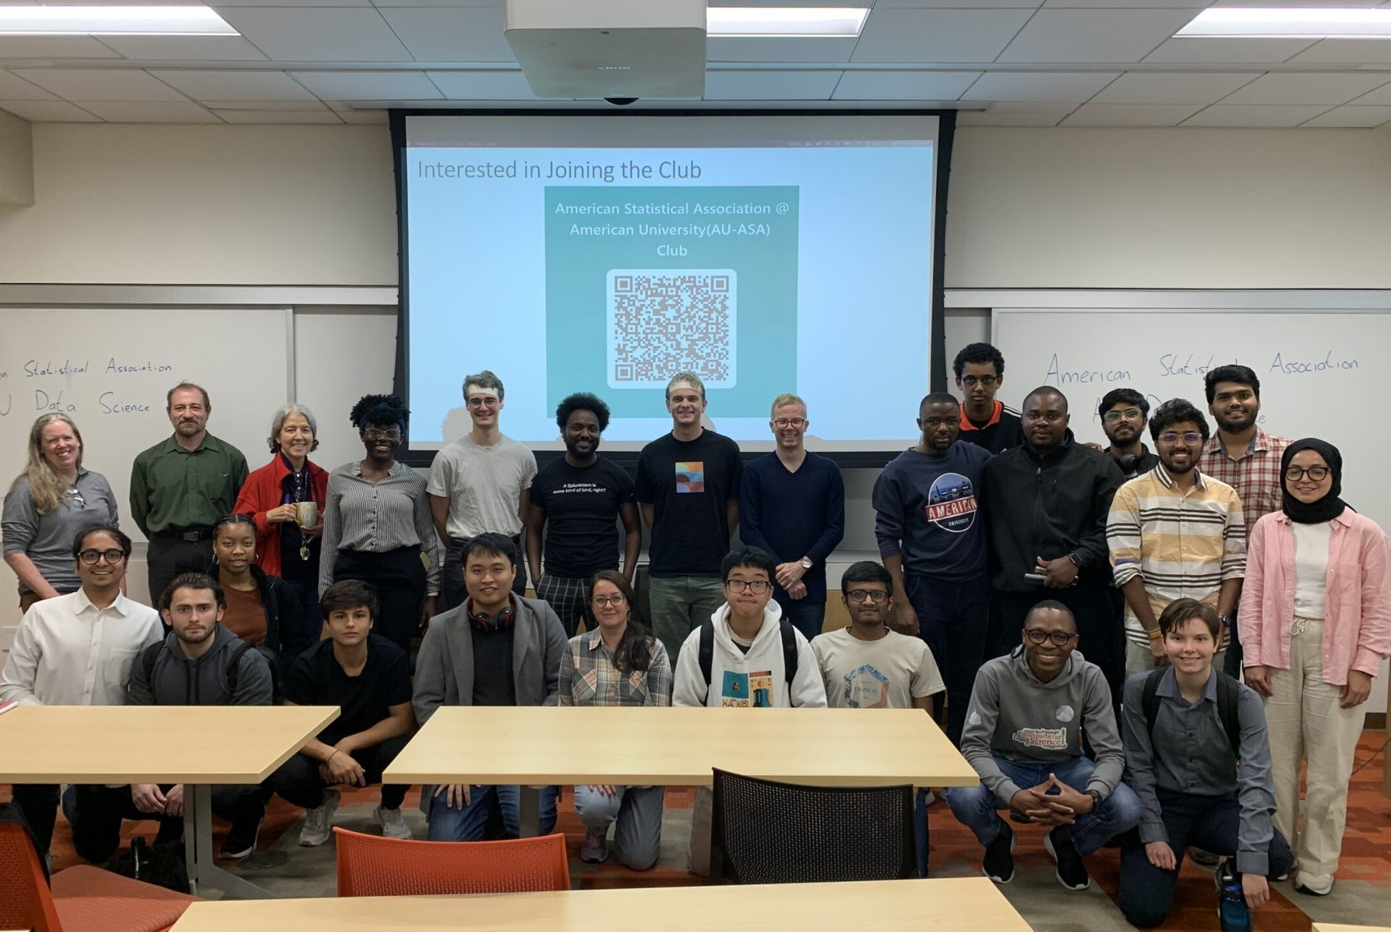
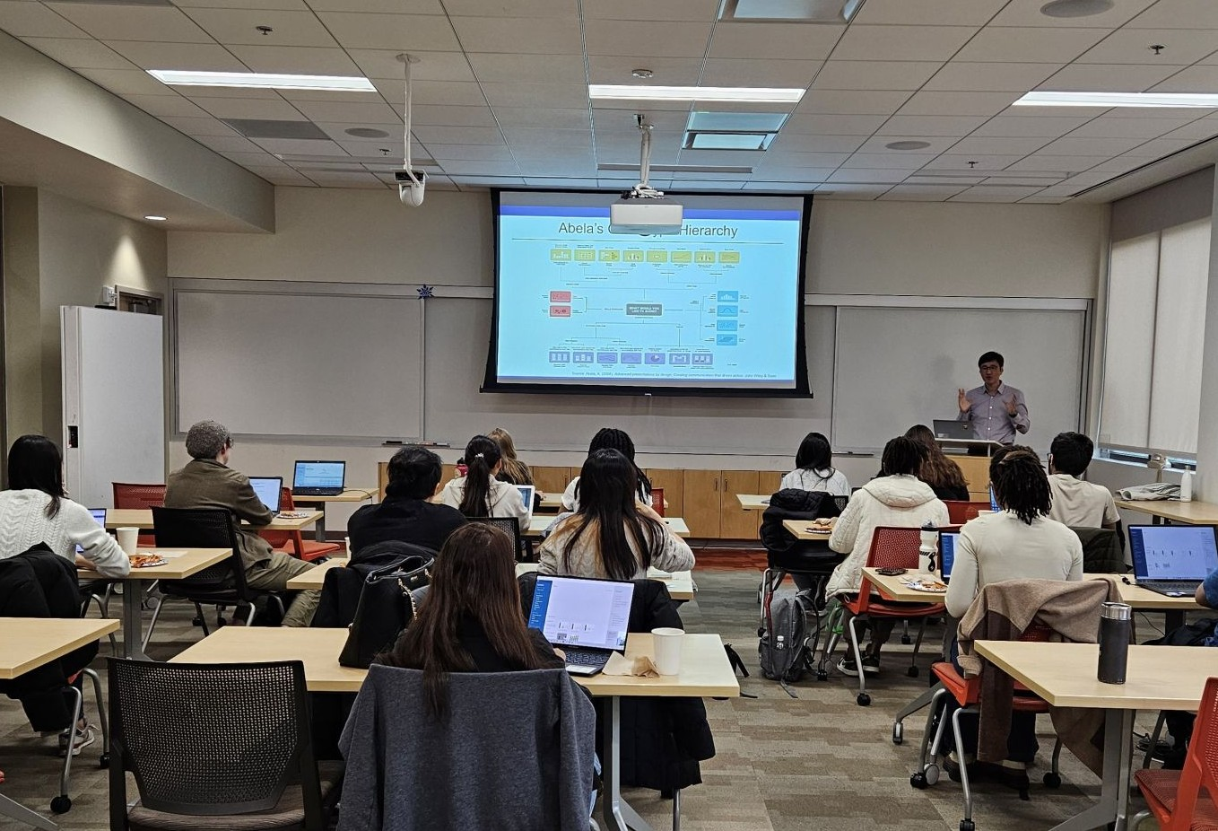
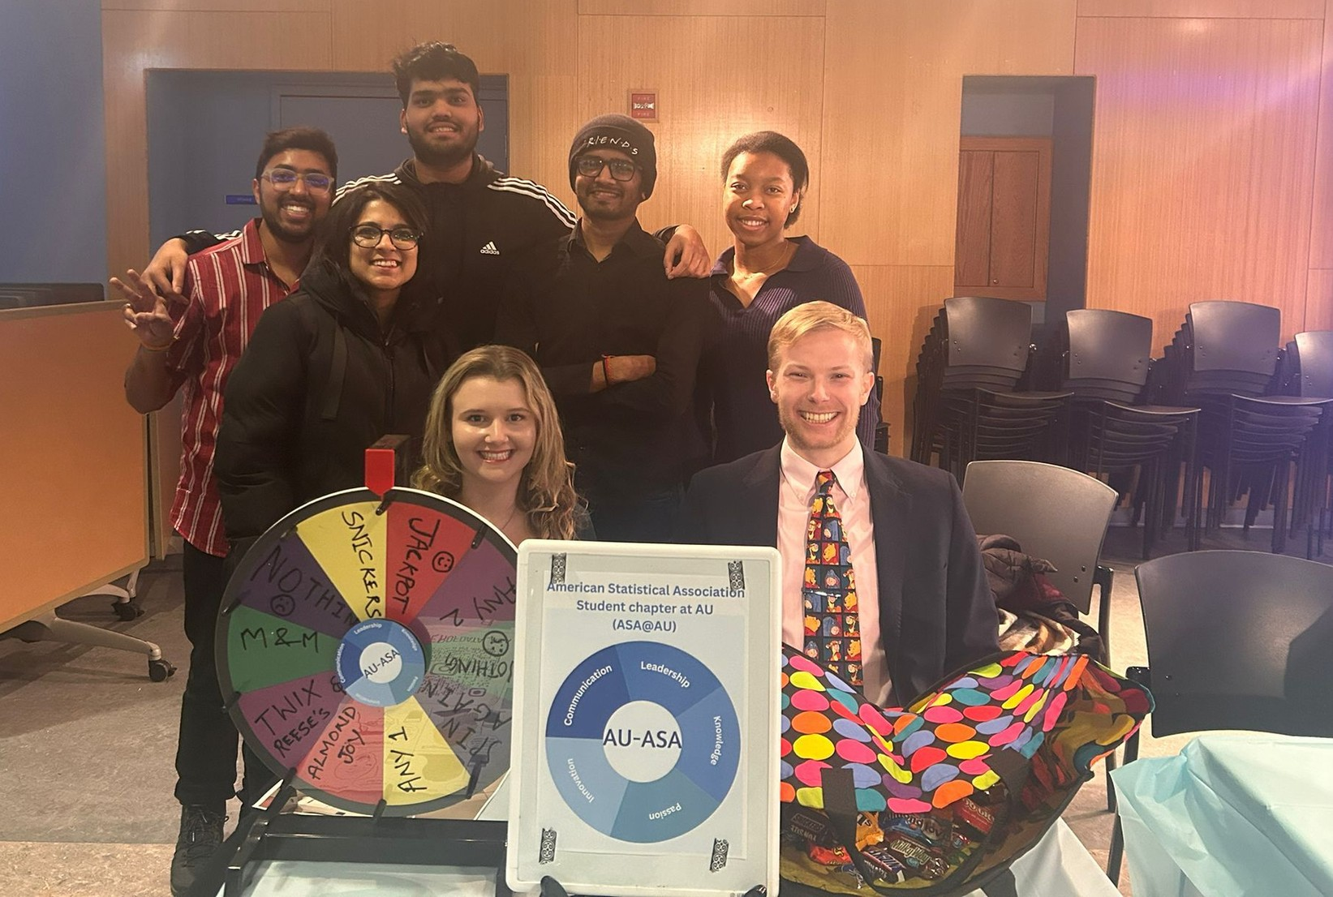

Data Visualization workshop AU-ASA at Club Involvement fair

