Anunci.us

Protocolos, tecnologías y servicios de Internet
Subject code: 51336

Sergio Anguita Lorenzo

Project requirements
According to student guide, the project must fulfill next guidelines:
TRABAJO INVIDIDUAL:
Desarrollo de una solución basada en Internet con parte tanto cliente como servidora por el estudiante aplicando los protocolos y tecnologías de Internet y Web, de última generación, estudiadas. Se documentará el uso de las herramientas aplicadas. Se contempla una entrega final, obligatoria y evaluable. El trabajo será evaluado sobre 7 puntos. La documentación asociada y la presentación del proyecto se realizarán en inglés.

Project description
The aim of this project is to create a RIA (Rich Internet Application) hosted on a cloud service. The selected RIA will focus on the concept of online shop in where anyone can sell and buy items. We could take as a reference milanuncios.com. So, taking a brief look to this platform, we are going to build something similar. With this idea in mind and in order to make it better (at least responsive) we will have a better platform than many others, at least from design point of view.
In the next section, project functional and non functional requirements are specified.

Functional requirements
In this section functional requirements are summarized.
- Application must have push notifications
- User login must be done using Single Sign On system
- Logged user will have the ability to edit and delete their published items.
- Not logged users can only publish an item
- Not logged users will not be able to edit or delete their items until the login.
- User defines the category where the item belongs to.

Non-functional requirements
In this section non functional requirements are summarized.
- Application must have a responsive design.

Project management
Project management is done using already known Github platform for code hosting and issue management. Current source code is located under a private repository. Repository URL is given below.
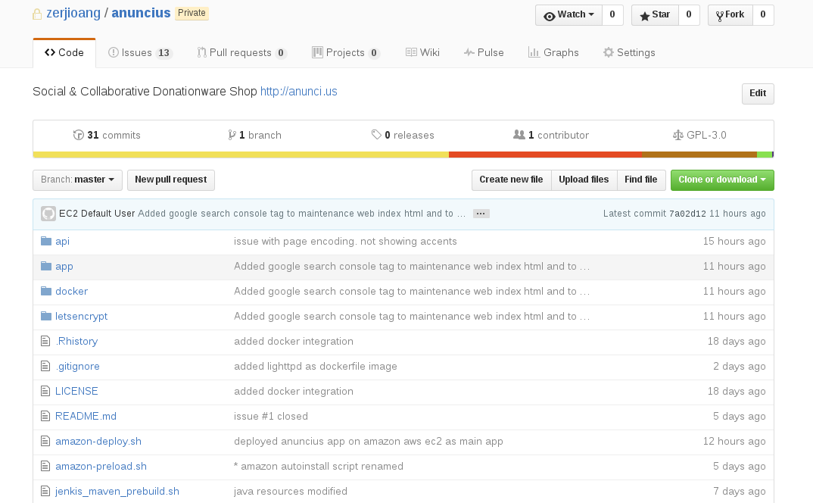
https://github.com/zerjioang/anuncius

Architecture

In this chapter, platform architecture is described. A different aproach is taken for architecture, since all platform will be based on Docker containers. For those of you, who do not know what a docker container is, let me show you:
Docker is a tool designed to make it easier to create, deploy, and run applications by using containers. Containers allow a developer to package up an application with all of the parts it needs, such as libraries and other dependencies, and ship it all out as one package. By doing so, thanks to the container, the developer can rest assured that the application will run on any other Linux machine regardless of any customized settings that machine might have that could differ from the machine used for writing and testing the code.
Using Docker as main environment for development it gives some advantages:
- More secure environment caused by shared docker env.
- Deploy and scale easily because docker containers can run almost everywhere: laptop, dedicated server, virtual machine, etc.
- Superfast to move from one environment to other. Easy migrations.

Architecture schema
{{todo add schema}}

Microservices
The platform is built on top of a series of services that run on a shared environment on the same machine. This services are:
- A Redis server for cache management
- A Mongo database for NoSQL data storage
- A tomcat webserver for application hosting
- A jenkins application for CI development.
- A Nginx based server as reverse proxy for routing mainly

Development

Deployment
Application deployment is done on AWS (Amazon Web Services) using a t.micro style EC2 instance thanks to Amazon Free-Tier. Thanks to this tier, billing cost are $0.00 as can be seen on
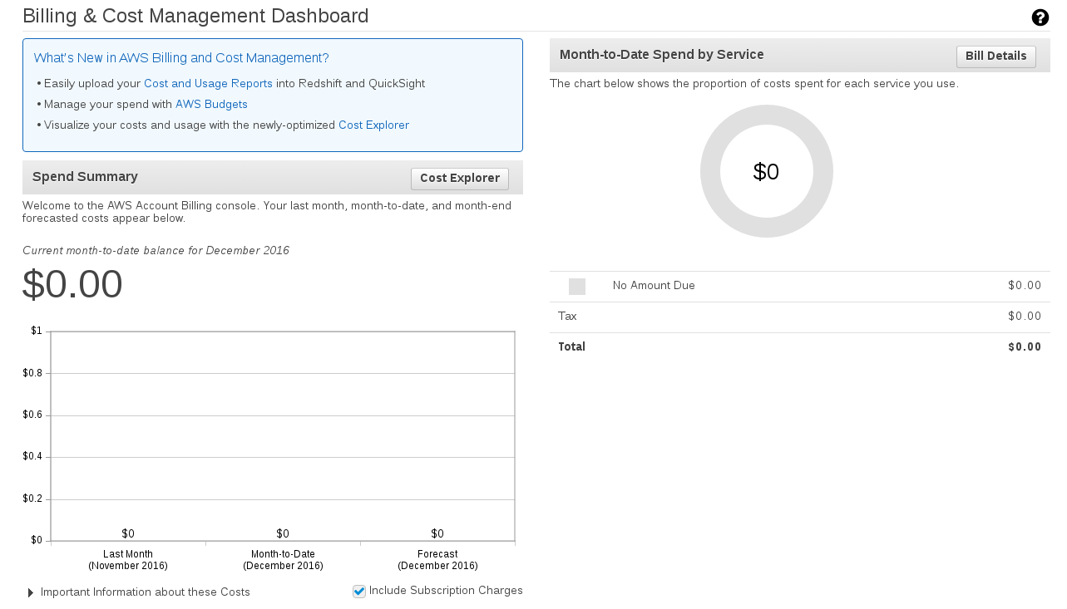
https://console.aws.amazon.com/billing/home?region=eu-west-1#/

Before uploading the application, there are several thing that have to be done in order to properly configure the server.

Used resources
Platform used resources by Amazon EC2
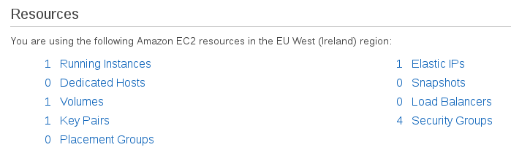

Server hardening
In this section, how server is secured for unwanted access is described. Current security measurements are based on AWS security groups for limiting server access. Current configuration is shown:

AWS Security Groups
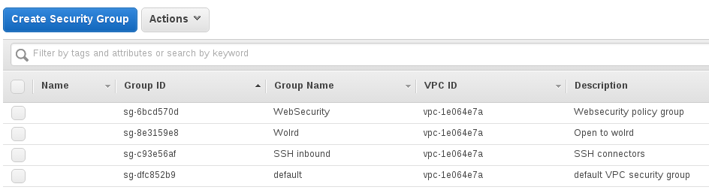
Used security groups are:
- WebSecurity: allows ANY incoming connection on ports 80 and 443 using HTTP and HTTPS protocols
- Wolrd: allows ANY incoming connection on ANY port using ANY protocol
- SSH inbounds: allows SSH connections via TCP on port 22 from my IP range.
- Default: allows EVERYTHING
With this security groups in mind, server instance has linked to SSH inbounds group and to WebSecurity group in order to have it available as Webserver and available for ssh connections.

DNS configuration
For DNS configuration, it is recommended to use Amazon Route 53 service, but since this service is out of the Amazon Free-tier, an alternative solution is found using an Elastic IP.
Configuring a DNS for our instance is as simple as generating an Elastic IP and linking to our domain using a DNS A record. Once this is done, the server will be available via http://anunci.us and http://www.anunci.us
Take into account that Amazon will charge you if you get an Elastic IP and you do not use it with ANY instance. Otherwise, feel free to use it on your t.micro instance.

Getting Elastic IP
Elastis Ips are like static IP and do not change when you stop or terminate your instance, so we can use if for DNS redirection. This Ips are available on Network & Security > Elastic Ips Section.
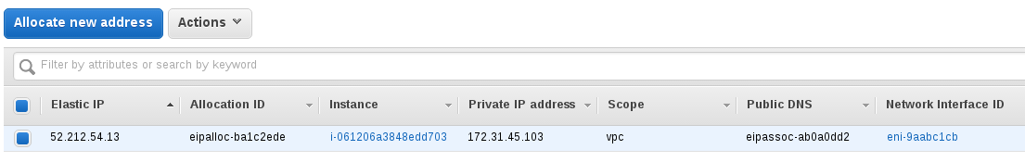
As you can see on the image above, my Elastic IP is 52.212.54.13 and this is the one that will be linked to DNS A Record.

Registering the IP as DNS A
An A record maps a domain name to the IP address (IPv4) of the computer hosting the domain. Simply put, an A record is used to find the IP address of a computer connected to the internet from a name.
The A in A record stands for Address. Whenever you visit a web site, send an email, connect to Twitter or Facebook or do almost anything on the Internet, the address you enter is a series of words connected with dots.
Knowing this, we only need to configure our elastic IP in our domain. Take a look to the next image to see how this simple process is done.

