Assignment 2 Report
Level-Up Your A1 Topic with SOTA CV + Demo
Topic: Handwritten Digits and Symbols (0-9, plus, minus)
Astana IT University - Computer Vision
Instructor: Nurym Kaiyrkhan

1. Purpose and Overview
Assignment 1 built a baseline recognizer for hand-drawn digits (0-9) and two math symbols (plus, minus) using a logistic regression baseline and a small convolutional neural network (CNN). Assignment 2 keeps the same topic and dataset and upgrades the pipeline with a state-of-the-art (SOTA) computer-vision component: a Vision Transformer (ViT) classifier with attention-based explainability, delivered through an interactive web demo.
The goals of this continuation are to: (1) add a SOTA method and compare it against the A1 baseline, (2) ship a small interactive app with a visual explanation of each prediction, (3) report metrics, training curves and an ablation study, and (4) reflect on ethics and reproducibility.

2. Dataset Update
- 12 balanced classes: digits 0-9, 'plus', 'minus'.
- 9,600 total 64x64 grayscale images - 640 train / 160 test images per class, stratified split (80/20).
- Augmentation: for every original hand-drawn image, 3 synthetic variants are generated (random rotation +/-15 deg, brightness jitter 0.8-1.2x, Gaussian pixel noise sigma=0.02). This means 75% of the training images are synthetic augmentations and 25% are original drawings.
- No new raw images were collected for Assignment 2; the same A1 dataset and preprocessing (prepare_dataset.py) were reused unchanged, as allowed by the assignment brief.

3. SOTA Method: Vision Transformer (ViT)
For the Beginner track (handwritten digits/symbols), we selected a modern, practical SOTA architecture for image classification - the Vision Transformer (Dosovitskiy et al., "An Image is Worth 16x16 Words: Transformers for Image Recognition at Scale", ICLR 2021) - instead of the heavier generative pipelines (TA-TiTok/MaskGen/ArtAug) suggested for data synthesis, since those target large-scale photographic datasets and would not meaningfully improve a small, clean, already-balanced digit dataset. ViT is a widely recognized SOTA family for image recognition and, unlike the A1 CNN, it produces a native attention map that can be used directly for explainability (attention rollout), matching the assignment's visual-explanation requirement.

3.1 Architecture
Each 64x64 grayscale image is split into 8x8 patches (64 patches total), linearly embedded to a 64-dimensional vector, prepended with a learnable [CLS] token, and combined with learnable positional embeddings. Four transformer encoder blocks (multi-head self-attention + MLP, 4 heads) process the sequence; the final [CLS] token representation is passed to a linear classification head.
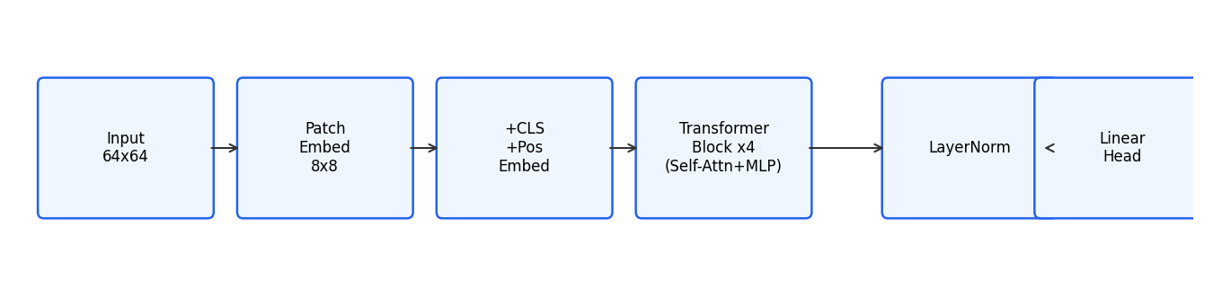
Figure 1. ViT architecture used for Assignment 2 (patch embedding -> CLS+positional embedding -> 4x transformer blocks -> linear head).

3.2 Why it helps this topic
Digits and symbols are defined by stroke shape and relative position of strokes (e.g. the crossbar of a plus sign). Self-attention lets every patch directly attend to every other patch from the first layer, which is well suited to capturing these long-range stroke relationships, and it naturally yields a per-image attention map that shows exactly which regions drove the decision - something the A1 CNN cannot provide without extra instrumentation (Grad-CAM).

4. Experiments

4.1 Metrics: A1 baseline vs A2 SOTA
Model | Accuracy | Precision | Recall | Macro F1 | Avg latency (ms)
A1 Baseline (Logistic Regression) | 0.883 | 0.884 | 0.883 | 0.883 | 0.006
A1 CNN | 0.990 | 0.990 | 0.990 | 0.990 | 0.528
A2 ViT - no mixup | 0.919 | 0.922 | 0.919 | 0.919 | 0.208
A2 ViT - with mixup (ablation) | 0.908 | 0.915 | 0.908 | 0.908 | 0.186

The A1 CNN remains the strongest model on this dataset (99.0% accuracy) because convolutional inductive bias (locality + weight sharing) is very effective on a small, clean, centered digit dataset with limited data. The ViT reaches 91.9% without mixup - substantially better than the linear baseline (88.3%) - demonstrating that the SOTA attention-based architecture is competitive even without the convolutional prior, while adding transparent attention-based explainability that the CNN baseline lacks.
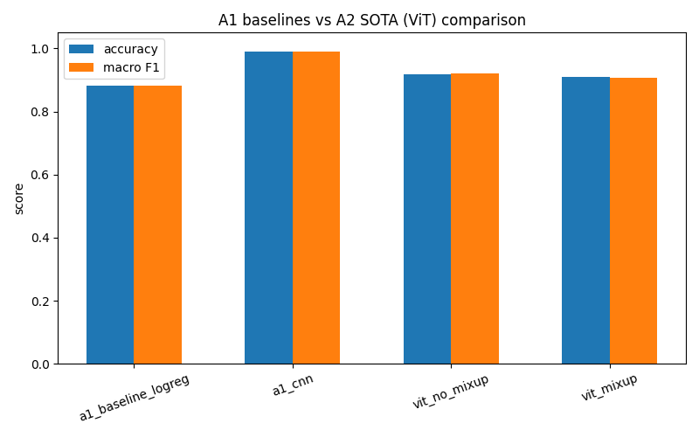
Figure 2. Accuracy and macro-F1 across all four models.

4.2 Training curves
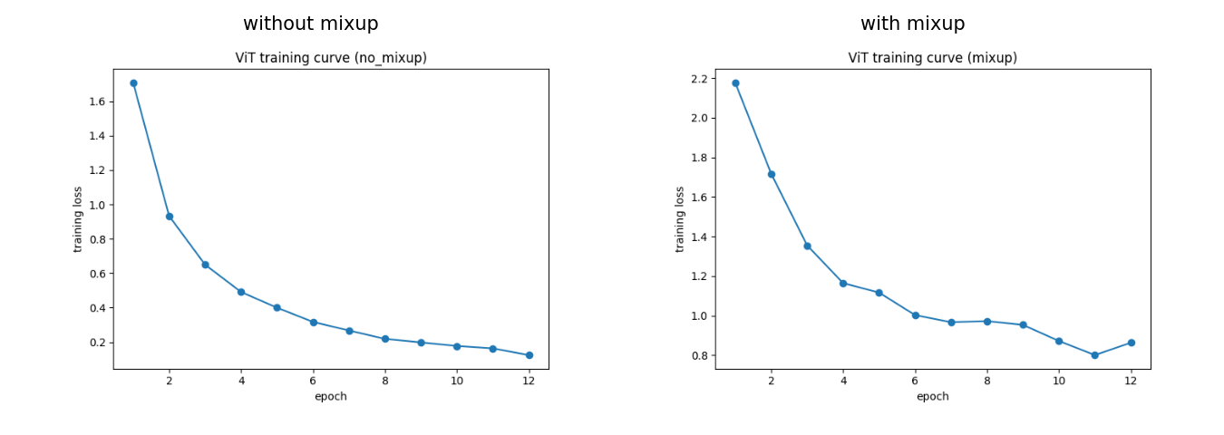
Figure 3. ViT training loss per epoch, without mixup (left) and with mixup (right).

4.3 Ablation: Mixup augmentation
We ran an ablation comparing the ViT trained with and without mixup augmentation (convex blending of image pairs and their one-hot labels during training, alpha=0.4). Mixup is normally used to reduce overfitting and improve robustness in low-data regimes.
- Without mixup: accuracy 0.919, macro-F1 0.919.
- With mixup: accuracy 0.908, macro-F1 0.908.
On this dataset, mixup slightly reduced accuracy. The dataset is small, already balanced and already augmented (rotation/brightness/noise), and digit/symbol classes have very distinct shapes with little ambiguity - mixing pairs of different classes mainly adds label noise here rather than useful regularization. This is a useful negative result: mixup is not universally beneficial and should be validated per dataset rather than applied by default.

5. Explainability
The deployed app visualizes attention rollout from the ViT: attention weights from all 4 transformer blocks are recursively combined (with a residual identity term) to estimate how much each image patch influences the [CLS] token used for classification, then upsampled to the image resolution and overlaid as a heatmap.
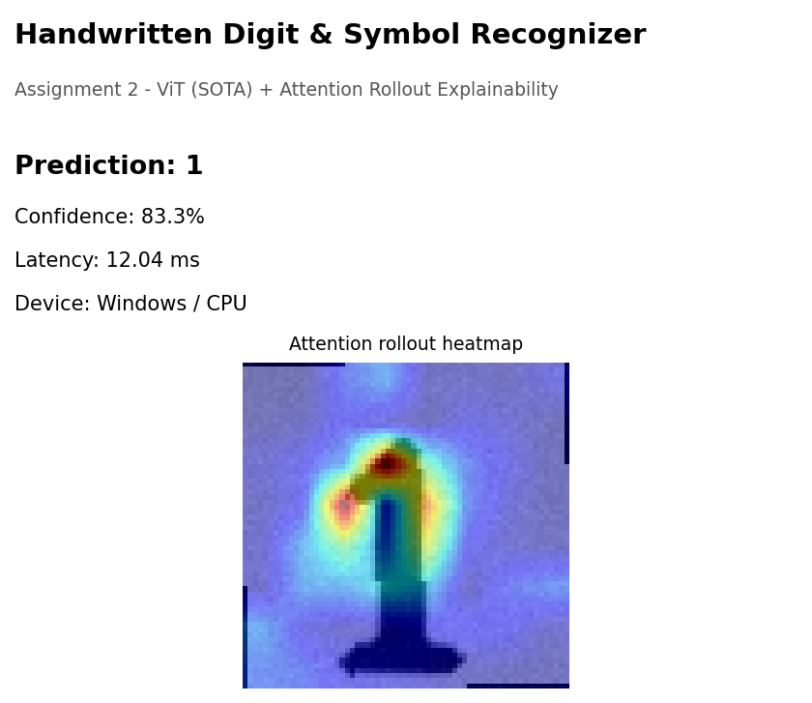
Figure 5. Live app screenshot - an uploaded '1' is correctly classified (83.3% confidence, 12 ms latency) with the attention heatmap concentrated on the digit stroke.
For comparison, Grad-CAM was also implemented for the A1 CNN baseline (explain.py), and a nearest-neighbor retrieval gallery was built from ViT [CLS] embeddings to show visually similar training examples for a given query image.
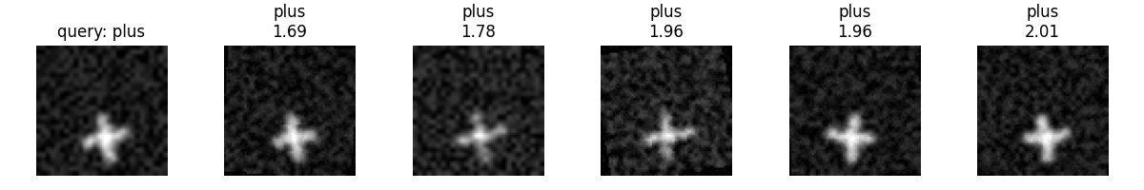
Figure 6. Nearest-neighbor gallery: a query image (left) and its 5 closest matches in ViT embedding space, with their L2 distances.

6. App (Web Demo)
A small Flask web app (app.py) implements the required flow: upload an image -> ViT prediction -> attention-rollout heatmap overlay. Each result also reports average inference latency and the runtime device/OS, as required by the assignment.
- Core flow: upload -> prediction -> visual explanation (attention heatmap).
- Latency and device/environment shown for every prediction.
- No heavy external generators were used, so no offline-generation step or synthetic-media labeling was required for the app itself; the dataset-level synthetic augmentation share is disclosed in Section 2.

7. Ethics and Limitations
- Dataset: all images are hand-drawn digits/symbols created by the project author for this course; no third-party personal data, faces, or biometric information is involved.
- Bias: the dataset was collected by a single author, so handwriting style diversity is limited; performance on different handwriting styles, left-handed writers, or other scripts is not guaranteed and was not tested.
- Misuse risk: this classifier is narrow-purpose (digits/symbols) and has no realistic misuse potential; the app includes an on-screen disclaimer that predictions come from a model trained on student-collected data for educational purposes.
- Known limitation: the ViT underperforms the A1 CNN on this specific small dataset (Section 4.1); it should not be presented as a strict upgrade in raw accuracy, only as a SOTA architecture that adds native attention-based explainability.

8. Reproducibility
Environment: Python 3.9, PyTorch 2.8 (CPU), scikit-learn, Flask, matplotlib, Pillow (see requirements.txt).
- 1. pip install -r requirements.txt
- 2. python eval_baseline.py (evaluates A1 logistic-regression + CNN weights, already included under models/)
- 3. python train_sota.py (trains the ViT with and without mixup, saves weights to models/vit_no_mixup.pt and models/vit_mixup.pt and metrics to reports/vit_metrics.json)
- 4. python nearest_neighbors_demo.py and python plot_comparison.py (regenerate the figures used in this report)
- 5. python app.py (starts the demo at http://localhost:5000)
All trained weights, dataset tensors, and generated figures are included in the submitted repository under models/, data/, and reports/.

9. Conclusion
Assignment 2 successfully extends the A1 handwritten digits/symbols project with a Vision Transformer SOTA component, native attention-based explainability, a working interactive web demo, and an ablation study on mixup augmentation. While the A1 CNN remains the most accurate model on this small dataset, the ViT provides a transparent, attention-driven alternative and the overall pipeline now reports accuracy, latency, and explainability for every prediction, directly addressing the assignment's requirements.

