Important Variables in Predicting grade Outcomes in intro courses

The Data:

The data consists of freshman admitted between Fall 2016 and Fall 2019, who are California residents. Some variables we are interested in are if they took AP tests for:

* Biology
* Calculus
* Chemistry
* Stats
* Physics
* Comp Sci

The introductory courses I picked to study are as follow:

* MAT_021A,
* MAT_021B
* BIS_002A,
* BIS_002B,
* CHE_002A,
* CHE_002B,
* MAT_016A,
* MAT_016B
* ECN_001A,
* HIS_017A,
* STA_013,
* PSC_001,
* PHY_007A,
* ANT 2
* ANS 1

I chose basic demographics for controls in addition to creating dummy variables for AP scores, and ethnicity.

MODELS:

Running a fancy function to compute a bunch of different models, I found that the random forest models had the lowest error, and highest R2 value, although linear regression and gradient boosted algorithms performed well.

WHAT I FOUND: [NOTE: I need to check accuracy using some sort of metric…]

There were to facets of this analysis that stuck out:

1. I found that the models predicted the grades in some classes better than others. For example, the test data of ANT 2 only had a R2 value of .10 (training data dim was 2499), whereas the model for ANS 1 (dim = 791) had an R2 value of 0.45.
2. The “important variable” varied depending on the type of class. In particular, there seems to be a divide between STEM and non-STEM classes, and the different disciplines. For example, it seems GPA and APPASSED is more important for non-STEM classes, and for STEM classes either the AP test in the subject or SAT scores are more important.
3. The models for the non-STEM classes seemed less predictive with lower R2 scores. Note: I should check the OOB scores, since they might be a better indicator of the model performance.

Analysis of individual courses…

MAT_021A

OOB score for random forest: 0.29

R2 score for test data: 0.288

Important variables (using permutation importance):

|  |  |
| --- | --- |
| 0.1032 ± 0.0167 | SAT_TOTAL_OFFICIAL_SQ |
| 0.0882 ± 0.0124 | AP_Calculus_AB_0.0 |
| 0.0688 ± 0.0045 | GPA |
| 0.0630 ± 0.0102 | AP_Calculus_AB_5.0 |
| 0.0457 ± 0.0046 | APPASSED |
| 0.0271 ± 0.0038 | LOWINCOME |
| 0.0256 ± 0.0017 | AP_Calculus_BC_0.0 |
| 0.0238 ± 0.0014 | ATOG |
| 0.0220 ± 0.0016 | LOW_INCOME |
| 0.0182 ± 0.0014 | ATOGE |
| 0.0152 ± 0.0014 | FIRST_GENERATION |
| 0.0152 ± 0.0032 | TRIPLE |
| 0.0139 ± 0.0009 | ATOGG |
| 0.0118 ± 0.0008 | ATOGA |
| 0.0111 ± 0.0019 | AP_Calculus_BC_5.0 |
| 0.0106 ± 0.0021 | AP_Chemistry_0.0 |
| 0.0100 ± 0.0010 | ATOGF |
| 0.0096 ± 0.0008 | ETH_MX |
| 0.0092 ± 0.0034 | AP_Calculus_AB_4.0 |
| 0.0088 ± 0.0009 | AP_Calculus_AB_3.0 |

Partial Dependency Plots:

Reading from left-to-right AP_CALC_AB_not_taken, AP_CALC_AB_3.0, AP_CALC_AB_4.0, AP_CALC_AB_5.0,

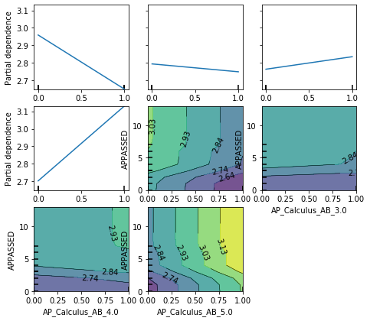

MAT_021B

BIS_002A,

BIS_002B,

CHE_002A,

CHE_002B,

MAT_016A,

MAT_016B

ECN_001A,

HIS_017A,

STA_013,

PSC_001,

PHY_007A,

ANT 2

ANS 1