GRAPHICS AND
VISUAL
COMPUTING
CHAPTER 4:
BUILDING &
DEPLOYING
VISION MODELS IN ROBOFLOW
GRAPHICS AND
VISUAL
COMPUTING
TOPICS
1.Roboflow Image Annotation
2.Training A Model using Roboflow 3.Evaluating and Fine Tuning the Model. 4.Testing and Deployment of the Model.
GRAPHICS AND
VISUAL
COMPUTING
Roboflow Image
Annotation
GRAPHICS AND
VISUAL
COMPUTING
Image Annotation
The process of labeling, tagging, or outlining specific objects or regions within an image to create"ground truth" data.
Purpose: To train artificial intelligence and machine learning models to identify and interpret visual data accurately.
GRAPHICS AND
VISUAL
COMPUTING
Annotation Methods
In Roboflow, you can either use Manual Annotation or AI Labeling.
Although Manual Annotation offers high accuracy, context understanding, and adaptability for complex task, it is still slow and time consuming.
AI Labeling provides a high speed, high scalable way of labeling data. This is good for very straightforward datasets.
The most appropriate approach is to combine the two, use AI labeling for initial labeling and the manual method is for validation.
GRAPHICS AND
VISUAL
COMPUTING
Bounding Boxes vs. Polygons vs. Masks
Bounding boxes are quicker and easier to annotate than polygons.
Polygons are more precise and can slightly improve performance.
Masks offer the highest accuracy for complex, pixel-level boundaries.
Segmentation tasks require polygons or masks for precise object separation.
GRAPHICS AND VISUAL
COMPUTING
_{Bounding Boxes} Polygon 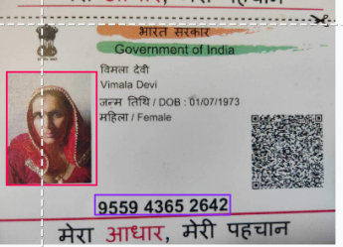Mask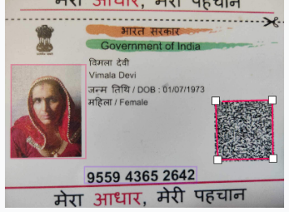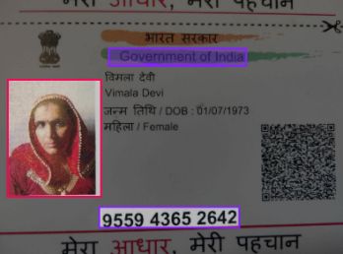
GRAPHICS AND
VISUAL
COMPUTING
Project Types and Annotations
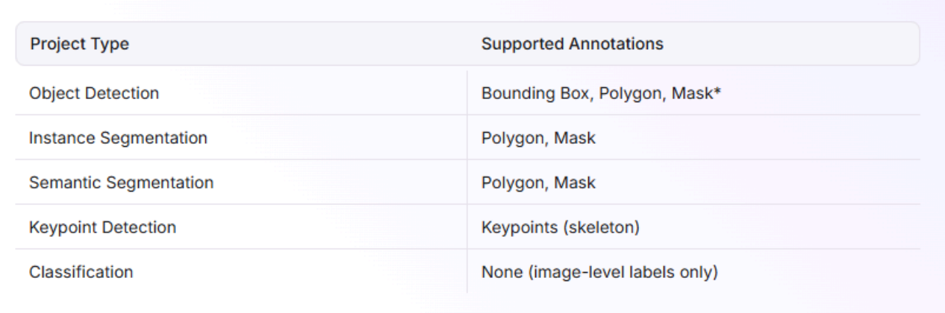
GRAPHICS AND
VISUAL
COMPUTING
Annotate and Image
You can access the labeling interface by selecting an image from the Assign or Dataset pages on the Roboflow dashboard. On the right-hand side of the labeling interface, you will find the toolbar. The toolbar has many features you can use for annotating images.
GRAPHICS AND
VISUAL
COMPUTING
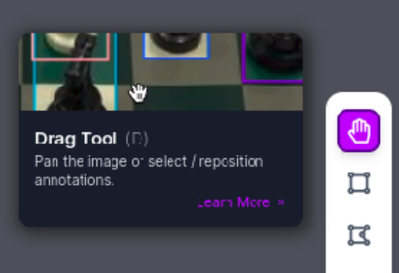
Drag and Select Represented by a hand icon, this feature allows you to select, edit, and drag individual annotations. Single-click an existing
bounding box to select it.
Drag a box to move it.
Drag the background to pan. Click the background to
deselect all boxes.
GRAPHICS AND
VISUAL
COMPUTING
Bounding Box
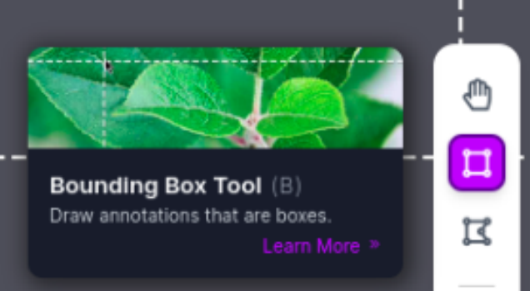
Annotation Tool The bounding box annotation tool (represented by a rectangular box icon) allows you to draw new bounding-box annotations
GRAPHICS AND
VISUAL
COMPUTING
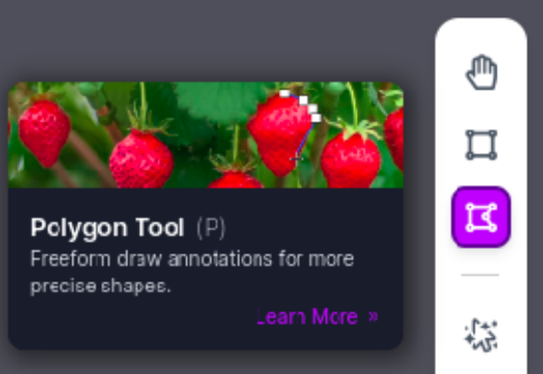
Polygon Annotation Tool
The polygon annotation tool allows you to draw new polygonal annotations. In this mode, you will see crosshairs that will help you determine where to start drawing.
GRAPHICS AND
VISUAL
COMPUTING
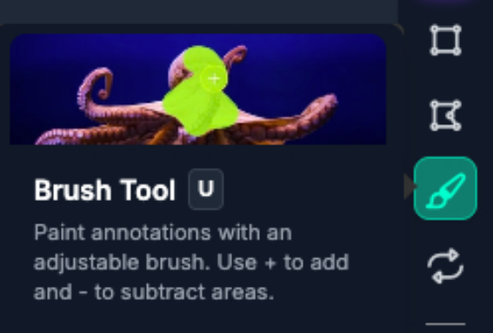
Brush Annotation Tool
The brush annotation tool lets you paint pixel-precise mask
annotations over regions of interest in your image. Use the on-canvas brush controls to adjust the brush size and switch between Add and Subtract modes, which respectively add to or erase from the current mask.
GRAPHICS AND
VISUAL
COMPUTING
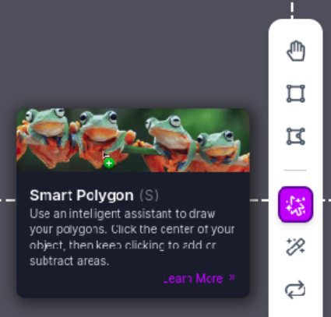
Smart Polygon Smart Polygon allows you to draw new Smart Polygon annotations.
A green dot appears when adding a new area of
interest.
A red dot appears when
removing parts from the
selected area.
You can refine the polygon using Convex Hull, Smooth, and Complex settings.
GRAPHICS AND
VISUAL
COMPUTING
Label Assist
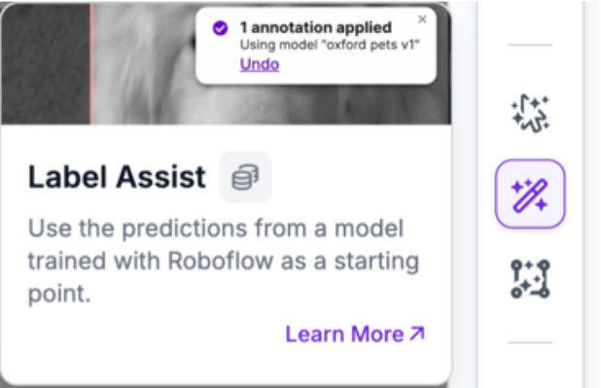
Label Assist uses predictions from a public model or a version trained with Roboflow Train to automatically suggest bounding box labels as you annotate.
GRAPHICS AND
VISUAL
COMPUTING
Mark Null
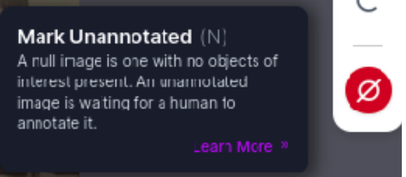
Mark null (Null annotation) is to be used for the"labeling"of
background, or null, images. This setting can also be used to clear all annotations from an image, or to mark the image as Unannotated.
GRAPHICS AND
VISUAL
COMPUTING
Bounding Box Annotation Tool The bounding box annotation tool (represented by a rectangular box icon) allows you to draw new bounding-box annotations. In this mode, you will see crosshairs that will help you determine where to start drawing.
GRAPHICS AND
VISUAL
COMPUTING
Train a Model
GRAPHICS AND
VISUAL
COMPUTING
Train a Model with Roboflow
You can train computer vision models in the Roboflow interface. Roboflow offers three training options:
Roboflow Train: Our flagship training service, ideal for creating production-ready models.
Roboflow Instant: Train models in a few minutes that are ideal for testing.
Neural Architecture Search: Discover novel model architectures and fine tune at the same time.
GRAPHICS AND
VISUAL
COMPUTING
Train a Model with Roboflow
When you approve a batch of image annotations, Instant models are automatically trained. These models can be used immediately.
Models trained on Roboflow can be deployed with Inference, our on-device inference server, or in the cloud using our Serverless Hosted API with Workflows, Batch Processing with Workflows, or with your model API endpoint.
GRAPHICS AND
VISUAL
COMPUTING
Train a Model with Roboflow
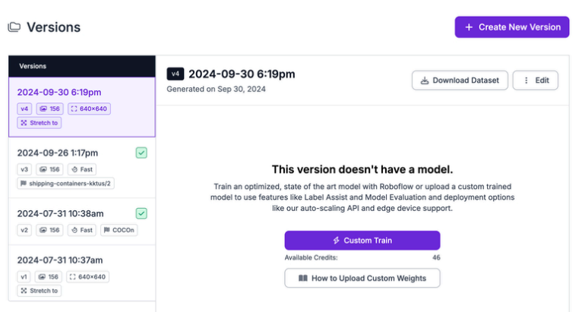
To train a computer
vision model, first
generate a dataset
version.
Click the"Custom Train"
button to start
configuring a training
job:
GRAPHICS AND
VISUAL
COMPUTING
Select a Model Architecture
Next, you need to select a model architecture. This is the machine learning technology used to train your model. The model architectures you can train depend on the type of project you have set up. Refer to the Supported Models table for details on training compatibility.
GRAPHICS AND
VISUAL
COMPUTING
Select a Model Architecture
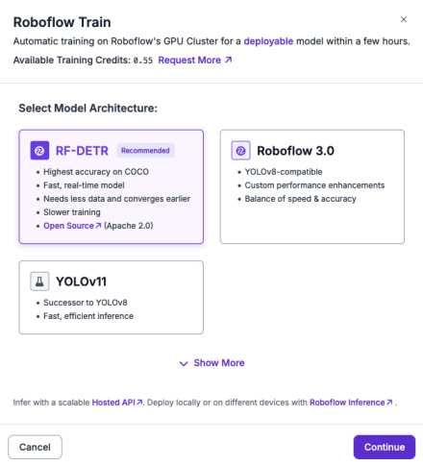
For object detection, RF-DETR
offers the best accuracy. For
instance segmentation, RF
DETR Seg (Preview) offers the
best accuracy.
GRAPHICS AND
VISUAL
COMPUTING
Select a Model Size
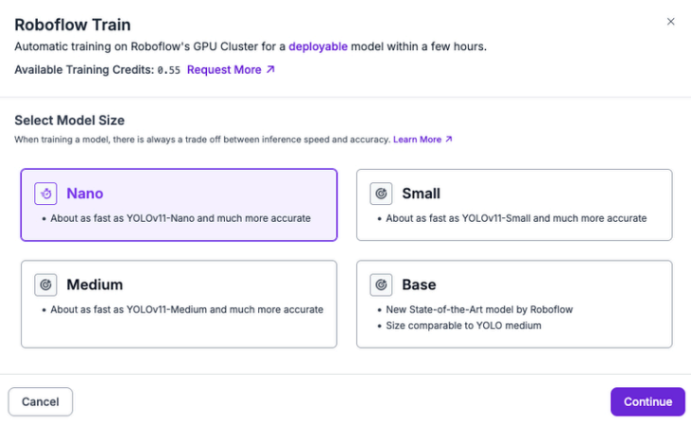
Next, you need to set a size
for your model.
Model sizes will vary
depending on the
architecture of the model
you choose. For example,
RF-DETR — a state-of-the
art object detection model
— offers Nano, Small,
Medium, and Base:
GRAPHICS AND
VISUAL
COMPUTING
Select a Checkpoint
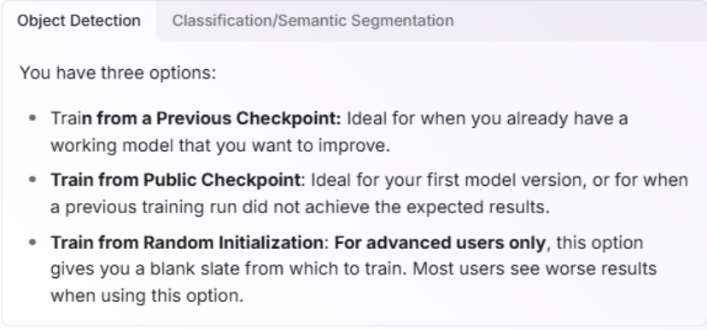
After selecting a training option,
you will be asked whether you
want to train from a checkpoint.
The tabs below show the
configuration options for each
model type.
GRAPHICS AND
VISUAL
COMPUTING
Start the Training Job Once you have chosen a
Checkpoint from which to train,
click Start Training.
Your dataset will then be zipped
and prepared for training in the
Roboflow cloud.
Before training starts, the
training summary shows
estimated duration and credit
cost:
GRAPHICS AND
VISUAL
COMPUTING
Start the Training Job Once you have chosen a
Checkpoint from which to train,
click Start Training.
Your dataset will then be zipped
and prepared for training in the
Roboflow cloud.
Before training starts, the
training summary shows
estimated duration and credit
cost:
GRAPHICS AND
VISUAL
COMPUTING
During Training View the Progress
Box, class, and objectness
losses together determine an
object detection model’s
performance: they ensure the
model accurately locates
objects (box loss), correctly
identifies them (class loss), and
reliably detects their presence
(objectness loss), where lower
losses across all three lead to
better overall predictions.
GRAPHICS AND
VISUAL
COMPUTING
Evaluate and Fine Tuning a Model
GRAPHICS AND
VISUAL
COMPUTING
What is the first thing we should do after we trained our model?
GRAPHICS AND
VISUAL
COMPUTING
View the metrics
GRAPHICS AND
VISUAL
COMPUTING
What is Mean Average Precision
Mean Average Precision (mAP) is used to measure the performance of computer vision models. mAP is equal to the average of the Average Precision metric across all classes in a model.
GRAPHICS AND
VISUAL
COMPUTING
What is Precision and Recall
Precision measures: of all the times your model predicted an object, how many were actually correct? (focuses on avoiding false positives) Recall measures: of all the real objects that exist, how many did your model successfully detect? (focuses on avoiding false negatives)
GRAPHICS AND
VISUAL
COMPUTING
GRAPHICS AND
VISUAL
COMPUTING
Testing and
Deployment of Model
GRAPHICS AND
VISUAL
COMPUTING
Testing your CV Model
You can test your model
on an image from the
Visualize page. Visualize is
a good way to run quick
checks to see how your
model performs before
you build your application
logic in Workflows.
GRAPHICS AND
VISUAL
COMPUTING
Deploy your Model
Hosted API (Cloud Deployment) Dedicated Deployment
Batch Processing
GRAPHICS AND
VISUAL
COMPUTING
Serverless Hosted API
Models deployed to Roboflow have a REST API available through which you can run inference on images. This deployment method is ideal for environments where you have a persistent internet connection on your deployment device.
You can use Serverless Hosted API:
in Workflows
with the REST API
with the Inference Python SDK
GRAPHICS AND
VISUAL
COMPUTING
Serverless Hosted API
GRAPHICS AND
VISUAL
COMPUTING
Serverless Hosted API
Limits
Our Serverless Hosted API supports file uploads up to 20MB. You may run into limitations with higher resolution images.
GRAPHICS AND
VISUAL
COMPUTING
Serverless Video Streaming API The Serverless Streaming API uses WebRTC to stream video from webcams, RTSP cameras, or video files to the Roboflow Cloud.
You can run any Workflow with this API. For single model inference, create a Workflow that wraps your model.
GRAPHICS AND
VISUAL
COMPUTING
Serverless Video Streaming API Supported input sources:
Webcam: Browser or device camera via MediaStream API RTSP: IP cameras or any RTSP-compatible source. is just a way to access a live video stream from a camera over the internet or a local network.
Video Files: Pre-recorded video uploaded via the Data Channel
GRAPHICS AND
VISUAL
COMPUTING
Dedicated Deployment
Dedicated Deployments are private cloud servers managed by Roboflow, specifically designed to run your computer vision models. These models can include:
Object detection
Image segmentation
Classification
Keypoint detection
Foundation models like CLIP (if trained on Roboflow) Roboflow Workflows (low-code vision applications)
GRAPHICS AND
VISUAL
COMPUTING
Batch Processing
Batch Processing is a cost-effective way to run Workflows on batches of images and stored videos. It's ideal for asynchronously processing large amounts of data.
GRAPHICS AND
VISUAL
COMPUTING
Create a Batch Processing Job
To create a Batch Processing job, click Deployments in the left sidebar of your Roboflow dashboard. Then, click on the"Batch Processing" tab:
GRAPHICS AND
VISUAL
COMPUTING
Create a Batch Processing Job
GRAPHICS AND
VISUAL
COMPUTING
Choose a Workflow
To start configuring a job, first select a Workflow.
Upload your images or on which you want to run your workflow.
GRAPHICS AND
VISUAL
COMPUTING
Configure Hardware
GRAPHICS AND
VISUAL
COMPUTING
Let’s create a model!
GRAPHICS AND VISUAL
COMPUTING
Activity # 1
“Which One Is It?” (Confusion Matrix Scenarios)
Instructions: Identify whether each situation is a True Positive (TP), False Positive (FP), True Negative (TN), or False Negative (FN).
1.The model predicts a dog, and there is actually a dog in the image. 2.The model predicts a cat, but there is actually no cat in the image. 3.The model says there is no car, and there is indeed no car in the image. 4.The model says there is no person, but there is actually a person in the image.
5.A medical test predicts a disease, and the patient actually has the disease.
GRAPHICS AND VISUAL
COMPUTING
Activity # 1
“Which One Is It?” (Confusion Matrix Scenarios)
Instructions: Identify whether each situation is a True Positive (TP), False Positive (FP), True Negative (TN), or False Negative (FN).
6.The model detects a fire alarm when there is actually no fire in the scene. 7.The system correctly identifies that no intruder is present in a security feed.
8.A medical model predicts no disease, but the patient actually has the disease.
9.The system correctly flags a spam email as spam.
10.The system labels a normal email as spam.
GRAPHICS AND VISUAL
COMPUTING
Lab Activity # 1
“Which One Is It?” (Confusion Matrix Scenarios)
Instructions: Identify whether each situation is a True Positive (TP), False Positive (FP), True Negative (TN), or False Negative (FN).
6.The model detects a fire alarm when there is actually no fire in the scene. 7.The system correctly identifies that no intruder is present in a security feed.
8.A medical model predicts no disease, but the patient actually has the disease.
9.The system correctly flags a spam email as spam.
10.The system labels a normal email as spam.

