
AI ADFORGE
Generative Marketing with Alibaba Cloud

TRIVIUM
SAHA RATHOR, ZERNISH NAZIR, NATALEE DE SILVA
Theme 3 – Generative AI for Marketing Creatives

Introduction
Marketing campaigns today are time-consuming, costly, and fragmented. Small businesses, financial institutions, and logistics companies in the UAE need constant, fresh, and engaging content to reach their audiences, but traditional agencies take weeks and require large budgets.

Our Objective:
To build an AI-powered workflow using Alibaba Cloud’s Qwen (text generation) and Wan (video generation) to create 20-second professional marketing videos in minutes — multilingual, scalable, and cost-effective.
Use Case Chosen:
Al Fardan Exchange – “Fast, Trusted, and Global Money Transfers.”

Solutions Overview
We designed a pipeline where:
- Qwen generates the campaign script, captions, and slogans in English and Arabic.
- Wan is used for video generation (visuals, animations, character-driven clips). It transforms these into visual 5–10 second clips.
- Final campaign video is stitched into a 20-second ad.

Key Features:
- Multilingual campaigns (Arabic + English).
- Customizable brand campaigns in minutes.
- Scalable to different industries (finance, logistics, retail).

System Architecture
- User Input: The user provides the brand name, campaign goal, and target audience.

- Content Generation with Qwen:
- Qwen-Max generates ad scripts and slogans.
- Qwen-Plus generates short social media captions.

- Video Generation with Wan:
- Wan converts text + images into short video scenes.
- Each scene is generated separately to ensure quality.

- Final Output:
- Scenes are combined into a polished 20-second video.
- Captions and brand logo are overlayed.

Alibaba Cloud Services Used
- Model Studio
- Qwen-Max, Qwen-Plus text generation.
- Used for multilingual ad copy.

- Wan Video Generation
- wan2.2-t2i-plus - For text-to-image generation
- wan2.2-i2v-plus - For image-to-video generation
- Generates professional-looking visuals based on prompts.

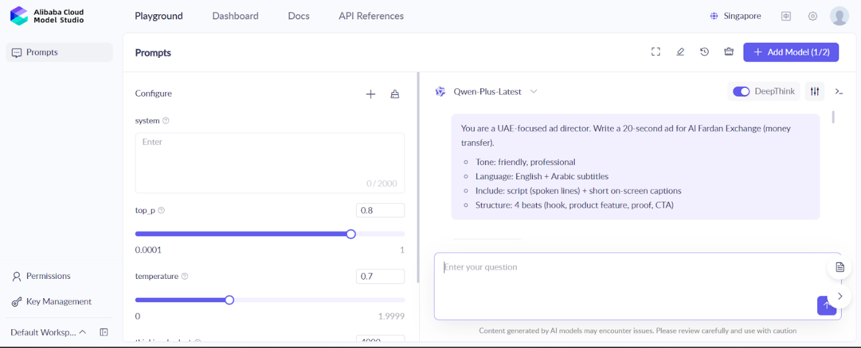

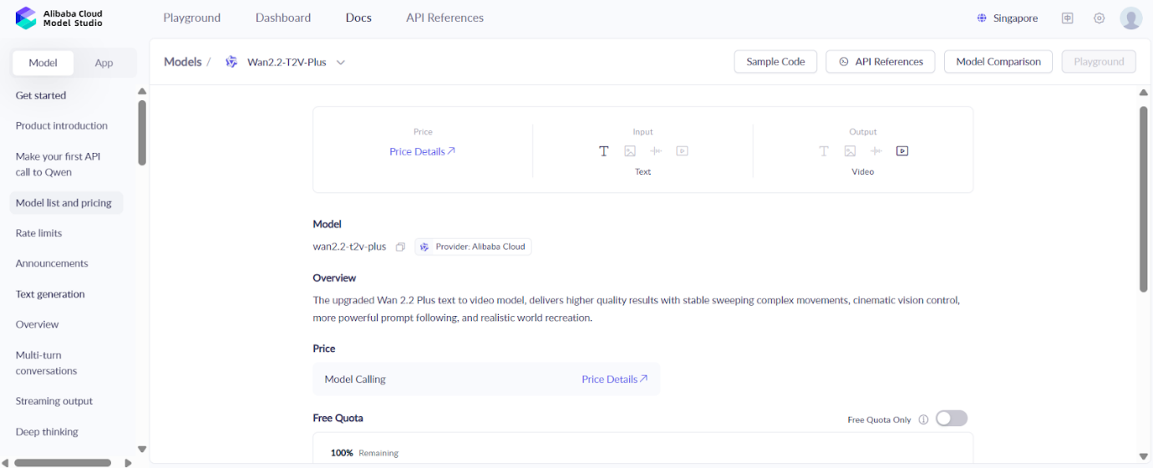

Technical Workflow
- Input brand + campaign details into the web interface.

- Backend triggers Qwen to generate:
- Marketing slogans.
- Video narration script.
- Scene descriptions.

- Prompts passed to Wan, generating 3–4 video clips (5–7 seconds each).

- Video assembly:
- Concatenation of clips.
- Background music applied.
- Brand logo and subtitles added.

- Final 20-second ad exported.

Example Prompts

Qwen Prompt
Write a 20-second promotional video script for Al Fardan Exchange. Include:
- English and Arabic captions.
- 3 scenes (customer using app, global money transfer animation, family receiving money).
- Short, clear slogans.

Wan Prompt
Generate a 7-second video: A young woman in Dubai skyline using her phone to send money. Add text overlay: “Send money fast & safely – Al Fardan Exchange”.

Challenges and Solutions
- Challenge: Garbled AI-generated text overlays.
Solution: Generate captions separately using Qwen, then manually overlay during editing.

- Challenge: Scene coherence between video clips.
Solution: Generate scene-by-scene instead of full 20s in one go.

- Challenge: Multilingual support.
Solution: Qwen’s multilingual capabilities ensured accurate Arabic + English copy.

Impact and Future Scope
- Impact: Businesses in the UAE can rapidly produce creative ads without agencies.

- Scalability: The same workflow can extend to retail, tourism, or government campaigns.

Future Enhancements:
- Add voice-over generation (Qwen + Wan).
- Build a web dashboard for non-technical users.
- Enable real-time ad personalization based on customer data.

Conclusion
Our project demonstrates how Alibaba Cloud’s Qwen + Wan ecosystem can empower businesses to produce cost-effective, scalable, and engaging AI-powered marketing campaigns. This solution reimagines traditional advertising by making it faster, smarter, and more inclusive for the UAE market.

Proof and Screenshots
Using Quwen Plus
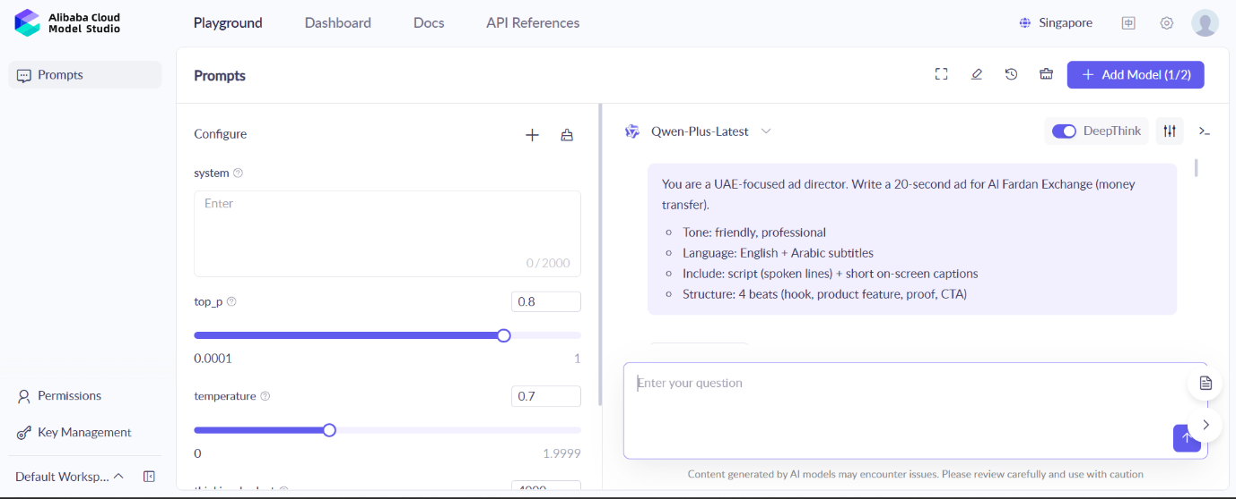
Changed environment variable to our API key
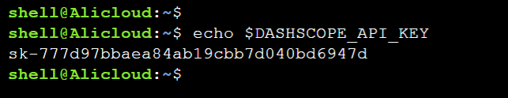
Installations on cloudshell terminal
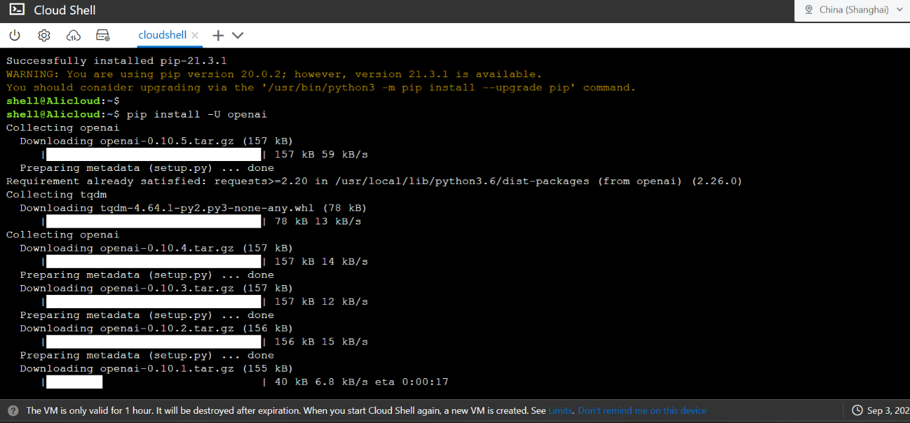
Use of 3 models to create working machine
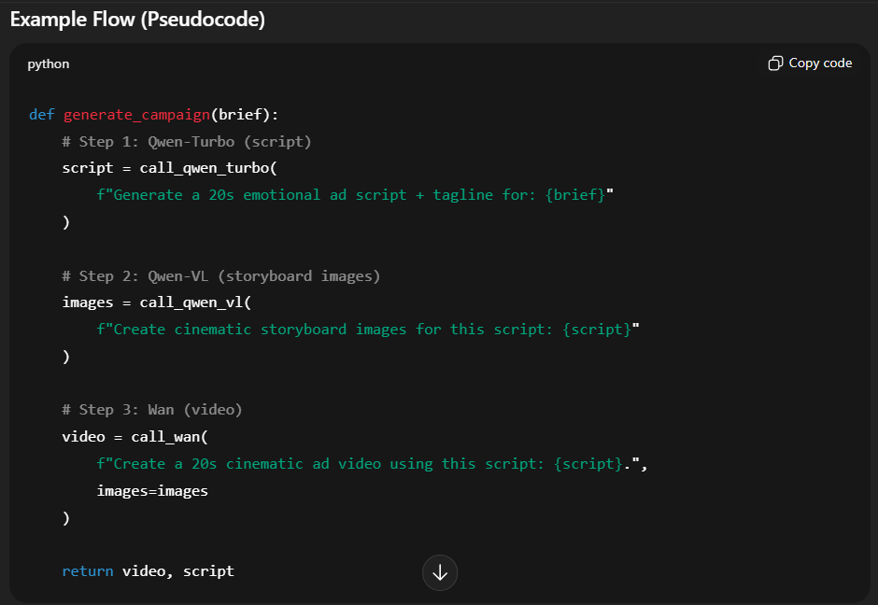
Running our code in the virtual environment
