Predicting Road Traffic Accident Severity: A Cross-National Comparison of Machine Learning Models on Ethiopian and New Zealand Crash Records

Mohammed Ishtiaq
Curtin University Dubai
Dubai, United Arab Emirates
mohammed.ishtiaq@curtindubai.ac.ae
Daksh Chauhan
Curtin University Dubai
Dubai, United Arab Emirates
daksh.chauhan@curtindubai.ac.ae
Zernish Nazir
Curtin University Dubai
Dubai, United Arab Emirates
zernish.nazir@curtindubai.ac.ae

Abstract— Road traffic injuries account for over 1 million deaths per year and cost most countries about 3% of GDP. After seeing this, we compared 5 models — LightGBM, Logistic Regression, Random Forest, XGBoost, and CatBoost — on 2 different datasets. The first dataset used was RTA (Ethiopia), with 12,316 records and 3 severity classes. The second dataset used was NZ CAS (New Zealand), which has 869,886 records and 4 severity classes. Both of these datasets had fatal-class records making up less than 1.5%, which is badly imbalanced. To tackle this, we decided to use a method called class weighting instead of resampling, and judged models by per-class recall, not just accuracy. The key finding was that Random Forest and XGBoost hit up to 85% accuracy but missed almost all fatal crashes (RTA: Random Forest, 84.6% accuracy, 0% fatal recall). On the other hand, CatBoost's result showed lower accuracy but had 44.9% fatal recall on RTA (5-fold CV) and 60% fatal recall on the New Zealand dataset, making it the model we recommend. When we looked at which factors the models relied on most to predict severity, the two datasets gave different answers: for RTA (Ethiopia), things like day of week, hour of day, and number of casualties mattered most, while in NZ CAS, things like speed limit and vehicle type mattered most. So this tells us both datasets don't rely on the same factors — they each have their own features they focus on to predict severity.This tells us that a model trained on one country's dataset might not be properly usable for another country, since this pattern we saw might not hold true elsewhere.
Keywords—machine learning, traffic accident severity, class imbalance, CatBoost, gradient boosting, feature importance, road safety

Introduction
Road injuries kill over 1.19 million people per year, according to studies [1]. Most of those affected are between the ages of 5 and 29 [1], and these accidents cost most countries about 3% of their gross domestic product [1].Knowing why and where these crashes happen, and which crashes are fatal or can later become severe, can help reduce this impact. This study helps anyone from road designers and police to emergency services, allowing them to prioritize their efforts and make their response more accurate.
There are some underlying problems with existing research. Machine learning has been used for finding the severity of accidents in many regional studies [2], [3]. But these studies have only used one dataset, from one country or city, and only report accuracy for a few classifiers. There is a much broader problem, which is that fatal or serious crashes are very rarely pointed out, or not even taken into account. Because of this, a model can end up with high accuracy just by predicting the majority outcome, without ever accurately identifying dangerous crashes. This is what is called the "accuracy paradox" — we all chase accuracy, but what is the point if that accuracy never captures the minute details we often overlook? Accuracy alone cannot tell us if a model is actually useful.
How are we doing it differently? First, we are using 5 classifiers on 2 datasets, unlike most studies, which focus on one dataset — ours are two orders of magnitude apart in size, from completely different reporting systems. This is the type of experiment that tests whether a "best model" found on one dataset actually holds up on another dataset. Secondly, we judge the classifiers by seeing how well they catch fatal or serious crashes, not by their overall accuracy — what matters is whether we are catching fatal crashes at a higher rate. Picking based on accuracy alone would have led us to choose the worst classifier on both datasets. Third, we compare which features matter most in each dataset; if feature importance changes from country to country, that is a warning against blindly trusting one country's model in another.
The remainder of this paper is organized as follows. Section II covers related work, Section III covers the two datasets, preprocessing, and classifiers used, Section IV covers results on both datasets and comparison to two earlier studies, Section V has the discussion — accuracy paradox implications and feature importance — and finally Section VI covers conclusion and future work.

Related Work
A Texas study by Çelik & Sevli [2] analyzed about 1.1 million traffic accident records. The main source was the Texas Department of Transportation, and the cities covered in the study were Austin, Dallas, and San Antonio, over a time period between 2011 and 2021. What they did was simplify severity down to just two categories: fatal/serious vs. everything else. They downsampled the majority class to deal with imbalance. There were 6 different classifiers in total. Logistic Regression was the obvious winner with 88.1% accuracy recorded, and XGBoost came close with a result of 87.9% accuracy. The top three factors contributing to these results were driver not paying attention, poor control of speed, and following the car ahead too closely.
Another study, from Maghelal et al. [3], based in Abu Dhabi, recorded 11,334 vehicle crash records from 2014 to 2017. What they did was they removed pedestrian and non-vehicle incidents first, then downsampled each severity class to 490 records. The final dataset had 1,960 usable records, and they used 4 severity classes compared to the Texas study. These were tested with 3 models: Random Forest, Gradient Boosting, and SVM. Random Forest won but only had 44.4% accuracy, which was much lower than the Texas study. The two main reasons for this gap were: first, way fewer records were used; second, more classes to split predictions across. Their top predictors were the age of the injured person, the age of the person who caused the crash, and the manufacturing year of the vehicle. The factor given least importance was the gender of the person.
The Kaggle notebook [4] we used is actually non-peer-reviewed, so it's fair to think of this as a weaker source than the two published papers. It used the same Ethiopian RTA dataset as our study. What it did was drop 13 columns that had missing data, instead of filling them in. It also label-encoded every categorical variable, including the target variable itself, and applied SMOTE oversampling after that. Label encoding assigns an arbitrary number to different categories that have no natural order — e.g., if "Rainy," "Foggy," "Clear" get turned into 1, 2, 3, the model might treat "Foggy" as somehow "between" or "worse than" the others, which is meaningless.
SMOTE then generates new data points based on the numerical relationships between already-existing records, but if the numbers are already fake and meaningless because of label encoding, the synthetic data inherits and amplifies the problem. What we did differently was use one-hot encoding, or let CatBoost and LightGBM handle categories natively — this is what Section III talks about in more detail.
There is a real gap between the accuracy in both studies. Texas shows 88.1%, whereas the Abu Dhabi study shows 44.4% — nearly half in comparison. A huge reason for this is the size of the dataset, and how many severity classes each used. The actual reason though, in the literature, is that neither paper tested their approach on more than one dataset. This means nobody checked whether their best model was actually the best, or even close to best, in a different dataset, and whether it could hold up its accuracy elsewhere. This is literally the gap our own paper solves — we use two datasets instead of one, to test how the results turn out for the best model in both cases.

Methodology
A. Datasets
Our research used two publicly available crash datasets. The first dataset, Addis Ababa Road Traffic Accident Dataset, has 12,316 records and 32 attributes involving driver characteristics, vehicle details, road conditions, environmental conditions, and crash outcomes [5]. Severity was classified under three categories: Slight Injury (84.6%), Serious Injury (14.2%), and Fatal Injury (1.3%).

The second dataset, the New Zealand Transport’s Crash Analysis System Dataset [6], has 869,886 records from 2000 to 2024. The data includes 57 attributes involving road characteristics, environmental conditions, vehicles involved, and traffic conditions. Severity was classified under four categories: Non-Injury Crash (69.8%), Minor Crash (23.5%), Serious Crash (5.8%), and Fatal Crash (0.9%).

TABLE I. DATASET SUMMARY
Property | RTA Dataset | NZ CAS Dataset
Records | 12,316 | 869,886
Features used | 30 | 57
Severity classes | 3 | 4
Fatal-class share | 1.3% | 0.9%

B. Data Preprocessing
Attributes involving fatality and injury counts were left out as those are mainly responsible for classifying severity. Keeping such attributes would allow the models to predict severity from simple attributes instead of learning from actual crash conditions. The timestamp recorded in the data would have also required special handling as one-hot encoding would have created thousands of similar columns that would give the model unnecessary amounts of information. The records were converted into a simpler format that recorded just the hour of the day.

Sixteen columns in the Addis Ababa Road Traffic Accident dataset also included unknown/missing data. Attributes were missing 1.2% to 35.9% of their values. Such records were labelled as ‘Unknown” as the record still contained useful information and dropping such records would significantly reduce the number of usable records.

The New Zealand Transport’s Crash Analysis System dataset also contained unknown/missing data. Attributes recording involved object/vehicle types contained blank/missing values. Such records had the missing data replaced by zeros. Attributes recording descriptive information (e.g., road and environmental conditions) that included unknown/missing data were given the same treatment as the Addis Ababa dataset. Attributes recording the speed limit and number of lanes that contained missing/unknown data were replaced by the median value of the respective attribute.

Categorical attributes were one-hot encoded for models such as Logistic Regression, Random Forest, and XGBoost. Models such as CatBoost and LightGBM include native categorical feature handling and so were given non-one-hot encoded data. Such models are better suited to datasets including a large number of categorical attributes. This means such models have a better chance of performing well with datasets such as the Addis Ababa Road Traffic Accident and New Zealand Transport’s Crash Analysis System Datasets.

C. Class Imbalance Handling
In both the Addis Ababa and New Zealand datasets, fatal crashes make up less than 1.5% of their respective datasets. This means that both datasets have a fatal imbalance problem which can be mitigated with class weighting during training. This penalizes getting a minority-class prediction wrong in proportion to how rare the severity class is, instead of resampling the data.

An attempt to down sample the Addis Ababa dataset was made which cut down every class to match the smallest one (127 fatal-class records), which left 381 rows of records in the dataset. This resulted in worse overall scores (51.8% accuracy, 7.8% fatal F1-score). Class weighting was selected as the best way to handle the data as it retains the entire datasets.

D. Models
Five classifiers were evaluated. Logistic Regression is a linear, easy-to-interpret baseline. Random Forest groups an ensemble of decision trees. XGBoost and LightGBM are gradient boosting methods which differ in how trees are grown and how they handle categorical data. CatBoost, while also a gradient boosting method, is built specifically to handle categorical features without requiring encoding. It uses ordered boosting to cut down a form of target leakage that can creep in during categorical processing [7].

Every model used class-weighted training wherever applicable. XGBoost did not offer a direct multi-class weighting parameter and so a similar effect was approximated with sample weights.

E. Evaluation Metrics
Model performance was recorded using the overall accuracy, the weighted F1-score, and a per-class recall with more attention given to the fatal crash class. As it will be demonstrated in Section IV, a classifier that only predicted the majority class on the Addis Ababa dataset achieved 84.6% accuracy while identifying 0% of the fatal/serious cases. Reporting Accuracy would favor a model that does not discriminate when it comes to the outcome that matters most to road safety applications.

F. Cross-Validation
For the Addis Ababa Road Traffic Accident Dataset, results were reported from an 80/20 train-test data split. A five-fold cross validation checked if a single-split number was not just a quirk of how the dataset was split.

The New Zealand Transport’s Crash Analysis System Dataset was large enough, so an 80/20 split, with a held-out validation set (16% of the data) for early stopping was used. While training models such as CatBoost and LightGBM, each model could run up to 3,000 boosting iterations and stop automatically if one hundred iterations in a row failed to improve on the validation set.

Results

RTA Dataset Results
Table II presents the performance of the different models on the RTA test dataset using a single 80/20 train-test split (n = 2,464). Random Forest achieved the highest accuracy of 84.6%; however, its fatal-class recall was 0%. The confusion matrix gives a clearer picture of this result. All 2,464 test records were predicted as slight injury, including the 349 serious-injury cases and all 31 fatal-injury cases.
CatBoost had a lower overall accuracy of 69.8%, but it performed much better when identifying the more severe cases. It achieved a fatal recall of 42% and a serious-injury recall of 43%. Unlike Random Forest, CatBoost produced predictions across all three severity classes instead of mainly predicting the majority class.
Five-fold stratified cross-validation produced similar results for CatBoost. Across the five folds, the model achieved an average accuracy of 67.2% (± 1.3%) and an average fatal recall of 44.9% (± 5.8%). This suggests that the results from the single train-test split were reasonably consistent and were not simply caused by the particular split of the dataset.
- MODEL PERFORMANCE ON THE RTA DATASET (TEST SET, n = 2,464)
Model | Accuracy | Weighted F1 | Fatal Recall
Logistic Regression | 49.2% | 0.581 | 39%
Random Forest | 84.6% | 0.775 | 0%
XGBoost | 73.5% | 0.757 | 23%
LightGBM | 79.7% | 0.796 | 23%
CatBoost (recommended) | 69.8% | 0.732 | 42%
Five-fold stratified cross-validation was consistent with these results: CatBoost averaged 67.2% accuracy (± 1.3%) and 44.9% fatal recall (± 5.8%) across the five folds, confirming the single-split result was not an outlier.

NZ CAS Dataset Results
The results for the NZ CAS are shown in Table III, which covers a test set of 173,978 records. CatBoost was run with early stopping to the 3,000-iteration cap, produced an accuracy of 57.4% and a fatal recall of 60%. LightGBM had a better accuracy figure of 62.5%, but its fatal recall was only 18%. This is not unlike the pattern seen with RTA where one can have high overall accuracy and still be poor at identifying the fatal crashes.
CatBoost’s better result on fatal recall in the NZ CAS may be a result of having more fatal examples to work with during training. The NZ CAS contains 8,031 such records compared to just 158 in the RTA, and those additional minority examples would have given the model a better opportunity to pick up on the patterns of a fatal crash
- MODEL PERFORMANCE ON THE NZ CAS DATASET (TEST SET, n = 173,978)
Model | Accuracy | Weighted F1 | Fatal Recall
LightGBM | 62.5% | 0.647 | 18%
CatBoost (recommended) | 57.4% | 0.614 | 60%

Feature Importance
Figures 1 and 2 show the top fifteen features for each dataset as determined by CatBoost’s feature importance metrics. With the RTA data, the most significant were day of week, junction type, hour of day and number of casualties. Driver age and experience were present too but with less weight.
For NZ CAS, the speed limit, vehicle type and crash year were the most influential features. Driver characteristics did not carry as much importance here mainly because the NZ CAS features we examined in this study were mostly related to environmental and road conditions rather than the driver.
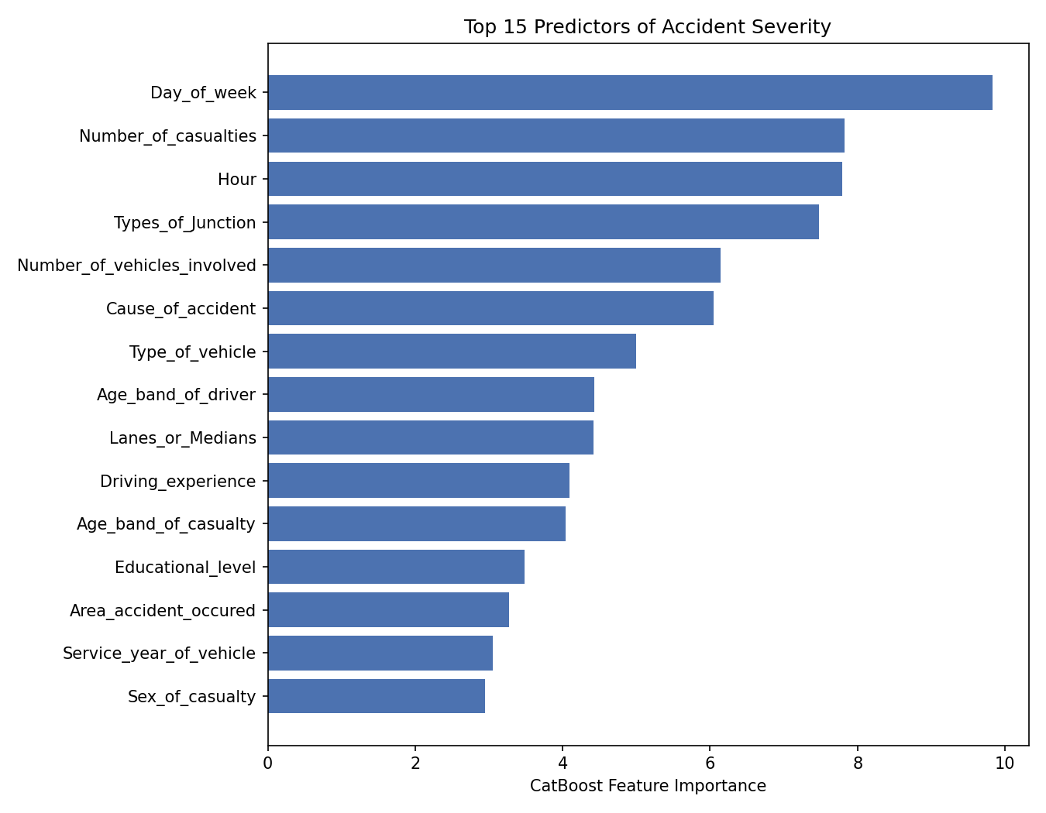
- Top 15 predictors of severity on the RTA dataset (CatBoost feature importance).
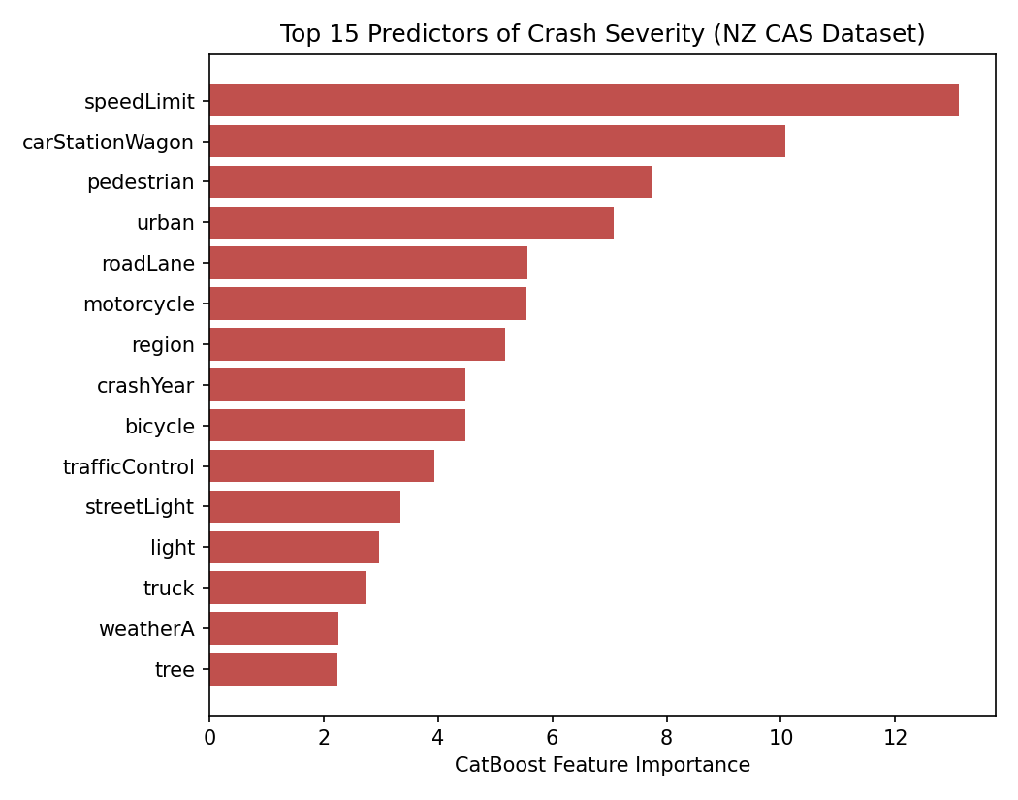
- Top 15 predictors of severity on the NZ CAS dataset (CatBoost feature importance).

Comparison with Published Studies
Table IV puts the findings of this study side by side with the two from Section II. The RTA came in at 67.2% accuracy (five-fold cross-validation), which is somewhere between the Texas study at 88.1% and Abu Dhabi’s at 44.4%. These differences can be attributed to variations in the severity classes and the size of the datasets, Texas had a larger pool with only two classes, but Abu Dhabi worked with four on a smaller scale.
For NZ CAS, CatBoost achieved a 60% fatal-class recall, exceeding both previous studies. This is likely from the larger number of fatal-crash examples in NZ CAS, providing more minority-class data during training.
- COMPARISON WITH PUBLISHED STUDIES
Study | Records | Classes | Best Model | Accuracy
Çelik & Sevli [2] | 1,100,000 | 2 | Log. Reg. | 88.1%
Maghelal et al. [3] | 1,960 | 4 | Rand. Forest | 44.4%
This study (RTA) | 12,316 | 3 | CatBoost | 67.2%†
This study (NZ CAS) | 869,886 | 4 | CatBoost | 57.4%
- † Five-fold cross-validated result.

Discussion

The Accuracy Paradox in Practice
Look at Table II and Table III and the case against picking a model on accuracy alone makes itself. Random Forest beats CatBoost by nearly 15 points of accuracy on the RTA data, and catches zero fatal or serious cases. Not a few. Zero. CatBoost, sitting at the “worse” accuracy score, catches 42% of fatal cases and 43% of serious ones. The New Zealand data tells the same story from a different angle: LightGBM edges out CatBoost by about 5 points of accuracy, but its fatal recall is not even a third of CatBoost's. Both high-accuracy models are winning by doing the same thing: correctly guessing the boring majority outcome over and over. That is not useful if the entire point of the system is to flag the crashes that actually kill people.

Cross-Dataset Differences in Feature Importance
The two datasets do not even agree on what matters. Day of week, hour, and casualty count lead on the RTA data; speed limit and vehicle type lead on the NZ CAS data. Some of that gap is just what each dataset happened to record, not a real difference in what causes crashes to turn deadly. The RTA data does not capture speed limit with anywhere near the same detail NZ CAS does, and the NZ feature set we used does not include driver age or experience at all, both of which mattered a lot in the RTA results and in the Abu Dhabi study [3]. So a feature missing from the top of the list might just mean it was not in the dataset, not that it does not matter. That is a real caution for anyone thinking a severity model trained in one country will just work in another: check what each dataset actually records before assuming the features line up.

Practical Implications
If the goal is catching accidents likely to turn serious or fatal, these results point in one direction: care about per-class recall on the rare, dangerous outcomes, not overall accuracy, and CatBoost with class weighting is the better pick over the higher-accuracy alternatives tested here. This held up across two countries, two very different dataset sizes, and two different ways of categorizing severity, which makes it harder to write off as a fluke of one particular dataset.

Conclusion and Future Work
We tested five classifiers across two crash datasets from separate national systems. One is nearly a hundred times the size of the other, which points to CatBoost seeming to be the best choice when class weighting is applied. While Random Forest and LightGBM put up better raw accuracy numbers, CatBoost was more effective at picking out fatal and serious cases in both instances. This result was consistent under five-fold cross-validation on the smaller dataset and on a test set of over 170,000 real records on the larger one, so it is not an isolated finding.
The two datasets disagreed on which features were most important; that seems to indicate that severity models might need to be adjusted to the specific data a region collects instead of being assumed to transfer across countries.
When considering future work, more national datasets should be tested to see whether this accuracy-versus-recall trade-off keeps showing up. Driver demographics, too, need to be added to the NZ feature set; otherwise, the two datasets are not exactly being compared fairly. As for whether CatBoost’s categorical handling, along with targeted oversampling of fatal cases rather than class weighting alone, can push recall higher without the data loss seen from plain downsampling remians an open question.

References
- World Health Organization, “Road traffic injuries,” Fact sheet, 2023. [Online]. Available: https://www.who.int/news-room/fact-sheets/detail/road-traffic-injuries
- A. Çelik and O. Sevli, “Predicting traffic accident severity using machine learning techniques,” Türk Doğa ve Fen Dergisi, vol. 11, no. 3, pp. 79–83, 2022, doi: 10.46810/tdfd.1136432.
- P. Maghelal, A. H. Ali, E. Azar, R. Jayaraman, and K. Khalaf, “Severity of vehicle-to-vehicle accidents in the UAE: An exploratory analysis using machine learning algorithms,” Heliyon, vol. 9, no. 10, e20694, 2023, doi: 10.1016/j.heliyon.2023.e20694.
- P. Telavane, “Road traffic accident severity prediction,” Kaggle notebook. [Online]. Available: https://www.kaggle.com/code/poojatelavane/road-traffic-accident-severity-prediction
- S. Shahane, “Road traffic accidents,” Kaggle dataset. [Online]. Available: https://www.kaggle.com/datasets/saurabhshahane/road-traffic-accidents
- Waka Kotahi New Zealand Transport Agency, “Crash Analysis System (CAS) data,” 2024. [Online]. Available: https://www.kaggle.com/datasets/maryamrahmani/crash-analysis-system-cas-data-new-zealand
- L. Prokhorenkova, G. Gusev, A. Vorobev, A. V. Dorogush, and A. Gulin, “CatBoost: unbiased boosting with categorical features,” in Advances in Neural Information Processing Systems 31 (NeurIPS 2018), 2018, pp. 6638–6648.
- T. Chen and C. Guestrin, “XGBoost: A scalable tree boosting system,” in Proc. 22nd ACM SIGKDD Int. Conf. Knowledge Discovery and Data Mining, 2016, pp. 785–794.
- G. Ke et al., “LightGBM: A highly efficient gradient boosting decision tree,” in Advances in Neural Information Processing Systems 30 (NIPS 2017), 2017, pp. 3146–3154.
- L. Breiman, “Random forests,” Machine Learning, vol. 45, no. 1, pp. 5–32, 2001.
- D. R. Cox, “The regression analysis of binary sequences,” J. Roy. Stat. Soc. B, vol. 20, no. 2, pp. 215–232, 1958.
- N. V. Chawla, K. W. Bowyer, L. O. Hall, and W. P. Kegelmeyer, “SMOTE: Synthetic minority over-sampling technique,” J. Artificial Intelligence Research, vol. 16, pp. 321–357, 2002.
- F. Pedregosa et al., “Scikit-learn: Machine learning in Python,” J. Machine Learning Research, vol. 12, pp. 2825–2830, 2011.

