ONLINE EXAMINATION SYSTEM

**Team Guide: MR. Abhishek Goyal**

**Members: 1.MEDHA GAUTAM**

**2. MINHAJ UDDIN**

**College Name: ABES Engineering College**

**Department: Computer Science**

**State: Uttar Pradesh**

2015

**4 4**

**1. Introduction**

**1.1 Purpose**

This Web Application provides facility of online examination worldwide. It saves time as it allows number of student candidates to give the exam at same time and display the results at the end of the test, so there is no need to wait for the result. It is evaluated and generated by the server. Examiner has privileges to create, modify and delete the test papers and its particular questions. Students can register, login and give the test with his specific id, and can see the results as well. It eliminates the use of items like pen, paper, etc.

**1.2 Document Conventions**

This document was prepared using the IEEE recommended practice for Software Requirements Specification.

**13 Intended Audience and Reading Suggestions**

The different types of reader that this document is intended for are developers, project managers. Marketing staff, users, testers, and documentation writers. The rest of this SRS contains Overall Description, External Interface Requirements, System Features, and Non Functional Requirements and Other Requirements. Suggested sequence for reading the document - begin with the overview sections and proceed through the sections that are most pertinent to each reader type.

**1.4 Product Scope**

Scope of this project is very broad compared to manually taken exams. They are:-

* This app can be used in educational institutions as well as in corporate world.
* Can be used anywhere any time as it is a web based application (user location doesn't matter).
* No restriction that examiner has to be present when the candidate takes the test.
* No manual work of preparing and storing the result information.
* Less time consumption, as the result is calculated immediately after the test and displayed to the student candidate.
* For students/candidates, it saves time of going too far away centers to give exams.

**1.5 References**

This web application has been prepared on the basis of discussion with Team members and also taken information from following website [www.google.com](http://www.google.com) .

**2. Overall Description**

**2.1 Product Perspective**

TEST_ONLINE is an on-line examination system. It is accessible via the Internet, 24 hours a day, 7 days a week. The objective of this app is to reach and connect candidate and examiner in remote communities and conduct exams in a virtual environment online. This app will only allow the registered users to enter the test module. The various stages in the app are as follows:-

* Login
* System Overview
* Test
* Result
* Login :

This window offers the user two choices for logging into the system according to the preset privileges – Student login and Faculty login.

The student login will take the user to the student profile.

The Faculty Login will take the user to the examiner profile.

* System Overview :

This window can only be accessed by the administrator. It allows the administrator to add and edit site preferences.

* Test :

This window contains all the exams candidate can give. All these exams are organized according to the categories they fall in. The test window will be different for students and corporate employees.

* Result **:**

This window displays the result of exams the candidate has just appeared, this data will be saved and displayed in the user profile. If the score is in top 10, the result will also be displayed in the rankings area of result window.

**2.2 Product Functions**

The functions are divided according to the user types such as:-

Administrator:- The function of the administrator is to add/remove/modify exams in the test module.

Candidate:- The function of the student is to update his/her profile and give various exams.

**2.3 User Classes and Characteristics**

The various users of this app are classified into two types:-

* Administrator
* Student

This app requires the user to have characteristics such as the user should be able to communicate and write in English and should have previous experience of giving an online exam. If not, the candidate should be instructed about the basics usage of the app by authorized personnel.

**2.4 Operating Environment**

This app is internet based so it will run in any operating systemwith internet access through a web browser.

**2.5 Design and Implementation Constraints**

The candidate is allowed to give the exams any number of times, until specified otherwise by the examiner while building the test.While giving the exam the candidate is given only a set amount of time (if specified by the examiner) and the remaining time should be displayed, after which the exam should close and display the result.

**2.6 User Documentation**

The product will include a user manual. The user manual will include product overview, complete configuration of the required software and hardware, technical details and contact information which will include email address of team members.

**2.7 Assumptions and Dependencies**

Proper working of this app is dependent on the internet connectivity of the users' computer. Assumptions and dependencies:

* It is assumed that the user has basic knowledge of the system as any action by the user is considered valid during an examination.
* It is assumed that the data entered by the user while registering is true.
* It is assumed that the candidate does not cheat during the exam as there are no supervisors around to monitor.

**3. External Interface Requirements**

**3.1.1 User Interfaces**

*Registration Screen:

Various fields available on this screen will be:

* Login Name
* Email Id
* Password
* Department Name

*Login Screen:

Fields available on this screen are:

* Login Name
* Password

*Entering Questions:

Various Fields are:

* Questions
* Options (4)
* Correct Answer

*Exam Detains Screen:

Various Fields are:

* Exam Name
* ­No. Of Questions
* Time Limit
* Passing Marks

*Result Displaying Screen:

Various Fields are:

* No. Of Correct Questions
* No. Of Incorrect Questions
* Total Marks
* Result(Pass/Fail)

**3.1.2 Hardware Interfaces**

Depends on the user comfortability.

**3.1.3 Software Interfaces**

* Any windows based operating system.
* Server Database
* Php and JavaScript
* Html Css
* Bootstrap
* Ajax

**3.2 Functional Requirements**

**This section gives a functional requirement that are applicable to the On-Line Examination system, there are three sub modules in this phase.**

* **Candidate module.**
* **Examiner module.**
* **Administrator module.**

**3.3 Behavior Requirement 3.3.1 Use Case Diagram**

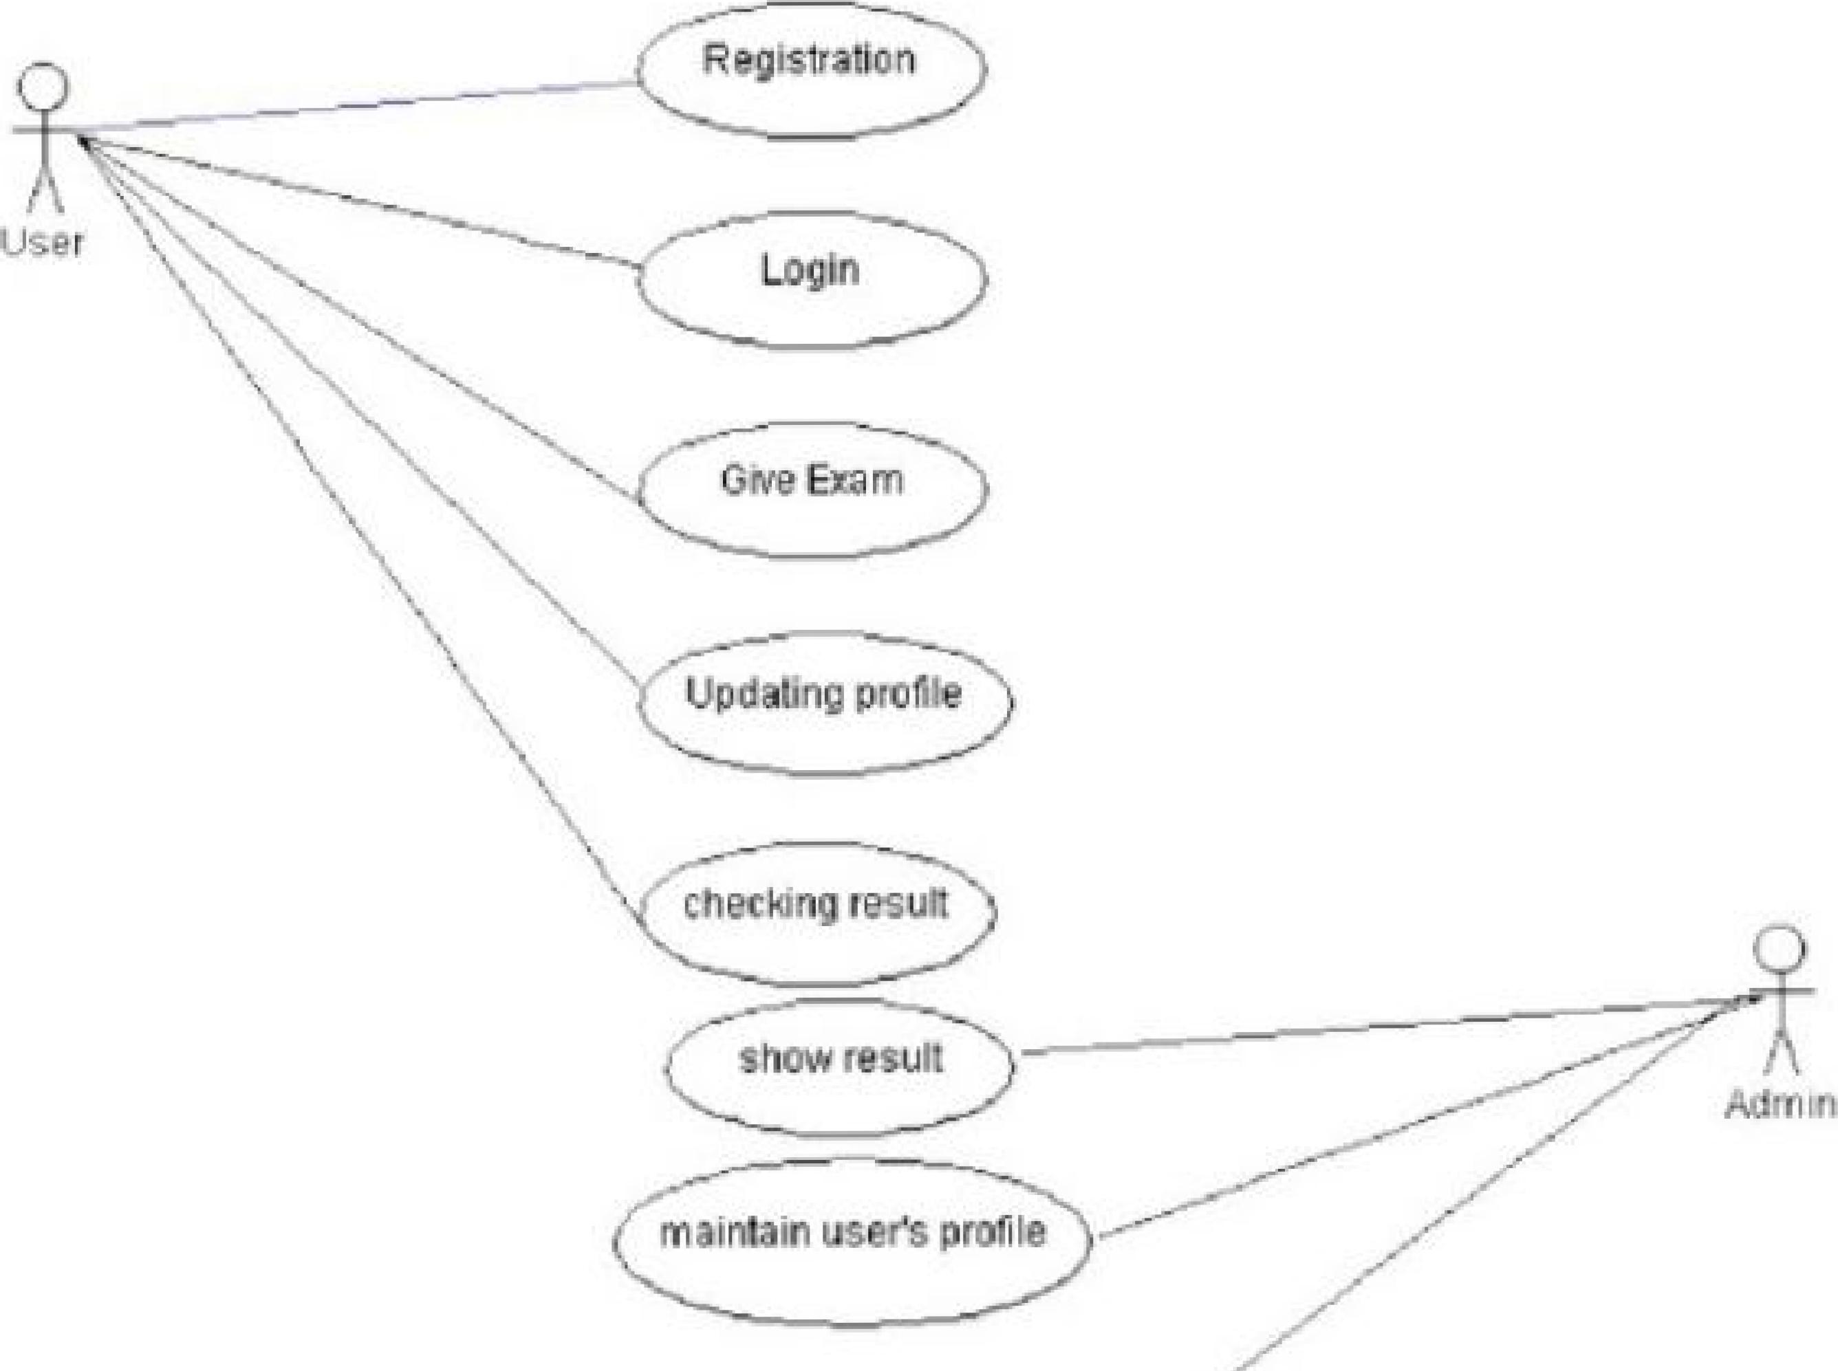

**3.3.2 Entity Relationship Diagram**

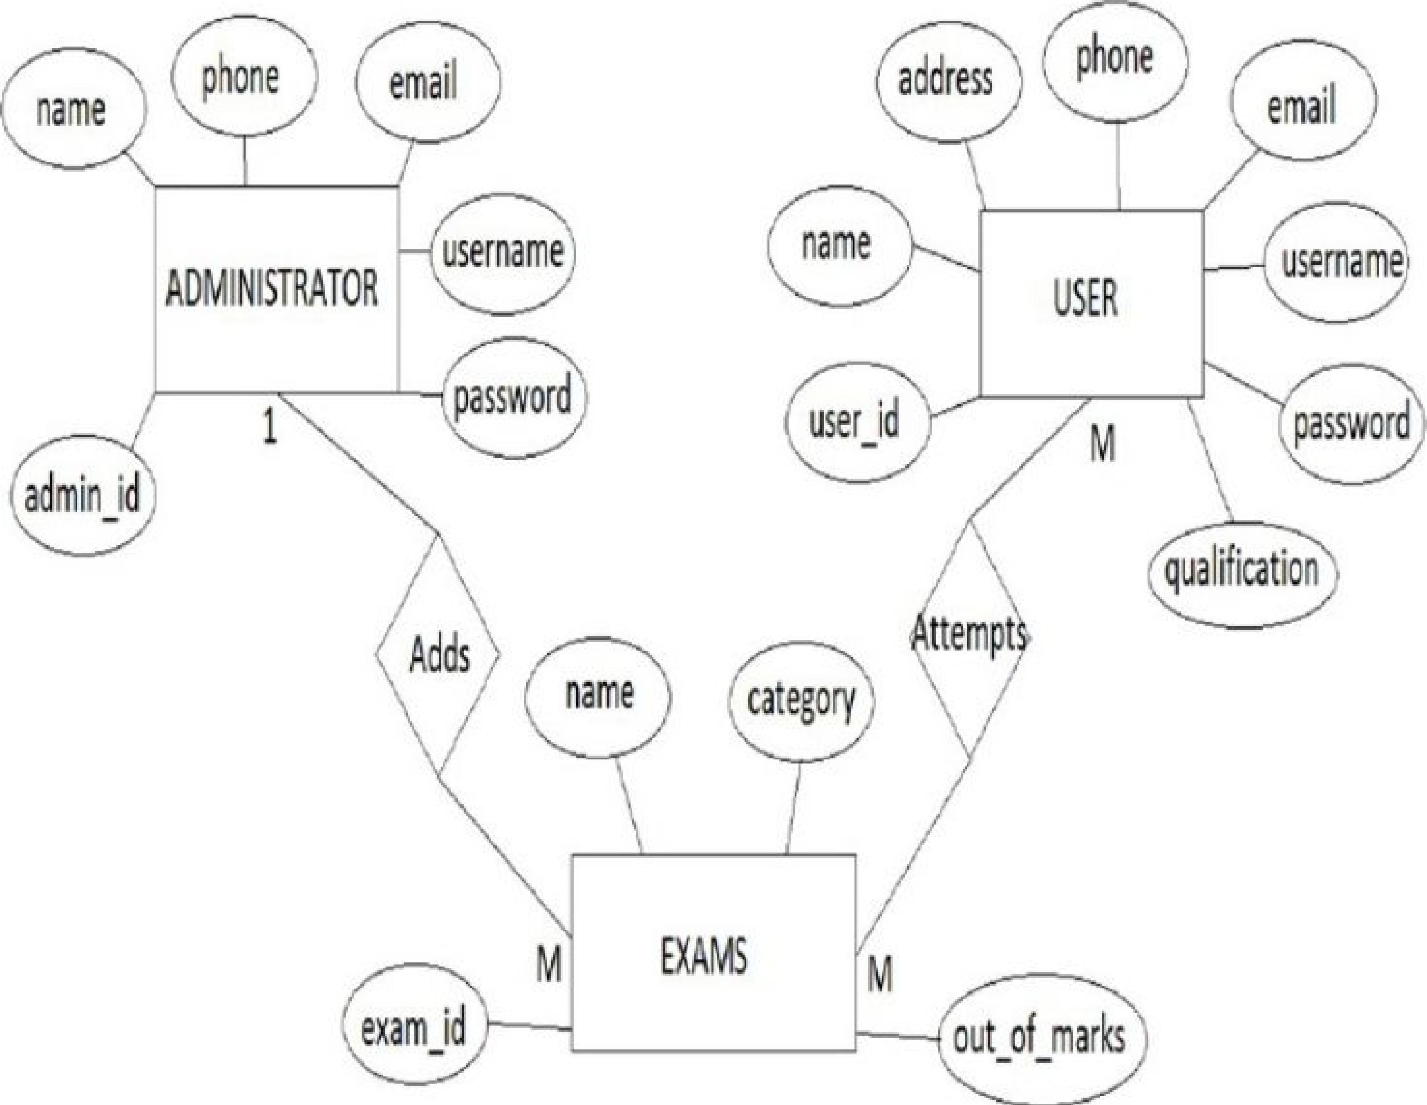

ADMINISTRATOR

**Online Examination System DFD**

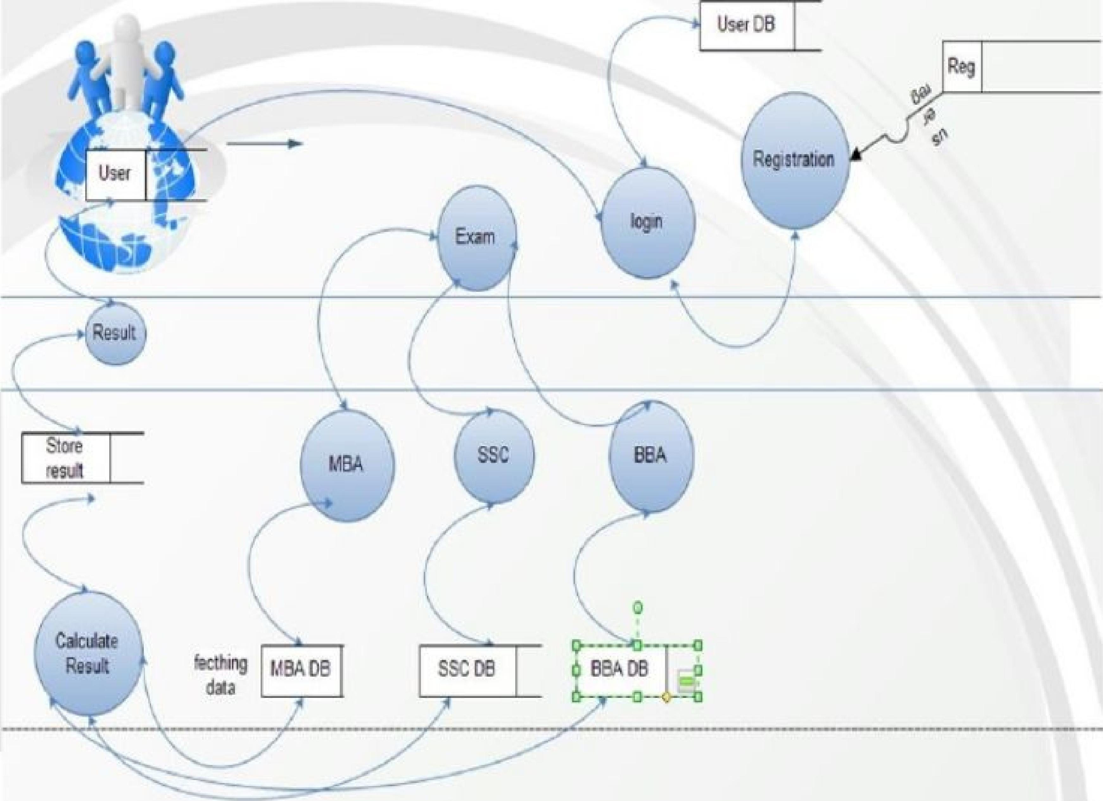

**DATABASE SYSTEM :** 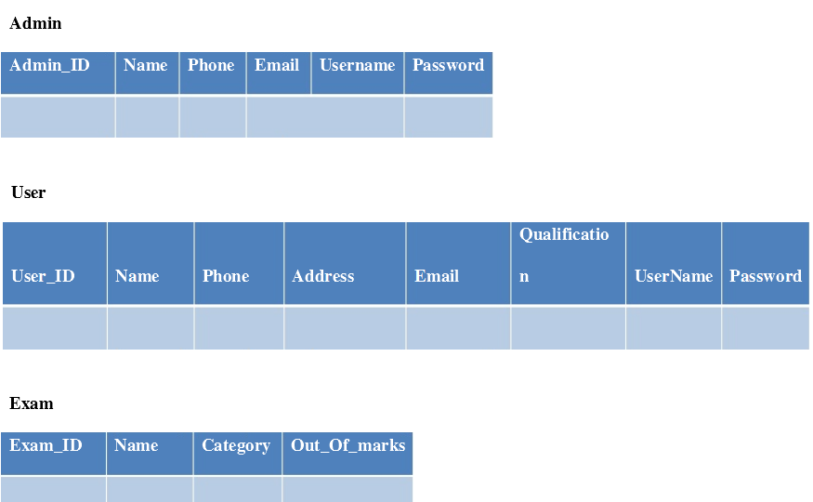

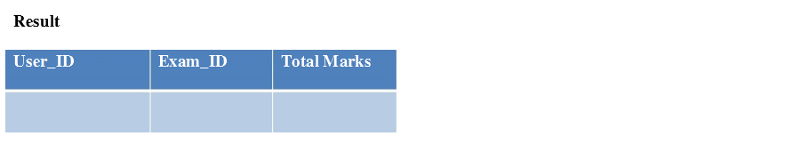

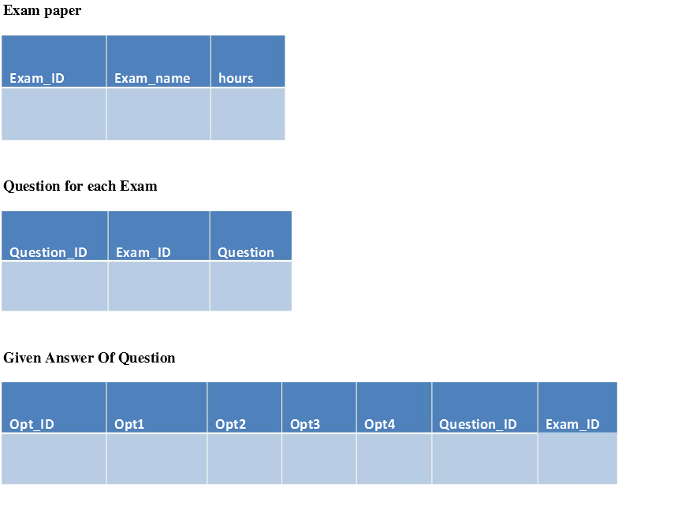Some Performance requirements identified is listed below:

* The database shall be able to accommodate a minimum of 1 ,000 records of Users,
* The software shall support use of multiple users at a time.
* There are no other specific performance requirements that will affect development.

**4.1 Safety and Security Requirements**

**4.1.2 Safety Requirements**

The database may get crashed at any certain time due to virus or operating system failure. Therefore, it is required to take the database backup.

**413 Security Requirements**

Some of the factors that are identified to protect the software from accidental or malicious access, use, modification below. Keep specific log or history data sets assign certain functions to different modules.

**4.2 Software Quality Attributes**

The Quality of the System is maintained in such a way so that it can be very user friendly to all the users.

The software quality attribute are assumed as under:

Accurate and hence reliable.

Some of the factors that are identified to protect the software from accidental or malicious access, use, modification below. Keep specific log or history data sets assign certain functions to different modules.

**4.2 Software Quality Attributes**

The Quality of the System is maintained in such a way so that it can be very user friendly to all the users.

The software quality attributes are assumed as under:

* + - * Fast speed.
      * Compatibility.
      * Secured.
      * Accurate and hence reliable.