|  |  |  |  |  |
| --- | --- | --- | --- | --- |
|  | PHYSICS 1 (1st Quarter) | |  |  |
| Module # | 6.0 | **Name:** |  |
| Module Title | Projectile Motion | **Section:** |  |
| Lesson # | 6.1 | **Date:** |  |
| Lesson Title | Activity: Projectile Motion using a Simulation | |  |

**Materials Needed:**

Internet connection

Tablet

Introduction:

Projectile motion is the motion of an object thrown or projected into the air, subject only to the force of gravity. The object is called a projectile, and its path is called its trajectory. The trajectory is influenced by the gravitational force. A projectile may be launched in three ways:

1. Throwing an object vertically upward.

2. Throwing an object upward at an angle to the horizontal

3. Throwing an object horizontally from a certain height.

**Procedure:**

**A. Horizontally Launched Projectiles**

1. Access the Physics Classroom Projectile Motion Simulator through the website:

https://www.physicsclassroom.com/Physics-Interactives/Vectors-and-Projectiles/Projectile-Simulator/Projectile-Simulator-Interactive

1. Press RESET to enlarge the simulation. Play around with the Flash presentation to get familiar with its tools. The launch speed, launch angle, and launch height can be varied by using the slider or the buttons. A trace of the object’s motion can be turned on, turned off or erased. The vector nature of velocity and acceleration can be depicted on the screen. The animation can be started, paused, continued, or rewound. In addition, the time of flight as well as the horizontal and vertical displacement are displayed during the course of the animation.
2. Raise the launch height to about 120 meters above the ground and adjust the launch angle to 0 degree. Set the initial speed to 40 m/s. Conduct several trials to answer the following questions:
3. During the course of the trajectory, does the horizontal component of the velocity remain constant or does it change? If it changes, describe the change in terms of magnitude and direction.

_________________________________________________________________________________________________________________________________________________________________________________________________________________________________________________________________________________________________________

b. During the course of the trajectory, does the vertical component of the velocity remain constant or does it change? If it changes, describe the change in terms of magnitude and direction.

_________________________________________________________________________________________________________________________________________________________________________________________________________________________________________________________________________________________________________

1. Describe the acceleration of a projectile (direction, constant or changing magnitude, etc). Provide a comprehensive description.

_____________________________________________________________________________________________________________________________________________________________________________________________________________________________________________________________________________________________

**B. Projectiles Launched at an Angle**

1. Access the Physics Classroom Projectile Motion Simulator through the website:

https://phet.colorado.edu/sims/html/projectile-motion/latest/projectile-m otion_en.html

2. Open the VECTOR section of the simulation. Set the angle of launch to 80 degrees with respect to the horizontal. Set the initial velocity to 18 m/s. Remove air resistance, select components (instead of total), then check the velocity and acceleration vectors components. You may set the simulation to slow motion.

3. Consider questions 1-3 in the previous section of this activity (horizontally-launched projectiles). Would launching a projectile at an angle affect any of your answers which you provided earlier? Consider path or trajectory, horizontal velocity (vx ), vertical velocity (vy ), and acceleration. Be thorough and organized in your discussion.

______________________________________________________________________________________________________________________________________________________________________________________________________________________________________________________________________________________________________________________________

4. At what point in the projectile’s trajectory is the velocity entirely horizontal (i.e. the vertical velocity is zero)? If necessary, slow down the simulation.

___________________________________________________________________________________________________________________________________________________________________________________________________________________________________________________________________________________________________________________________

5. Set the launch speed to 15 m/s and the launch height to 0. Fill out the table below to investigate the effect of launch angle on horizontal displacement.

to where the projectile hit the ground to see the horizontal displacement or range.

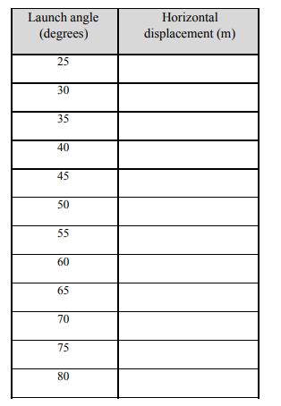

6. What do you observe about the pattern of the values of horizontal displacement with respect to the angle of launch?

__________________________________________________________________________________________________________________________________________________________________________________________________________________________________________________________________________________________________________________