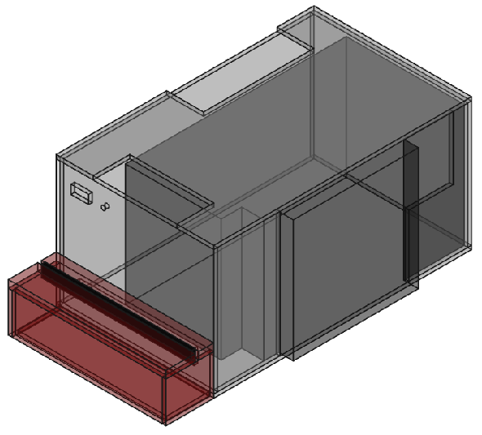
Pseudo-Stablized Power Supply from ATX PSU
Table of Contents
Overview 3
Diagrams 4
Case 4
Left Side 4
Right Side Front 5
Right Side Back 5
Back 6
Front 6
Back 7
Bottom 8
Top 9
Control Panel 10
Front 10
Right/Left Side 10
Bottom 10
Top Back 10
Top Front 11

Overview
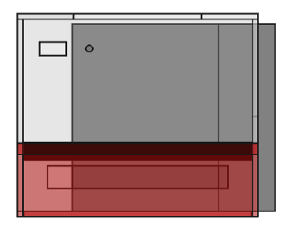
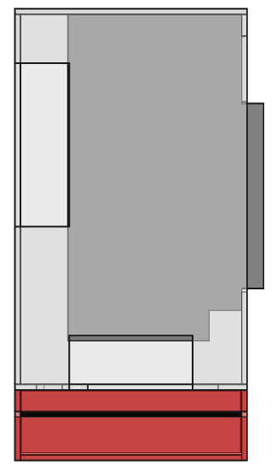
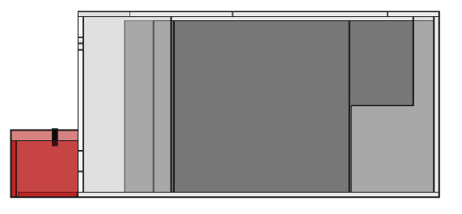

Diagrams

Case

Left Side
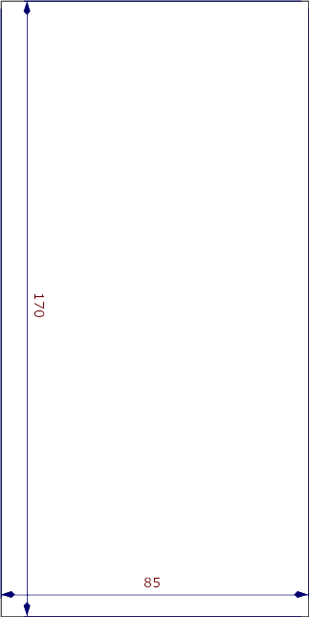
Left Side - Case

Right Side Front
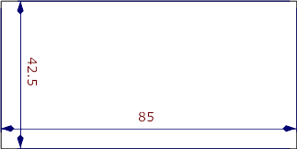
Right Side Front - Case

Right Side Back
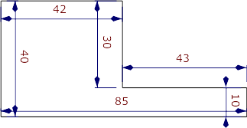

Right Side Back - Case

Back
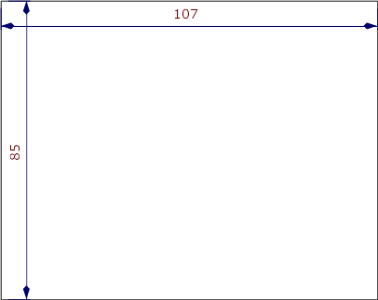

Back - Case

Front
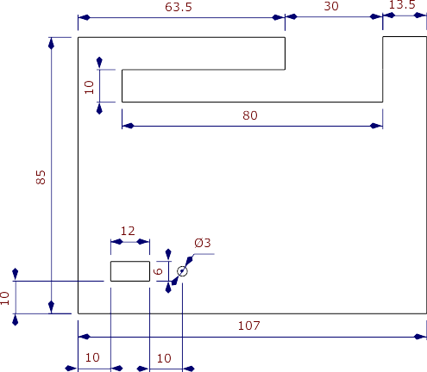
Front - Case

Bottom
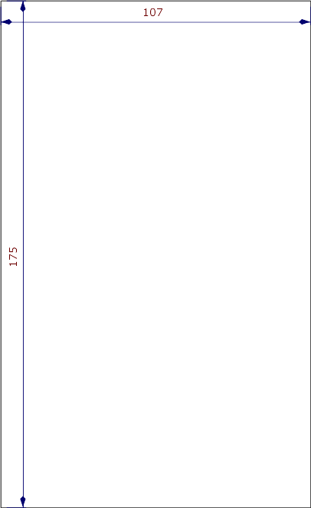
Bottom - Case

Top
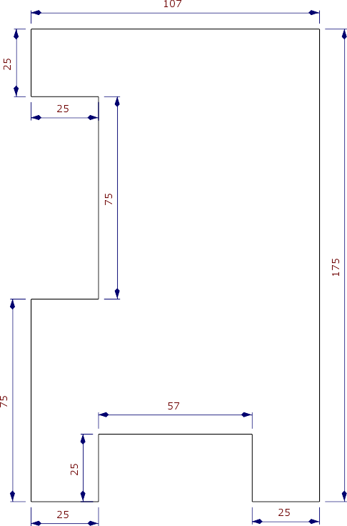
Top - Case

Control Panel

Front

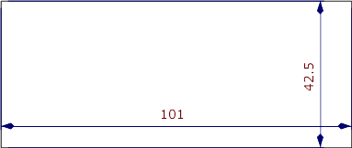
Front – Ctrl Panel

Right/Left Side
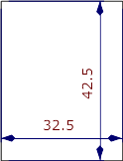
R/L Side
Ctrl Panel

Bottom
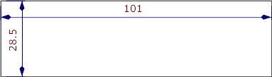

Bottom – Ctrl Panel

Top Back
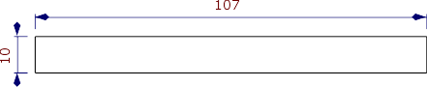
Top Back – Ctrl Panel

Top Front
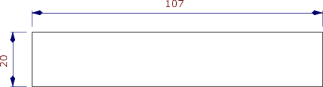
Top Front – Ctrl Panel

