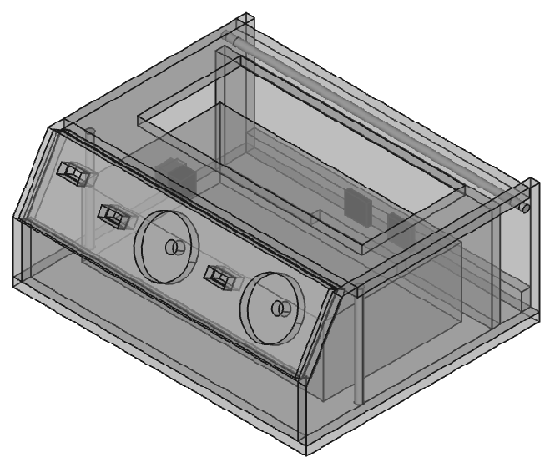
Control Panel – Video Light
Table of Contents
Overview 3
Diagrams 5
Case 5
Base 5
Side 6
Front 7
Panel 8
Top 9
Back 10
Socket Support 11
Circuit Layout 12

Overview
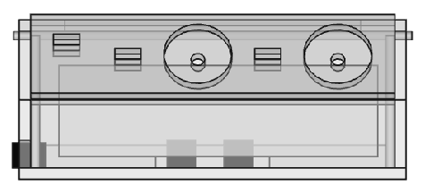
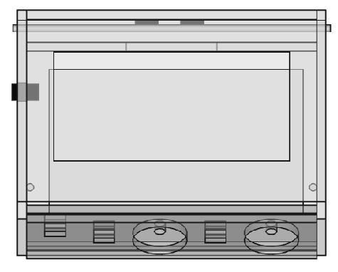
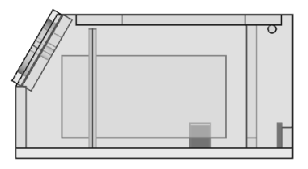
Panel Description
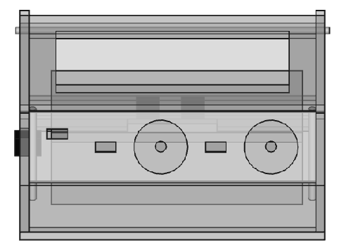
main
switch
light
switch
dimmer
light #1
light #2

Diagrams

Case

Base
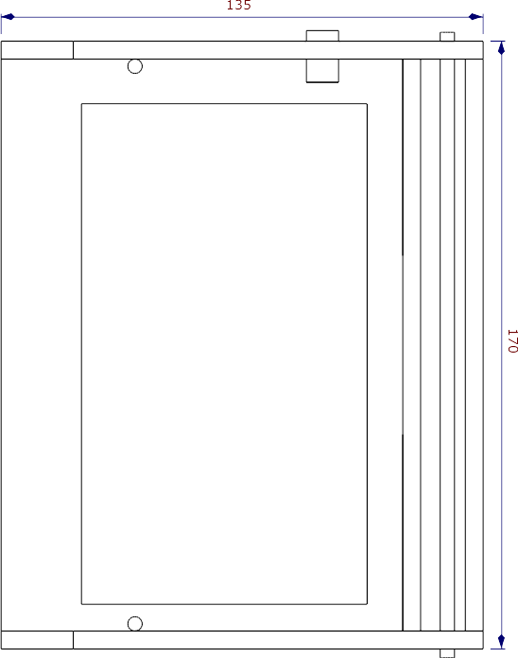
Base – Case – Ctrl Panel

Side
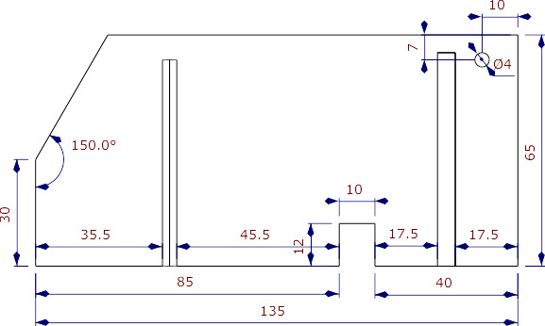
For left side only
Side – Case – Ctrl Panel

Front
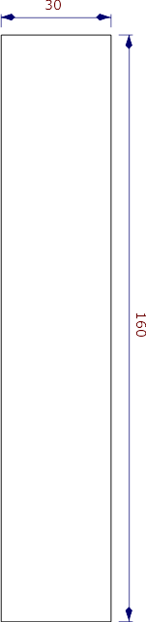
Front – Case – Ctrl Panel

Panel
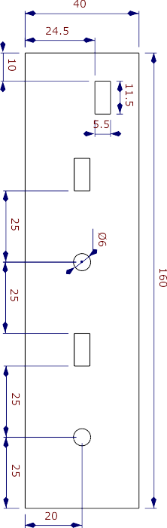
Panel – Case – Ctrl Panel

Top
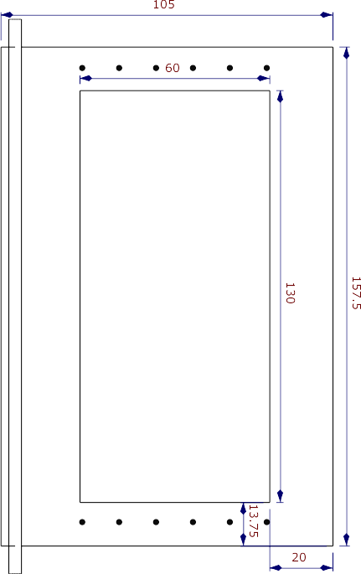
Top – Case – Ctrl Panel

Back
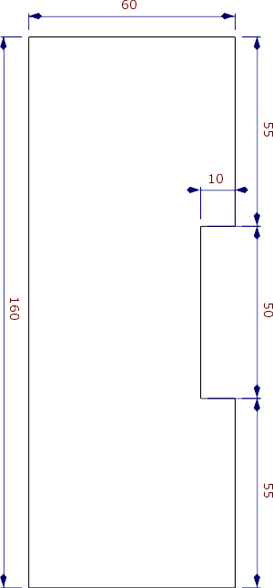
Back – Case – Ctrl Panel

Socket Support
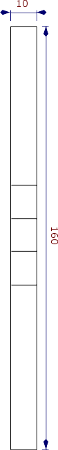
Socket Support – Case – Ctrl Panel

Circuit Layout
