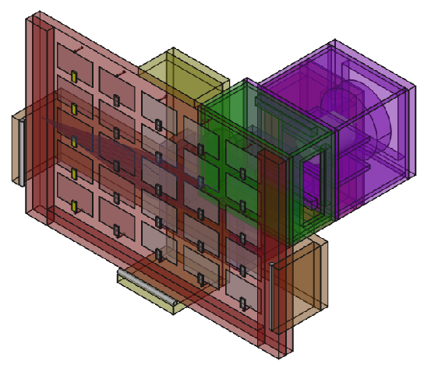
Light – Video Light
Table of Contents
Overview 3
Diagrams 4
HFrame 4
VFrame 5
Frame 6
Socket 8
Plug 9
Connector 10
CtrlBox 12
FanBox 14
LED Layout Guide 16
Frame Back 17
CtrlBox Layout 18
FanBox Layout 19
Power Supply Wires 20
18V 20
1.25V 20

Overview
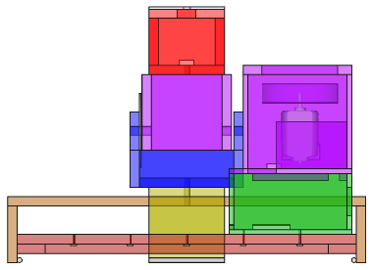
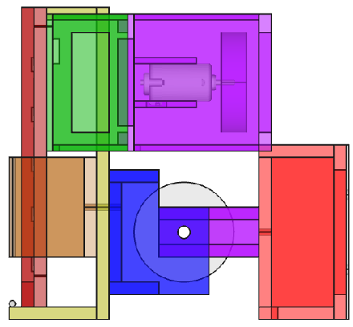
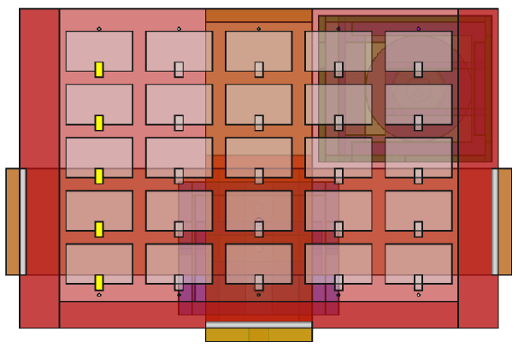

Diagrams

HFrame

Bar
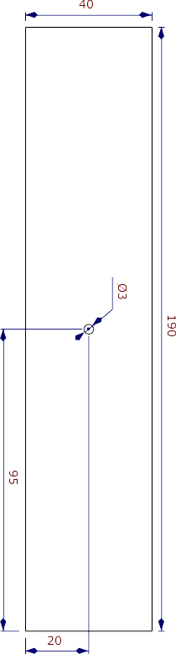
Bar
HFrame
Light

Side
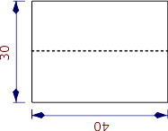
Side – Frame
Light

VFrame

Base

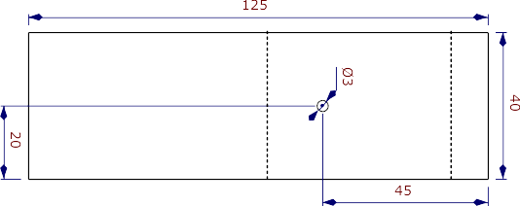
Connector Top
Base – VFrame - Light
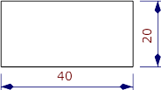
Connector Top
VFrame - Light

Connector Bottom
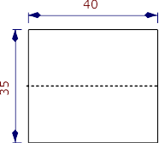
Connector Bottom
VFrame - Light

Frame

Base
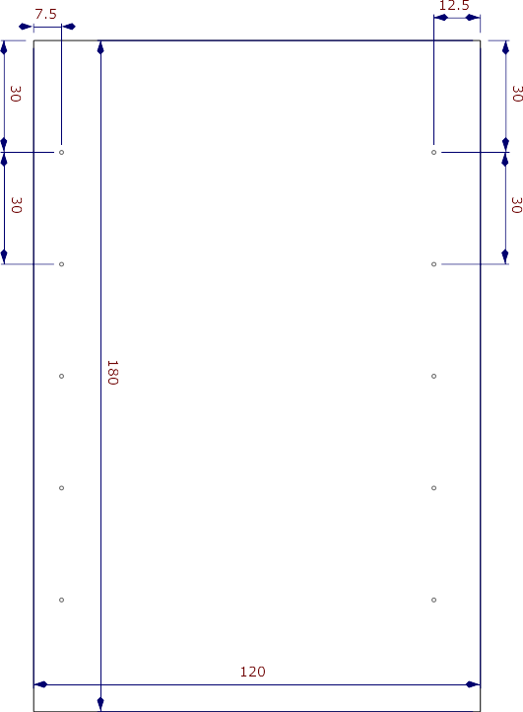
Base – Frame - Light

Side Base
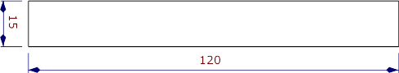
Side Base – Frame - Light

Bottom Base
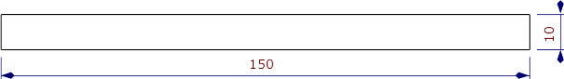
Bottom Base – Frame - Light

Socket

Side
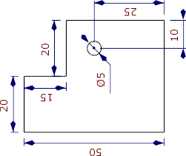

Side - Socket
Light

Top/Bottom
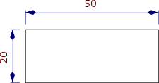
Top/Bottom - Socket
Light

Wheel
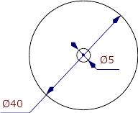
Wheel
Socket
Light

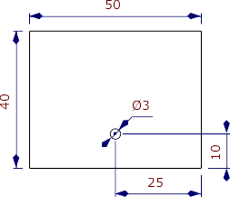
Base
Base – Socket - Light

Plug

Side/Inner
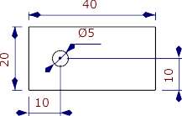

Side/Inner – Plug
Light

Top/Bottom
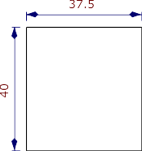
Top/Bottom
Plug - Light

Connector

Front
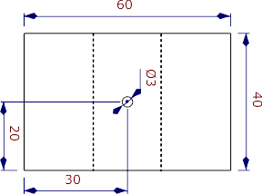
Front – Connector
Light

Side
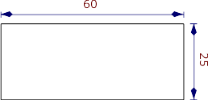
Side – Connector - Light

Top
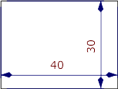
Top
Connector
Light

Bottom
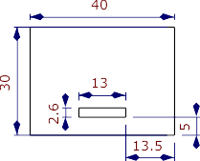
Bottom
Connector
Light

Back
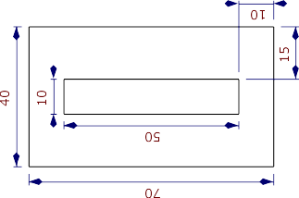
Back – Connector - Light

Back Cover
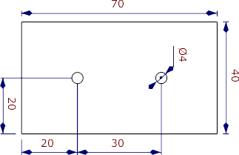
Back Cover
Connector - Light

CtrlBox

Top Side
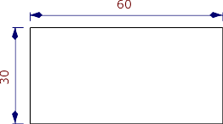
Top Side – CtrlBox - Light

Bottom Side
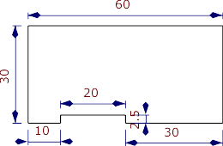
`
Bottom Side – CtrlBox
Light

Left Side
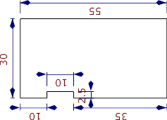
Left Side – CtrlBox
Light

Right Side
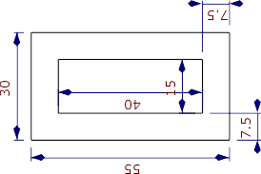
Right Side – CtrlBox
Light

Top
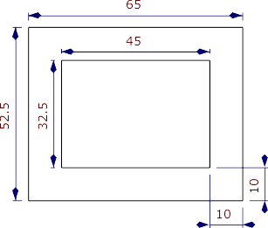
Top – CtrlBox - Light

FanBox

Back
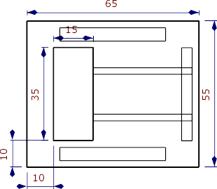

Back – FanBox
Light

Side
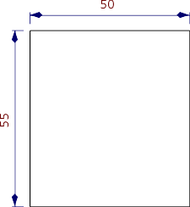
Side – FanBox - Light

Fan
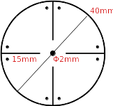
Fan – FanBox
Light

Top/Bottom
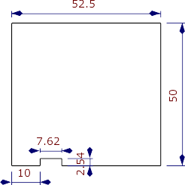
Top/Bottom – FanBox
Light
No notch for Top

Front
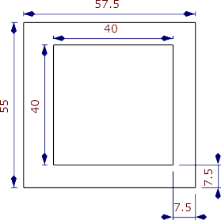
Front – FanBox
Light

Support
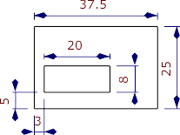
Support – FanBox
Light

LED Layout Guide
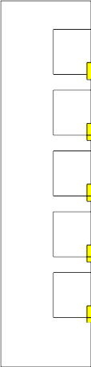

Frame Back
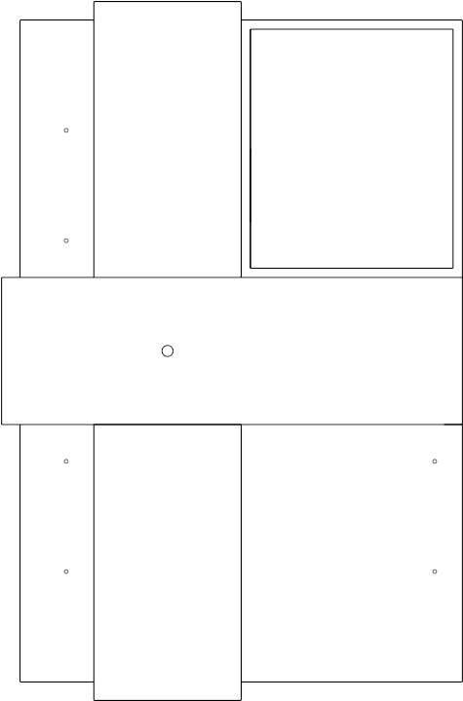

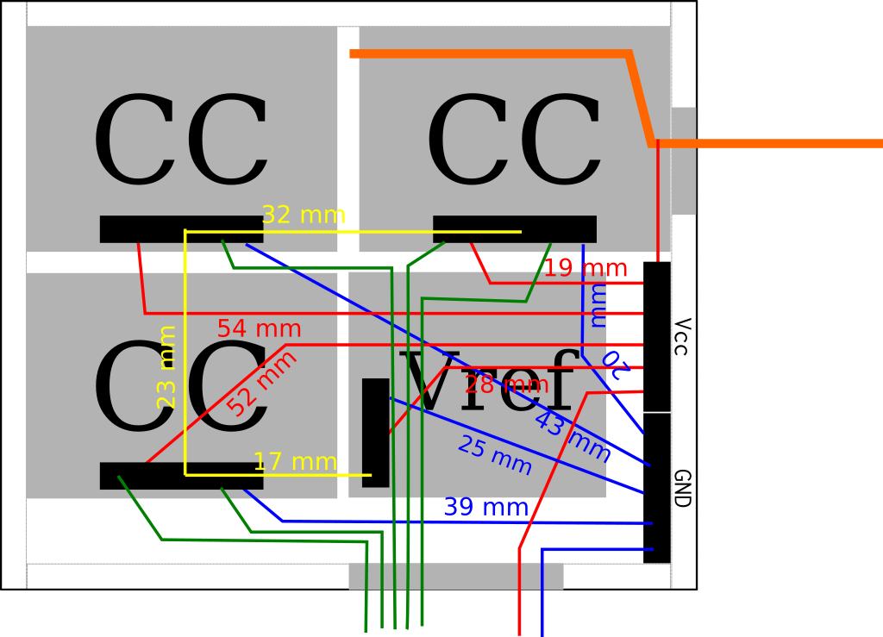
CtrlBox Layout

FanBox Layout
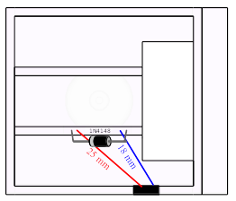

Power Supply Wires

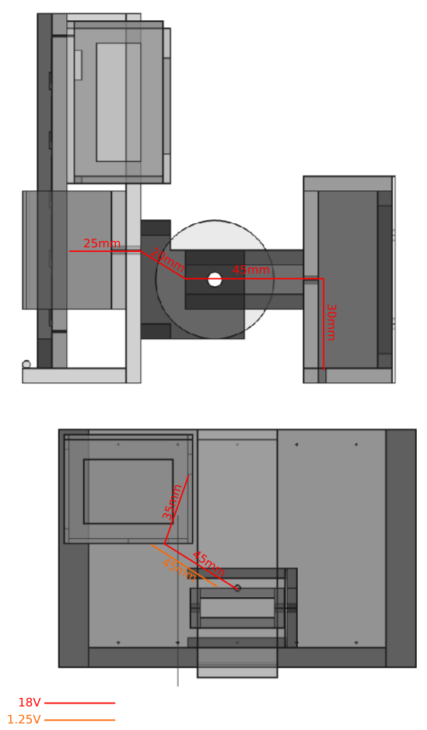

18V
Minimum length of power supply wire: 200mm
With 50mm margin: 250mm

1.25V
Minimum length of power supply wire: 120mm
With 50mm margin: 170mm

