Stand – Video Light
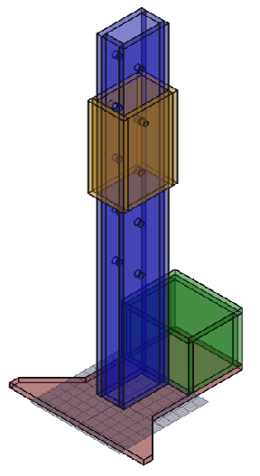
Table of Contents
Overview 3
Diagrams 4
Base 4
Pole 5
Side 5
Front/Back 6
Weight Box 7
Side 7
Front/Back 7
Top 7
Connector 8
Side 8
Front/Back 8

Overview
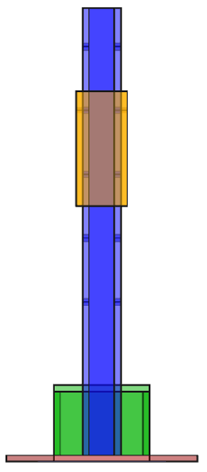
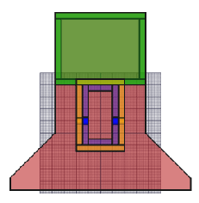
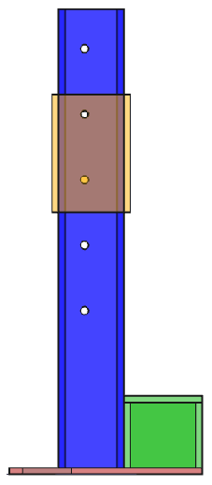

Diagrams

Base
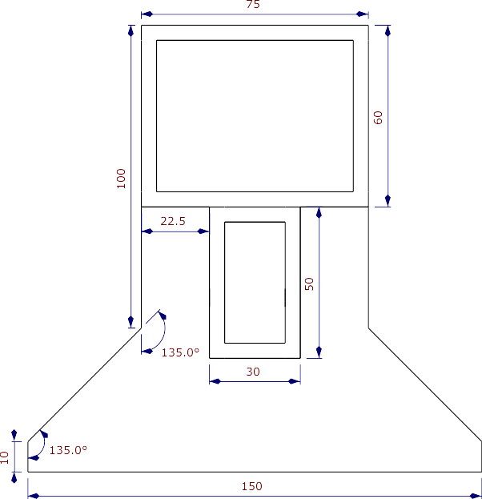
Base – Stand – Video Light

Pole

Side
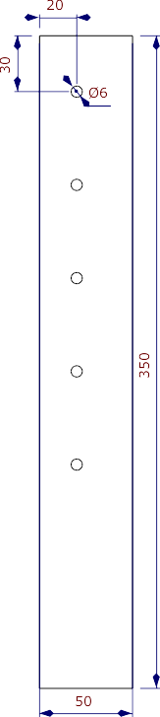
Side – Pole Stand – Video Light

Front/Back
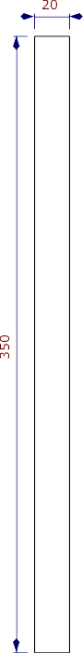
Front/Back – Pole Stand – Video Light

Weight Box

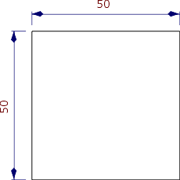
Side

Side
Weight Box
Stand
Video Light

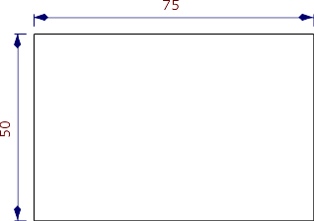
Front/Back

Front/Back
Weight Box
Stand
Video Light

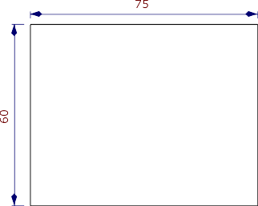
Top

Top
Weight Box
Stand
Video Light

Connector

Side
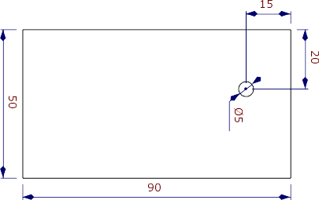
Side - Connector – Stand – Video Light

Front/Back
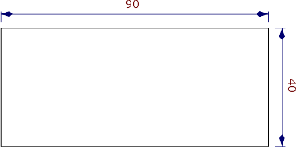
Front/Back - Connector – Stand – Video Light

