LED Test Board
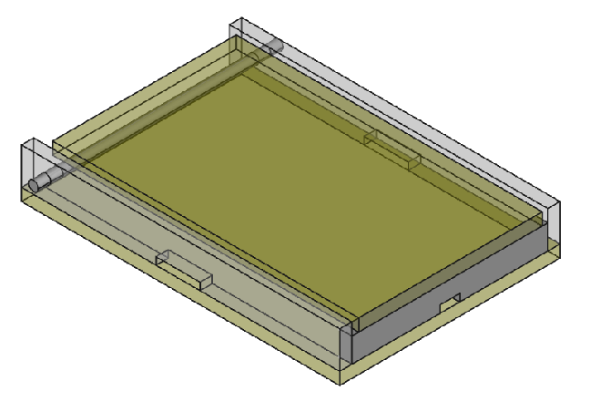
Table of Contents
Overview 3
Diagrams 4
Case 4
LED Layout 6

Overview
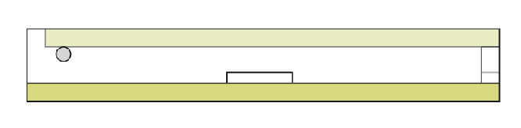
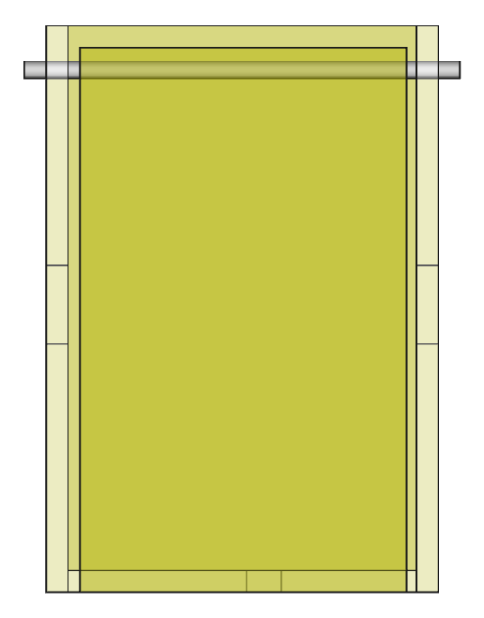
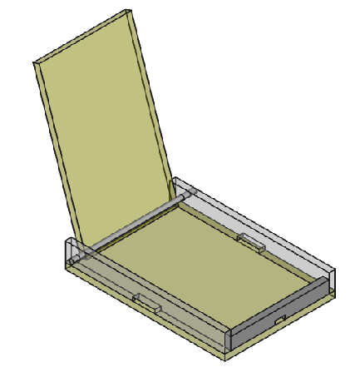
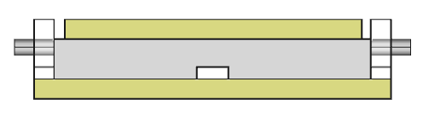

Diagrams

Case

Base
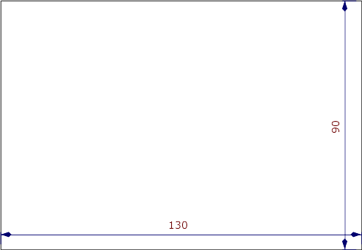
Base - Case

Side
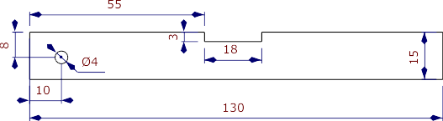
Side - Case

Top
Rod diameter: 4mm
Rod Length: 100mm
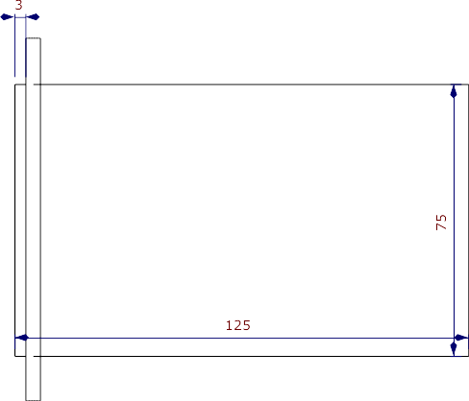
Top - Case

Front
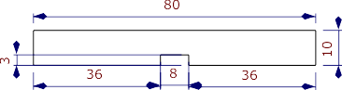
Front - Case

LED Layout
