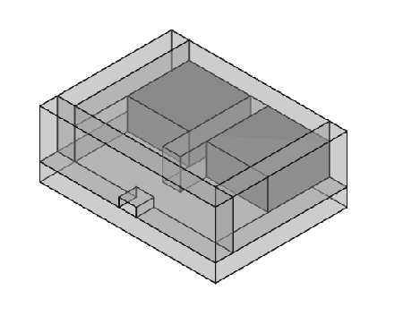
USB Charging Socket
Table of Contents
Overview 3
Diagrams 4
Case 4

Overview
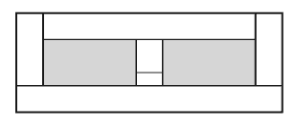
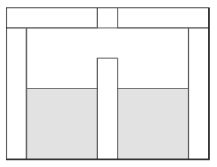
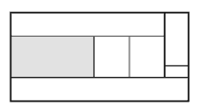

Diagrams

Case

Bottom
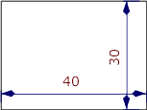
Bottom
Case

Top
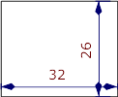
Top
Case

Side3
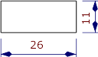
Side - Case

Column
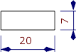
Column

Back
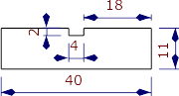
Back

Wiring
- AWG 25 (0.455mm in diameter) wire or thicker for Vbus and GND.
- Any gauge for green wires between D- and D+.
