Assignment On

**Digital System Design**

**Submitted To:**

Md. Rashedul Islam

Lecturer

Dept. Of C.S.E

Hajee Mohammad Danesh Science & Technology University

**Submitted By**

Iqbal Mahmud

Id: 1402048

Dept.: C.S.E

Level: 4 Sem.: I

Date Of Submission: 08.07.18

**BCD Adder:**

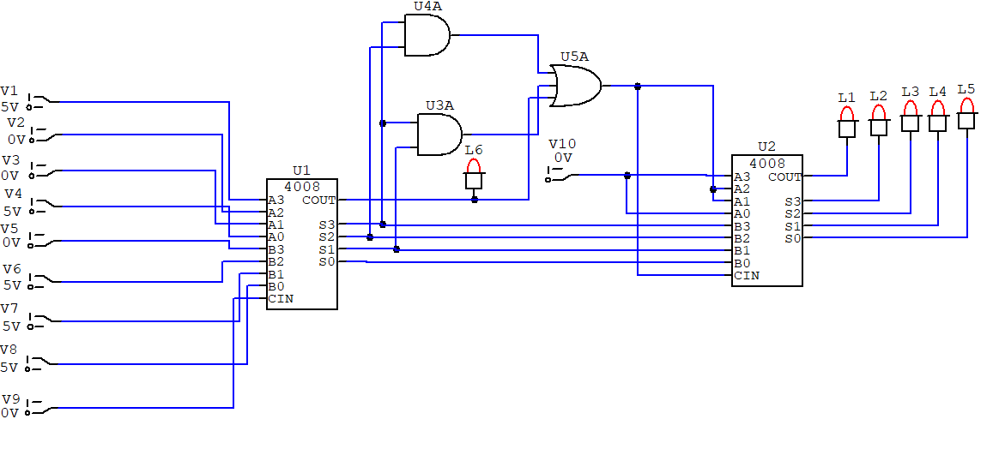

**BCD to Excess 3 Code Converter:**

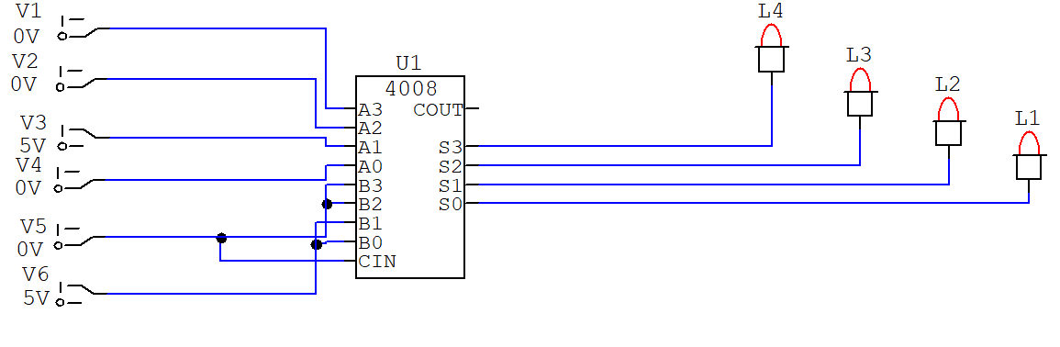

**Comparator:**

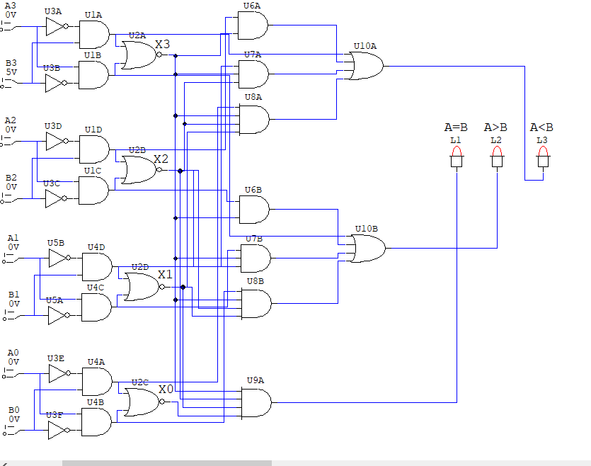

**Full Adder with Decoder:**

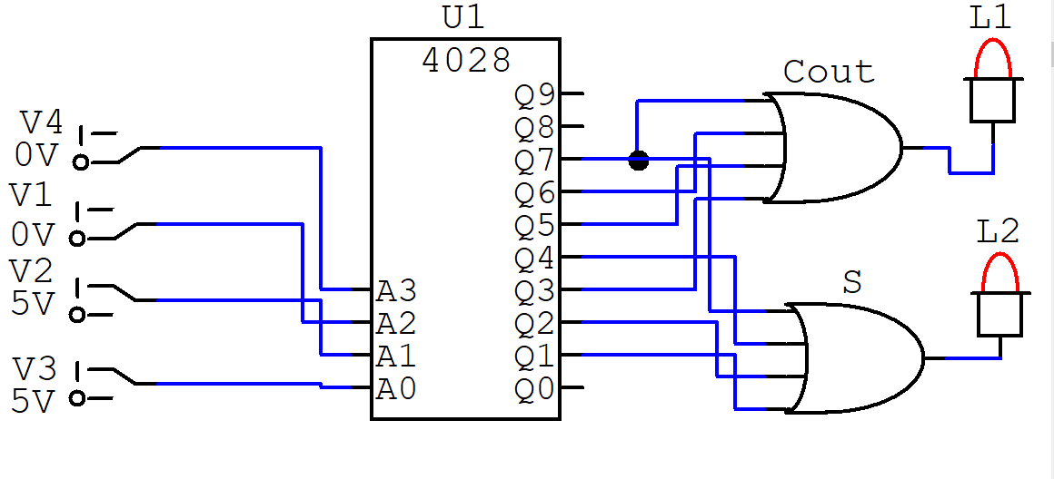

**Full Adder:**

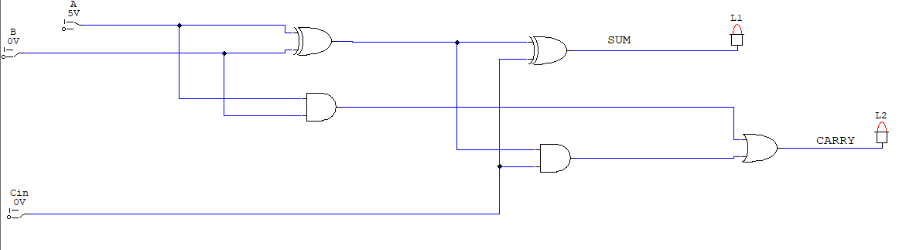

**Half Adder:**

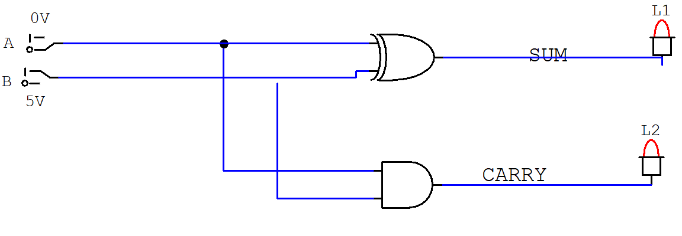

**Look Ahead Carry Genarator:**

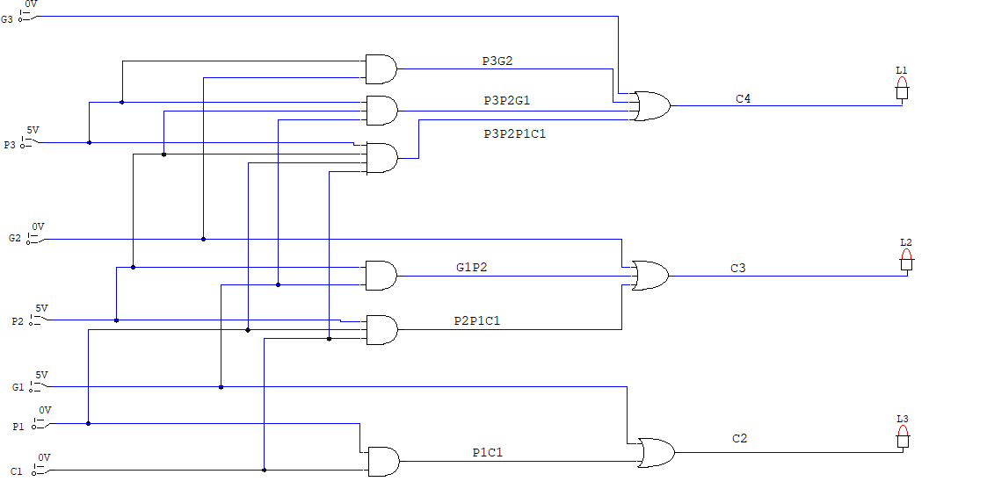

**Quadtruple 2 to 1 MUX:**

