Report On

Wholesale Management System

**Submitted To:**

Masud Ibn Afjal

Asst. Professor

Dept. of CSE

Hajee Mohammad Danesh Science & Technology University

**Submitted By:**

Jyotirmoy Pulak - 1302029

Md. Khairul Basar - 1302030

Md. Arshad Khan - 1402012

Tasnim Tabassum - 1402020

Iqbal Mahmud - 1402048

Date of Submission: 04.07.2018

**TITLE**

**Wholesale Management System**

**ABSTRACT :**

The design phase in a System Development life cycle is crucial in the success of the software development process. To this end, many standard object oriented specifications are available in the literature. This paper presents an application of a Unified Modelling Language (UML), as a standard notation of real-world objects for developing object-oriented design methodology for whole sales inventory applications. UML enables the visualization, specification, construction, and documentation of the artifacts of a software-intensive system. Class diagram is a structure diagram that is used to show the classes and their association with each other. The class diagram includes the notations such as classes, attributes, operations and associations. The study has an important managerial implication and the benefit of UML (class diagram) implication improvement and the flow chart for the whole sale application have been discussed.

**INTRODUCTION:**

Wholesale management system is developed aim to improve the efficiency and performance of daily business activity of the wholesaler. The wholesaler did not have any computerized system for now. All the business activity are recorded and documented manually. A lot of time is consumed during the process of the business activity. The Wholesale Management System (WMS) has an administrator login for the wholesaler with built-in features to keep a check on the sales and the inventory so as to efficiently run the sales division. The customers and suppliers of the wholesale business can also be registered so as to ensure the smooth functioning of sales. There is also a customer login option which helps the customer in monitoring his purchases from the wholesaler. By having the above features, the WMS greatly simplifies the daily functioning of the business.

**PROBLEM DEFINITION:**

At present the owner has no stock control system in place. Any items that are sold are not re- stocked. His employees normally check the shelves in the store every week to see what stocks are needed, write up a list of items, which are purchased from the wholesalers. Telephone calls are made to the frozen food supplier to re-order frozen food items when needed; this can take up significant amounts of time, especially if the sales assistant is managing the shop counter alone. The stakeholders who are affected by this problem include; the owner, employees, and the supplier. The impact of the problem outlined is that the current business system does not allow for efficient business practices, which essentially can be costly to the business and generating stock information can be time consuming for the owner. The system will allow the user to keep track of his stocks. At any given time the user should be able to see the stock available, print out reports of specific queries, and update prices when they change. Currently there is no indication of when the stocks need to be replenished.

**PROPOSED SOLUTION:**

The SDLC technique is the chosen methodology which will be used to conduct the project. The SDLC will be used as the basic framework which will keep the project flowing from one phase to the next. Microsoft Windows has been chosen to be used as the platform to create the RDMS in Microsoft Access. Recommendations to install a broadband cable modem for internet access, along with a ‘pay as you go’ secondary broadband line have been made so that orders can be sent. The Peninsula Phoenix II CCD Barcode Reader has been recommended for purchase. Suggestions have been made to use Norton Personal Firewall and Anti virus software for internet security along with recommendations to archive the system on a weekly basis in the event of unexpected system or power failure.

**OBJECTIVES:**

The purpose of the inventory control system is to save the owner time and encourage more organized and efficient business processes. This will allow the owner to know what stocks are presently available enabling him to manage and organize his business more effectively.

The software package should be general purpose for users who have similar inadequacies with their existing inventory control system, allowing the user to manage stocks more efficiently.

**STUDY OF EXISTING SYSTEM:**

It is essential to determine what system is currently in place at The Wholesale shop, and to ensure that this is fully understood in order to undergo and identify the justification for a new system. Initially a look at the users of the system and current processes will provide the basis for this.

* ***System Users***

*-*By gaining an insight into the main users of the system, some of the specific requirements can then be determined.

* ***Inputs, Processes and Outputs***

*-*The process of stock control within The Wholesale Shop consists of three main areas; firstly the stocks are purchased from Industry or have been ordered from suppliers. Secondly the stock is either delivered by the supplier or delivered by the owner. Lastly the stock is sold to the customers and leaves the store.

**Disadvantages of the Existing System:**

* More time is consumed.
* More hard work to maintain all records.
* Bulk of paper is to be searched for a single search.

**USER REQUIREMENTS:**

* The system will be able to input product information via barcode technology
* The system will be able to generate ‘best’ and ‘worst’ product reports
* The system will allow categories to be added, updated and deleted
* The system will generate a report of stocks at re-order level
* The system will allow for a product search, indicating the units in stock and price of the product
* The system will be able to add new suppliers to the database with a printable list of the suppliers
* The system will be able to hold contact information about employees

**SYSTEM REQUIREMENTS:**

The user requirements which have been discussed in previous section will be used to assess if the system has met these requirements. System testing will be conducted in the form of user interface testing, system requirement testing which will be cross referenced with the list of requirements, to determine if all the requirements have been met.

**FEASIBILITY STUDY:**

**Technical feasibility:**

The system is being developed in Visual Basic 6.0. It provides comprehensive function to make it user friendly. The data entry and report generation is also made easy. Backup and restore of the database facility are also provided. It also provides easy retrieval of data. The machine configuration also supports this software.

**Social feasibility:**

As this system is user friendly and flexible some problems will also be solved which employee may be facing when using existing system. So we can say that system is socially feasible.

**Economical feasibility:**

The cost of converting from manual system to new automatic computerized system is not probably more. For construction of the new system, the rooms and its facilities are available so it does not require any extra resource, only the software requirement is there.

**Operation feasibility:**

Since the system is being in user friendly way, the employees customers within a few time can master it.

**SYSTEM ANALYSIS & DESIGN:**

**UML CLASS DIAGRAM**

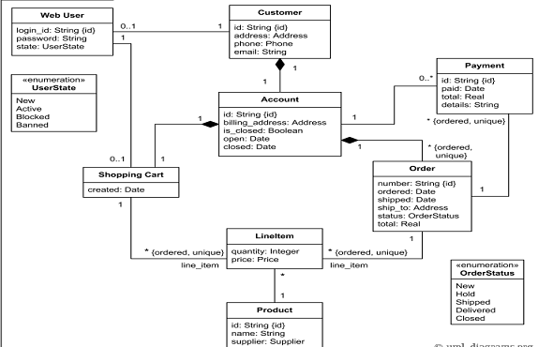

**DESIGN:**

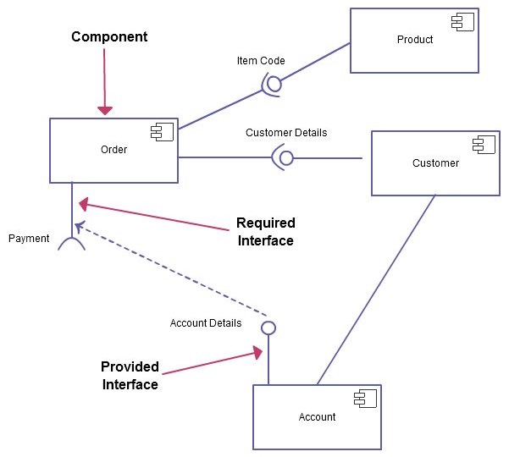

**ADVANTAGES:**

This system provides paperless maintenance. Initially an employee can be appointed to do all the transaction and update and maintain records.

* + Less effort to complete transaction.
  + Less time required.
  + No need to maintain the bulk of papers.

**REFERENCES:**

[1] Ritchie, B. Marshall, D. Eardley, A. (1998) *Information Systems in Business*, International Thomson Business Press

[2] Stephen, M. (2004) *‘Teach Yourself’ Access 2003*, Hodder Headline

[3] Phoenix II barcode readers for connection to Mac or PC, USB [On-line] [Accessed 15th Nov 2005] Available from World Wide Web: <http://www.peninsulagroup.com/barcodereader/default.html#Buynow>