Assignment-11
Firstly visiting the http://10.0.2.8/search.php for the sqli.
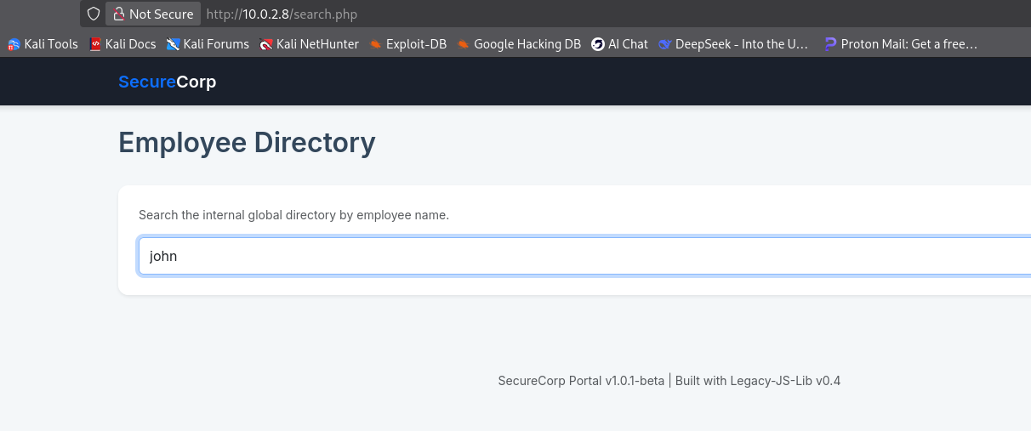
We will input one of the users john and capture the request via burpsuite.
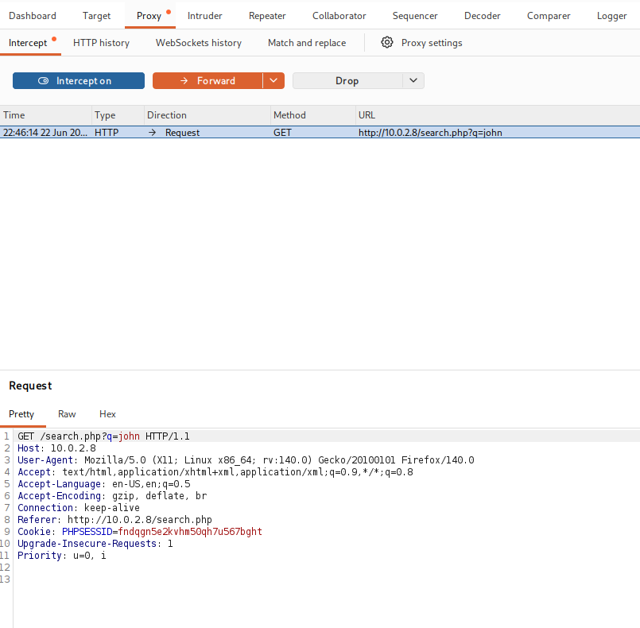
After capturing our request we will forward it to repeater and input ‘*’ just after john, doing this will tell the sqlmap[our sqli tool] to know where to perform the injection.
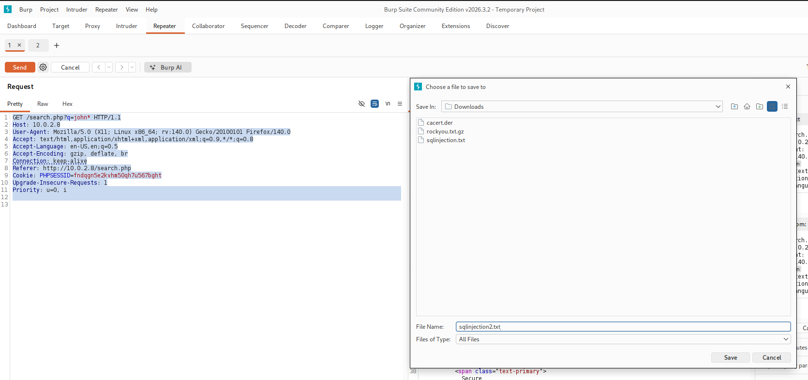
Select all the text and righ-click and select save selected text and a file and save it with your desired name with .txt extension.
Open terminal where you saved your file and give root privileges.
And write this command sqlmap -r sqlinjection2.txt --dbs --random-agent .
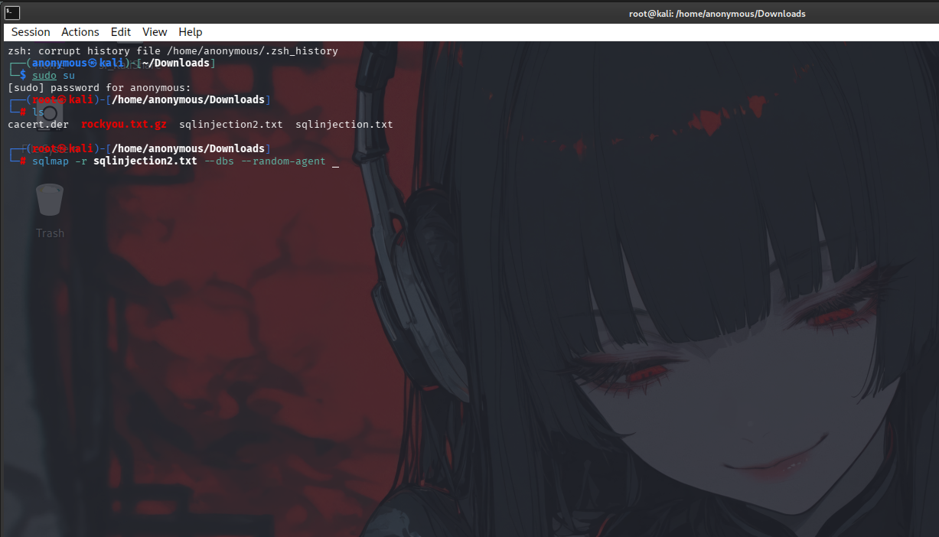
In this command -r instructs sqlmap to use a custom HTTP request stored in a file
And --random-agent makes sqlmap rotate through different User-Agent headers to avoid detection or blocking.
–dbs tells it to find databases in the sql.
After the running the command enter y whenever asked and wait for the output.
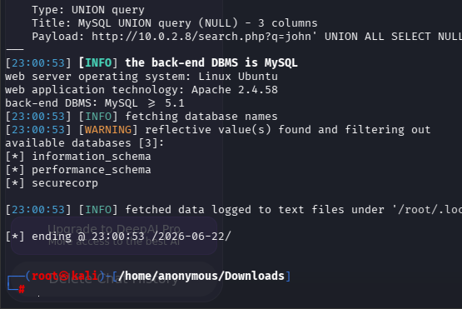
It successfully founded 3 databases but we will use securecorp as we our working on that website.
Now write this new command
sqlmap -r sqlinjection2.txt -D securecorp --tables --random-agent
Now we have given the database we want and given the clause –tables to find the available tables in that database.
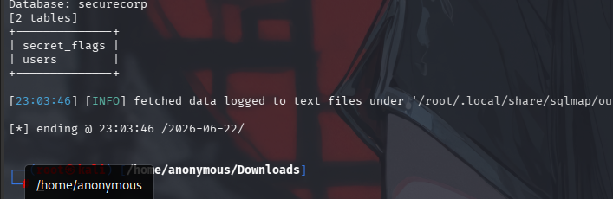
We will now use the table secret_flag as we want the flag hidden in that, so we will use a new command as follows.
sqlmap -r sqlinjection2.txt -D securecorp -T secret_flags --dump --random-agent
–dump will give the content of the secret_flags table.
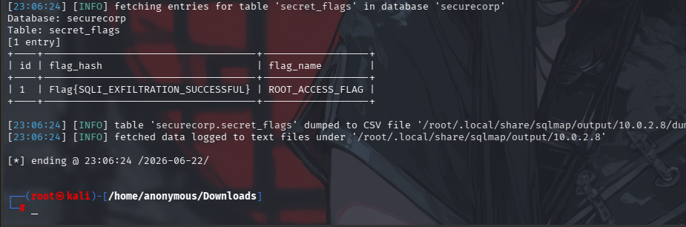
Here we the required flag we wanted = Flag{SQLI_EXFILTRATION_SUCCESSFUL}
