Assignment-7
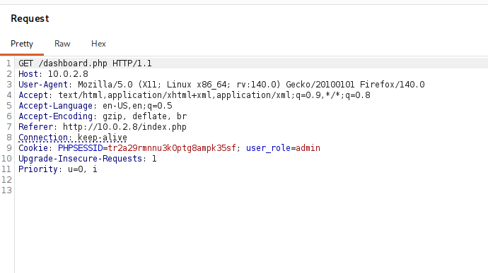
From the previously captured request where we change the user role to admin, on that same request on top change the /dashboard.php to admin.php to get the admin panel access and the flag.
